INTERNATIONAL TELECOMMUNICATION UNION |  | Focus Group on  Smart Sustainable Cities
TELECOMMUNICATION  STANDARDIZATION SECTOR  STUDY PERIOD 2013-2016 |  | SSC-I-0022
English only
Original: English
WG(s): | All | Geneva, 3-4 March 2014
DOCUMENT
Source: | TSB
Title: | Remote Participation - Adobe Connect Guide
Remote Participation Guide
ITU-T’s FG SWM meeting (3-4 March 2014) will be made available as a live audio and video in order that remote participants can see and hear presentations.
To participate remotely, please follow these steps:
Logging in the Room:
a) The list of the TSB e-Meetings can be found at: http://www.itu.int/en/ITU-T/events/Pages/emeetings.aspx
b) Click on the session that you wish to attend
c) Login with your TIES credentials

Note: Please login to the meeting room at least 15 minutes before the session is due to start. This will ensure that we can start the meeting on time.

Adobe Connect Interface:

- Call Pod: To connect to the audio bridge.
- Video Pod: Used to display any video used in the web meeting.
- Attendee Pod: Displays names of all participants logged into the meeting room.
- Share Pod: Used to share meeting documents. Can contain documents uploaded to the Connect server and can also be used for screen sharing
- Chat Pod: Used to exchange chat messages. Messages can be sent to everyone, or privately to individuals.
- Note Pod: Displays information about the meeting.

Audio connection:
There are two options to join this meeting:
Option 1: Listen through computer speakers (listen mode only)
Option 2: Dial-In or dial-out to yourself over the phone.

Option 1:

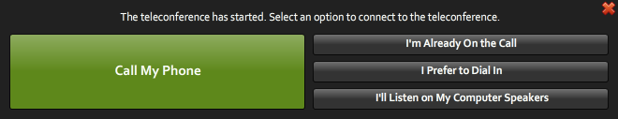

By choosing this option, you can only listen to the conference. You won’t be able to speak.
A chat box is available if you wish to make some comments.

Option 2:

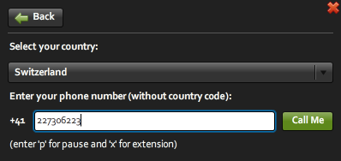

- Click on “Call My Phone”
- Select the country
- Type in your number

The system will then call you on the specified number.

Meeting Participation

By default you will be on the Floor Channel and muted until you request the floor by clicking on the “raise hand” button.
The meeting host then will give you the floor and you will hear a short audio message on your phone stating that you can speak now.

When you make your intervention, please start by stating your name and the entity you are representing. Please click on the Lower Hand button when you finish your intervention.

For more information concerning the remote participation, please send an e-mail to tsbemeetings@itu.int.
_______________

