 |  | International Telecommunication Union
 |  | ITU-T | FG-SSC
 |  | TELECOMMUNICATION  STANDARDIZATION SECTOR  OF ITU |  | (05/2015)
 | ITU-T Focus Group on Smart Sustainable Cities
 | Multi-service infrastructure for smart sustainable cities in new-development areas
 | Focus Group Technical Specifications

FOREWORD
The International Telecommunication Union (ITU) is the United Nations specialized agency in the field of telecommunications, information and communication technologies (ICTs). The ITU Telecommunication Standardization Sector (ITU-T) is a permanent organ of ITU. ITU-T is responsible for studying technical, operating and tariff questions and issuing Recommendations on them with a view to standardizing telecommunications on a worldwide basis.
The procedures for establishment of focus groups are defined in Recommendation ITU-T A.7. ITU-T Study Group 5 set up the ITU-T Focus Group on Smart Sustainable Cities (FG-SSC) at its meeting in February 2013. ITU-T Study Group 5 is the parent group of FG-SSC.
Deliverables of focus groups can take the form of technical reports, specifications, etc., and aim to provide material for consideration by the parent group in its standardization activities. Deliverables of focus groups are not ITU-T Recommendations.
SERIES OF FG-SSC TECHNICAL REPORTS/SPECIFICATIONS
Technical Report on "Smart sustainable cities: a guide for city leaders"
Technical Report on "Master plan for smart sustainable cities"
Technical Report on "An overview of smart sustainable cities and the role of information and communication technologies"
Technical Report on "Smart sustainable cities: an analysis of definitions"
Technical Report on "Smart water management in cities"
Technical Report on "Electromagnetic field (EMF) considerations in smart sustainable cities"
Technical Specifications on "Overview of key performance indicators in smart sustainable cities"
Technical Report on "Information and communication technologies for climate change adaptation in cities"
Technical Report on "Cybersecurity, data protection and cyber resilience in smart sustainable cities"
Technical Report on "Integrated management for smart sustainable cities"
Technical Report on "Key performance indicators definitions for smart sustainable cities"
Technical Specifications on "Key performance indicators related to the use of information and communication technology in smart sustainable cities"
Technical Specifications on "Key performance indicators related to the sustainability impacts of information and communication technology in smart sustainable cities"
Technical Report on "Standardization roadmap for smart sustainable cities"
Technical Report on "Setting the stage for stakeholders’ engagement in smart sustainable cities"
Technical Report on "Overview of smart sustainable cities infrastructure"
Technical Specifications on "Setting the framework for an ICT architecture of a smart sustainable city"
Technical Specifications on "Multi-service infrastructure for smart sustainable cities in new-development areas"
Technical Report on "Intelligent sustainable buildings for smart sustainable cities"
Technical Report on "Anonymization infrastructure and open data in smart sustainable cities"
Technical Report on "Standardization activities for smart sustainable cities"

© ITU 2015
All rights reserved. No part of this publication may be reproduced, by any means whatsoever, without the prior written permission of ITU.

Multi-service infrastructure for
smart sustainable cities in
new-development areas

Acknowledgements
These Technical Specifications were researched and written by Dave Faulkner (Climate Associates), Paolo Gemma (Huawei), Ziqin Sang (Fiberhome Technologies), N.S. Deepu (Ministry of Communications and Information Technology, India), R.M. Argarwal (Ministry of Communications and Information Technology, India), Flavio Cucchietti (Telecom Italia), Leonidas Anthopoulos (Technological Education Institute of Thessaly, Greece), John Faulkner (Environment Agency, United Kingdom), Nilesh Kumar Purey (Gujarat International Finance Tec-City Co. Ltd., India), Satish Kamat (Lavasa Corporation Limited, India), Neeraj Mishra (Telecommunication Regulatory Authority, India) and Keith Dickerson (Climate Associates), as a contribution to ITU-T Focus Group on Smart Sustainable Cities (FG-SSC).
Additional information and materials relating to this report can be found at: www.itu.int/itu-t/climatechange. If you would like to provide any additional information, please contact Cristina Bueti at tsbsg5@itu.int.

Multi-service infrastructure for smart sustainable cities
in new-development areas
Table of Contents
Page
1 Introduction 1
2 Scope 2
3 SSC Utility Service Requirements 2
3.1 Opportunities for Infrastructure Sharing in Central City Locations 6
3.2 Growth, Maintenance and Upgrade in New Build Situations 22
3.3 Lifecycle and obsolescence 22
4 Smart Sustainable Building Utility Services 24
4.1 Opportunities for sharing risers (e.g., inside or alongside buildings) 24
4.2 Smart Sustainable Building Service Requirements 24
5 Opportunities for sharing infrastructure at street level 26
6 Opportunities for ICT to support other utilities 27
7 Opportunities for sharing the Application Platform 28
Annex A – Glossary and list of abbreviations 29
Appendix I – Bibliography 30

Multi-service infrastructure for smart sustainable cities
in new-development areas
Executive Summary
This document focuses on answering the question, “How should ICT infrastructure be planned for a new city given that it has to be both 'smart' and 'sustainable'?”.
The approach taken assumes that no infrastructure exists and the city or urban development area is to be built from new. A feature which is new for smart sustainable cities (SSCs) is the need for a sensor layer network and peripheral devices which may be directly connected to the internet, i.e., the internet of things (IoT).
To reduce whole life costs, this document explores the opportunities for infrastructure sharing from the outset. The primary concern for all types of installation is safety.
The location or collocation of ICT infrastructure is considered in urban corridors, trenches, urban tunnels and risers into buildings and rooms. Examples of web-based software platforms are provided which enable data sharing via application programming and other interface.
Keywords
Urban Corridor, Utility Tunnel, Trench, sensor layer, application program interface.

1 Introduction
New cities are being planned in some countries where there is rapid growth in industrialisation. This leads populations to migrate from a rural to an urban environment to seek higher paid employment. This trend is expected to continue at least to year 2050. City planners therefore have the task of planning a city with a 'clean sheet of paper'. It is intended that this document will also be applicable to for suburban or city expansion which is being planned on a clean slate.
Until now city infrastructure, including ICT, has evolved to meet the needs of 'organic growth' whereby villages grew into towns and then into cities as populations have grown. Each new building or group of buildings was planned at a different time.
This document focuses on answering the question, "How should ICT infrastructure be planned for a new city given that it has to be both 'smart' and 'sustainable'?". The ICT infrastructure can then be planned and a set of technical requirements can be drawn up. After that, relevant specifications can be written, drawing upon the wealth of existing ICT specifications and standards.
The approach taken assumes that the city or development area of an existing city is to be built from new with no existing structures above or below ground. A feature which is new for smart sustainable cities (SSCs) is the need for a sensor layer network and peripheral devices which may be directly connected to the internet, i.e., the internet of things (IoT).
Sensors may be connected directly to a source of power and transmission such as an electricity cable or metallic pair. Sensors which require high bandwidth could be connected by optical fibre and wire for electricity. Sensors which use radio communication would need a source of power such as batteries.
Building and maintaining telecommunications and sensor layer networks is expensive, especially when installed on a reactive basis to meet emerging demand. To reduce costs, this document explores the opportunities for infrastructure sharing from the outset. The infrastructure could focus on a central location, such as the main railway station, city centre, or multiple clusters forming a city, where high capacity services are radiate towards the periphery of the city where individual homes, people, places and things require services. Shared infrastructure can save significant costs, especially when provision is made for maintenance, upgrade and growth over the lifecycle.
The primary concern for all types of installation is safety.

2 Scope
These Technical Specifications describe the various infrastructures for a smart sustainable city in a new-development area.
The designated infrastructure in this document includes: common physical infrastructure highlighting ICT, ducted and trenched infrastructure below ground, over ground common physical infrastructure, common risers in buildings, etc. The following issues are considered: safety, maintenance, lifecycle including possible obsolescence, flexibility points, scalability and growth. Examples are included of best practices for physical infrastructure including opportunities for sharing service paths below and above ground, such as conduits.
NOTE – Sharing wireless service infrastructure, such as lampposts and masts is mentioned in the FG-SSC report "EMF Considerations in Smart Sustainable Cities" [b-24].
It is not intended to address rehabilitation schemes such as upgrade of existing buildings. The focus is on establishing principles with outline rather than detailed dimensions.
This is one of a possible series of specifications to be addressed in Question 20 of ITU-T Study Group 5 (SG5).

3 SSC Utility Service Requirements
[b-1] identifies a number of services which utilize an urban corridor. The urban corridor is more commonly understood as a roadway or boulevard etc. The urban corridor is found in both new-build and existing cities and may be regarded as the conventional approach where each utility is installed separately in its own trench.
Underground services mentioned here and elsewhere include:
- Water distribution system
- Wastewater collection system
- Landscape irrigation water supply system
- Urban storm water drainage system
- Gas network medium and low pressure
- Power supply, including high voltage that supplies primary substations, medium voltage low voltage
- Telecommunication networks (e.g., fiber optic cables and twisted pair cables) and Community Antenna Television (CATV)
- Fiber optic networks including: Intelligent Transportation System, Traffic Control System, Closed Circuit TV, and Police
- District Heating/Cooling Network
- Power for public street lighting
- Oil pipeline for oil refining plant
- Solid waste collection is shown in [b-2] (vacuum pipes use suction of air to propel waste to a central waste processing unit-plasma gasification in this example). This is illustrated below as an example of a new service not present in most existing cities. An ICT management system is needed to support this.
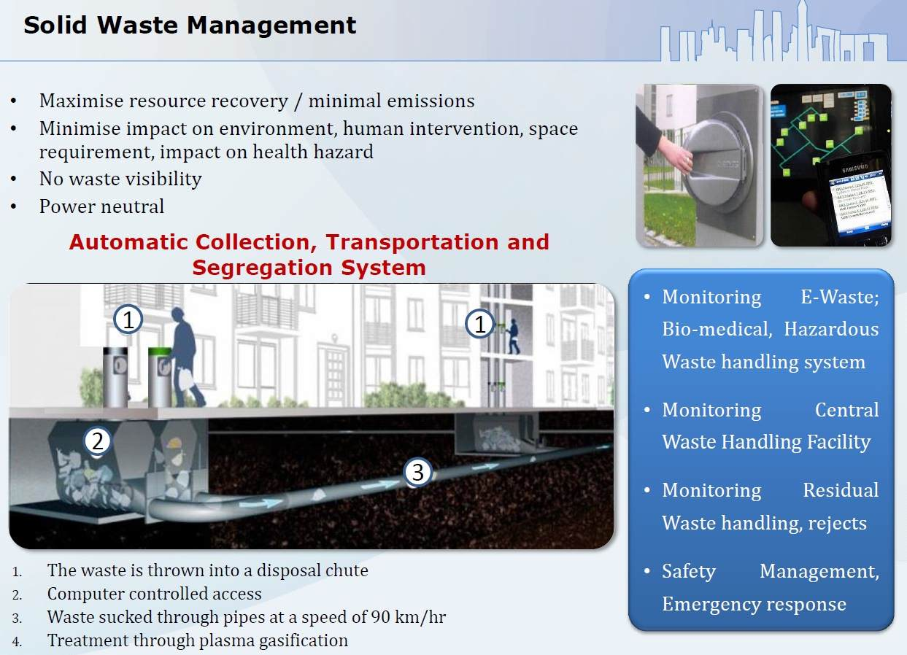
Figure 1 – Solid waste collection
[Source: Nilesh Puery, b-2]
- Collective antennas for wireless systems [b-28]
- Ducted transport (e.g. pneumatic tubes [b-28] or automatic railway [b-10])
NOTE – Usually subway signalling systems (e.g., Leaky coaxial cable or rail transit wireless communication system) are not taken into consideration as these are most likely to be an independent underground service.
[b-26] classifies the underground pipelines into 8 categories according to the functions, i.e. water supply, drainage, gas, heat, electricity, telecommunication, industry and other pipelines (Figure 2).

Underground pipelines
Water supply pipelines
Drainage pipelines
Gas pipelines
Heat pipelines
Electricity pipelines
Telecom pipelines
Industry pipelines
Other pipelines
Municipal water pipelines
Fire fighting water pipelines
Industrial water pipelines
Agricultural irrigation water pipelines
Effluent pipelines
Rainfall pipelines
Effluent/rainfall interflow pipelines
Coal gas pipelines
Natural gas pipelines
Hot water pipelines
Steam pipelines
Telecommunication cable
Radio and television cable
Special communication cable
Petroleum pipelines
Chemical industry pipelines
Deslagging pipelines
Liquefied petroleum gas pipelines
Power cable
Lighting cable
Figure 2 Functional classification of underground pipelines [source: CJJ 61-2003, b-26]

[b-26] also lists the buildings and their affiliated facilities for various underground pipelines (Table 1).

Table 1 Buildings and their affiliated facilities for various underground pipelines [source: CJJ 61-2003, b-26]
Pipeline type | Buildings | affiliations
Water supply | Water source well, water supply pump station, water tower, reservoir of clean water, purifying pond | Valve, water meter, hydrant, air evacuation valve, mud valve, preserved joint, valve pit
Drainage (rainfall, slops) | Drainage pumping station, drain trap, septic tank, purification structures, ground outlet for covered drain | Inspection pit, drop well, dry box with seal, flushing manhole, catch basin, inlet and outlet, water grate, effluent device
Gas, heat, industry pipelines | Pressure regulating house, gas station, boiler house, power station, gas tank, cooling tower | Expansion joint, exhaust/drain/effluent device, condensate well, various cellar wells, valve
Electricity | Power substation, power distribution room, cable examine hole, electricity tower/pole | Pole transformer, open ground transformer, various cellar wells, examine hole
Telecommunication | Transit exchange, control room, cable recondition hole, telecommunication tower/pole, repeater station | Connector box, distribution box, various cellar wells, examine hole

NOTE - Different countries may have other national standards or regulations for functional classification of underground pipelines as well as the buildings and their affiliated facilities.
Surface and above ground utilities.
In addition to the above, there are a number of surface services mentioned in [b-1] and elsewhere such as:
- Roadways
- Footpaths
- Tramways
- Street lighting
- Wireless networks
- Corridors for trees (e.g., to provide cooling and absorb polluting gases (NOx and CO₂)
- Arrangement of solid waste collection facilities/bins.
Utility corridors could radiate out from a central location such as a central railway station or could terminate at a point near a river so that water flow by gravity can be easily exploited throughout the system.
As far as is known underground and surface railway systems generally operate as a single service without sharing facilities with other utilities. Safety considerations may dictate such separation. However there are precedents such as tramways sharing services with roads in some cities such as Geneva. Thus there may be cost advantages when an underground railway is to be built directly under a road (e.g., London's Circle Line) to have common utility tunnels constructed alongside the railway but separated by a reinforced concrete wall.

3.1 Opportunities for Infrastructure Sharing in Central City Locations
Opportunities for infrastructure sharing occur when several services need to be provided along a common path to buildings or other locations such as where sensors or actuators are to be located.

3.1.1 Urban Corridors with Direct Trenching
[b-1] shows a specification of a corridor with a metro (surface tramway) in the centre of the corridor. Lines and electric power are separate from the other utilities in the corridor. This is illustrated in [b-1, Figure 5:37].
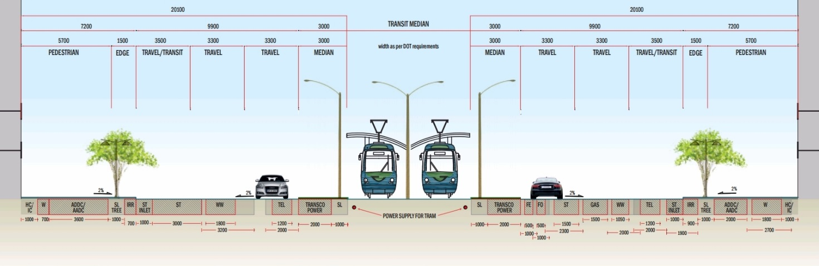
Figure 3 – Typical Utility Corridor Arrangement for Streets with Metro/Tram Lanes
[Source: Abu Dhabi Utility Corridors Design Manual, b-1]
The operation and maintenance of the utilities will benefit from efficient and effective coordination.
Inter-agency coordination during the installation and/or operation and maintenance activities will maximize the benefits and ensure the following [b-1]:
- Reduction in road maintenance costs [b-1]
- Provision of smoother roads with fewer closures for maintenance / rehabilitation activities [b-1]
- Provision of cost effective engineered solutions which are suitable for the local conditions [b-1]
- Promotion of consistent policies which eliminate disputes among stakeholders [b-1]
- Expediting project delivery and avoidance of project delays in the preliminary engineering, pre-construction and construction phases [b-1].

3.1.1.1 Advantages of Trenching (direct burial) include:
- Initial costs may be lower because of the avoidance of the cost of the utility duct and subsequent installation of the cables into such duct
- Planning time needed among stakeholders is minimized
- Maintenance workers can focus their expertise (training) on one utility
- No central authority is needed to manage the stakeholders.

3.1.1.2 Disadvantages of Trenching (direct burial) include:
- Maintenance costs are higher. Damage to one utility during repair or installation work on another utility is more likely because location information is not shared well among stakeholders
- Robust, precise location records for older utility trenches are often not provided or maintained, and older trench locations are often unknown. Low levels of collaboration among stakeholders is a limiting factor [b-3]
- Single-purpose trenches encourage a utility to follow a single-minded route to shorten runs and save initial installation costs for that particular utility. But uncoordinated routing encourages spatial chaos, using more space than if trenches were parallel [b-3]
- Access to a trenched network typically requires locating the utility network, cutting open the road or pavement surface, breaking open the concrete platform and excavating a trench, followed by reinstatement of the trench, concrete platform and road surface afterwards. (This is where most of the financial cost of network renewals and maintenance is incurred.) Road surfaces can be seriously damaged by frequent trenching, requiring more frequent resurfacing. In the process, pavement slabs are often broken and badly aligned. UK roads are subject to 5 million roadworks per year (mainly for utility works) [b-3]
- Maintenance of networks in trenches requires re-digging and restoring the trench and any roadbed above it. This is often performed in two steps. For example, a temporary layer of tarmac is laid so to allow the soil underneath to stabilize and then, after a few weeks, the road is re-dug, the soil is pressed again and the final layer of tarmac is put in place. Road users suffer repeated delays from roadworks, particularly in dense cities. Roadworks for trench adjustments also require large quantities of sand, aggregate, cement, tarmac and marking paint [b-3]
- Rural properties (e.g., SSC suburbs and periphery locations) are often denied access to services such as gas or cable telecom because the cost of new trench deployment cannot be economically justified independently of other networks. Therefore rural networks for electricity and telecoms are often above ground, with increased risk of disruption, even though there are usually local underground water and gas networks serving the same properties [b-3]
- Without common utility ducts, new types of networks require new trenches or independent ducts. Such expansions have already included cable telephone and television networks. Proposed local heat transfer systems and more localized, reconfigured power generation systems would also require new trenches [b-3]
- The high thermal conductivity of soil could cause overheating problems, e.g., from electricity cables.

3.1.1.3 Example of trench sharing
The following extract from [b-4] provides an example of trench sharing practice in the UK where the trench is backfilled after the work is carried out. It also provides an example of cooperation among stakeholders to save cost.
"Trench sharing may be beneficial in reducing disruption to both vehicular and pedestrian traffic, as well as offering cost savings in construction methods and reinstatement liability for utilities. Trench sharing can also be useful in maximizing the limited available space in the highway.
- Wherever practical and appropriate trench sharing should be considered
- When trench sharing is an option it is essential that early consultation takes place with representatives from relevant authorities and all other interested parties
- Agreement on the positioning of apparatus within a shared trench together with the reinstatement specification should be made between all interested parties (including the relevant authority) as early as possible as part of the planning process
- A primary promoter should be identified to take overall responsibility as the agreed point of contact with the relevant authority. The primary promoter would normally excavate the trench and install its own apparatus. The secondary promoter/s would then install their apparatus in the same trench. The primary promoter would then backfill the trench and reinstate unless an alternative agreement has been made
- With regard to statutory noticing and permit requirements it is the responsibility of each party to individually notify their own works".
Further information about UK practice is given in [b-4]. This indicates that the local street authority has ultimate responsibility for coordination among stakeholders if difficulties arise. "A street authority should discuss any difficulties that the proposed works cause with the promoter and agree an acceptable way forward. However, safety concerns, urgency or lack of co-operation, may make it necessary for the street authority to use its powers of direction [b-5].
Similar coordination examples come from other Countries too. In Italy, the city managing body notifies each request for trenching to a list of all utilities and other parties potentially interested, requiring them to evaluate the opportunity to share the same path for the installation of their cables/ducts. This is done to minimize disruption to the traffic and to minimize costs. In some cities, after a road has been subject to trenching, it cannot be dug again before three years.

3.1.2 Utility Tunnel
A utility tunnel is considered an optimal solution to avoid underground crowding of utilities in narrow Right-of-Ways.
Sections 4 and 5 of ITU-T Recommendation L.11 [b-28] provide details on safety in utility tunnels. This Recommendation notes that
- many countries are interested in the joint use of tunnels and are aware of the advantages, disadvantages and specific dangers they hold;
- the rules governing this type of ducting vary significantly from country to country;
- the importance of the joint use of tunnels increases with increasing density of population and shrinking open spaces, i.e. in large towns.
Annex 1 of [b-28] provides an example Safety Plan against outside risks such as incoming gas and water and an example Safety Plan for risks inherent in tunnel ducts such as smoke and gas leakage
One of the major issues to be considered for the implementation of utility tunnels is that through all phases of planning, financing, construction and operation, the cooperation and agreement of all concerned parties should be ensured. The policies and practices of government, public and private utility providers and the various regulatory bodies should be considered.
Generally, pressure lines, such as water, irrigation, district cooling, as well as power and telecommunication cables, are installed within the utility tunnels. Gravity lines, such as wastewater and storm water drainage are normally avoided in tunnels due to difficulties in ensuring the minimum slopes necessary for gravity flow which might have implications for the tunnel grade/slope and depth causing deeper excavations and higher costs. In addition, gas lines are sometimes avoided in tunnels to reduce risks of explosion that may be caused by accidents and/or heat dissipation from power cables.
The following considerations should be accounted for in designing utility tunnels:
- Wet utilities should be separated from the dry utilities and installed in a separate compartment
- Tunnels should be designed as a walk-through system providing walkway access, and allowing for removal and replacement of valves, expansion joints etc.
- Tunnels may typically have a height of 1.9m or more. See Figures 15 and 17 which are from ITU-T [b-27]. The example shown in [b-1] is 4m high.
- Tunnels may typically have a width of 0.7 m or more. See Figures 15 and 17 which are from ITU-T [b-28]. The example shown in [b-1] is 4m wide.

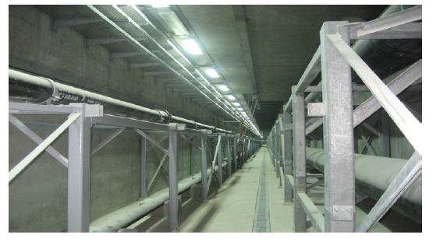
Figure 4 – Example of utility tunnel
[Source: Abu Dhabi Utility Corridors Design Manual, b- 1]
- Tunnels should be accessible through on-grade entrances with sloped hatches and sloping walkways
- Tunnels should be properly ventilated; ventilation shafts should be constructed at a minimum spacing of 50-75 m or as deemed necessary based on actual tunnel dimensions.
NOTE – Different countries may have other national standards or regulations.

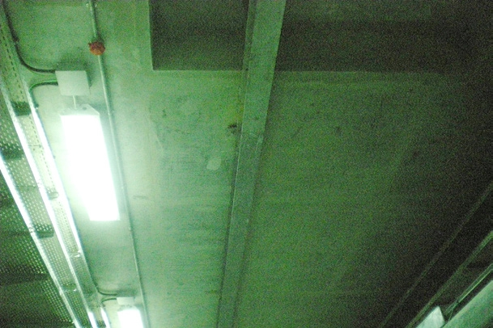
Figure 5 – Example of utility tunnel lighting
[Source: Abu Dhabi Utility Corridors Design Manual, b-1]
- Lighting should be designed to maintain a minimum light level of 150 LUX at the walk surface and be fitted with motion detectors and any necessary overrides for safety purposes.
NOTE – Different countries may have other national standards or regulations.
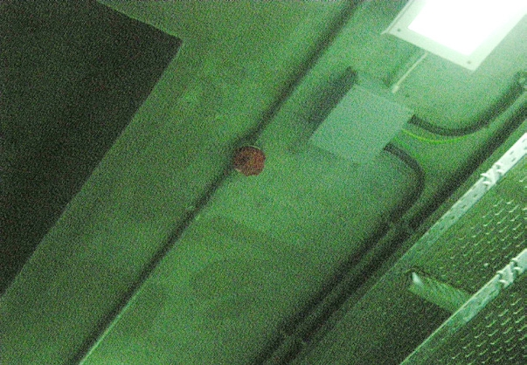
Figure 6 – Example of utility tunnel fire detection/sprinkler system
[Source: Abu Dhabi Utility Corridors Design Manual, b-1]
- Utility tunnels should be equipped with fire detection and alarm systems
- Firewalls may be required to isolate sections of the tunnel during a fire event, as per the local authority requirements
- Tunnels should include an emergency escape
- Wet utilities tunnels should include floor drains draining into a sump.
- Tunnels should include a closed-circuit TV system
- Tunnels should be equipped with a gantry for lifting heavy equipment, such as valves.
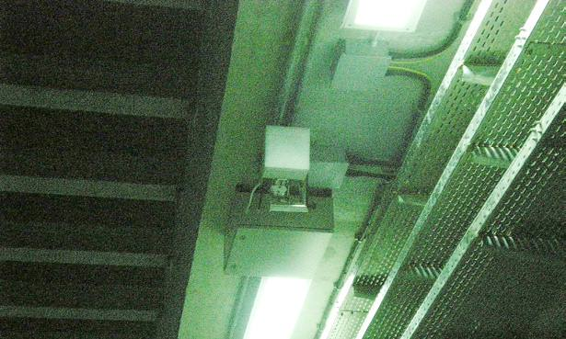
Figure 7 – Example of heavy lifting equipment
[Source: Abu Dhabi Utility Corridors Design Manual, b-1]
- The utility tunnels should support their own weight as well as the weight of all installed equipment in (or on) the structures. The utility tunnels should support the weight and forces of all movable and active components and systems in (or on) the structures. For example, the steel cable trays should be able to carry the weight of the proposed number of cables
- Utility pipes and cables should be secured and fixed in their locations in the tunnel; for example, cables should be supported with cable cleats every 1.0 – 1.5 m
- Optical fibre and electrical cables need to be protected against rodents chewing the PVC. Some cables are specified to be rodent resistant.
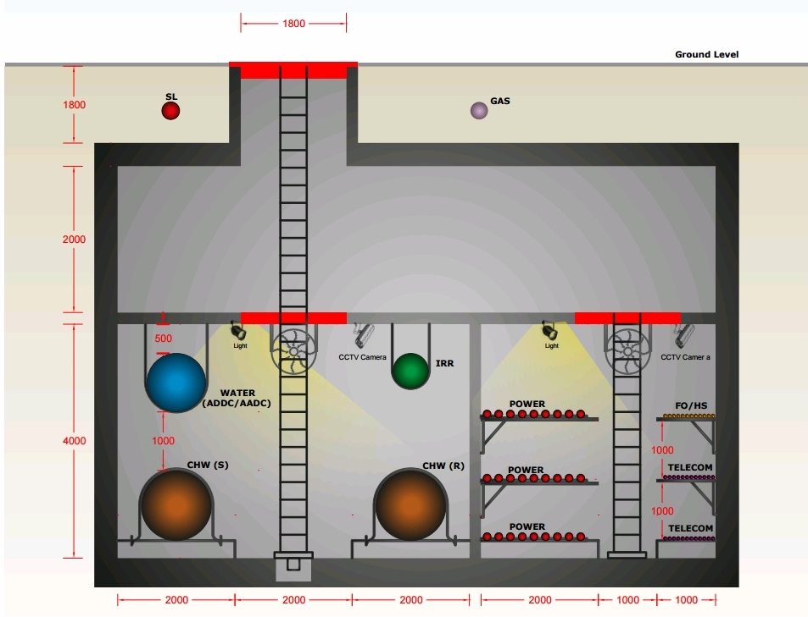
Figure 8 – Typical Arrangement of Utility Tunnel Showing Manhole
[Source: Abu Dhabi Utility Corridors Design Manual, b-1]
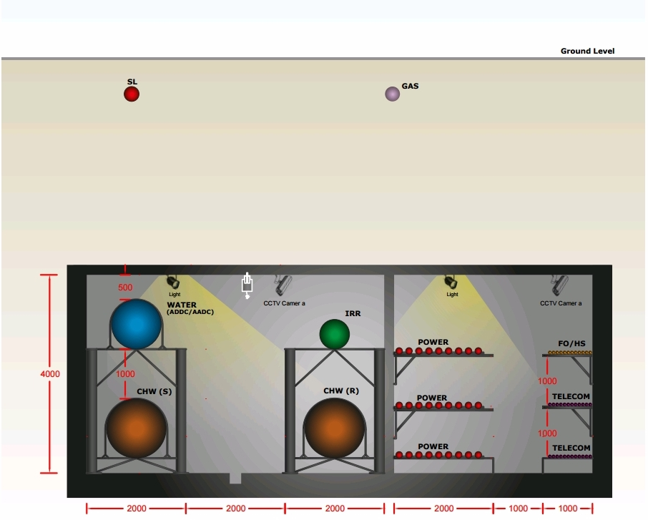
Figure 9 – Typical Arrangement of Utility Tunnel
[Source: Abu Dhabi Utility Corridors Design Manual, b-1]
The following Figures illustrates some of the features supported by sensor network in the "GIFT city Gujarat", India. In August 2012, GIFT won the most prestigious award in the category of 'Best Industrial Development & Expansion' at the 'Infrastructure Investment Awards – 2012' organized by World Finance Group. GIFT Project was considered of world class value in terms of its potential for enabling economy growth in the region – through the relocation and centralization of India's financial and IT sectors and in providing the turn-key location for global financial & IT firms."
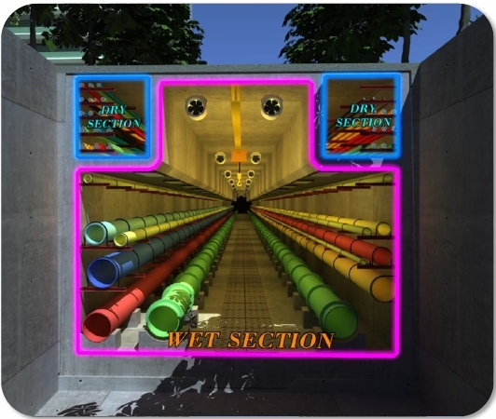
Figure 10 – Utility Tunnel, showing wet and dry sections
[Source: Nilesh Puery b-2]
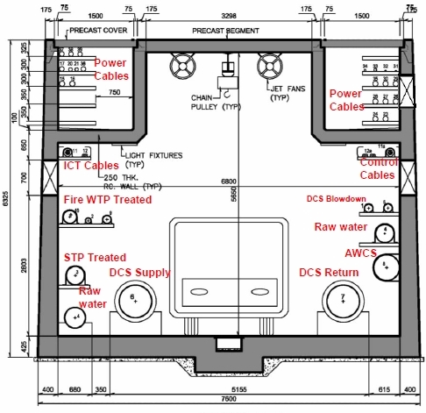
Figure 11 – Utility Tunnel, showing dimensions
[Source: Nilesh Puery, b-2]
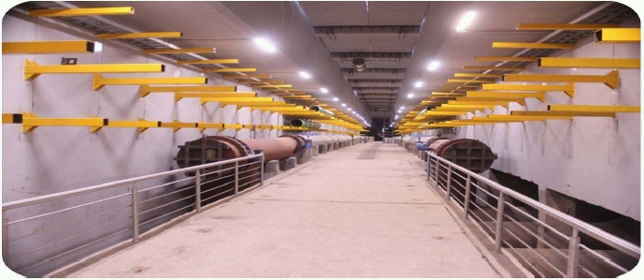
Figure 12 – Utility Tunnel, showing support brackets
[Source: Nilesh Puery, b-2]
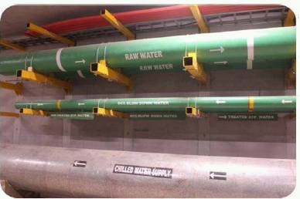
Figure 13 – Utility Tunnel, showing waste and water pipes
[Source: Nilesh Puery, b-2]
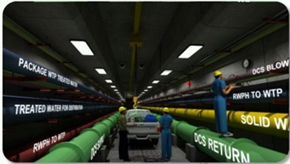
Figure 14 – Utility Tunnel, showing district cooling system solid waste and water pipes [Source: Nilesh Puery, b-2]
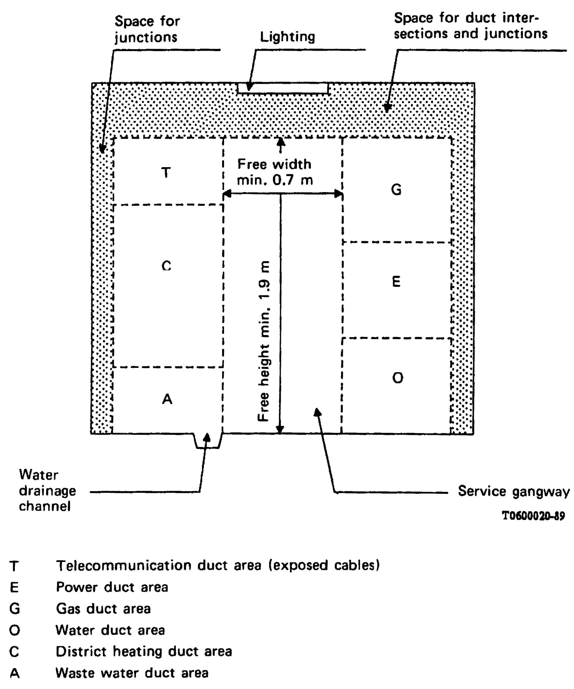
Fig.15 Example Utility Tunnel of Rectangular Cross Section
[Source: ITU-T, b-28]

An example of a multi service tunnel construction standard which has been used in many cities in Italy [b-29] is shown below. This standard considers the possibility of coexistence in the utility tunnel of the following services: distribution networks of aqueducts; electricity distribution grids; electrical networks for public lighting systems and systems for traffic lights; telecommunications networks (telephone, data transmission, cable TV, etc.) and district heating networks.
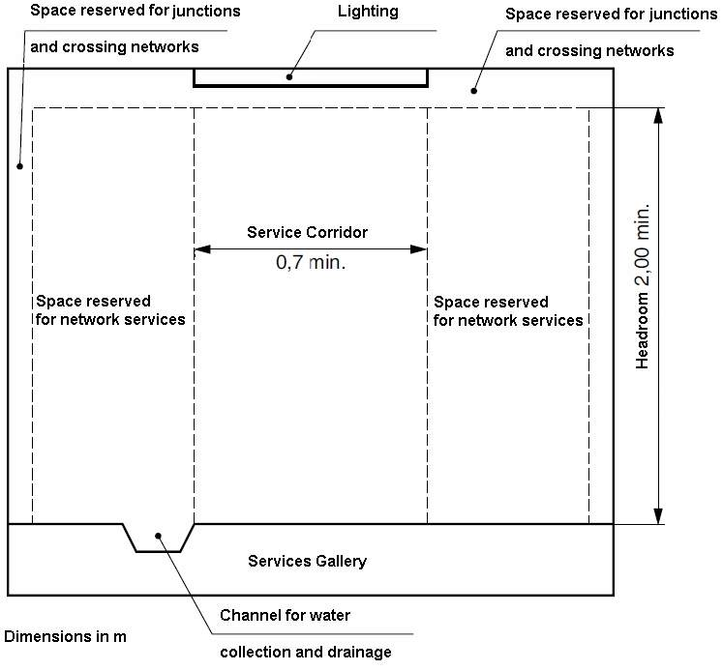
Fig.16 Example Utility Tunnel of Rectangular Cross Section
[Source: Italian Norm, b-29]

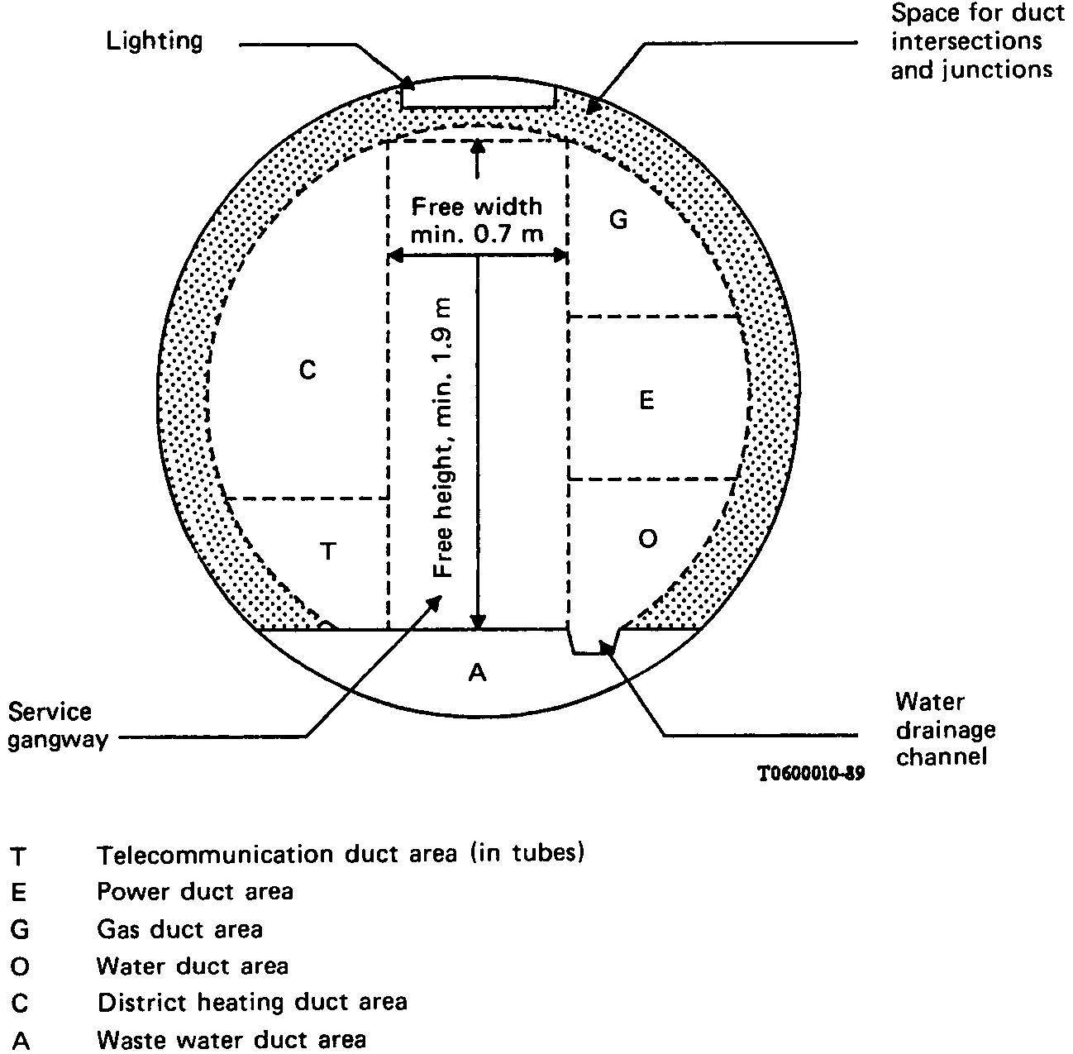
Figure 17 – Example Utility Tunnel with circular cross section
[Source: ITU-T, b-28]

3.1.3 Advantages of Utility Tunnels
Advantages of Utility Tunnels include:
- Easier accessibility to utilities for maintenance, upgrading and future expansion [b-1]
- Environmental impacts are minimized: such as noise, vibration, dust, disruption to traffic and services, street maintenance requirements [b-1]
- Location information is made more accessible. Long-term collaboration among stakeholders often includes greater emphasis on making duct locations easily known [b-3]
- Utility ducts greatly reduce the per unit of surface area occupied [b-3]
- Ducts allow maintenance through their access points. Since access points mostly obviate new roadway intrusions, traffic delays from duct-related road works are greatly reduced and avoid the high cost of surface reinstatement [b-3]
- Sharing the higher initial installation cost of ducts across all services could make rural service, and SSC suburbs, more economically feasible. Where ducts are used, all networks are typically underground in multi-purpose ducts. Above-ground electricity and telecom poles are avoided, increasing safety and reducing natural disaster impacts [b-3]
- Common utility ducts are designed to accommodate anticipated new and evolving networks [b-3] saving the high cost of retrofitting
- An adequate airflow in ducts allows better heat transmission from electricity cables than in direct trenched/buried situations.

3.1.4 Limitations/disadvantages of Utility Tunnels include:
- High initial construction cost as compared to traditional open excavation methods [b-1]
- The issue of compatibility between the utilities housed in the tunnel. A defect in one system may adversely affect the other systems. There has been considerable concern about compatibility between utilities, issues such as induction between electrical and communication lines, gas conduits explosion hazards, in-tunnel temperature rising due to heating and electrical lines.
- The concerns of people entering the tunnels to maintain one service when they are not experienced in dealing with other types of services (and associated risks) of other utilities

3.1.5 Resilience and reliability of a common infrastructure
An example of a utility duct with resilience is the Shin-Sugita Common Utility Duct [b-6]. To make local infrastructure more resistant to disasters, such as earthquake, a 220-kilometer common utility duct is being planned for the Yokohama-Kawasaki area in Kanagawa Prefecture. The common utility duct typically carries many different kinds of utility lines, including gas, electricity, water, sewage and other types of infrastructure that are indispensable to our daily lives. Once a common utility duct has been constructed, it is no longer necessary to excavate the street every time something must be replaced, and the ability to visually inspect water lines etc. greatly simplifies the task of maintenance. Furthermore, if an earthquake or other major disaster occurs, damage can be quickly pinpointed and repaired. Where common utility ducts are in place, a city is much better prepared to deal with emergencies.
GIFT City [b-2] includes connection to two telecommunications service providers which operate services in adjacent regions at opposite sides of the city. The advantage of this is that any user can opt for services from either service provider or both to ensure continuation of service in the event of a single point of failure.

3.1.6 Provision for multiple service providers
A single authority is needed when a shared infrastructure such as a utility tunnel is to be provided and maintained.
For example in the new city Lavasa, India [b-7], a single appointed company establishes and maintains the assets such as dark fibers, rights of way, duct space and towers for the purpose of granting rights on lease/rent/sale basis to the licensees of telecom services licensed under section 4 of Indian Telegraph Act 1885 on mutually agreed terms & conditions.
This approach is pioneering as no authority traditionally exists in India to manage cooperation among utility stakeholders over such a wide range of services.

3.1.7 Risks or vulnerabilities which need to be considered with shared infrastructure
A utility tunnel with multiple service providers requires:
- Easy access for repair or maintenance
- Access authorization, security (keys/locks) to minimize theft and wilful damage
- Wet and dry partitions to maintain continuity of service in event of flooding.
Allowing for changes in climate is increasingly being considered as a factor which affects the lifecycle of an asset such as a railway or telecommunication facility [b-8]. A risk assessment of built infrastructure may be carried out according to guidelines in [b-8].
Dual networks and/or multiple service providers should be considered as methods to maintain service continuity against a single point of failure in telecommunications networks.
Example 1: Dual-fiber entry to all buildings with more than 100 occupants.
Example 2: Both wired and wireless (cellular) services to be accessible in all buildings.
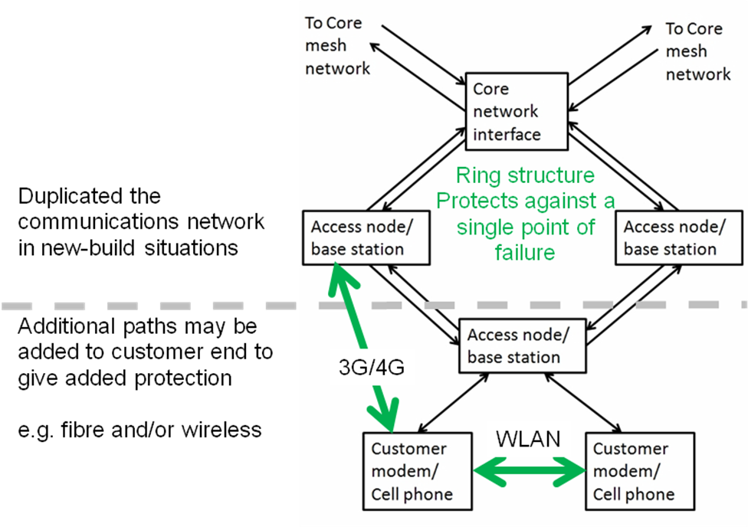
Figure 18 – Ensuring Telecommunications Service Continuity
[Source: ITU-T, b-9]
The service provider protects the network to access nodes such as telecommunications exchanges using a synchronous digital hierarchy (SDH) ring. In the access network, wireless networks such as 3G/4G and Wireless LAN may be used to provide an alternative path to the fixed network.
It is not clear how the sensor layer network should be provided with resilience to a single point of failure close to and including the sensor (or actuator). For critical applications duplication of sensors may be required. This could be using a protected ring or on separate but interleaved networks.
The resilience of wireless sensor networks including protection against intrusion or deliberate jamming is the subject of research.

3.2 Growth, Maintenance and Upgrade in New Build Situations

3.2.1 Growth and flexibility for upgrade
Growth and flexibility for upgrade is required in all infrastructures. Provision of utility tunnels or accessible duct can save cost.
Fibre infrastructure for ICT services could be laid in easily-accessible covered trenches sharing conduits for optical fibre, electricity, fresh water, and possibly storm water sewerage if gravity flow can be maintained. There would be removable covers along the entire route length to ensure easy access for installation and maintenance. These covers could have a surface suitable for pedestrians or cyclists.
Retrofitting utility cables is costly. Blown fibre microducts should be considered to allow for addition or replacement of fibre as demand for services increases [b-11].
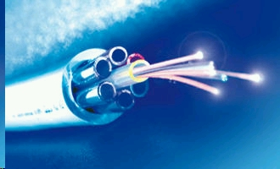
Figure 19 – Air Blown Fibre Tubing
[Brand-Rex Ltd, b-12]

3.2.2 Provision for Branching
No branching is allowed in the utility tunnel according to [b-1].
Even so branching is essential for services involving gravity such as storm water run-off.

3.2.3 Identification and Location of nodes/plant
Provision is needed for identification and location of underground ICT infrastructure. Examples include barcodes and radio frequency identification tags.
As the sensor layer network evolves the precise geographic location of "a thing" will be critical. For example, wireless devices containing a battery will need locating to replace the battery.

3.3 Lifecycle and obsolescence

3.3.1 Life of built infrastructures and provision for replacement
The built infrastructure may be considered to have a life ranging from 5-100 years. A common infrastructure therefore needs to be accessible to allow service providers to carry out work including new service provision, upgrade and replacement.
Examples of typical life times are: ICT (5 years), rail track and signalling (15-20 years, [b-8]), road surface (20 years, [b-8]), electricity (20 years), data centre 20 years [b-8], storm water run-off (30 years), water pipeline (100 years [b-8]), and sewerage (100 years [b-8]).

3.3.2 The built-infrastructure – radical changes can be envisaged
Infrastructure, such as a utility tunnel, could have a lifetime of 100 years or more. The speed of technological advances especially in the ICT sector could render some of the city infrastructure obsolete within 10 years. Examples include: self-drive vehicles, tracked buses superseding rail, delivery services by autonomous vehicles including drones, solid refuse collection using underground ducting powered by suction of air. An issue for planners to consider is to what extent the infrastructure should be future-proofed.
Provision for additional storm water run-off is a major consideration for some cities as the impact of climate change is factored in. One example is G-Cans Project, or the Metropolitan Area Outer Underground Discharge Channel, which is the world's largest underground flood water diversion facility. It is located between Showa in Tokyo and Kasukabe in Saitama prefecture, on the outskirts of the city of Tokyo in the Greater Tokyo Area, Japan [b-13]. Utility tunnels may be an essential part of a SSC's storm water run-off plan.

3.3.3 Powering the sensor layer network
Powering the sensor layer network is an important lifecycle consideration. Visiting remote locations to replace batteries in wireless sensors is an expensive service maintenance consideration. A battery life of less than 10 years can destroy a remote sensor business proposition. Wireline options should therefore be considered as an alternative to wireless devices.

Box 1
Example: Power over Ethernet [b-14] can power sensors or actuators in a sensor layer network without recourse to batteries or a separate electricity supply from the network connection.
Box 2
Example: The HomePlug Powerline Alliance (HPPA) has developed standards and technology enabling devices to communicate with each other, and the Internet, over existing home electrical wiring. Power and communications may therefore be combined over a common mains facility to sensors or actuators on the periphery.

Box 3
Example: USB Wall socket [b-15]. In the domestic environment USB wall sockets are available combining both a mains outlet and a USB charger outlet. Due to the reach limitation of 3 m the sockets would need a secondary communications path (e.g., HPPA) to enable communications to a central server.

Box 4
Example: Telephony cable (twisted pair) may be used to provide both backhauling (e.g. A/VDSL) and powering. This is a typical case of use of the telecommunication company’s access network with power (e.g. power for a telephone or ADSL loop extender is provided along the line together with DSL signals for internet access).

4 Smart Sustainable Building Utility Services

4.1 Opportunities for sharing risers (e.g., inside or alongside buildings)
Utility tunnels require branching points under or alongside buildings, such as hotels or offices. Multiple service risers are then needed to carry services to the floors in the building. The example shown below is part of the prefabricated T-30A hotel [b-16].

4.2 Smart Sustainable Building Service Requirements
A wider range of services are identified in [b-16] than in the utility corridor described in the introduction to Section 6.
The additional services include:
- Airshafts with separation of regulating (conditioned) air, fresh air and exhaust air
- Chimney duct to remove kitchen smoke
- A garbage shaft with separate ducts to remove: metal, glass, plastics, batteries, electronic waste, kitchen waste, paper and cloth waste.
- Linen shaft to allow linen to be sent to the laundry.
A consideration for SSC planners is to what extent these additional services could be carried in utility tunnels. If waste is to be collected could an additional facility be included in the utility tunnel to handle recyclable and other waste products. A further consideration for SSC planners is how the intersection between the horizontal and vertical section is designed and managed. Once inside the building the SSC planners are less responsible other than to ensure that buildings meet local planning regulations from the perspectives of safety and efficiency.
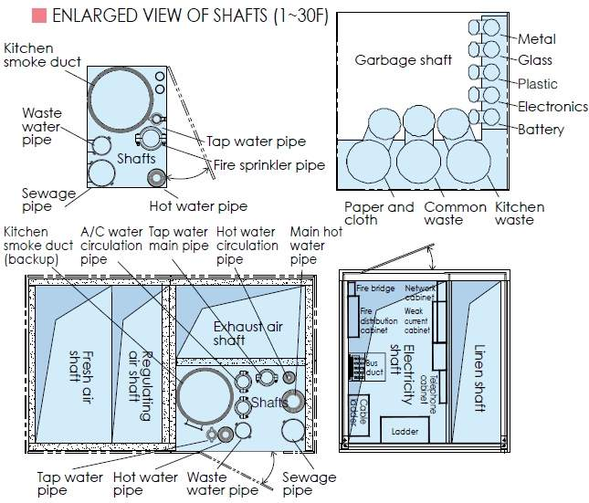
Figure 20 – Utility Shafts in the T-30 Prefabricated Hotel
[Source: BROAD Sustainable Building Co. Ltd., b-16]
[b-16] provides useful guidance on best practice for the ICT within a building such as a hotel.
A sensor network is provided to each room for environmental control. This is shown below.
Environmental sensors include:
- Indoor temperature sensor
- Indoor humidity sensor
- Formaldehyde sensor [b-17] (for sick building sickness sufferers, for whom the World Health Organization has set a 30 min exposure limit of 0.08 ppm)
- CO₂ sensor
- Particulate Matter Sensor (Acceptable indoor air quality is an occupant need and should be sensed and controlled for. Particulate matter sensors measure the particulate concentration, which, at high levels, correlates to health problems [b-18])
- Indoor infrared sensor (for room occupancy)
- Water leakage sensor
- Air flow sensor
- Supply air temperature sensor
- Fire detection
NOTE - in some building types a gas leakage detector may be required
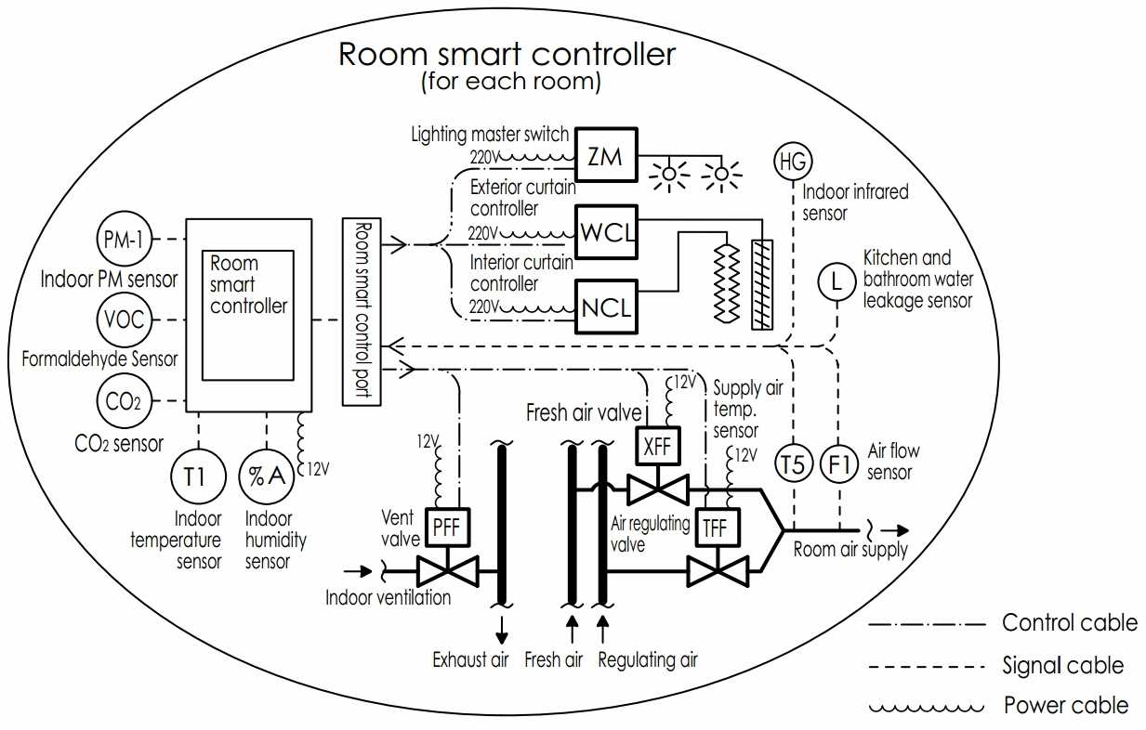
Figure 21 – Smart Room Controller in the T-30 Prefabricated Hotel
[Source: BROAD Sustainable Building Co. Ltd., b-16]
Room controllers include:
- Indoor ventilation
- Fresh air inlet
- Regulating air (conditioned air)
- Lighting
- Exterior shutter/curtain
- Interior curtain.
The wiring for the interior of the room (sensor network) is not described but with at least 15 connected devices represents a significant need for sensor infrastructure with a structured wiring loom and conduit, sharing infrastructure costs.

5 Opportunities for sharing infrastructure at street level
Opportunities for wireless mast and facility sharing are discussed in [b-19]. This document also mentions the opportunity for installing small base stations on street lampposts and use of wireless technology to provide traffic monitoring and traffic light synchronization. Duct sharing is very promising in enabling low cost installation of optical cables. Optical cables require very small space. Typically, a 144 fibre cable can be less than 1cm wide. Such cables can be fully dielectric too, so they are not subject to special requirements on safety.
Such duct sharing is valuable in new built areas, but looks even more fundamental in built areas where optical fibre overlay is required to add broadband capacity.

6 Opportunities for ICT to support other utilities
When facilities are shared between ICT and other utilities, the ICT is in close proximity to other utilities and may be used to support them at lower cost than when separate infrastructure is provided. The sensors can facilitate better monitoring and control and give advance warning of failure or blockages. Possible examples include:
- Flood detection sensors in utility ducts
- Fire detection sensors in utility ducts
- Temperature sensors in electric cables
- Gas leakage detectors
- Traffic flow monitoring
- Street lamp control
- Street lighting control
- Water utility (The sensor network needed for monitoring and control is illustrated below).
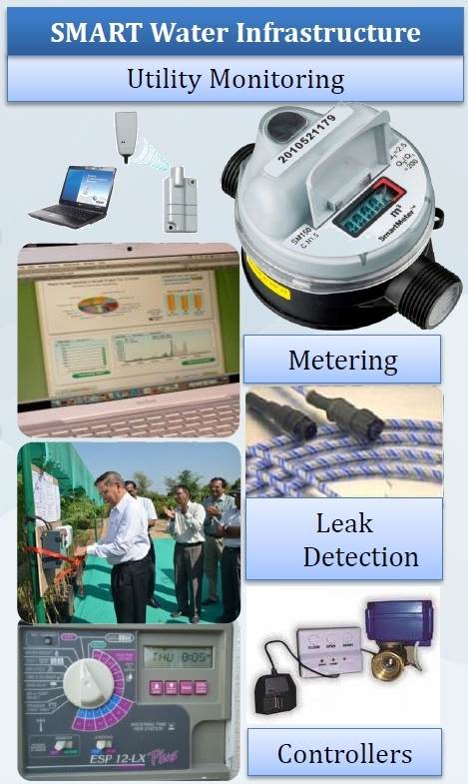
Figure 22 – The sensor network for water utility monitoring
[Source: Nilesh Puery, b-2]

7 Opportunities for sharing the Application Platform
At the service layer a wide range of applications are envisaged for the SSC ranging from e-health to e-transport. Each requires termination onto a server, data storage, a smart processor and connection to devices including personal devices, sensors and controllers. Most existing cities have a multiplicity of platforms to support these services which have arisen because expertise for managing the various service classes resides in silos. When building a new SSC planners have the option to select a service platform which can handle the bulk of the software functions required by application developers on a single platform.
Box 4 – Example of an open platform from the EU
An example of an Open Platform for Application Program Interfaces (APIs) is FIWARE [b-20] which was funded by the European Union under the Seventh Framework Programme, which is a 100M Euro R&D Programme which seeks to provide an open, public and royalty-free managed service architecture for smart cities. This offers a set of open APIs that allow developers to avoid getting tied to any specific vendor, therefore protecting application developers' investments.
The FIWARE platform provides a rather simple yet powerful set of APIs (Application Programming Interfaces) that ease the development of Smart Applications in multiple vertical sectors. The specifications of these APIs are public and royalty-free. Besides, an open source reference implementation of each of the FIWARE components is publicly available so that multiple FIWARE providers can emerge faster in the market with a low-cost proposition.
FIWARE Lab is a non-commercial sandbox environment where innovation and experimentation based on FIWARE technologies take place. Entrepreneurs and individuals can test the technology as well as their applications on FIWARE Lab, exploiting Open Data published by cities and other organizations. FIWARE Lab is deployed over a geographically distributed network of federated nodes leveraging on a wide range of experimental infrastructures.
Could FIWARE meet your requirements for an open application platform for SSCs?

Box 5 – Example of an open data platform from the City of Leeds UK
Other options exist for sharing information such as direct posting of databases on a website [b-21]. This was done on a low budget with the aim of releasing public information rapidly at low cost. The aim is to ensure that all of our data sets meet quality assurance standards and where possible gain ODI certification [b-22]. The files are mostly in .csv spreadsheet format. So far 140 datasets have been published along with 82 downloadable APIs and community initiatives.

Box 6 – Example of open data format
"Proper database management, analytics and sharing of information can help increasing coordination between stakeholders. For sharing of files, .csv or .json format can be used because they are very fast to process, easy to manipulate and consume lesser memory. For the databases, eventually consistent non relational databases can be considered because of their speed advantages" [b-23].
All the information of the facilities can be collected and converged to a holistic platform such as a city level integrated management system [b-25]. With integrated management for smart sustainable city, the sensors, and sensing networks can function in an organized way to detect various infrastructure. As a result, emergency events can be rapidly discovered and acquired. Then the services for information resource publishing and sharing as well as result fusing are provided to disseminate information across the concerned agencies. Thus the goal is achieved to make the city smarter and more sustainable.

.

Annex A
Glossary and list of abbreviations
Glossary
'Urban Corridor'. An urban corridor is more commonly understood as a roadway or boulevard etc. In this report it reaches from building-to-building and may include footpaths, tramways, avenues of trees, above ground and below ground infrastructure.

List of Abbreviations
API Application Program Interface
CATV Community Antenna Television
EMF Electromagnetic Field
HPPA HomePlug Powerline Alliance
ICT Information Communication Technologies
IoT Internet of Things
NOx Oxides of Nitrogen
SSC Smart Sustainable City

Appendix I
Bibliography

[b-1] Abu Dhabi Urban Planning Council, “Abu Dhabi Utility Corridors Design Manual” Vesrion 1
http://www.upc.gov.ae/template/upc/pdf/UCDM_Version-1-En.pdf
[b-2] Nilesh Puery: Presentation "Gujarat International Finance Tec-City" made at ITU Training Event "Leveraging ICTs for Smart Sustainable Cities for Asia-Pacific Region", Delhi, March 24-26, 2015.
http://www.itu.int/en/ITU-D/Regional-Presence/AsiaPacific/Pages/Events/2015/March%20SSC%202015/ITUTRAISSC2015.aspx
[b-3] World heritage Encyclopedia http://www.worldheritage.org/article/WHEBN0002291091/Utility%20tunnel
[b-4] National Joint Utilities Group UK "NJUG Guidelines on the Positioning and Colour Coding of Underground Utilities Apparatus", Issue 8, 29 Oct. 2013.
http://www.njug.org.uk/wp-content/uploads/V1-Positioning-Colour-Coding-Issue-8.pdf
[b-5] UK Department of Transport, "Code of Practice for the Co-ordination of Street Works and Works for Road Purposes and Related Matters", page 19
https://www.gov.uk/government/uploads/system/uploads/attachment_data/file/43578/street-works-code-of-practice.pdf
[b-6] Kajima, Corporation, "Shin-Sugita Common Utility Duct"
http://www.kajima.co.jp/english/csr/infra/safety/#lifeline
[b-7] Satish Kamat: Presentation, "Lavasa" made at TRAI ITU Symposium "ICT Regulatory challenges in Indian Smart Cities" 27 March 2015, New Delhi, India, personal communication for this document.
[b-8] UK Government, "Climate Resilient Infrastructure: Preparing for a Changing Climate"
https://www.gov.uk/government/uploads/system/uploads/attachment_data/file/69269/climate-resilient-infrastructure-full.pdf
[b-9] ITU-T "Resilient pathways: the adaptation of the ICT sector to climate change, page 27
http://www.itu.int/en/ITU-T/climatechange/Documents/Publications/Resilient_Pathways-E.PDF
[b-10] Mole Solutions Ltd “Urban Freight Pipeline Project”. April 2015
http://www.molesolutions.co.uk/our-latest-news/
[b-11] Networx3 "The Benefits of Blown Fibre"
http://www.networx3.co.uk/resources/the-benefits-of-blown-fibre/
[b-12] Brand-Rex Ltd "Air Blown Optical Fibre Solutions"
https://www.brand-rex.co.uk/Products/Optical-Systems/Air-Blown-Fibre-System
[b-13] G-Cans Project, Kasukabe, Saitama, Greater Tokyo Area, Japan
http://www.water-technology.net/projects/g-cans-project-tokyo-japan/
[b-14] IEEE Standard IEEE 802.3 series; see IEEE 802.3af-2003 and the higher power IEEE 802.3at-2009. These are both included in 802.3-2012.
[b-15] BRE Trust
http://www.designingbuildings.co.uk/wiki/Power_over_USB
[b-16] BROAD Sustainable Building Co. Ltd. ‘Tower Hotel Technical Briefing’
http://en.broad.com/uploads/pdf/tsjd.pdf
[b-17] Po-Ren Chung, et al., "Formaldehyde Gas Sensors: A Review"
http://www.ncbi.nlm.nih.gov/pmc/articles/PMC3673094/
[b-18] Kevin Weekly, et al., "Low-cost coarse airborne particulate matter sensing for indoor occupancy detection", 2013 IEEE International Conference on Automation Science and Engineering,
http://bayen.eecs.berkeley.edu/sites/default/files/conferences/Low-cost_coarse_airborne.pdf
[b-19] ITU-T FG SSC Report "EMF Considerations in Smart Sustainable Cities", 2014, page 31
[b-20] "FIWARE an Open Interface for Open Minds"
http://www.fiware.org/about/
[b-21] Leeds City Council, UK, "Leeds Data Mill",
http://www.leedsdatamill.org/
[b-22] The Open Data Institute
https://certificates.theodi.org/
[b-23] Personal Communication: Neeraj Mishra of TRAI, India, March 2015.
[b-24] ITU-T FG-SSC deliverable, Technical Report on electromagnetic field (EMF) consideration in smart sustainable cities (2014).
[b-25] ITU-T FG-SSC deliverable, Technical Report on integrated management for smart sustainable cities (2015).
[b-26] Standard of Ministry of Construction of China CJJ 61-2003, Technical specifications for detecting and surveying underground pipelines and cables in city (2003), in Chinese.
[b-27] ITU-T Recommendation L.79 “Optical fibre cable elements for microduct blowing-installation application”
http://www.itu.int/rec/T-REC-L.79-200807-I
[b-28] ITU-T Recommendation L.11 “Joint use of tunnels by pipelines and telecommunication cables, and the standardization of underground duct plan”, 1988.
http://www.itu.int/ITU-T/recommendations/rec.aspx?rec=1415
[b-29] Multipurpose underground facilities for the coexistence of network services different Design, construction, management and use General criteria and safety, Italian Norm. UNI CEI 70029, Sept 1998
http://webstore.ceiweb.it/webstorecopertina.aspx?ID=3780&PR=NO

_______________

