INTERNATIONAL TELECOMMUNICATION UNION |  | Focus Group on  MACHINE-TO-MACHINE SERVICE LAYER
TELECOMMUNICATION
STANDARDIZATION SECTOR
STUDY PERIOD 2009-2012
English only
Original: English
 |  | Beijing, China, 26-28 June 2012
MEETING ANNOUNCEMENT
Source: | TSB
Title: | Second meeting of FG M2M, Beijing, China, 26-28 June 2012

1 The second meeting of FG M2M is scheduled to take place at China Academy of Telecommunication Research (CATR) in Beijing, China, from 26-28 June 2012 inclusive, at the kind invitation of CATR and China Communications Standards Association (CCSA).
2 The results from the last meeting of FG M2M are available at http://ifa.itu.int/t/fg/m2m/docs/1204-Geneva/out/. Please note that a TIES or Guest account is required to access these documents. If you do not have a TIES account, a Guest account can be obtained at http://www.itu.int/ITU-T/edh/faqs-guest.html.
3 The FG M2M is open to ITU Member States, Sector Members and Associates. It is also open to any individual from a country which is a member of ITU and who is willing to contribute to the work. This includes individuals who are also members or representatives of interested standards development organizations.
4 The items for discussion at the meeting will be made available on the Focus Group web page:
http://www.itu.int/en/ITU-T/focusgroups/m2m/. Information related to the meeting and contributions received will be made available on the Focus Group web page.
The meeting will open at 0930 hours on 26 June 2012. Participant registration will begin at 0900 hours. No registration fee is required for participating in this meeting.
The discussions will be held in English only.
The documents will be made publicly available for this meeting. In preparing documents please use the basic template for the FG documents available from the Focus Group web page.
Participants shall submit input documents to FG M2M in electronic format to TSB as follows:
- Contact TSB at tsbfgm2m@itu.int to receive a number (nnn) for each document
- Prepare documents with a file name as follows: m2m-i-nnn (with the appropriate file extension)
- Using an FTP client, upload the document to the document drop folder in the FG Distraction FTP area, namely:
  - Host name: ifa.itu.int
  - Path: /t/fg/m2m/docs/incoming
- Alternatively, send your input document to tsbfgm2m@itu.int
- Note: contents of the document drop box can be read with a web browser at: http://ifa.itu.int/t/fg/m2m/docs/incoming/.
Documents will be processed by TSB and moved to the relevant read only folder: http://ifa.itu.int/t/fg/m2m/docs/1206-Beijing/in/.
Meeting documents can also be quickly and easily viewed and downloaded by clicking on the “Meeting Documents” link on the FG M2M website.
In agreement with the Focus Group management, the deadline for document submission for this meeting is 18 June 2012. Please note that this is a paperless meeting.
5 Wireless LAN facilities are available for use by delegates at the venue. Detailed information is available on site.
6 For practical information, please refer to the Annex 1 of this document.
7 Remote Participation: You can participate remotely at the FG M2M meeting. As a remote delegate you will be able to hear discussions, see documents and presentations and interact with the remote meeting host. If you wish to participate as a remote delegate, you need to register in advance at http://www.itu.int/reg/tsg/3000402.
Remote participation instructions will be made available on the Focus Group website.
8 To enable TSB to make the necessary arrangements concerning the organization of the Focus Group meeting, please register via the on-line form at: http://www.itu.int/reg/tsg/3000402 as soon as possible, but not later than 18 June 2012. Please note that pre-registration of participants to the meeting is carried out exclusively online. To easily provide you with any updates concerning the meeting planning, please fill in your valid e-mail address on your registration form.
9 To enter China for the meetings indicated above, you may need a letter of invitation from the Chinese host, which you will need to present to the Chinese Embassy/Consulate in your area in order to obtain your visa (see Annex 3 for the letter of Invitation). The visa must be requested and obtained from the office (embassy or consulate) representing China in your country or, if there is no such office in your country, from the one that is closest to the country of departure. Please be aware that visa approval might take time so kindly make your visa request as soon as possible.

ANNEX 1
Practical information

Meeting Venue
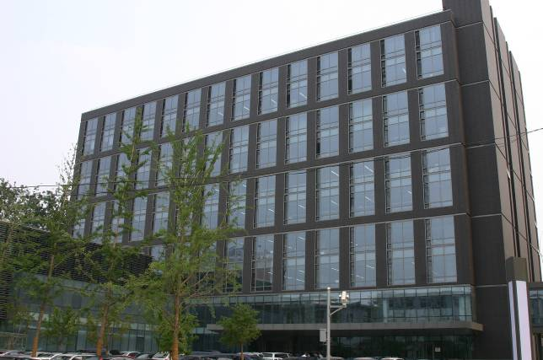
Meeting Hall on the second floor of CATR Building B
Address: 52, Hua Yuan Bei Road, Haidian District, Beijing, China

Hotels
Option 1: (Recommended, see reservation form in Annex 2)
Vision Plaza
Address: 39, Xueyuan Road, Haidian District, Beijing, China
Tel: +86-10-62308899
Fax: +86-10-62308818
URL: http://www.visionplaza.cn/en/index.html
Distance to the meeting venue: 5 minutes by walk
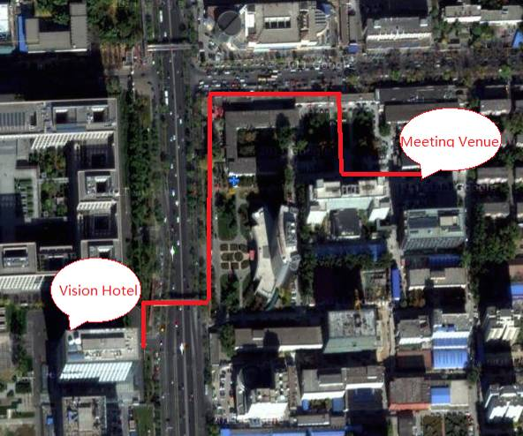
Option 2: (Delegates have to make their own arrangements)

Park Plaza Beijing Science Park
Address: 25, Zhichun Road, Haidian District, Beijing, China
Reservations: + 400 6780 687 (China Toll-free), +1 (800) 777-1700 (US/Canada Toll-free)
Tel: + 86-10-8235-6699
Fax: + 86-10-8235-6688
URL: http://www.parkplaza.com/
Distance to the meeting venue: 10 minutes by walk

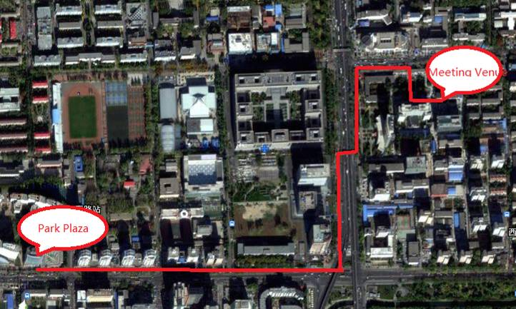

Option 3: (Delegates have to make their own arrangements)
Jadepalace Hotel
Address: 76, Zhichun Road, Haidian District, Beijing, China
Tel: +86-10-6262-8888
Fax: +86-10-6263-8255
URL: http://www.jadepalace.com.cn/en/index.html
Distance to the meeting venue: 20 minutes by walk

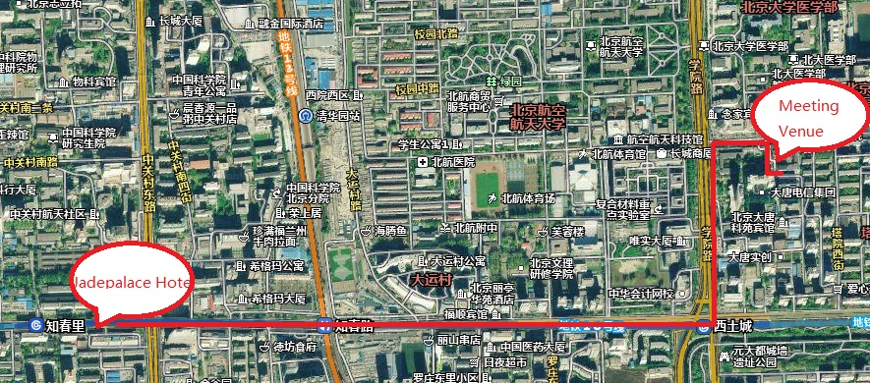
- Directions
  - Local airport

Beijing Capital International Airport (http://en.bcia.com.cn/)
  - Transportation to/from airport

It is about 30 minutes’ drive from Beijing Capital International Airport to the Vision Hotel according to traffic condition. Taxis are always available. The fare will be approximately 100 CNY.

The taxi drivers may not speak English, so make sure you have the name of your hotel or address written in Chinese. The following is the name and address of Vision Hotel in Chinese; please print it for your convenience:

唯实国际文化交流中心

地址：中国北京市海淀区学院路39号
酒店总机电话：（8610）62308899/（8610）82338889
The other way is to take subway. Take the Airport Express at Beijing Capital International Airport and transfer to line 10 at Sanyuanqiao Station. Please stop at Xitucheng Station, and find Exit A to get out the subway.

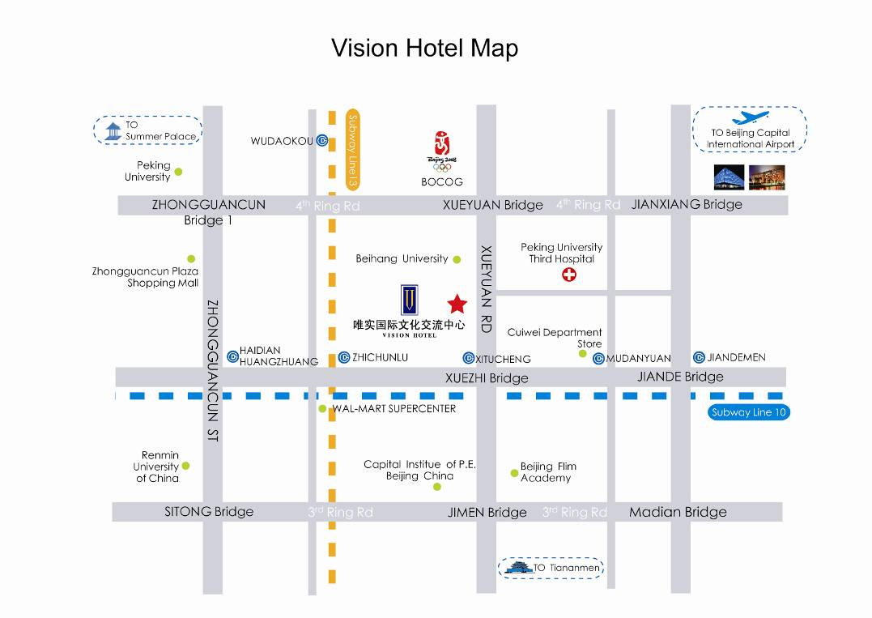
- During Your Stay
  - WLAN

All meeting rooms will have a wireless network with access to the Internet. Every guest room offers a high-speed Internet access for free.
  - Electricity

China's A/C supply is 230v-50Hz. Please take the necessary adapter if your equipment does not have the correct plug.
  - Wireless Coverage

There are cdma2000 1x/1xEVDO, GSM, TD-SCDMA, and WCDMA coverage in Beijing.
  - Additional information

General information about Beijing: See http://www.ebeijing.gov.cn/
- Contact person
Mr Xu Qi
Tel: +86 10 82056206
Mobile: +86 13466724696
Email: qixu@ccsa.org.cn
Ms Huijuan Guo
Tel: +86 10 82052795
Mobile: +86 13581614793
Email: guohuijuan@ccsa.org.cn
ANNEX 2

Vision Hotel – Beijing
39 Xueyuan Road, Haidian District

Group Name: ITU-T FG M2M
Room Reservation Form
Name:
Nationality:
Address:
Telephone: |  |  | Fax |  |  | Email
Date of Arrival: |  |  |  |  | Flt/ ETA:
Date of Departure: |  |  |  |  | Flt/ ETD
Please reserve _____ room(s) under name:
Rates will be valid between 25 June 2012 to 30 June 2012
Superior Room
◻ Business Room （King/Twin） RMB 658
◻ Deluxe Room （King/Twin）RMB 728
◻ Smoking ◻ Non-smoking
The rates are per room per night rates, including breakfast, TV and free Internet access in rooms.
Other special requests
(incl. Dietary requirements):
To guarantee the room(s), details of my credit/charge card are as follows:
◻ Visa |  | □ Master |  |  | ◻ Diners | ◻Amex |  |  | ◻ JCB
Name of Card Holder:
Card Number: |  |  |  |  |  |  | Expiry Date:
Signature:
IMPORTANT INFORMATION:
1). Please forward your reservation/payment on or before June 15, 2012.
2). Copied both side of your credit card with your signature to guarantee your booking.
3). Please inform us of any changes of your reservation in writing.
Cancellation requests must be made in writing and sent to the hotel directly.
Reservation should be made directly with the Vision Hotel.
Email: reservation@visionplaza.cn
Fax:86-(10)-62308818 Tel:86-(10)-62308899-5305 www.visionplaza.cn
If you have not received a faxed or emailed confirmation within 48 hours of sending the form, please call Reservation at: 86-(10)-62308899-5305 or Email: reservation@visionplaza.cn
ANNEX 3

INVITATION LETTER REQUEST FORM
To enter China for the meetings indicated above, you may need a letter of invitation from the Chinese host, which you will need to present to the Chinese Embassy/Consulate in your area in order to obtain your visa. In order to obtain the invitation letter, please:

- Fill out the form below
- Send it to (please reference “Invitation letter request for ITU-T FG M2M meeting” as the subject):

Mr. Xu Qi and Ms. Huijuan Guo

China Communications Standards Association (CCSA)

qixu@ccsa.org.cn

guohuijuan@ccsa.org.cn
(It is recommended to scan your passport page and email to us so that it is discernible and can be used.)
Fax number: +86 10 82053019 (if your passport page is photocopied and enlarged)
Company
Applicant  Information | [ Click and Type in your full name ] |  |  | rMr rMs rMrs
Applicant  Information | [ Nationality ] |  |  | [ Passport No.]
Applicant  Information | Date of birth : |  |  | [ Job Title ]
Applicant  Information | Is this your first visit to China? |  |  | __ Yes ___ No
Applicant  Information | If the country in which you'll obtain your visa is different from your nationality, please indicate it here:  [ Country to obtain your visa]
Address
Places to visit after entry | (In this case, it is Beijing by default; if you want to visit other places than Beijing, please indicate here.)
Date of arrival in China |  |  | Date of departure from China
(Please do not forget to attach a copy of your passport photograph page before sending.)
Your information should be sent out before 25th May 2012.

For Chinese Embassy or Consulate information, please visit http://www.fmprc.gov.cn/eng/.

