

**Practical Information**

**Ninth meeting of the ITU/FAO Focus Group on "Artificial Intelligence (AI) and Internet of Things (IoT)**

**for Digital Agriculture" (FG-AI4A) and**

**Workshop on "** **Cultivating tomorrow: Advancing digital agriculture through IoT and AI "**

**New Delhi, India 18-19 March 2024**

# MEETING VENUE

The ninth meeting of the ITU/FAO Focus Group on "Artificial Intelligence (AI) and Internet of Things (IoT) for Digital Agriculture" (FG-AI4A) and Workshop on " Cultivating tomorrow: Advancing digital agriculture through IoT and AI" will take place at **National Agricultural Science Complex (NASC), Indian Council of Agricultural Research (ICAR), New Delhi, India on 18-19 March 2024** at the following address:

**Address of the Venue:** NASC, ICAR, 124, Dev Prakash Shastri Marg, Krishi Kunj, Inder Puri, New Delhi, 110012

**(google map:** [**https://maps.app.goo.gl/PW9CwEGo7HLZR4bN6**](https://maps.app.goo.gl/PW9CwEGo7HLZR4bN6)**)**

**Website (Building location):** [**https://www.icar.org.in/**](https://www.icar.org.in/)

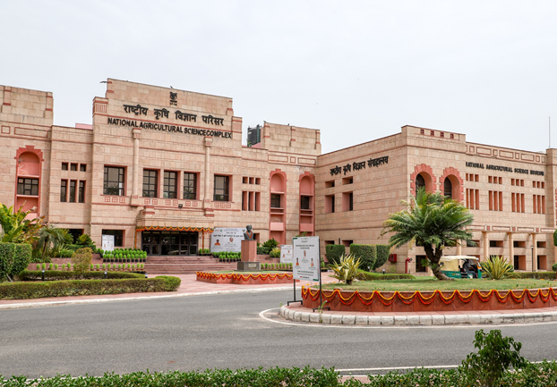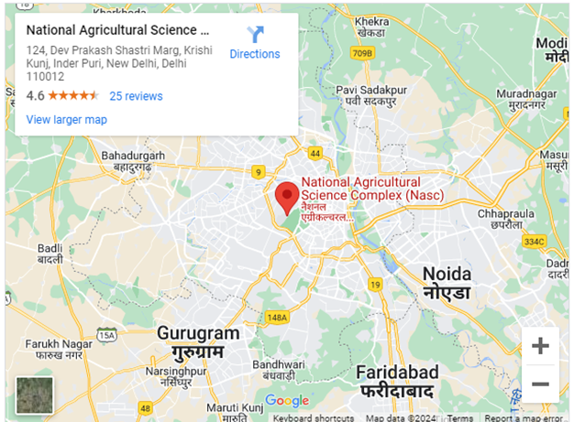

# FOCAL POINTS

|  |  |
| --- | --- |
| **ITU**  Ms Mythili Menon ITU-T FG-AI4A Advisor  Email: [tsbfgai4a@itu.int](mailto:tsbfgai4a@itu.int) | **HOST**  **Mr. R. S. Singh**  E-mail: [ddgsd.tec@gov.in](mailto:ddgsd.tec@gov.in)  **Mr. Atique Ahmed**  E-mail: [dirir2-dot@nic.in](mailto:dirir2-dot@nic.in)  **Dr. Anil Rai**  E-mail: [adg.ict@icar.gov.in](mailto:adg.ict@icar.gov.in) |

1. **HOTEL RESERVATION**

Experts are requested to make their own hotel arrangement and the list of recommended hotels located near the venue is as below:

|  |  |  |  |
| --- | --- | --- | --- |
| **No.** | **Name & Address** | **Phone/**  **Website** | **Time to NASC** |
|  | International Guest House, NASC | igh.nasc@icar.gov.in, vikram.icar@nic.in  mobile: 8588865372 | At Venue |
|  | Jaypee Siddharth | +91-11-25760000, +91-11-43662500  Maps: <https://maps.app.goo.gl/FKRYXvbE7U7zfuUz7>  Website: <https://www.jaypeehotels.com/hotel/jaypee-siddharth-new-delhi?utm_source=gmb&utm_medium=google&utm_campaign=organic> | 5- 8 min by cab |
|  | ITC Maurya | +91-18004196444, +91-11- 26112233  Maps: <https://maps.app.goo.gl/omacGLfPxD9HCfbB9>  Website:  <https://www.marriott.com/en-us/hotels/dellc-itc-maurya-a-luxury-collection-hotel-new-delhi/overview/?scid=f2ae0541-1279-4f24-b197-a979c79310b0> | 12- 14 min by cab |
|  | Taj Palace | +91-11-64804425, +91-11-68183700  Maps:  <https://maps.app.goo.gl/MxNP2PJAgkfMN17k9>  Website:  https://www.tajhotels.com/en-in/taj/taj-palace-new-delhi/ | 15- 18 min by cab |
|  | The Ashok | +91-11-24360303, 24307601  Maps:  <https://maps.app.goo.gl/NAqwyDqMpe6KpDSe7>  Website:  <https://www.theashokhotel.com/> | 20 min by cab |
|  | The Leela Palace | Maps:  <https://maps.app.goo.gl/8qaLTKELk6ViiaF58>  Website:  <https://www.theleela.com/the-leela-palace-new-delhi> | 23 min by cab |
|  | Hotel Le Meridian | +91-11-45020200  Maps:  <https://maps.app.goo.gl/X266kkwidvFJjDDa6>  Website:  <https://www.marriott.com/en-us/hotels/delmd-le-meridien-new-delhi/overview/> | 21 min by cab |

# TRANSPORTATION

- Map of NASC and nearby

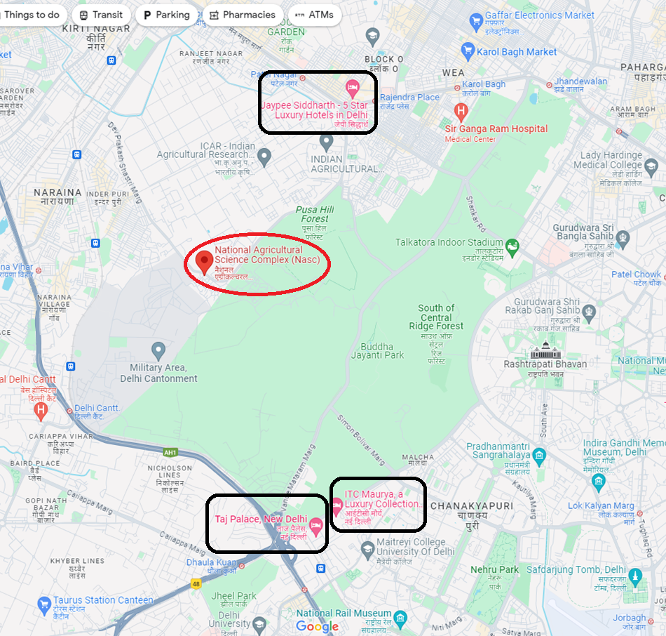

# VISA REQUIREMENTS AND ENTRY PERMITS

Entry visa may be necessary for participants from some countries to enter India. To check the visa requirements, please contact the Indian Embassy or Consulate in your country.

You can also find visa-related information on the webpage <https://www.mha.gov.in/MHA1/TourVisa.html>. And, COVID-19 specific information related to participation in India can be found at [here](https://www.newdelhiairport.in/covid19).

All requests for letters of invitation for visa purposes must be addressed to **Mr. Atique Ahmed (e-mail:** [**dirir2-dot@nic.in**](mailto:dirir2-dot@nic.in)**)** with copy to ITU: [tsbfgai4a@itu.int](mailto:tsbfgai4a@itu.int), bearing the words **“Letter of support for visa”** as the subject and should be sent by **22 February 2024** at the latest.

In case there is no Embassy or Consulate of India in your country, it is recommended to send, at least three weeks before the event, the present form (see Annex 1) duly completed specifying the name as written in the passport, date of birth, passport number, dates of issue and expiry of the passport of the individual(s) for whom the visa(s) is/are requested and a scanned copy of the passport to **Mr. Atique Ahmed (e-mail:** [**dirir2-dot@nic.in**](mailto:dirir2-dot@nic.in)**)** in order to assist in the issuing of your visa.

# GENERAL INFORMATION AND TOURIST INFORMATION

Delhi, India’s capital territory, is a massive metropolitan area in the country’s north. You can find tourist related information about Delhi at <https://www.delhitourism.gov.in/delhitourism/aboutus/history_of_delhi.jsp>. Famous Tourist places nearby Delhi are Agra, Jaipur, Haridwar etc.

# TIME ZONE

India is GMT/UTC+ 5:30 hours.

# WEATHER

In March, average temperatures in New Delhi (India) ranges between 14°C - 32°C.

# VOLTAGE AND POWER PLUG

The standard voltage in India is 230V/50Hz. Plug Type C, D and M are used (see examples below).



# EMERGENCY SERVICES

For any emergencies that can occur, participants are requested to call from any landline or mobile phone in India on the emergency number 112.

1. **CURRENCY**

The official currency of India is the Indian Rupee (INR). The symbol of the Indian Rupee is ₹ .

Please check the currency exchange rate using the following link as a reference: <https://www.canarabank.com/pages/forex-card-rates>.

# SMOKING POLICY

Smoking is prohibited in public places and inside of the building in India. Some bars, restaurants, theatres, museums and other public places have designated areas for smoking. The meeting venue (NASC), is a no smoking zone.

**ANNEX 1**

**LETTER OF INVITATION FOR VISA REQUEST**

**For the ninth ITU-T FG-AI4A meeting and related ITU Workshop**

**(Deadline for sending is 22 February 2024)**

*[Note: Visa approval might take time. Please send your request as soon as possible]*

Please use **CAPITAL** letters.

|  |  |
| --- | --- |
| **Surname & first name(s):** |  |
| **Gender:** |  |
| **Position:** |  |
| **Organization:** |  |
| **Address:** |  |
| **Telephone:** |  |
| **Fax:** |  |
| **Nationality:** |  |
| **Passport number:** |  |
| **Date of issue:** |  |
| **Place of issue:** |  |
| **Date of expiry:** |  |
| **Country & city where you will obtain the visa:** |  |
| **Date of birth:** |  |
| **Place of birth:** |  |
| **Date of arrival:** |  |
| **Date of departure:** |  |

All requests for letter of invitation for visa purposes must be addressed to **Mr. Atique Ahmed (e-mail:** [**dirir2-dot@nic.in**](mailto:dirir2-dot@nic.in)**)** with copy to ITU: [tsbfgai4a@itu.int,](mailto:tsbfgai4a@itu.int) bearing the words **“Letter of support for visa”** as subject and should be sent by at the latest.

**Note: the email should also include as attachments the present form duly completed specifying the name as written in the passport, date of birth, passport number, dates of issue and expiry of the passport of the individual(s) for whom the visa(s) is/are requested, scanned copy of the passport and a copy of the notification of confirmation of registration for the FG-AI4A meeting.**