“Shaping Smart Sustainable Cities: Towards Habitat III”
6th ITU Green Standards Week
5-9 September 2016, Montevideo, Uruguay
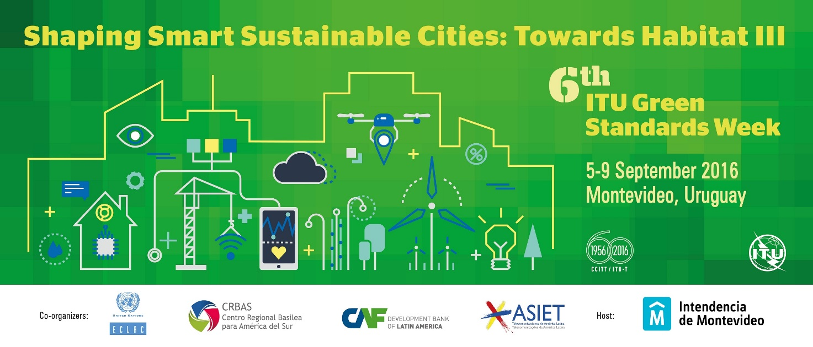

Practical Information

- Conference venue
Conference Centre - Room Azul
Municipality of Montevideo
Av. 18 de Julio 1360
Montevideo, Uruguay | C.P. 11200

- Entry formalities
We recommend that you consult the embassy or consulate in your country for the fullest possible information.
For general and full information regarding formalities for entering the territory of the Eastern Republic of Uruguay, and in order to locate the Uruguayan representation closest to you, please visit the following webpage: www.mrree.gub.uy

- Airports
The Carrasco Gral. Cesáreo L. Berisso International Airport is located in the Carrasco area, approximately 25 minutes from the centre of the city of Montevideo, Ruta 101 Km. 19,950. It is the Eastern Republic of Uruguay’s main air terminal, with state-of-the-art facilities leading the American website www.architizer.com to set it apart from other terminals in the region and worldwide.

Its construction facilitates the movement of aircraft from countries in Europe and North, South and Central America.

Passenger information: Tel. +598 2604 0329

For information on national and international flights:
www.aeropuertodecarrasco.com.uy

- Language
Spanish is the official language of the Eastern Republic of Uruguay.

- Climate
The Eastern Republic of Uruguay has a temperate, subtropical, semi-humid climate. Because of its latitude, between 29°S and 35°S, the four seasons are well differentiated by temperature. The annual average is around 17.5°C, with the highest temperatures in January and February and the lowest in June and July. The maximum and minimum temperatures in summer (January) in Montevideo are 28°C and 17°C, respectively, with an absolute maximum of 43°C. The average maximum and minimum temperatures in winter (July) are 14°C and 6°C, respectively, though the high humidity makes it seem cooler; the lowest temperature recorded in Montevideo is −5.4°C.

- Time
For further information on the time in Montevideo, Eastern Republic of Uruguay, please visit:

http://www.timeanddate.com/worldclock/uruguay/montevideo

- Currency
The Uruguayan peso is the Eastern Republic of Uruguay’s currency, represented by the symbol $. The Uruguayan peso divides into 100 centésimos, and along with the United States dollar is the currency accepted in the main local places of commerce. The current average exchange rate for purchasing Uruguayan pesos is USD 1.00 = $UY 30.
Banks and foreign exchange offices are authorized to change foreign currencies. Many foreign currencies can be exchanged for pesos in the banks and foreign exchange offices.
The currencies readily exchanged in the authorized outlets are the United States dollar, euro, Argentine peso and Brazilian real. It is advisable to convert other currencies into United States dollars before travelling to Montevideo.

The following credit cards are accepted in Uruguay: MasterCard, American Express, Diners Club and Visa.

- Electricity
The electric voltage in Montevideo is 220 Volts/50Hz.

- Business hours
Banks in Montevideo are open from Monday to Friday, from 1300 to 1700 hours; foreign exchange offices are open from Monday to Friday from 0900 to 1900 hours, and until midday on Saturdays.

- Tips
It is customary to leave a 10 per cent tip in cafés and restaurants, and to tip porters.

- Important phone numbers
For all emergencies: 911

- Montevideo, Uruguay
Montevideo is the capital of Uruguay, and the country’s most populated city. As a port city, it is the hub for all of Uruguay’s commercial and tourist activity, making it the country’s most visited city. As a result, it offers an excellent infrastructure for receiving the travellers that visit it every year, providing them with all the information they could require on Montevideo.
The main tourist sites include the Old Town, the Prado, the Rambla, and the squares and parks.

- Suggested Hotels:

All recommended hotels have a preferential rate for the event. In order to book at the given rates, it is essential to mention that you will be attending the Green Standards Week hosted by the Municipality of Montevideo.

1. RADISSON MONTEVIDEO VICTORIA PLAZA HOTEL
Phone No. 2902 0111
Plaza Independencia/Independence Plaza 759
radisson@radisson.com.uy

- CLASSIC FLAT Standard Single US $130 (US DOLLARS)
- CLASSIC FLAT Standard Double US $150 (US DOLLARS)
- HIGH FLOOR Standard Single US $169 (US DOLLARS )
- HIGH FLOOR Standard Double US $189 (US DOLLARS)

Includes:
- Breakfast Buffet served at the Arcadia Restaurant
- Access to the Victoria Spa (Indoor semi-olympic heated pool, sauna, jogging track, fitness room and gym)
- Cafeteria
- Free Internet access in the room (Up to 1 Mb)

2. FOUR POINTS BY SHERATON MONTEVIDEO
Phone No. 2901 7000
Ejido 1275

To make reservations, please send an email to: ramiro.posse@fourpoints.com mentioning your registered name/business name and the name of your company.

- TRADITIONAL SINGLE US $105 (US DOLLARS)
- TRADICIONAL DOUBLE US $115 (US DOLLARS)
- DELUXE SINGLE US $129 (US DOLLARS)
- DELUXE DOUBLE US $139 (US DOLLARS)
- SUITE CORNER SINGLE US $165 (US DOLLARS)
- SUITE CORNER DOUBLE US $175 (US DOLLARS)
- SUITE SINGLE US $185 (US DOLLARS)
- SUITE DOUBLE US $195 (US DOLLARS)

Includes:
- American Breakfast Buffet at the El Ejido y el Arte Restaurant
- High-speed Internet
- Free access to the Spa and Fitness Center
- Private parking with 24 hrs security
- Free of charge Registration to the Frequent Flyer of Starwood (SPG)

3. BALMORAL PLAZA
Phone No. 2902 2393
Circunvalación Plaza Cagancha 1126
reservas@balmoral.com.uy

- SINGLE STANDARD US $60 (US DOLLARS)
- SINGLE SUPERIOR US $68 (US DOLLARS)
- SINGLE EXECUTIVE US $78 (US DOLLARS)
- DOUBLE SUPERIOR US $78 (US DOLLARS)
- DOUBLE EXECUTIVE US $88 (US DOLLARS)
- TRIPLE ROOM US $120 (US DOLLARS)

Includes:
- Breakfast Buffet, Wifi, Spa and Sauna.
- The Bio Restaurant offers its services and Executive Menu (at a preferential corporate rate) at a cost of US $20 (including main dish, juice, water or soda, dessert and coffee.

4. ARMON SUITES HOTEL
Phone No. 2712 4120
21 de Setiembre 2885
Rates for the 6th Edition of the Green Standards Week

SUITE SINGLE/DOUBLE US $80 (US DOLLARS)

5. MY SUITES HOTEL
Phone No. 2712 3434
Juan Benito Blanco 674
Rates for the 6th Edition of the Green Standards Week

- SINGLE ROOM/DOUBLE US $100 (US DOLLARS)
- SUITE SINGLE/DOUBLE US $112 (US DOLLARS)
- TRIPLE ROOM US $122 (US DOLLARS)
- TRIPLE SUITE US $136 (US DOLLARS)

To book your hotel, please send the following information as soon as possible:

PLEASE COMPLETE THE FOLLOWING:
HOTEL

CHECK-IN DATE | CHECK OUT DATE

NAME | SURNAME | ID NUMBER | DATE OF BIRTH

After completing this form please send it as soon as possible to tania.fernandez@imm.gub.uy to complete your booking.

- Visa contact point:
Ms Tania Fernandez
tania.fernandez@imm.gub.uy
Municipality of Montevideo, Uruguay

______________

