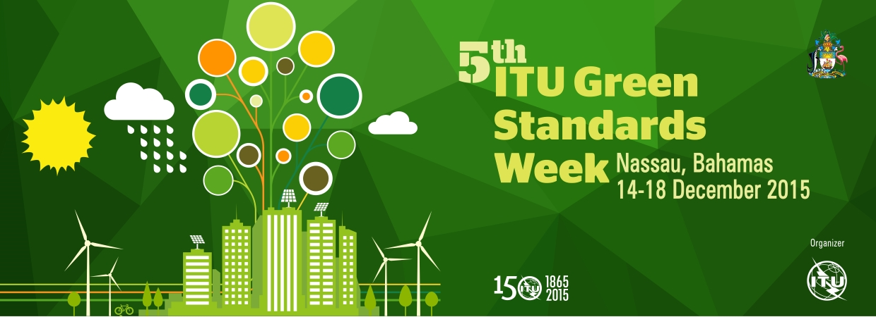

The Bahamas Declaration
Powering Smart Sustainable Cities, Nations & Islands

18 December 2015

ITU’s 5th Green Standards Week, held from 14 to 18 December 2015 in Nassau, the Bahamas, on the theme "Powering Smart Sustainable Cities, Nations & Islands" has:

1. Recognized that uncontrolled urbanization is a widespread socio-economic phenomenon the world is witnessing in the 21st century, which significantly affects the way we live. Urban areas reflect the complexity of human societies, where social, economic and environmental issues are interconnected.

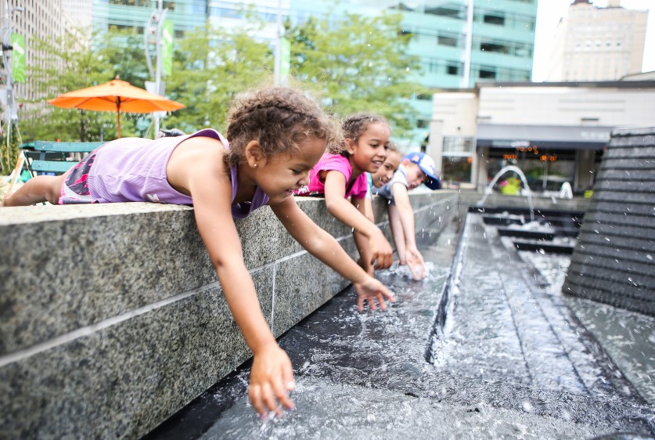
2. Acknowledged that while urbanization has brought economic and technological progress that has helped provide a higher quality of life, it has also burdened us with negative social, economic and environmental consequences including greenhouse gas emissions, global warming, changes in land use, overcrowding, traffic jams, unmet demand of public services, increased emission, pollution, wastewater and waste generation, among others.

3. Been mindful that increasing population growth brings economic competition as well as more complex environmental challenges such as climate change and increased urban sprawl that have impacted availability of potable water, increased levels of energy consumption, and have further contributed to pressures on cities and countries, particularly on small island developing states (SIDS).

Noting that, concerted planning and actions are essential for the well-being of our planet, humans and all other species.

In light of the above, achieving sustainable urbanization to contribute to inclusive and sustainable development along with the preservation of our planet, has been recognized as one of the major challenges for our society in the coming decades.

Therefore, we the participants of the Green Standards Week 2015 declare our willingness and commitment to:

1. Contribute towards the implementation of the new Paris Agreement on climate change and the New Urban Agenda: Improve awareness and promote information sharing on the role of ICTs to meet the targets laid out by the new COP-21 Paris Agreement on climate change, the UN 2030 Agenda Sustainable Development Goals (SDGs), ITU’s Connect 2020 Agenda and to contribute to the third UN Conference on Housing and Sustainable Urbanization (Habitat III) in order to achieve sustainable urbanization along with the preservation of our planet.

2. Foster smart e-waste management: Raise public awareness on the potential benefits of end of life of ICT such as the reduction of the digital divide and recycling opportunities. Make efforts directed towards setting up effective e‑waste management systems which can withstand the scrutiny of environment, health and safety standards. This will include detection and measurement of emissions as well as safety and protection for workers involved in e-waste recycling.

3. Build a circular economy: Design and promote green products and services using international standards that are developed based on life cycle assessment. Scaling up a circular economy at an international level will require government support. Support a coordinated approach by world leaders to introduce positive legislative drivers such as e-waste prevention targets and incentives based on eco-design to promote products that are easier to reuse, remanufacture and disassemble.

4. Lead with vision: Develop and foster the adoption of policies, international standards, key performance indicators, innovative ICT-based sources of information (such as those provided by the Internet of Things (IoT) and crowdsourcing to collect citizens perceptions), and best practices to shape smart sustainable cities, countries and islands to promote the use of green ICTs for sustainable development including climate change adaptation and mitigation as well as e-waste management.

5. Think sustainable: Bridge the gap between experts from the ICT, environment, urban planning, energy sectors and policy makers, to encourage the integration of ICTs into environmental, urban and energy policies in order to improve knowledge on the catalytic role that ICTs can play in reducing energy consumption, increasing environmental resilience, tackling climate change impacts, and enhancing energy efficiency and promoting a circular economy.

6. Support greening technologies by design: Achieve high energy performance through a fundamental change in design principles and implementing practices within the ICT industry. For example, high energy performance targeting reduced network energy consumption is a critical requirement of IMT-2020/5G. It enables the reduction in total cost of ownership, facilitates the extension of network connectivity to remote areas, and provides network access in a sustainable and more resource-efficient way. ITU-T Study Group 5” Environment & Climate Change” is called upon to develop standards that will ensure that 5G systems will be deployed based on eco-design principles including high energy performance, hazardous substances free e-products, circular economy principles and smart e-waste management.

7. Foster the development and convergence of global standards and open Application Programme Interfaces (APIs) for IoT: ITU-T Study Group 20 on “Internet of Things and its Applications including Smart Cities and Communities” is called upon to support the development and convergence of global IoT standards and open APIs and interfaces, including for open data, in view of enabling interoperability among technologies, services and applications.

8. Develop a global smart sustainable index for cities, countries and SIDS: Develop a scoring system that would allow to measure how each city, country or island would score on an accepted global smart sustainable index.

9. Building trust and develop secure and privacy by design approaches for IoT lifecycle, sustainability issues with the devices, applications and solutions: ITU-T Study Group 20 is called upon to identify solutions aimed at building trust and ensuring privacy compliance of IoT devices and services, according to modalities that preserve their efficiency and economic value.

10. Ensure end-user involvement and user-centric approaches: ITU-T Study Group 20 is called upon to consider approaches and models for active involvement of end-users in IoT technology development and deployment, such as crowdsourcing, in particular in smart city environment.

11. Demonstrate success and feasibility: Carry out pilot and flagship projects to demonstrate “smart” ICT solutions to enable a smart environment by utilizing new technologies and standards to enable countries, cities and islands to become smarter and more sustainable. Identify strengths and weaknesses of implementation strategies, and report success stories and cost implications in dealing with the challenges met, and innovative solutions used.

12. Boost partnerships and mobilize expertise: Enhance cooperation at international, regional, and national level, between organizations, research institutes, academics, governments, small medium enterprises (SMEs) and civil society, on the use of ICT for a smart sustainable world. Create business models that would encourage partnerships among stakeholders through win- win solutions.

13. Shape the global agenda: Establish an Initiative on “Powering Smart Sustainable Cities, Nations & SIDS” that will assist countries, cities and SIDS to become smarter and more sustainable across their respective territories.

Additional information on 5th Green Standards Week can be found at: http://www.itu.int/en/ITU-T/Workshops-and-Seminars/gsw/201512/Pages/

