CLIMATE CHANGE AND THE NEW URBAN AGENDA
One UN solutions for sustainable urbanization

Joint statement by ITU, UNECE, UNIDO, UNU, ECLAC and Basel Convention

18 December 2015

Cities are not only one of the major causes of climate change but are also heavily vulnerable to its consequences. The complexity of climate change and the related challenges, ranging from global warming, sea-level rise, increasing frequency and intensity of storms and glacial melting, has required mankind to review its approach towards urbanization. This has facilitated and provided the much-needed impetus to the drive for sustainable urban development worldwide.

Urbanization has the ability to transform the social and economic landscape of countries. Cities are engines of economic growth, accounting for 80% of the global GDP. However, they also consume around 75% of global primary energy and are responsible for 70% of the global greenhouse gas (GHG) emissions. As of 2014, an ever increasing number of people live in cities, and the global urban population is at 54%. Urban population is projected to rise to 70% by 2050. Additionally, new cities have emerged across the globe, and hundreds are expected to be built in the future, thereby potentially exacerbating GHG emissions and global energy consumption rates.

Urbanization trends pose a need for strategic and innovative approaches to urban design, planning, management and governance. The drive for sustainable urbanization should aim for an integrated approach, making cities resource efficient, less carbon intensive and enhancing the infrastructural systems that provide services to their citizens. In this regard, most aspects relevant to the new urban agenda reference the role and potential of industry and technology, in particular ICTs, to advance goals and address challenges, presenting new opportunities and smart approaches for the global community to make cities inclusive, safe, resilient, and sustainable.

It is essential to improve the overall urban ecosystem rather than merely sustaining them in its current condition. Cities need to be properly planned, capacitated, resourced, and managed through appropriate governance structures to ensure that they can continue to be centers of innovation and efficiency. Additionally, urban stakeholders should focus on transforming cities based on a regenerative urban model that would reduce dependency on fossil fuels, promote the use of renewable energy sources, improve urban waste management systems and raise the standard of living for the citizens.

In line with the above and calling on for timely action, Sustainable Development Goal (SDG) 11 (“Make cities inclusive, safe, resilient and sustainable”) focusses on the adoption and implementation of participatory policies and frameworks that promote resource efficiency, reduce pollution, improve resilience, and promote adaptation and mitigation of climate change within urban boundaries. As for the New Urban Agenda, there is already a wide range of technical and management solutions ; however, their implementation for the New Urban Agenda as well as the Goals stipulated in the SDGs need to be done on a global scale.

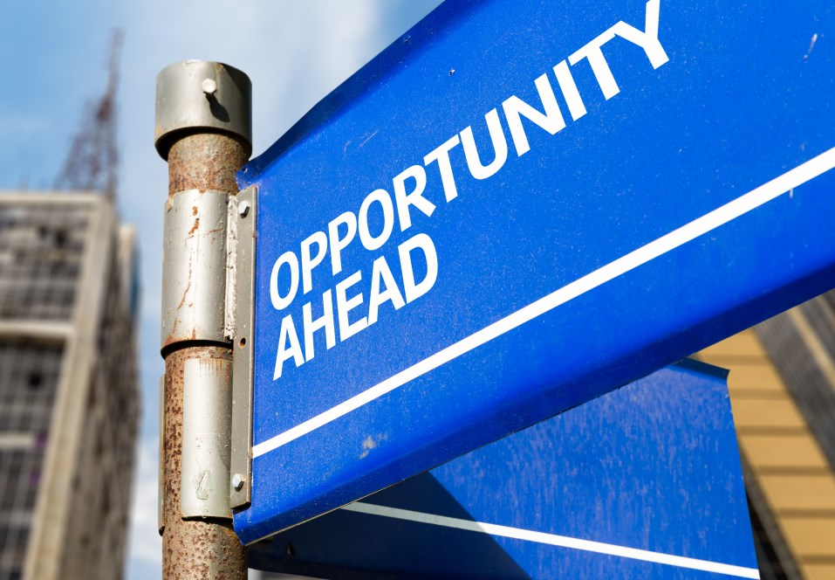
The International Telecommunication Union (ITU), the United Nations Economic Commission for Europe (UNECE), the United Nations Industrial Development Organization (UNIDO), the United Nations University (UNU), the Economic Commision for Latin America and the Caribbean (ECLAC) and Basel Convention, call upon policy makers, government authorities, academic institutions and relevant international and regional organizations to collaborate to:

- Lead the vision: The development of a common vision is essential to ensure that all actors work in unison to achieve sustainable urbanization discussed and agreed upon at Habitat III and the New Urban Agenda. This also involves enabling policy and resource frameworks, constituting the foundation of progressive social and economic development and achieving climate protection goals.

- Establish a circular economy: The promotion of green industries, products and services based on international standards that are developed on life cycle assessments, and raise awareness on the blue, green, and grey water footprints and carbon footprints of commonly used products, services, and economic activities.

- Achieve inclusive and sustainable industrial development: Industries drive economic growth, social mobility and sustainable urbanization. However, they can also contribute significantly to environmental stress and climate change. Sound industrial policies thus embrace green technologies, cleaner production methodologies and greater energy and resource efficiency, in order to reduce carbon emissions and environmental degradation. Any industrialization or industrial retrofitting process must be buttressed by a robust environmental and social framework that is inclusive and sustainable for all people. This will facilitate achieving SDG 9 (“Build resilient infrastructure, promote inclusive and sustainable industrialization and foster innovation”)

- Share knowledge: Knowledge sharing is an essential tool that can accelerate innovation and thus the rate of development across cities, including secondary and growing cities. Learning from the experiences of others and replicating successful results are integral parts of urban management techniques.

- Mobilize expertise: Mobilizing expertise among citizens and policy makers will assist in the adoption of policies, strategies, funding arrangements, new technological and industrial innovations (particularly in the information and communication technologies realm) and plans for sustainable urbanization. This will inculcate in cities a strong institutional capacity to develop a flexible, creative, and operational framework in order to deal pragmatically and efficiently with regional and global urban challenges.

- Evaluate and measure progress: Progress and performance should be measured to gauge the extent to which the drive for sustainable development in cities, in line with the New Urban Agenda, has been successful. These evaluations can be conducted using existing international frameworks/standards and key performance indicators (KPIs) developed by international standards developing organizations.

- Drive the evolution to smart sustainable cities and communities: While policies help streamline the process for transition to smart sustainable cities (SSC), advanced technologies like the Internet of Things (IoT) are expected to assist in the seamless integration of various industrial systems, with a plethora of services for citizens. Urban IoT networks can be specially developed to support the SSC vision, which aims at leveraging the potential of new technologies like IoT to support added-value services for urban administration in order to improve the overall quality of life for the citizens. It is also important to highlight that the establishment of SSC will further facilitate the achievement of SDG 9 (“Build resilient infrastructure, promote inclusive and sustainable industrialization and foster innovation”).

- Provide energy efficiency: The need for sustainable energy efficiency falls within the domain of urban responsibilities given the current dynamic and uncertain energy landscape. This requires commitment for improvement and enhancement of energy security through multi-stakeholder cooperation and dialogue on issues including renewable energy, investments and need for diversification of energy sources.

- Mitigate and adapt to climate change: Climate change is viewed as a global challenge and has a fundamental effect on the environment. Accordingly, action must be taken on two fronts: first, climate change must be minimized by drastically reducing global greenhouse gas (GHG) emissions of industries, buildings, and transport systems, avoiding future emissions and ensuring that carbon sinks, including rainforests, are preserved. Second, adaptive responses to climate change must be adopted to reduce vulnerability to climate change impacts. These proposed lines of action are also directed towards attainment of SDG 13 (“Take urgent action to combat climate change and its impacts”).

- Increase efficiency of capacity building: Capacity building is viewed as a means to promote sustainable urban development at the local and national levels. This requires to underscore the importance of training of relevant stakeholders in the public and private sector so that they are able to take decisions and set the required policy systems focusing on housing, integrated infrastructural development, inclusive and sustainable industrialization, and financial management.

- Reduce and manage safely E-waste: The growing challenge of e-waste also needs to be dealt with in an ecologically friendly manner. E-waste is the fastest growing waste stream, which is considered hazardous and expensive to treat. Many countries do not have a concrete legislation to deal with e-waste and most of its treatment takes place in the informal economy using rudimentary techniques without the required measures to protect the workers and the environment. Therefore, improper e-waste management has adverse environmental and health implications. Keeping the above in mind, in line with SGD 12 (“Ensure sustainable consumption and production patterns”), dialogue and cooperation with electronics industries and other stakeholders will be essential for reducing future e-waste volumes and hazardousness, and advancing reuse and recycle schemes for e-products.

- Advance on the Sustainable Development Goals: Following the adoption of the encompassing development agreement entitled “Transforming our world: the 2030 Agenda for Sustainable Development”, it is important that the objectives established for cities should complement the targets elaborated in the SDGs. Consequently, it is essential that cities cater to the requirements and limits set forth in SDGs.

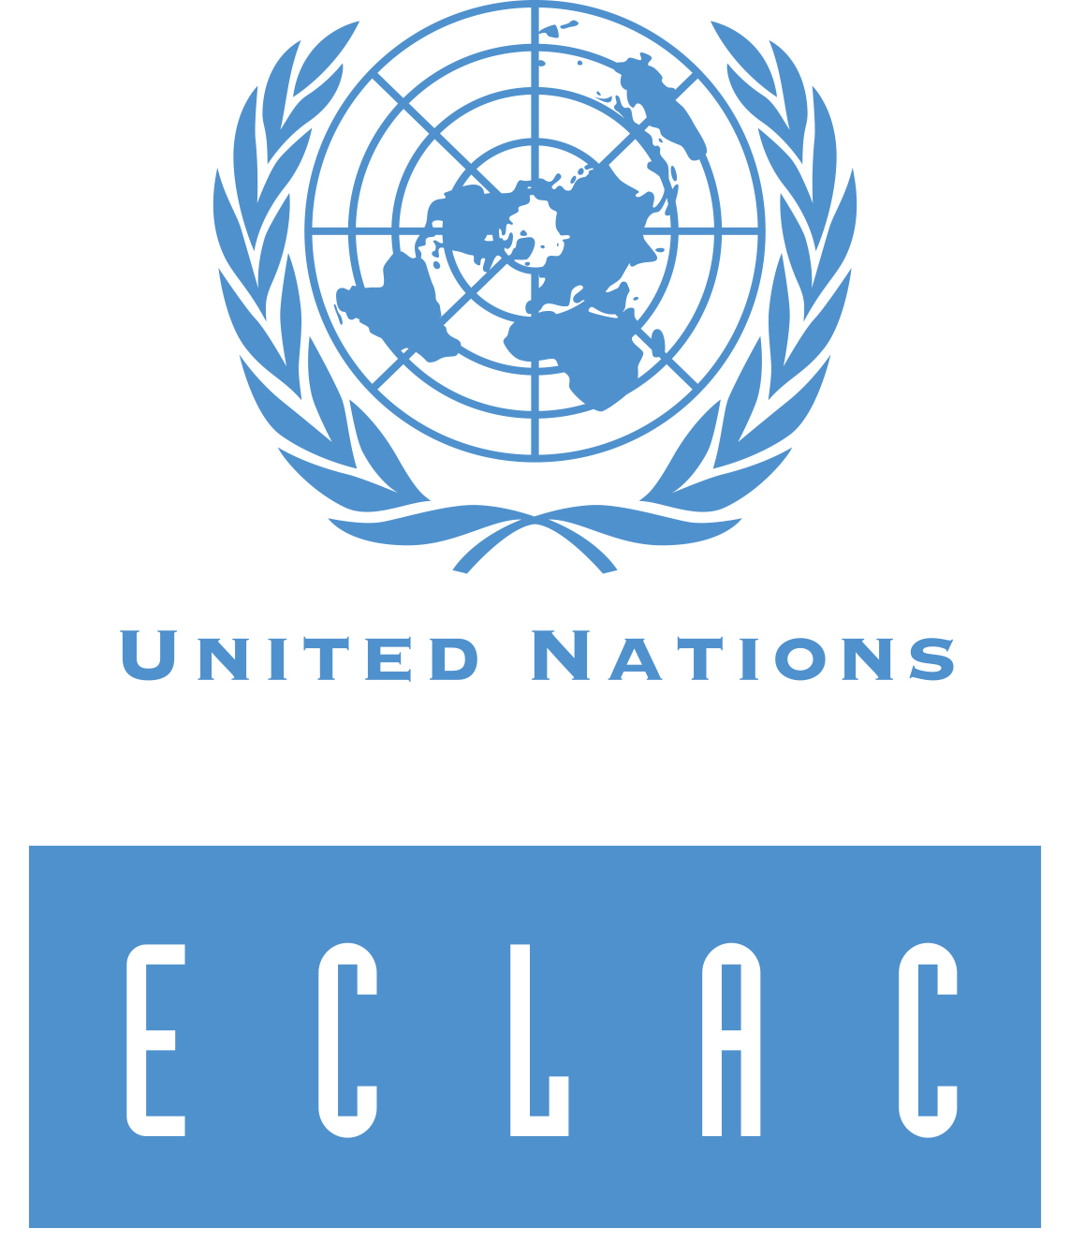
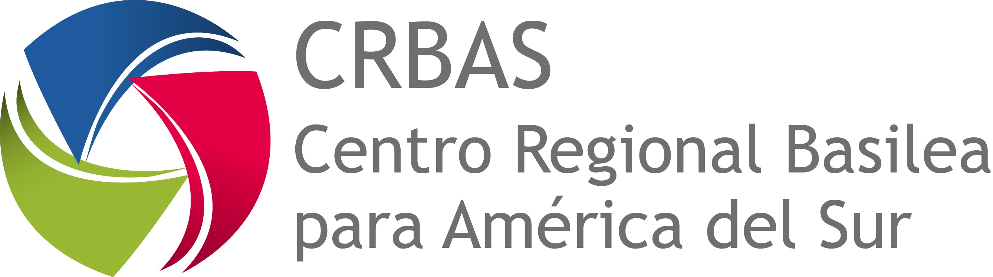
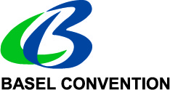
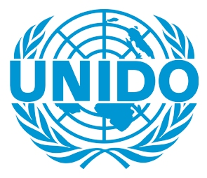
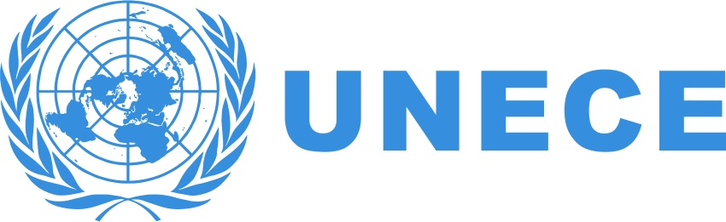
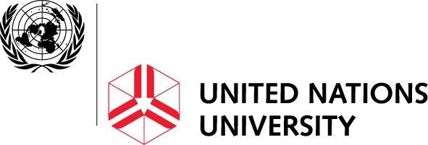

One UN solutions for sustainable urbanization

UN-Habitat 2011. Hot cities battleground for climate change

