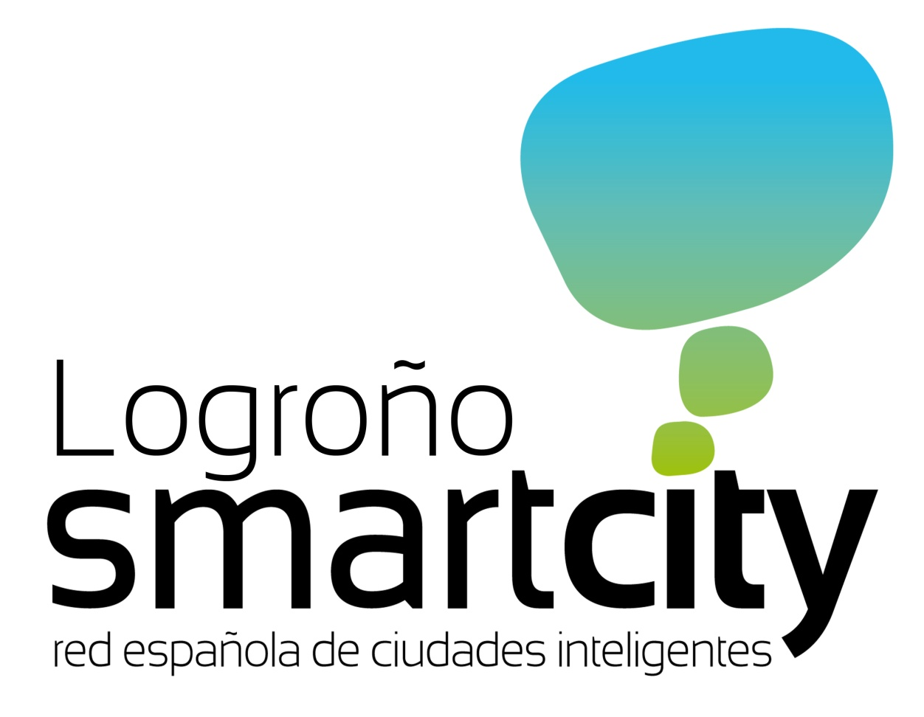
Logroño knows that the city of the future is a 'smart city' and it aspires to become a reference in that regard.

It is therefore taking measures to ensure the competitiveness of our city and is collaborating in the implementation of this new paradigm nationwide, through the vice-presidency of the Spanish Smart Cities Network (SSCN).

Logroño has always had close links with the SSCN since its birth on 13 January 2012, when the founding session of the NETWORK took place in this city.
On 27 June 2012, in Valladolid, the SSCN officially became a non-profit association with a legal personality and full capacity to act. The City Council of Santander was entrusted with the presidency and the City Council of Logroño with the vice-presidency of the association.

In order to be able to understand the spirit of the SSCN, we need to analyse just what a smart city is. In the words of the Mayor of Logroño and Vice-President of the SSCN: "a smart city is one which enables its citizens to have two-way interaction and which makes intensive use of technology to provide quality services".

The Spanish Smart Cities Network is a space for collaboration between municipalities in order to jointly develop sustainable management models and to improve citizens' quality of life, with particular emphasis on key aspects of municipal management and with clear objectives: energy efficiency, sustainability, social innovation, entrepreneurship, technological development, sustainable mobility and attention to people.

The SSCN is composed of 41 cities: A Coruña, Alcobendas, Alicante, Barcelona, Burgos, Cáceres, Castellón, Córdoba, Guadalajara, Elche, Gijón, Logroño, Lugo, Huesca, Madrid, Malaga, Marbella, Murcia, Palencia, Pamplona, Rivas-Vaciamadrid, Salamanca, Santander, Segovia, Valencia, Valladolid, Vitoria-Gasteiz, Sabadell and Zaragoza. Recently, at the meeting of the Executive Board held in Castellón, the following cities were incorporated into the association: Alcorcón, Avila, Badajoz, Móstoles, Oviedo, Palma de Mallorca, Ponferrada, Seville, Tarragona, Torrejón de Ardoz and Torrent.

The SSCN has defined its strategic lines:

In the area of social innovation, the association is committed to Open Governance, which means transparency, access to and the reuse of information, and the transfer of experiences and solutions that are already working.

With regard to energy, it has been agreed to share different documents of an administrative nature, such as bid specifications and ordinances to regulate electrical grids, lighting or energy efficiency, which will serve as a model for those cities that wish to implement a sustainable city model.

With regard to the environment, infrastructure and human habitability, the following are stipulated as preferential lines of action: the efficient management of the water cycle; waste management; the management of green zones; and the indicators of urban quality and efficiency.

In the area of urban mobility, it is agreed to promote the interoperability of public electric vehicle recharging points, adopting common initiatives in the cities that currently have these, with the ultimate aim of being able to establish a common protocol for all the cities which are members of the SSCN. Likewise, the implementation of smart transport systems and sustainable urban mobility plans.

Finally, with regard to governance, the economy and business, it is agreed to ensure the fulfilment of citizens' electronic rights, electronic sites, certification and authentication services and a future catalogue of administrative procedures.

The Network has made a strong commitment to telecommuting and meetings via video-conferencing, and for this it has created an online platform which supports collaboration and makes it possible to undertake collaborative forms of work following the principles of energy efficiency, minimising the carbon footprint and reducing the amount of travel.

The Spanish Smart Cities Network also seeks public/private collaboration formulas, necessary to guarantee the provision of services at the present time. The participation in national and community forums was significant in 2012.

The Transformation of Logroño into a smart city does not depend on the council alone. All the social agents must be involved, and therefore the City Council, the SSCN and the Spanish Federation of Municipalities and Provinces are all working for ever-increasing global awareness of energy efficiency and the intelligent management of resources, including participation on European projects through adhesion to the Covenant of Mayors, approved by the Plenary Session on 6 September 2012.

