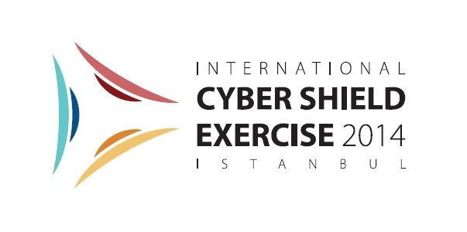
Organized by
International Telecommunication Union, Information and Communication Technologies Authority and Ministry of Transport, Maritime Affairs and Communications of the Republic of Turkey
in collaboration with
International Multilateral Platform Against Cyber Threats
15-16 May 2014, Istanbul, Turkey

REGISTRATION FORM

Please use CAPITAL letters.

Family Name:…………………………………………………………………………………………. .

Given Name:……………………………………………………………………………………………

Title/Function:…………………………………………………………………………………………..

Name of Organisation/Company:…………………………………………………………………….

…………………………………………………………………………………………………….……..

Office Address:…………………………………………………………………………………………

……………………………………………………………………………………………………………

Town:……… ……………………………………… Country:…………………………………………

Telephone Number(s):………………………………………………………………………………..

……………………………………………………………………………………………………………

Fax Number(s):…………………………………………………………………………………………

E-mail:…………………………………………………………………………………………………...

Date of arrival: ……………………………
Date of departure:……………………………..
Hotel Name:……………………………………………………………………………………………..

Please fax or e-mail this form duly completed by Monday, 5 May 2014 at the latest, to:
Name: Yuksel Gunaydin  e-mail: ygunaydin@btk.gov.tr  Phone: +903122947078 | Name: Fatih TAPARLI  e-mail: fatih.taparli@btk.gov.tr  Phone: +903122947809

