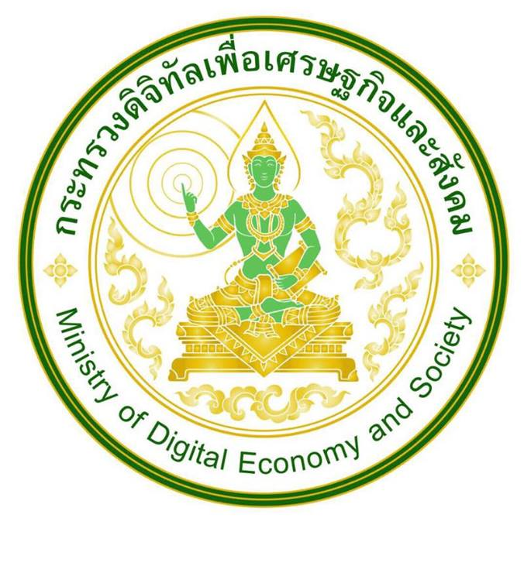

Annex 1
TRAINING OUTLINE

ITU CENTRES OF EXCELLENCE NETWORK FOR ASIA PACIFIC REGION

Developing the ICT ecosystem to harness Internet-of-Things (IoTs)
13-15 December 2016, Bangkok, Thailand

COURSE DESCRIPTION

Title | Developing ICT ecosystem to harness Internet-of-Things (IoTs)
Method of delivery | Face-to-face
Objectives | - To provide an overview on the ICT ecosystem and enabling environment to foster Internet of Things (including technology, standards, cross-sectoral policy and regulatory frameworks, and applications) deployments  - To build skills for ICT policy makers, regulators, telecom operators, and academia required to develop IoT Strategies.  - To demonstrate how to make practical use of IOTs and associated technologies (Big data, Analytics etc.) using hands-on exercises.
Dates | 13 – 15 December 2016
Duration | Three days
Registration deadline | 5 December 2016
Training fees | Free with support from the Ministry of Digital Economy and Society (Thailand) and the National Broadcasting and Telecommunications Commission (Thailand)
Course code | 16DL18189ASP-E

LEARNING OUTCOMES

Upon completion of this training, participants will be able to

- Understand the technology and standards relating to IoTs;
- Understand the critical parts of the ICT ecosystem required to mainstream IoTs;
- Visualize practical examples of how IoTs can be deployed in other verticals;
- Acquire skills on developing their own national and enterprise level strategies;

TARGET POPULATION
Policy makers, regulators, service providers and academia involved in Internet of Things.
FACILITATOR/EXPERTS

The experts for the training include ITU and other invited experts (Details to be available at course webpage).

EVALUATION
The assessment of the participants shall be based on the - time spent on the training and the following parameters:
Evaluation Parameter | Weightage ( in %)
Quizzes and presentations | 60 %
Attendance | 10 %
Participation | 30 %

The minimum passing requirement for certificate is 60%.

DRAFT TRAINING SCHEDULE AND CONTENTS / AGENDA
(Updated information will be available at http://www.itu.int/itu-d/asp)

Tuesday 13th December (Day-1)
0830–0900 | Registration
0900-0915 | Opening Session
0915–1030 | SESSION 1: Internet of Things (IoTs) – A technical overview of the ecosystem  Objective: To develop an overview of the trends, technology, standards and the institutional framework relating to the IoTs at international and national level.
1030–1100 | COFFEE BREAK
1100–1230 | SESSION 2: Internet of Things – Policy and regulatory enablers  Objective: To understand the policy and regulatory enablers for fostering the deployment of IoTs and machine-to-machine (M2M) within the ICT sector and the need for cross-sectoral collaboration.
1230–1400 | LUNCH BREAK
1400–1530 | SESSION 3: IOT: Application and services  Objective: To develop a comprehensive understanding of how IoTs can be deployed in various sectoral verticals with specific focus on applications (e.g. health, agriculture, transport)
1530–1545 | COFFEE BREAK
1545–1700 | SESSION 4: Working group exercise-I  Objective: To develop an understanding through working group exercise of how IoTs can be used to carry out analytics

Wednesday 14th December (Day-2)
0900-1030 | SESSION 5: IOT Technical planning: Network planning, big data and analytics Objective: To understand how enterprises plan for IoT deployment in networks?, what are the key network planning parameters?, How data is collected?, what are the tools available? and how analytics are used for decision making?.
1030–1100 | COFFEE BREAK
1100–1230 | SESSION 6: IOT Technical Planning: Network planning, big data and analytics (continued)  Objective: To understand how enterprises plan for IoT deployment in networks?, what are the key network planning parameters?, How data is collected?, what are the tools available?,and how analytics are used for decision making?.
1230–1400 | LUNCH BREAK
1400–1530 | SESSION 7: Working group exercise - I (continued)  Objective: To develop an understanding through working group exercise of how IoTs can be used to carry out analytics
1530–1545 | COFFEE BREAK
1545–1630 | SESSION 8: Working group presentation – I (continued)  Objective: To develop an understanding through working group exercise of how IoTs can be used to carry out analytics
1630-1700 | Quiz 1

Thursday 15th December (Day-3)
0900–1030 | SESSION 9: IOT: Solutions and deployment experiences  Objective: To develop an understanding of practical solution and deployment experiences.
1030–1100 | COFFEE BREAK
1100-1200 | SESSION 10: IOT: Solutions and deployment experiences (continued)  Objective: To develop an understanding of practical solution and deployment experiences.
1200–1300 | LUNCH BREAK
1300-1400 | SESSION 11: Working group exercise - II  Objective: To work in groups to identify critical elements in developing an ecosystem for fostering IoTs at national level
1400–1500 | SESSION 12: Working group presentations
1500–1515 | COFFEE BREAK
1515-1600 | SESSION 13: Tying it all together – How to develop an ICT ecosystem for IoTs?
1600-1630 | Quiz 2
1630-1700 | Closing

METHODOLOGY
The face-to-face programs will include
  - Instructor-led presentations,
  - Case studies,
  - Group exercises

TRAINING COORDINATION
ITU coordinator:
Mr. Ashish Narayan,
ITU Regional Office for Asia & the Pacific, 5th Floor, Thailand Post Training Centre,111Moo3 Chaengwattana Road, Laksi Bankok 10210,Thailand
Tel: +66 257 500 55, FAX: +66 257 535 07
Email: ashish.narayan@itu.int

Ministry of Digital Economy and Society (Thailand) coordinator:
Ms. Tharinee Limpibunterng,
TOT Academy, TOT Public Company Limited
174 Moo 2, Ngamwongwan Rd.
Nonthaburi, 11000, Thailand
Tel: +66 2596 1104, Fax: +66 2591 8087
Email: thalimne@tot.co.th

NBTC Coordinator:
Ms. Sasimon Perunavin
The Office of NBTC,
87 Soi Phaholyothin 8, Samsen Nai,
Phayathai, Bangkok 10400 Thailand
Email: sasimon.peru@gmail.com

REGISTRATION
Registration on ITU Academy Portal
Application to participate in this course should be made at http://www.itu.int/itu-d/asp

Please note that online registration should be done before 5 December 2016.

