PATENT ROUNDTABLE
ITU Headquarters, Geneva
10 October 2012

Submitted by: WiseHarbor
Contact point: Keith Mallinson

Success for Licensors, Licensees and Consumers with Patents in Standards

An ITU press release, dated 6th July 2012, announcing this Patent Roundtable is headlined “[i]nnovation-stifling use of intellectual property to be tackled” alleges a “growing lack of adherence to standards bodies’ existing patent policies” and “an unwelcome trend in today’s marketplace to use standards-essential patents to block markets”. As a longstanding ICT industry analyst and commentator I believe these descriptions are inaccurate.
With little or no evidence of actual harm from alleged “hold-up”, “patent thickets” and “royalty stacking” with standard-essential patents (SEPs), we should not undermine the highly-successful IP in standards-setting processes. IP in standard-setting, together with follow-on technology developments, product and service implementations in ICT are generally working very well, as illustrated by many highly-successful standards, including those for video “codecs” (e.g., H.264) and in mobile communications (e.g., with 2G GSM, 3G UMTS and 4G LGE):
Video and Audio Codecs
–Widely used in DVDs, broadcast streams, PCs and smartphones
–29 voluntary licensors and 1,000 licensees for H.264 patent pool
–2,600 patents deemed essential by H.264 pool examiners
–Proprietary and open source software (eg, x.264) implementations
–Aggregate patent royalties averaging approximately $3 per device ($0.20 maximum for H.264)

Mobile Phones
–5 billion phone subscribers in a $1 trillion market including handsets and services
–Phone prices as low as $20 (unsubsidized)
–Most vibrant and innovative market with smartphone revolution
–Data speeds 1,000 times faster in 10 years from 56kbps GPRS in 2000
–Hundreds of companies contribute to and implement 3GPP and 3GPP2 standards
–124,000 declared essential patents
–10 major standards releases by 3GPP and pace of innovation is relentless
–Aggregate royalty rates have declined
Evidence shows that innovation from R&D is substantial and ongoing with many collaborators as licensors and licensees. Competition is healthy with major changes in manufacturer market shares, and consumers are benefitting from improved technical performance, increasing choice and widespread adoption.
The following three articles and article extracts are a small selection from among many of mine on the issue of IP in standards that were first published on the IP Finance blog and that can also most easily all be access via the WiseHarbor web site. Please note that various sources cited can be accesses via embedded hyperlinks in these articles. Please read the articles online and click on the underlined blue text.
1. There Aren’t Too Many Patents
Monday, 3 September 2012
Innovation is the lifeblood of various technology markets including pharmaceuticals, software, telecommunications, consumer and automotive electronics. It is facilitated by R&D investments and secured from misappropriation by patenting. Meddling with patent law to discriminate among different types of inventions, industries or business models is unwarranted and would be harmful.

It is generally agreed that patents encourage innovation in “static” or “non-sequential” developments where a patent corresponds to a single product, and upfront costs are high, such as in drug development. However, the enormous success of standards-based technologies such as those implemented in video codecs (e.g., H.264) and in mobile communications (e.g., GSM, UMTS and LTE)—each including hundreds or thousands of standards-essential patents (SEPs)—show that the patent system also works well when innovation is both “sequential” (each successive innovation builds on its predecessors) and “complementary” (various different innovations are combined).

Specious theories

With the rise in patent litigation among some well-known smartphone technology companies, various theories of harm are being promoted seeking to radically undermine the patent system. Most recently, following US Judge Richard Posner’s June 2012 Opinion and Order including his decision to dismiss a case in which Apple and Motorola had sued each other for alleged smartphone patent infringement, the judge published an article in the Atlantic entitled “Why there are too many patents in America”. He is persuaded that the pharmaceutical industry “really does need” patent protection, but he would have patent law discriminate among different types of inventions or particular industries. However, his theory of differences fails when tested with examples in software and telecommunications.

Similarly, a report commissioned by the UK Prime Minister and written by Professor Ian Hargreaves entitled Digital Opportunity: A Review of Intellectual Property and Growth, May 2011, states that patent “thickets” with “strategic” patenting in software and telecoms is a problem, as illustrated in Figure 1. His report cites academic research erroneously asserting that, in contrast to industries with non-sequential developments which underlie the traditional justification for patents, in industries with many sequential and complementary technologies—the software industry is given as an example—consumers and even technology innovators could be better off if there were no patents.

Figure 1:
“Which Technologies are Causing the Problem?”

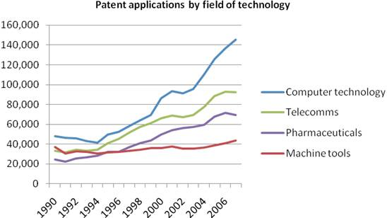

Source: Digital Opportunity: A Review of Intellectual Property and Growth, May 2011, by Professor Ian Hargreaves, based on WIPO Statistics Database, September 2010

Pharma is not unique
The context of Judge Posner’s article is a comparison of pharmaceuticals versus software and communications technologies. Patented software in mobile phone user interfaces, operating systems and for communications functions have figured prominently along with industrial design rights in recent litigation among smartphone technology companies. Judge Posner incorrectly asserts, or overstates, three reasons why pharmaceuticals is different to other industries, in justification for weaker or no patent protection elsewhere: high R&D costs; long delays after patenting before revenues are generated; and low production costs.

Cost of inventing – R&D comparisons
Whereas pharmaceuticals companies typically have R&D spending levels, as a percentage of sales, five times higher than an average of only 3.3% among 1,400 leading companies according to The 2011 EU Industrial R&D Investment Scoreboard, the corresponding percentages for software product companies are very similar to pharmaceutical companies, as shown in Figure 2. Microsoft’s total R&D expenditure ($9.8 billion over the last year) exceeds that of any pharmaceutical company.

Figure 2:
R&D Investment Intensity and Gross Profit Margins are Similar for Major Pharmaceutical and Software Product Companies

 | R&D/Sales | Annual R&D  (millions) | Gross Profit Margin
Roche | 18.1% | CHF 8,266  ($8,640) | 73.0%
Pfizer | 11.0% | $7,766 | 82.3%
Novartis | 16.0% | $9,518 | 67.8%
Merck | 16.2% | $7,834 | 77.2%
Pharmaceutical Average | 15.3% |  | 75.1%
Microsoft | 14.4% | $9,811 | 76.9%
SAP | 15.2% | $2,064 | 67.6%
Oracle | 11.2% | $4,523 | 81.6%
Red Hat | 19.0% | $220 | 85.4%
Software average | 15.0% |  | 77.9%
Source: Google Finance

Increases in R&D investment since the 2009 downturn have been most significant in both pharmaceuticals and ICT and have fuelled economic growth. The top 50 Scoreboard companies invested €194 billion ($243 billion) in 2010, accounting for 42.5 % of the total R&D investment by the companies. Thirty-eight companies in the top 50 showed positive R&D investment growth over the preceding year including: Merck US (47 %), Abbot (35.7 %), Pfizer (21.4 %), LG (39.5 %), Oracle (38.9 %), Google (32.3 %), and Samsung (24.9 %).
Time on market for patented technologies
Whereas half of a 20-year patent term can elapse before a drug is clinically tested and approved for sale, there can also be similar length delays before patented ICT technologies are fully commercialised for adoption globally. For example, it took many years before new cellular technologies were adopted around the world with generational advances from 1G analogue to 2G (with mostly TDMA-based technology systems), then to 3G CDMA-based systems and most recently to 4G OFDMA-based systems. These new technologies have been brought to market commercially in nine year intervals, with peak sales reached after around 16 years, as indicated in Figure 3. Patented pharmaceuticals tend to reach peak sales sooner. However, European legislature has allowed extensions for pharmaceutical patentees through Supplementary Protection Certificates.

Figure 3:
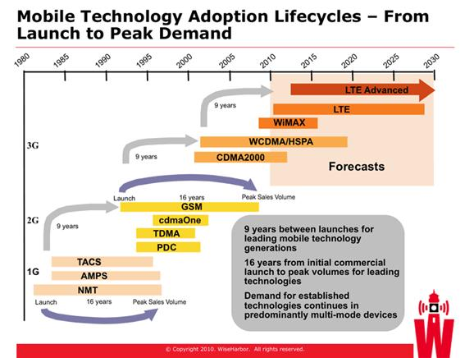

Pioneering cellular technology innovation was undertaken around one generation ahead of widespread implementation. CDMA technologies were developed for cellular by Qualcomm, Motorola and others by the early 1990s, but it was 1999 before these were adopted by ETSI and 3GPP in the UMTS 3G standard with WCDMA. These organisations have defined the cellular technologies for 80% of mobile users worldwide since the mid 1990s. UMTS was gradually introduced by mobile operators over several years. Japan’s NTT DoCoMo was a solitary frontrunner with UMTS from 2001. UMTS was not commercially deployed until 2003 in Europe, until 2005 in the US by AT&T and until 2008 by T-Mobile USA. Prior to the UMTS standard, CDMA technologies in the cdmaOne standard were generally excluded by regulation except in the Americas, Korea and Japan. The oldest CDMA patents expired from around 2010.

Similarly, OFDMA-based technologies for cellular communications were implemented by Flarion in Flash-OFDM and by many others in WiMAX from the mid 2000s, but market demand was niche and commercial performance for suppliers was poor until OFDMA cellular technologies were standardised for LTE by 3GPP with its Release 8 in 2008. The first LTE network was launched at the end of 2009.

Widespread availability and adoption follows as network technologies are rolled out over several years. This is subject to national spectrum licensing and construction cycles that are capital intensive and time consuming. For example, LTE is still not available in the UK. In contrast, blockbuster drugs can be distributed most extensively through well-established product distribution channels once national regulatory approvals are given.
Cost of producing – Gross Profit Margin comparisons
Judge Posner correctly states that “the cost of producing, as distinct from inventing and obtaining approval for selling, a drug tends to be very low, which means that if copying were permitted, drug companies that had not incurred the cost of invention and testing could undercut the price charged by the inventing company yet make a tidy profit, and so the inventing company would never recover its cost.” However, as also illustrated in Figure 2, the gross profit margins of pharmaceutical and software companies are around the same high levels. This is unsurprising given the ease with which software functions or entire programs can be copied. It makes software companies just as vulnerable to undercutting. Low cost copying and counterfeiting—notably in China—is a major problem with various ICT products.

Best of both worlds with SEP licensing
Academic research cited by Professor Hargreaves, and its 2009 re-publication entitled “Sequential innovation, and imitation” by James Bessen and Eric Maskin makes some sweeping statements, including asserting patentees’ unwillingness to collaborate with other innovators, that do not apply in the extensive context of ICT standards that include SEPs. The authors appear oblivious and make no mention of these in their articles. The authors claim that “patents may actually reduce welfare: by blocking innovation”. They assert that “licensing may fail” and so complementary technologies will not be shared among innovators. They lend feeble support to their notion that companies will not collaborate or share by citing a distant example in the oil industry where only 12 out of 3,000 oil fields were completely covered by joint production agreements despite economic and regulatory incentives.

Yet it is precisely those industry sectors and R&D activities under criticism by Professor Hargreaves where ICT SEP patentees provide open and non-discriminatory access to their technologies for other innovators and product manufacturers. Standards setting organisations (SSOs), patent disclosures and conformance testing arrangements enable all-comers to implement technologies most easily. Agreements to license to all on (Fair) Reasonable and Non-Discriminatory terms invariably prevail, despite some well-publicised disputes. In some cases, licensing (e.g., Bluetooth) is overwhelmingly royalty-free through a patent pool. In mobile communications technologies licensing costs are predominantly eliminated through cross-licensing. For example, while 40% market share leader, Nokia stated that “until 2007 it has paid less than 3 percent aggregate license fees on WCDMA handset sales under all its patent license agreements”. While concluding that patent holders cannot make enough in licensing fees to make up for a loss of market share in downstream markets, Bessen and Maskin concede in a footnote that their findings “might change if the firms developed complementary innovations that could be advantageously be cross-licensed.” This is exactly what occurs with SEPs, but they make no further comments.
Licensing SEPs fosters downstream market development and competition, and upstream collaboration by sharing and building upon the fruits of innovation. Video and cellular standards, for example, have been phenomenally successful with billions of users and flourishing supply sectors. Thousands of patents have been declared to ETSI as likely to be essential to 3GPP standards including GSM, UMTS and LTE. Hundreds of companies collaborate in development of these standards. Most develop or manufacture products that implement the standards in downstream markets. Some of these specialise in upstream technology development but do not themselves implement their new technologies in products. They also deserve compensation for their innovation efforts. The thriving mobile phone sector with reducing prices, increasing choice and blossoming smartphone functionality has been described in several of my previous IP Finance postings, including this one from July 2011.

This article also rebuts the discredited Swanson and Baumol ex-ante IP auctioning proposal that Judge Posner cites in his Opinion and Order. By timing SEP auctions after upstream innovators have sunk their enabling technology development costs, but before downstream companies have sunk their product development costs, it would in theory be possible to drive IP prices below upstream innovation costs on a one-off basis. However, in a dynamic marketplace, such loss-making R&D would soon dry up to the detriment of everybody.

In addition (to numerous problems with that particular method of fixing prices) evidence presented in my article shows that consumers are doing rather well amid the efficient status quo in licensing SEPs. With standards of great complexity and involving hundreds or thousands of patents in mobile communications each covering different portions of each standard, it would be very cumbersome to administer IP auctions and there would be all manner of undesirable consequences. Whereas standards-based technologies are selected in a collective process on the basis of technical merit by a wide assortment of companies who generally negotiate licensing terms on a separate bilateral basis, auctions create a high risk of collusion among purchasers and would likely unduly emphasise price over other important factors (such as functionality, features, performance, and even total system cost and price to consumers).

A new world in ICT
The means of innovation has changed significantly over the last 30 years with a revolution in ICT industries. The rise of personal computing, the Internet, mobile communications, globalisation and the demise of national monopolies in telecommunications has increased upstream specialisation in R&D, increased collective efforts in standards-based innovation and increased competition among technologies, standards and companies. Some ICT developments tasks are so extensive and economies of scale in production and distribution are so great that collaboration with voluntary sharing of intellectual property on a widespread basis through licensing has proven indispensible. The patent system has underpinned change and growth as ICT’s global economic share has increased with the advance of personal computing, media and communications including extensive software functionality and technical standardisation.

The patent system is not perfect, but it is not broken and certainly does not require the radical change proposed by Posner and Hargreaves. There are some bad actors by both infringers as well as patentees, as I have also discussed in another of my IP Finance articles, but courts can and do redress imbalances under the existing law. There is no justification to exclude or discriminate against software and other industry sectors, methods of patent licensing or business models. The consequences of any such exclusions or discriminatory changes to the patent system run the high risk of stifling the very innovation that these sectors generate.

2. Sister Act (article extract)
Thursday, 21 July 2011
The FTC’s sister agency, the Federal Communications Commission, provides plentiful evidence that consumers are served very well with diverse choice in suppliers, handset models and with innovative new offerings in smartphones.
The FCC’s fourteenth Annual Commercial Mobile Radio Service (CMRS) Competition Report, published one year ago, ‘examined, for the first time, competition across the entire mobile wireless ecosystem, including an analysis of the “upstream” and “downstream” market segments, such as spectrum, infrastructure, devices, and applications’. The fifteenth report, recently published, “follows the same analytical framework”. In this, it shows how consumer choice in handset devices has increased significantly in recent years. According the FCC’s latest report:
From 2006 to 2010, the number of mobile wireless handset manufacturers that distribute in the U.S. market increased from eight to 21 [see Exhibit 1]. As of June 2010, these 21 handset manufacturers offered a total of 302 handset models to mobile wireless service providers in the United States. Eleven of these handset manufacturers offered at least ten handset models each.
Exhibit 1 Handset Manufacturers and Handset Models Offered, U.S., 2006-2009
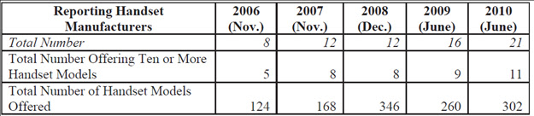
Source: FCC, 2011
On the important matter of innovation, the FCC goes on to state:
Over the past three years handset manufacturers have introduced a growing number of smartphones with the following features: an HTML browser that allows easy access to the Internet, an operating system that provides a standardized interface and platform for application developers, and a larger screen size than a traditional handset. In contrast to traditional handsets with applications that include voice and messaging, smartphones have more user-friendly interfaces that facilitate access to the Internet and software applications. Ten handset manufacturers offered a total of 144 smartphones in June 2010, compared to 56 in June 2009. [Exhibit 2] lists the top five smartphone and handset manufacturers, by number of models offered, that distributed in the United States in June 2010.

Exhibit 2: Smartphone Manufacturers Offering Largest
Number of Smartphone Models (U.S., June 2010)
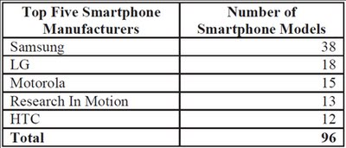
Source: FCC, 2011
The total number of 230.7 million handsets sold in the year to Q2 2010 is quite remarkable, given a US population of 309 million. Exhibit 3 shows quarterly U.S. handset shipments by manufacturer. With subscriber penetration exceeding 100%, the vast majority of Americans already have a phone. Proven consumer desire to keep trading-up, so frequently and extensively with new and additional devices, flies in the face of arguments that IP prices are causing consumer prices to be excessive and not providing value for money with the costs of technology development.

Exhibit 3 U.S. Handset Shipments, Q2 2009 – Q2 2010
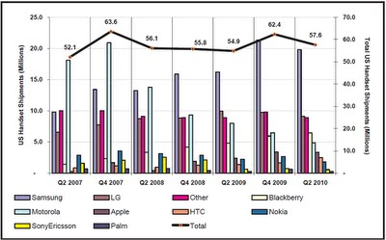
Source: FCC, 2011
What consumers want and how they are able to get it
As indicated in my previous IP Finance postings, essential IP costs are modest in comparison to the total spent by consumers on mobile communications. However, value derived by consumers from these proprietary technologies is enormous. Whereas technology developers only deserve to reap financial rewards on essential IP technologies that are actually selected and used with commercial success downstream, if and when this occurs, it is quite legitimate that financial returns on these alone should be large enough to cover risks and costs of investing in portfolios of developments. Otherwise, such investments will simply dry up because technologists cannot reliably predict the “winners.” Portfolios will include both technologies that succeed and those that fail technically, are not selected for standardization, or fall short commercially in the marketplace with poor overall demand or in face of competition from alternatives. Competitors with a variety of business models including upstream licensors and vertically-integrated manufacturers generate these returns in different ways, including licensing fees and through profits on product sales. Consumers want improving capabilities, quality and value for money in the devices they buy, and they are willing to pay a fair premium for such value".

3. Patent Licensing Fees Modest in Total Cost of Ownership for Cellular
Sunday, 12 June 2011
Patented technology is the lifeblood of today’s advanced mobile handsets, network equipment and operator services. As mobile services become increasingly sophisticated, manufacturing of handsets and network equipment represents a declining share of value compared to investments in innovative mobile technologies and software. There is no inherent maximum value share for the IP created with such investments. Aggregate IP fees are a small proportion of handset costs and are very modest compared to operator service charges. Handset costs as a percentage of total ownership expenditures including operator services are 17% in the US and Canada and 13% in Western Europe.
My previous IP Finance posting showed markets for mobile phones and operator services have flourished with outstanding growth, technological innovation, significant competition and tumbling prices on the basis of (Fair) Reasonable and Non-discriminatory licensing for technologies required to implement mobile communications standards. Despite all these positives, some still complain IP fees are excessive in comparison to other costs. In this article, I evaluate fees paid upstream in technology licensing in comparison to downstream expenditures in supply of handsets and provision of operator services.
Caps to fix IP charges
There are concerted attempts to limit licensing fees in standards-essential IP. For example, downstream equipment manufacturers seek to minimize out-payments for licensing standards-essential IP by promoting aggregate royalty caps. In 2008, Alcatel-Lucent, Ericsson, NEC, NextWave Wireless, Nokia, Nokia Siemens Networks and Sony Ericsson announced their agreement that aggregate royalties for handsets implementing the 3G/4G LTE standard should be capped below 10% of handset prices. Similarly, mobile operators, who in many cases subsidize handset prices to consumers, also seek to limit these licensing fees. A common proposal from several mobile operators is to limit aggregate essential-IP charges by establishing an LTE patent pool. Patent pooling will be the topic of my next IP Finance posting. However, one immediate and obvious observation is that if a patent pool is designed to limit aggregate license fees for the benefit of downstream licensees, then it will be unattractive to upstream licensors that depend on licensing revenue to fund continued investments in R&D and earn a return on prior investments. Also, the major vertically-integrated companies have mostly preferred to enter into bilateral agreements with other vertically-integrated companies in order to be able to negotiate cross-licenses with trade-offs between their business interests and patent portfolios.
Unproven suppositions of licensing excesses by some technology licensors and resulting harm abound by predominant voices downstream and their cheerleaders. For example, an August 2009 contribution to the European Competition Journal by Philippe Chappatte of Slaughter and May argues that:
- There is likely to be an upward spiral of royalty claims for many standards including telecoms standards resulting in higher costs for handsets and other standardised products; and

- Operators will be reluctant to invest in new technologies or upgrade their networks to endorse faster and higher quality networks and the quality and range of services that will be available to consumers may be prejudiced.
Contrary evidence is that handset prices and royalty costs have actually fallen—with handset prices, upon which royalty fees are based, declining 77% on average since 1993—despite the addition of many new technologies and increasing demand for advanced features and functionality.
Estimates for “cumulative royalties” vary widely. In 1998, International Telecommunications Standards User Group (representing some operators and manufacturers) complained to the European Commission that “when GSM handsets first appeared on the marketplace cumulative royalties amounted to as much as 35 percent to 40 percent of the ex-works selling price”. Much lower estimates for the cumulative GSM royalty rate paid, by companies that do not have any patents to trade, include 10-13 percent (IP Law and Business reporting PA Consulting Group estimate, July, 2005). In September 2005, CSFB’s “3G Economics” report estimated cumulative royalties had fallen to single digits and predicted 17.3% cumulative royalties in WCDMA “for those vendors without an IPR position to trade off”. Whereas ABI Research described average WCDMA cumulative royalties of 9.4% in 2007 “a most challenging barrier... ...to the development of more affordable devices”, the market-leading handset manufacturer with 37% share was paying much less: Nokia stated that “until 2007 it has paid less than 3 percent aggregate license fees on WCDMA handset sales under all its patent license agreements”.
In addition, there have been various attempts to determine aggregate fees sought by licensors for new technologies. In 2007, the Next Generation Mobile Network (NGMN) Alliance, an industry group led by mobile operators and including major 4G equipment vendors, established a confidential process for the ex ante disclosure and aggregation of expected licensing fees for a number of upcoming 4G standards including LTE. The process concluded in 2009 and the results are confidential. However, commentators have suggested the individual disclosures of expected licensing fees—which were in several cases accompanied by public disclosures on company websites—produced misleading and unrealistic figures.
Aggregate figures derived are not actual prices paid including cross-licensing and do not reflect other realities in negotiations such as identification of patents that are weak or inapplicable. Patent strengths and “essentiality” were not validated. In 2003, the 3G Patent Platform Partnership (including 19 telecommunications operators and equipment makers) estimated “that several hundred different patents, among several thousand publicly claimed as essential, will actually be determined to be ‘essential patents’ in implementing 3G standards”. Some candidate licensees would rather risk being sued than pay “rack rates” in these circumstances. Licensors prefer to negotiate settlements than litigate and subject their patents to invalidity and non-infringement claims. Vertically-integrated licensors are particularly concerned about their product revenues with the risk of being counter-sued for infringement.
Mobile operators are as eager as ever to invest in new technologies to improve performance and lower total costs. New technology cost savings outweigh licensing fees. For example, while mobile operators spend billions of dollars on spectrum, technological advancements have mitigated this cost with 20-fold spectral efficiency increases and much improved voice encoding since 1G analogue cellular. Operators worldwide are investing extensively in advanced technologies HSPA+ and LTE that have increased network capacity and maximum end-user data speeds 1,000-fold since the introduction of 2G technologies around 1993. In the US, for example, all the major operators (and smaller ones too) claim to have introduced “4G services” over the last couple of years. Operators are also making major investments in associated devices by significantly subsidising end-user prices. With demand for HSPA+ and LTE so strong, IP cost issues can be no more significant than they were with previously and currently successful 2G and 3G technologies.

Increasing value share in software and patents
There is no reason why any arbitrary percentage limit should be imposed on IP costs. It is widely accepted that when one pays, for example, $25 for a hardback or $10 for a paperback book, production costs in printing account for but a small proportion of these figures. Royalties to authors, illustrators and agents as well as costs in distribution, marketing and the publisher’s profit margin account for the vast majority of these prices. Similarly, other IP-intensive products, as illustrated in Exhibit 1, have a significant proportion of costs in the intangibles.

Exhibit 1: Manufactured content value varies substantially by product category
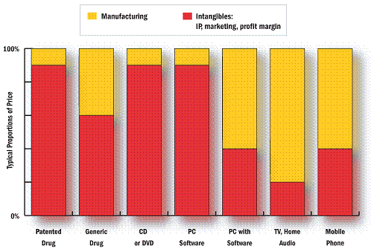
Source: WiseHarbor
I have predicted a marked trend of increasing value with the intangibles in mobile devices—including embedded and aftermarket software predominating over hardware—since Apple’s 2008 3G iPhone launch. The success of the iPhone including its Apps store proves my point. The iPhone leads the smartphone market and has a manufacturing cost around just one third of its $600 average wholesale pricing (before operator subsidies to consumers). Gross profit margins approaching 60% provide a significant return on investments in software, brand and distribution, while Apple largely relies on the essential IP developed and contributed to mobile standards by others.

Handset, network and services-essential IP
Mobile phones are inextricable from the networks and operator services with which they are used: licensing fees should be considered in this broader context. In contrast to technologies that can be used offline, such as in audio and video players, standards-essential IP is implemented end-to-end in handsets and network equipment with the provision of cellular voice and data services. In addition to increased speeds and network capacity, end-to-end innovations include voice encoding, encryption, automatic roaming and location tracking. A handset in isolation from a network cannot make calls or receive data, let alone exploit any of these capabilities. By convention, licensing fees are charged on wholesale mobile phone prices. Whereas this royalty base is simple and convenient to administer in licensing, it overlooks where most ecosystem value is generated—in operator service revenues. In fact, phone prices are commonly subsidised—to substantial extent in many cases—by operators in anticipation of these revenues.
The average service life of a phone from purchase until retirement is around 20 months in the US where postpaid contracts predominate and 34 months in Western Europe where most users have prepaid or SIM-only service with unsubsidised phones. Exhibit 2 shows that during a handset’s service life, consumers spend on average around five or six times more on service fees than they or their operators spend on the handset. Handset costs in the US/Canada and Western Europe represent 17% and 13% respectively of total ownership expenditures including handset costs and operator service charges.

Exhibit 2: Handsets, a small proportion of total ownership expenses
 | US and Canada | Western Europe
Average service revenue per user (per month) | $50 | $32
Service life (in months) | 20 | 34
Total operator services expenditures | $1,001 | $1,087
Average unsubsidised wholesale phone price | $207 | $167
Total lifecycle expenditures | $1,208 | $1,254
Handset cost/total expenditures | 17% | 13%
Source: WiseHarbor, based on 2009 and 2010 market figures
Royalty rates expressed as a percentage of total ownership lifecycle expenses are therefore much lower than rates based on handset prices. Exhibit 3 shows that converting aggregate handset cost-based royalty rates to rates based on total ownership expenditures reduces the rate to 13% and 17% of the rate based on handset costs for Western Europe and US/Canada respectively. More frequent handset upgrades in the US account for most of the differences between the two regions.
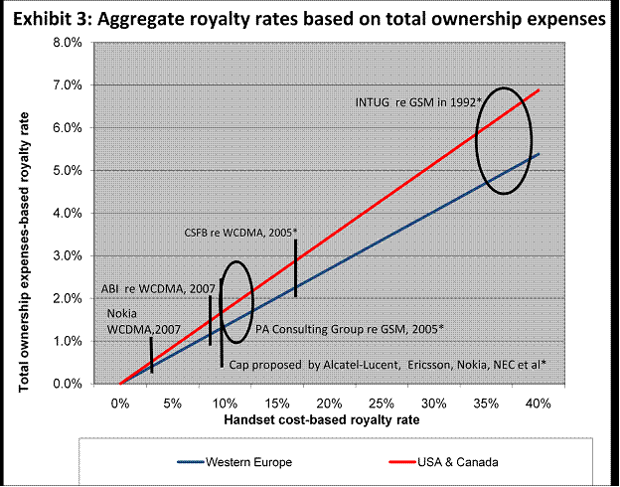
Source: WiseHarbor Research * For companies with no IP to trade

Competitive advantage with IP
It is not the average level of IP charges that affects competition; it is the different rates paid among competitors. Aggregate royalty rates are significantly less than European Union VAT rates that have mostly ranged from 15% to 25% in recent years. Applied uniformly among competitors, taxing phones and services at these VAT rates has not significantly impeded their sales versus nations where consumption taxes on phone sales are much lower.
The asymmetry in licensing costs between manufacturers with IP who can cross-license to minimise their licensing expenditures and manufacturers without essential-IP patents who must pay more is a significant competitive factor. Manufacturers are faced with a business choice: bear the up-front costs and risks of investing in technologies with the aim to cross-license for much of the essential IP required, or pay to license others’ IP. Investing up to several billions of dollars per year in R&D in the hope that some of it will prove effective enough to be accepted in leading mobile standards merits competitive benefits and commercial returns. Nevertheless, latter-day cellular market entrants including Research in Motion, HTC, Apple and others succeeded with little or nothing in the way of essential IP at the outset".

