 |  | International Telecommunication Union
 |  | ITU-T | Technical Paper
 |  | TELECOMMUNICATION  STANDARDIZATION SECTOR  OF ITU |  | (13 December 2013)
SERIES L:
CONSTRUCTION, INSTALLATION AND PROTECTION OF TELECOMMUNICATION CABLES IN PUBLIC NETWORKS
 | Validation test of a data centre cooling method using renewable energy in a cold region

Summary
This Technical Paper refers to the Best Practices defined in Recommendation ITU-T L.1300. More precisely, this Technical Paper firstly provides a background, purpose, and overview of the validation test of a data centre cooling method using renewable energy. Then, test results of such a cooling method are reported together with predictions of future yearly energy consumption.
Keywords
Best practice, data centre, energy efficient, information and communication technology and climate change (ICT & CC).

Change Log
This document contains Version 1 of the ITU-T Technical Paper on “Validation test of a data centre cooling method using renewable energy in a cold region” approved at the ITU-T Study Group 5 meeting held in Lima, 2-13 December 2013.

Editor: | Gianluca Griffa  Telecom Italia  Italy | Tel: +39 331 600 1341  Email: gianluca.griffa@telecomitalia.it

Contents
Page
1 Scope 4
2 Definitions 4
3 Abbreviations 4
4 Background and purpose of the test 4
5 Overview of the test 5
5.1 Specifications of the test facility 5
5.2 Overview of the air conditioning system 5
5.3 Measurement items 6
6 Test results 8
6.1 Outdoor air cooling test results 8
6.2 Snow and ice cooling test results 11
7 Prediction of annual energy consumption 14
7.1 Annual energy consumption estimation method 14
7.2 Estimation of annual energy consumption of the test facility 16
7.3 Calculation of energy consumption of the model data centre 17
8 Conclusion 22
References and Bibliography 24

List of Tables
Page
Table 1 – Specifications of air conditioning equipment 8
Table 2 – 10-day power consumption 14
Table 3 – Estimate time during which outdoor air cooling can be done in Sapporo 15
Table 4 – Operation time of each air conditioning method 16
Table 5 – Specifications of the air conditioning system 16
Table 6 – Calculated annual power consumption of the test facility 17
Table 7 – Calculated annual power consumption of the 1000-rack model data centre 18
Table 8 – Calculated annual electricity charges for the 1000-rack model data centre 19
Table 9 – Estimated volumes of snow required for snow and ice cooling of the 1000-rack model data centre 20
Table 10 – Estimated annual PUE of the 1000-rack model data centre 21
Table 11 – Carbon dioxide emissions due to air conditioning of the 1000-rack model data centre 22

List of Figures
Page
Figure 1 – Layout of the test facility 5
Figure 2 – Image of each cooling mode 6
Figure 3 – Air conditioning heat source diagram and measurement points 7
Figure 4 – Outdoor air temperature and absolute humidity 9
Figure 5 – Air (SA, RA, OA) temperature and heat energy 9
Figure 6 – Air temperature and airflow rate 10
Figure 7 – Absolute humidity of air and the humidification rate 10
Figure 8 – Power consumption of servers and air conditioning equipment 11
Figure 9 – Chilled water flow rate in snow and ice cooling 12
Figure 10 – Air temperature in snow and ice cooling 12
Figure 11 – Relative humidity of air and the humidification rate 13
Figure 12 – Air temperature in snow and ice cooling 13
Figure 13 – Power consumption of servers and air conditioning equipment (snow and ice cooling) 14
Figure 14 – Psychometric chart: Sapporo weather data 15
Figure 15 – Calculated annual power consumption of the test facility 17
Figure 16 – 1000-rack model data centre 18
Figure 17 – Calculated annual power consumption of the 1000-rack model data centre 19

ITU-T Technical Paper
Validation test of a data centre cooling method using renewable energy in a cold region
Summary
This Technical Paper describes validation test of a data centre cooling method using renewable energy in a cold region based on Recommendation ITU-T L.1300.
Keywords
Best practice, data centre, energy efficient, information and communication technology and climate change (ICT & CC).

1 Scope
This Technical Paper describes validation test of a data centre cooling method using renewable energy in a cold region based on Recommendation ITU-T L.1300. The scope of this Technical Paper include:
– a background, purpose, and overview of the validation test of a data centre cooling method using renewable energy;
– test result of a data centre cooling method using renewable energy; and
– prediction of annual energy consumption.

2 Definitions
This Technical Paper uses the following terms:
None.

3 Abbreviations
AHU Air Handling Unit
CDP Cooling Water Pump
CT Cooling Tower
OA Outdoor Air
PUE Power Usage Effectiveness
RA Return Air
SA Supply Air

4 Background and purpose of the test
The test was conducted by the Ministry of Internal Affairs and Communications of Japan in the fiscal year 2009, as part of a promotion project for the realization of a low-carbon society utilizing ICT. The purpose of the test is to verify the usefulness of outdoor air cooling, and snow and ice cooling, to make effective use of the characteristics of cold regions in order to reduce power consumption for data centre cooling.

5 Overview of the test

5.1 Specifications of the test facility
Figure 1 shows the layout of the test facility. In the "server room," a cold aisle was formed by a total of six racks consisting of two 3-rack rows placed face-to-face. The server room was surrounded by panelling and provided with floor supply air conditioning. Simulated servers, with built-in heaters with a total power rating of 24 kW, were installed in the server room.
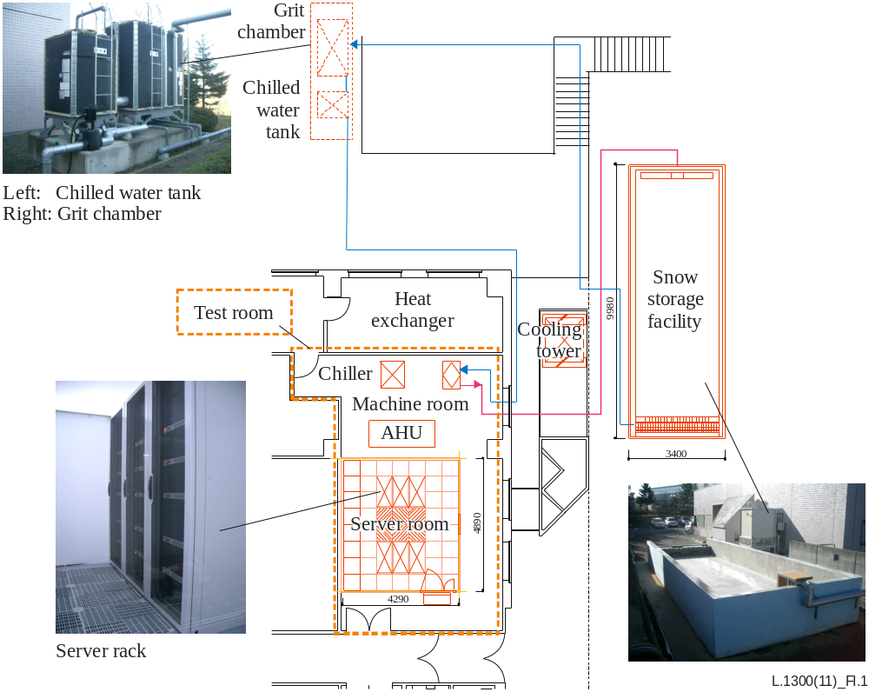
Figure 1 – Layout of the test facility

5.2 Overview of the air conditioning system
In the test, air conditioning conditions were adjusted so as to keep supply air temperature (SA) at 18°C ±2°C, return air temperature (RA) at 24°C ±2°C and return air humidity at 45% ±10%.
The air conditioning system has the three modes described below. Figure 2 illustrates each air conditioning mode.
(1) Conventional air conditioning (Mode 1: ordinary heat source).
(2) Outdoor air cooling (Mode 2: OA and RA are mixed together by AHU, and the mixed air is humidified to achieve the target SA temperature and humidity).
(3) Snow and ice cooling (Mode 3: water, for which the temperature has been raised by heat exchange, is sent to the snow storage facility, and the water chilled by snow is stored in the chilled water tank. Then, chilled water to be sent to AHU's snow and ice cooling coils is chilled down by the heat exchanger, and the SA temperature is kept constant by controlling the flow rate of chilled water to be sent to the coils by means of a three-way valve).
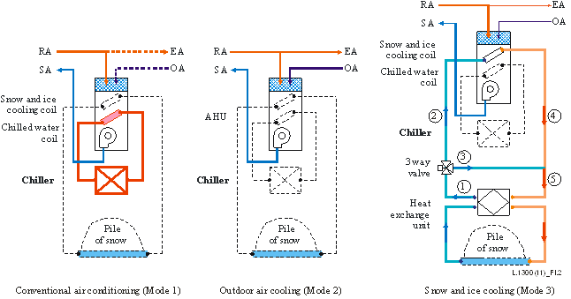
Figure 2 – Image of each cooling mode

5.3 Measurement items
The following items were measured:
(1) Temperature of chilled water and cooling water [°C].
(2) Flow rate of chilled water and cooling water [L/min].
(3) Temperature and humidity of supply and return air [°C, %].
(4) Airflow rate (duct air velocity) [m³/h].
(5) Power consumption of equipment [kW].
Figure 3 shows the air conditioning heat source diagram and measuring points. Table 1 shows the specifications of the air conditioning equipment.
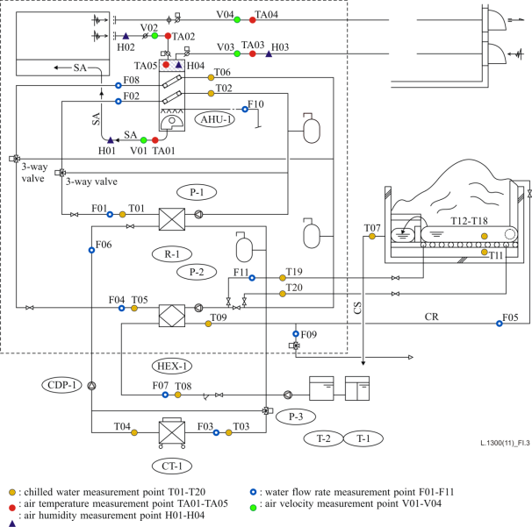
Figure 3 – Air conditioning heat source diagram and measurement points
Table 1 – Specifications of air conditioning equipment
No. | Name
AHU-1 | Air handling unit
CDP-1 | Cooling water pump (for chiller)
CT-1 | Water cooling tower
HEX-1 | Heat exchanger (for snow cooling)
P-1 | Chilled water pump (for chilled water)
P-2 | Chilled water pump (for chilled water for snow cooling)
P-3 | Chilled water pump (for snow cooling tank circulation)
R-1 | Water chilling unit
T-1 | Settling tank (for snow cooling)
T-2 | Chilled water tank (for snow cooling)

6 Test results

6.1 Outdoor air cooling test results
Figure I.4 shows the outdoor air temperature. Figure 5 shows the air temperature and air conditioning heat load. The air conditioning heat load was calculated as follows:
Air conditioning heat load [W]= Q [m³/h] × (T-SA [°C] − T-RA [°C]) × 1.2 [kg/m³] × 1.006 [kJ/kg·°C]/3.6
where
Q: airflow rate [m³/h]
T-SA : supply air temperature [°C]
T-RA : return air temperature [°C]
Outdoor air temperature fluctuated between 0 and 8°C. The SA temperature was around 18°C, and the RA temperature was 25 to 26°C. Thus, the SA and RA temperatures were kept within their target ranges. These results indicate that air temperature can be controlled to stay within the specified range by damper operation without relying on heat source (chiller) operation.
The air conditioning heat load was overestimated (33.6 kW) compared with the amount of heat generated by the servers (24 kW). The reason for this is thought to be that air velocity measurement is prone to error, and measurements tended to be too large in the test.
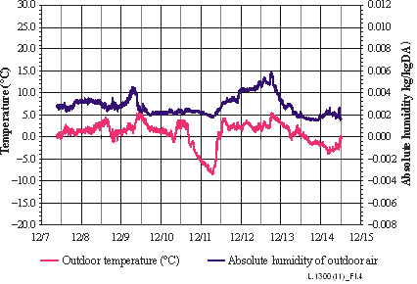
Figure 4 – Outdoor air temperature and absolute humidity

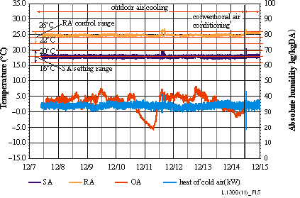
Figure 5 – Air (SA, RA, OA) temperature and heat energy
To evaluate the state of outdoor air cooling operation, Figure 6 shows changes in air temperature and airflow rate during a particular period. As shown, as outdoor air temperature falls, the RA flow rate increases, and the SA temperature is kept constant by changing the RA/OA ratio.
Figure 7 shows absolute humidity and the humidification rate during the same period. The absolute humidity of outdoor air was as low as about 0.002 kg/kgDA. By mixing outdoor air with the RA, however, absolute temperature rose to about 0.007 kg/kgDA and, through further humidification, reached about 0.008 kg/kgDA. This has shown that the required humidification rate is now high if OA and RA are mixed together.
Figure 8 shows the power consumption of the servers and the air conditioning equipment. The power consumption of a server rack averaged 24.0 kWh. The power consumption required to lower the temperature of the servers was 2.4 kWh during outdoor air cooling and 16.1 kWh during conventional air conditioning. This is because outdoor air cooling requires only AHU's built-in fans. Thus, it has been shown that outdoor air cooling is highly energy efficient.
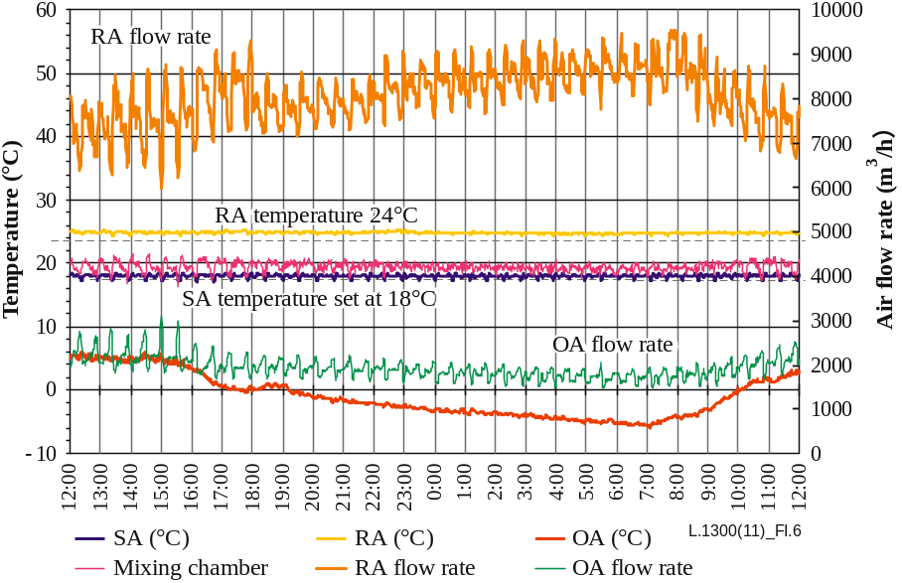
Figure 6 – Air temperature and airflow rate
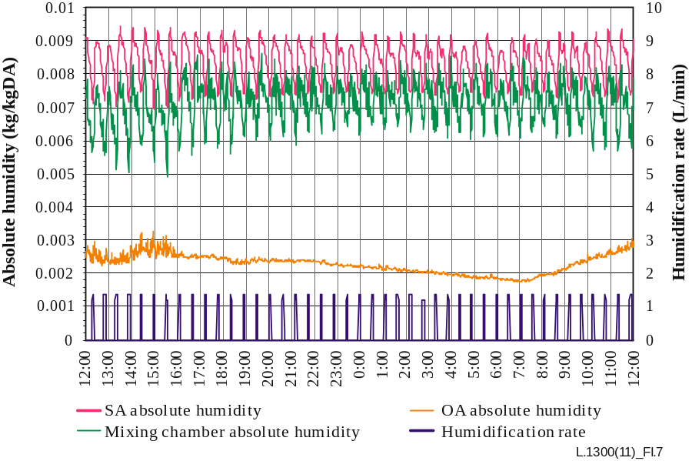
Figure 7 – Absolute humidity of air and the humidification rate
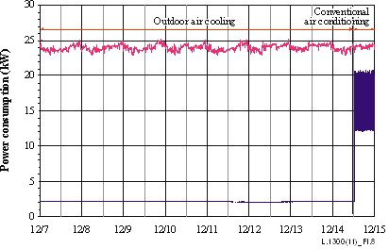
Figure 8 – Power consumption of servers and air conditioning equipment

6.2 Snow and ice cooling test results
Figure 9 shows the chilled water flow rate and the air conditioning heat load in the case where snowmelt water is used. Figure I.10 shows air temperature during snow and ice cooling. The air conditioning heat load is calculated as follows:
Air conditioning heat load [W] = V [L/min] × (AHU return water temperature [°C] − AHU supply water temperature [°C]) × 4 200 [kJ/m³·°C] × 60/3.6/1000
where
V: chilled water flow rate [L/min]
The amount of heat load removed was about 25 to 27 kW, which was sufficiently large. As shown in Figure 10, the SA temperature was kept constant at about 18°C. This indicates that the flow rate at the snow and ice cooling coil inlet was effectively controlled by a three-way valve.
Figure 11 shows the relative humidity of air and the humidification rate. Relative humidity fluctuated between 38 and 45%, and the amplitude of fluctuation remained constant and stayed within the target range.
To evaluate the state of snow and ice cooling operation, Figure 12 shows the temperature of air and the temperature of chilled water used for snow and ice cooling during a particular period. The temperature difference between the water supplied to and the water returned from the snow storage facility was about 5°C; more or less kept constant regardless of temperature fluctuations. In the test, as the temperature of chilled water from the pile of snow rose, the flow rate at the snow and ice cooling coil inlet increased under the control of the three-way valve so that temperature rose and the amount of heat required was kept constant.
Figure 13 shows the power consumption of the servers and the air conditioning equipment. The power consumption of a server rack averaged 23.9 kWh, and the power consumption for snow and ice cooling averaged 5.5 kWh. The power consumption for air conditioning was small because no heat source was used, indicating high energy efficiency.
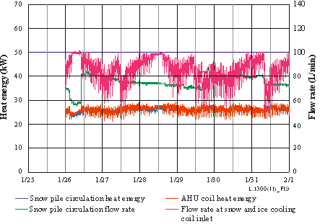
Figure 9 – Chilled water flow rate in snow and ice cooling
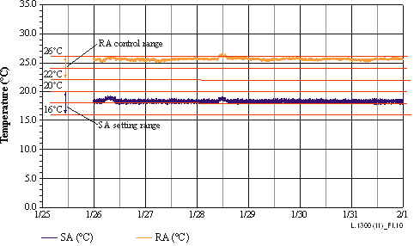
Figure 10 – Air temperature in snow and ice cooling
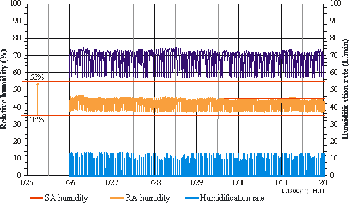
Figure 11 – Relative humidity of air and the humidification rate
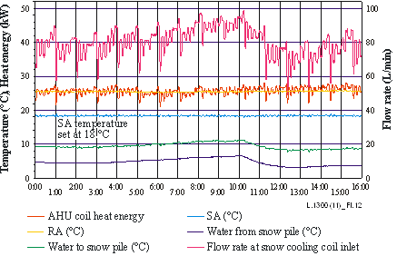
Figure 12 – Air temperature in snow and ice cooling
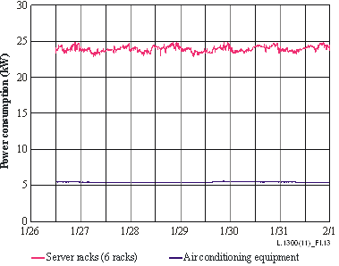
Figure 13 – Power consumption of servers and air conditioning
equipment (snow and ice cooling)
Table 2 shows the 10-day power consumption for outdoor air cooling and snow and ice cooling. The percentage reduction from the power consumption for conventional air conditioning is 85.3% for outdoor air cooling and 68.7% for snow and ice cooling, both of which are significantly high.
Table 2 – 10-day power consumption
 | Power consumption （kWh）
 | Outdoor air cooling | Conventional air conditioning | Percentage reduction（％）
Outdoor air cooling period | 566.4 | 3864 | 85.3
 | Snow and ice cooling | Conventional air conditioning | Percentage reduction（％）
Snow and ice cooling period | 1308 | 4176 | 68.7

7 Prediction of annual energy consumption

7.1 Annual energy consumption estimation method
Figure 14 shows a psychometric chart showing plots of Sapporo weather data used to predict annual energy consumption.
The test results have confirmed that outdoor air cooling is feasible even in midwinter. It is thought that the period during which outdoor air cooling can be done is determined by the ranges of temperature and humidity in which the supply air temperature can be controlled so that it is kept within the target range.
Table 3 shows the estimated time during which outdoor air cooling can be done. Under the conditions assumed in this study, outdoor air cooling can be done during 6 267 hours (71.6%) out of the annual total of 8 760 hours.
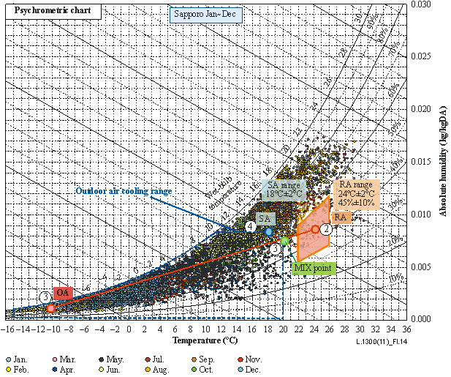
Figure 14 – Psychometric chart: Sapporo weather data
Table 3 – Estimate time during which outdoor air cooling can be done in Sapporo
 | Jan | Feb | Mar | Apr | May | Jun | Jul | Aug | Sep | Oct | Nov | Dec | Total
Time (h) | 744 | 672 | 744 | 720 | 744 | 720 | 744 | 744 | 720 | 744 | 720 | 744 | 8 760
Time during which outdoor air cooling can be done (h) | 744 | 672 | 744 | 701 | 718 | 384 | 11 | 31 | 177 | 628 | 720 | 744 | 6 274
Percentage（％） | 100.0 | 100.0 | 100.0 | 97.4 | 96.5 | 53.3 | 1.5 | 4.2 | 24.6 | 84.4 | 100.0 | 100.0 | 71.6
Energy consumption during the rest of the year is calculated for a total of six cases (shown below), involving different combinations of the following conditions: snow and ice cooling 75%, 50% and 25% and conventional air conditioning. It is assumed that conventional air conditioning is used during the periods other than the periods during which outdoor air cooling or snow and ice cooling is used. It is also assumed that snow and ice cooling is used, wherever possible, early during the period in which a large amount of snow is available. Table 4 shows the amount of time each air conditioning method is used, as the basis for the calculation of annual energy consumption.
Table 4 – Operation time of each air conditioning method
 | Outdoor air cooling  (h) | Snow and ice cooling  (h) | Conventional air conditioning  (h)
Pattern 1: outdoor air cooling + snow cooling | 6274 | 2486 | 0
Pattern 2: outdoor air cooling + snow cooling 75% + conventional air conditioning 25% | 6274 | 1865 | 621
Pattern 3: outdoor air cooling + snow cooling 50% + conventional air conditioning 50% | 6274 | 1243 | 1 243
Pattern 4: outdoor air cooling + snow cooling 25% + conventional air conditioning 75% | 6274 | 621 | 1 865
Pattern 5: outdoor air cooling + conventional air conditioning | 6274 | 0 | 2 486
Pattern 6: conventional air conditioning | 0 | 0 | 8 760

7.2 Estimation of annual energy consumption of the test facility
Table 5 shows the specifications of the air conditioning system of the test facility. Power consumption is calculated by multiplying the test result (average value) per equipment by the time (hours) during which snow and ice cooling is feasible.
Table 5 – Specifications of the air conditioning system
Element | Test room
number of rack | 6
capacity | 4 kW/rack
heat value | 24 kW
Heat source | Cooling capacity | Power consumption | Number
water-cooled chiller | 24.0 kW | 9.5 kW | 1
Auxiliary machine | Cooling capacity | Power consumption | Number
cooling tower | 24 kW | 2.1 kW | 1
cooling water pump | 142 L/min | 2.2 kW | 1
chilled water pump | 115 L/min | 2.1 kW | 1
AHU | Cooling capacity | Power consumption | Number
airflow rate | 12 000 m³/h | 2.2 kW | 1

Table 6 – Calculated annual power consumption of the test facility
 | Outdoor air cooling  kWh/year | Snow cooling  kWh/year | Conventional AC  kWh/year | Total power consumption  kWh/year | Percentage of reduction  %
Pattern 1: outdoor air cooling + snow cooling | 13 800 | 13 670 | 0 | 27 470 | 83
Pattern 2: outdoor air cooling + snow cooling 75% + conventional air conditioning 25% | 13 800 | 10 260 | 11 240 | 35 300 | 78
Pattern 3: outdoor air cooling + snow cooling 50% + conventional air conditioning 50% | 13 800 | 6 840 | 22 498 | 43 138 | 73
Pattern 4: outdoor air cooling + snow cooling 25% + conventional air conditioning 75% | 13 800 | 3 420 | 33 757 | 50 977 | 68
Pattern 5: outdoor air cooling + conventional air conditioning | 13 800 | 0 | 44 997 | 58 797 | 63
Pattern 6: conventional air conditioning | 0 | 0 | 158 556 | 158 556 | 0
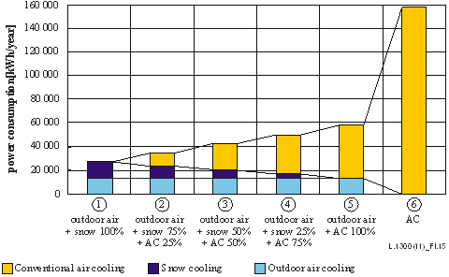
Figure 15 – Calculated annual power consumption of the test facility

7.3 Calculation of energy consumption of the model data centre
(1) Preparation of a 4 kW-per-rack 1000-rack model
Figure 16 illustrates a 1000-rack data centre and the schematic diagram of the air conditioning system. Basically, the air conditioning system shown in Figure 16 is based on the same principle as that of the air conditioning system used in the test.
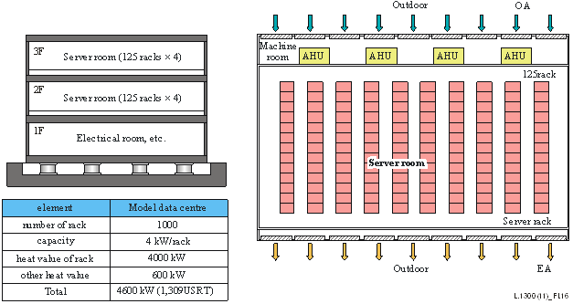
Figure 16 – 1000-rack model data centre
(2) Estimation of energy consumption by air conditioning pattern
Table 7 and Figure 17 show the calculated annual power consumptions of the 1000-rack model data centre. As shown, the percentages of reduction of annual power consumption are smaller than those for the test facility. One reason for this is that both supply and exhaust of air are taken into consideration in order to balance the indoor and outdoor pressures when taking in outdoor air. Another reason is that the efficiency of chiller operation has improved, and power consumption for conventional air conditioning has decreased, so that the percentage of reduction has decreased in relative terms.
Table 7 – Calculated annual power consumption of the 1000-rack model data centre
 | Outdoor air cooling  kWh/year | Snow cooling  kWh/year | Conventional AC  kWh/year | Total power consumption  kWh/year | Percentage of reduction  %
Pattern 1: outdoor air cooling + snow cooling | 4 972 100 | 2 372 900 | 0 | 7 345 000 | 44.5
Pattern 2: outdoor air cooling + snow cooling 75% + conventional air conditioning 25% | 4 972 100 | 1 780 100 | 982 100 | 7 734 300 | 41.6
Pattern 3: outdoor air cooling + snow cooling 50% + conventional air conditioning 50% | 4 972 100 | 1 186 400 | 1 986 000 | 8 144 500 | 38.5
Pattern 4: outdoor air cooling + snow cooling 25% + conventional air conditioning 75% | 4 972 100 | 592 700 | 2 984 500 | 8 549 300 | 35.5
Pattern 5: outdoor air cooling + conventional air conditioning | 4 972 100 | 0 | 3 971 400 | 8 943 500 | 32.5
Pattern 6: conventional air conditioning | 0 | 0 | 13 244 700 | 13 244 700 | 0.0

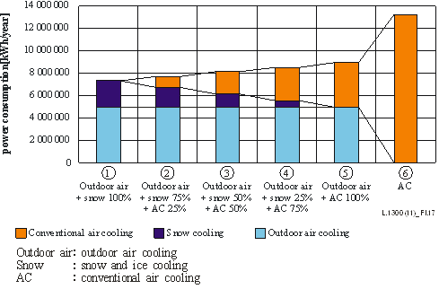
Figure 17 – Calculated annual power consumption of the 1000-rack model data centre
(3) Calculation of running costs
The running cost of the air conditioning system was calculated by using the electricity charge in Hokkaido. Table 8 shows the calculation results. The effect of power consumption reduction is relatively small because of the basic charge.
Table 8 – Calculated annual electricity charges for the 1000-rack model data centre
 | Electric power charge（1 kW=9.77 yen） | Electric power base charge  yen/year | Total cost  yen | Reduction of electric power cost  yen
Pattern 1: outdoor air cooling + snow cooling | 71 760 700 | 21 768 300 | 93 529 000 | 74 076 200
Pattern 2: outdoor air cooling + snow cooling 75% + conventional air conditioning 25% | 75 564 100 | 36 857 500 | 112 421 600 | 55 183 600
Pattern 3: outdoor air cooling + snow cooling 50% + conventional air conditioning 50% | 79 571 800 | 38 204 500 | 117 776 300 | 49 828 900
Pattern 4: outdoor air cooling + snow cooling 25% + conventional air conditioning 75% | 83 526 700 | 38 204 500 | 121 731 200 | 45 874 000
Pattern 5: outdoor air cooling + conventional air conditioning | 87 378 000 | 38 204 500 | 125 582 500 | 42 022 700
Pattern 6: conventional air conditioning | 129 400 700 | 38 204 500 | 167 605 200 | 0
Table 9 shows estimated volumes of snow required for snow and ice cooling calculated by assuming a remaining snow percentage of 70%. A 20 metre high pile of snow, in the shape of a 45-degree frustum, served as the basis of the calculation for the area of the snow storage facility.
The required size of the snow pile is calculated according to the snow and ice cooling period assumed. The required volume of snow is calculated as follows:
Required volume of snow (m³) = Cooling load (kW) × Snow and ice cooling period (h) ÷ Amount of heat available for snow and ice cooling (kWh/kg) ÷ Density of snow (kg/m³)
where the amount of heat available for snow and ice cooling is 0.1 kWh/kg and the density of snow is 500 kg/m³.
Table 9 – Estimated volumes of snow required for snow
and ice cooling of the 1000-rack model data centre
(Remaining snow percentage: 70%)
 | Required snow volume  m³ | Snow pile volume  m³ | Snow storage area  m² | Width  m | Depth  m
Pattern 1: outdoor air cooling + snow cooling | 228 700 | 326 700 | 21 693 | 147 | 147
Pattern 2: outdoor air cooling + snow cooling 75% + conventional air conditioning 25% | 171 600 | 245 100 | 16 900 | 130 | 130
Pattern 3: outdoor air cooling + snow cooling 50% + conventional air conditioning 50% | 114 400 | 163 400 | 12 022 | 110 | 110
Pattern 4: outdoor air cooling + snow cooling 25% + conventional air conditioning 75% | 57 100 | 81 600 | 6 860 | 83 | 83
(5) Evaluation in terms of PUE
For the purpose of evaluating the effect of outdoor air cooling, and snow and ice cooling, on PUE (power usage effectiveness), an advanced 1000-rack data centre is assumed. To calculate the power consumption of equipment other than the ICT and air conditioning equipment, it is assumed that power supply facilities, and other facilities, account for 9% and 1% respectively, of the total power consumption. The power consumption of the ICT equipment is calculated as 4 000 kW × 8 760 hours = 35 040 000 kW. Table I.10 shows the PUE calculation results.
Table 10 – Estimated annual PUE of the 1000-rack model data centre
 | IT equipment  kWh/year | Cooling  kWh/year | Power-supply  kWh/year | Other equipment  kWh/year | Total  kWh/year | PUE
Pattern 1: outdoor air cooling + snow cooling | 35 040 000 | 7 345 000 | 4 829 400 | 536 600 | 47 751 000 | 1.36
Pattern 2: outdoor air cooling + snow cooling 75% + conventional air conditioning 25% | 35 040 000 | 7 734 300 | 4 829 400 | 536 600 | 48 140 300 | 1.37
Pattern 3: outdoor air cooling + snow cooling 50% + conventional air conditioning 50% | 35 040 000 | 8 144 500 | 4 829 400 | 536 600 | 48 550 500 | 1.39
Pattern 4: outdoor air cooling + snow cooling 25% + conventional air conditioning 75% | 35 040 000 | 8 549 300 | 4 829 400 | 536 600 | 48 955 300 | 1.40
Pattern 5: outdoor air cooling + conventional air conditioning | 35 040 000 | 8 943 500 | 4 829 400 | 536 600 | 49 349 500 | 1.41
Pattern 6: conventional air conditioning | 35 040 000 | 13 244 700 | 4 829 400 | 536 600 | 53 650 700 | 1.53
Percentage of electric power consumed(％) | 65.3 | 24.7 | 9.0 | 1.0 | 100 | –
Table 11 shows annual carbon dioxide emissions due to air conditioning operation. As shown, when compared with Pattern 6 (conventional air conditioning), Pattern 1 (outdoor air cooling + snow and ice cooling) enables a reduction of about 3 500 t-CO₂/year.
Table 11 – Carbon dioxide emissions due to air conditioning of the
1000-rack model data centre
 | Total power consumption  kWh/year | Carbon dioxide emission rate  t-CO2/year | Percentage of  reduction  %
Pattern 1: outdoor air cooling + snow cooling | 7 345 000 | 4318.9 | 44.5
Pattern 2: outdoor air cooling + snow cooling 75% + conventional air conditioning 25% | 7 734 300 | 4547.8 | 41.6
Pattern 3: outdoor air cooling + snow cooling 50% + conventional air conditioning 50% | 8 144 500 | 4789.0 | 38.5
Pattern 4: outdoor air cooling + snow cooling 25% + conventional air conditioning 75% | 8 549 300 | 5027.0 | 35.5
Pattern 5: outdoor air cooling + conventional air conditioning | 8 943 500 | 5258.8 | 32.5
Pattern 6: conventional air conditioning | 13 244 700 | 7787.9 | 0.0

8 Conclusion
The verification test has yielded the following findings concerning the air conditioning methods that make effective use of the characteristics of a cold region:
(1) In outdoor air cooling, indoor supply air temperature can be controlled to a target level by appropriately adjusting the damper opening of the OA and RA ducts.
(2) Humidification during outdoor air cooling can be controlled with vaporizing humidifiers because the humidification of introduced outdoor air is done at the point where the outdoor air is mixed with indoor return air.
(3) Concerning snow and ice cooling, the temperature of snowmelt water obtainable from the snow pile turned out to be about 5°C, and the required amount of heat was made available through heat exchangers. Even if the temperature of melt water changes under the influence of water paths or cavities, the rate of chilled water flow to the coils is adjusted according to such changes, and a constant amount of heat is made available.
(4) In the test, the power consumption during outdoor air cooling, snow and ice cooling and conventional air conditioning, were about 2.4 kWh, 5.5 kWh and 17.4 kWh respectively. Thus, it has been verified that outdoor air cooling and snow and ice cooling are much more energy efficient than conventional air conditioning.
(5) When conventional air conditioning is not used, power consumption for the air conditioning of the 1000-rack data centre can be reduced by about 45% by using outdoor air cooling and snow and ice cooling. It can therefore be said that in cold regions, the method of using outdoor air and snow and ice for air conditioning will greatly contribute to air conditioning energy reduction, which has been a difficult to solve problem.
(6) The power usage effectiveness (PUE) evaluation of the 1000-rack data centre has shown that the use of outdoor air cooling and snow and ice cooling may make it possible to improve the PUE to 1.36, which is better than the PUE (1.53) that can be achieved by conventional air conditioning.
(7) The test and the annual power consumption estimation have confirmed that the air conditioning system utilizing outdoor air and snow and ice in a cold region is highly energy efficient. This result indicates that in non-cold regions, also, energy efficiency can be improved by using similar methods if outdoor air conditions are met.
References and Bibliography
[ITU-T L.1300] Recommendation ITU-T L.1300 (2011), Best practices for green data centres.

_________________

