 |  | International Telecommunication Union
 |  | ITU-T | Technical Paper
 |  | TELECOMMUNICATION  STANDARDIZATION SECTOR  OF ITU |  | (6 November 2009)
SERIES G: TRANSMISSION SYSTEMS AND MEDIA, DIGITAL SYSTEMS AND NETWORKS
Digital sections and digital line system – Access networks

GSTP-G7291
Performance of ITU-T G.729.1

Summary
This technical paper compiles performance assessment of Recommendation ITU-T G.729.1. Information on algorithmic complexity, memory requirements and algorithmic delay are collected. The quality performance assessment reported during various standardization phases of G.729.1 and its Annexes are also gathered. Thus, it reports the quality performance assessment from both steps of the Characterization phase of G.729.1 main body and from the characterization phase of G.729.1 Annex C. The verification results for the floating-point implementations of G.729.1 main body and of its Annex C (G.729.1 Annex B and G.729.1 Annex D) are also given.

Change Log
This document contains Version 1 of the ITU-T Technical Paper on “Performance of ITU-T G.729.1”, which was approved on 6 November 2009 at the ITU-T Study Group 16 meeting held in Geneva, 26 October - 6 November 2009.

Editors: | Mr Balazs Kovesi  France Telecom Orange  France | Tel: +33 2 96 05 22 89  Fax: +33 2 96 05 35 30  Email: balazs.kovesi@orange-ftgroup.com
 | Mr Eyal Shlomot  Huawei Technologies  China | Tel: +1 562 856 8602  Email: eshlomot@gmail.com

Contents
Page
1 Scope 1
2 References 1
3 Definitions 2
4 Abbreviations and acronyms 2
5 History of G.729.1 3
6 Scope of the Codec 3
7 Algorithm overview 4
7.1 G.729.1 main body algorithm overview 4
7.2 G.729.1 DTX/CNG algorithm overview 4
8 Codec Complexity and Memory 5
9 Codec Algorithmic Delay 6
10 G.729.1 main body characterization phase step 1 6
10.1 Quality performance assessment 6
10.1.1 Formal subjective test results 8
10.1.2 Quality performance assessment with objective test methodology 13
10.1.3 Quality performance assessment with informal listening test 14
10.2 Codec frequency response 14
10.3 Achieved requirements and objectives 17
11 G.729.1 main body characterization phase step 2 20
12 G.729.1 Annex B: Floating point implementation 27
12.1 Methodology 27
12.2 Quality assessment organization 27
12.2.1 Results for narrowband case 28
12.2.2 Results for wideband case 31
13 G.729.1 Annex C (DTX/CNG) characterization phase 36
13.1 G.729.1 DTX/CNG efficiency 36
13.2 Quality Performance assessment 37
13.2.1 Formal subjective test results 38
13.2.2 Informal subjective test results 39
13.2.3 Achieved requirements and objectives 40
14 G.729.1 Annex D: Floating point implementation 40
14.1 Methodology 40
14.2 Objective test results 40

List of Tables
Table 1: Algorithm overview 4
Table 2: SID bit allocation (per 20 ms superframe) 5
Table 3: G.729.1 codec complexity and memory consumption (main body) 5
Table 4: G.729.1 codec complexity and memory consumption (DTX/CNG) 6
Table 5: G.729.1 algorithmic delay 6
Table 6: Overview of the quality assessment tests in characterization phase step 1 Subjective experiments 7
Table 7: Overview of the quality assessment tests in characterization phase step 1 Objective experiment 7
Table 8: Overview of the quality assessment tests in characterization phase step 1 Informal subjective experiment 7
Table 9 - Experiment processing and cross-check allocation in characterization phase step 1 8
Table 10 - Subjective Experiments Languages and allocation in characterization phase step 1 8
Table 11: G.729.1 Quality Requirements in Narrowband conditions 18
Table 12: G.729.1 Quality Requirements in Wideband conditions 18
Table 13: G.729.1 Quality Objectives in Narrowband conditions 20
Table 14: G.729.1 Quality Objectives in Wideband conditions 20
Table 15: Overview of the quality assessment tests in characterization phase step 2 21
Table 16: Experiment processing and cross-check allocation in characterization phase step 2 21
Table 17: Subjective Experiments Languages and allocation in characterization phase step 2 21
Table 18: Comparison of G.729.1 low delay modes at 8 kbit/s and 12 kbit/s in FER (NB clean speech) with G.729A and G.729 E (Step 2 Exp#1) 24
Table 19: Comparison of G.729.1 default and low delay modes at 8 kbit/s and 12 kbit/s for narrowband clean speech in FER (Step 2 Exp#1) 25
Table 20: Comparison of G.729.1 default and low delay modes at 14 kbit/s for clean wideband speech in FER (Step 2 Exp#2) 25
Table 21: Comparison of G.729.1 at 14 kbit/s with G.722.2 for various input levels and wideband clean speech (Step 2 Exp#2) 25
Table 22: Comparison of G.729.1 at 14 kbit/s with G.722.2 for clean wideband speech in FER (Step 2 Exp. 2) 26
Table 23: Comparison of G.729.1 at 24 & 32 kbit/s with G.722.1 and G.722.2 for clean wideband speech in FER (Step 2 Exp. 2) 26
Table 24: Comparison of G.729.1 at 24 & 32 kbit/s with G.722 for wideband music (Step 2 Exp. 3) 26
Table 25: Comparison of G.729.1 at 24 & 32 kbit/s with G.722.1 & G.722.2 for wideband music (Step 2 Exp. 3) 27
Table 26: Lab and languages in G.729 Annex B verification phase 27
Table 27: Lab F objective scores for clean speech narrowband conditions (Experiment 1a Step 1 & Experiment 1 Step 2) 28
Table 28: Lab K objective scores for clean speech narrowband conditions (Experiment 1a Step 1 & Experiment 1 Step 2) 28
Table 29: Lab J objective scores for clean speech narrowband conditions (Experiment 1a Step 1 & Experiment 1 Step 2) 29
Table 30: Lab E objective scores for clean speech narrowband conditions (Experiment 1a Step 1 & Experiment 1 Step 2) 29
Table 31: Lab CE objective scores for clean speech narrowband conditions (Experiment 1a Step 1) 30
Table 32: Lab CF objective scores for clean speech narrowband conditions (Experiment 1 Step 2) 30
Table 33: Lab G objective scores for clean speech narrowband conditions (Experiment 1a Step 1 & Experiment 1 Step 2) 30
Table 34: Lab F objective scores for clean wideband conditions (Experiment 1b Step 1 & Experiment 2 Step 2) 31
Table 35: Lab K objective scores for clean wideband conditions (Experiment 1b Step 1 & Experiment 2 Step 2) 32
Table 36: Lab J objective scores for clean wideband conditions (Experiment 1b Step 1 & Experiment 2 Step 2) 33
Table 37: Lab E objective scores for clean wideband conditions (Experiment 1b Step 1 & Experiment 2 Step 2) 34
Table 38: Lab CE objective scores for clean wideband conditions (Experiment 1b Step 1) 34
Table 39: Lab CF objective scores for clean wideband conditions (Experiment 2 Step 2) 35
Table 40: Lab G objective scores for clean wideband conditions (Experiment 1b Step 1 & Experiment 2 Step 2) 36
Table 41: DTX Efficiency for the Chinese Database 37
Table 42: Overview of formal subjective experiments in G.729.1 DTX/CNG characterization phase 37
Table 43: Subjective Experiments allocation in G.729.1 DTX/CNG characterization phase 38
Table 44: P.862 results for clean reference/clean degraded at 12, 22 and 32 kbit/s 41
Table 45: P.862 results for clean reference/noisy degraded at 12, 22 and 32 kbit/s 41

List of Figures
Figure 1: Characterization step 1 results for Experiment 1a (NB clean speech) in Lab A 9
Figure 2: Characterization step 1 results for Experiment 1a (NB clean speech) in Lab B 9
Figure 3: Characterization step 1 results for Experiment 1b (WB clean speech) in Lab A 10
Figure 4: Characterization step 1 results for Experiment 1b (WB clean speech) in Lab B 10
Figure 5: Characterization step 1 results for Experiment 2 (NB noisy speech) in Lab A 11
Figure 6: Characterization step 1 results for Experiment 2 (NB noisy speech) in Lab B 11
Figure 7: Characterization step 1 results for Experiment 3 (WB noisy speech) in Lab A 12
Figure 8: Characterization step 1 results for Experiment 3 (WB noisy speech) in Lab B 12
Figure 9: Characterization step 1 results for Experiment 4 (WB music) 13
Figure 10: Wideband bit rate granularity 13
Figure 11: Frequency response in dB for male speech input at 8 kbit/s and 12 kbit/s 14
Figure 12: Frequency response in dB for male speech input from 14 kbit/s to 20 kbit/s 14
Figure 13: Frequency response in dB for male speech input from 20 kbit/s to 26 kbit/s 15
Figure 14: Frequency response in dB for male speech input from 26 kbit/s to 32 kbit/s 15
Figure 15: Frequency response in dB for female speech input at 8 kbit/s and 12 kbit/s 16
Figure 16: Frequency response in dB for female speech input from 14 kbit/s to 20 kbit/s 16
Figure 17: Frequency response in dB for female speech input from 20 kbit/s to26 kbit/s 17
Figure 18: Frequency response in dB for female speech input from 26 kbit/s to 32 kbit/s 17
Figure 19: Characterization step 2 results in Experiment 1 (NB clean speech) in Lab A 22
Figure 20: Characterization step 2 results in Experiment 1 (NB clean speech) in Laboratory B 22
Figure 21: Characterization step 2 results in Experiment 2 (WB clean speech) for level dependency 23
Figure 22: Characterization step 2 results in Experiment 2 (WB clean speech) for frame erasure conditions 23
Figure 23: Characterization step 2 results in Experiment 3 (WB music) 24
Figure 24: DTX/CNG Characterization results in Exp. 1a (Narrowband speech) in Lab A 38
Figure 25: DTX/CNG Characterization results in Exp. 1a (Narrowband speech) in Lab B 38
Figure 26: DTX/CNG Characterization results in Experiment 1b (Wideband speech) in Lab A 39
Figure 27: DTX/CNG Characterization results in Experiment 1b (Wideband speech) in Lab B 39

ITU-T Technical Paper GSTP-G7291
Performance of ITU-T G.729.1
Summary
This technical paper compiles performance assessment of Recommendation ITU-T G.729.1. Information on algorithmic complexity, memory requirements and algorithmic delay are collected. The quality performance assessment reported during various standardization phases of G.729.1 and its Annexes are also gathered. Thus, it reports the quality performance assessment from both steps of the Characterization phase of G.729.1 main body and from the characterization phase of G.729.1 Annex C. The verification results for the floating-point implementations of G.729.1 main body and of its Annex C (G.729.1 Annex B and G.729.1 Annex D) are also given.

Scope
This document addresses the performance assessment of recommendation ITU-T G.729.1 [1]. It collects performance evaluation results provided in various documents issued during the standardization of ITU-T G.729.1 main body and its annexes.

References
[1] ITU-T Recommendation G.729.1 (2006), G.729 based Embedded Variable bit-rate coder: An 8-32 kbit/s scalable wideband coder bitstream interoperable with G.729
[2] TD 38(WP3/16), Rapporteur Q10/16, “Q10/16 Draft Report (Geneva, 16-26 November 2004)”, Geneva, 16-26 November 2004
[3] TD 115(WP3/16), Rapporteur Q10/16, “G.729EV Optimisation/characterization phase step 1 Quality Assessment Test Plan”, Geneva, 3 - 13 April 2006
[4] TD 116(WP3/16), Q10/16 Rapporteur, “G.729EV Optimisation/Characterization Phase step 1 Processing Test Plan”, Geneva, 3 - 13 April 2006
[5] TD 202/Gen, Rapporteurs Q7/12, “LS on audio issues”, Geneva, 3 - 13 April 2006
[6] TD 125(WP3/16), Rapporteur Q10/16, “G.729EV Optimisation/characterization phase step 1 test results: Experiment 5 (Clean Speech; wideband case, Bit rate granularity)”, Geneva, 3 - 13 April 2006
[7] TD 126(WP3/16), Rapporteur Q10/16, “G.729EV Optimisation/characterization phase step 1 test results: Experiment 6 (Clean Speech; bit rate switching case)” Geneva, 3 - 13 April 2006
[8] TD 155(WP3/16), Rapporteur Q10/16, “Q10/16 Draft Report (Geneva, 3 – 13 April 2006)”, Geneva, 3 - 13 April 2006
[9] TD 178 (WP 3/16), Rapporteur Q10/16, “G.729EV Characterization phase step 2 Quality Assessment Test Plan”, Geneva, 14 - 24 November 2006
[10] TD 177 (WP 3/16), Rapporteur Q10/16, “Processing Test Plan for G.729EV characterization phase step 2”, Geneva, 14 - 24 November 2006
[11] TD 258 (Gen/16), Rapporteurs Q7/12, “LS on testing issues”, Geneva, 14 - 24 November 2006
[12] TD 283(WP3/16), Rapporteur Q10/16, “Report of Question 10/16 'Software tools for signal processing standardization activities and maintenance and extension of existing voice coding standards'“, Geneva, 26 June - 6 July 2007
[13] TD 325 (WP 3/16), Rapporteur Q10/16, “G.729.1 DTX/CNG extension characterization Quality Assessment Test Plan”, Geneva, 22 April - 2 May 2008
[14] TD 324 (WP 3/16), Rapporteur Q10/16, “Processing Test Plan for the ITU-T G.729.1 DTX/CNG scheme optimization/characterization phase”, Geneva, 22 April - 2 May 2008
[15] TD 513 (GEN/16), Q7/12 Rapporteur’s meeting, “LS on speech and audio coding matters”, Geneva, 22 April - 2 May 2008
[16] ITU-T Recommendation P.862.2 (2005), Wideband extension to Recommendation P.862 for the assessment of wideband telephone networks and speech codecs
[17] COM 16 – C 38 – E, France Telecom, ETRI, Matsushita, Mindspeed, VoiceAge, Siemens Networks, “Quality performance of G.729.1 floating Point implementation”, source: Geneva, 14 - 24 November 2006
[18] AC-0809-Q10-37, Huawei Technologies, Siemens Enterprise Communications, “Objective quality evaluation of the floating point version of G.729.1 Annex C”, Geneva, 25 September– 3 October 2008.

Definitions
3.1 Codec: encoding and decoding algorithm.
3.2 Narrowband audio: audio signals sampled at 8 kHz
3.3 Wideband audio: audio signals sampled at 16 kHz within 50-7000 Hz bandwidth
3.4 Superwideband audio: audio signals sampled at 32 kHz within 50-14000 Hz bandwidth

Abbreviations and acronyms
The following is the list of abbreviations and acronyms used in this document.
ACR | Absolute category rating
BT | Better than (in statistical analysis)
CCR | Comparison category rating
CI | Confidence interval
CNG | Comfort noise generator
DCR | Degradation category rating
DTX | Discontinuous transmission
FER | Frame erasure rate
NB | Narrowband
NT | Non-transmitted
NWT | Not worse than (in statistical analysis)
PESQ | Perceptual evaluation of speech quality
SID | Silence insertion descriptor
SNR | Signal-to-noise ratio
SWB | Superwideband
VAD | Voice Activity Detection
WB | Wideband
WB-PESQ | Wideband extension to PESQ
WMOPS | Weighted million operations per second

History of G.729.1
The idea to develop a Variable Bit-Rate (VBR) coder in ITU-T was first proposed as early as in 1999. Subsequently, three approaches were discussed: specialized variable bit rate (with source classification) similar to source-controlled 3GPP2 codecs, multirate/VAD similar to network-controlled 3GPP AMR codecs, and embedded VBR approach (EV). Embedded variable bit-rate coding providing both bit-rate and bandwidth scalabilities was then identified as the feasible way. In May 2003, bitstream interoperability with already existing standard codecs was emphasized. During SG16 January 2004 Plenary meeting, it was proposed to allocate to Q10/16 the standardization of an embedded coder with a core bitstream interoperable with G.729. The terms of reference have been approved in November 2004 (see in Annex Q10/16 E of [2]) and the qualification phase launched. Five candidate coders (in floating point) participated in the qualification phase (November 2004 – July 2005). The qualification meeting took place in summer 2005. Four candidates were qualified. As it was pointed out that these four candidates were technically very close; following SG16 chairman's advice, the six companies representing the four qualified candidates agreed to merge their technologies and to work together in order to provide a single candidate and a characterization phase was organized. The characterization phase was conducted in two steps: step 1 to check requirements and some objectives and step 2 to check further objectives, the consent meeting being at the end of step 1. At April 2006 SG16 plenary meeting, G.729.EV characterization phase step 1 was successfully completed and G.729EV was moved for Consent under AAP. Approved in May 2006, the Recommendation has been published as G.729.1 as well as G.729 Annex J.
After its approval, several amendments [1] were brought providing new annexes that extend G.729.1functionalities:
- Amendment 1 in January 2007 includes Annex A that contains the RTP payload format , capability identifiers and parameters for signalling of G.729.1 capabilities using H.245,
- Amendment 2 in February 2007 provides Annex B which defines an alternative implementation of the G.729.1 algorithm using floating point arithmetic,
- In August 2007; to address use cases, such as VoIP enterprise, where low end-to-end delay is crucial, G.729.1 low-delay mode functionality initially limited to the narrowband layers (8-12 kbit/s) was extended to the first wideband layer 14 kbit/s in Amendment 3,
- The next two amendments, Amendments 4 (June 2008) and 5 (November 2008) specify a Discontinuous Transmission (DTX) and a Comfort Noise Generation scheme, respectively in fixed point (Annex C) and floating point (Annex D).
A future extension is under development to provide superwideband on top of 32 kbit/s.

Scope of the Codec
As mentioned in the ToRs of G.729.1, G.729.1 was prepared in a timely fashion, while maintaining speech quality requirements. So the work was focused on main application constraints (e.g. NB to WB only, bit-rate range limited to 8-32 kbit/s).
The targeted applications can be classified into two types: packetized wideband voice and high quality audio/video conferencing.
Packetized wideband voice applications include VoIP, VoATM, ToIP, IP phone, and private networks (this does not prevent from having access to the wireless networks through a gateway). For this application, the following was observed:
- Designed for applications requiring scalable wideband on top of G.729, in particular for residential and corporate services such as providing mono or multi-lines
- Designed for an easy integration with existing VOIP infrastructure and services and for a fast deployment
- Designed to cope with other services as videoconferencing, VOD, etc.
- Scalability used for:
- Gateways or other devices that multiplex or combine data streams (including audio)
- Handling heterogeneous accesses/terminals
Examples for packetized wideband voice include residential gateways, IPBX, and CME/Trunking equipment:
- optimization of bitrate allocation
- network congestion handling
- voice messaging: capacity versus quality tradeoff optimisation and access adaptation (in terms of bitrate and format, for heterogeneous accesses)
For high quality audio/video conferencing, G.729.1 allows for graceful degradation from wideband (face-to-face) quality to narrowband (telephone) quality. Stereo capability would be a desirable feature, and was being worked on as of the publication of this Technical Paper.

Algorithm overview

G.729.1 main body algorithm overview
G.729.1 coder is an 8-32 kbit/s scalable wideband (50-7000 Hz) extension of ITU-T Recommendation G.729. By default, the encoder input and decoder output are sampled at 16 000 Hz. The bitstream produced by the encoder is scalable and consists of 2 narrowband and 10 wideband embedded layers, where the first, or core layer, corresponds to a bit rate of 8 kbit/s and is compliant with G.729 bitstream.
The underlying algorithm is based on a three-stage coding structure: embedded Code-Excited Linear Predictive (CELP) coding of the lower band (50-4000 Hz), parametric coding of the higher band (4000-7000 Hz) by Time-Domain Bandwidth Extension (TD-BWE), and enhancement of the full band (50-7000Hz) by a predictive transform coding technique referred to as Time-Domain Aliasing Cancellation (TDAC).
Table 1 gives an overview of coding technologies used in G.729.1.
Table 1: Algorithm overview
Bit Rates | Coding Technology
8 kbit/s | G729-Like
12 kbit/s | Embedded CELP
14 kbit/s | + Time Domain Bandwidth Extension (TDBWE)
16-32 kbit/s | + Joint MDCT Coding Of LPC Weighted CELP Difference signal and higher band

G.729.1 DTX/CNG algorithm overview
Similar to G.729.1, the silence compression scheme operates on 20 ms frames. However, the narrowband stage operates on 10 ms frames, like G.729B.
The input signal is separated by the QMF filters to the lower band (LB) components and the higher band (HB) components. The parameters of the LB and the HB are extracted and used to generate the LB DTX indicator and the HB DTX indicator. The final DTX decision is a combined DTX decision, obtained from both DTX indicators and additional logic. When there is a need to send an update of the background noise characteristics, indicated by setting to 1 the combined DTX decision, the LB and the HB parameters are quantized separately and are combined to create the SID frame, which is sent to the decoder. Otherwise, if the DTX decision is reset, i.e., set to 0, the encoder does not send any information to the decoder (non-transmission - NT). G.729.1 DTX/CNG generates SID superframe with three embedded layers:
G.729.1 DTX/CNG algorithm has a minimum SID interval of two superframes, and a user-configured maximum SID interval, with 25 superframes as the default. The bit allocation in a SID frame is given in Table 2.
Table 2: SID bit allocation (per 20 ms superframe)
 | Parameter description | Bits
LB  core layer | Switched predictor index of LSF quantizer | 1
LB  core layer | First stage vector of LSF quantizer | 5
LB  core layer | Second stage vector of LSF quantizer | 4
LB  core layer | Gain (Energy) | 5
LB  enhancement layer | The index of third stage vector of LSF quantizer | 6
LB  enhancement layer | Gain (Energy parameter) | 3
HB layer | Time envelope mean | 5
HB layer | Frequency envelope split VQ | 14

Codec Complexity and Memory
The complexity of G.729.1 main body was assessed during the characterization phase step 1. The complexity of the G.729.1 DTX/CNG (G.729.1 Annex C) was assessed during the DTX/CNG characterization phase. Table 3 and Table 4 give the complexity and memory consumption for the main body and DTX/CNG respectively.
Table 3: G.729.1 codec complexity and memory consumption (main body)
Items | G.729.1 main body
Computational Complexity (WMOPS) | 35.15
Static RAM (kwords) | 4.2
Scratch RAM (kwords) | 4.6
Data ROM (kwords) | 8.5
Program ROM (kwords) | 32
Program ROM (operations plus function calls) | 8325
Table 4: G.729.1 codec complexity and memory consumption (DTX/CNG)
Items | G.729.1 DTX/CNG
Computational complexity (WMOPS) | 16.06 (inactive)
Computational complexity (WMOPS) | 35.42 (active)
Static RAM (kwords) | G.729.1+0.34
Scratch RAM (kwords) | G.729.1+0.03
Data ROM (kwords) | G.729.1+0.287
Program ROM (operations plus function calls) | 9557

Codec Algorithmic Delay
The G.729.1 delay is detailed in Table 5.
Table 5: G.729.1 algorithmic delay
Default wideband mode | 48.9375 ms
Low-delay mode (narrowband), 8 – 12 kbit/s | 25 ms
Low-delay mode, 14 kbit/s | 28.94 ms

G.729.1 main body characterization phase step 1
Launched in July 2005, the characterization phase step 1 (also dubbed optimization/characterization) ended by April 2006. During this phase, besides the evaluation of the complexity and the algorithmic delay, the quality performance was assessed in various conditions and the codec frequency response was also measured,

Quality performance assessment
In characterization phase step 1, the quality of G.729.1 was mainly assessed with 5 formal subjective experiments (see Table 6). The quality assessment test plan for the formal subjective experiments was prepared by Q7/12 during SG12 October 2005 Plenary meeting and delivered on WP3 audio reflector on November 2005 ([3]). In addition, an experiment (see Table 7) was run to objectively (WB-PESQ) assess the quality for wideband clean speech signals at 10 bit rates from 14 to 32 kbit/s with 2 kbit/s steps. The quality in clean speech for the bit rate switching case was assessed via informal experts listening of a demo tape (see Table 8).

Table 6: Overview of the quality assessment tests in characterization phase step 1
Subjective experiments
Exp | NB/WB | Methodology | Conditions | CuT rates (kbit/s) | Coder reference  (rates in kbit/s)
1a | NB | ACR | Clean speech, different input levels, frame erasures and bitstream interoperability with G729 legacy system decoder for narrowband speech signal | 8 & 12 | G729A & G729E
1b | Mixed bandwidths | ACR | Quality under error free and different input levels and frame erasure for wideband speech signal | 14; 24 & 32 | G729A,  G.722.2 at 8.85  G.722 at 48 & 56
2 | NB | DCR | Speech quality with background noise  2a: Background music SNR=25dB;  2b: office noise SNR=20dB;  2c: babble noise SNR=30dB | 8 & 12 | G729A & G729E
3 | WB | DCR | Speech quality with background noise  3a: Background music SNR=25dB;  3b: office noise SNR=20dB;  3c: babble noise SNR=30dB; | 24 & 32 | G.722 at 48 & 56
4 | WB | ACR | Music signals | 32 | G.722 at 56
Table 7: Overview of the quality assessment tests in characterization phase step 1
Objective experiment
Exp | NB/WB | Methodology | Conditions | CuT rates
5 | WB | WB-PESQ | Wideband, speech signals | From 14 to 32 by 2 kbit/s increment step
Table 8: Overview of the quality assessment tests in characterization phase step 1
Informal subjective experiment
Exp | NB/WB | Methodology | Conditions | CuT rates
6 | Mixed | Informal | Bit rate switching | Variable

The processing test plan is in TD 116/WP3 [4]. Processing batch files were distributed to the processing laboratories candidates. Common frame erasure rate (FER) pattern files and background noise files (except interfering talkers) were also provided to these laboratories. The allocation of the experiment processing for the subjective experiments is given in Table 9. These experiments were performed in two different languages and their processing performed twice by two different laboratories for cross-checking. The listening sessions were conducted between February and mid March 2006 by six listening laboratories. Table 10 indicates for each experiment the two languages and the two listening laboratories.
Table 9 - Experiment processing and cross-check allocation
in characterization phase step 1
Laboratory | Exp. 1a | Exp. 1b | Exp. 2 | Exp. 3 | Exp. 4
A | France Telecom | France Telecom | Siemens | Matsushita | France Telecom
B | VoiceAge | VoiceAge | ETRI | Mindspeed | VoiceAge
Table 10 - Subjective Experiments Languages and allocation
in characterization phase step 1
Experiment | Lab A | Language A | Lab B | Language B
1a | France Telecom | French | VoiceAge | North American English
1b | France Telecom | French | VoiceAge | North American English
2 | BenQ | German | TTA | Korean
3 | NTT-AT | Japanese | Dynastat | North American English
4 | France Telecom | Music | VoiceAge | Music

Formal subjective test results
Q7/12 analysis of formal subjective experiments was reported in section 2 of TD 202-GEN [5]. In addition to the conventional 95% confidence interval, analysis at 99% confidence level was also performed to give further information on whether a requirement is seriously failed (or largely passed). Objectives, for which data were available, were also verified. Figure 1 and Figure 2 shows the results of Experiment 1a, Figure 3 and Figure 4 of Experiment1b, Figure 5 and Figure 6 of Experiment 2, Figure 7 and Figure 8 of Experiment 3, Figure 9 of Experiment 4.
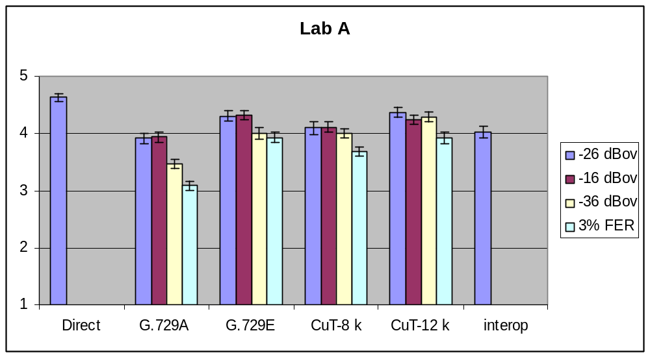
Figure 1: Characterization step 1 results for Experiment 1a (NB clean speech) in Lab A

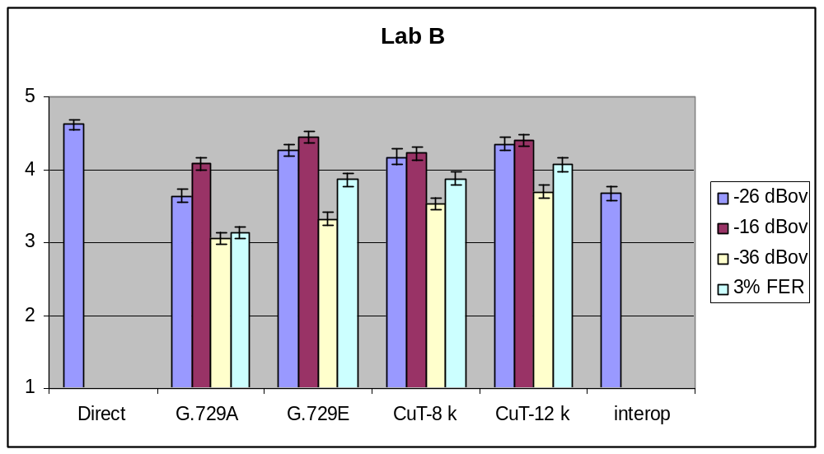
Figure 2: Characterization step 1 results for Experiment 1a (NB clean speech) in Lab B

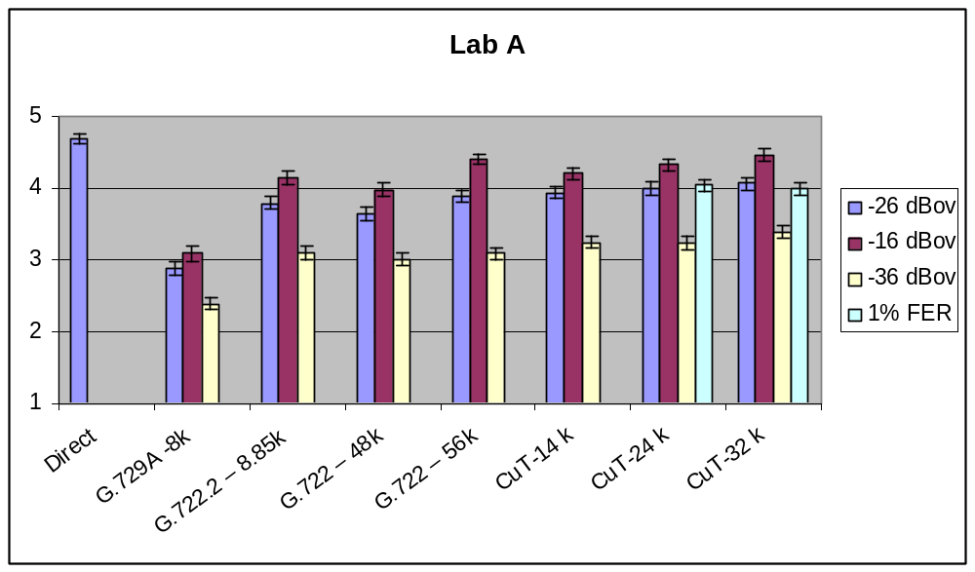
Figure 3: Characterization step 1 results for Experiment 1b (WB clean speech) in Lab A

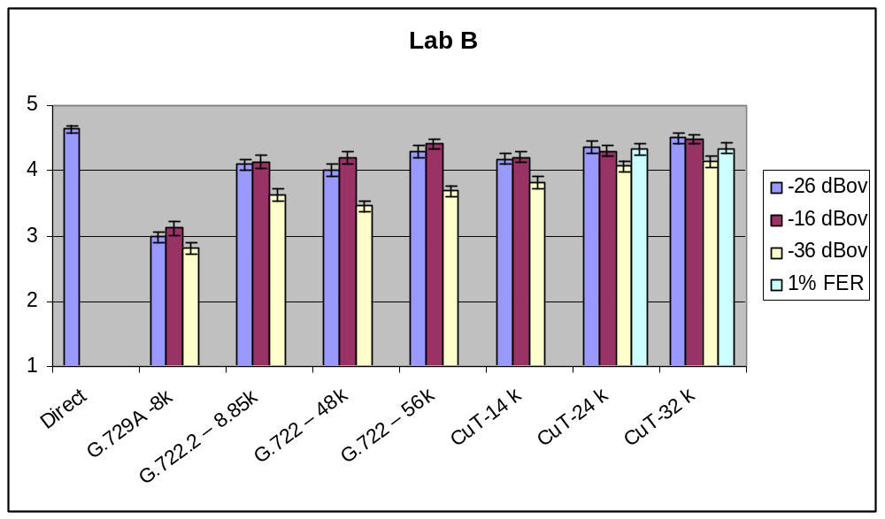
Figure 4: Characterization step 1 results for Experiment 1b (WB clean speech) in Lab B

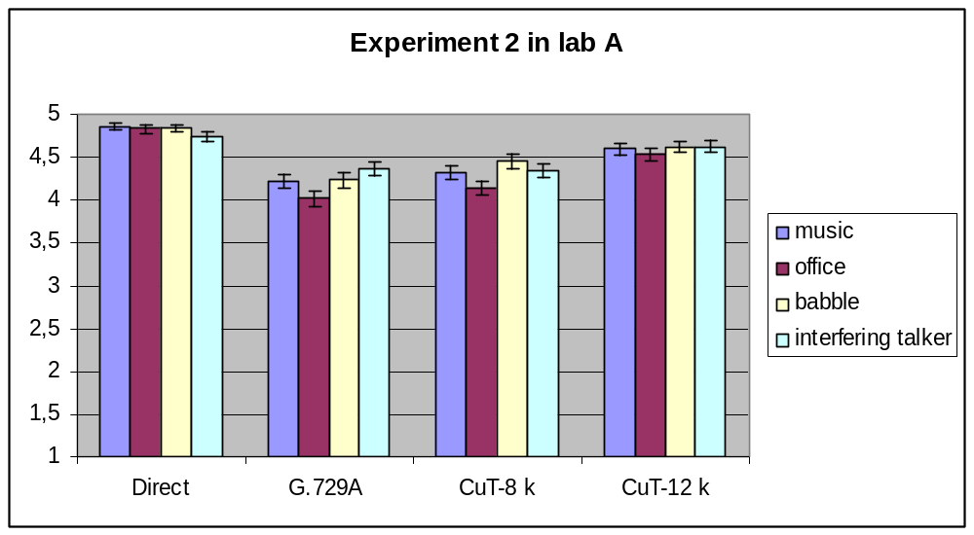
Figure 5: Characterization step 1 results for Experiment 2 (NB noisy speech) in Lab A

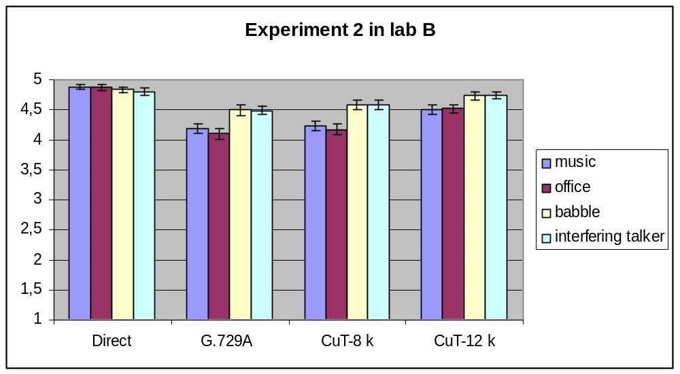
Figure 6: Characterization step 1 results for Experiment 2 (NB noisy speech) in Lab B

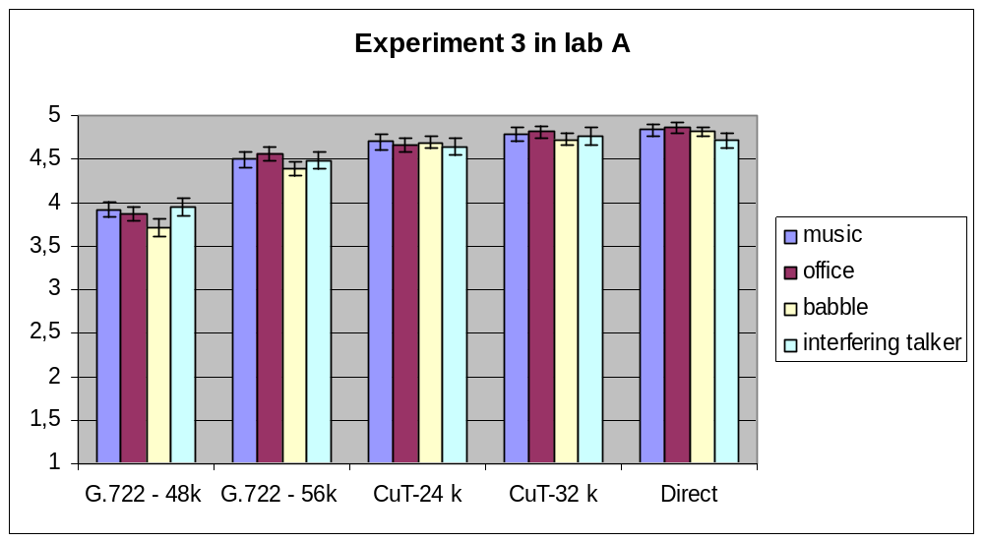
Figure 7: Characterization step 1 results for Experiment 3 (WB noisy speech) in Lab A

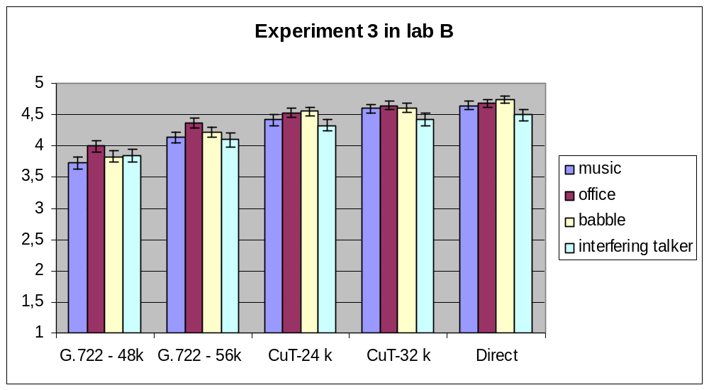
Figure 8: Characterization step 1 results for Experiment 3 (WB noisy speech) in Lab B

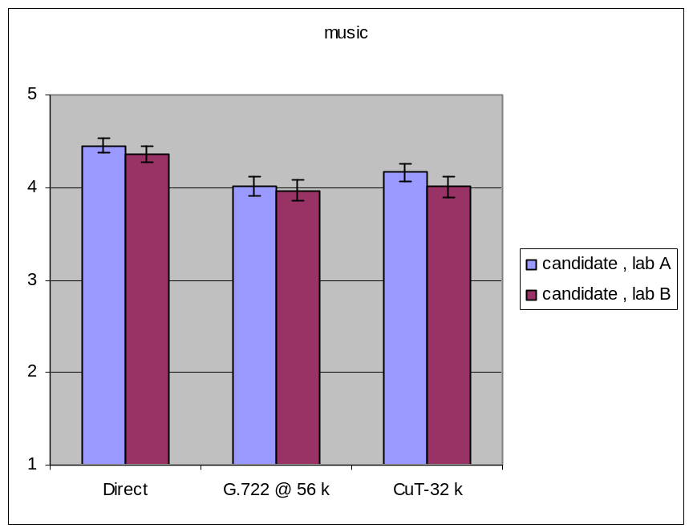
Figure 9: Characterization step 1 results for Experiment 4 (WB music)

Quality performance assessment with objective test methodology
The requirement on the codec quality codec with bit rate decrease - graceful degradation with regards to the bitrate - was verified using the wideband version of the objective measurement tool P.862.2 (WB-PESQ). The scores for wideband clean speech signals at ten bit rates from 14 to 32 kbit/s with 2 kbit/s steps reported in [6] are shown in Figure 10.
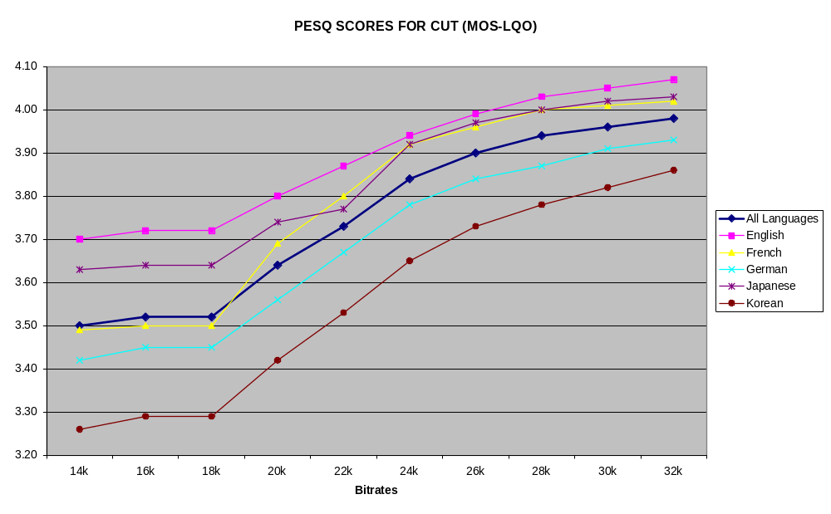
Figure 10: Wideband bit rate granularity

Quality performance assessment with informal listening test
Experiment 6 that assesses the quality in clean speech for the bit rate switching case is reported in TD 126/WP3 [7]. Its attachment contains processed speech files demonstrating bit rate switching operations.

Codec frequency response
The measured frequency responses of G.729.1 coder at bit rates of 8 kbit/s and 12 kbit/s and from 14 to 32 kbit/s with a 2 kbit/s step granularity are given for male (P50m.16k) and female (P50f.16k) speech files in Figure 11 to Figure 18 respectively (extracted from [8]).

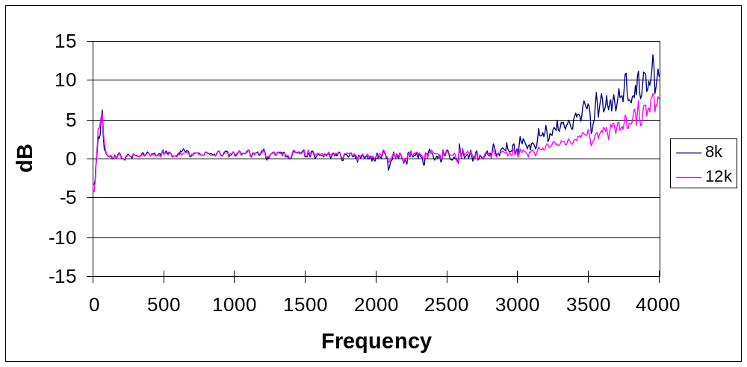
Figure 11: Frequency response in dB for male speech input at 8 kbit/s and 12 kbit/s

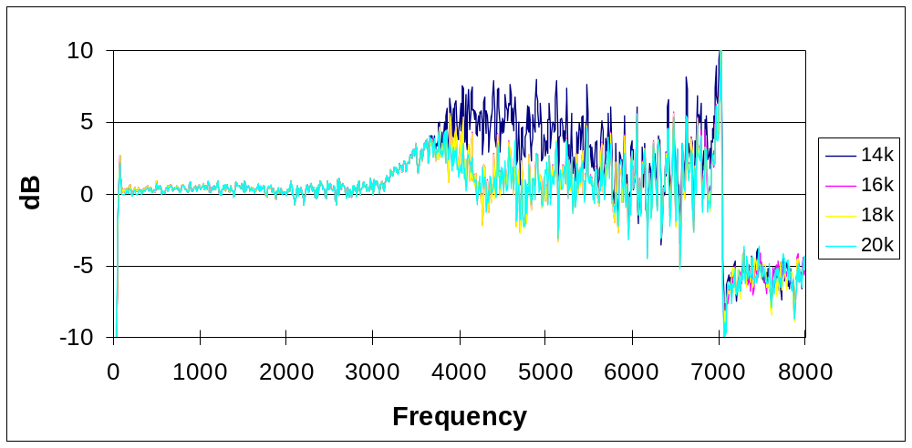
Figure 12: Frequency response in dB for male speech input from 14 kbit/s to 20 kbit/s

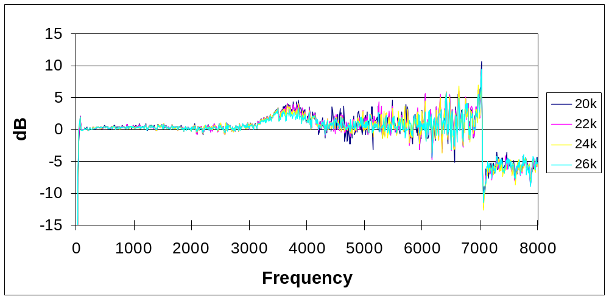
Figure 13: Frequency response in dB for male speech input from 20 kbit/s to 26 kbit/s

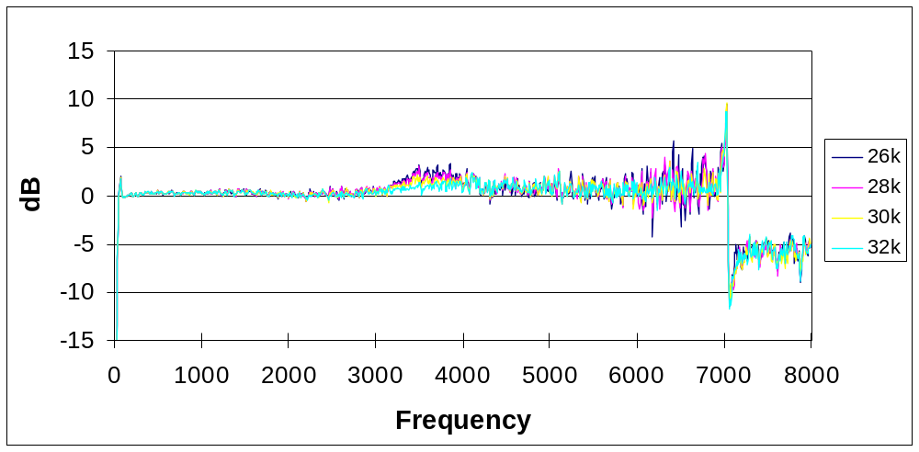
Figure 14: Frequency response in dB for male speech input from 26 kbit/s to 32 kbit/s

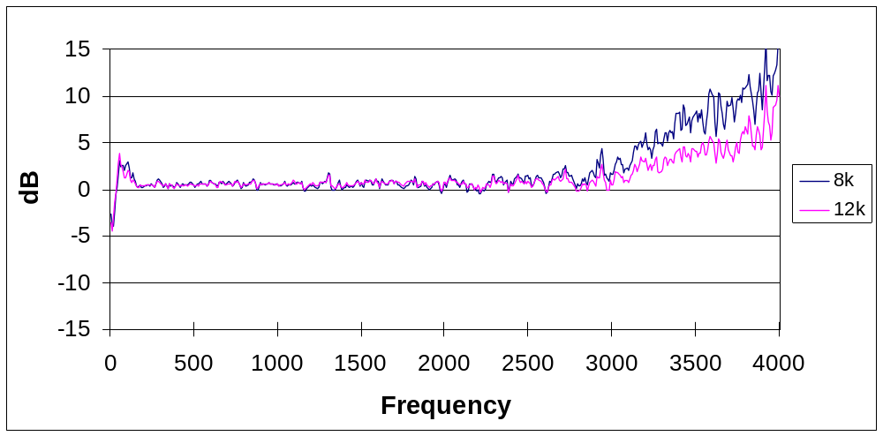
Figure 15: Frequency response in dB for female speech input at 8 kbit/s and 12 kbit/s
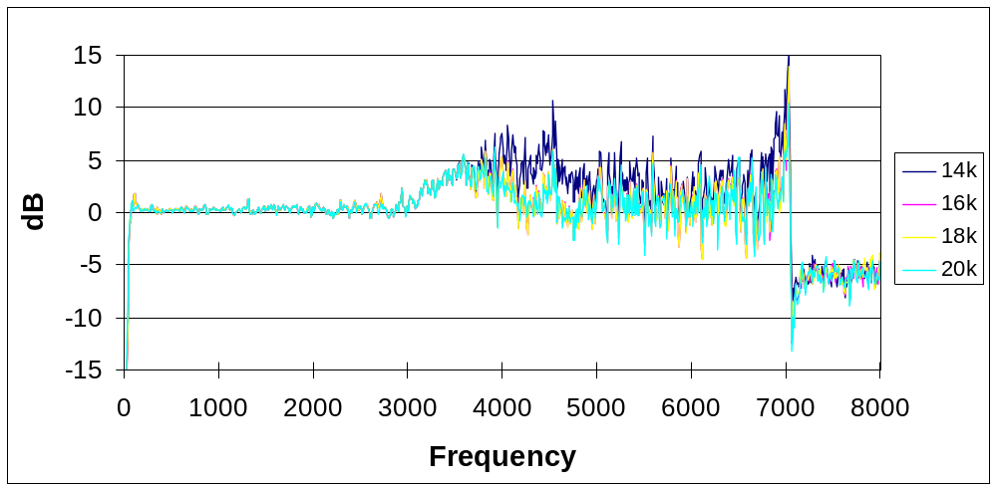
Figure 16: Frequency response in dB for female speech input from 14 kbit/s to 20 kbit/s
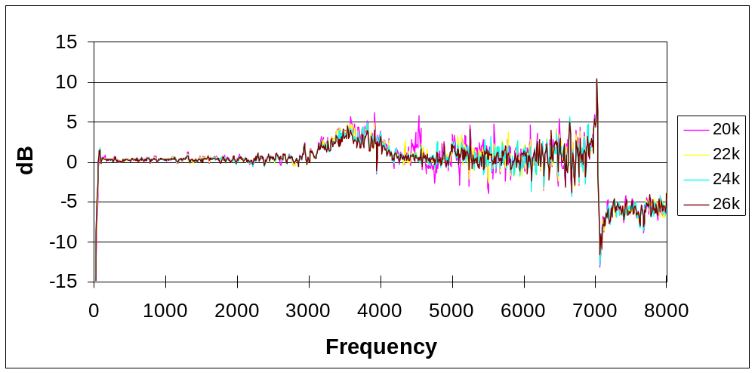
Figure 17: Frequency response in dB for female speech input from 20 kbit/s to26 kbit/s

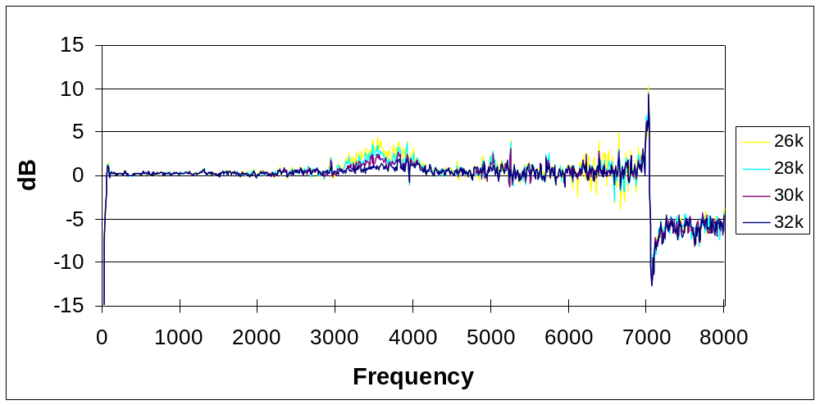
Figure 18: Frequency response in dB for female speech input from 26 kbit/s to 32 kbit/s

Achieved requirements and objectives
G.729.1 candidate coder met all requirements (complexity, delay, quality, frequency response). Table 11 and Table 12 summarize the quality requirements checked by formal subjective tests for narrowband and wideband conditions respectively. The quality objectives that could be computed were also verified. Table 13 and Table 14 indicate whether these objectives are passed/failed in narrowband and wideband conditions respectively. In these tables, “PASS” (respectively “FAIL”) denotes a pass (respectively a fail) in both laboratories whereas “pass” denotes a pass in one laboratory and a fail in the other laboratory.
Figure 10 shows that WB-PESQ scores of the G.729.1 coder increase with bit rates. No annoying artefacts were noted at the informal listening of the demo of bit rate switching operations.
Table 11: G.729.1 Quality Requirements in Narrowband conditions
 | 8 kbit/s |  | 12 kbit/s
Conditions | Requirement | Pass/Fail | Requirement | Pass/Fail
Nominal Input Level  (-26 dBov)* | Same as or better than G.729A | PASS | Not worse than G729E | PASS
High Input Level  (-16 dBov)* | Same as or better than G.729A | PASS | Not worse than G729E | PASS
Low input Level  (-36 dBov)* | Same as or better than G.729A | PASS | Not worse than G729E | PASS
Frame erasure | Not worse than G729A at 3% FER | PASS | Better than G729A at 3% FER | PASS
Music noise  25 dB SNR | Not worse than G.729A | PASS | Better than G729A | PASS
Office Noise  20 dB SNR | Not worse than G.729A | PASS | Better than G729A | PASS
Babble Noise  30 dB SNR | Not worse than G.729A | PASS | Better than G729A | PASS
Interfering Talker  15 dB SNR | Not worse than G.729A | PASS | Better than G729A | PASS
NOTE *: Reference and CuT at the same input level.
Table 12: G.729.1 Quality Requirements in Wideband conditions
 | 14 kbit/s |  | 24 kbit/s |  | 32 kbit/s
Conditions | Requirement | Pass/  Fail | Requirement | Pass/  Fail | Requirement | Pass/  Fail
Nominal input level  (-26 dBov)* | Better than G.729A and not worse than G.722.2 at 8.85 kbit/s | PASS | Not worse than G.722 at 48 kbit/s | PASS | Not worse than G.722 at 56 kbit/s | PASS
High input level  (-16 dBov)* | Better than G.729A and not worse than G.722.2 at 8.85 kbit/s | PASS | Not worse than G.722 at 48 kbit/s | PASS | Not worse than G.722 at 56 kbit/s | PASS
Low input level  (-36 dBov)* | Better than G.729A and not worse than G.722.2 at 8.85 kbit/s | PASS | Not worse than G.722 at 48 kbit/s | PASS | Not worse than G.722 at 56 kbit/s | PASS
Frame erasure** |  | PASS | Not worse than G.722 at 48 kbit/s at 1% | PASS | Not worse than G.722 at 56 kbit/s at 1% | PASS
Music noise  25 dB SNR |  | PASS | No more than 10% additional annoying degradation, in terms of annoying or very annoying with respect to G.722 at 48 kbit/s | PASS | No more than 10% additional annoying degradation, in terms of annoying or very annoying with respect to G.722 at 56 kbit/s | PASS
Office Noise  20 dB SNR |  | PASS | No more than 10% additional annoying degradation, in terms of annoying or very annoying with respect to G.722 at 48 kbit/s | PASS | No more than 10% additional annoying degradation, in terms of annoying or very annoying with respect to G.722 at 56 kbit/s | PASS
Babble Noise  30 dB SNR |  | PASS | No more than 10% additional annoying degradation, in terms of annoying or very annoying with respect to G.722 at 48 kbit/s | PASS | No more than 10% additional annoying degradation, in terms of annoying or very annoying with respect to G.722 at 56 kbit/s | PASS
Interfering talker  15 dB SNR |  | PASS | No more than 10% additional annoying degradation, in terms of annoying or very annoying with respect to G.722 at 48 kbit/s | PASS | No more than 10% additional annoying degradation, in terms of annoying or very annoying with respect to G.722 at 56 kbit/s | PASS
Music |  |  |  | PASS | Not worse than G722 at 56 kbit/s | PASS
NOTES: * Reference and CuT at the same input level; ** no errors applied to G722.
Table 13: G.729.1 Quality Objectives in Narrowband conditions
 | 8 kbit/s |  | 12 kbit/s
Conditions | Objective | Pass/ Fail | Objective | Pass/ Fail
Nominal Input Level (-26 dBov) | BT G.729A | PASS | BT G729E | FAIL
High Input Level (-16 dBov) | BT G.729A | PASS | BT G729E | FAIL
Low input Level (-36 dBov) | BT G.729A | PASS | BT G729E | PASS
Frame erasure at 3% | BT G.729A | PASS | NWT G729E | PASS
Music noise 25 dB SNR | BT G.729A | FAIL | BT G729E | *
Office 20 dB SNR | BT G.729A | pass | BT G729E | *
Babble 30 dB SNR | BT G.729A | pass | BT G729E | *
Interfering Talker 15 dB SNR | BT G.729A | FAIL | BT G729E | *
NOTE * In step 1, G.729E was not tested in noisy conditions.
Table 14: G.729.1 Quality Objectives in Wideband conditions
 | 24 kbit/s |  | 32 kbit/s
Conditions | Objective | Pass/ Fail | Objective | Pass/ Fail
Nominal Input Level (-26 dBov) | BT G.722 at 48 kbit/s | PASS | BT G.722 at 56 kbit/s | PASS
High Input Level (-16 dBov) | BT G.722 at 48 kbit/s | pass | BT G.722 at 56 kbit/s | FAIL
Low Input Level (-36 dBov) | BT G.722 at 48 kbit/s | PASS | BT G.722 at 56 kbit/s | PASS
Frame Erasure At 1% | BT G.722 at 48 kbit/s | PASS | BT G.722 at 56 kbit/s | pass
Music Noise 25 dB SNR | BT G.722 at 48 kbit/s | PASS | BT G.722 at 56 kbit/s | PASS
Office Noise 20 dB SNR | BT G.722 at 48 kbit/s | PASS | BT G.722 at 56 kbit/s | PASS
Babble Noise 30 dB SNR | BT G.722 at 48 kbit/s | PASS | BT G.722 at 56 kbit/s | PASS
Interfering Talker 15 dB SNR | BT G.722 at 48 kbit/s | PASS | BT G.722 at 56 kbit/s | PASS

G.729.1 main body characterization phase step 2
After the Consent meeting in April 2006, the characterization phase step 2 was launched and ended on November 2006. It consisted of characterising further the quality of G.729.1 with formal subjective tests.
In addition to objectives not tested in step 1, the codec was further characterized with higher frame erasure rate and some other music conditions. Older ITU-T wideband standards (G.722, G.722.1, and G.722.2) were also included. Moreover, some low delay modes were tested to be compared to the default modes in error conditions.
In characterization phase step 2, the quality of G.729.1 was assessed with 3 formal subjective experiments (see Table 15). The quality assessment test plan prepared by Q7/12 during SG12 June 2006 Plenary meeting was revised in TD 178/WP3 [9].
The processing test plan is in TD 177/WP3 [10]. Processing batch files were distributed to the processing laboratories candidates. Common FER pattern files were also provided to these laboratories. The allocation of the experiment processing is given in Table 16. The listening sessions were conducted between July 2006 and October 2006 by four listening laboratories. Table 17 indicates for each experiment the languages and the listening laboratories.
Table 15: Overview of the quality assessment tests in characterization phase step 2
Exp | NB/WB | Methodology | Conditions | CuT (rates) | Coder reference
1 | NB | ACR | Clean speech, frame erasure (0%, 3% and 6% random) | 8 & 12 (default and low-delay modes) | G729A & G729E
2 | WB | ACR | Clean speech, different input levels at 14 kbit/s, and frame erasure 0%, 3%, 6%, 10% random | 14 (default & low delay mode), 24 & 32 | G.722 at 56 & 64 kbit/s, G.722.1 at 24 & 32 kbit/s G.722.2 at 12.65 & 23.85 kbit/s
3 | WB | ACR | Music signals | 24 & 32 | G.722 at 48 & 64 kbit/s, G.722.1 at 24 & 32 kbit/s G.722.2 at 23.85 kbit/s
Table 16: Experiment processing and cross-check allocation in characterization phase step 2
Lab | Exp.1 | Cross-check | Exp.2 | Cross-check | Exp.3 | Cross-check
A | France Telecom | ETRI | VoiceAge | France Telecom | France Telecom | ETRI
B | ETRI | France Telecom | ETRI | France Telecom | VoiceAge | France Telecom
C | - | - | Siemens | Dynastat | - | -
Table 17: Subjective Experiments Languages and allocation in characterization phase step 2
Exp | Lab A | Language A | Lab B | Language B | Lab C | Language C
1 | France Telecom | French | ETRI | Korean | - | -
2 | ETRI | Korean | VoiceAge | French | Dynastat | North American English
3 | France Telecom | Music | VoiceAge | Music | - | -

Q7/12 experts reviewed the results during their October 2006 Rapporteurs meeting. The analysis is reported in section 2 of TD 258/Gen [11].
Figure 19 and Figure 20 shows the results of Experiment 1, Figure 21 and Figure 22 of Experiment 2, and Figure 23 of Experiment 3.
Note that at the end of the listening test, a bug in G.722.2 was discovered that affects six conditions of Experiment 2. Experiment 2 was rerun using ETSI-interface for G.722.2 in French language at VoiceAge laboratory and in American English language at Dynastat laboratory. First results for experiment 2 with a bug in G.722.2, coming from Dynastat and ETRI are not reported here.
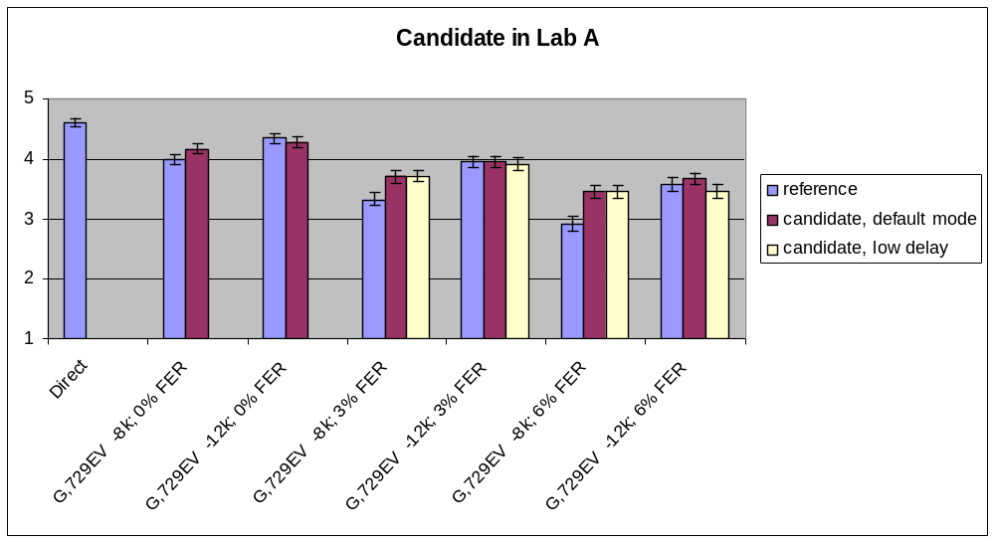
Figure 19: Characterization step 2 results in Experiment 1 (NB clean speech) in Lab A

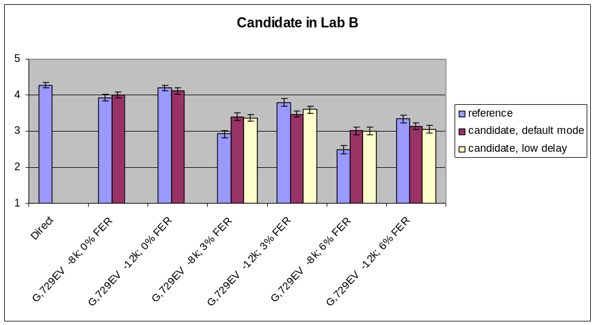
Figure 20: Characterization step 2 results in Experiment 1 (NB clean speech) in Laboratory B

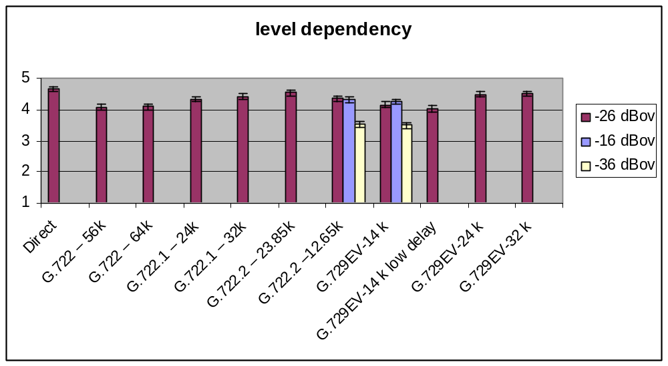
Figure 21: Characterization step 2 results in Experiment 2 (WB clean speech)
for level dependency

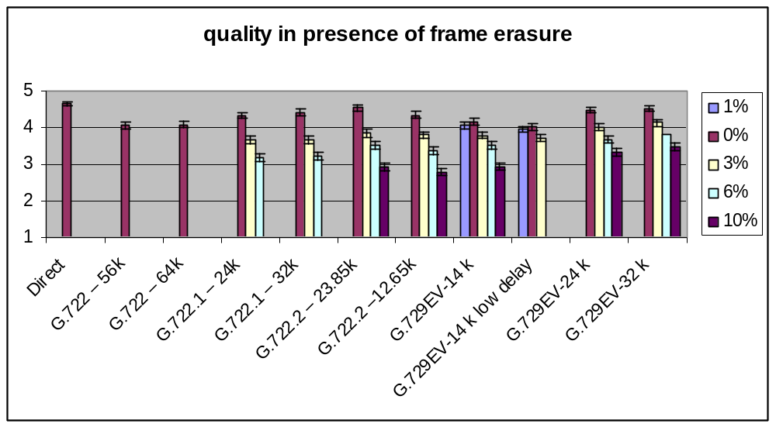
Figure 22: Characterization step 2 results in Experiment 2 (WB clean speech)
for frame erasure conditions

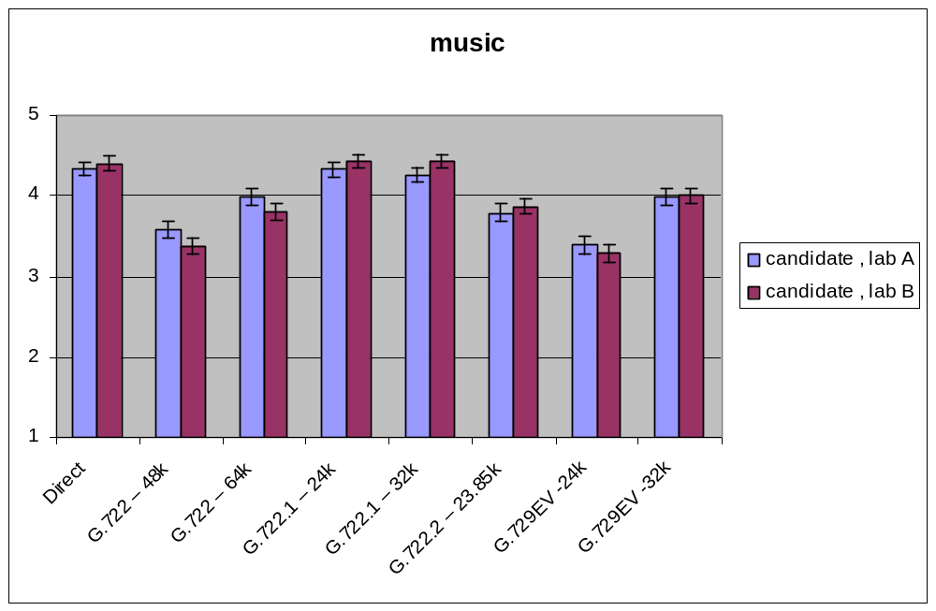
Figure 23: Characterization step 2 results in Experiment 3 (WB music)

The results of the comparison of the low delay mode with the references of the default mode are given in Table 18 for NB rates. The comparison of the low delay mode with the default mode is given in Table 19 for the NB rates and in Table 20 for the WB mode (14 kbit/s). The results of the comparison of the lowest G.729.1 WB mode (14 kbit/s) with G.722.2 at 12.65 kbit/s are given in Table 21 for various input levels and in Table 22 for various FER conditions. For two other WB modes 24 and 32 kbit/s, the comparison results with their respective references are given in Table 23 for WB clean speech in FER conditions. For WB music, the results of the comparison of G.729.1 at 24 kbit/s and 32 kbit/s are given in Table 24 for the comparison with G.722 at 48 and 64 kbit/s and in Table 25 for the comparison with G.722.1 and G.722.2. In these tables, NWT denotes “not worse than” and BT denotes “better than”.
Table 18: Comparison of G.729.1 low delay modes at 8 kbit/s and 12 kbit/s in FER (NB clean speech) with G.729A and G.729 E (Step 2 Exp#1)
 |  | 95%CI |  | 99%CI
Test  Condition | Reference  Condition | NWT  pass/fail | BT  pass/fail | NWT  pass/fail | BT  pass/fail
G.729.1 low delay mode, 8 kbit/s, 3% FER | G.729A, 3% FER | PASS | PASS | PASS | PASS
G.729.1 low delay mode, 12 kbit/s, 3% FER | G.729A, 3% FER | PASS | PASS | PASS | PASS
G.729.1 low delay mode, 12 kbit/s, 3% FER | G.729E, 3% FER | pass | FAIL | pass | FAIL
G.729.1 low delay mode, 8 kbit/s, 6% FER | G.729A, 6% FER | PASS | PASS | PASS | PASS
G.729.1 low delay mode, 12 kbit/s, 6% FER | G.729A, 6% FER | PASS | PASS | PASS | PASS
G.729.1 low delay mode, 12 kbit/s, 6% FER | G.729E, 6% FER | FAIL | FAIL | pass | FAIL

Table 19: Comparison of G.729.1 default and low delay modes at 8 kbit/s and 12 kbit/s
for narrowband clean speech in FER (Step 2 Exp#1)
 |  | 95%CI |  | 99%CI
Test  Condition | Reference  Condition | NWT  pass/fail | BT  pass/fail | NWT  pass/fail | BT  pass/fail
G.729.1 low delay mode, 8 kbit/s, 3% FER | G.729.1 default mode, 8 kbit/s, 3% FER | PASS | - | PASS | -
G.729.1 low delay mode, 12 kbit/s, 3% FER | G.729.1 default mode, 12 kbit/s, 3% FER | PASS | - | PASS | -
G.729.1 low delay mode, 8 kbit/s, 6% FER | G.729.1 default mode, 8 kbit/s, 6% FER | PASS | - | PASS | -
G.729.1 low delay mode, 12 kbit/s, 6% FER | G.729.1 default mode, 12 kbit/s, 6% FER | pass | - | pass | -

Table 20: Comparison of G.729.1 default and low delay modes at 14 kbit/s
for clean wideband speech in FER (Step 2 Exp#2)
 |  | 95%CI |  | 99%CI
Test  Condition | Reference  Condition | NWT  pass/fail | BT  pass/fail | NWT  pass/fail | BT  pass/fail
G.729.1 low delay mode, 14 kbit/s, 0% FER | G.729.1 default mode, 14 kbit/s, 0% FER | FAIL | - | PASS | -
G.729.1 low delay mode, 14 kbit/s, 1% FER | G.729.1 default mode, 14 kbit/s, 1% FER | PASS | - | PASS | -
G.729.1 low delay mode, 14 kbit/s, 3% FER | G.729.1 default mode, 14 kbit/s, 3% FER | PASS | - | PASS | -

Table 21: Comparison of G.729.1 at 14 kbit/s with G.722.2
for various input levels and wideband clean speech (Step 2 Exp#2)
 |  | 95%CI |  | 99%CI
Test  Condition | Reference  Condition | NWT  pass/fail | BT  pass/fail | NWT  pass/fail | BT  pass/fail
G.729.1, 14 kbit/s, -26 dBov | G.722.2, 12.65 kbit/s, -26 dBov | FAIL | - | pass | -
G.729.1, 14 kbit/s, -16 dBov | G.722.2, 12.65 kbit/s, -16 dBov | FAIL | - | FAIL | -
G.729.1, 14 kbit/s, -36 dBov | G.722.2, 12.65 kbit/s, -36 dBov | FAIL | - | pass | -

Table 22: Comparison of G.729.1 at 14 kbit/s with G.722.2
for clean wideband speech in FER (Step 2 Exp. 2)
 |  | 95%CI |  | 99%CI
Test  Condition | Reference  Condition | NWT  pass/fail | BT  pass/fail | NWT  pass/fail | BT  pass/fail
G.729.1, 14 kbit/s, 0% FER | G.722.2, 12.65 kbit/s, 0% FER | FAIL | - | pass | -
G.729.1, 14 kbit/s, 3% FER | G.722.2, 12.65 kbit/s, 3% FER | pass | - | pass | -
G.729.1, 14 kbit/s, 6% FER | G.722.2, 12.65 kbit/s, 6% FER | PASS | - | PASS | -
G.729.1, 14 kbit/s, 10% FER | G.722.2, 12.65 kbit/s, 10% FER | pass | - | pass | -

Table 23: Comparison of G.729.1 at 24 & 32 kbit/s with G.722.1 and G.722.2
for clean wideband speech in FER (Step 2 Exp. 2)
 |  | 95%CI |  | 99%CI
Test  Condition | Reference  Condition | NWT  pass/fail | BT  pass/fail | NWT  pass/fail | BT  pass/fail
G.729.1, 24 kbit/s, 0% FER | G.722.1, 24 kbit/s, 0% FER | PASS | PASS | PASS | PASS
G.729.1, 24 kbit/s, 3% FER | G.722.1, 24 kbit/s, 3% FER | PASS | PASS | PASS | PASS
G.729.1, 24 kbit/s, 6% FER | G.722.1, 24 kbit/s, 6% FER | PASS | PASS | PASS | PASS
G.729.1, 24 kbit/s, 0% FER | G.722.2, 23.85 kbit/s, 0% FER | PASS | FAIL | PASS | FAIL
G.729.1, 24 kbit/s, 3% FER | G.722.2, 23.85 kbit/s, 3% FER | PASS | pass | PASS | FAIL
G.729.1, 24 kbit/s, 6% FER | G.722.2, 23.85 kbit/s, 6% FER | PASS | pass | PASS | FAIL
G.729.1, 24 kbit/s, 10% FER | G.722.2, 23.85 kbit/s, 10% FER | PASS | PASS | PASS | PASS
G.729.1, 24 kbit/s, 0% FER | G.722, 56 kbit/s, 0% FER | PASS | PASS | PASS | PASS
G.729.1, 32 kbit/s, 0% FER | G.722.1, 32 kbit/s, 0% FER | PASS | Pass | PASS | pass
G.729.1, 32 kbit/s, 3% FER | G.722.1, 32 kbit/s, 3% FER | PASS | PASS | PASS | PASS
G.729.1, 32 kbit/s, 6% FER | G.722.1, 32 kbit/s, 6% FER | PASS | PASS | PASS | PASS
G.729.1, 32 kbit/s, 0% FER | G.722, 64 kbit/s, 0% FER | PASS | PASS | PASS | PASS
Table 24: Comparison of G.729.1 at 24 & 32 kbit/s with G.722
for wideband music (Step 2 Exp. 3)
 |  | 95%CI |  | 99%CI
Test  Condition | Reference Condition | NWT  pass/fail | BT  pass/fail | NWT  pass/fail | BT  pass/fail
G.729.1, 24 kbit/s | G.722, 48 kbit/s | pass | FAIL | PASS | FAIL
G.729.1, 32 kbit/s | G.722, 64 kbit/s | PASS | pass | PASS | FAIL
Table 25: Comparison of G.729.1 at 24 & 32 kbit/s with G.722.1 & G.722.2
for wideband music (Step 2 Exp. 3)
 |  | 95%CI |  | 99%CI
Test  Condition | Reference  Condition | NWT  pass/fail | BT  pass/fail | NWT  pass/fail | BT  pass/fail
G.729.1, 24 kbit/s | G.722.1, 24 kbit/s | FAIL | FAIL | FAIL | FAIL
G.729.1, 24 kbit/s | G.722.2, 23.85 kbit/s | FAIL | FAIL | FAIL | FAIL
G.729.1, 32 kbit/s | G.722.1, 32 kbit/s | FAIL | FAIL | FAIL | FAIL

G.729.1 Annex B: Floating point implementation
After the approval of G.729.1 main body in May 2006, an alternative implementation based on floating-point arithmetic was developed. It was approved in February 2007 as Annex B to G.729.1.

Methodology
To assess the quality of the floating-point implementation and check different interoperability configurations with the fixed-point version of the algorithm, objective quality measurements have been performed using ITU-T P.862 (WB-PESQ [16]). PESQ is appropriate to check the performance of different arithmetic implementations of the same codec. The 2005 revision to Recommendation P.862 Annex A that describes the revised ANSI C reference implementation of PESQ including modes of operation for Recommendation P.862.1 (narrowband MOS-LQO mapping) and Recommendation P.862.2 (the wideband extension) has been used. Besides these formal objective quality assessment tests, quality was further checked with informal expert listening.

Quality assessment organization
For the conditions assessed in both steps of the fixed point characterization phase, six talkers (three male and three female) with four samples per talker are used. Individual measurement results were obtained and transformed to the MOS-LQO domain and then averaged to obtain a per-condition evaluation over talkers and speech samples.
The same databases (clean speech) as in the characterisation phase experiments (steps 1 and 2) are used. Table 26 gives the languages and the laboratories for both cases (narrowband and wideband).
Table 26: Lab and languages in G.729 Annex B verification phase
Lab identifier | Laboratory | Language
F | France Telecom | French
J | Matsushita | Japanese
K | ETRI | Korean
E | Mindspeed | North American English
CE | VoiceAge | North American English
CF | VoiceAge | French
G | Siemens Networks | German

The results given in the next two sections are extracted from [17].

Results for narrowband case
The results for Lab F, Lab K, Lab J, Lab E, Lab CE, Lab CF and Lab G are given in Table 27 to Table 33.
Table 27: Lab F objective scores for clean speech narrowband conditions
(Experiment 1a Step 1 & Experiment 1 Step 2)
No. | Test Condition | Input level | FER | Fix/Fix | Float/Fix | Fix/Float | Float/Float
1 | G.729.1, 8 kbit/s | -26 dBov | 0% | 3.42 | 3.44 | 3.41 | 3.42
2 | G.729.1, 12 kbit/s | -26 dBov | 0% | 3.62 | 3.61 | 3.61 | 3.60
3 | G.729.1, 8 kbit/s | -16 dBov | 0% | 3.45 | 3.47 | 3.45 | 3.47
4 | G.729.1, 12 kbit/s | -16 dBov | 0% | 3.65 | 3.64 | 3.65 | 3.64
5 | G.729.1, 8 kbit/s | -36 dBov | 0% | 3.12 | 3.13 | 3.26 | 3.26
6 | G.729.1, 12 kbit/s | -36 dBov | 0% | 3.31 | 3.33 | 3.43 | 3.43
7 | G.729.1, 8 kbit/s | -26 dBov | 3% | 3.06 | 3.04 | 3.05 | 3.02
8 | G.729.1, 12 kbit/s | -26 dBov | 3% | 3.18 | 3.17 | 3.18 | 3.15
9 | Enc G.729.1, dec G 729A | -26 dBov | 0% | 3.42 | 3.43 | 3.42 | 3.43
10 | G.729.1 default mode, 8 kbit/s | -26 dBov | 6% | 2.85 | 2.85 | 2.81 | 2.81
11 | G.729.1 default mode, 12 kbit/s | -26 dBov | 6% | 2.93 | 2.94 | 2.91 | 2.91
12 | G.729.1 low delay mode, 8 kbit/s | -26 dBov | 3% | 3.03 | 3.00 | 3.02 | 3.00
13 | G.729.1 low delay mode, 12 kbit/s | -26 dBov | 3% | 3.14 | 3.13 | 3.13 | 3.12
14 | G.729.1 low delay mode, 8 kbit/s | -26 dBov | 6% | 2.78 | 2.78 | 2.77 | 2.77
15 | G.729.1 low delay mode, 12 kbit/s | -26 dBov | 6% | 2.87 | 2.87 | 2.87 | 2.87
Table 28: Lab K objective scores for clean speech narrowband conditions
(Experiment 1a Step 1 & Experiment 1 Step 2)
No. | Test Condition | Input level | FER | Fix/Fix | Float/Fix | Fix/Float | Float/Float
1 | G.729.1, 8 kbit/s | -26 dBov | 0% | 3.29 | 3.28 | 3.30 | 3.30
2 | G.729.1, 12 kbit/s | -26 dBov | 0% | 3.53 | 3.51 | 3.56 | 3.54
3 | G.729.1, 8 kbit/s | -16 dBov | 0% | 3.35 | 3.34 | 3.34 | 3.33
4 | G.729.1, 12 kbit/s | -16 dBov | 0% | 3.57 | 3.55 | 3.57 | 3.55
5 | G.729.1, 8 kbit/s | -36 dBov | 0% | 2.99 | 3.01 | 3.13 | 3.16
6 | G.729.1, 12 kbit/s | -36 dBov | 0% | 3.20 | 3.25 | 3.37 | 3.41
7 | G.729.1, 8 kbit/s | -26 dBov | 3% | 2.93 | 2.91 | 2.93 | 2.91
8 | G.729.1, 12 kbit/s | -26 dBov | 3% | 3.08 | 3.07 | 3.10 | 3.09
9 | Enc G.729.1, dec G 729A | -26 dBov | 0% | 3.28 | 3.31 | 3.28 | 3.31
10 | G.729.1 default mode, 8 kbit/s | -26 dBov | 6% | 2.73 | 2.68 | 2.72 | 2.68
11 | G.729.1 default mode, 12 kbit/s | -26 dBov | 6% | 2.84 | 2.83 | 2.84 | 2.83
12 | G.729.1 low delay mode, 8 kbit/s | -26 dBov | 3% | 2.87 | 2.87 | 2.89 | 2.89
13 | G.729.1 low delay mode, 12 kbit/s | -26 dBov | 3% | 3.02 | 3.03 | 3.05 | 3.05
14 | G.729.1 low delay mode, 8 kbit/s | -26 dBov | 6% | 2.67 | 2.65 | 2.69 | 2.67
15 | G.729.1 low delay mode, 12 kbit/s | -26 dBov | 6% | 2.77 | 2.79 | 2.80 | 2.81
Table 29: Lab J objective scores for clean speech narrowband conditions
(Experiment 1a Step 1 & Experiment 1 Step 2)
No. | Test Condition | Input level | FER | Fix/Fix | Float/Fix | Fix/Float | Float/Float
1 | G.729.1, 8 kbit/s | -26 dBov | 0% | 2.97 | 2.94 | 2.98 | 2.95
2 | G.729.1, 12 kbit/s | -26 dBov | 0% | 3.12 | 3.11 | 3.15 | 3.12
3 | G.729.1, 8 kbit/s | -16 dBov | 0% | 2.98 | 2.97 | 2.97 | 2.97
4 | G.729.1, 12 kbit/s | -16 dBov | 0% | 3.15 | 3.14 | 3.15 | 3.14
5 | G.729.1, 8 kbit/s | -36 dBov | 0% | 2.82 | 2.84 | 2.90 | 2.90
6 | G.729.1, 12 kbit/s | -36 dBov | 0% | 2.97 | 3.00 | 3.05 | 3.07
7 | G.729.1, 8 kbit/s | -26 dBov | 3% | 2.68 | 2.66 | 2.68 | 2.67
8 | G.729.1, 12 kbit/s | -26 dBov | 3% | 2.77 | 2.77 | 2.78 | 2.78
9 | Enc G.729.1 Dec G 729A | -26 dBov | 0% | 3.01 | 2.99 | 3.01 | 2.99
10 | G.729.1 default mode, 8 kbit/s | -26 dBov | 6% | 2.49 | 2.48 | 2.49 | 2.49
11 | G.729.1 default mode, 12 kbit/s | -26 dBov | 6% | 2.57 | 2.56 | 2.59 | 2.56
12 | G.729.1 low delay mode, 8 kbit/s | -26 dBov | 3% | 2.65 | 2.65 | 2.66 | 2.65
13 | G.729.1 low delay mode, 12 kbit/s | -26 dBov | 3% | 2.73 | 2.74 | 2.75 | 2.75
14 | G.729.1 low delay mode, 8 kbit/s | -26 dBov | 6% | 2.47 | 2.45 | 2.46 | 2.45
15 | G.729.1 low delay mode, 12 kbit/s | -26 dBov | 6% | 2.54 | 2.53 | 2.54 | 2.53
Table 30: Lab E objective scores for clean speech narrowband conditions
(Experiment 1a Step 1 & Experiment 1 Step 2)
No. | Test Condition | Input level | FER | Fix/Fix | Float/Fix | Fix/Float | Float/Float
1 | G.729.1, 8 kbit/s | -26 dBov | 0% | 2.97 | 2.94 | 2.98 | 2.95
2 | G.729.1, 12 kbit/s | -26 dBov | 0% | 3.12 | 3.11 | 3.15 | 3.12
3 | G.729.1, 8 kbit/s | -16 dBov | 0% | 2.98 | 2.97 | 2.97 | 2.97
4 | G.729.1, 12 kbit/s | -16 dBov | 0% | 3.15 | 3.14 | 3.15 | 3.14
5 | G.729.1, 8 kbit/s | -36 dBov | 0% | 2.82 | 2.84 | 2.90 | 2.90
6 | G.729.1, 12 kbit/s | -36 dBov | 0% | 2.97 | 3.00 | 3.05 | 3.07
7 | G.729.1, 8 kbit/s | -26 dBov | 3% | 2.68 | 2.66 | 2.68 | 2.67
8 | G.729.1, 12 kbit/s | -26 dBov | 3% | 2.77 | 2.77 | 2.78 | 2.78
9 | Enc G.729.1 Dec G 729A | -26 dBov | 0% | 3.01 | 2.99 | 3.01 | 2.99
10 | G.729.1 default mode, 8 kbit/s | -26 dBov | 6% | 2.49 | 2.48 | 2.49 | 2.49
11 | G.729.1 default mode, 12 kbit/s | -26 dBov | 6% | 2.57 | 2.56 | 2.59 | 2.56
12 | G.729.1 low delay mode, 8 kbit/s | -26 dBov | 3% | 2.65 | 2.65 | 2.66 | 2.65
13 | G.729.1 low delay mode, 12 kbit/s | -26 dBov | 3% | 2.73 | 2.74 | 2.75 | 2.75
14 | G.729.1 low delay mode, 8 kbit/s | -26 dBov | 6% | 2.47 | 2.45 | 2.46 | 2.45
15 | G.729.1 low delay mode, 12 kbit/s | -26 dBov | 6% | 2.54 | 2.53 | 2.54 | 2.53
Table 31: Lab CE objective scores for clean speech narrowband conditions
(Experiment 1a Step 1)
No. | Test Condition | Input level | FER | Fix/Fix | Float/Fix | Fix/Float | Float/Float
1 | G.729.1, 8 kbit/s | -26 dBov | 0% | 3.23 | 3.22 | 3.24 | 3.23
2 | G.729.1, 12 kbit/s | -26 dBov | 0% | 3.42 | 3.41 | 3.44 | 3.43
3 | G.729.1, 8 kbit/s | -16 dBov | 0% | 3.25 | 3.22 | 3.24 | 3.21
4 | G.729.1, 12 kbit/s | -16 dBov | 0% | 3.44 | 3.43 | 3.44 | 3.43
5 | G.729.1, 8 kbit/s | -36 dBov | 0% | 2.98 | 3.00 | 3.10 | 3.12
6 | G.729.1, 12 kbit/s | -36 dBov | 0% | 3.14 | 3.18 | 3.31 | 3.34
7 | G.729.1, 8 kbit/s | -26 dBov | 3% | 2.87 | 2.87 | 2.88 | 2.86
8 | G.729.1, 12 kbit/s | -26 dBov | 3% | 3.01 | 3.00 | 3.02 | 3.00
9 | Enc G.729.1, dec G 729A | -26 dBov | 0% | 3.21 | 3.23 | 3.21 | 3.23
Table 32: Lab CF objective scores for clean speech narrowband conditions
(Experiment 1 Step 2)
No. | Test Condition | Input level | FER | Fix/Fix | Float/Fix | Fix/Float | Float/Float
10 | G.729.1 default mode, 8 kbit/s | -26 dBov | 6% | 2.53 | 2.52 | 2.54 | 2.53
11 | G.729.1 default mode, 12 kbit/s | -26 dBov | 6% | 2.65 | 2.64 | 2.67 | 2.65
12 | G.729.1 low delay mode, 8 kbit/s | -26 dBov | 3% | 2.70 | 2.69 | 2.72 | 2.71
13 | G.729.1 low delay mode, 12 kbit/s | -26 dBov | 3% | 2.83 | 2.82 | 2.86 | 2.86
14 | G.729.1 low delay mode, 8 kbit/s | -26 dBov | 6% | 2.51 | 2.48 | 2.53 | 2.50
15 | G.729.1 low delay mode, 12 kbit/s | -26 dBov | 6% | 2.62 | 2.59 | 2.64 | 2.62
Table 33: Lab G objective scores for clean speech narrowband conditions
(Experiment 1a Step 1 & Experiment 1 Step 2)
No. | Test Condition | Input level | FER | Fix/Fix | Float/Fix | Fix/Float | Float/Float
1 | G.729.1, 8 kbit/s | -26 dBov | 0% | 2.98 | 2.97 | 3.00 | 2.99
2 | G.729.1, 12 kbit/s | -26 dBov | 0% | 3.21 | 3.21 | 3.24 | 3.25
3 | G.729.1, 8 kbit/s | -16 dBov | 0% | 2.99 | 2.97 | 2.98 | 2.97
4 | G.729.1, 12 kbit/s | -16 dBov | 0% | 3.24 | 3.23 | 3.24 | 3.23
5 | G.729.1, 8 kbit/s | -36 dBov | 0% | 2.72 | 2.74 | 2.85 | 2.87
6 | G.729.1, 12 kbit/s | -36 dBov | 0% | 2.92 | 2.96 | 3.09 | 3.13
7 | G.729.1, 8 kbit/s | -26 dBov | 3% | 2.62 | 2.62 | 2.63 | 2.63
8 | G.729.1, 12 kbit/s | -26 dBov | 3% | 2.77 | 2.77 | 2.79 | 2.78
9 | Enc G.729.1, dec G 729A | -26 dBov | 0% | 3.00 | 3.01 | 3.00 | 3.01
10 | G.729.1 default mode, 8 kbit/s | -26 dBov | 6% | 2.40 | 2.40 | 2.41 | 2.40
11 | G.729.1 default mode, 12 kbit/s | -26 dBov | 6% | 2.55 | 2.53 | 2.56 | 2.54
12 | G.729.1 low delay mode, 8 kbit/s | -26 dBov | 3% | 2.59 | 2.59 | 2.60 | 2.61
13 | G.729.1 low delay mode, 12 kbit/s | -26 dBov | 3% | 2.75 | 2.74 | 2.78 | 2.76
14 | G.729.1 low delay mode, 8 kbit/s | -26 dBov | 6% | 2.38 | 2.37 | 2.40 | 2.38
15 | G.729.1 low delay mode, 12 kbit/s | -26 dBov | 6% | 2.51 | 2.48 | 2.52 | 2.50

Results for wideband case
The results for Lab F, Lab K, Lab J, Lab E, Lab CE, Lab CF and Lab G are given in Table 34 to Table 40.
Table 34: Lab F objective scores for clean wideband conditions
(Experiment 1b Step 1 & Experiment 2 Step 2)
No. | Test Condition | Input level | FER | Fix/Fix | Float/Fix | Fix/Float | Float/Float
1 | G.729.1, 14 kbit/s | -26 dBov | 0% | 3.77 | 3.78 | 3.78 | 3.81
2 | G.729.1, 24 kbit/s | -26 dBov | 0% | 4.08 | 4.06 | 4.09 | 4.09
3 | G.729.1, 32 kbit/s | -26 dBov | 0% | 4.19 | 4.20 | 4.20 | 4.23
4 | G.729.1, 14 kbit/s | -16 dBov | 0% | 3.76 | 3.79 | 3.77 | 3.79
5 | G.729.1, 24 kbit/s | -16 dBov | 0% | 4.03 | 4.03 | 4.03 | 4.04
6 | G.729.1, 32 kbit/s | -16 dBov | 0% | 4.20 | 4.21 | 4.19 | 4.20
7 | G.729.1, 14 kbit/s | -36 dBov | 0% | 3.51 | 3.62 | 3.62 | 3.77
8 | G.729.1, 24 kbit/s | -36 dBov | 0% | 3.69 | 3.78 | 3.85 | 4.04
9 | G.729.1, 32 kbit/s | -36 dBov | 0% | 3.77 | 3.86 | 3.93 | 4.20
10 | G.729.1, 24 kbit/s | -26 dBov | 1% | 3.84 | 3.83 | 3.83 | 3.85
11 | G.729.1, 32 kbit/s | -26 dBov | 1% | 3.91 | 3.93 | 3.91 | 3.96
12 | G.729.1, 14 kbit/s | -26 dBov | 1% | 3.57 | 3.60 | 3.57 | 3.62
13 | G.729.1, 14 kbit/s | -26 dBov | 3% | 3.16 | 3.17 | 3.11 | 3.18
14 | G.729.1, 24 kbit/s | -26 dBov | 3% | 3.37 | 3.38 | 3.33 | 3.41
15 | G.729.1, 32 kbit/s | -26 dBov | 3% | 3.43 | 3.47 | 3.40 | 3.49
16 | G.729.1, 14 kbit/s | -26 dBov | 6% | 2.86 | 2.87 | 2.81 | 2.86
17 | G.729.1, 24 kbit/s | -26 dBov | 6% | 3.03 | 3.05 | 3.00 | 3.05
18 | G.729.1, 32 kbit/s | -26 dBov | 6% | 3.09 | 3.11 | 3.06 | 3.11
19 | G.729.1, 14 kbit/s | -26 dBov | 10% | 2.35 | 2.35 | 2.31 | 2.33
20 | G.729.1, 24 kbit/s | -26 dBov | 10% | 2.49 | 2.47 | 2.48 | 2.47
21 | G.729.1, 32 kbit/s | -26 dBov | 10% | 2.50 | 2.49 | 2.50 | 2.49
Table 35: Lab K objective scores for clean wideband conditions
(Experiment 1b Step 1 & Experiment 2 Step 2)
No. | Test Condition | Input level | FER | Fix/Fix | Float/Fix | Fix/Float | Float/Float
1 | G.729.1, 14 kbit/s | -26 dBov | 0% | 3.69 | 3.67 | 3.74 | 3.75
2 | G.729.1, 24 kbit/s | -26 dBov | 0% | 3.90 | 3.88 | 3.99 | 4.04
3 | G.729.1, 32 kbit/s | -26 dBov | 0% | 4.03 | 3.99 | 4.11 | 4.18
4 | G.729.1, 14 kbit/s | -16 dBov | 0% | 3.73 | 3.71 | 3.72 | 3.71
5 | G.729.1, 24 kbit/s | -16 dBov | 0% | 4.01 | 4.00 | 4.01 | 4.01
6 | G.729.1, 32 kbit/s | -16 dBov | 0% | 4.14 | 4.14 | 4.14 | 4.14
7 | G.729.1, 14 kbit/s | -36 dBov | 0% | 3.22 | 3.41 | 3.33 | 3.66
8 | G.729.1, 24 kbit/s | -36 dBov | 0% | 3.37 | 3.56 | 3.55 | 3.98
9 | G.729.1, 32 kbit/s | -36 dBov | 0% | 3.46 | 3.58 | 3.61 | 4.08
10 | G.729.1, 24 kbit/s | -26 dBov | 1% | 3.57 | 3.58 | 3.65 | 3.71
11 | G.729.1, 32 kbit/s | -26 dBov | 1% | 3.67 | 3.66 | 3.74 | 3.83
12 | G.729.1, 14 kbit/s | -26 dBov | 1% | 3.39 | 3.39 | 3.42 | 3.45
13 | G.729.1, 14 kbit/s | -26 dBov | 3% | 3.07 | 3.05 | 3.07 | 3.09
14 | G.729.1, 24 kbit/s | -26 dBov | 3% | 3.20 | 3.22 | 3.27 | 3.35
15 | G.729.1, 32 kbit/s | -26 dBov | 3% | 3.27 | 3.28 | 3.33 | 3.43
16 | G.729.1, 14 kbit/s | -26 dBov | 6% | 2.74 | 2.74 | 2.74 | 2.77
17 | G.729.1, 24 kbit/s | -26 dBov | 6% | 2.85 | 2.88 | 2.89 | 2.95
18 | G.729.1, 32 kbit/s | -26 dBov | 6% | 2.91 | 2.92 | 2.95 | 3.03
19 | G.729.1, 14 kbit/s | -26 dBov | 10% | 2.16 | 2.20 | 2.17 | 2.24
20 | G.729.1, 24 kbit/s | -26 dBov | 10% | 2.24 | 2.31 | 2.29 | 2.39
21 | G.729.1, 32 kbit/s | -26 dBov | 10% | 2.27 | 2.32 | 2.31 | 2.44
Table 36: Lab J objective scores for clean wideband conditions
(Experiment 1b Step 1 & Experiment 2 Step 2)
No. | Test Condition | Input level | FER | Fix/Fix | Float/Fix | Fix/Float | Float/Float
1 | G.729.1, 14 kbit/s | -26 dBov | 0% | 3.77 | 3.75 | 3.77 | 3.77
2 | G.729.1, 24 kbit/s | -26 dBov | 0% | 4.02 | 4.02 | 4.03 | 4.04
3 | G.729.1, 32 kbit/s | -26 dBov | 0% | 4.12 | 4.14 | 4.14 | 4.17
4 | G.729.1, 14 kbit/s | -16 dBov | 0% | 3.70 | 3.68 | 3.69 | 3.66
5 | G.729.1, 24 kbit/s | -16 dBov | 0% | 3.93 | 3.94 | 3.92 | 3.93
6 | G.729.1, 32 kbit/s | -16 dBov | 0% | 4.03 | 4.03 | 4.03 | 4.04
7 | G.729.1, 14 kbit/s | -36 dBov | 0% | 3.55 | 3.64 | 3.64 | 3.77
8 | G.729.1, 24 kbit/s | -36 dBov | 0% | 3.70 | 3.81 | 3.87 | 4.01
9 | G.729.1, 32 kbit/s | -36 dBov | 0% | 3.79 | 3.88 | 3.93 | 4.11
10 | G.729.1, 24 kbit/s | -26 dBov | 1% | 3.75 | 3.75 | 3.78 | 3.76
11 | G.729.1, 32 kbit/s | -26 dBov | 1% | 3.85 | 3.86 | 3.88 | 3.89
12 | G.729.1, 14 kbit/s | -26 dBov | 1% | 3.52 | 3.48 | 3.52 | 3.50
13 | G.729.1, 14 kbit/s | -26 dBov | 3% | 3.13 | 3.14 | 3.12 | 3.14
14 | G.729.1, 24 kbit/s | -26 dBov | 3% | 3.35 | 3.37 | 3.34 | 3.38
15 | G.729.1, 32 kbit/s | -26 dBov | 3% | 3.44 | 3.46 | 3.42 | 3.46
16 | G.729.1, 14 kbit/s | -26 dBov | 6% | 2.77 | 2.79 | 2.68 | 2.78
17 | G.729.1, 24 kbit/s | -26 dBov | 6% | 2.97 | 2.99 | 2.91 | 3.01
18 | G.729.1, 32 kbit/s | -26 dBov | 6% | 3.04 | 3.07 | 2.97 | 3.09
19 | G.729.1, 14 kbit/s | -26 dBov | 10% | 2.31 | 2.33 | 2.28 | 2.32
20 | G.729.1, 24 kbit/s | -26 dBov | 10% | 2.48 | 2.50 | 2.47 | 2.49
21 | G.729.1, 32 kbit/s | -26 dBov | 10% | 2.53 | 2.54 | 2.51 | 2.53
Table 37: Lab E objective scores for clean wideband conditions
(Experiment 1b Step 1 & Experiment 2 Step 2)
No. | Test Condition | Input level | FER | Fix/Fix | Float/Fix | Fix/Float | Float/Float
1 | G.729.1, 14 kbit/s | -26 dBov | 0% | 3.77 | 3.75 | 3.77 | 3.77
2 | G.729.1, 24 kbit/s | -26 dBov | 0% | 4.02 | 4.02 | 4.03 | 4.04
3 | G.729.1, 32 kbit/s | -26 dBov | 0% | 4.12 | 4.14 | 4.14 | 4.17
4 | G.729.1, 14 kbit/s | -16 dBov | 0% | 3.70 | 3.68 | 3.69 | 3.66
5 | G.729.1, 24 kbit/s | -16 dBov | 0% | 3.93 | 3.94 | 3.92 | 3.93
6 | G.729.1, 32 kbit/s | -16 dBov | 0% | 4.03 | 4.03 | 4.03 | 4.04
7 | G.729.1, 14 kbit/s | -36 dBov | 0% | 3.55 | 3.64 | 3.64 | 3.77
8 | G.729.1, 24 kbit/s | -36 dBov | 0% | 3.70 | 3.81 | 3.87 | 4.01
9 | G.729.1, 32 kbit/s | -36 dBov | 0% | 3.79 | 3.88 | 3.93 | 4.11
10 | G.729.1, 24 kbit/s | -26 dBov | 1% | 3.75 | 3.75 | 3.78 | 3.76
11 | G.729.1, 32 kbit/s | -26 dBov | 1% | 3.85 | 3.86 | 3.88 | 3.89
12 | G.729.1, 14 kbit/s | -26 dBov | 1% | 3.52 | 3.48 | 3.52 | 3.50
13 | G.729.1, 14 kbit/s | -26 dBov | 3% | 3.13 | 3.14 | 3.12 | 3.14
14 | G.729.1, 24 kbit/s | -26 dBov | 3% | 3.35 | 3.37 | 3.34 | 3.38
15 | G.729.1, 32 kbit/s | -26 dBov | 3% | 3.44 | 3.46 | 3.42 | 3.46
16 | G.729.1, 14 kbit/s | -26 dBov | 6% | 2.77 | 2.79 | 2.68 | 2.78
17 | G.729.1, 24 kbit/s | -26 dBov | 6% | 2.97 | 2.99 | 2.91 | 3.01
18 | G.729.1, 32 kbit/s | -26 dBov | 6% | 3.04 | 3.07 | 2.97 | 3.09
19 | G.729.1, 14 kbit/s | -26 dBov | 10% | 2.31 | 2.33 | 2.28 | 2.32
20 | G.729.1, 24 kbit/s | -26 dBov | 10% | 2.48 | 2.50 | 2.47 | 2.49
21 | G.729.1, 32 kbit/s | -26 dBov | 10% | 2.53 | 2.54 | 2.51 | 2.53
Table 38: Lab CE objective scores for clean wideband conditions
(Experiment 1b Step 1)
No. | Test Condition | Input level | FER | Fix/Fix | Float/Fix | Fix/Float | Float/Float
1 | G.729.1, 14 kbit/s | -26 dBov | 0% | 3.72 | 3.67 | 3.76 | 3.74
2 | G.729.1, 24 kbit/s | -26 dBov | 0% | 3.93 | 3.93 | 4.00 | 4.05
3 | G.729.1, 32 kbit/s | -26 dBov | 0% | 4.05 | 4.02 | 4.11 | 4.17
4 | G.729.1, 14 kbit/s | -16 dBov | 0% | 3.71 | 3.69 | 3.70 | 3.69
5 | G.729.1, 24 kbit/s | -16 dBov | 0% | 3.94 | 3.96 | 3.95 | 3.97
6 | G.729.1, 32 kbit/s | -16 dBov | 0% | 4.07 | 4.08 | 4.07 | 4.09
7 | G.729.1, 14 kbit/s | -36 dBov | 0% | 3.29 | 3.45 | 3.42 | 3.65
8 | G.729.1, 24 kbit/s | -36 dBov | 0% | 3.46 | 3.65 | 3.64 | 4.01
9 | G.729.1, 32 kbit/s | -36 dBov | 0% | 3.58 | 3.70 | 3.75 | 4.10
10 | G.729.1, 24 kbit/s | -26 dBov | 1% | 3.69 | 3.69 | 3.75 | 3.79
11 | G.729.1, 32 kbit/s | -26 dBov | 1% | 3.78 | 3.75 | 3.84 | 3.88
Table 39: Lab CF objective scores for clean wideband conditions
(Experiment 2 Step 2)
No. | Test Condition | Input level | FER | Fix/Fix | Float/Fix | Fix/Float | Float/Float
1 | G.729.1, 14 kbit/s | -26 dBov | 0% | 3.45 | 3.49 | 3.52 | 3.64
2 | G.729.1, 14 kbit/s | -26 dBov | 1% | 3.21 | 3.23 | 3.25 | 3.37
3 | G.729.1, 24 kbit/s | -26 dBov | 0% | 3.79 | 3.79 | 3.90 | 3.98
4 | G.729.1, 32 kbit/s | -26 dBov | 0% | 3.91 | 3.89 | 4.03 | 4.13
5 | G.729.1, 14 kbit/s | -26 dBov | 3% | 2.80 | 2.84 | 2.84 | 2.94
6 | G.729.1, 24 kbit/s | -26 dBov | 3% | 3.07 | 3.07 | 3.11 | 3.21
7 | G.729.1, 32 kbit/s | -26 dBov | 3% | 3.14 | 3.14 | 3.18 | 3.31
8 | G.729.1, 14 kbit/s | -26 dBov | 6% | 2.45 | 2.45 | 2.48 | 2.56
9 | G.729.1, 24 kbit/s | -26 dBov | 6% | 2.61 | 2.63 | 2.64 | 2.76
10 | G.729.1, 32 kbit/s | -26 dBov | 6% | 2.66 | 2.67 | 2.69 | 2.82
11 | G.729.1, 14 kbit/s | -26 dBov | 10% | 1.98 | 2.03 | 1.99 | 2.08
12 | G.729.1, 24 kbit/s | -26 dBov | 10% | 2.13 | 2.19 | 2.14 | 2.23
13 | G.729.1, 32 kbit/s | -26 dBov | 10% | 2.16 | 2.21 | 2.16 | 2.28
14 | G.729.1, 14 kbit/s | -16 dBov | 0% | 3.57 | 3.54 | 3.57 | 3.57
15 | G.729.1, 14 kbit/s | -36 dBov | 0% | 3.01 | 3.23 | 3.10 | 3.43
Table 40: Lab G objective scores for clean wideband conditions
(Experiment 1b Step 1 & Experiment 2 Step 2)
No. | Test Condition | Input level | FER | Fix/Fix | Float/Fix | Fix/Float | Float/Float
1 | G.729.1, 14 kbit/s | -26 dBov | 0% | 3.49 | 3.43 | 3.58 | 3.59
2 | G.729.1, 24 kbit/s | -26 dBov | 0% | 3.77 | 3.72 | 3.86 | 3.94
3 | G.729.1, 32 kbit/s | -26 dBov | 0% | 3.88 | 3.82 | 3.97 | 4.07
4 | G.729.1, 14 kbit/s | -16 dBov | 0% | 3.50 | 3.51 | 3.50 | 3.52
5 | G.729.1, 24 kbit/s | -16 dBov | 0% | 3.82 | 3.82 | 3.81 | 3.82
6 | G.729.1, 32 kbit/s | -16 dBov | 0% | 3.96 | 3.95 | 3.95 | 3.96
7 | G.729.1, 14 kbit/s | -36 dBov | 0% | 3.01 | 3.17 | 3.15 | 3.51
8 | G.729.1, 24 kbit/s | -36 dBov | 0% | 3.19 | 3.33 | 3.39 | 3.88
9 | G.729.1, 32 kbit/s | -36 dBov | 0% | 3.29 | 3.35 | 3.46 | 3.96
10 | G.729.1, 24 kbit/s | -26 dBov | 1% | 3.47 | 3.44 | 3.54 | 3.64
11 | G.729.1, 32 kbit/s | -26 dBov | 1% | 3.56 | 3.52 | 3.64 | 3.76
12 | G.729.1, 14 kbit/s | -26 dBov | 1% | 3.16 | 3.17 | 3.24 | 3.31
13 | G.729.1, 14 kbit/s | -26 dBov | 3% | 2.80 | 2.78 | 2.86 | 2.89
14 | G.729.1, 24 kbit/s | -26 dBov | 3% | 3.04 | 2.98 | 3.09 | 3.16
15 | G.729.1, 32 kbit/s | -26 dBov | 3% | 3.09 | 3.02 | 3.15 | 3.23
16 | G.729.1, 14 kbit/s | -26 dBov | 6% | 2.40 | 2.38 | 2.38 | 2.45
17 | G.729.1, 24 kbit/s | -26 dBov | 6% | 2.56 | 2.54 | 2.55 | 2.64
18 | G.729.1, 32 kbit/s | -26 dBov | 6% | 2.60 | 2.57 | 2.59 | 2.69
19 | G.729.1, 14 kbit/s | -26 dBov | 10% | 1.93 | 1.95 | 1.92 | 1.99
20 | G.729.1, 24 kbit/s | -26 dBov | 10% | 2.07 | 2.09 | 2.08 | 2.17
21 | G.729.1, 32 kbit/s | -26 dBov | 10% | 2.10 | 2.13 | 2.11 | 2.21

G.729.1 Annex C (DTX/CNG) characterization phase
Launched in November 2006, the standardization of a DTX/CNG scheme for G.729.1 ended by April 2008. The objective was to extend G.729.1 with a silence compression scheme for VoIP applications such as enterprise networks. The term of reference were established with the VAD of G.722.2 as a provisional VAD for the test. They were approved in approved March 2007 and slightly revised in July 2007 (see Annex Q10.F of [12]). As the two candidate companies agreed to collaborate the qualification phase was skipped and an optimization/characterization phase was launched.

G.729.1 DTX/CNG efficiency
Table 41 provides the statistics of the DTX efficiency, based on the Chinese language database.
Table 41: DTX Efficiency for the Chinese Database
Conditions | Clean speech | Office noise | Babble noise (128) | Babble noise (40)
Number of superframes | 12500 | 12500 | 12500 | 12500
Percentage of active superframes | 56.18 | 65.06 | 56.20 | 56.80
Percentage of hangover frames | 4.56 | 9.27 | 3.63 | 4.11
Percentage of inactive superframes | 39.26 | 25.66 | 40.17 | 39.09
Percentage of SID frames | 4.22 | 2.90 | 3.44 | 4.31
Percentage of NT superframes | 35.04 | 22.76 | 36.72 | 34.78
Overall bitrate (kbit/s) | 18.708 | 22.181 | 18.567 | 18.844
Average SID distance (superframe) | 10.953 | 15.649 | 13.870 | 10.576

Quality Performance assessment
In its characterization phase, the quality of G.729.1 DTX/CNG was mainly assessed with 2 formal subjective experiments (see Table 42). The quality assessment test plan for these formal subjective experiments was prepared by Q7/12 during SG12 October 2005 Plenary meeting and delivered on WP3 audio reflector on November 2005 (TD 115/WP3). In addition, the quality in clean speech for the bit rate switching case was assessed via informal experts listening of a demo tape.
Table 42: Overview of formal subjective experiments
in G.729.1 DTX/CNG characterization phase
Exp. | NB/WB | Methodology | Conditions | CuT (Rates)
1a | NB | DCR | Speech Quality with background noise  - office noise SNR=20dB;  - babble noise (128 voices) SNR=20dB;  - babble noise (40 voices) SNR = 30dB | 12 kbit/s
1b | WB | DCR | Speech Quality with background noise  - office noise SNR=20dB;  - babble noise (128 voices) SNR=20dB;  - babble noise (40 voices) SNR = 30dB | 22 kbit/s & 32 kbit/s

Prepared by Q7/12 during SG12 October 2007 plenary meeting and revised in January 2008, the quality assessment test plan is in TD 325/WP3 [13] and the processing test plan in TD 324/WP3 [14].
Each experiment was performed in two different languages and the processing performed twice for cross-checking. The listening sessions were conducted between end of February and mid March 2008 by two listening laboratories. Table 43 below indicates for each experiment the two languages and the listening laboratories.
Table 43: Subjective Experiments allocation in G.729.1 DTX/CNG characterization phase
Exp. | Lab A | Language A | Lab B | Language B
1 | Beijing Institute of Technology | Chinese | France Telecom | French
2 | Beijing Institute of Technology | Chinese | France Telecom | French

Formal subjective test results
Q7/12 experts have reviewed the formal subjective test results at their April 2008 meeting. The summary of the quality test results is in attachment 1 of TD 513/Gen [15].
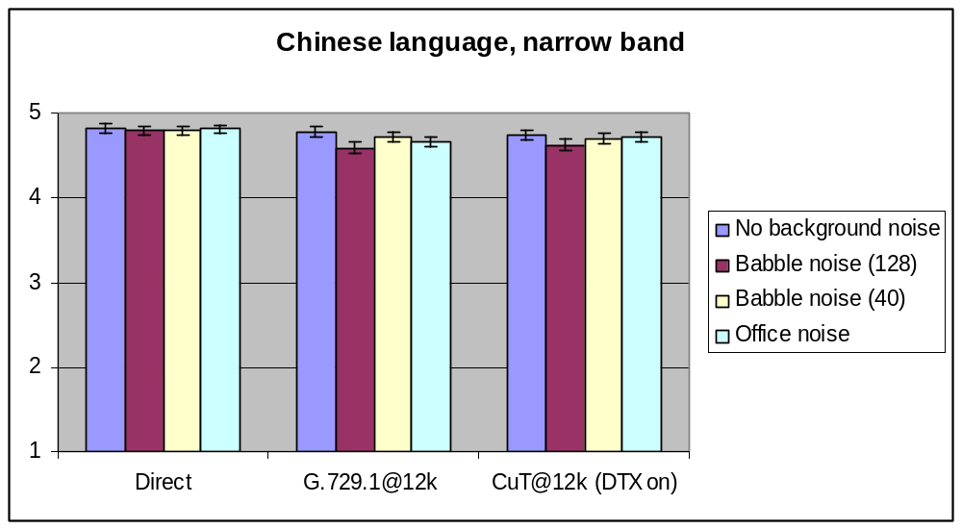
Figure 24: DTX/CNG Characterization results in Exp. 1a (Narrowband speech) in Lab A

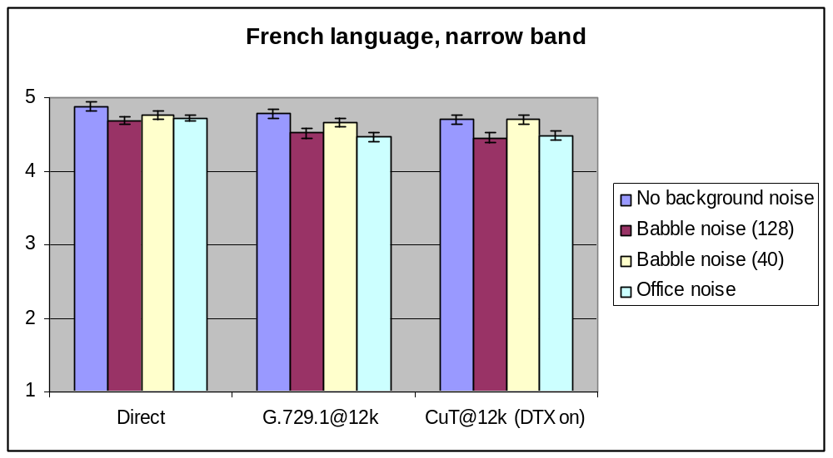
Figure 25: DTX/CNG Characterization results in Exp. 1a (Narrowband speech) in Lab B

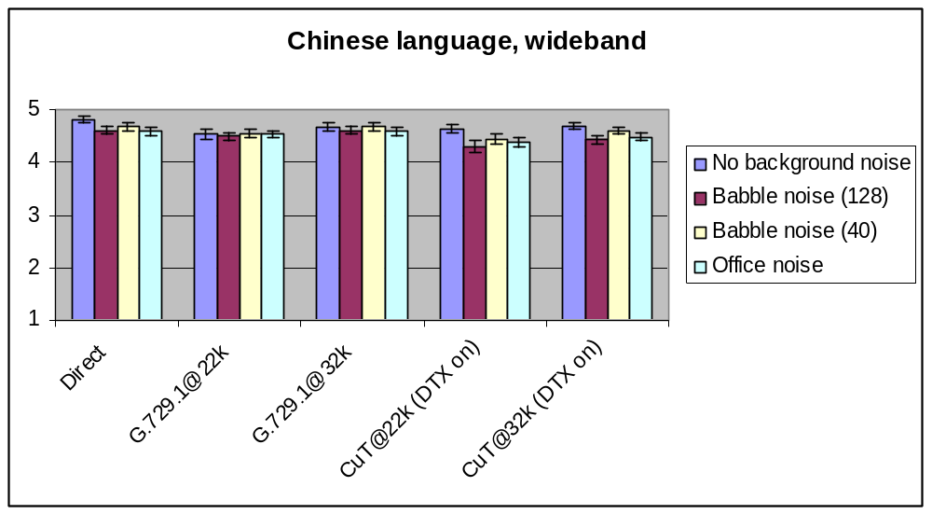
Figure 26: DTX/CNG Characterization results in Experiment 1b (Wideband speech) in Lab A

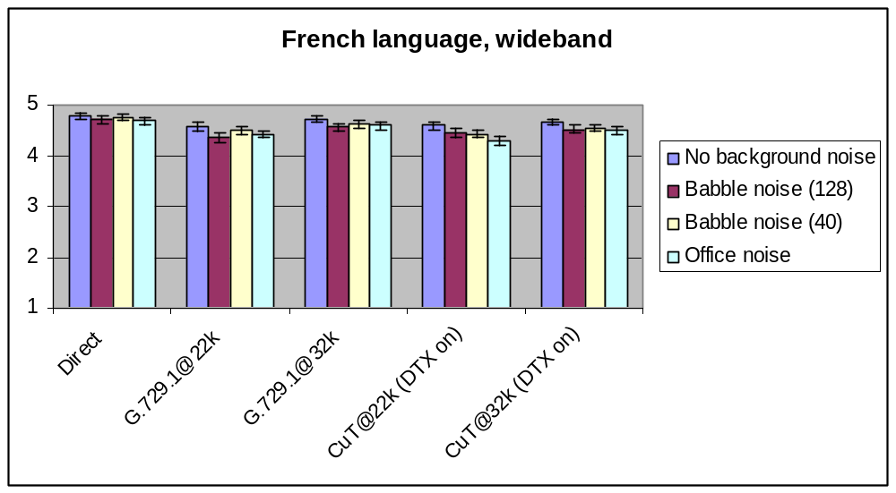
Figure 27: DTX/CNG Characterization results in Experiment 1b (Wideband speech) in Lab B

Informal subjective test results
TD 332/WP3 (“G.729.1 DTX/CNG Optimization/characterization phase test results: Interoperability with G.729B, lost SID update superframes and objective performance”) describes the interoperability and lost SID update experiments and also provides additional data on the DTX efficiency and complexity.

Achieved requirements and objectives
In Experiment 1a (narrowband speech) all requirements are passed in both labs. All objectives are also passed in both labs i.e. the quality with DTX was not worse than the quality without DTX operation.
In Experiment 1b (wideband speech) all requirements are passed in both labs. All objectives (quality with DTX not worse than quality without DTX operation) but one are failed in Chinese (BIT) and some in French (France Telecom). The Failed objectives in French language are:
- CuT at 22k (DTX on) fails to be not worse than G.729.1 at 22k in both labs in presence of office noise.
- CuT at 32k (DTX on) fails to be not worse than G.729.1 at 32k in both labs in presence of office noise.
- CuT at 32k (DTX on) fails to be not worse than G.729.1 at 32k in both labs in presence of babble noise (40 voices).
In both labs and in narrowband and wideband, it can be noted that in absence of background noise G729.1 used with the proposed DTX/CNG scheme is not worse than G729.1.

G.729.1 Annex D: Floating point implementation
The standardization of the floating point implementation of G.729.1 Annex C was launched at the SG16 April 2008 plenary meeting.

Methodology
To assess the quality of the floating-point implementation under the various interoperability configurations, objective quality measurements have been performed using ITU-T P.862 (WB-PESQ [16]). PESQ is appropriate to check the performance of different arithmetic implementations of the same codec. The 2005 revision to Recommendation P.862 Annex A that describes the revised ANSI C reference implementation of PESQ including modes of operation for Recommendation P.862.1 (narrowband MOS-LQO mapping) and Recommendation P.862.2 (the wideband extension) has been used. Besides these formal objective quality assessment tests, quality was further checked with informal expert listening.

Objective test results
Following Q9/12 recommendation, various sets of quality assessment scores were computed; the tables given below are extracted from the results reported n AC-0809-Q10-37 ([18].)
Table 44 shows the results obtained for clean speech in the four interoperability configurations respectively in Narrowband at 12 kbit/s and wideband at 22 and 32 kbit/s on the database used for G.729.1 Annex C characterization phase (experiments 1a and 1b).
Table 45 shows the results for the fixed point codec (G.729.1 Annex C) and its alternative floating point implementation (G.729.1 Annex D) for noisy degraded files respectively in narrowband at 12 kbit/s and wideband at 22 and 32 kbit/s. The scores with the DTX off (G.729.1 or G.729.1 B) are also given.
Table 44: P.862 results for clean reference/clean degraded at 12, 22 and 32 kbit/s
Bitrate | Bandwidth | Fixed Codec | Fix enc./Flt dec. | Flt enc./Fix dec | Float Codec
12 kbit/s | Narrowband | 3.90 | 3.90 | 3.90 | 3.89
22 kbit/s | Wideband | 3.38 | 3.43 | 3.48 | 3.55
32 kbit/s | Wideband | 3.55 | 3.60 | 3.65 | 3.72
Table 45: P.862 results for clean reference/noisy degraded at 12, 22 and 32 kbit/s
Bitrate | Bandwidth | DTX | Noise type | Float Codec | Fixed Codec
12 kbit/s | Narrowband | On | Office noise | 3.03 | 3.04
12 kbit/s | Narrowband | On | Babble noise (40) | 3.49 | 3.49
12 kbit/s | Narrowband | On | Babble noise (128) | 3.00 | 3.00
12 kbit/s | Narrowband | Off | Office noise | 3.05 | 3.06
12 kbit/s | Narrowband | Off | Babble noise (40) | 3.52 | 3.52
12 kbit/s | Narrowband | Off | Babble noise (128) | 3.02 | 3.01
22 kbit/s | Wideband | On | Office noise | 2.09 | 2.10
22 kbit/s | Wideband | On | Babble noise (40) | 2.86 | 2.86
22 kbit/s | Wideband | On | Babble noise (128) | 2.15 | 2.16
22 kbit/s | Wideband | Off | Office noise | 2.11 | 2.12
22 kbit/s | Wideband | Off | Babble noise (40) | 2.91 | 2.89
22 kbit/s | Wideband | Off | Babble noise (128) | 2.19 | 2.16
32 kbit/s | Wideband | On | Office noise | 2.04 | 2.06
32 kbit/s | Wideband | On | Babble noise (40) | 2.90 | 2.89
32 kbit/s | Wideband | On | Babble noise (128) | 2.11 | 2.12
32 kbit/s | Wideband | Off | Office noise | 2.07 | 2.06
32 kbit/s | Wideband | Off | Babble noise (40) | 2.95 | 2.95
32 kbit/s | Wideband | Off | Babble noise (128) | 2.14 | 2.12

___________________

