International telecommunication union
Telecommunication Standardization Bureau
 |  |  |  | Geneva, 8 November 2021
Ref: |  | Addendum 1 to  TSB Collective letter 16/13  SG13/TK |  | - To Administrations of Member States of  the Union;  - To ITU-T Sector Members;  - To ITU-T Associates of Study Group 13;  - To ITU Academia
Tel: |  | +41 22 730 5126
Fax: |  | +41 22 730 5853
E-mail: |  | tsbsg13@itu.int
Web: |  | http://itu.int/go/tsg13
Subject: |  | Virtual meeting of ITU-T Study Group 13, 29 November-10 December 2021
Dear Sir/Madam,
I wish to inform you that draft new Recommendations ITU-T Y.3057 “A trust index model for ICT infrastructures and services”, Y.3805 “Quantum Key Distribution Networks - Software Defined Networking Control” and Y.3606 “Big data - deep packet inspection mechanism for network big data” received substantial comments during the Last Call period of AAP-110, dated 16 August 2021.
The comments resolution for these draft Recommendations is still in progress and since a planned study group meeting is sufficiently close, the Acting Chairman of Study Group 13, in consultation with TSB, took the decision to consider these draft Recommendations for approval at the 29 November-10 December 2021 Study Group 13 virtual meeting, in accordance with Recommendation ITU-T A.8, § 4.4.2, as reflected in TSB AAP-115, dated 1 November 2021, for draft Recommendation ITU-T Y.3057 and will be captured in the TSB announcement AAP-116 of 16 November 2021 for draft Recommendations ITU-T Y.3805 and Y.3606. Corresponding documentation is available in TDs 643, 646, 647/WP3 for draft Recommendation Y.3057, TDs 644, 648, 649 for draft Recommendation Y.3805 and TDs 799, 800 and 801/WP2 for draft Recommendation Y.3606.
I wish you a productive and enjoyable meeting.
Yours faithfully,  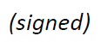  Chaesub Lee  Director of the Telecommunication  Standardization Bureau | 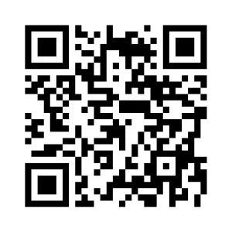 ITU-T SG13
 | Latest meeting information

