General Secretariat (SG)
 |  |  | Geneva, 2 February 2022
Ref: | DM-22/1000 |  | To Member States of ITU Council
Contact: | Ms Béatrice Pluchon
Telephone: | +41 22 730 6266
E-mail: | gbs@itu.int
Subject: | Consultation by correspondence on the change of place and dates of the World Telecommunication Development Conference 2021 (WTDC-21)
Dear Madam/Sir,
On 21 January 2022, Member States of the ITU Council held an informal consultation to discuss the preparations for the upcoming WTDC, WTSA and Council.
After further discussion on the issues raised in the circular letter DM-21/1025 dated 6 December 2021 from the Chairman of Council, the Councillors were in agreement that hosting the WTDC in Addis Ababa, Federal Democratic Republic of Ethiopia, was no longer a feasible option, and united in their wish to maintain the conference in Africa if possible. On the understanding that the fallback venue (in the absence of a new host) would be Geneva, the meeting sought proposals for an alternate venue from African Member States. Following this request for proposals, the Councillor from Rwanda informed the meeting of Rwanda’s willingness to host the conference in Kigali, which received unanimous support from the meeting.
I am pleased to inform you that on 30 January 2022 the Secretary-General received an official invitation from the Government of Rwanda to hold the next WTDC in the city of Kigali from 6 to 16 June 2022, immediately preceded by the Youth Summit starting on 2 June 2022.
In accordance with No. 42 of the Convention, the Council shall determine the precise place and exact dates of a WTDC with the concurrence of a majority of the Member States. Any changes to these decisions are also subject to the same process.
…/…
Consequently, I hereby invite Member States of the ITU Council to inform the Secretary-General of their concurrence with the change of place and dates of WDTC-21 as described above using the online tool or using the template in Annex 1 by e-mail to memberstates@itu.int, not later than Tuesday 8 February 2022. The agreement of the Council on the matter will then be subject to the concurrence of the majority of the Member States of ITU, as per No. 46 of the Convention. The secretariat remains at your disposal if needed.
I look forward to receiving your reply.
Yours faithfully,
(signed)
Dr Elsayed Azzouz
Chair of the Council
Annexes: 2
Annex 1 – Consultation on the change of place and dates of the World Telecommunication Development Conference 2021 (WTDC-21)
Annex 2 – Invitation letter from Rwanda

ANNEX 1
Consultation on the change of place and dates of WTDC-21
Name of the Member State of the Council:
We agree to the change of place and dates of WTDC-21 to Kigali, Rwanda, from 6 to 16 June 2022:
Yes  No   Abstention 
Councillors are kindly invited to send their reply via the online tool, or alternatively by e-mail to memberstates@itu.int not later than Tuesday 8 February 2022.

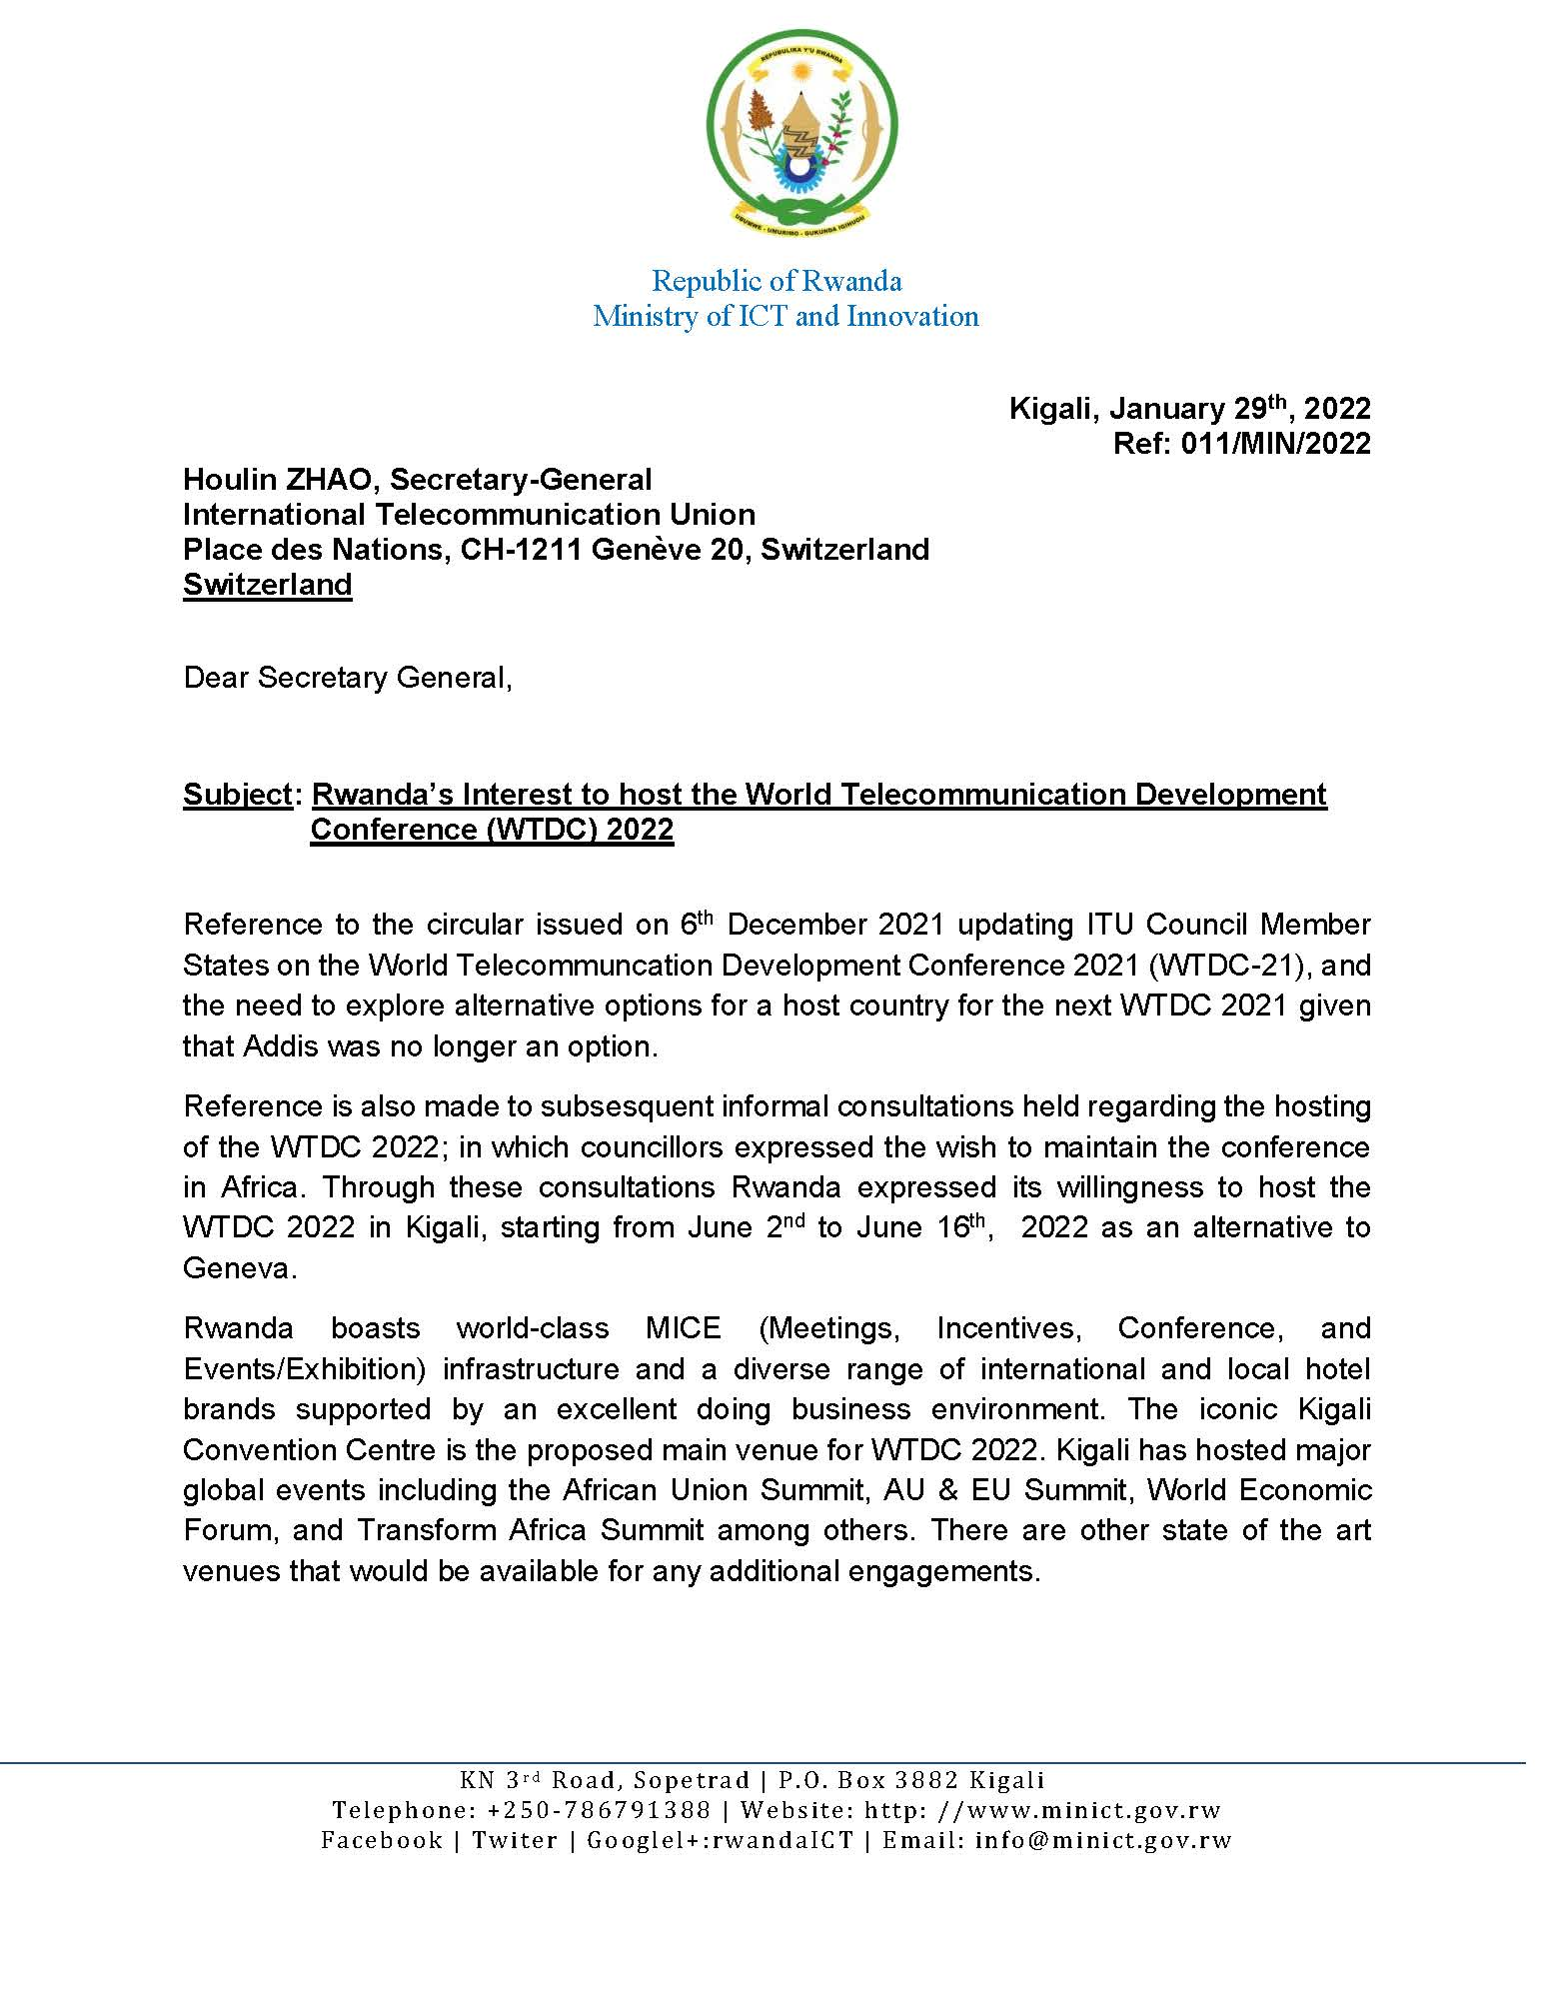

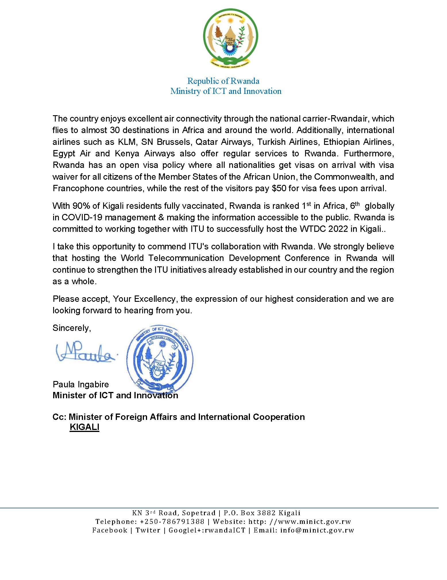

Online tool: Each Councillor can access directly the online tool by using her/his ITU User account with TIES access login details (username and password). Only one Councillor will be able to answer on behalf of his/her Council Member State. Any Councillor wishing to designate another person to respond to the Consultation through the online tool is invited to inform ITU via memberstates@itu.int, providing the Username of that designated person. Please note that the online tool is in English only.

