ITU - Telecommunications Standardization Sector  STUDY GROUP 16  Video Coding Experts Group (Question 15)  _________________  Ninth Meeting: Red Bank, New Jersey, 19-22 October, 1999 | Document Q15-I-38  Filename: q15i38.doc  Generated: 9 Oct. ’99

Question: | Q.15/SG16
Source: | J. Shen and J. Ribas-Corbera  Sharp Labs of America  5750 NW Pacific Rim Blvd  Camas, WA 98607 | Tel:  Fax:  Email: | (360) 817-8487  (360) 817-8436  jordi@sharplabs.com
Title: | More experiments and low-complexity AMA for H.26L
Purpose: | Proposal
_____________________________

This contribution provides more information on our proposal for AMA (adaptive motion accuracy), which was recently presented in Berlin [1].

1. Introduction
The current test model TML1 proposed by Telenor for H.26L [2] achieves high compression efficiency, both in terms of PSNR and subjective image quality, with a reasonable level of computational complexity. In the inter-coded frames, TML1 consists of :
- a) a motion compensation scheme that uses variable block sizes (16x16 or smaller), an improved filter interpolator, and 1/3-pel motion accuracy, and
- b) a prediction error encoder that applies an integer transform on each 4x4 block, quantizes the transform coefficients, and then codes the quantized coefficients with VL codes.
AMA allows the encoder to adapt motion accuracy at each 16x16 macroblock. Specifically, the encoder can compute and encode motion vectors with 1/2, 1/3, and 1/6 pixel accuracy, instead of only 1/3. The encoder selects the best motion vector for each macroblock using TML1’s RD criteria and encodes the accuracy mode and vector/s for the macroblock using the codec’s single VLC table.
The observations from Berlin’s contribution [1] were the following:
- AMA is basically a minor extension on TML1. It requires a very small change in the bit stream syntax of H.26L and does not increase the decoder’s complexity.
- In complex video sequences, AMA provided coding gains of about 0.5-1 dB in PSNR over TML1, which corresponded to bit rate savings in the range of 5-13 percent. These gains represented 30-50 percent of the total gain over the optimized H.263+ anchor.
- The coding gains were visually noticeable in some cases.
- In easier scenes, the gains were not significant, but the performance was always as good or better than that of TML1 without AMA.
- The relative gains of AMA remain similar whether the encoder uses one or multiple reference frames.
In this contribution, we present more experiments with AMA, which confirm that it can provide coding benefits in a wider variety of scenes.
We also describe a new encoder implementation of AMA that provides most of the coding benefits with a minimum of computation and memory requirements.

- Adaptive Motion Accuracy (AMA)
AMA is motivated by the techniques in [3,4], which achieved significant compression gains by adapting motion accuracy according to the complexity and compression noise in the video sequence. To be more concrete, the methods in [3,4] showed that when a scene is complex (i.e., with much motion and texture) higher motion vector accuracy leads to bit rate savings, particularly at higher bit rates. Conversely, low motion accuracy saves bit rate for easy scenes encoded at low bit rates.
Next we describe the few changes necessary to implement our AMA technique into an H.26L decoder. Later, we will discuss a new encoder implementation of AMA and will present new experimental results.

2.1 Decoder
We modified the decoder in TML1’s software [2] at the macroblock layer. The decoder finds the motion accuracy of the vector/s in the macroblock by decoding 1 or 2 bits at the marcroblock layer according to Table 1. Such table is a little different from the one proposed in Berlin [1]. It contains the first three entries from TML1’s unique VLC [2], but without the redundant 0 bit in the last two entries, as suggested by the Chair Dr. Gary Sullivan.

Code | Motion Accuracy
1 | 1/3-pel
01 | 1/2-pel
11 | 1/6-pel
Table 1. VLC table to indicate the accuracy mode for a given macroblock.

The following bits in the macroblock layer will indicate the value of the vector/s in the respective accuracy space. The key idea is that these bits are interpreted differently depending on the motion accuracy for the macroblock. For example, if the motion accuracy is 1/3 and the code bits for the x component of the difference motion vector are 00001, the x component of the vector is vx= 2/3. If the accuracy is 1/2, such code corresponds to vx= 1.
Once the motion vector is decoded, the associated block in the previous frame is reconstructed using a typical 4-tap cubic interpolator [6]. There is a different 4-tap filter for each motion accuracy. Currently, TML1 uses a cubic-like, 4-tap filter for the 1/3-pel case.
Observe that AMA does not increase decoding complexity, because the number of operations needed to reconstruct the predicted block are the same, regardless of the motion accuracy.
2.2 Encoder
In the first step of TML1’s motion estimation, the encoder searches for the best pixel-accurate motion vector V₁ that minimizes an effective RD criteria. In the second step, it searches for the best sub-pixel accurate vector V_{1/3} in a grid of 1/3-pixel resolution that is centered on V₁. A total of 8 sub-pixel locations are tested, as illustrated in Figure 1. Since the grid can contain a circle of 1 unit radius, we will say that such grid is of 1/3-pixel resolution and radius 1.

Figure 1. Illustration of full-pel and 1/3-pel locations in velocity space. TML1 finds the the best 1/3-pel motion vector in the 8 locations around the best full-pel vector V₁.

In order to implement AMA, we modified the second (sub-pixel) step of this process, so that the encoder also searches for motion vector candidates in other sub-pixel locations in the velocity space. We considered full search (as in Berlin [1]) and a new fast search strategy, which we describe next.

2.2.1 Full-search AMA
In this case, the encoder checks all the motion vector candidates in a grid of 1/6-pixel resolution of radius 5 and selects the best vector, i.e., the one that minimizes the RD criteria. This approach is computationally complex since it searches 120 sub-pixel candidates, as shown in Figure 2. Nevertheless, we used it to explore the full potential of our method.
In general, any RD criteria of the type “distortion + Lambda*bits” would work with our approach. However, with AMA the number of bits for a motion vector candidate should include the bits for the vector and those for its accuracy mode. In fact, observe that some candidates can have several bit values, because they can have several accuracy modes. For example, the candidate at location (1/2, -1/2) can be thought of having 1/2 or 1/6 pixel accuracy.
Figure 2. Location of motion vector candidates for full-search in sub-pixel velocity space.

2.2.2 Low-complexity AMA (AMALC)
In Berlin [1], we suggested a fast-search approach for AMA that achieved similar coding gains at a fraction of the computational complexity.
Here we present a new fast-search approach that is even simpler and refer to this method as the low-complexity AMA or AMALC.
AMALC is a small variation on the technique described in [7], in which we present a low-complexity implementation for estimating 1/3-pel motion vectors in H.26L. Specifically, AMALC can be explained in the following four steps:

- Up-sample the reference frame using bilinear interpolation (instead of TML1’s cubic-like filter) and only by 2x2 (instead of 3x3).
- At each macroblock, use 1/2-pel motion vectors to decide which is the best block-size pattern (e.g., 16x16, four 8x8, etc.)
- Do a small search (only three or four locations) around the best 1/2-pel vector to find the best 1/3 motion vector for each sub-block in the macroblock (now using TML1’s cubic-like filter). See the appendix of [7] for details on this step.
- Check the eight 1/6-pel motion candidates around the best 1/3 vector.

Out of all the motion candidates checked, we simply select the candidate (and accuracy) that produce the lowest RD cost.

This process is illustrated in Figure 3 for a particular case. The best 1-pel (integer-pel) motion vector for a given block in a macroblock is V₁. The best 1/2-pel, 1/3-pel, and 1/6-pel vectors are V_{1/2}, V_{1/3}, and V_{1/6}, respectively. The motion candidates checked are also shown in the figure.

Figure 3. An example of the location of motion vector candidates for AMALC.

Table 2 compares the computation and memory requirements of the current TML1 and this new simple approach.

 | Fast memory | Interpolations  (per pixel)
TML1 | 9*size | 8 cubic
AMALC | 4*size | 3 bilinear + {10,11} cubic
Table 2.

Observe that the fast memory requirement is reduced by a factor 2.25 (i.e., 9/4) and that the number of (complex) cubic interpolations is only two or three more. (The relative effect of the bilinear interpolations should be minor.) We will show later in the experimental results that the running time of both techniques was very close.

3. Experimental Results
We tested TML1 with and without AMA in a variety of video sequences, resolutions, and frame rates. The tests as described in Table 2. Sections 3.1 and 3.2 show rate-distortion (RD) plots for each case. Section 3.1 presents the results for the H.26L common testing conditions, which correspond to the top six experiments in the table. Section 3.2 presents additional tests on more complex video sequences.
Each rate-distortion plot includes the following curves :
- TML1 : Current test model TML1 of H26L
- TML1+AMA: Full-search AMA
- TML1+AMALC: Low-complexity AMA
The encoder and decoder were verified so that they matched in the three cases.

Video sequence | Resolution | Frame rate
Container | QCIF | 10
Foreman | QCIF | 10
News | QCIF | 10
Silent | QCIF | 10
Hall | QCIF | 10
Paris | CIF | 15
Mobile | QCIF | 10
Garden | QCIF | 15
Tempete | QCIF | 15
Trash | QCIF | 15
Forest | QCIF | 15
Paris shaked | QCIF | 10
Table 2. Description of the experiments

As it was shown in [1], AMA does not provide any significant coding gain for the common testing conditions (e.g., the PSNR is usually within plus or minus 0.1 dB). This is because in such cases the best motion accuracy happens to be either 1/3-pel or near 1/3-pel, and hence there is no benefit from using other accuracies.
The video sequences “mobile”, “garden”, and “tempete” are well known by the video coding community. They are harder to compress than typical video phone scenes. They contain the kind of complex motion and textures present in many video sources for multimedia applications, and hence we also used them as part of our experiments. We obtained “mobile” (QCIF) from the MPEG4 set and “garden” and “tempete” (SIF) from the RPI ftp site at “ipl.rpi.edu”. We down-sampled “garden” and “tempete” to QCIF using the default Lanczos filter from Image Magick (v. 4.2.8).
The video sequences “trash” and “forest” were obtained from two segments of a film known as “The secret of life on earth” (produced and directed by 70mm Inc). They are provided in order to show additional examples of where AMA can provide coding benefits, as requested by the group.
“Paris_shaked” is a synthetic sequence obtained by shifting the sequence “paris” by a motion vector whose X and Y components take a random value within [-1,1]. The sub-pixel locations were interpolated using a cubic interpolator. This synthetic sequence simulates small movements caused by a hand-held camera in a typical video phone scene.
In Section 3.3, we present plots that compare the running time of the algorithms. Finally, Section 3.4 compares AMA to fixed motion accuracy, i.e., when the accuracy is fixed for the whole sequence to either 1/2, 1/3, or 1/6.

3.1 Experimental results on common testing conditions

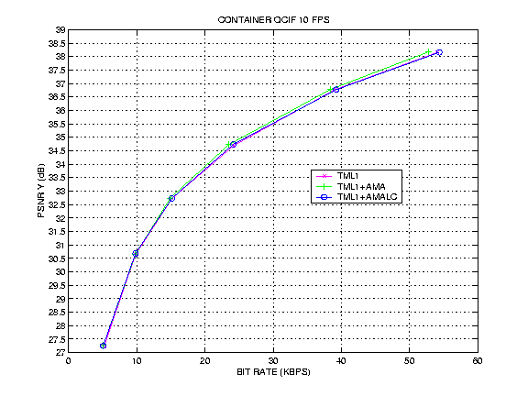
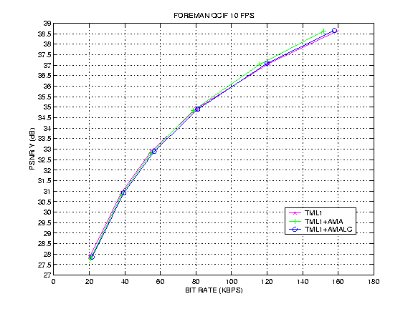
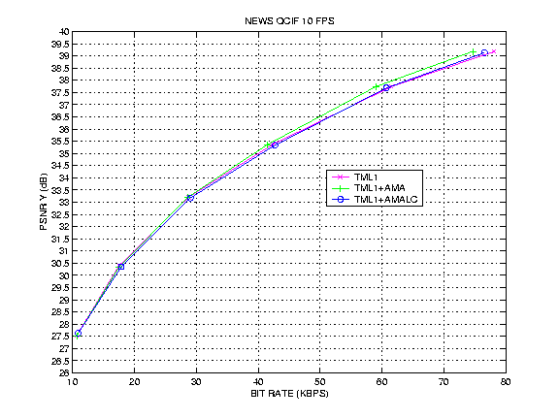
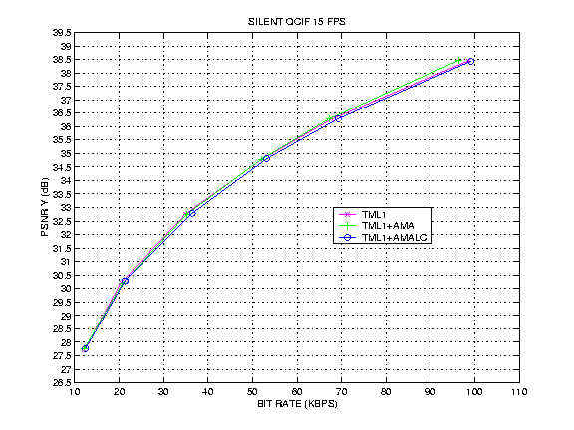
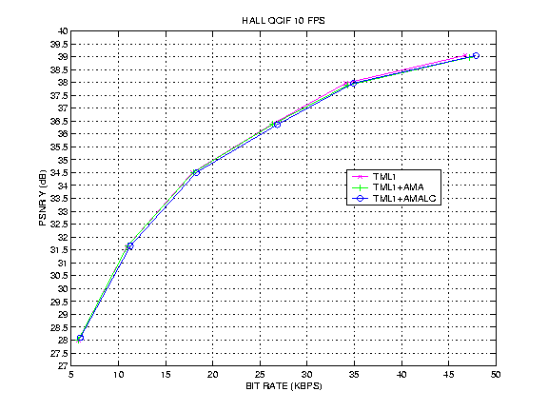
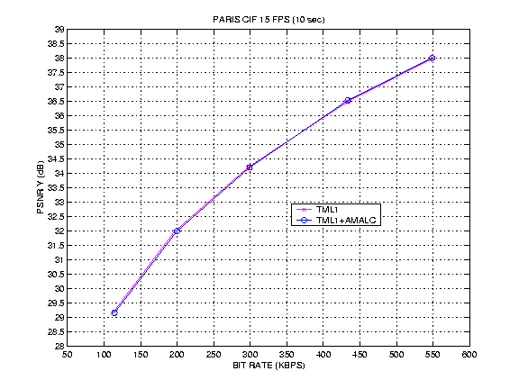
  - Experimental results on complex video sequences

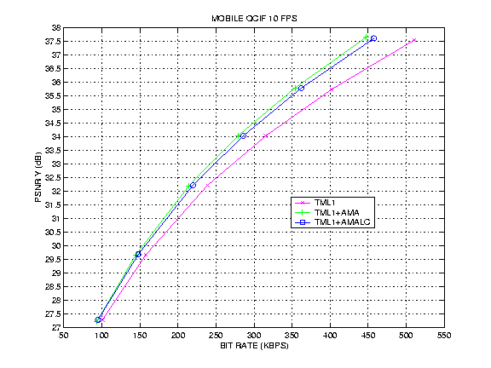

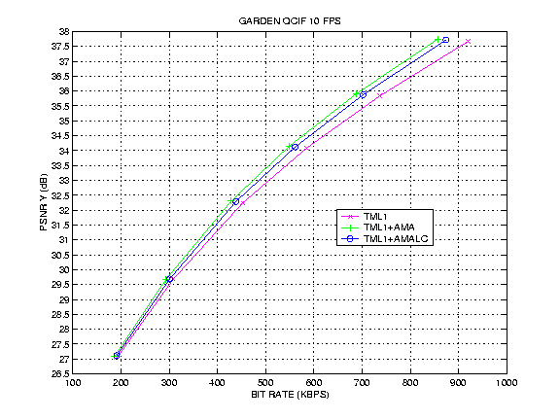

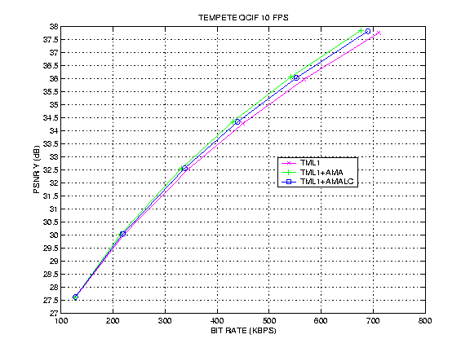
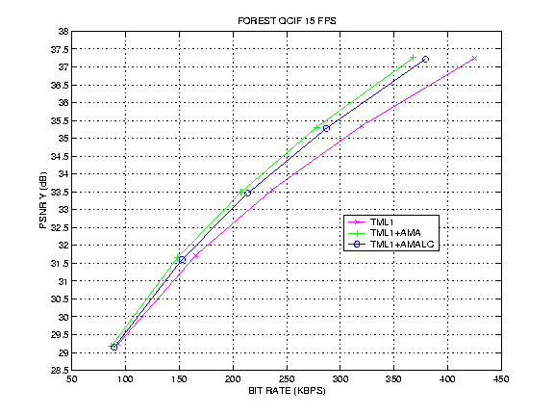

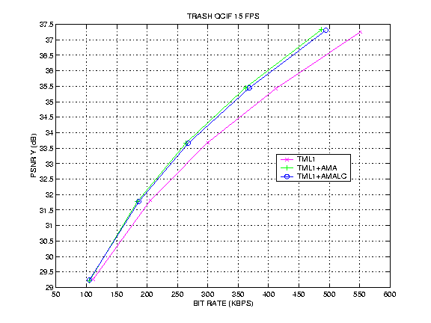

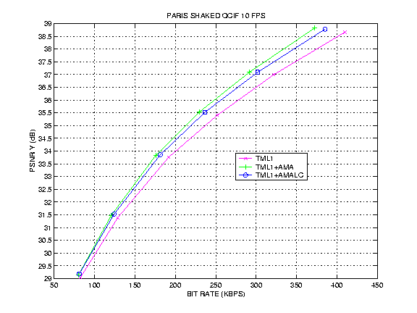

Multiple reference frames

The plot below shows that the relative coding gains from AMA are maintained when several reference frames are considered (as it was shown in [1]). In this example, we used 5 reference frames.

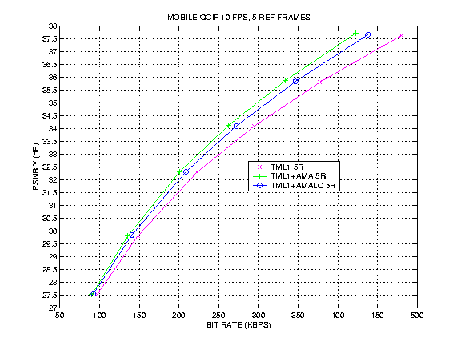

3.3 Run-time results

The plots in the figures below show the running time (versus bit rate) of TML1 and TML1+AMALC in a Sun Ultra 10 workstation. The time was obtained from the time utility in Telenor’s TML1 codec. These results will certainly vary depending on the details in the implementation and the computer platform, but nevertheless they suggest that the complexity of both techniques is relatively close.

The full-search version of AMA took about five times longer to run, which makes it more appropriate for off-line encoding (e.g., video streaming).

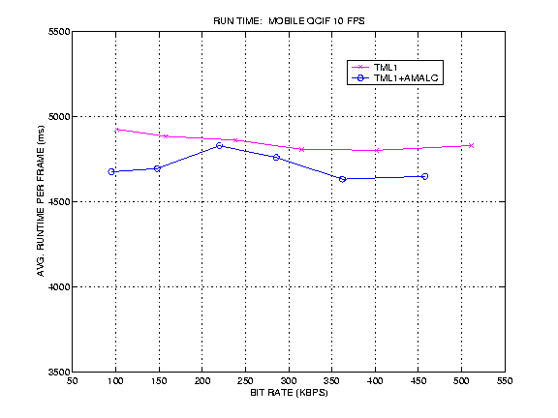

3.3 Comparison to fixed motion accuracy

Another approach for AMA could modify the accuracy on a frame-by-frame basis. To do this effectively, some research issues need to be resolved, as we discussed in [1] (e.g., some predictor is needed to choose the best accuracy for a given frame before that frame is encoded). However, the study in [3,4] indicated that the best frame-based motion accuracy should not change for different frames within a scene, since the level of texture and noise is roughly the same in all the frames. Therefore, we decided to encode several sequences with several fixed motion accuracies. Our results below show that AMA performs as well or better than the fixed-accuracy cases.

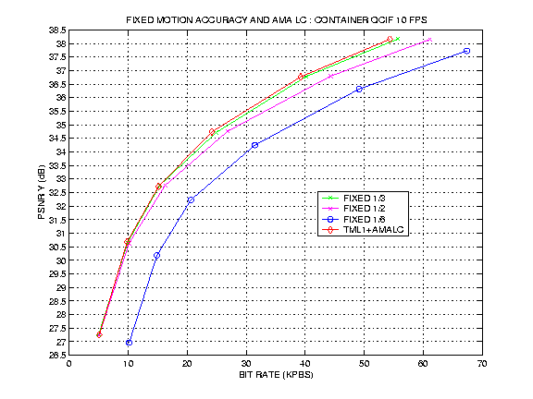
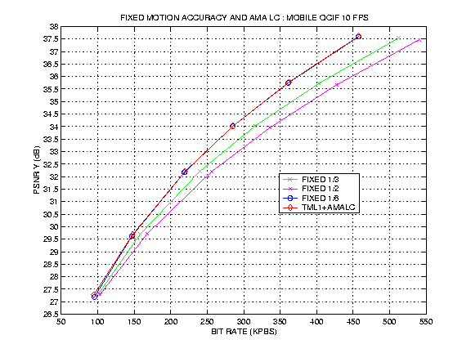

4. Conclusions

- AMA provides significant compression gains in complex video scenes. For example, we obtained PSNR gains of about 0.5-1 dB (i.e., about 5-15 percent in bit rate savings) for sequences such as “mobile”, “garden”, “tempete”, “paris_shaked”, “trash” and “forest”.
- As discussed in [1], the gains in complex sequences represented about 30-50 percent of the gain over the optimized H.263++ anchor.
- AMA does not increase the complexity of the decoder.
- With low-complexity strategies, the encoder complexity can be as low as to that of TML1. In fact, our AMALC reduced the fast memory requirements and run a little faster than TML1 in a Sun Ultra 10 workstation.
- The only change required in the H26L syntax for AMA is the insertion of a 1 or 2-bit code at macroblock level to indicate the macroblock’s motion accuracy.
- The benefits of AMA have been cross-verified by an independent implementation from LG Electronics [5].
As a result, we propose to incorporate the syntax changes required by AMA into H.26L.

5. References

[1] J. Shen and J. Ribas-Corbera, “Adaptive motion accuracy (AMA) in Telenor’s proposal,” ITU-T SG16/Q15, doc. Q15-H-20, Berlin, Aug. 99.
[2] Test Model TML1, ITU-T SG16/Q15, doc. Q15-H-36, Berlin, Aug. 99.
[3] J. Ribas-Corbera and D. Neuhoff, “On the optimal motion vector accuracy for block-based, motion-compensated video coders,” Proc. SPIE 2727 (Digital video compression: algorithms and technologies), pp. 811-817, March 96.
[4] J. Ribas-Corbera and D. Neuhoff, “Optimizing block-size in motion-compensated video coding,” Journal of Electronic Imaging, 7 (1), pp. 155-165, Jan. 98.
[5] Y.-S. Soh and M.-C. Hong, “Cross-check results of H.26L AMA (Q15-H-20),” ITU-T SG16/Q15, doc. Q15-I-31, Red Bank, Oct. 99.
[6] R.G. Keys, “Cubic convolution interpolation for digital image processing.” IEEE trans. on Acoustics Speech and Si gnal Processing, Vol. 29, pp. 1153-1160, Dec. 81.
[7] J. Shen and J. Ribas-Corbera, “Low-complexity 1/3-pel motion estimation for H.26L,” ITU-T SG16/Q15, doc. Q15-I-37, Red Bank, Oct. 99.

Observe that this code is the fourth entry (code number 3) of TML1’s VLC table in [1].

