ITU - Telecommunications Standardization Sector  STUDY GROUP 16  Video Coding Experts Group (Question 15)  _________________  Eighth Meeting: Berlin, Germany, 3-6 August, 1999 | Document Q15-H-26  Filename: q15h26.doc  Generated: July 28th, 1999

Question: | Q.15/SG16
Source: | Hyun-Duk Cho, Yoo-Sok Saw, and Victor V. Redkov  LG Information & Communications  533, Hogye-dong, Dongan-gu, Anyang-shi, Kyoungki-do, 431-080, Rep. Of Korea | Tel:  Fax:  Email: | +82 343 450 2956  +82 343 450 2944  chohd@lgic.co.kr
Title: | The VERA - A simulation software for evaluating error resilience performance
Purpose: | Information
_____________________________

1. Introduction
In this contribution, we present a simulation software, whose name is VERA. The VERA is abbreviation of “LG’s simulation software performing Video Error Resilience Algorithm.” The VERA provides user-friendly environment that enables us to evaluate various kinds of simulations.
It supports three algorithms: H.263 without any error resilience algorithm [1], MPEG-4 error resilience algorithm such as data partitioning, RVLC and video packetization [2], and the method scheduled to be presented at Berlin meeting [3]. In VERA, the first two methods are defined as the reference codec, and the last methods are defined as the proposed codec.
It enables us to set various encoding and decoding parameters easily by graphic user interface. Since it has the error generation program, we can experiment on various error environments.

2. How to use it
Fig. 1 shows the environment setting screen. The graphic user interface of this software perform a function call the execution program that a user want. So, first of all, a user must specify specifies the target execution program. As mentioned previously, this software accepts two kinds of algorithms; the reference codec and the proposed codec. Consequently, four programs have to be linked; the reference encoder, the reference decoder, the proposed encoder and the proposed decoder.
As shown in Fig. 1, there are two buttons in the middle part of the screen. The button is for the reference codec and the button (the symbol of LG) is for the proposed codec. If these buttons are clicked, then they will be highlighted to and . So, after clicking a button, user have to write the path and the program corresponding to the button. For example, if is clicked, it will be highlighted and you have to write the path and the program corresponding to the reference encoder and decoder. In case of the proposed codec, you may just do the same process.
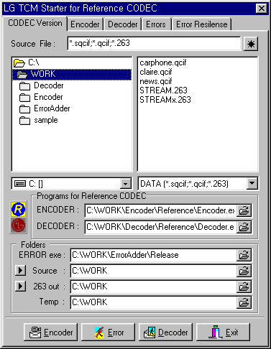
Fig.1 Environment setting screen

And, this software adopts error generation programs proposed by MPEG[4]. So, the path of it has to be specified.
After setting contents in this screen, the encoder parameter has to be set in the next screen. (See Fig. 2) If the encoder button in the bottom part of this screen after setting parameters, the encoder will work.
And, in case of decoder, a user may just do the same process. (See Fig.3)

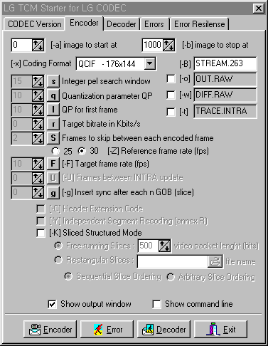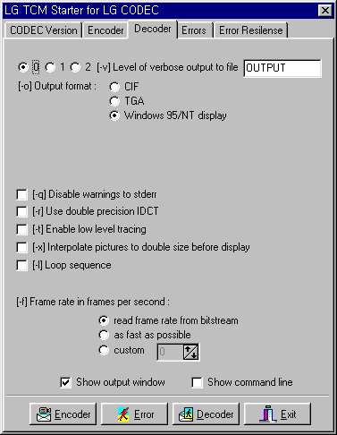
Fig. 2 Encoder parameter setting screen Fig. 3 Decoder parameter setting screen
A user has to set error parameters for adding emulated channel errors to a bit stream. (See Fig. 4.) The error button in the bottom part of this screen will add the errors.
Finally, Fig. 4 shows the final screen, in case that a user clicks the button in the first screen, and Fig. 5 shows the final screen, in case that a user clicks the button .

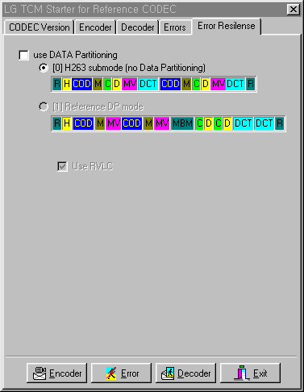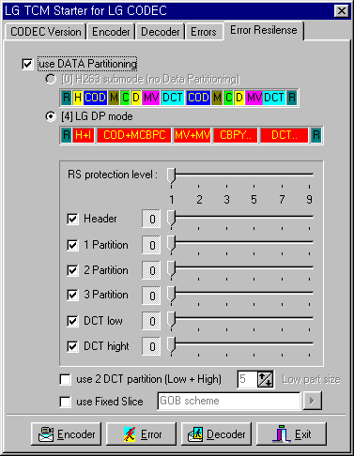
Fig. 4 The final screen when the reference Fig. 5 The final screen when the proposed
codec button is selected. codec button is selected.

As shown in Fig. 4, a user can select one codec among H.263 without error resilient algorithm and MPEG-4 data partitioning and RVLC algorithm. And, as shown in Fig. 5, a user can select the RS protection level and 2 DCT partition mode (Refer [3].)

3. Conclusions
The VERA software helps us make various experiments. We believe the VERA will improve the standardization activities, on behalf of LG Information and Communications Ltd.

Reference

[1] ITU-T Recommendation H.263, “Video coding for low bit rate communication,” 1997.
[2] ISO/IEC JTC1/SC29/WG11 14496-2 Committee Draft, “Information technology – Coding of audio-visual objects: Visual,” Tokyo, March 1998.
[3] ITU-T Q15-H-26, “A New Error Resilient Coding Method using Data Partitioning and Reed-Solomon Protection,” Berlin, Aug. 1999.
[4] ISO/IEC JTC1/SC29/WG11 1496, Nov. 1996

