ITU - Telecommunications Standardization Sector  STUDY GROUP 16  Video Coding Experts Group (Question 15)  _________________  Eighth Meeting: Berlin, 03-06 August, 1999 | Document Q15-H-09  Filename: q15h09.doc  Generated: 09 July ’99

Question: | Q.15/SG16
Source: | Kui Zhang and Josef Kittler  CVSSP, School of EEIT&M  University of Surrey  Guildford, Surrey, UK | Tel:  Fax:  Email: | +44-1483-876045  +44-1483-876031  K.Zhang@surrey.ac.uk
Title: | Proposed Amendments for Annex U on Enhanced Reference Picture Selection
Purpose: | Proposal
_____________________________
Abstract
It has been widely accepted that the use of multi-frame motion-compensated prediction can improve the coding efficiency of the video coding system. The upcoming H.263++ has adopted the method as one of its options (Annex U)[4]. The use of more than one past frame in the motion-compensated prediction can significantly improve the coding efficiency. In some special situations, the gain could be substantial such as in sequences with repeating scene cuts. However, the use of long-term memory scheme in such situations often involves large memory requirement and high computational costs. Here, we propose an amendment to the existing scheme to enable it being used in such situations more effectively without the need to increase the memory requirement and computational costs unnecessarily.

1. Introduction
A repeating scene change is a common feature found in many video applications such as surveillance cameras, conversational shot in a film, news and sports broadcasting etc. The cycle of the scene repetition ranges from a few seconds in a close up conversation to a few minutes in news and sports broadcasting. Such a change in the video scene will cause the scene cut frame to be coded in the INTRA mode as the correlation between the scene cut frame and its immediate previous frame is likely to be quite small. As INTRA coded frames require more bits to be transmitted than INTER coded frames, they can cause a buffer overflow in a fix-rate transmitting channel. This problem will be particularly significant in low bit rate applications. As pointed out earlier [2], there are three alternative ways to absorb such a burst of bit rate, each having a different effect on the video quality: increasing the quantisation step will lower video quality; dropping out a few following frames will freeze the picture; increasing the buffer length will create longer delays.

The combination of the first two options is widely used in the current rate control mechanism such as TMN-10 of H.263 to deal with the scene-change frame. The recent developments employing more memory to achieve better coding efficiency provide alternative solutions. The multiple thread background memory scheme [2] and the long term memory scheme [1] are two examples. However, the long-term memory scheme is only effective when dealing with a repeating scene-change if the memory length is sufficient to cover the scene-change cycle. In practice, this approach may require thousands of frames of memory to achieve this objective. In news broadcasting for instance, scene cuts typically happen with the frequency of a few seconds to a few minutes. The coverage of one minute of video material will require 1800 frames to be stored. Therefore, it becomes impractical simply to increase the capacity of the long-term memory to solve the problem. On the other hand, the multiple thread background memory is capable of dealing with a repeating scene change of arbitrary length but its application is restricted to sequences with a stationary background. Here, we extend our previous work [2] and propose a new scheme which combines the multiple thread memory and long-term memory ideas into an integrated scheme that can be used in almost any type of video sequences.

2. Multiple-Thread Long-term Memory Motion Prediction
In our previous work [2], a scene change detector and multiple background memory were used to improve the efficiency of coding uncovered background regions and the scene cut frames. An exponential moving average number of INTRA coded macroblocks and a percentage thresholding are used to detect each scene change and partial scene change frame in a video sequence. The memory requirement for the scheme only depends on the number of scenes to be stored so that a very long scene repetition cycle can be accommodated. One of the major drawbacks of the scheme is that it can only be applied to sequences in which the background is stationary. This seriously restricts the scheme's application range. In order to overcome this drawback, we use long-term memory motion prediction to deal with uncovered background regions and multiple thread memory to deal with repeating scene cuts.

2.1 Long-term Memory Motion Prediction
The long term memory scheme proposed in [1] extends the motion vector by a frame reference parameter permitting the use of several reference frames for motion-compensated prediction. Such an extension can significantly improve the accuracy of motion compensated prediction and consequently a better coding efficiency can be achieved. However, both the computational load and memory requirements are linear functions of the number of reference frames used in the scheme. Interestingly, it has been noted that the most significant gain with the scheme is obtained when using a small number of reference frames. When the number of reference frames increases, the additional benefit from using extra frames diminishes. One exceptional case is when there is a repeating scene change in the sequence and the length of the reference memory can cover the scene change cycle. Due to the restrictions imposed by the computational load and memory requirements, the number of reference frames stored is normally less than 50 and that can only cover 2 seconds of video material at 25 frames/second.

2.2 Using Multiple-Thread Memory Scheme with Long-term Memory
The multiple thread memory scheme can deal with multiple repeating scene changes at a low computational cost. The memory requirement only depends on the number of scenes to be stored. Both the computational cost and memory requirements are independent of the scene repetition cycle. Thus in principle the scheme can be used for sequences with long scene repetition cycles. To improve the coding efficiency between two scene cuts, the above mentioned ``long-term'' memory scheme can be employed. For each scene cut, a fixed length ``long-term'' memory is used to form a multiple thread long-term memory prediction system. Figure 1 gives a schematic diagram for the encoder. We use an Access Variable (AV) associated with each memory thread to indicate its status. Initially, all AVs are initialised to 100 to indicate an empty state. When a memory thread is in use, its AV will be set to zero whereas the values of all the other AVs is increased by one until they reach 100. When a scene cut frame is detected, the scene matching will be conducted involving memory threads with AV less than 100. If a scene match is found, the AV of the thread with the matching scene is set to zero whereas the values of all the other AVs are increased by one until they reach 100. If no scene match is found, the thread with a maximum AV is used to store the new scene.

2.3 Changes to Annex U syntax
With a small change to the syntax of Draft Annex U, the multiple thread feature can easily be integrated. We only need to add two fields to the ERPS layer to add the multiple thread feature to the Annex as shown below.

NRPA | RPBS | RPS | RPB | RPI | RPP | API | APP | MTI | MTN

Where MTI and MTN are additional fields and are defined as follows:
Multiple Thread Indicator (MTI) (variable length)
MTI is a fixed length code word that is present only if the Enhanced Reference Picture Selection layer is indicated. If MTI is set to 0, current thread of picture memory is used. If MTI is set to 10, a different thread of picture memory will be used for prediction specified in the following MTN field. If MTI is set to 11, a new thread of picture memory is created and its index is indicated by the MTN field that follows.

Multiple Thread Number (MTN) (variable length)
MTN is a variable length code word that is present only if the Enhanced Reference Picture Selection layer is present and the MTI is not set to 0. The code table as given in Table U.1 is used to specify the thread index number of the multiple picture memory. If MTI is set to 10, MTN will be the thread to be used for prediction and will be set as the current thread. If MTI is set to 11, MTN will be the thread number to start a new multiple picture memory and any previous contents in that thread will be overwritten.

The use of multiple thread picture memory only slightly increases the bit consumption in a scene change frame or when ERPS layer is present. The benefit of adding this feature to the current Annex U syntax is apparent when there are repeating scene changes in the sequence being coded.

3. Experimental Results
Experiments are conducted on a synthetically composed sequence consisting of three 100-frame clips from ``Akiyo'', ``Weather'' and ``silent''. In Figure 2, the numbers of bits per frame used to encode the sequences are presented. The figure clearly shows that the scene cut frame is associated with a sudden increase in the number of bits used. The use of the multiple thread memory scheme can significantly reduce the number of bits consumed for a repeating scene cut. Table 1 gives the average PSNR and bit rate results obtained. The results show that the multiple thread memory scheme can improve the coding efficiency slightly when compared with the long-term scheme using the same number of memory frames. This benefit derives from the fact that the number of scene cut frames is usually only a small fraction of the overall number of video frames. The major benefit of using the proposed scheme is the relatively stable bit rate distribution that alleviates sudden video quality deterioration around scene cut frames.

4. Conclusions
The proposed multiple thread long-term memory motion prediction scheme improves the coding efficiency in sequences with repeating scene-changes or partial scene-changes. It can significantly reduce the number of the INTRA coded macroblocks in repeating scene cut frames. The scheme not only provides a practical means to deal with repeating scene changes, but it can also cope with video material containing multiple scene compositions as illustrated in our experiment. The low computational cost and low bit consumption of the proposed scheme make it an attractive additional feature of the Annex U. Therefore, we propose such a feature be added to the Annex U.

References:
[1] T.Wiegand, X.Zhang, and B.Girod, Motion-compensating long-term memory prediction, In ICIP-97, volume II, pages 53--56, Santa Barbara, CA, USA, October, 1997.

[2]K Zhang and J Kittler, Using scene-change detection and multiple-thread background memory for efficient video coding, Electronics Letters, 35(4):290--291, 1999.

[3]. K Zhang and J Kittler, A background memory update scheme for h.263 video codec, In EUSIPCO-98, Island of Rhodes, Greece, pages 2101--2104, September 8 - 11, 1998.

[4]. Thomas Wiegand, Niko Faerber, Bernd Girod and Barry Andrews, Proposed Draft for Annex U on Enhanced Reference Picture Selection, Q15-G-18, Study Group 16 Video Coding Expert Group (Question 15) Seventh Meeting, February 1999, Monterey, CA, USA.

Table 1
Thread | LTM Length | PSNR(dB) | Bit Rate (kbps)
1 | 8 | 32.38 | 74.32
1 | 24 | 32.39 | 74.17
3 | 2 | 32.34 | 67.69
3 | 8 | 32.43 | 64.68

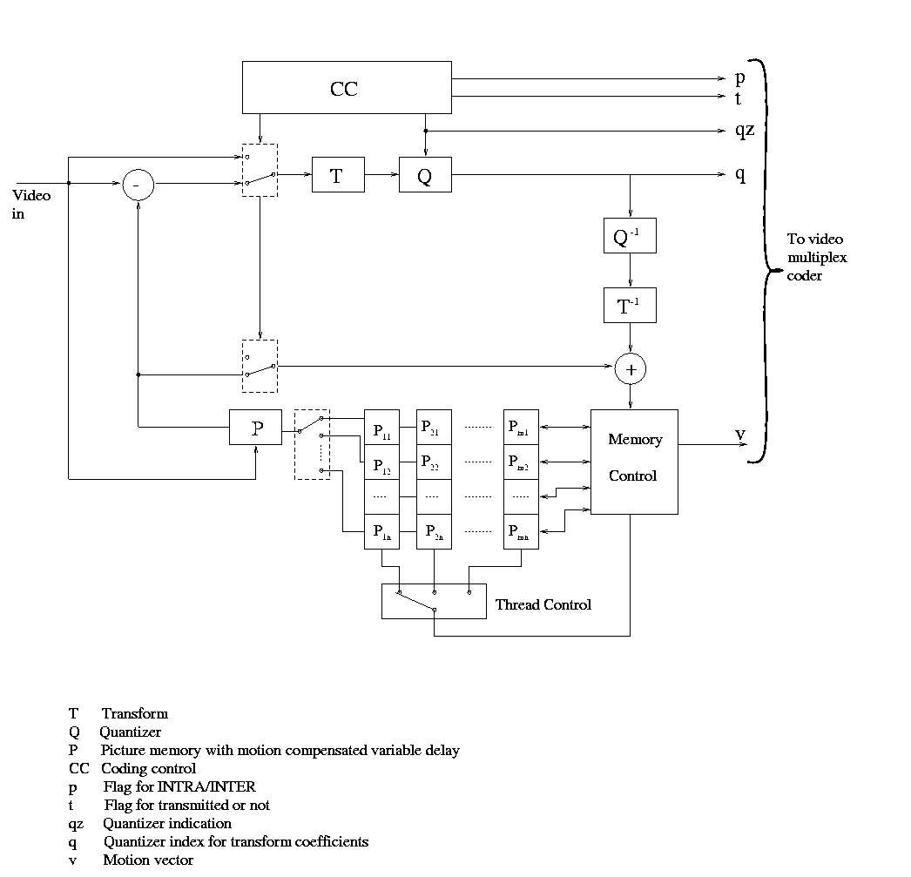
Figure 1 Diagram of Multiple Thread LTM Coder

Figure 2 Number of Bits Per frame for Combined Sequence

