ITU – Telecommunications Standardization Sector  STUDY GROUP 16  Video Coding Experts Group (Question 15)  _________________  Seventh Meeting: Monterey, 16-19 February, 1999 | Document Q15-G-22  Filename: q15g22.doc  Generated: 09 Feb ’99

Question: | Q.15/SG16
Source: | Hwangjun Song, Jongwon Kim and C.-C. Jay Kuo  Univ. of Southern California  3740 McClintock Ave. Los Angeles, CA, USA. | Tel:  Fax:  Email: | +1 - 213 - 740 4656  +1 - 213 - 740 4651  {hwangjun, jongwon, cckuo} @sipi.usc.edu
Title: | Performance analysis of real-time encoding frame rate control proposal
Purpose: | Proposal
_____________________________
- Introduction

In this document, the improved performance of our previous real-time encoding frame rate control algorithm proposal (Q15-F-14), especially the low complexity version, is demonstrated under more realistic channel bandwidth environments. In addition, as a clarification, we want to address that the proposed encoding frame rate control is completely compatible with TMN8 rate control algorithm by employing TMN8 rate control algorithm as a macroblock layer rate control component.

The objective of proposed rate control scheme for H.263+ is to keep the quality of P-frames in the tolerable range under sudden motion change and time-varying communication channel environments without obvious degradation in the perceptual motion smoothness. The proposed rate control algorithms adjust the encoding frame rate adaptively based on the temporal motion to keep the image quality of each P-frame in a tolerable range. Since it is difficult to support good quality in both spatial and temporal resolution (in terms of motion smoothness) at very low bit rates, an encoding frame rate control is adopted for a tradeoff of spatial/temporal quality based on the motion in video and the available channel bandwidth. It is observed that human eyes are sensitive to the abrupt encoding frame rate (or interval) change. Our scheme aims at the reduction of temporal degradation in terms of motion jerkiness perceived by human beings. At the same time, no encoding time-delay is imposed for real-time processing.

We explain the proposed rate control algorithm under time-varying CBR and the relation with TMN8 rate control algorithm in Section 2, and we show the experiment results under various channel bandwidth conditions to verify that the proposed encoding frame rate control works in Section 3. In addition, we will show D-1 tape demos for performance comparison.

- Real-time Rate Control based on R-D Models under Time-varying CBR

We model the time-varying channel bandwidth as piecewise constant (time-varying CBR). It can include feedback-VBR, renegotiated-CBR and approximation of VBR and so on. We consider a rate control algorithm, which is robust to time-varying channel bandwidth and compatible with the existing TMN8 rate control algorithm. The proposed rate control algorithm consists of three layers as shown in the flow chart of the proposed rate control algorithm in Fig. 1: [Layer1] encoding frame rate control, [Layer2] frame rate control, and [Layer3] macroblock layer rate control. TMN8 rate control algorithm is employed as a macroblock layer rate control tool.

No
Yes
Yes
No
BEGIN
Update R-D database
and
Derive R-D models
Calculate or detect
available channel
bandwidth

Estimate
The distortion

Keep the current
frame interval
Increase the frame
Interval by
Calculate the target
bit rates for the current
frame
Run the macroblock
layer rate control
(TMN8 rate control)
Continue?
END
Fig. 1. Flow chart of the proposed encoding frame rate control algorithm
2.1. Frame layer rate and distortion models

We have chosen a variation of frame layer R-D modeling approach that constructs both the rate and distortion models with respect to the averaged quantization parameters (QP's) of all macroblocks in each frame. It can be viewed as a hybrid statistical/experimental method. To be more specific, the quadratic rate model and the affine distortion model are employed for the data fitting process while rate control results of the macroblock layer (TMN8) are used to determine the coefficients of the frame layer R-D model. Thus, required computational complexity for the frame layer R-D modeling is negligible. In terms of mathematics, the rate and distortion models can be written, respectively, as:
$\begin{aligned}\hat{R}({\bar{q}}_{i})=(a{\bar{q}}_{i^{−1}}+b{\bar{q}}_{i^{−2}})⋅\text{MAD}(f_{\text{ref}},f_{\text{cur}}), \\ \hat{D}({\bar{q}}_{i})=a'{\bar{q}}_{i}+b\text{',}\end{aligned}$

where $a,b,a'\text{ and }b'$ are model coefficients, $f_{\text{ref}}$ is the reconstructed reference frame at the previous time instant, $f_{\text{cur}}$ is the uncompressed image at the current time instant, ${\bar{q}}_{i}$ is the average QP of all macroblocks in a frame, $\hat{R}({\bar{q}}_{i})\text{ and \{}\hat{D}({\bar{q}}_{i})$ are the rate and distortion models of a frame respectively, and $\text{MAD}(f_{\text{ref}},f_{\text{cur}})$is the mean of absolute difference between $f_{\text{ref}}\text{ and }f_{\text{cur}}$.

We implemented an outlier removal process to improve the model accuracy. That is, if the difference between a data point and the derived model is greater than one standard deviation, the datum is removed. Based on filtered data, we derive the rate and distortion models again. Thus, as shown in Fig. 1, we can get a reasonable R-D models.

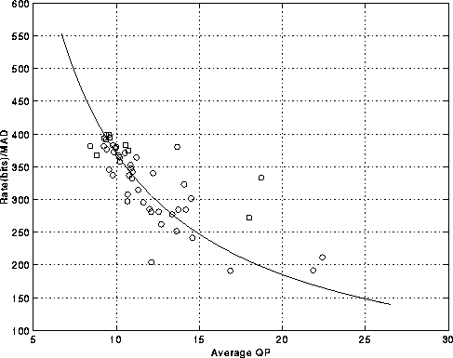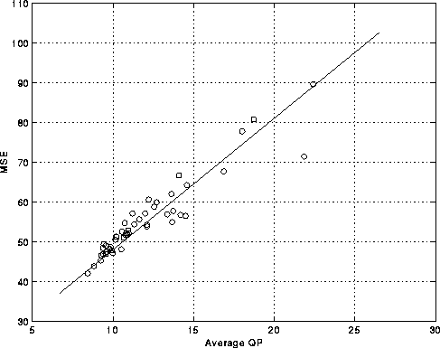
(a) (b)

Fig. 1. Frame layer R-D modeling results for the QCIF Salesman sequence:
(a) the rate model and (b) the distortion model as a function of the average QP of macroblocks, respectively.

2.2. [Layer 1] Encoding frame rate control algorithm (low complexity version)

Based on the above rate and distortion models, we can estimate the distortion of current frame. Since ${\bar{q}}_{i}$>0, the estimated distortion $\hat{D}$ can be expressed as follows:
$\hat{D}=a'a⋅\text{MAD}(f_{\text{ref}},f_{\text{cur}})+\sqrt{(a⋅\text{MAD}(f_{\text{ref}},f_{\text{cur}}))^{2}+4b⋅B(F_{\text{cur}}^{\text{int}})⋅\text{MAD}(f_{\text{ref}},f_{\text{cur}})}\begin{aligned}\frac{2B(F_{\text{cur}}^{\text{int}})}{B(F_{\text{cur}}^{\text{int}})=\frac{F_{\text{cur}}^{\text{int}}}{\text{30}}⋅C_{\text{tcbr}}\text{.}}\end{aligned}+b\text{',}$
where $C_{\text{tcbr}}$ is the current channel bandwidth and $F_{\text{cur}}^{\text{int}}$ is the current encoding frame interval under the assumption the camera captures frames at a rate of 30 fps. Note that $\hat{D}$ increases when fast motion change occurs (with an increasing $\text{MAD}$) or when the channel bandwidth decreases (with a decreasing $B(F_{\text{cur}}^{\text{int}})$) suddenly.
Now, let us consider the frame rate control scheme. If the spatial quality is below a tolerable level due to fast motion change or sudden channel bandwidth decrease, we should reduce the temporal quality and improve the spatial quality in order to reduce the flickering artifact. At the same time, it is still desirable to control the temporal quality degradation. On the contrary, if the spatial quality is above a certain level, we should increase the temporal quality. Thus, the encoding frame rate control algorithm can be stated as follows:
$\begin{aligned}\text{If \{}\hat{D}>{\text{TH}}_{d1},\text{ then increase the encoding frame interval by }{ΔF}^{\text{int}}(F_{\text{cur}}^{\text{int}})\text{.}\end{aligned}\text{If \{}\hat{D}<{\text{TH}}_{d2},\text{ then decrease the encoding frame interval by }{ΔF}^{\text{int}}(F_{\text{cur}}^{\text{int}})\text{.}\text{Otherwise keep the current encoding frame interval,}$

${ΔF}^{\text{int}}(F_{\text{cur}}^{\text{int}})=\left\lceil 0\text{.}3⋅F_{\text{cur}}^{\text{int}}\right\rceil$where ${\text{TH}}_{d1}$ and ${\text{TH}}_{d2}$ are two threshold values to be selected. Next, ${ΔF}^{\text{int}}(F_{\text{cur}}^{\text{int}})$ is chosen based on the empirical rule described as follows.

Where $\left\lceil x\right\rceil$ is the smallest integer number which is larger than $x$.

By adopting this rate control scheme, we can avoid the abrupt change of the encoding frame rate and improve the spatial quality. This algorithm can be applied in real-time processing since the computational complexity is very low and low latency can be guaranteed.

2.3. [Layer 2] Frame layer rate control algorithm (low complexity version)

If the encoding frame interval is determined, we can calculate the bit rates for the current frame under the time-varying CBR as follows.

$$B^{t\text{arg}\text{et}}=\begin{aligned}\left\{(F_{\text{cur}}^{\text{int}}+ΔF(F_{\text{cur}}^{\text{int}}){)⋅C_{\text{tcbr}}}/{\text{30}}\text{ if \{}\hat{D} | | {\text{TH}}_{d1,} | \right.\left\{(F_{\text{cur}}^{\text{int}}−ΔF(F_{\text{cur}}^{\text{int}}){)⋅C_{\text{tcbr}}}/{\text{30}}\text{ if \{}\hat{D} | | {\text{TH}}_{d2,} | \right.\end{aligned}$$

where $B^{t\text{arg}\text{et}}$ is the target bit rates for the current frame. Then, we employ TMN8 rate control algorithm to allocate the bit rates for the current frame to each macroblock efficiently.

- Experimental Results

For the simulation, we implemented our rate control algorithm by modifying the UBC’s implementation of an H.263+ codec (version 3.1). Basically we implemented the encoding frame rate control algorithm under the framework of TMN8 rate control. In addition, to make it more conforming to the H.263++ simulation conditions, we evaluated the performance of our rate control with annexes D, F, I, J, and T. Also, for the time-varying CBR channel, the channel condition is modeled as follows.

$$\text{BW}={\text{BW}}_{\text{max}}−\left|Δ\text{BW}\right|$$

where ${\text{BW}}_{\text{max}}$ is the maximum channel bandwidth and $Δ\text{BW}$ is the channel bandwidth fluctuation, which is a Gaussian random variable with mean 0. We did experiments under three standard deviation values: 0 (CBR), low variance (${\text{BW}}_{\text{max}}$/6) and high variance (${\text{BW}}_{\text{max}}$/3). And the duration time for a channel bandwidth to stay constant is another random variable with a uniform distribution between 30 and 50 frames. Also, in this experiment, we set the above threshold values (${\text{TH}}_{1}$ and ${\text{TH}}_{2}$) for the frame rate control in Section 2.2 as follows.

$$\begin{aligned}{\text{TH}}_{1}=(1+c)⋅D_{\text{avg}}, \\ {\text{TH}}_{2}=(1−c/2)⋅D_{\text{avg}},\end{aligned}$$

where $c$is a constant and $D_{\text{avg}}$ is the average distortion of previous 5 encoded frames. $c$ is set to 0.03 and 0.05 for Silent Voice and Foreman, respectively.

Finally, among the extensive simulation results, we select the results for QCIF Foreman at maximum 48Kbps and QCIF Silent Voice at maximum 24Kbps considering the degree of inherent motion in video. First, in Table 1 and Table 2, the average PSNR and number of encoded frames are provided. The average PSNR is calculated by averaging the PSNR of only encoded frames without considering the skipped frames. As shown in Table 1 and Table 2, proposed variable frame rate control reduce the temporal resolution to keep the spatial quality in the tolerable ranges as the channel bandwidth fluctuation is increasing. Also in Fig. 3, Fig. 4, Fig. 5 and Fig. 6, the PSNR curve is depicted with the simulated channel condition side by side, where one can easily see the increased adaptation capability of the proposed rate control algorithm. To help best comparison of visual quality, we are planning to show D1 tape demos at Monterey.

Method | Average PSNR | No. of encoded frames
TMN8 (CBR) | 30.0892 | 139
TMN8 (std:4 kbps) | 29.6293 | 138
TMN8 (std:8 kbps) | 29.4601 | 130
VFR (CBR) | 30.3594 | 127
VFR (std:4 kbps) | 29.8696 | 127
VFR (std: 8 kbps) | 29.9255 | 105

Table 1. Performance comparison under time-varying CBR for QCIF Silent Voice.
Maximum bandwidth is 24 kbps.

Method | Average PSNR | No. of encoded frames
TMN8 (CBR) | 30.8537 | 97
TMN8 (std:8 kbps) | 30.1418 | 95
TMN8 (std:16 kbps) | 29.8753 | 96
VFR (CBR) | 31.6028 | 84
VFR (std:8 kbps) | 31.1692 | 75
VFR (std: 16 kbps) | 31.2522 | 69

Table 2. Performance comparison under time-varying CBR for QCIF Foreman.
Maximum bandwidth is 48 kbps.

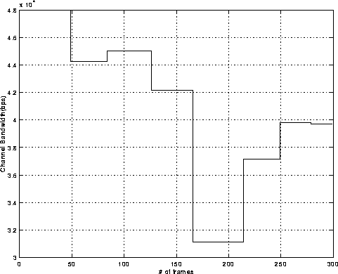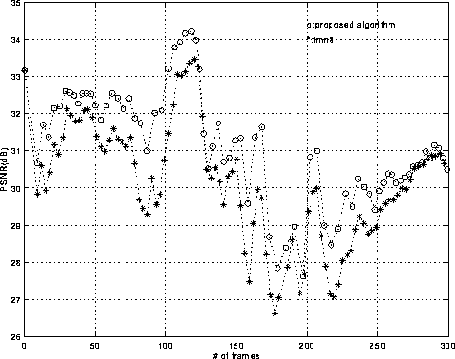
(a) (b)
Fig. 3. Performance comparison for QCIF Foreman under time-varying CBR with 8 kbps standard deviation (low variance case):
(a) the channel bandwidth variation plot, (b) the PSNR plot.

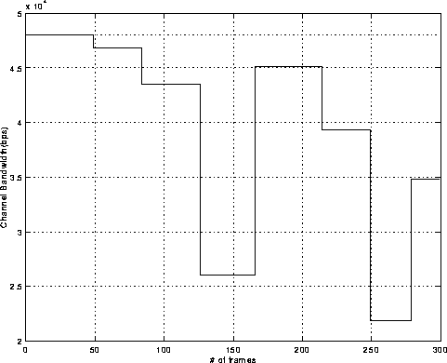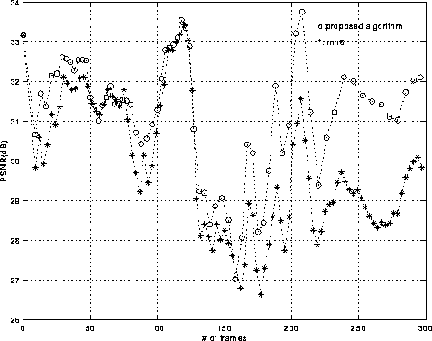
(a) (b)
Fig. 4. Performance comparison for QCIF Foreman under time-varying CBR with 16 kbps standard deviation (high variance case):
(a) the channel bandwidth variation plot, (b) the PSNR plot.

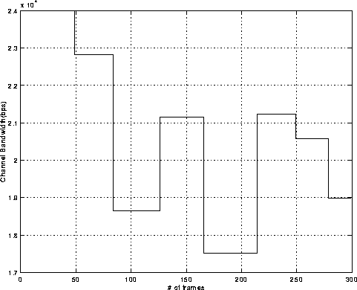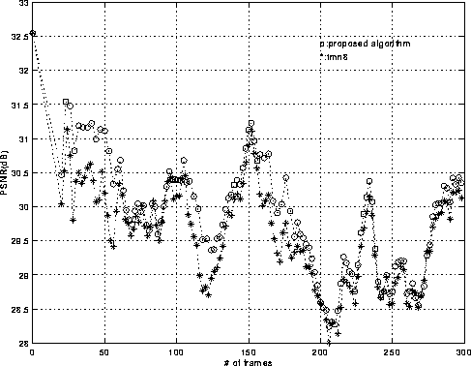
(a) (b)
Fig. 5. Performance comparison for QCIF Silent Voice under time-varying CBR with 4 kbps standard deviation (low variance case):
(a) the channel bandwidth variation plot, (b) the PSNR plot.

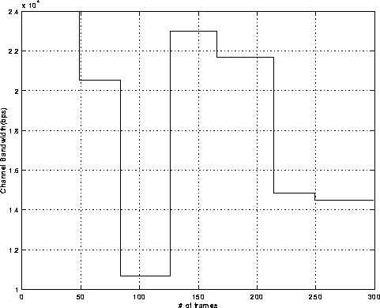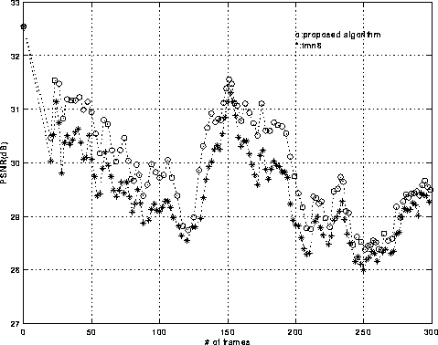
(a) (b)

Fig. 6. Performance comparison for QCIF Silent Voice under time-varying CBR with 8 kbps standard deviation (high variance case):
(a) the channel bandwidth variation plot, (b) the PSNR plot.

