ITU – Telecommunications Standardization Sector  STUDY GROUP 21 Question 6  Video Coding Experts Group (VCEG)  80th Meeting: 17 October – 23 October 2026, Hangzhou, China | Document VCEG-CB05-v1

Question: | 6/21 (VCEG)
Source: | Tsvetomira Tsoneva (Philips) | Email: | tsvetomira.tsoneva@philips.com
Title: | Evaluation of T.261 against IEC 60601 ECG and EEG Requirements
Purpose: | Informational
_____________________________

Summary
This document presents a codec-domain evaluation of ITU-T T.261 using synthetic ECG and EEG waveforms derived from selected performance requirements in four IEC medical electrical equipment standards. The evaluation examines how lossless and lossy compression affect waveform amplitude, frequency and pulse response, baseline recovery, DC-offset behaviour, multichannel crosstalk and temporal alignment across different input gains and quantization parameters.
Lossless reconstruction was bit-exact, and most evaluated waveform properties remained within the selected IEC-derived limits across the tested lossy configurations. The main exceptions were small deviations in the relative amplitude of short and long ECG triangular pulses, which exceeded a strict upper response limit of 100%, and reduced reconstruction fidelity for very-low-amplitude EEG signals at low gain and high QP. The latter was particularly evident in the 50 µV frequency-response tests, where attenuation of the reconstructed reference signal led to failures of the relative-response criteria.
The results demonstrate the value of evaluating biomedical waveform compression using signal-specific performance requirements alongside conventional rate–distortion measures. They also identify input resolution, quantization settings and reference-dependent measurements as important considerations when selecting lossy compression operating points. The evaluation is limited to the digital codec domain and does not establish conformity of complete medical electrical equipment with the cited IEC standards.

Scope
IEC 60601 standards series define basic safety and essential-performance requirements for medical electrical equipment and provide an important framework for device development and regulatory assessment. This document specifies a codec-domain signal-preservation benchmark for T.261 standard against selected test conditions and numerical limits derived from these standards, focusing on waveform characteristics relevant to clinical interpretation, monitoring, review, and further analysis. It considers T.261 not only as a compression method, but as part of the digital waveform chain, and examines whether these properties remain preserved after encoding and decoding.

Introduction
Biomedical waveform compression is intended to reduce storage and transmission cost while preserving the diagnostic and clinical value of the recorded signal. This means that compression performance cannot be assessed only in terms of coding efficiency. In addition to bitrate reduction and reconstruction quality, it is necessary to verify that the reconstructed waveform preserves the signal characteristics required for medical interpretation, monitoring, and downstream processing.
Medical device and health informatics standards play a central role in this context. They are used to ensure that physiological measurements are safe, clinically trustworthy, and interoperable across devices and systems. In practice, such standards define what level of performance is acceptable, how that performance should be verified, and how medical data should be represented and exchanged. For waveform data, this is particularly important because a compressed biosignal is not only a technical data stream: it may be used for diagnosis, patient monitoring, alarms, reporting, storage, retrospective review, or automated analysis. A compression method therefore has to preserve the signal fidelity ensuring clinically relevant waveform characteristics remain unchanged.
Across biosignal modalities, several families of standards are especially important. The IEC 60601 family is central for medical electrical equipment because it defines requirements for basic safety and essential performance, with particular standards for a range of device types and signal modalities. These include, for example, standards for electrocardiographs, electroencephalographs, pulse oximeters and photoplethysmographs, as well as other physiological monitoring equipment.
More broadly, the importance of compliance does not depend on the specific biosignal modality. Clinical systems do not judge a signal only by compression ratio or by mathematical reconstruction error. They rely on standards to ensure that the signal remains safe to use, clinically meaningful, and interoperable with the surrounding ecosystem. A technically efficient codec that changes waveform behavior in a way that could affect diagnosis, monitoring, or downstream interpretation would not be acceptable in practice. For this reason, evaluation against relevant standards is needed not only to demonstrate technical quality, but also to build confidence that the compression method can be used in realistic clinical and regulatory settings.

Objective
The objective of this report is to evaluate the preservation of selected ECG and EEG waveform properties following lossless and lossy T.261 compression, using synthetic test signals and acceptance criteria derived from IEC medical electrical equipment standards. The evaluation examines the influence of input gain and quantization parameter (QP) on reconstructed waveform fidelity, identifies configurations that meet or exceed the selected limits, and characterizes compression performance and observed failure patterns.
Specifically, the study aims to:
- Assess amplitude accuracy, frequency and impulse response, DC-offset behaviour, crosstalk and temporal alignment using clause-specific measurements.
- Evaluate reconstruction performance across the tested gain and QP combinations, including the alternative test routes permitted by the relevant IEC requirements.
- Characterize compression rate, PSNR and the main factors associated with reconstruction errors and failed criteria.
- Distinguish codec-domain findings from medical-equipment conformity requirements and identify limitations of the evaluation.

Standards included
The benchmark draws on selected ECG and EEG performance requirements from four IEC particular standards. Table 1 summarizes the equipment scope, signal modality and waveform properties considered from each standard.
Table 1: Standards and selected codec-relevant properties
Standard | Equipment covered | Signal modality | Main properties selected
IEC 60601-2-25 | Diagnostic electrocardiographs | ECG | Frequency response, impulse response, linearity, crosstalk, sampling/input conditions
IEC 60601-2-27 | ECG monitoring equipment | ECG | Amplitude accuracy, DC-offset response, frequency and impulse response, crosstalk
IEC 60601-2-47 | Ambulatory ECG systems | ECG | Linearity, frequency and impulse response, crosstalk, temporal alignment
IEC 80601-2-26 | Electroencephalographs | EEG | Amplitude accuracy, rate of variation, DC-offset response, frequency response

Selected clauses
The clauses below were selected because their essential performance requirements could be represented by controlled digital test signals and evaluated directly at the codec output after reconstruction. The selection therefore focuses on requirements that can be meaningfully translated into a digital signal-preservation test, including amplitude accuracy, frequency and pulse response, impulse recovery, crosstalk, temporal alignment, and dynamic-range/DC-offset behaviour. Where the original clause addresses complete equipment performance, only the part that can be isolated and assessed in the digital codec domain is implemented. Tables 2-5 summarize the selected clauses and their codec-domain implementation.

IEC 60601-2-25 Diagnostic electrocardiographs
Table 2: Selected IEC 60601-2-25 clauses
Clause | Clause topic | What the clause essentially tests | Codec-domain implementation
201.12.4.106.2 | Multichannel crosstalk | Whether a signal applied to one ECG channel appears in other channels. | Four-channel record; 30 Hz, 2.5 mV p-p triangle on one channel at a time. Measure inactive-channel p-p response relative to applied input.
201.12.4.107.1.1.1 | High-frequency response | Amplitude response across specified sine-wave bands or an alternative triangular-pulse route. | Methods A–D use fitted sine-amplitude ratios to a decoded 10 Hz response of the same family. Method E uses per-cycle 20 ms/200 ms peak-to-base ratios. Apply A AND [E OR (B AND C AND D)].
201.12.4.107.1.1.2 | Low-frequency/impulse response | Baseline displacement and recovery after a 3 mV, 100 ms impulse. | Measure the reconstructed pre-pulse baseline, maximum post-pulse displacement and maximum 200 ms windowed recovery slope.
201.12.4.107.2 | Linearity and dynamic range | Constancy of a 10 mV p-p, 40 Hz deflection at different recording positions. | Segment a 40 Hz sine shifted by an approximately 2 Hz square wave; fit the sine in each 250 ms position and retain the worst absolute deviation from 10 mV. This is a digital position proxy.
201.12.4.107.3 | Sampling, quantization and channel skew | Minimum acquisition rate, input-referred quantization and maximum timing skew between channels. | Check source/manifest sampling rate and BDF+ resolution; use simultaneous four-channel pulse edges as a reconstruction-skew diagnostic. This does not test acquisition hardware.

IEC 60601-2-27 ECG monitoring equipment
Table 3: Selected IEC 60601-2-27 clauses
Clause | Clause topic | What the clause essentially tests | Codec-domain implementation
201.12.1.101.1 | Accuracy of signal reproduction | Accuracy for ECG triangles at several amplitudes and visibility of a 20 Hz sine. | Measure decoded triangle p-p amplitude against the quantized BDF+ source; fit the decoded 20 Hz sine amplitude.
201.12.1.101.2 | Input dynamic range and differential offset | Preservation of a 10 mV p-p waveform with 0 and ±300 mV differential DC offset. | For each QP, divide decoded p-p amplitude at each non-zero offset by the decoded zero-offset p-p response.
201.12.1.101.5 | Multichannel crosstalk | Unwanted response in inactive monitoring channels. | Four-channel record; 30 Hz, 2.5 mV p-p triangle applied to one channel at a time; inactive p-p/input p-p ratio.
201.12.1.101.8 | Frequency and impulse response | Sinusoidal bandwidth, triangular-pulse response and baseline recovery. | Method A: 0.67 and 40 Hz fitted amplitudes relative to decoded 5 Hz. Method B: each of ten 20 ms pulse amplitudes relative to decoded 200 ms response. Impulse displacement and slope are also measured; all required parts are aggregated with AND.

IEC 60601-2-47 Ambulatory ECG systems
Table 4: Selected IEC 60601-2-47 clauses
Clause | Clause topic | What the clause essentially tests | Codec-domain implementation
201.12.4.4.101 | Linearity and dynamic range | Digital-recorder amplitude accuracy for triangular signals at several amplitudes and DC offsets. | Measure decoded p-p amplitude of 6.25 Hz triangles at 0.5, 1, 2 and 10 mV p-p and 0/±300 mV; compare every case directly with the source input.
201.12.4.4.107 | Multichannel crosstalk | Unwanted response in channels not receiving the ECG signal. | Four-channel record; 10 Hz, 4 mV p-p sine on one channel at a time; inactive p-p/input p-p ratio.
201.12.4.4.108 | Frequency and impulse response | Baseline/overshoot response and either sinusoidal or triangular-pulse frequency response. | Measure rectangular-impulse displacement, slope and overshoot, plus sine ratios and triangular-pulse ratios. Aggregate as impulse AND (sine OR triangle); report the conflicting 60% verification statement separately.
201.12.4.4.112 | Temporal alignment | Maximum timing difference between simultaneously recorded channels. | Use simultaneous 1 mV, 200 ms rectangular pulses on four channels and compare reconstructed rising/falling edge times. This is a condensed codec-domain proxy.

IEC 80601-2-26 Electroencephalographs
Table 5: Selected IEC 80601-2-26 clauses
Clause | Clause topic | What the clause essentially tests | Codec-domain implementation
201.12.1.102 | Accuracy of amplitude and rate of variation | Amplitude reproduction of scalp and cortical EEG triangles over specified amplitudes/rates. | Measure decoded p-p amplitude of 6 Hz scalp triangles (0.1–1 mV) and cortex/subdural triangles (2–20 mV) against the quantized BDF+ source.
201.12.1.103 | Input dynamic range and differential offset | Preservation of a 1 mV p-p, 6 Hz triangle with 0 and ±150 mV DC offset. | For each QP, divide decoded p-p amplitude at each non-zero offset by the decoded zero-offset p-p response.
201.12.1.105 | Frequency response | Relative EEG amplitude response at the low and high band edges. | Fit 50 µV p-p sines at 0.5, 5 and 50 Hz; divide the decoded 0.5 and 50 Hz amplitudes by the decoded 5 Hz response.

Excluded requirements
Requirements are excluded from the codec-domain evaluation when their assessment depends on equipment behaviour or measurements beyond the digital waveform at the T.261 input and output. These requirements remain relevant to medical-device performance but cannot be verified through codec testing alone. Table 6 summarizes the excluded requirement categories.
Table 6: Requirement types excluded from the codec-domain benchmark
Excluded requirement type | Reason for exclusion | Treatment in this report
Electrical safety, EMC, mechanical and environmental tests | Depend on physical equipment, isolation, leakage current, enclosure, power and environmental conditions. | Out of scope; no codec proxy.
Analogue front end, electrodes, lead wires and patient-cable behaviour | Require analogue signal injection, impedance networks, common-mode voltages and hardware channel paths. | Digital DC-offset/crosstalk tests are explicitly labelled as reconstruction proxies only.
Display, recorder, effective recording width and hard-copy measurements | Depend on gain controls, screen/print geometry, visibility and operator measurement. | Only the underlying digital waveform quantity is measured where a meaningful proxy exists.
Noise, CMRR and mains-interference rejection | Require analogue noise sources, common-mode injection and defined hardware test circuits. | Excluded from clause-derived pass/fail.
Alarms, heart-rate calculation, arrhythmia analysis and diagnostic interpretation | Depend on downstream algorithms and clinical decision logic rather than codec reconstruction alone. | Out of scope.
Proprietary or paywalled calibration waveform datasets | The required calibration signals are not openly available for reproducible publication. | Not used; no substitute waveform is claimed as equivalent.
Acquisition sampling hardware | The benchmark starts from a generated digital record and cannot prove how an ME device acquired it. | Source rate and input resolution are checked as test conditions; reconstruction skew is reported as a codec proxy.

References
The exact editions and amendment status shall be confirmed before publication.
[IEC 60601-2-25] IEC 60601-2-25, Medical electrical equipment — Particular requirements for the basic safety and essential performance of electrocardiographs, Edition 2.0 2011-10.
[IEC 60601-2-27] IEC 60601-2-27, Medical electrical equipment — Particular requirements for the basic safety and essential performance of electrocardiographic monitoring equipment, Edition 3.0 2011-03.
[IEC 60601-2-47] IEC 60601-2-47, Medical electrical equipment — Particular requirements for the basic safety and essential performance of ambulatory electrocardiographic systems, Edition 2.0 2012-02.
[IEC 80601-2-26] IEC 80601-2-26, Medical electrical equipment — Particular requirements for the basic safety and essential performance of electroencephalographs, Edition 1.1 2024-02.
[T.261] T.261 specification and reference software version 6.0, [insert approved document identifier and date].
[G8] American Clinical Neurophysiology Society. Guideline 8: Guidelines for recording clinical EEG on digital media. J Clin Neurophysiol. 2006 Apr;23(2):122-4.
[INCART] Yakushenko, E., St Petersburg INCART 12-lead Arrhythmia Database, version 1.0.0, PhysioNet, 2008

Terms and definitions

Terms defined elsewhere
Terms printed in capitals in the IEC standards retain the definitions given in the applicable standards. This report uses those terms only to describe the source requirements and does not reproduce the complete definitions.

Terms defined in this report
Codec-domain evaluation: Assessment of changes introduced by encoding and decoding digital waveform samples, excluding acquisition, display and other equipment-dependent effects.
Codec-domain pass: All counted reconstruction metrics for a tested gain × QP condition satisfy the implemented clause-derived aggregation rule.
Codec-domain proxy: A digital waveform measurement used to assess a selected aspect of an equipment-level IEC requirement without reproducing the complete equipment test.
Clause-level outcome: Final result obtained by combining the individual measurements and test methods according to the implemented clause-specific assessment rule.
Diagnostic metric: A measured value retained to explain codec behaviour but excluded from clause pass/fail aggregation.
Input gain: Scaling factor, expressed in digital counts per millivolt, used to represent the generated waveform as integer input samples
Reference response: The nominal source value, quantized BDF+ source measurement or decoded reference-frequency/long-pulse response specified for a metric.
Test condition: One combination of standard, clause, waveform, input gain and T.261 QP.

Abbreviations
Table 7: Abbreviations
Abbreviation | Meaning
ACNS | American Clinical Neurophysiology Society
BDF+ | BioSemi Data Format Plus
DC | Direct current
ECG | Electrocardiogram
EEG | Electroencephalogram
IEC | International Electrotechnical Commission
ITU-T | International Telecommunication Union – Telecommunication Standardization Sector
T.261 | ITU-T Recommendation T.261, Biomedical Waveform Compression
LSB | Least significant bit
p-p | Peak-to-peak
PCM | Pulse-code modulation
PSNR | Peak signal-to-noise ratio
RMSE | Root mean square error
QP | Quantization parameter / quantization step setting
RIFF | Resource Interchange File Format
WAV | Waveform Audio File Format

T.261 configuration and test conditions

Software configuration
The compression system evaluated in this work is the T.261 reference software, version 6.0, using the implementation available in the shared development repository at the time of evaluation. A common encoder and decoder baseline was used across all test conditions so that differences between results can be attributed to the input waveform, input gain, and selected QP rather than to changes in software configuration.
For lossy operating points with QP greater than 1, the encoder used the modality-appropriate combinedPresetECG or combinedPresetEEG configuration. For QP = 1, the corresponding lossless configuration was used. The complete software version, configuration file, QP set, input bit depth, sample rate, gain settings, and validation checks are listed in Table 8.
The reported results apply to this reference-software configuration. They characterize codec-domain preservation for the evaluated operating points and do not by themselves generalize to other encoder implementations, configuration profiles, input representations, or clinical recording conditions.
Table 8: T.261 configuration and test conditions
Parameter | Setting
T.261 reference software | Version 6.0 (from: https://vcgit.hhi.fraunhofer.de/vceg-sw/bwc/-/tree/BWC-6.0)
ECG configurations | Lossy: combinedPresetECG.cfg; lossless: combinedPresetECG_lossless.cfg
EEG configurations | Lossy: combinedPresetEEG.cfg; lossless: combinedPresetEEG_lossless.cfg
Input format | 24-bit BDF+
Source sampling rate | 2000 samples/s per channel
Input gains | 250, 500, 1000 and 2000 counts/mV (4, 2, 1 and 0.5 µV/LSB)
Signal duration | Defined separately for each clause-derived waveform
QP range | ECG: 1, 1.125, 1.5, 2, 3, 4, 5.5, 7, 9, 11, 13.5, 16, 19, 22  EEG: 1, 1.125, 1.5, 2, 3, 4, 5.5, 7, 9, 11, 13.5, 16, 22, 33, 44, 55, 66, 77, 88, 99, 110
Single-channel tests | Amplitude, frequency, triangular-pulse, impulse and DC-offset response
Multichannel tests | Four channels for crosstalk and temporal alignment
Lossless validation | Exact equality of source BDF+ and normalized reconstructed digital samples

Test approach
The evaluation treats T.261 as one stage in a digital waveform chain. Deterministic synthetic ECG and EEG waveforms were generated from the selected clause conditions, quantized into BDF+ digital samples at the specified input gain, encoded and decoded, and evaluated against the stored source samples or the applicable decoded reference response.
Synthetic signals were used because their amplitude, frequency, offset, timing, channel arrangement, and duration are known exactly. This allows the effect of compression on one waveform property to be isolated from clinical variability. The resulting tests probe amplitude accuracy, dynamic-range behaviour, sinusoidal and triangular-pulse response, impulse recovery, multichannel crosstalk, and temporal alignment.
Where a source clause describes behaviour of complete equipment rather than of a digital waveform alone, the implementation uses a documented codec-domain proxy. Examples include translating a display- or recorder-related requirement into a waveform-amplitude or relative-response measurement. These proxies provide evidence about waveform preservation through the codec, but do not reproduce the complete IEC equipment test procedure.
Each condition is evaluated at the selected gain and QP. Results are retained at three levels: individual measurement or cycle, gain × QP condition, and final aggregated clause outcome. Clause aggregation follows the specified logical structure where alternative routes or mandatory components apply. Coding rate and PSNR are reported as supporting diagnostics; they do not replace the property-specific clause-derived metrics.

Processing pipeline
The evaluation pipeline comprises five controlled stages: (1) deterministic generation of synthetic test signals and conversion to 24-bit BDF+ at the selected input gain, (2) T.261 encoding and decoding, (3) validated loading of the reconstructed WAV samples, and (4) extraction and aggregation of clause-derived metrics and (5) visualization of the results.
Figure 1. Codec-domain evaluation pipeline.

Signal generation
Deterministic synthetic reference signals were constructed for each selected clause following the specified waveform shapes, amplitudes, frequencies, offsets and durations as closely as possible within the digital codec-domain evaluation framework. This controlled approach provides exactly known input conditions and allows the effect of compression on individual waveform properties, such as amplitude accuracy, frequency response, pulse response, baseline recovery, crosstalk and temporal alignment, to be assessed independently of variability in clinical recordings. The synthetic signal families and their associated waveform parameters are summarized in Table 9.
Some clause procedures describe properties of the complete medical device rather than the applied waveform alone. These include acquisition characteristics, analogue input behaviour, display or printout dimensions, recording width and long-duration equipment operation. Where such procedures could not be reproduced directly in the digital codec domain, a documented signal-domain interpretation was used. For example, a requirement expressed in terms of display position or recording range was translated into the corresponding waveform amplitude or relative-response measurement. These tests are therefore codec-domain proxies for the selected signal-preservation requirements and not complete implementations of the equipment conformity procedures. Clause-specific interpretations and limitations are described with the corresponding metrics.
Table 9: Synthetic signal families
Signal family | Principal parameters | Use in the benchmark
Sinusoidal signals | 0.5–500 Hz; 50 µV to 10 mV p-p depending on clause | Amplitude accuracy and relative frequency-response ratios using least-squares sine fitting.
Symmetric triangular waves | 2, 6, 6.25 or 16 Hz; 0.1–20 mV p-p | Amplitude accuracy, rate of variation and DC-offset response.
Triangular pulse trains | 1 pulse/s; 20, 40 or 200 ms base width; 1.5 or 2 mV peak | High-frequency/pulse response measured per cycle relative to a decoded long-pulse response.
Rectangular impulses | 3 mV amplitude; 100 ms duration; defined pre/post baselines | Baseline displacement, recovery slope and, where required, leading-edge overshoot.
Position-shift composite | 40 Hz, 10 mV p-p sine superimposed on approximately 2 Hz square wave | Digital proxy for deflection constancy at different recording positions.
Active-channel multichannel signals | Four channels; signal on one channel and zeros on the others | Crosstalk and active-channel amplitude diagnostics.
Simultaneous multichannel pulses | Four equal 1 mV, 200 ms pulses at 1/s | Reconstructed channel-to-channel edge alignment.
The same clause-aligned case definitions, test identifiers, sampling rates and waveform parameters were maintained throughout signal generation, encoding, decoding, reference-signal plotting and result evaluation. All signals in the present experiment were sampled at 2000 samples/s per channel. The generated BDF+ records formed the encoder inputs, and their quantized digital samples provided the reference against which the reconstructed outputs were evaluated.

Signal scaling and digital representation
The reference waveforms were defined in physical units of microvolts. The waveform generator first sampled the analytical waveform and rounded each value to the nearest microvolt. These physical sample values were subsequently mapped to signed 24-bit BDF+ digital counts using the selected gain:
$$x_{digital}\left[n\right]=\operatorname{round}\left(g x_{physical}\left[n\right]\right)$$
where $x_{physical}\left[n\right]$is expressed in millivolts and $g$is the gain in counts per millivolt.
Four gains were evaluated:
$$g∈\left\{250 , , 500 , 1000, 2000\right\} counts/mV$$
These correspond to nominal BDF+ quantization steps of:
$$q_{LSB}=\frac{1000}{g} \left[μV/LSB\right]$$
and therefore to 4, 2, 1 and 0.5 µV/LSB, respectively.
The gain selection was informed by the count-per-millivolt convention used in the INCART database and by the digital-resolution guidance considered from ACNS Guideline 8. Gains of 250, 500 and 1000 counts/mV span commonly used waveform representations, while 2000 counts/mV extends the benchmark to a finer-resolution condition.
The same gain was used to convert the reconstructed digital samples back to physical units during evaluation. The selected gain does not change the clause-derived physical limits; it determines how the waveform is represented in the codec input. Because the current waveform generator rounds the analytical samples to whole microvolts before BDF+ conversion, the generated reference has an additional 1 µV sampling-amplitude granularity. This limitation mainly affects the nominal 0.5 µV/LSB condition at 2000 counts/mV. Nevertheless, all reconstruction comparisons use the stored BDF+ digital samples as their reference, so the reported codec error is measured relative to the waveform actually presented to the encoder.

Rate-distortion curves and PSNR
Coding rate and PSNR were evaluated for all successfully reconstructed test configurations. Because they are supporting codec diagnostics rather than clause-level acceptance criteria, the individual rate–distortion curves are not reported in detail and only their overall behaviour is summarized here.
Coding rate was expressed per scalar input sample, including the samples from all channels where applicable. PSNR was calculated in the digital-count domain using the full 24-bit code range. A bit-exact reconstruction has an RMSE of zero and is therefore reported as having infinite PSNR.

Coding rate:
$$R=\frac{8S_{bitstream}}{N_{frames} C} \left[bit/input sample\right]$$
where $S_{bitstream}$is the compressed bitstream size in bytes; $N_{frames}$is the number of temporal input samples per channel; and $C$is the number of channels.
Root-mean-square error:
$$RMSE=\sqrt{\frac{1}{N_{frames} C}\sum_{c=1}^{C}{\sum_{n=1}^{N_{frames}}{{\left({\hat{x}}_{c}\left[n\right]-x_{c}\left[n\right]\right)}^{2}}}}$$
PSNR:
$$PSNR=20\log_{10}\left(\frac{2^{24}-1}{RMSE}\right) \left[dB\right]$$
Across the four input gains, the rate–distortion results showed the expected overall behaviour: increasing the QP generally reduced the bitrate while progressively lowering PSNR. At QP 1, reconstruction was bit-exact and PSNR was therefore infinite. The overall trends were consistent across gains, although some signals showed small local variations rather than strictly monotonic curves. Across all validated configurations, coding rates ranged from 0.030 to 2.52 bits per input sample.
PSNR provided a useful global indication of reconstruction error but did not predict every clause-level failure. The clause-derived metrics assess specific waveform properties, such as relative amplitude, pulse height, baseline recovery and frequency-response ratios, which can exceed their limits even when the overall sample error remains small and PSNR is high. Moreover, the deterministic and repetitive synthetic signals used in this study compress more efficiently than typical clinical recordings. The reported coding rates are therefore specific to this benchmark and should not be interpreted as estimates of compression performance for real-world ECG or EEG recordings.

Tested concepts and measurement framework
The selected clauses are grouped by the waveform property they evaluate rather than reported separately by source standard. Several standards assess the same underlying codec-domain behaviour, such as amplitude preservation, frequency response, impulse recovery, or crosstalk, even when their test signals, limits, and aggregation rules differ. This concept-based structure makes the common preservation question and the differences between clause implementations easier to compare, while retaining the individual clause outcomes, limits, and qualifications in the corresponding subsections. Table 10 summarizes the tested concepts, associated clauses, and implemented measurement definitions.
Table 10: Tested concepts and measurement definitions
Concept | Exact metric | Reference | Compact limit summary | Aggregation | Applicable clauses
Amplitude accuracy and linearity | Decoded p-p amplitude or absolute p-p error; worst position error | Nominal value or quantized source BDF+ amplitude | Typically ±10–20%; absolute floors from 10 µV to 0.5 mV | Every required amplitude/position passes | IEC 60601-2-25 / 201.12.4.107.2  IEC 60601-2-27 / 201.12.1.101.1  IEC 60601-2-47 / 201.12.4.4.101  IEC 80601-2-26 / 201.12.1.102
Dynamic range and DC-offset response | p-p(offset)/p-p(0), or direct error to input | Decoded zero-offset output or source input | 0.90–1.10 where a ratio is specified; direct error for IEC 60601-2-47 | Both offsets and all amplitudes pass | IEC 60601-2-27 / 201.12.1.101.2  IEC 60601-2-47 / 201.12.4.4.101  IEC 80601-2-26 / 201.12.1.103
Sinusoidal frequency response | Least-squares fitted amplitude ratio | Decoded reference-frequency response | Lower bounds 0.70/0.71/0.90; upper bounds 1.10 or 1.40 | Every required frequency passes within the applicable route | IEC 60601-2-25 / 201.12.4.107.1.1.1 A–D  IEC 60601-2-27 / 201.12.1.101.8 A  IEC 60601-2-47 / 201.12.4.4.108 sine  IEC 80601-2-26 / 201.12.1.105
Triangular-wave and triangular-pulse response | p-p amplitude or per-cycle peak-to-base ratio | Source triangle or decoded long-pulse response | Amplitude tolerances ±10–20%; pulse ratios approximately 0.70–1.10 | Every required amplitude/cycle passes; route logic applied | IEC 60601-2-25 / 201.12.4.107.1.1.1 E  IEC 60601-2-27 / 201.12.1.101.1 and 201.12.1.101.8 B  IEC 60601-2-47 / 201.12.4.4.101 and 201.12.4.4.108 triangle  IEC 80601-2-26 / 201.12.1.102–103
Impulse and baseline recovery | Post-pulse displacement, maximum recovery slope, optional overshoot | Decoded pre-pulse baseline | ≤0.10 mV, ≤0.30 mV/s; overshoot <10% where applicable | Every required impulse metric passes | IEC 60601-2-25 / 201.12.4.107.1.1.2  IEC 60601-2-27 / 201.12.1.101.8  IEC 60601-2-47 / 201.12.4.4.108
Multichannel crosstalk | inactive-channel p-p / applied active-channel input p-p | Applied active-channel input | ≤2% or ≤5% | Every inactive channel for every active-channel case passes | IEC 60601-2-25 / 201.12.4.106.2  IEC 60601-2-27 / 201.12.1.101.5  IEC 60601-2-47 / 201.12.4.4.107
Temporal alignment and input-format conditions | Edge-time difference; source rate; input µV/LSB | Simultaneous source edge and source metadata | ≤0.10 ms or <20 ms; ≥500 samples/s; ≤5 µV/LSB | Every edge/channel and each input condition passes | IEC 60601-2-25 / 201.12.4.107.3  IEC 60601-2-47 / 201.12.4.4.112

Amplitude accuracy and linearity

General description
This concept evaluates whether T.261 preserves the magnitude of reconstructed waveforms over the tested amplitude range and under the selected position or offset conditions. The measurements address preservation of waveform magnitude, including the amplitudes of ECG deflections, EEG signal levels, and amplitude-dependent features used in waveform review or automated analysis. The implemented tests assess digital reconstruction accuracy only; they do not evaluate analogue gain accuracy, calibration, display scaling, or clinical interpretation.

Applicable clauses
Table 11: Amplitude-accuracy and linearity limits
Clause | Synthetic condition | Metric/reference | Limit | Aggregation/qualification
IEC 60601-2-25 / 201.12.4.107.2 | 40 Hz, 10 mV p-p sine at square-wave positions | Worst fitted p-p deviation from 10 mV | ≤0.50 mV | Every segmented position; codec proxy for effective recording width
IEC 60601-2-27 / 201.12.1.101.1 | 2 Hz triangles: 10, 5, 2, 1 mV p-p | Decoded p-p versus source | Error ≤max (20% of nominal, 0.10 mV) | Every amplitude passes
IEC 60601-2-27 / 201.12.1.101.1 | 20 Hz, 2 mV p-p sine | Fitted decoded p-p | 1.6–2.4 mV | Signal condition passes
IEC 60601-2-47 / 201.12.4.4.101 | 6.25 Hz triangles: 0.5, 1, 2, 10 mV p-p | Absolute decoded p-p error to input | ≤max (10% of nominal, 0.050 mV) | Every amplitude and offset passes; requirement-paragraph interpretation
IEC 80601-2-26 / 201.12.1.102 | 6 Hz scalp 0.1–1 mV; cortex 2–20 mV | Decoded p-p versus source | Error ≤max (20% of nominal, 0.010 mV) | Every amplitude passes

Synthetic signals
The test set contains 2 Hz ECG triangles at 1, 2, 5 and 10 mV p-p; a 20 Hz, 2 mV p-p ECG sine; 6.25 Hz ambulatory-ECG triangles at 0.5, 1, 2 and 10 mV p-p; and 6 Hz EEG triangles spanning 0.1-1 mV p-p for scalp signals and 2-20 mV p-p for cortical/subdural signals (see Figure 2a). A 40 Hz, 10 mV p-p sine superimposed on an approximately 2 Hz square-wave baseline is used for the position-linearity proxy (see Figure 2b). Together, these signals represent the range from small scalp EEG activity to larger cortical and ECG deflections, and test whether both amplitude and fast rate-of-variation components survive coding. The position-shift composite represents the same ECG deflection occurring at different vertical baseline positions across an effective recording range.

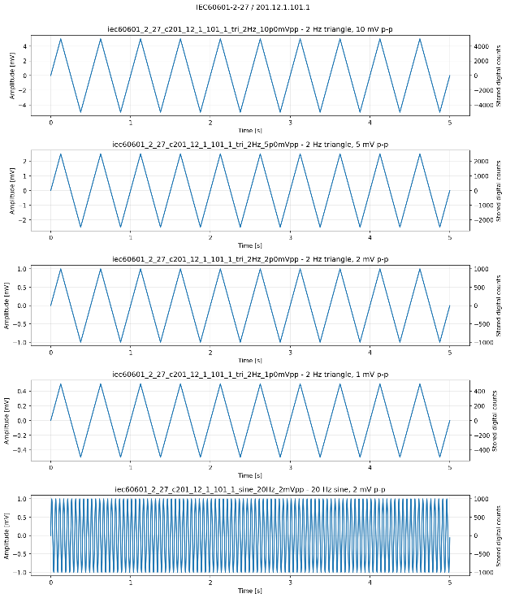
- IEC 60601-2-27 / 201.12.1.101.1: 2 Hz triangles: 10, 5, 2, 1 mV p-p (panel 1-3) and 20 Hz, 2 mV p-p sine (panel 4)
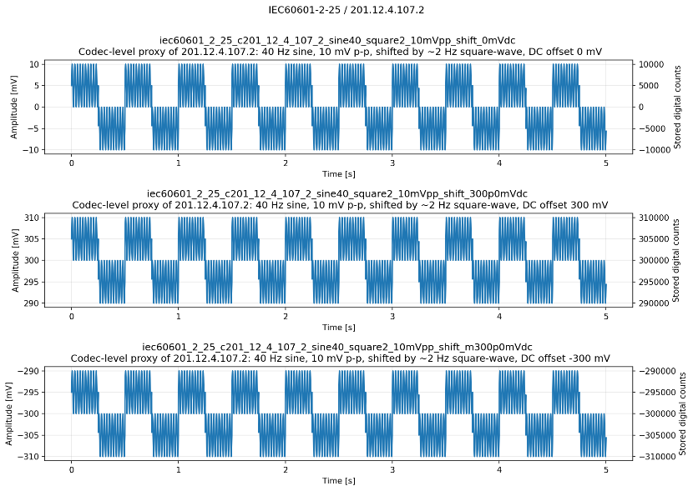
- IEC 60601-2-25 / 201.12.4.107.2: 40 Hz, 10 mV p-p sine with superimposed 2 Hz square-wave at 0 DC offset (panel 1), +300 DC offset (panel 2) and -300 DC (panel 3)
Figure 2. Example synthetic signals testing amplitude accuracy and linearity.

Metrics

Peak-to-peak amplitude
The peak-to-peak amplitude is the difference between the maximum and minimum values in the evaluated signal:
$$A_{pp}\left(x\right)=\max_{n}x\left[n\right]-\min_{n}x\left[n\right]$$
The decoded peak-to-peak amplitude is:
$$A_{dec}=A_{pp}\left(\hat{x}\right)$$
The reference amplitude is measured from the generated synthetic source:
$$A_{ref}=A_{pp}\left(x_{ref}\right)$$
The absolute amplitude error is:
$$E_{A}=∣A_{dec}-A_{ref}∣$$
The error is expressed in millivolts. A value of zero means that the reconstructed peak-to-peak amplitude is identical to the reference amplitude.
The absolute amplitude error is then evaluated against the following pass conditions:
- IEC 60601-2-27 / 201.12.1.101.1:
$$E_{A}≤\max\left(0.20A_{ref} , 0.10 mV\right)$$
- IEC 80601-2-26 / 201.12.1.102:
$$E_{A}≤\max\left(0.20A_{ref} , 0.010 mV\right)$$
- IEC 60601-2-47 / 201.12.4.4.101:
$$E_{A}≤\max\left(0.10A_{in} , 0.050 mV\right)$$
For IEC 60601-2-47, the decoded amplitude is compared directly with the nominal input amplitude at every input amplitude and DC-offset condition and detects both general codec attenuation and offset-dependent changes.

Fitted sinusoidal amplitude
For the 20 Hz visibility test in IEC 60601-2-27, a sinusoidal model is fitted to the decoded signal:
$$\hat{x}\left[n\right]≈c+a\sin\left(2πf\frac{n}{f_{s}}\right)+b\cos\left(2πf\frac{n}{f_{s}}\right)$$The constant $c$ absorbs any DC component. Using both sine and cosine terms makes the amplitude estimate independent of phase.
The fitted peak-to-peak amplitude is:
$$A_{fit,pp}\left(f\right)=2\sqrt{a^{2}+b^{2}}$$
The pass condition for the 20 Hz sine test in IEC 60601-2-27 / 201.12.1.101.1 is as follows:
$$1.6 mV≤A_{fit,pp}\left(20 Hz\right)≤2.4 mV$$

Position-dependent linearity
For IEC 60601-2-25 / 201.12.4.107.2, the signal is divided into 250 ms sections corresponding to the successive positions produced by the 2 Hz square wave. The first 10 ms of each section is excluded to avoid the square wave transition. A 40 Hz sine is then fitted to the remainder of each segment as explained above.
The fitted 40 Hz peak-to-peak amplitude at position $j$is:
$$A_{40,j}=2\sqrt{a_{j}^{2}+b_{j}^{2}}$$
The position-specific error is:
$$E_{j}=∣A_{40,j}-10 mV∣$$
The reported metric is the worst error over all tested positions:
$$E_{pos,max}=\max_{j}E_{j}$$
The pass condition for IEC 60601-2-25 / 201.12.4.107.2 is then:
$$E_{pos,max}≤0.50 mV$$
Thus, every recording position is evaluated, and the worst position determines the result. The test is repeated at 0 and ±300 mV DC. This is a codec-domain proxy for the effective-recording-width procedure.

Results
Amplitude accuracy and linearity were evaluated using four clause-derived tests covering ECG and EEG signals. The ECG tests used four input gains and 14 QP values from 1 to 22, whereas the EEG test used the same four gains and 21 QP values from 1 to 110. All evaluated gain–QP conditions passed the corresponding clause-derived metrics. Differences between clauses were nevertheless observed in the magnitude of reconstruction error and in the sensitivity to gain, QP and signal amplitude.
Table 12: Amplitude-accuracy and linearity results summary
Clause | Signals per gain–QP condition | Gain–QP conditions | Individual measurements | Outcome
IEC 60601-2-25 / 201.12.4.107.2 | 3 position-shift signals | 56 | 168 | 56/56 PASS
IEC 60601-2-27 / 201.12.1.101.1 | 4 triangles + 1 sine | 56 | 280 | 56/56 PASS
IEC 60601-2-47 / 201.12.4.4.101 | 4 amplitudes × 3 offsets | 56 | 672 | 56/56 PASS
IEC 80601-2-26 / 201.12.1.102 | 4 scalp + 4 cortical signals | 84 | 672 | 84/84 PASS

IEC 60601-2-25 / 201.12.4.107.2
All 56 gain–QP conditions passed the selected linearity and dynamic-range position-shift proxy. Each condition included signals centred at −300, 0 and +300 mV, giving 168 individual measurements. The worst amplitude variation across the evaluated waveform positions ranged from 0.000029 to 0.00834 mV, remaining well below the 0.5 mV limit.
The largest error, 0.00834 mV, occurred at gain 250 and QP 19 for the +300 mV position-shift signal. Even this value represented less than 2% of the permitted 0.5 mV error (see Figure 3). The maximum errors observed at gains 250, 500, 1000 and 2000 counts/mV were 0.00834, 0.00440, 0.00212 and 0.00081 mV, respectively. Although the errors appear nearly flat at the scale of the acceptance limit, the maximum position-dependent error decreased consistently with increasing input gain. Within each gain, errors varied discretely with QP; the larger values generally occurred at more aggressive quantization settings, but the dependence was not monotonic.

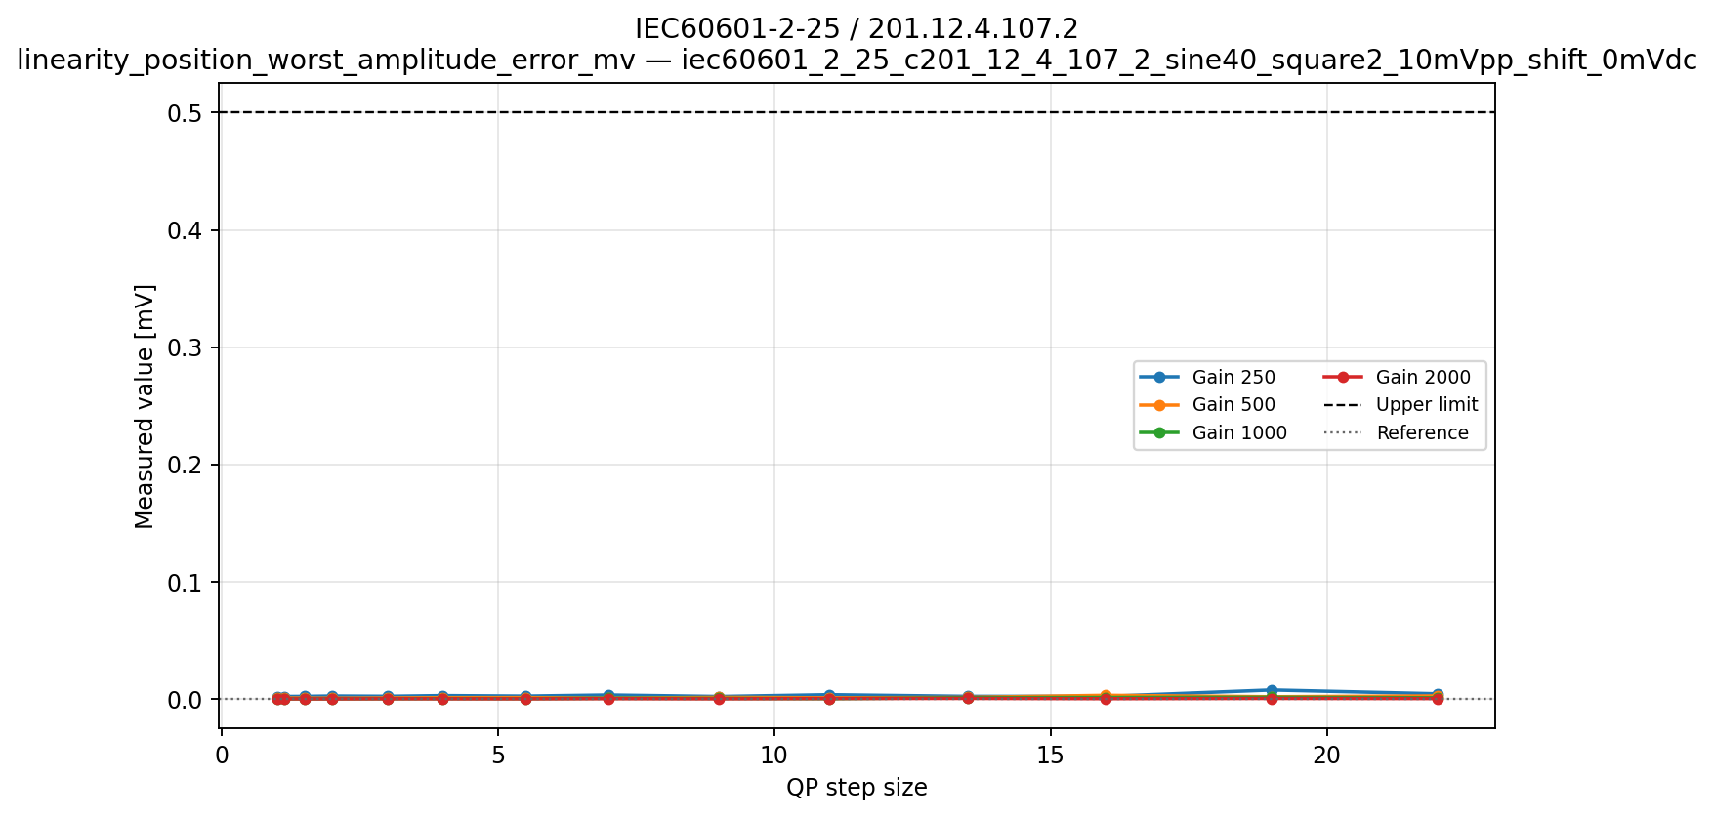
(a)
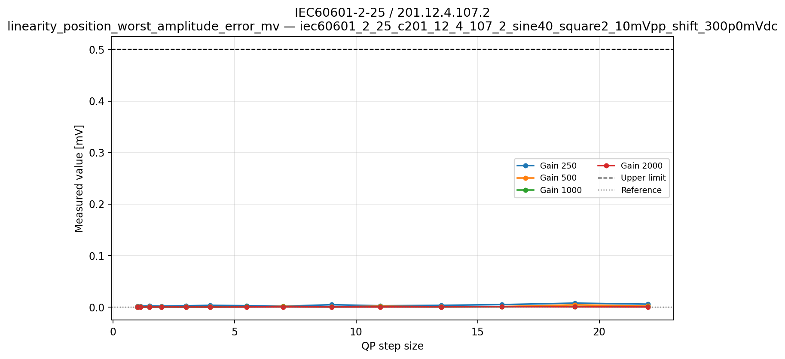
(b)
Figure 3. Position-dependent amplitude error for IEC 60601-2-25 / 201.12.4.107.2.
Amplitude error across the evaluated waveform positions as a function of QP at DC offset of 0 mV (a) and +300 mV (b). The horizontal line indicates the 0.5 mV clause-derived limit. All generated shift conditions were included in the pass/fail evaluation.

IEC 60601-2-27 / 201.12.1.101.1
All 56 gain–QP conditions passed both components of the clause-derived evaluation. Each condition included 2 Hz triangular waves with nominal peak-to-peak amplitudes of 1, 2, 5 and 10 mV and a 20 Hz, 2 mV peak-to-peak sinusoid. In total, all 280 individual amplitude measurements passed their applicable limits.
For the triangular signals, the largest absolute deviation from the nominal amplitude was 0.068 mV, observed for the 10 mV triangle at gain 250 and QP 16. Relative deviations were largest for the smallest triangle: the 1 mV signal ranged from 0.976 to 1.004 mV, corresponding to −2.4% to +0.4%. This remained comfortably within its permitted range of 0.8–1.2 mV.
The fitted amplitude of the 20 Hz sinusoid ranged from 1.9925 to 2.0044 mV, corresponding to a maximum deviation of approximately 0.38% from the 2 mV target and remaining well within the 1.6–2.4 mV acceptance range.
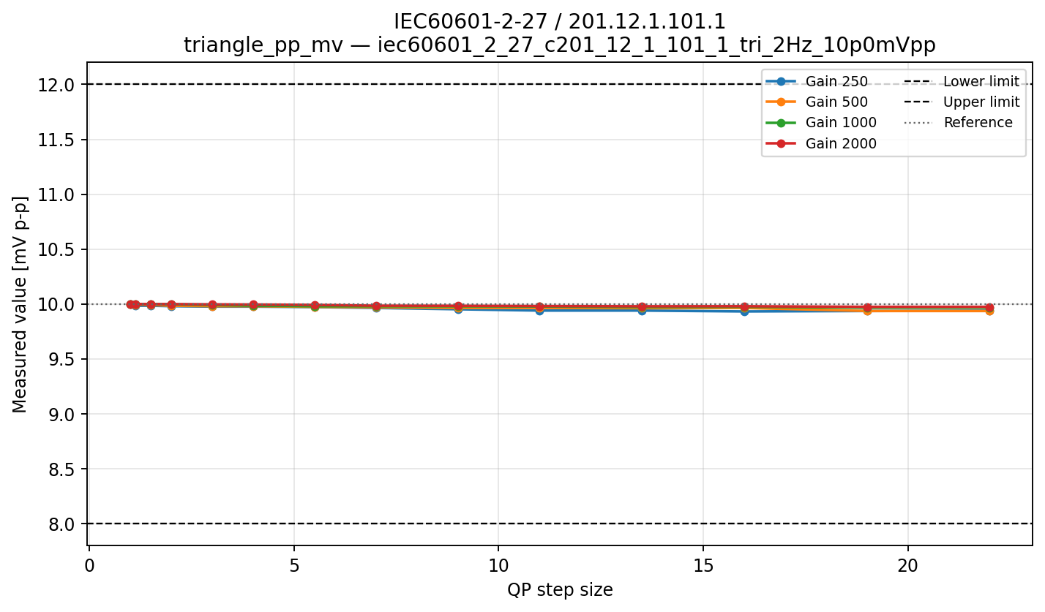
(a)
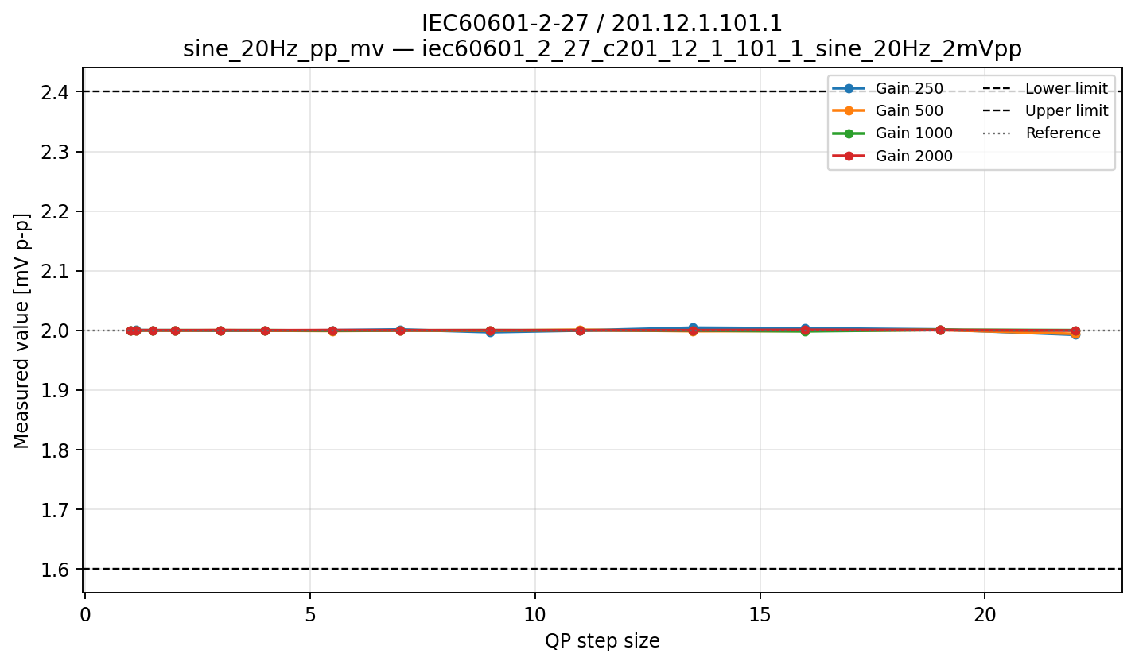
(b)
Figure 4. Signal-reproduction accuracy for IEC 60601-2-27 / 201.12.1.101.1. (a) Reconstructed peak-to-peak amplitude of the 2 Hz triangular signals at 10 mV p-p as a function of QP; (b) Fitted peak-to-peak amplitude of the 20 Hz, 2 mV sinusoid. Horizontal lines indicate the applicable clause-derived acceptance ranges. All four triangle amplitudes and the sinusoidal condition were included in the pass/fail evaluation.
Amplitude deviations generally became larger at lower gains and higher QP values, although the results contained small local variations and were not monotonic with QP. The effect was most visible for the smaller-amplitude triangles because a given digital-count error represents a larger fraction of their amplitude.

IEC 60601-2-47 / 201.12.4.4.101
All 56 gain–QP conditions passed the digital-recorder amplitude criterion. Each condition included 6.25 Hz triangular waves with peak-to-peak amplitudes of 0.5, 1, 2 and 10 mV, each tested at −300, 0 and +300 mV DC offset. This produced 672 individual amplitude-error measurements.
The largest absolute amplitude error was 0.164 mV, observed for a 10 mV signal at gain 250 and QP 19 or 22 (see Figure 5a). This remained well below the applicable 1.0 mV limit. However, the closest approach to an acceptance boundary occurred for the smallest signal: the 0.5 mV triangle at zero offset produced an error of 0.040 mV at gain 250 and QP 13.5, compared with the 0.050 mV limit (see Figure 5b).
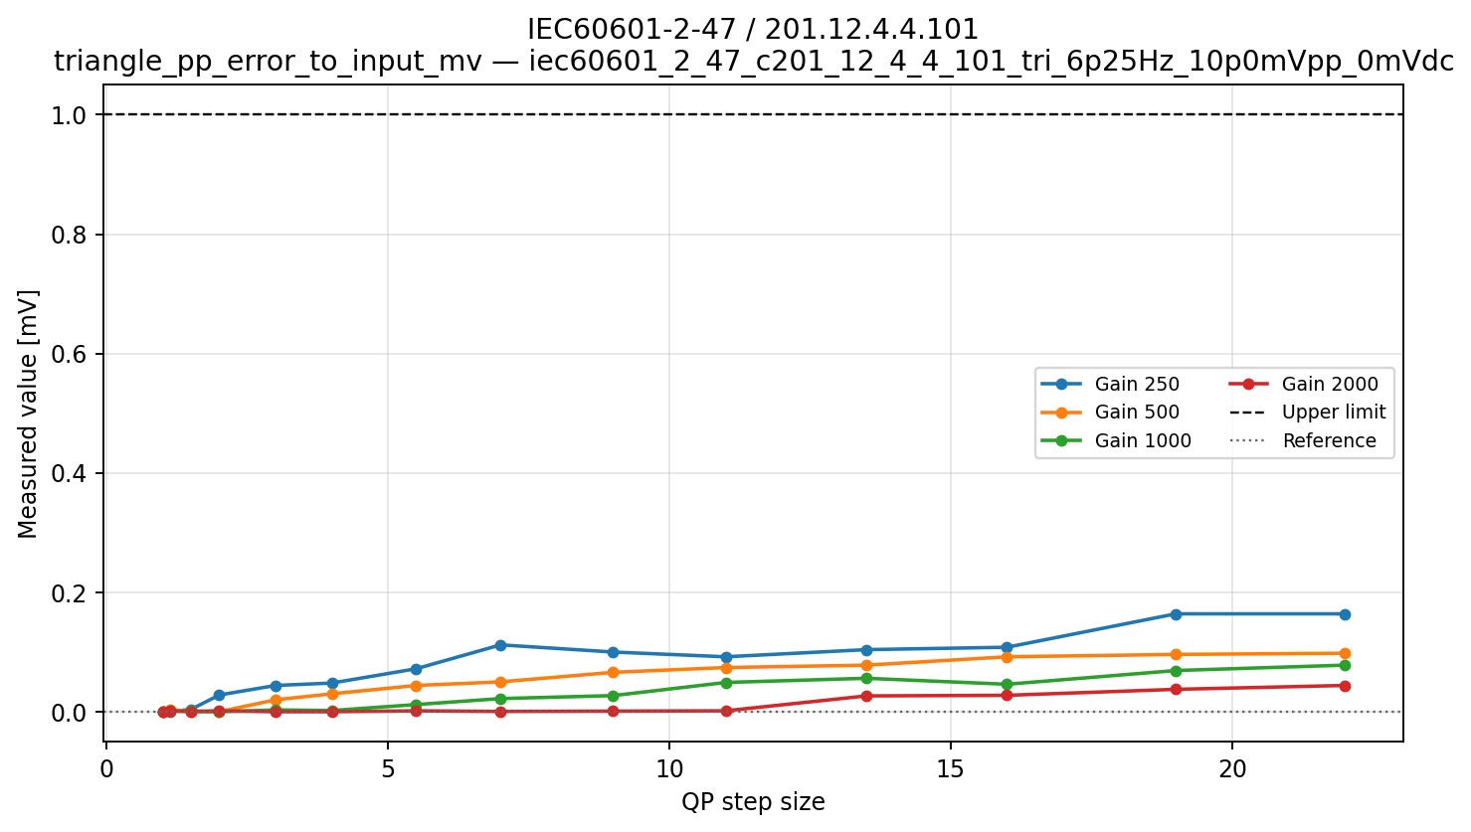
(a)
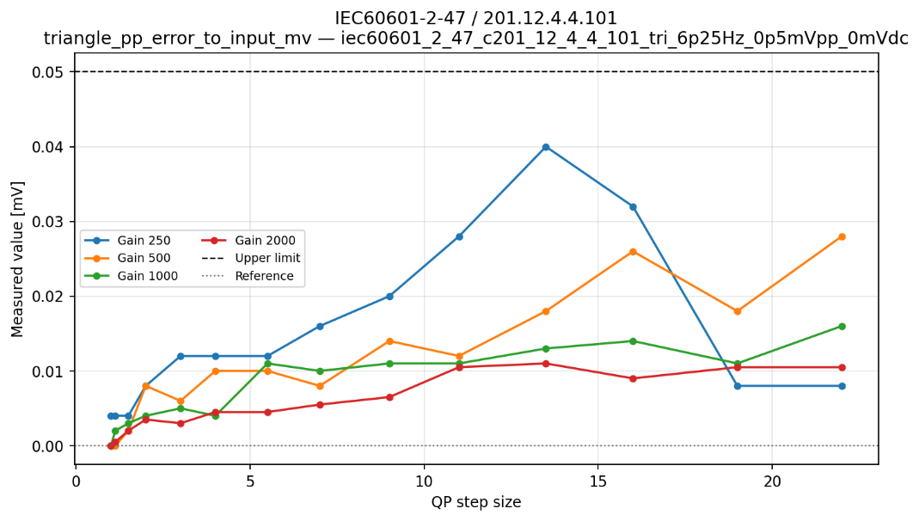
(b)
Figure 5. Triangle-amplitude error for IEC 60601-2-47 / 201.12.4.4.101. Absolute differences between reconstructed and nominal p-p amplitudes as a function of QP for (a) the 10 mV signal with the largest observed absolute error, and (b) the 0.5 mV signal with the smallest acceptance margin. Horizontal lines indicate the applicable limits of 1.0 mV and 0.05 mV, respectively.
Amplitude error generally increased as QP increased and decreased as gain increased. Across gains 250, 500, 1000 and 2000 counts/mV, the largest absolute errors were 0.164, 0.102, 0.078 and 0.046 mV, respectively. The progression was not fully monotonic at individual QP values, particularly for the 0.5 mV signal, for which discrete changes in the reconstructed peak-to-peak value had a relatively large effect on the reported error.
Comparable results were obtained at −300, 0 and +300 mV. The effect of DC offset relative to the matching zero-offset reconstruction is examined separately under dynamic range and DC-offset response.

IEC 80601-2-26 / 201.12.1.102
All 84 gain–QP conditions passed the clause-derived amplitude metric. Each condition included four scalp-EEG triangle amplitudes from 0.1 to 1 mV peak-to-peak and four cortical-EEG triangle amplitudes from 2 to 20 mV peak-to-peak, giving 672 individual measurements.
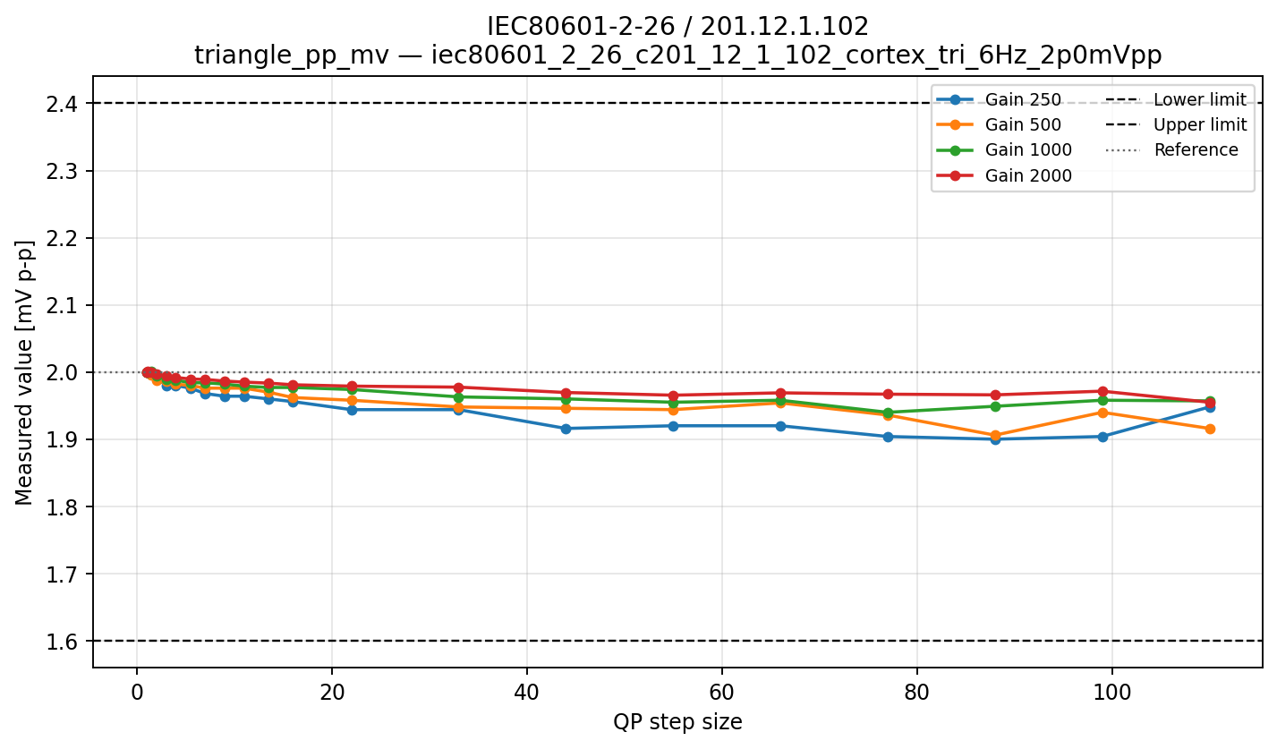
(a)
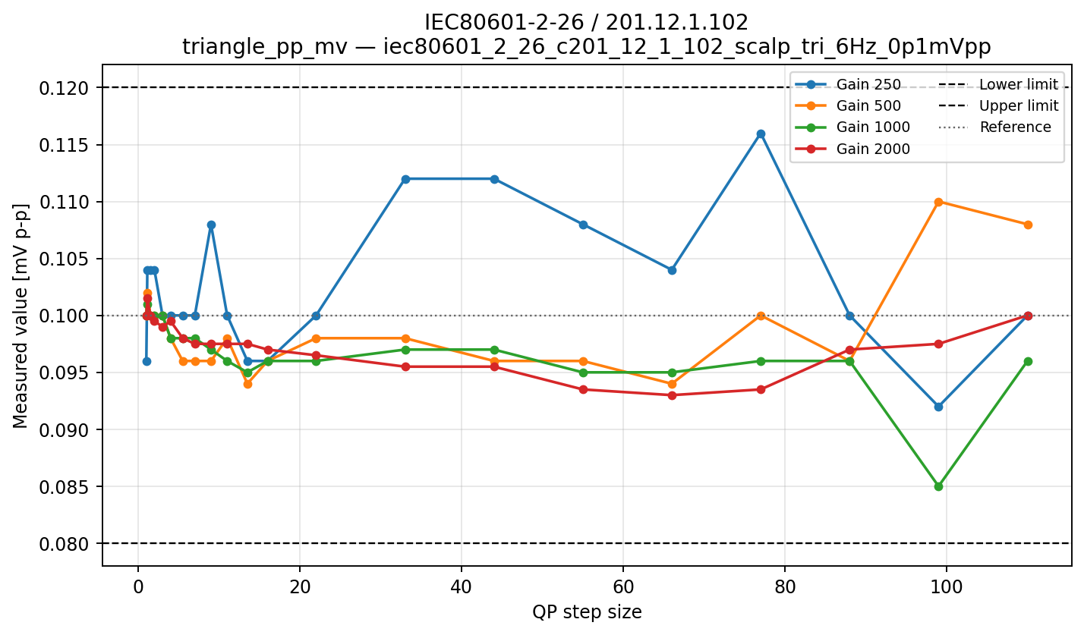
(b)
Figure 6. EEG triangle-amplitude accuracy for IEC 80601-2-26 / 201.12.1.102. Reconstructed peak-to-peak amplitudes as a function of QP for (a) the cortical-EEG signals, and (b) the scalp-EEG signals. The worst results are displayed. Horizontal lines indicate the applicable ±20% acceptance ranges.
The cortical signals remained well within their ±20% limits (see Figure 6a). Their largest relative deviation was −5.0%, observed for the 2 mV signal, while the largest absolute deviation was 0.376 mV for the 20 mV signal at gain 250 and QP 77. The higher amplitude cortical results generally showed increasing attenuation at higher QP values, particularly at lower gains.
As expected, the smallest scalp signals were more sensitive to quantization (see Figure 6b). The reconstruction of the 0.1 mV signal ranged from 0.085 to 0.116 mV, corresponding to −15% to +16% relative error. The closest approaches to the acceptance boundaries were 0.116 mV at gain 250 and QP 77, 0.004 mV below the upper limit of 0.120 mV; and 0.085 mV at gain 1000 and QP 99, 0.005 mV above the lower limit of 0.080 mV.
These were the only meaningful boundary cases in the amplitude-accuracy results, although both still passed. The smallest signals showed non-monotonic changes with QP because their reconstructed peak-to-peak amplitudes changed in discrete sample-value increments. Consequently, increasing gain generally improved amplitude resolution, but it did not guarantee a strictly smaller relative error at every individual QP. The broader pattern nevertheless remained that small-amplitude scalp signals were more vulnerable than the larger cortical signals at higher QP settings.

Overall interpretation
Across all four clauses, every evaluated gain–QP condition passed the selected amplitude-accuracy or linearity metric. Reconstruction errors were generally smallest at higher gains and smaller QP settings. The main vulnerability was not large-amplitude signal reproduction but the relative error of very small signals, particularly the 0.1 mV EEG triangle at higher QP settings. The IEC 80601-2-26 results approached, but did not cross, the applicable limits, while the other three clauses retained substantial margins. These findings support accurate amplitude preservation within the tested digital codec configurations.

Dynamic range and DC-offset response

General description
This set of clauses evaluates whether the reconstructed waveform amplitude remains stable when the same signal is represented at different DC offsets or within the selected dynamic range. Preserving amplitude under these conditions helps prevent baseline displacement from changing the apparent size of clinically relevant waveform features. The codec-domain measurements isolate the effect of compression on the digital waveform and do not test analogue front-end headroom, saturation, or electrode behaviour.

Applicable clauses
Table 13: Dynamic-range and DC-offset limits
Clause | Synthetic condition | Metric/reference | Limit | Aggregation/qualification
IEC 60601-2-27 / 201.12.1.101.2 | 16 Hz, 10 mV p-p triangle; 0 and ±300 mV | Offset/zero decoded p-p ratio | 0.90–1.10 | Both +300 and −300 mV pass
IEC 60601-2-47 / 201.12.4.4.101 | 6.25 Hz triangles; 0 and ±300 mV | Absolute decoded p-p error to input | ≤max(10%, 0.050 mV) | Every amplitude and offset passes; not a ratio test in the current implementation
IEC 80601-2-26 / 201.12.1.103 | 6 Hz, 1 mV p-p triangle; 0 and ±150 mV | Offset/zero decoded p-p ratio | 0.90–1.10 | Both +150 and −150 mV pass

Synthetic signals
The ECG-monitoring condition is a 16 Hz, 10 mV p-p triangle at 0 and +/-300 mV DC offset. The ambulatory-ECG condition uses 6.25 Hz triangles at 0.5, 1, 2 and 10 mV p-p with 0 and +/-300 mV offsets. The EEG condition is a 6 Hz, 1 mV p-p triangle at 0 and +/-150 mV. The DC level shifts the complete waveform without multiplying its alternating amplitude. These records represent relatively small physiological variations superimposed on large electrode or half-cell potentials and test whether the codec can preserve the alternating biosignal while representing a much larger baseline value.
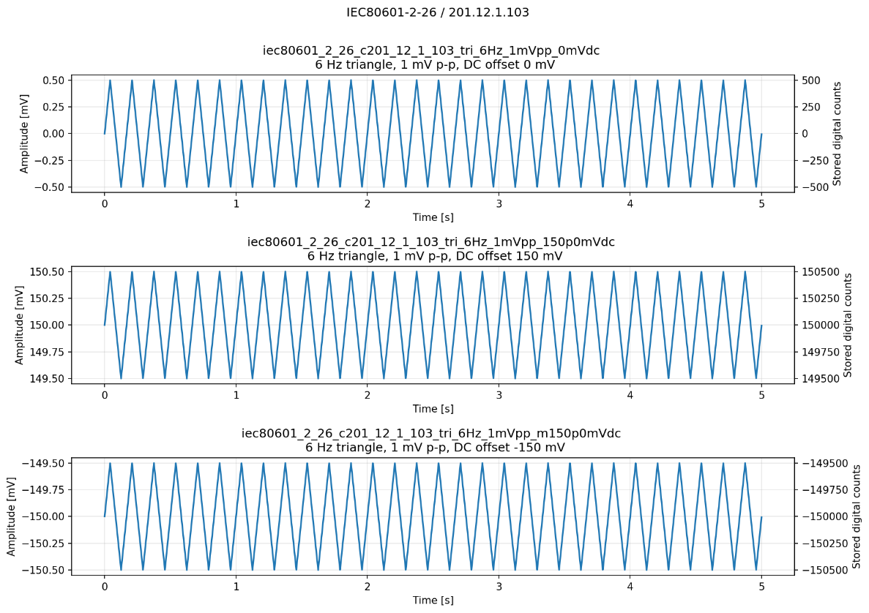
Figure 7. Example DC-offset waveforms and amplitude testing.
IEC 80601-2-26 / 201.12.1.103: 6 Hz, 1 mV p-p triangle wave; 0 and ±150 mV

Metrics

Zero-offset reference amplitude
For each QP, gain and waveform, the decoded zero-offset signal is measured first:
$$A_{0}=A_{pp}\left({\hat{x}}_{0 mV}\right)$$
It is a diagnostic reference and does not independently determine PASS/FAIL. It shows how much of the original signal amplitude remains after coding without an applied DC offset. For example, if a nominal 10 mV signal produces $A_{0}=9.7$mV, the codec has already introduced a 3% amplitude reduction before the offset comparison is made.

Dynamic-range ratio to zero offset
For an applied offset $d$:
$$R_{DC}\left(d\right)=\frac{A_{pp}\left({\hat{x}}_{d}\right)}{A_{pp}\left({\hat{x}}_{0}\right)}$$
The numerator and denominator are decoded signals from the same gain, QP and waveform condition.
A value of:
- $R_{DC}=1$: no additional offset-dependent amplitude change;
- $R_{DC}<1$: more attenuation with offset;
- $R_{DC}>1$: amplitude enlargement with offset.

This metric is used for IEC 60601-2-27 / 201.12.1.101.2, at $±300$mV DC offset and IEC 80601-2-26 / 201.12.1.103, at $±150$mV DC offset. The pass condition is:
$$0.90≤R_{DC}\left(d\right)≤1.10$$
Both positive and negative offset cases must pass.
Because the decoded zero-offset signal is used as the denominator, common amplitude loss affecting all three offset conditions may cancel in the ratio. Therefore, $A_{0}$is also reported as a diagnostic.

Direct amplitude error under offset
IEC 60601-2-47 / 201.12.4.4.101 is evaluated differently. Every decoded signal, including the zero and non-zero offset cases, is compared directly with its nominal input amplitude:
$$E_{offset}\left(d\right)=∣A_{pp}\left({\hat{x}}_{d}\right)-A_{in}∣$$
Pass condition:
$$E_{offset}\left(d\right)≤\max\left(0.10A_{in} , 0.050 mV\right)$$
This method is applied separately to every 0.5, 1, 2 and 10 mV input; 0, +300 and −300 mV offset; gain and QP. It detects both general codec amplitude loss and additional offset-dependent loss.

Results
The dynamic-range tests evaluated whether a waveform’s alternating amplitude remained stable when superimposed on a large positive or negative DC offset level. All tested conditions passed.
Table 14: Dynamic-range and DC-offset results summary
Clause | Signals per condition | Gain–QP conditions | Counted measurements | Outcome
IEC 60601-2-27 / 201.12.1.101.2 | 0 and ±300 mV | 56 | 112 ratios | 56/56 PASS
IEC 60601-2-47 / 201.12.4.4.101 | 4 amplitudes × 3 offsets | 56 | 672 errors | 56/56 PASS
IEC 80601-2-26 / 201.12.1.103 | 0 and ±150 mV | 84 | 168 ratios | 84/84 PASS

IEC 60601-2-27 / 201.12.1.101.2
All 56 gain–QP conditions passed. The ratios between the decoded amplitudes at ±300 mV and at zero offset ranged from 0.9984 to 1.0020, compared with the permitted range of 0.90–1.10. The minimum and maximum ratios both occurred at gain 250, at QP 7 and QP 4 respectively. The decoded amplitude ratios to 0 mV DC offset for both offset conditions are shown in Figure 8.
The decoded zero-offset amplitude ranged from 9.792 to 9.928 mV for the nominal 10 mV triangle. It generally decreased at lower gain and higher QP, but the offset and zero-offset waveforms changed together. Consequently, most amplitude loss cancelled in the offset ratio. No systematic difference between positive and negative offset was identified.
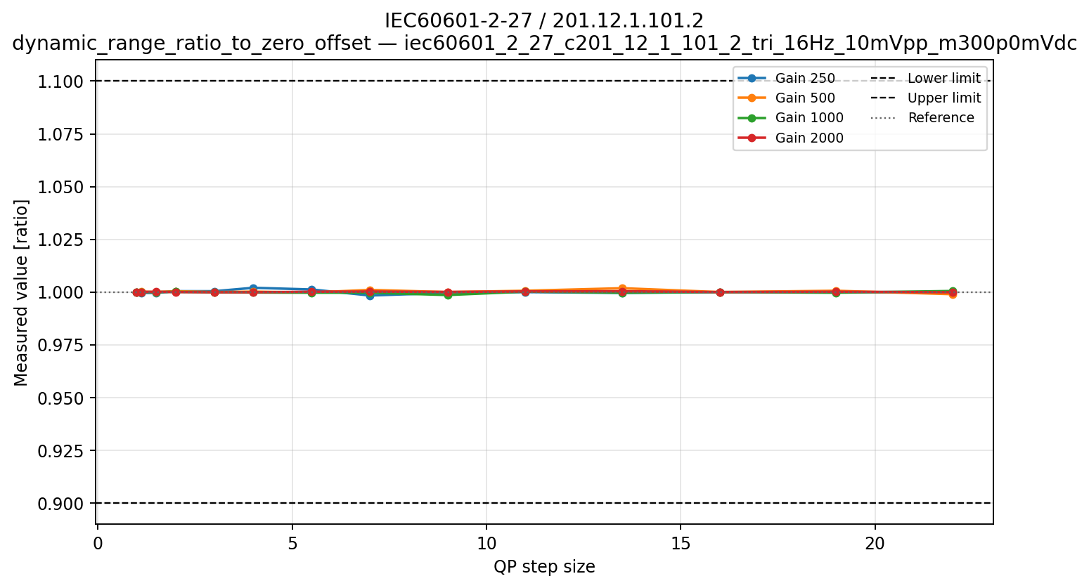
(a)
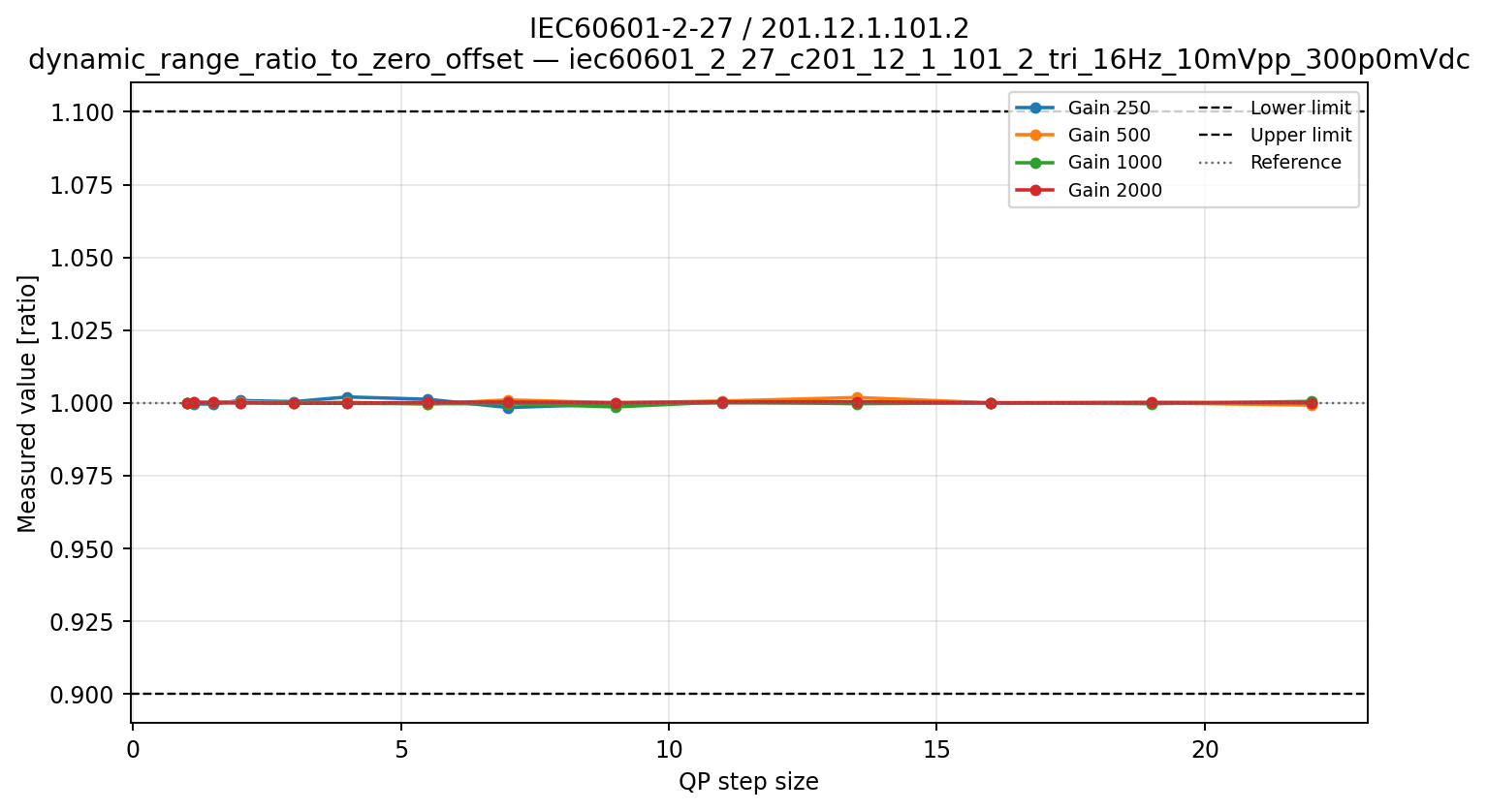
(b)
Figure 8. ECG dynamic-range response for IEC 60601-2-27 / 201.12.1.101.2. Decoded amplitude ratios to 0 mV DC offset for the −300 (a) and +300 mV (b) conditions. Results are shown across QP for four input gains. The dashed lines indicate the permitted ratio range of 0.90–1.10.

IEC 60601-2-47 / 201.12.4.4.101
The direct amplitude-error results and overall clause outcome are reported under amplitude accuracy and linearity. The present section considers only whether applying a ±300 mV DC offset introduced an additional change in the reconstructed alternating amplitude.
The diagnostic amplitude ratios to 0 mV DC offset ranged from 0.9796 to 1.0348, with a maximum absolute amplitude difference of 0.032 mV. The largest variations occurred at gain 250 and higher QP steps, but neither offset direction produced a consistent increase or decrease in amplitude. The results therefore show no systematic additional degradation caused by the ±300 mV offsets.
This comparison is only a supporting diagnostic. The clause outcome remains based on the direct difference between each reconstructed peak-to-peak amplitude and its nominal input amplitude as described in the previous section.

IEC 80601-2-26 / 201.12.1.103
All 84 gain–QP conditions passed. The decoded amplitude ratios to the 0 mV DC offset condition ranged from 0.9792 to 1.0426, within the permitted range of 0.90–1.10. The minimum ratio occurred at gain 500 and QP 66, while the maximum occurred at gain 250 and QP 110 both in the +150 mV offset condition (see Figure 9a).
The decoded zero-offset amplitude ranged from 0.928 to 1.0005 mV as shown in Figure 9b. Its lowest value occurred at gain 250 and QP 99, demonstrating appreciable general attenuation of the small EEG signal. Because the offset and zero-offset signals were affected similarly, the counted ratio still passed. The zero-offset diagnostic should therefore be shown alongside the ratio.

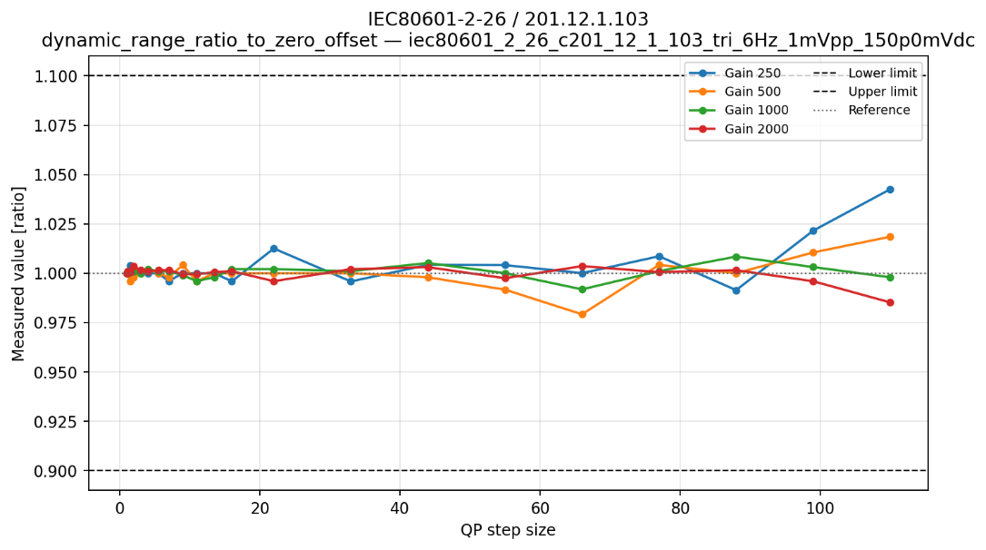
(a)
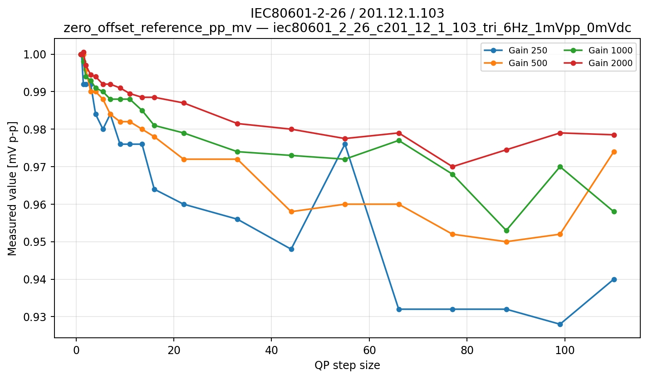
(b)
Figure 9. EEG dynamic-range response for IEC 80601-2-26 / 201.12.1.103.
(a) Decoded amplitude ratios to 0 mV DC offset for the +150 mV condition; (b) decoded zero-offset peak-to-peak amplitude. Results are shown across QP for four input gains. The dotted lines in panel (a) indicate the permitted ratio range of 0.90–1.10.

Overall interpretation
Across all three clauses, large positive and negative DC offsets did not introduce a systematic additional loss of waveform amplitude. All offset-dependent metrics passed, with the ECG-monitoring ratios remaining particularly close to unity. The EEG ratios showed greater variation at low gain and high QP steps because the 1 mV waveform was more sensitive to quantization, but they remained within the applicable limits. The zero-offset diagnostics also showed that an offset-to-zero ratio can conceal general amplitude attenuation when the offset and zero-offset signals are affected similarly. Direct amplitude results should therefore be considered alongside the offset ratios.

Sinusoidal frequency response

General description
This concept evaluates whether reconstructed amplitude is preserved across the selected frequency range relative to the specified reference frequency. It relates to preservation of waveform components with different temporal scales, including low-frequency ECG morphology and baseline-related content, faster ECG features, and EEG activity across relevant frequency bands. The sinusoidal inputs provide a controlled measure of relative amplitude response; they are codec-domain proxies and do not replace clinical validation with physiological recordings.

Applicable clauses and limits
Table 15: Sinusoidal frequency-response limits
Clause/method | Reference | Evaluated frequencies | Limit | Aggregation/route
IEC 60601-2-25 / 201.12.4.107.1.1.1 A | Decoded 10 Hz in Method A | 0.67, 1, 2, 5, 10, 20, 40 Hz | 0.90–1.10 | A must pass
Same clause, B | Decoded 10 Hz in B | 40, 70, 100 Hz | 0.70–1.10 | B, C and D form one alternative to E
Same clause, C | Decoded 10 Hz in C | 100, 125, 150 Hz | 0.70–1.10 | B, C and D all pass if this route is used
Same clause, D | Decoded 10 Hz in D | 150, 200, 300, 500 Hz | 0–1.10 | No lower bound; upper bound applies
IEC 60601-2-27 / 201.12.1.101.8 A | Decoded 5 Hz | 0.67 and 40 Hz | 0.71–1.10 | Method A passes only if both frequencies pass
IEC 60601-2-47 / 201.12.4.4.108 sine route | Decoded 5 Hz | 0.67, 1, 2, 10, 20, 40 Hz | 0.70–1.40 | Alternative to triangle route; impulse still required
IEC 80601-2-26 / 201.12.1.105 | Decoded 5 Hz | 0.5 and 50 Hz | 0.71–1.10 | Both frequencies pass

Synthetic signals
The ECG sinusoidal tests span approximately 0.67-500 Hz, with clause-dependent amplitudes from 0.25 to 2 mV p-p and decoded 5 or 10 Hz reference signals. The EEG test uses a deliberately small 50 microV p-p sine at 0.5, 5 and 50 Hz. Low-frequency conditions represent slow baseline and ST/EEG components, whereas the upper frequencies represent rapidly changing ECG morphology, narrow QRS-related content and faster EEG activity. The test therefore measures whether coding changes the relative spectral balance of the reconstructed waveform rather than only its overall sample-domain error.
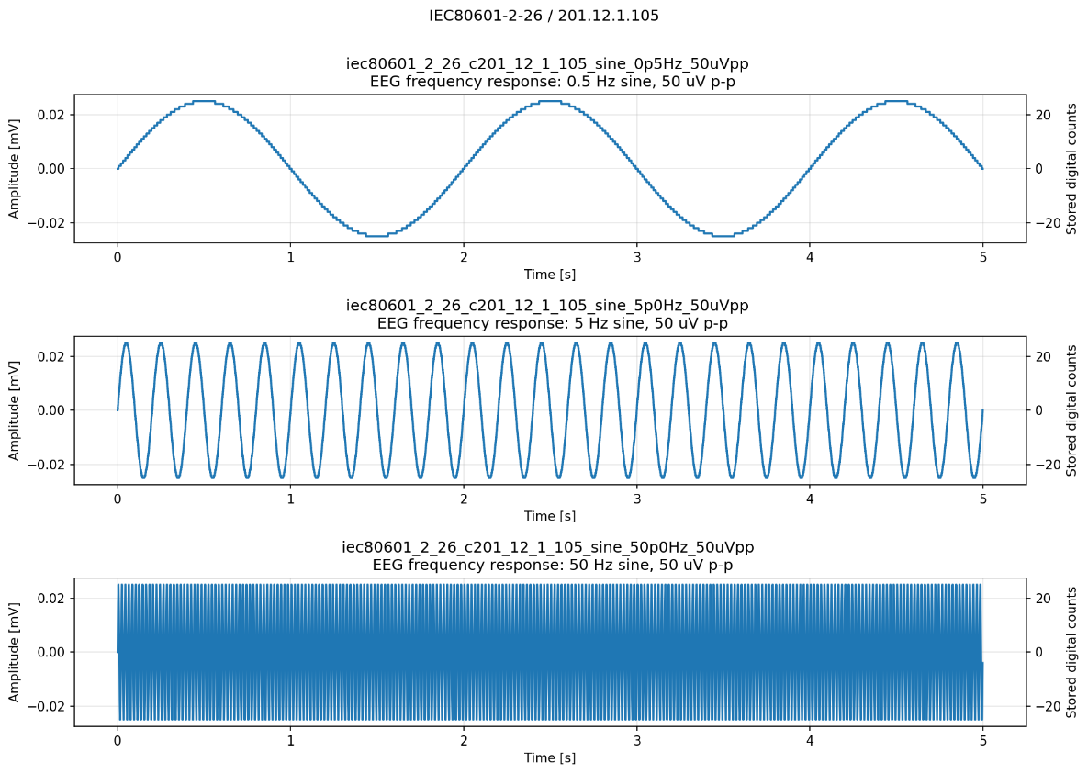
Figure 10. Example synthetic signals testing sinusoidal frequency response.
IEC 80601-2-26 / 201.12.1.105: 0.5, 5 and 50 Hz, 0.05 mV p-p sine wave

Metrics

Fitted sinusoidal amplitude
At each test frequency $f$, the decoded signal is fitted to:
$$\hat{x}\left[n\right]≈c+a_{f}\sin\left(2πf\frac{n}{f_{s}}\right)+b_{f}\cos\left(2πf\frac{n}{f_{s}}\right)$$
The fitted peak-to-peak amplitude is:
$$A_{fit}\left(f\right)=2\sqrt{a_{f}^{2}+b_{f}^{2}}$$
Least-squares fitting estimates the component specifically at the intended test frequency and is less sensitive to residual DC offsets, phase and isolated sample errors than a simple maximum-minus-minimum measurement.

Frequency-response ratio to 5 Hz
Where the same nominal input amplitude is used at every frequency:
$$R_{f}=\frac{A_{fit}\left(f\right)}{A_{fit}\left(5 Hz\right)}$$
The denominator is the decoded 5 Hz response at the same QP and gain. It is not the original 5 Hz input amplitude. The decoded 5 Hz amplitude is also stored as diagnostic only but the frequency-response ratios determine PASS/FAIL.

This metric is used for:
- IEC 60601-2-27 / 201.12.1.101.8, Method A:
$$0.71≤R_{f}≤1.10$$Method A is not evaluated alone but in combination with Method B and the impulse response of the same clause as follows:
$$\text{Method A}∧\text{Method B}∧\text{Impulse}$$
- IEC 60601-2-47 / 201.12.4.4.108, sinusoidal route:
$$0.70≤R_{f}≤1.40$$The sine route is an alternative to the triangular-pulse route of the same clause, but the impulse response remains mandatory:
$$\text{Impulse}∧\left(\text{Sine route}∨\text{Triangle route}\right)$$
- IEC 80601-2-26 / 201.12.1.105:
$$0.71≤R_{f}≤1.10$$

Response relative to the method-specific 10 Hz reference
IEC 60601-2-25 uses different input amplitudes in some method families. Therefore, the output is first normalized by the input amplitude:
$$G\left(f\right)=\frac{A_{fit}\left(f\right)}{A_{in}\left(f\right)}$$
It then divides by the normalized decoded 10 Hz response from the same method family:
$$R_{f,10}=\frac{G\left(f\right)}{G\left(10 Hz\right)}$$
This prevents differences in the prescribed input amplitudes from being mistaken for frequency-response changes.
The test limits for IEC 60601-2-25 / 201.12.4.107.1.1.1 are as follows:
- Method A:
$$0.90≤R_{f,10}≤1.10$$
- Methods B and C:
$$0.70≤R_{f,10}≤1.10$$
- Method D:
$$0≤R_{f,10}≤1.10$$
All required frequencies within a method must pass.
The clause aggregation follows:
$$\left(A∧E\right)∨\left(A∧B∧C∧D\right)$$

Results
Sinusoidal frequency response was evaluated relative to a reconstructed reference-frequency signal at the same gain and QP. All ECG sinusoidal-response components passed. The EEG test was substantially more demanding because it used 50 µV peak-to-peak signals: 9 of 84 gain–QP conditions failed at low gains and higher QP steps.
Table 16: Sinusoidal frequency-response results summary
Clause | Sinusoidal coverage | Gain–QP conditions | Counted ratios | Component outcome
IEC 60601-2-25 / 201.12.4.107.1.1.1 A–D | 20 frequencies (0,67 – 500 Hz) relative to 10 Hz | 56 | 1120 | 56/56 PASS
IEC 60601-2-27 / 201.12.1.101.8 A | 0.67 and 40 Hz relative to 5 Hz | 56 | 112 | 56/56 PASS
IEC 60601-2-47 / 201.12.4.4.108 sine route | 6 frequencies (0.67 – 40 Hz) relative to 5 Hz | 56 | 336 | 56/56 PASS
IEC 80601-2-26 / 201.12.1.105 | 0.5 and 50 Hz relative to 5 Hz | 84 | 168 | 75/84 PASS

IEC 60601-2-25 / 201.12.4.107.1.1.1, Methods A–D
All 1120 sinusoidal-response measurements passed. Normalized responses ranged from 0.9641 to 1.0317 across Methods A–D. The results for two of the methods are shown in Figure 11. The minimum occurred for the 125 Hz Method C signal at gain 250 and QP 19, while the maximum occurred for the 70 Hz Method B signal at gain 250 and QP 22.
Deviations were greatest at gain 250 and higher QPs, particularly for the smaller, higher-frequency signals. Nevertheless, every required frequency retained substantial margin relative to its method-specific limits.
The overall clause passed in all 56 conditions through the $\left(A∧B∧C∧D\right)$ route. Method E results are reported separately under triangular-pulse response.
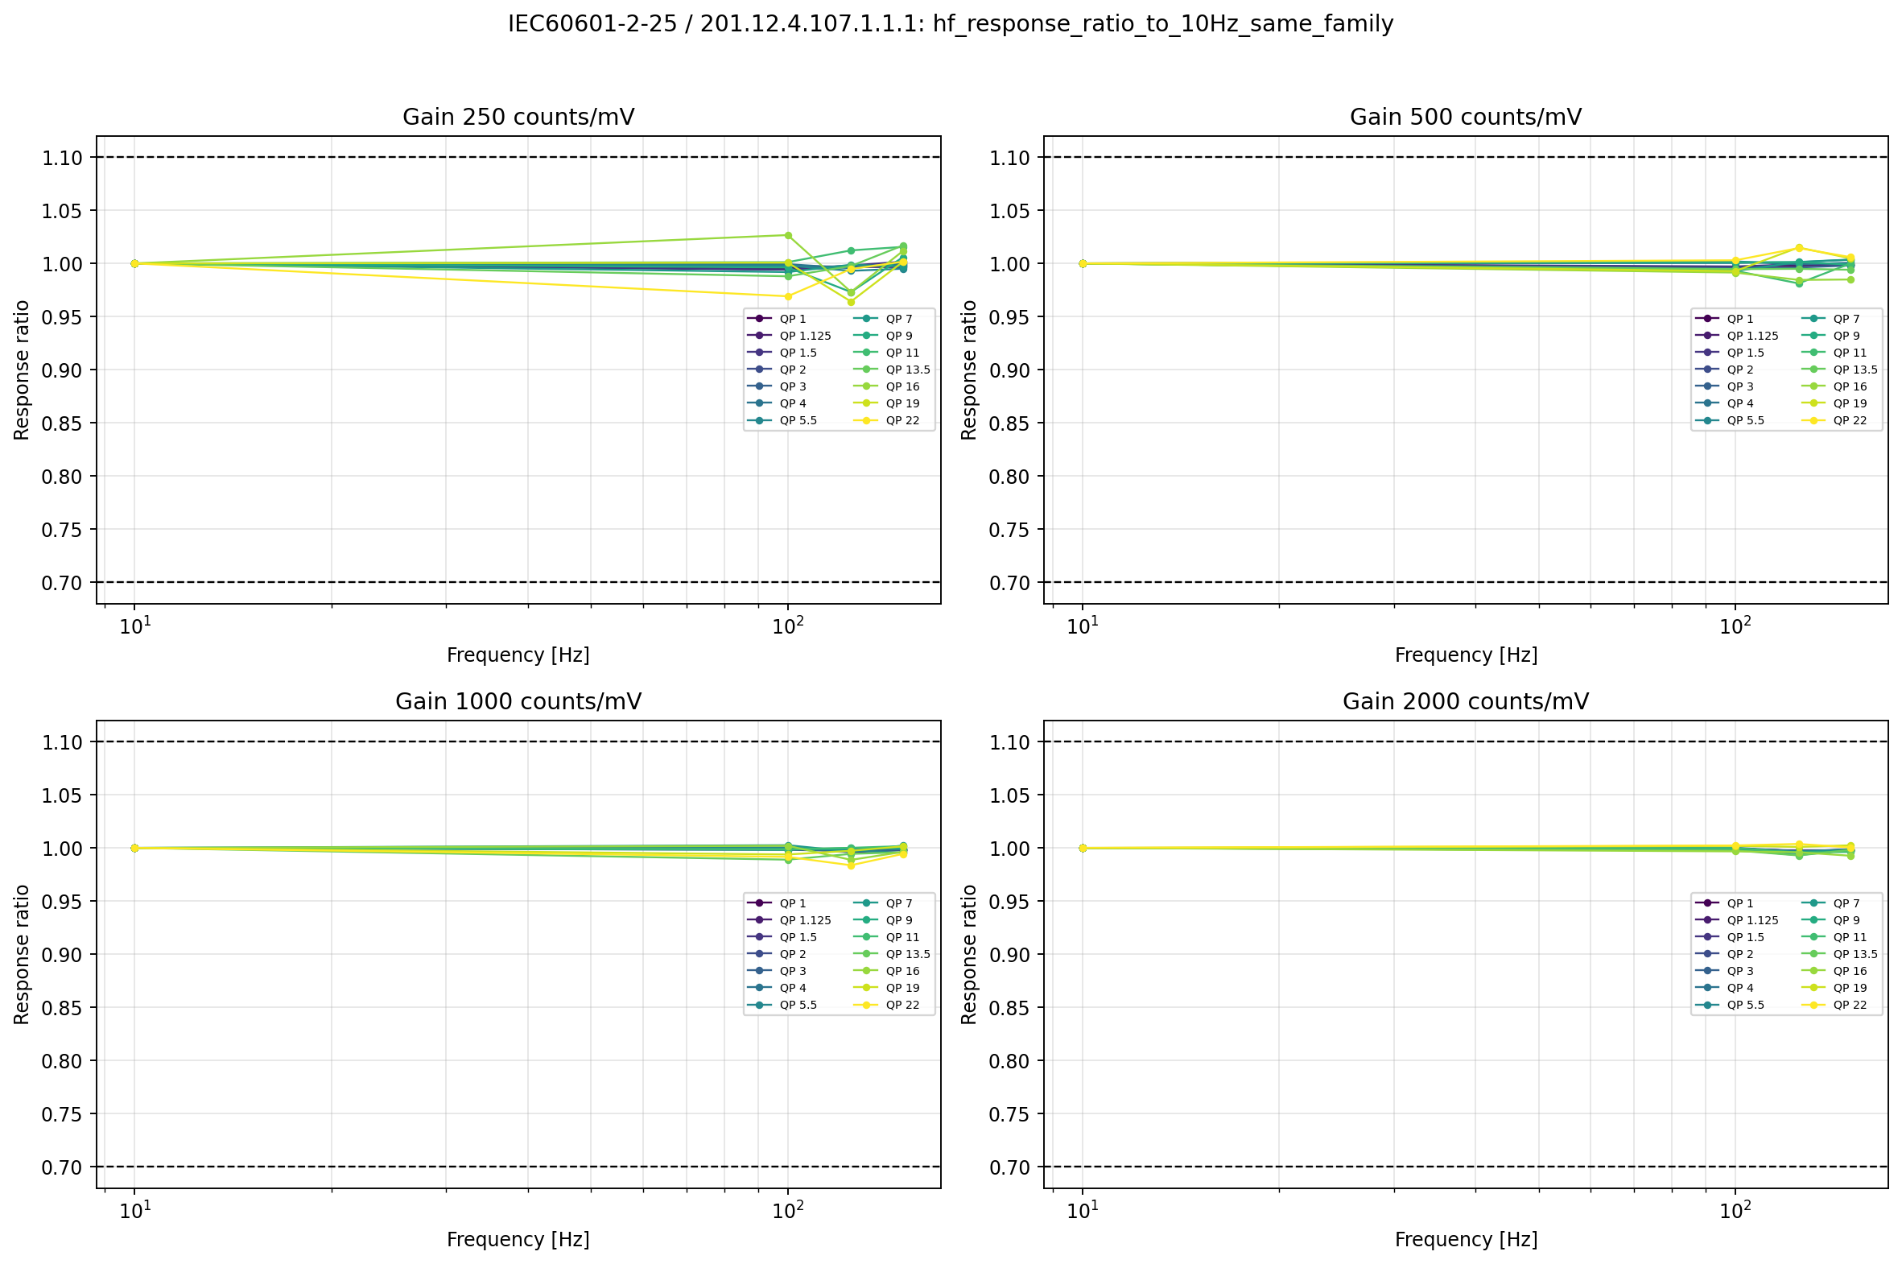
(a)
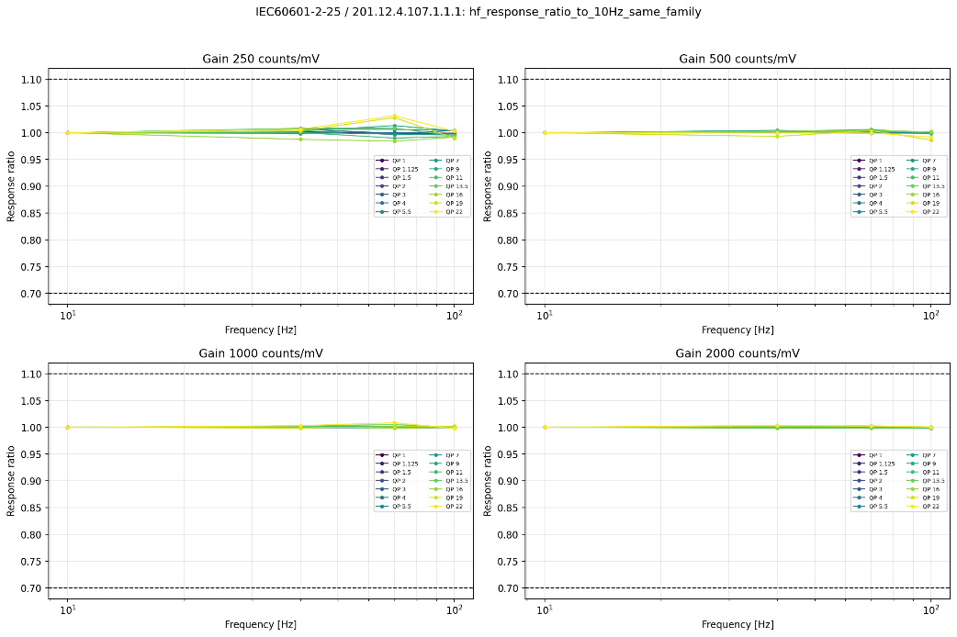
(b)
Figure 11. Normalized sinusoidal response for IEC 60601-2-25 / 201.12.4.107.1.1.1, Methods A–D. (a) Method C minimum and (b) Method B maximum response relative to the method-specific decoded 10 Hz reference across the required frequencies. Results are shown by gain and QP. Dashed lines indicate the applicable method-specific limits.

IEC 60601-2-27 / 201.12.1.101.8, Method A
All 56 Method A conditions passed. The 0.67 and 40 Hz amplitude ratios relative to the decoded 5 Hz response ranged from 0.9927 to 1.0100, well within the permitted range of 0.71–1.10. The decoded 5 Hz reference amplitude remained between 0.9970 and 1.0030 mV.
Only small local variations with QP were observed. The largest deviations occurred at gain 250 and high QP, but there was no meaningful approach to either acceptance boundary.
Method A therefore passed throughout. The complete clause nevertheless failed 31 conditions because Method B is also mandatory.

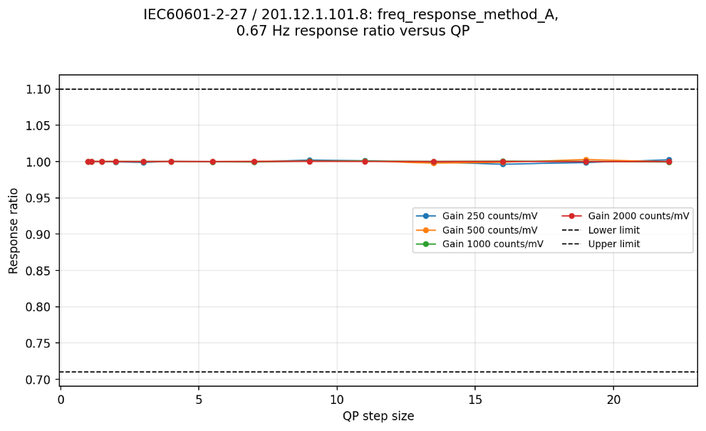
(a)
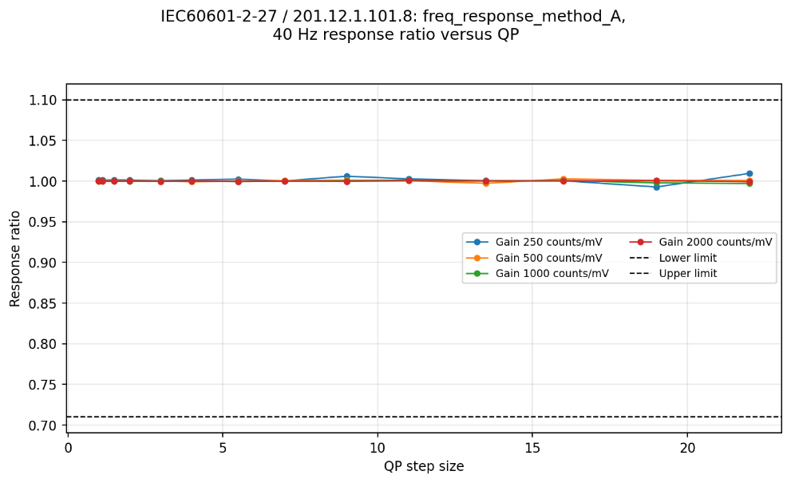
(b)
Figure 12. Method A sinusoidal frequency response of IEC 60601-2-27 / 201.12.1.101.8. Reconstructed amplitude ratios for (a) 0.67 Hz and (b) 40 Hz relative to the decoded 5 Hz response. Results are shown across QP for four gains. The dashed lines indicate the permitted range of 0.71–1.10.

IEC 60601-2-47 / 201.12.4.4.108, sinusoidal route
All 56 gain–QP conditions passed the sinusoidal route. Across 336 counted measurements, ratios ranged from 0.9954 to 1.0035, compared with the permitted range of 0.70–1.40. The decoded 5 Hz reference amplitude remained between 1.9951 and 2.0035 mV compared with the original 2 mV.
No material frequency-dependent attenuation was observed. Small deviations increased at lower gain and higher QP but remained negligible relative to the available margin. The sine route, triangle route and impulse component all passed, so the complete clause passed all conditions.
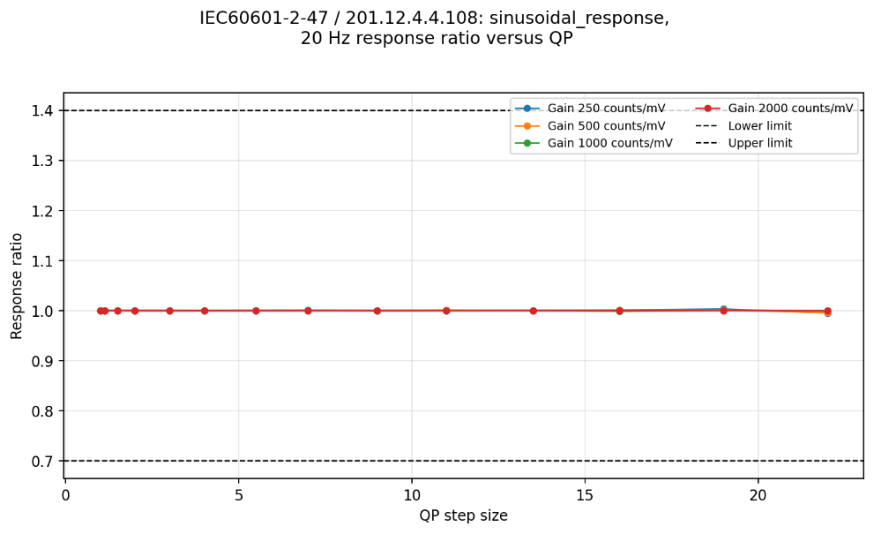
Figure 13. Sinusoidal frequency-response route for IEC 60601-2-47 / 201.12.4.4.108 at 20 Hz relative to the decoded 5 Hz response. Results are shown by gain and QP. The dashed lines indicate the permitted range of 0.70–1.40. All six non-reference frequencies were included in the evaluation.

IEC 80601-2-26 / 201.12.1.105
Of the 84 gain–QP conditions, 75 passed and 9 failed. Failures occurred at gain 250 for QP 55, 66, 77, 88, 99 and 110, and at gain 500 for QP 77, 99 and 110. All conditions at gains 1000 and 2000 passed. Figure 14 summarizes the frequency-response ratios across all evaluated gain–QP conditions and identifies the conditions that exceeded the applicable limits.
The failures were confined to the 50 µV p-p EEG test signal at the two lowest gains and high QP steps. The large 0.5 Hz-to-5 Hz ratios predominantly reflected under-reconstruction of the decoded 5 Hz reference rather than amplification of the 0.5 Hz signal. For example, at gain 250/QP 77 the reconstructed 0.5 Hz amplitude remained close to nominal at 0.0504 mV p-p, whereas the decoded 5 Hz reference decreased to 0.0375 mV p-p, producing a ratio of 1.344. At gain 250/QP 99, the amplitudes decreased further to 0.0334 and 0.0206 mV p-p, producing a ratio of 1.622; at the same condition the reconstructed 50 Hz signal was zero and therefore failed the lower ratio limit.
Inspection of the failed waveforms showed that attenuation of the decoded 5 Hz reference was not uniform over the recording. The failures occurred only for the very small 50 µV p-p input at the two lowest gains, corresponding to approximately 12.5 digital counts p-p at gain 250 and 25 counts p-p at gain 500. At high QPs, this leaves relatively little amplitude margin relative to the quantization step, making prediction residuals or transform coefficients more likely to fall within the effective quantization dead zone.
The temporal structure of the failures suggests that this quantization effect is also influenced by block-based codec processing. At gain 250/QP 77, the first 2048 decoded samples of the 5 Hz reference were exactly zero; at QP 88, the first 3072 samples were zero; and at QP 99, the intervals from samples 0–3071 and 6144–9999 were reconstructed as zero. At QP 110, the entire 5 s reference was suppressed. These boundaries occur at exact multiples of power-of-two sample counts, consistent with the block-structured processing supported by the codec. A possible explanation is that, for the 5 Hz signal, the combination of prediction/transform representation and coarse quantization causes the coded representation to fall below the reconstruction threshold for selected coding intervals, whereas the more slowly varying 0.5 Hz and more rapidly oscillating 50 Hz signals retain a more robust representation.
These observations point to low effective amplitude resolution and possible block-dependent coding effects rather than a general stationary frequency-response limitation. The specific coding mode and internal block size responsible were not extracted and therefore remain unconfirmed.
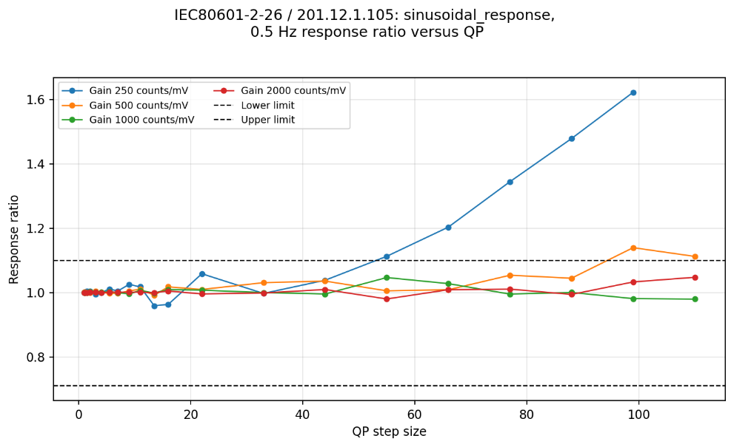
(a)
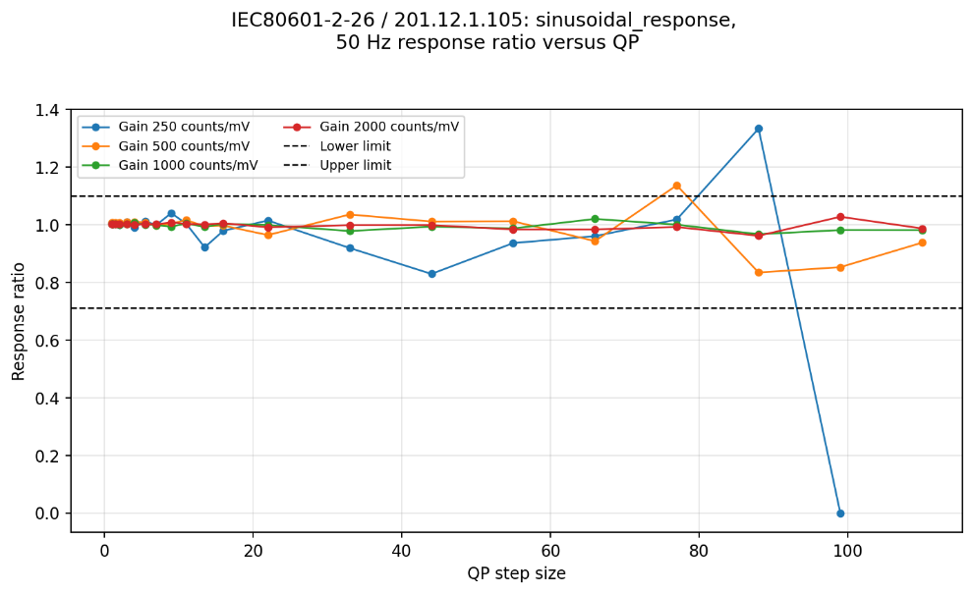
(b)
Figure 14. Sinusoidal frequency response for IEC 80601-2-26 / 201.12.1.105. Reconstructed amplitude ratios for (a) 0.5 Hz and (b) 50 Hz relative to the decoded 5 Hz response for the 50 µV peak-to-peak EEG signals. Dashed lines indicate the permitted range of 0.71–1.10.
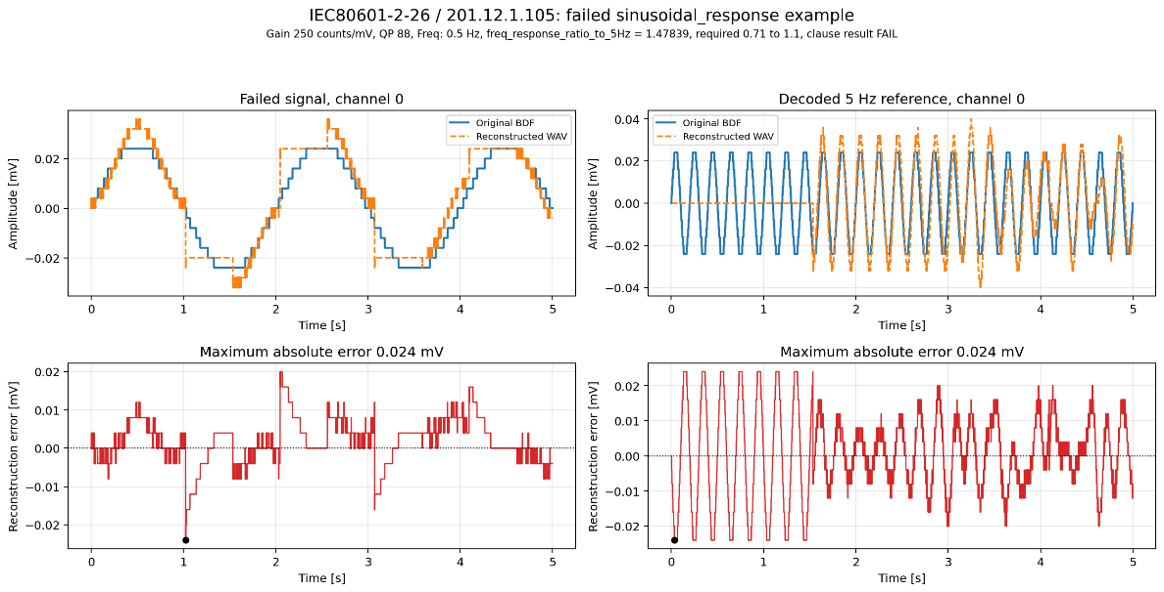
Figure 15. Example of non-uniform reconstruction in a failed sinusoidal frequency-response condition. IEC 80601-2-26 / 201.12.1.105, gain 250/QP 88. Top: source and decoded 0.5 Hz and 5 Hz sine waves. Bottom: corresponding decoded-minus-source differences.

Overall interpretation
The sinusoidal-response results showed stable relative amplitude preservation for the evaluated ECG conditions. All IEC 60601-2-25, IEC 60601-2-27 and IEC 60601-2-47 sinusoidal tests passed across all gains and QPs, including frequencies extending from sub-hertz components up to 500 Hz. The decoded reference amplitudes also remained close to nominal. This indicates that no general frequency-dependent attenuation was observed for the higher-amplitude ECG signals evaluated here.
The only failures occurred for the 50 µV p-p EEG test signal in IEC 80601-2-26, and only at gains 250 and 500 with high QP settings. The large 0.5 Hz-to-5 Hz ratios predominantly resulted from attenuation of the decoded 5 Hz reference rather than amplification of the 0.5 Hz signal. This could be an effect of the very small effective digital amplitude of the signals at gain 250, 50 µV p-p corresponds to only 12.5 digital counts p-p, compared with 50 and 100 counts p-p at gains 1000 and 2000, where all conditions passed. The results therefore indicate reduced amplitude resolution for very small signals under coarse quantization rather than a general stationary frequency-response limitation. In several failed conditions, reconstruction of the 5 Hz reference was also non-uniform over time, with some portions strongly attenuated or nearly flat while others remained recognizable. This occurred over long intervals of 2048, 3072 and related sample counts, with complete suppression at the highest QP steps. The structured nature of these intervals might be related to block-dependent lossy-coding behaviour superimposed on the underlying quantization sensitivity. However, the actual encoder block sizes and coding modes were not investigated further, so the specific mechanism remains unconfirmed.
Overall, the results indicate that T.261 preserved sinusoidal amplitude relationships over the evaluated ECG frequency ranges and amplitudes, while very-low-amplitude EEG signals became vulnerable when input scaling and QP reduced the effective representation margin. Appropriate gain and QP selection therefore appears more critical for low-amplitude EEG than for the ECG conditions evaluated here.

Triangular-pulse response

General description
Continuous triangular waves evaluate the preservation of waveform amplitude and rate of variation. As described in the preceding sections, they are used to assess amplitude accuracy, linearity, and tolerance to DC offsets. In contrast, short triangular pulses contain greater high-frequency content and are therefore more sensitive to smoothing, attenuation, and ringing effects that may not be apparent in continuous-wave measurements. They are therefore used to assess pulse-width-dependent relative amplitude response, and their measurements and references are reported separately here. In the ECG context, this provides a controlled codec-domain proxy for preservation of rapid waveform transitions, such as those contributing to QRS morphology, rather than a direct assessment of clinical ECG interpretation.

Applicable clauses
Table 17: Triangular-pulse limits
Clause/method | Synthetic condition | Reference | Limit | Aggregation/route
IEC 60601-2-25 / 201.12.4.107.1.1.1 E | 1.5 mV peak; 20 and 200 ms at 1/s | Mean decoded 200 ms peak-to-base | Each of first 10 cycles: 0.90–1.00 | E is an alternative to B AND C AND D; A remains mandatory
IEC 60601-2-27 / 201.12.1.101.8 B | 2 mV peak; 20 and 200 ms at 1/s | Mean decoded 200 ms peak-to-base | Each of first 10 cycles: 0.75–1.00 | Method B is required together with A and impulse in current clause logic
IEC 60601-2-47 / 201.12.4.4.108 triangle route | 1.5 mV peak; 40 and 200 ms at 1/s | Maximum decoded 200 ms peak-to-base | Each 40 ms cycle: 0.70–1.10 | Alternative to sine; impulse mandatory
Same clause, verification diagnostic | Lowest 40 ms versus highest 200 ms | Maximum decoded 200 ms | ≥0.60 | Reported separately, not counted, because the clause text contains a conflicting verification statement

Synthetic signals
Continuous triangular waves cover 2, 6, 6.25 and 16 Hz with amplitudes from 0.1 to 20 mV p-p, as described in the amplitude and DC-offset concepts. Pulse-train pairs use 20 and 200 ms base widths for IEC 60601-2-25 and IEC 60601-2-27, and 40 and 200 ms for IEC 60601-2-47, at one pulse per second. Short triangular pulses contain stronger high-frequency components and approximate sharp physiological transients such as QRS-like deflections; the 200 ms pulse provides a slower reference response. Comparing them reveals smoothing, ringing or unequal attenuation of narrow and broad waveform components.
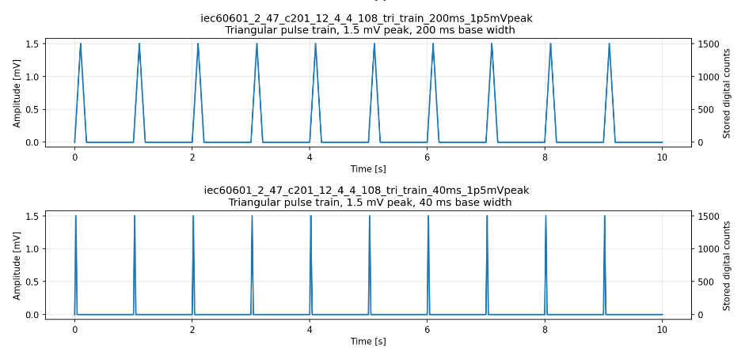
Figure 16. Example synthetic signals testing short and long triangular pulses.
IEC 60601-2-47 / 201.12.4.4.108 triangle route: 1 Hz 40 and 200 ms base width triangle pulses, 1.5 mV peak

Metrics
These clauses do not primarily test general amplitude accuracy but whether short pulses (20 or 40 ms) containing more high-frequency energy are attenuated relative to longer pulses (200 ms).
For each short-pulse cycle $k$, its peak-to-base amplitude is measured as follows:
$$A_{short,k}=M_{k}-P_{k}$$
where:
- $M_{k}$is the maximum response in cycle $k$;
- $P_{k}$is the inter-pulse baseline sample located midway between consecutive pulse onsets
Short-pulse amplitudes are compared with reconstructed long-pulse amplitudes, rather than with the nominal input amplitude. This isolates differential attenuation or enhancement of the sharper, higher-frequency-content short pulses.

Response ratio relative to mean of long pulses
This metric compares each short-pulse response with the mean response of the long-pulse train:
$${\overset{‾}{A}}_{long}=\frac{1}{N}\sum_{j=1}^{N}{A_{long,j}}$$
The cycle-specific response ratio for each of the first ten decoded short pulses is then evaluated separately as follows:
$$R_{pulse,k}=\frac{A_{short,k}}{{\overset{‾}{A}}_{long}}$$
A value of one indicates equal reconstructed peak-to-base amplitude for the short and long pulses. Values below one indicate relative attenuation of the short pulse; values above one indicate relative enhancement.
This mean-reference metric is used for the following clauses:
- IEC 60601-2-25 / 201.12.4.107.1.1.1 Method E: each of the first ten 20 ms pulse responses shall satisfy:
$$0.90≤R_{pulse,k}≤1.00$$
Method E is one route through the overall frequency-response clause and can fail while the complete clause still passes through Methods A–D:
$$\left(A∧E\right)∨\left(A∧B∧C∧D\right)$$
- IEC 60601-2-27 / 201.12.1.101.8 Method B: each of ten consecutive 20 ms pulse responses shall satisfy:
$$0.75≤R_{pulse,k}≤1.00$$
The pass/fail decision is made separately for every required short-pulse cycle. A single out-of-range cycle causes the relevant method to fail. This method belongs to the standard’s frequency-response clause but is presented under triangular-pulse response because its measurement uses pulse amplitudes rather than fitted sine amplitudes.

Response ratio relative to the maximum of long pulses
IEC 60601-2-47 / 201.12.4.4.108, triangle route uses the maximum peak-to-base amplitude in the 200 ms long-pulse train as the reference.
$$R_{40,k}=\frac{A_{40,k}}{\max_{j}\left(A_{200,j}\right) }$$
For the general IEC 60601-2-47 requirement, every 40 ms short-pulse response shall satisfy:
$$0.70≤R_{40,k}≤1.10$$
The verification text instead compares the lowest short-pulse response with the maximum long-pulse response:
$$R_{min}=\frac{\min_{k}\left(A_{40,k}\right)}{\max_{j}\left(A_{200,j}\right)}$$
General verification condition:
$$R_{min}≥0.60$$
The 60% verification condition is less strict than requiring every short pulse to be within 70% to 110%. Thus, the pass/fail decision is made using 0.70–1.10 per-cycle limit.

Results
The triangular-pulse tests compared the peak-to-base response of short pulses with a decoded 200 ms reference. The strict upper boundary of 1.00 caused small exceedances for IEC 60601-2-25 Method E and IEC 60601-2-27 Method B. The wider IEC 60601-2-47 range was passed throughout.
Table 18: Triangular-pulse results summary
Clause and method | Cycles per condition | Gain–QP conditions | Cycle measurements | Method outcome
IEC 60601-2-25 / Method E | 10 | 56 | 560 | 29 PASS, 27 FAIL
IEC 60601-2-27 / Method B | 10 | 56 | 560 | 25 PASS, 31 FAIL
IEC 60601-2-47 / triangle route | 10 | 56 | 560 + 56 diagnostics | 56/56 PASS

IEC 60601-2-25 / 201.12.4.107.1.1.1, Method E
Method E passed 29 conditions and failed 27. Of 560 individual cycle ratios, 314 passed and 246 exceeded the strict upper limit. Ratios ranged from 0.9565 to 1.00738 and no failures occurred at the 0.90 lower boundary. The largest exceedance was 0.738%. The results are shown in Figure 17.
Inspection of the underlying pulse amplitudes confirmed that the generated 20 ms and 200 ms source pulses both had the intended 1.5 mV peak-to-base amplitude. The ratios above the upper limit of 1 therefore arose during reconstruction. In the failing cases, the decoded 200 ms reference was typically attenuated slightly more than the decoded 20 ms pulse, causing the normalized short-pulse response to exceed 1.00 despite the small absolute amplitude difference. This behaviour was not monotonic with QP and at some more strongly quantized conditions the 20 ms pulse was instead attenuated more than the 200 ms pulse, resulting in ratios below unity that remained within the acceptance range.
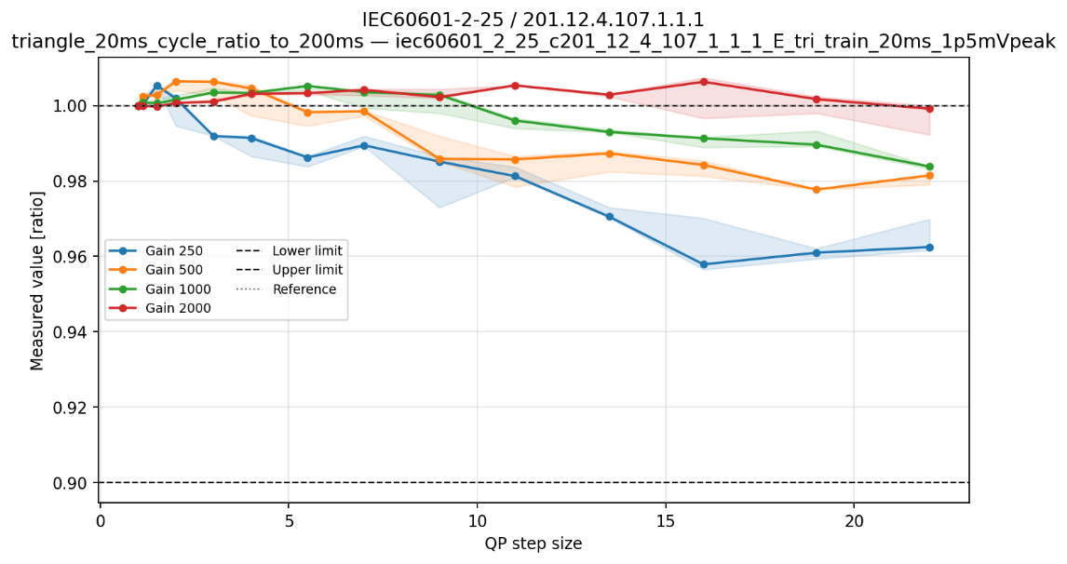
Figure 17. Method E short-to-long triangular-pulse ratios for IEC 60601-2-25 / 201.12.4.107.1.1.1. 20 ms-to-200 ms cycle ratio in each gain–QP condition. Lines show the mean across evaluated cycles; shading shows the cycle min–max range. The dashed lines indicate the permitted range of 0.90–1.00. The 1.00 upper limit and the 1.00 nominal reference happen to coincide.
A cycle-dependent effect was also observed. For example, at gain 2000 and QP 16, the decoded 200 ms mean amplitude was 1.4905 mV. The first 20 ms pulse reconstructed to 1.4855 mV and passed with a ratio of 0.9966, whereas cycles 2–10 reconstructed consistently to 1.5015 mV and failed with a ratio of 1.00738 (see Figure 18). Similar first-cycle differences occurred in other gain–QP conditions.
The complete clause nevertheless passed all 56 conditions because Methods $\left(A∧B∧C∧D\right)$ route passed, providing the permitted alternative to Method E.
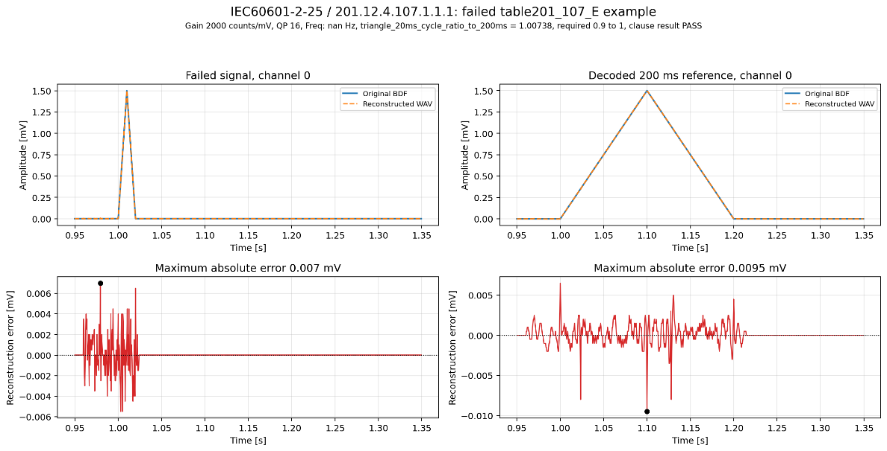
Figure 18. Example of Method E failure caused by differential reconstruction of short and long pulses. IEC 60601-2-25 / 201.12.4.107.1.1.1 Method E, gain 2000, QP 16. Top: source and decoded 20 ms and 200 ms triangular pulses. Bottom: corresponding decoded-minus-source differences.

IEC 60601-2-27 / 201.12.1.101.8, Method B
Method B passed 25 conditions and failed 31. Of 560 individual cycle ratios, 264 passed and 296 failed. Ratios ranged from 0.9562 to 1.00704 (see Figure 19). Every genuine failure was caused by the strict upper boundary of 1.00; none approached the 0.75 lower boundary. The largest exceedance was 0.704% at gain 500 and QP 5.5. Nine cycle values numerically slightly above 1.00 because of floating-point representation were treated as boundary values rather than failures in the final evaluation. This correction did not change the condition-level outcome: the affected gain 250/QP 1.5 condition also contained a genuine ratio of approximately 1.002 and therefore remained a failure.
As in Method E, the failures were caused by small differences introduced during reconstruction rather than by differences in the input signals. At gain 500 and QP 5.5, for example, the decoded mean 200 ms amplitude was 1.988 mV. The first decoded 20 ms pulse had an amplitude of 1.978 mV and passed with a ratio of 0.9950, whereas cycles 2–10 reconstructed consistently to 2.002 mV, giving a ratio of 1.00704 and causing nine cycle failures (see Figure 20). Thus, an approximately 0.7% relative difference between the reconstructed short- and long-pulse responses was sufficient to change the result from pass to fail.
Because Method B is mandatory together with Method A and the impulse response, these failures produced 31 complete-clause failures.

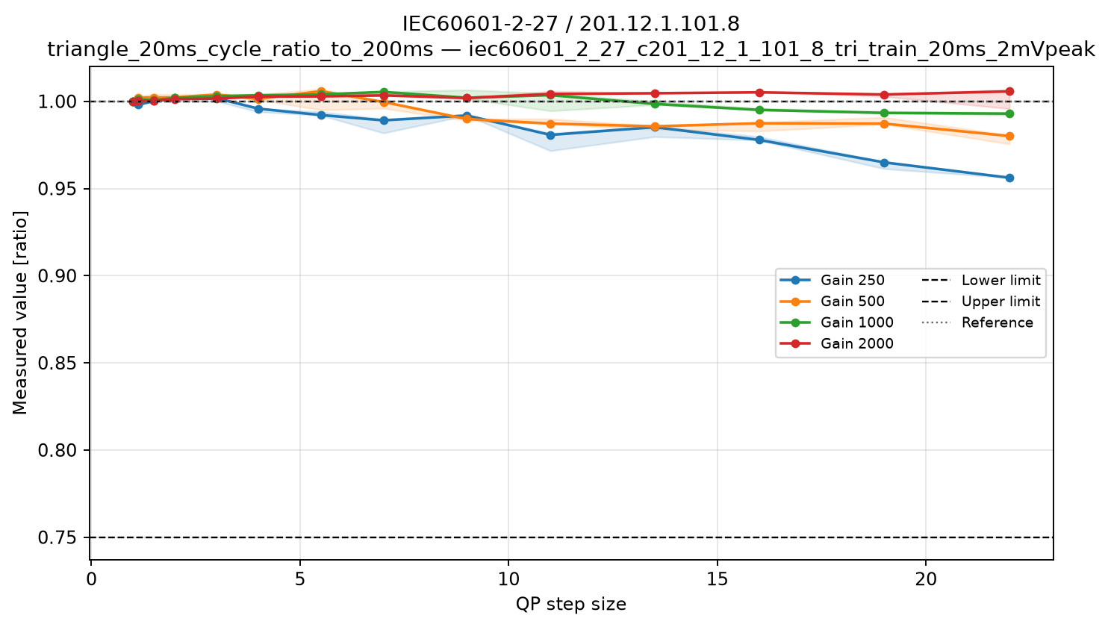
Figure 19. Method B short-to-long triangular-pulse ratios for IEC 60601-2-27 / 201.12.1.101.8. 20 ms-to-200 ms cycle ratio in each gain–QP condition. Lines show the mean across evaluated cycles; shading shows the cycle min–max range. The dashed lines indicate the permitted range of 0.75–1.00. The 1.00 upper limit and the 1.00 nominal reference happen to coincide.
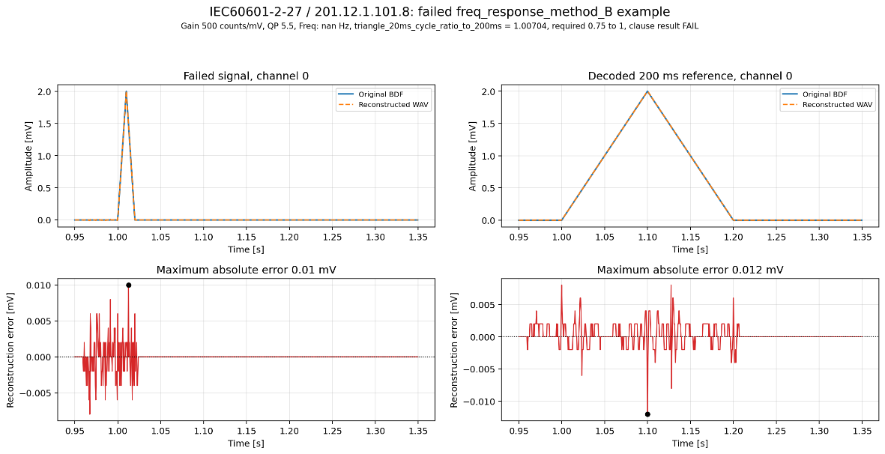
Figure 20. Example of a triangular-pulse ratio failure caused by differential reconstruction of short and long pulses. IEC 60601-2-27 / 201.12.1.101.8 Method B, gain 500, QP 5.5. Top: source and decoded 20 ms and 200 ms triangular pulses. Bottom: corresponding decoded-minus-source differences.

IEC 60601-2-47 / 201.12.4.4.108, triangle route
All 56 conditions and all 560 counted cycle ratios passed. The 40 ms-to-maximum-200 ms ratios ranged from 0.9699 to 1.0054 (see Figure 21a), comfortably within the permitted range of 0.70–1.10.
The clause also states separately that the lowest 40 ms peak shall be at least 60% of the highest 200 ms peak. This extreme-value check was therefore retained as a supporting verification diagnostic. The ratios ranged from 0.9699 to 1.0030 (see Figure 21b), well above the 0.60 threshold. Pass/fail was based on the stricter cycle-wise 0.70–1.10 requirement, which assesses every counted 40 ms pulse rather than only the single lowest pulse. Neither metric showed a consequential gain- or QP-dependent boundary.
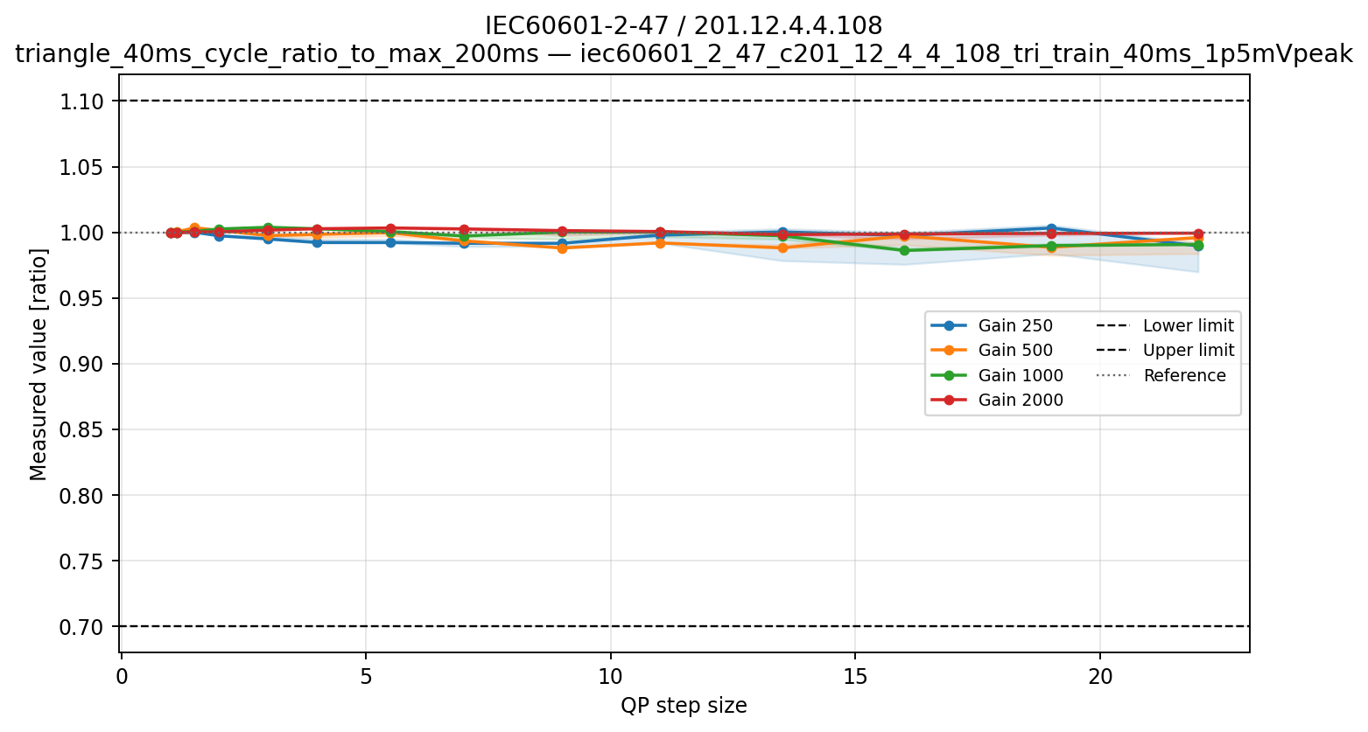
(a)
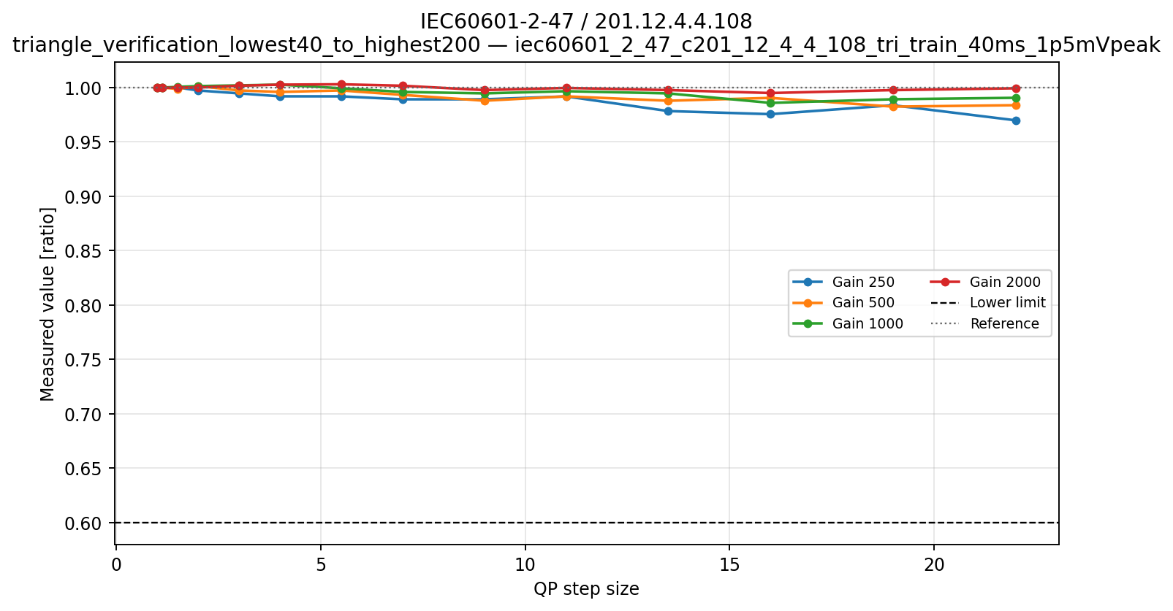
(b)
Figure 21. Triangular-pulse response for IEC 60601-2-47 / 201.12.4.4.108. (a) Per-condition range of the counted 40 ms-to-maximum-200 ms cycle ratios; (b) lowest-40 ms-to-highest-200 ms verification diagnostic. Dashed lines indicate the applicable 0.70–1.10 and ≥0.60 criteria.

Overall interpretation
The triangular-pulse failures observed for IEC 60601-2-25 Method E and IEC 60601-2-27 Method B were driven by the strict upper response ratio of 1.00 rather than by excessive attenuation of the short-duration pulse. All lower acceptance limits were met. In the failing conditions, small differential reconstruction between the short and long pulses was observed with the decoded 200 ms reference appearing slightly more attenuated than the corresponding 20 ms pulse, and producing ratios marginally above the limit of 1.00. The largest excess was 0.738% for IEC 60601-2-25 and 0.704% for IEC 60601-2-27.
The pulse-level results also revealed a possible coding-context effect that is not visible from the condition-average ratios alone. In several representative failing conditions, the first short pulse reconstructed differently from the subsequent pulses, while cycles 2–10 were nearly or completely identical in amplitude. Because the first pulse occurs at the start of the encoded sequence, possible explanations include codec initialization, predictor or transform state, and coding-block context. Pulse alignment relative to the codec processing blocks may also contribute. These mechanisms were not isolated experimentally and are therefore treated as hypotheses rather than established causes.
The regulatory significance of the upper-bound failures should also be considered in the context of the emerging replacement ECG standard. The Draft International Standard text of IEC 80601-2-86 as balloted in October 2026 by IEC retains triangular-pulse frequency-response testing but changes the diagnostic ECG criterion to require the lowest 20 ms peak-to-base response to be at least 90% of the highest 200 ms peak-to-base response. No corresponding 100% upper limit is specified. The draft also defines a general ECG 40 ms/200 ms triangular-pulse criterion requiring the lowest 40 ms response to be at least 70% of the highest 200 ms response, again without an upper bound. Consequently, the small above-unity deviations responsible for the present IEC 60601-2-25 and IEC 60601-2-27 failures would not, by themselves, constitute failures under these draft triangular-pulse criteria. Because IEC 80601-2-86 remains a draft, this comparison is reported as contextual information and was not used to alter the pass/fail results of the standards evaluated here.
The difference illustrates the strong dependence of clause status on the definition of the reference response and aggregation rule. IEC 60601-2-25 passed all 56 complete-clause conditions through its permitted A∧B∧C∧D alternative despite 27 Method E failures. IEC 60601-2-27 failed 31 of 56 conditions because Method B was mandatory in the evaluated logic. In contrast, the IEC 60601-2-47 triangular-pulse route passed all conditions. Taken together, the results indicate good preservation of short-pulse amplitude across the evaluated configurations, while also showing that sub-percent differential reconstruction can trigger failures if the clause has a strict upper boundary of 1.

Impulse and baseline recovery

General description
These tests evaluate baseline displacement, recovery slope, and, where applicable, leading-edge overshoot after a defined pulse or impulse. They assess whether codec-induced ringing, baseline shift, or residual transient distortion that could alter ECG baseline or ST-related interpretation is introduced. The test evaluates reconstruction behaviour after a synthetic disturbance and does not assess the full equipment response, including analogue filtering or display behaviour.

Applicable clauses
Table 19: Impulse and baseline-recovery limits
Clause | Displacement | Recovery slope | Overshoot | Aggregation/qualification
IEC 60601-2-25 / 201.12.4.107.1.1.2 | ≤0.10 mV | ≤0.30 mV/s | Not applied | Both counted metrics pass
IEC 60601-2-27 / 201.12.1.101.8 | ≤0.10 mV | ≤0.30 mV/s | Not applied | Both impulse metrics pass, together with Methods A and B
IEC 60601-2-47 / 201.12.4.4.108 | ≤0.10 mV | ≤0.30 mV/s | <10% | All impulse metrics pass; then either sine or triangle route must pass

Synthetic signals
The input is a 3 mV rectangular pulse with a duration of 100 ms, preceded and followed by a constant baseline. The IEC 60601-2-25 and IEC 60601-2-27 records place the impulse after a 5 s pre-pulse baseline; the IEC 60601-2-47 record uses a 20 s pre-pulse baseline. This step-like excitation stresses the low-frequency and transient response and represents the tendency of an ECG processing chain to show baseline displacement, slow recovery, ringing or leading-edge overshoot after a large rapid deflection.
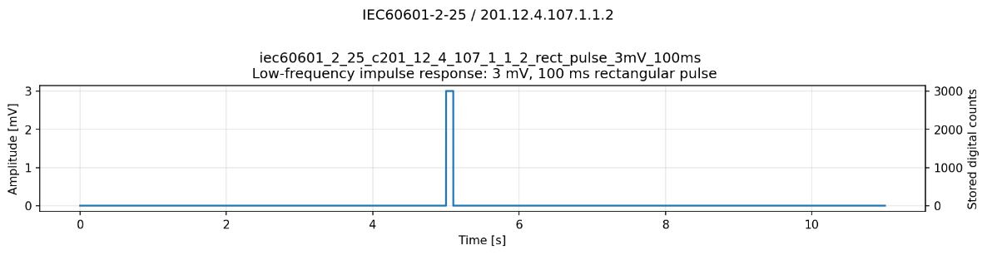
Figure 22. Example synthetic signals testing impulse response and baseline recovery.
IEC 60601-2-25 / 201.12.4.107.1.1.2: 3 mV, 100 ms rectangular pulse

Metrics

Reconstructed pre-pulse baseline
The baseline is the mean of the decoded samples during the 50 ms immediately before pulse onset:
$$B_{pre}=\frac{1}{N_{B}}\sum_{n=n_{0}-N_{B}}^{n_{0}-1}{\hat{x}}\left[n\right]$$
where:
$$N_{B}≈0.050f_{s}$$
This baseline is used as the reference for displacement, recovery slope and overshoot. It is not stored as an independent metric row.

Post-pulse baseline displacement
After the 100 ms pulse has ended, the maximum absolute deviation from the pre-pulse baseline is:
$$D_{post}=\max_{n≥n_{1}}∣\hat{x}\left[n\right]-B_{pre}∣$$

Maximum post-pulse recovery slope
The post-pulse signal is divided into overlapping windows of 200 ms length and 50 ms overlap. For each window $W$, a least-squares line is fitted.
With centred time samples $t_{n}-{\overline{t}}_{W}$, the slope is:
$$β_{W}=\frac{\sum_{n∈W}{(}\left.t_{n}-{\overline{t}}_{W}\right)\left(y_{n}-{\overline{y}}_{W}\right)}{\sum_{n∈W}{(}\left.t_{n}-{\overline{t}}_{W}{\left.)\right.}^{2}\right.}$$
where:
$$y_{n}=\hat{x}\left[n\right]-B_{pre}$$
The retained metric is:
$$S_{post}=\max_{W}∣β_{W}∣$$

Leading-edge overshoot ratio
This metric is used only for IEC 60601-2-47.
The pulse plateau $L$ is the median of the central 10%–90% portion of the decoded pulse:
$$L=\operatorname{median}\left\{\hat{x}\left[n\right]:n\text{ lies within the central 10\%-90\% of the pulse}\right\}$$
The reconstructed pulse response is:
$$A_{pulse}=L-B_{pre}$$
The overshoot ratio is:
$$O=\frac{\max\left(0 , \max_{pulse}\hat{x}\left[n\right]-L\right)}{∣L-B_{pre}∣}$$
Pass condition for all three applicable clauses are as follows:
- IEC 60601-2-25 / 201.12.4.107.1.1.2
$$D_{post}≤0.10 mV ∧ S_{post}≤0.30 mV/s$$
The pre-pulse baseline is 5 s.
- IEC 60601-2-27 / 201.12.1.101.8
$$D_{post}≤0.10 mV ∧ S_{post}≤0.30 mV/s$$
The pre-pulse baseline is 5 s. The complete clause condition also requires Methods A and B:
$$\text{Method A}∧\text{Method B}∧\text{Impulse}$$
- IEC 60601-2-47 / 201.12.4.4.108
$$D_{post}≤0.10 mV \\ S_{post}≤0.30 mV/s \\ O<0.10$$
The pre-pulse baseline is 20 s.
All impulse metrics must pass, followed by either the sine or triangular-pulse route:
$$\text{Impulse}∧\left(\text{Sine route}∨\text{Triangle route}\right)$$

Results
Impulse response was evaluated using baseline displacement and recovery slope after a 3 mV, 100 ms rectangular pulse. IEC 60601-2-47 additionally included leading-edge overshoot. Every impulse component passed, although this did not prevent failures of IEC 60601-2-27 / 201.12.1.101.8 caused by its separate triangular-pulse component.
Table 20: Impulse and baseline-recovery results summary
Clause | Metrics per condition | Conditions | Measurements | Impulse outcome
IEC 60601-2-25 / 201.12.4.107.1.1.2 | 2 | 56 | 112 | 56/56 PASS
IEC 60601-2-27 / 201.12.1.101.8 | 2 | 56 | 112 | 56/56 PASS
IEC 60601-2-47 / 201.12.4.4.108 | 3 | 56 | 168 | 56/56 PASS

IEC 60601-2-25 / 201.12.4.107.1.1.2
All 56 conditions passed both impulse metrics. Baseline displacement ranged from 0 to 0.0768 mV against the 0.10 mV limit. The maximum occurred at gain 250 and QP 22. See Figure 23a. Recovery slope ranged from 0 to 0.01574 mV/s against the 0.30 mV/s limit, with the maximum at gain 250 and QP 19 as visible in Figure 23b. Both metrics generally increased at lower gain and higher QP, but recovery slope retained especially large margin.
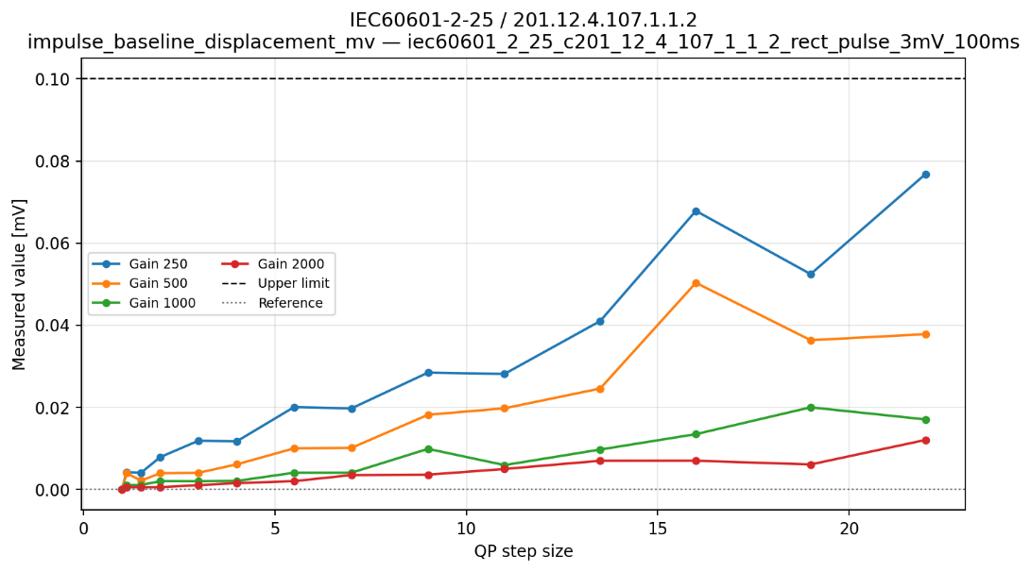
(a)
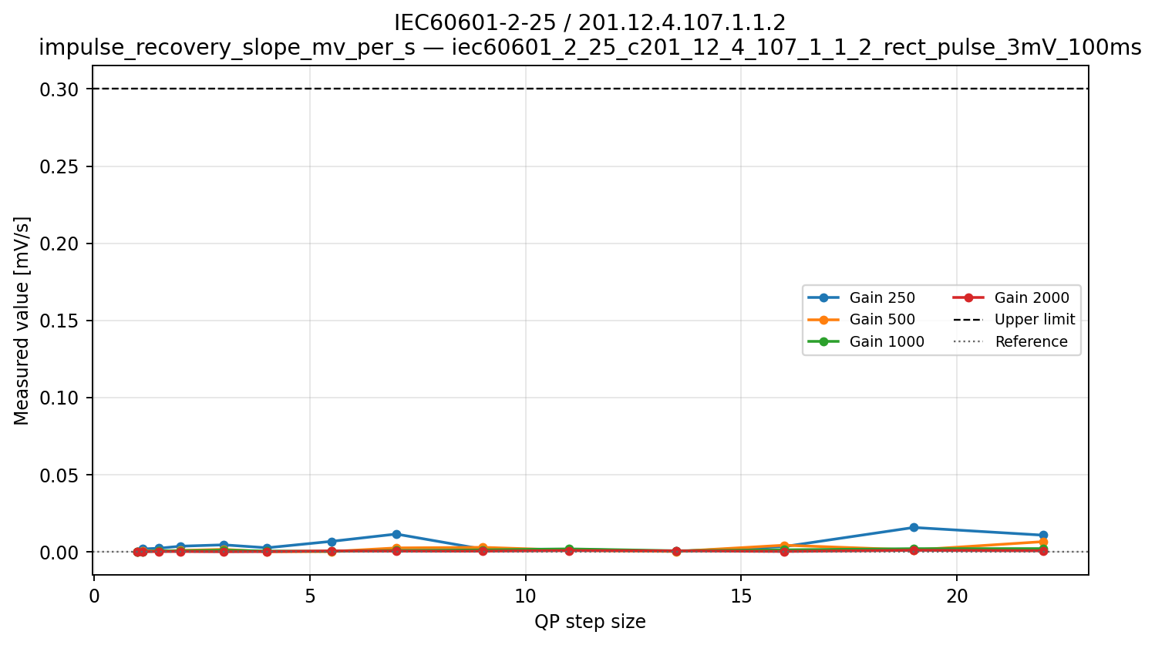
(b)
Figure 23. Impulse displacement and baseline recovery for IEC 60601-2-25 / 201.12.4.107.1.1.2 and the corresponding impulse component of IEC 60601-2-27 / 201.12.1.101.8. (a) Post-pulse baseline displacement and (b) recovery slope across gain and QP. Dashed lines indicate the limits of 0.10 mV and 0.30 mV/s.

IEC 60601-2-27 / 201.12.1.101.8
All 56 impulse-response components passed. Within this codec-domain proxy, the impulse component used the same rectangular-pulse construction, baseline-displacement metric, and recovery-slope metric as clause IEC 60601-2-25 / 201.12.4.107.1.1.2. The component results were therefore identical: baseline displacement ranged from 0 to 0.0768 mV against the 0.10 mV limit, and recovery slope ranged from 0 to 0.01574 mV/s against the 0.30 mV/s limit. The relevant extrema occurred at gain 250/QP 22 and gain 250/QP 19, respectively.
The impulse component therefore did not contribute to any of the 31 complete-clause failures. Those failures were caused exclusively by Method B.

IEC 60601-2-47 / 201.12.4.4.108
All 56 conditions passed all three impulse metrics. Maximum baseline displacement was 0.07284 mV against the 0.10 mV limit. Maximum recovery slope was 0.02033 mV/s against the 0.30 mV/s limit. Maximum leading-edge overshoot was 0.02267, or 2.27%, against the 10% limit. All three maxima occurred at gain 250 and QP 22. The results are visualized in Figure 24.
Displacement and overshoot increased at lower gain and high QP steps, but all conditions retained clear margin.
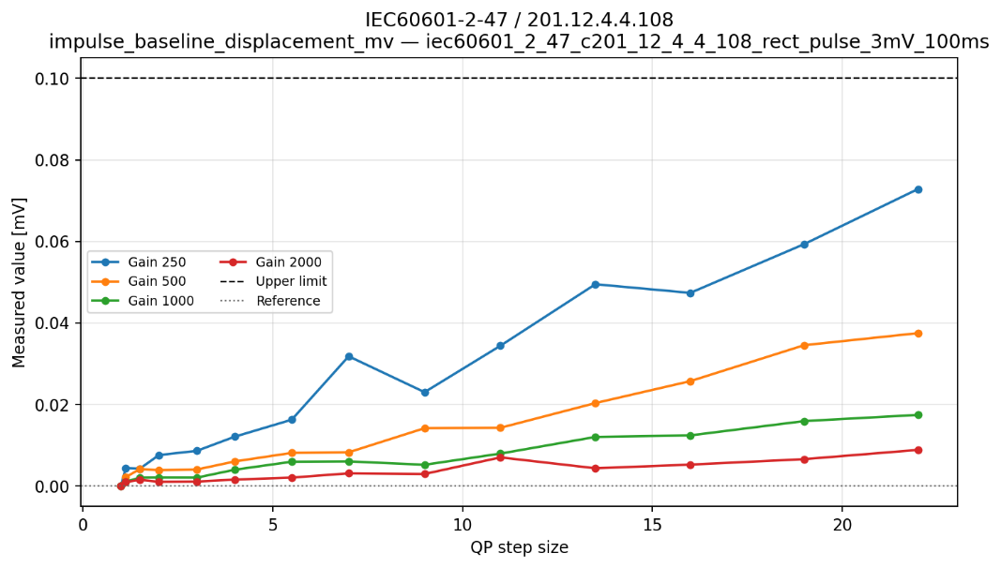
(a)
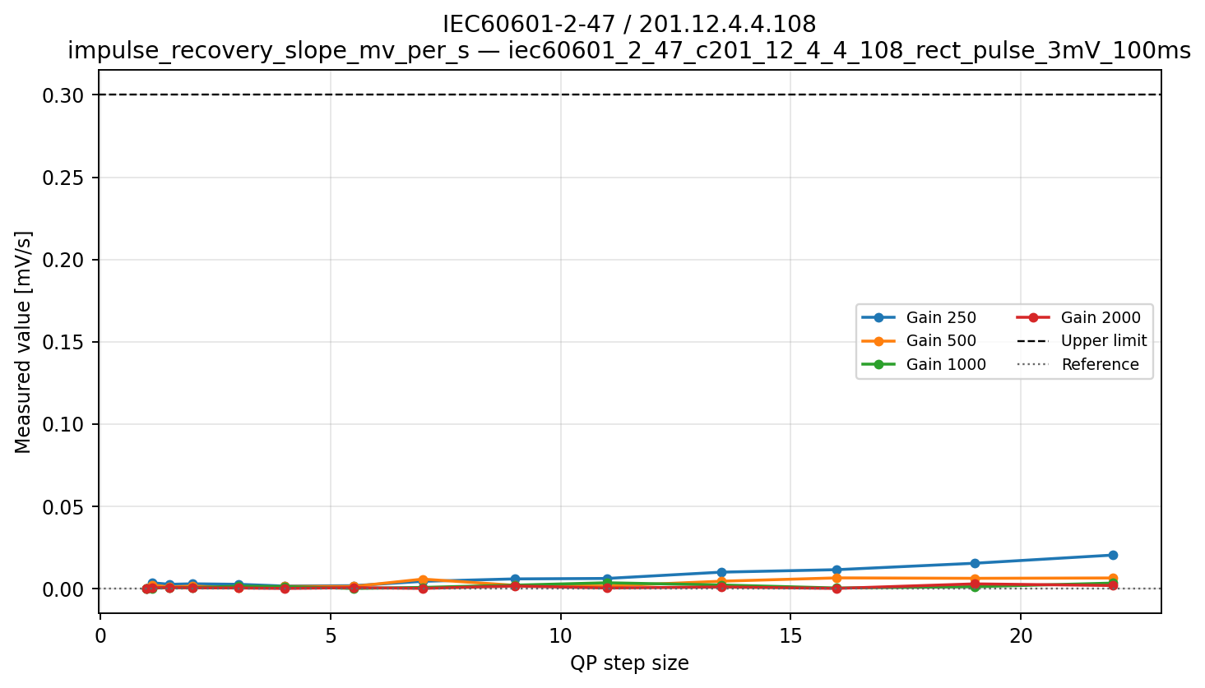
(b)
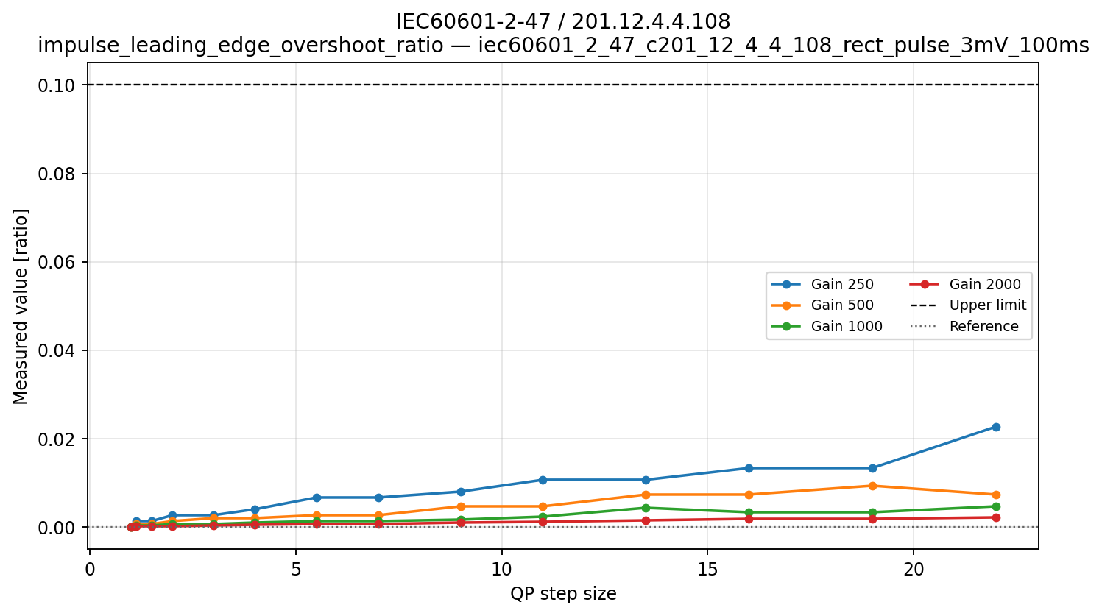
(c)
Figure 24. Baseline recovery and leading-edge overshoot for IEC 60601-2-47 / 201.12.4.4.108. Baseline displacement (a), recovery slope (b), and leading-edge overshoot ratio (c). Dashed lines indicate the metric-specific limits of 0.10 mV, 0.30 mV/s and 0.10 respectively.

Overall interpretation
All evaluated impulse-response components passed. Baseline displacement, recovery slope and, where applicable, leading-edge overshoot generally increased at lower gain and higher QP steps, but remained within their respective limits. Baseline displacement approached its limit more closely than recovery slope or overshoot and was therefore the most sensitive impulse metric in the tested range. The results indicate that T.261 did not introduce excessive post-pulse baseline drift, slow recovery or leading-edge ringing into the synthetic rectangular impulses.

Multichannel crosstalk

General description
This concept evaluates whether activity in one reconstructed channel produces an unwanted response in inactive channels and whether active-channel amplitude is retained. It relates to channel independence, which is important when multichannel ECG or EEG recordings are reviewed, interpreted, or processed using spatial or cross-channel features. The test examines digital channel separation through the codec; it does not assess electrode coupling, patient-related artefacts, or hardware crosstalk before digitization.

Applicable clauses
Table 21: Multichannel crosstalk limits
Clause | Applied signal | Counted metric | Limit | Aggregation
IEC 60601-2-25 / 201.12.4.106.2 | 30 Hz triangle, 2.5 mV p-p | Inactive p-p/input p-p | ≤0.02 (2%) | Every inactive channel for every active-channel case passes
IEC 60601-2-27 / 201.12.1.101.5 | 30 Hz triangle, 2.5 mV p-p | Inactive p-p/input p-p | ≤0.05 (5%) | Every inactive channel for every active-channel case passes
IEC 60601-2-47 / 201.12.4.4.107 | 10 Hz sine, 4 mV p-p | Inactive p-p/input p-p | ≤0.05 (5%) | Every inactive channel for every active-channel case passes

Synthetic signals
Four-channel records are used, with one active channel at a time and nominally zero input in the other three channels. IEC 60601-2-25 and IEC 60601-2-27 use the same 30 Hz, 2.5 mV p-p triangle, while IEC 60601-2-47 uses a 10 Hz, 4 mV p-p sine. The construction represents a physiological waveform present in one ECG lead while testing whether the codec introduces artificial copies into unrelated leads. Activating every channel in turn also checks whether the result depends on channel position or ordering.
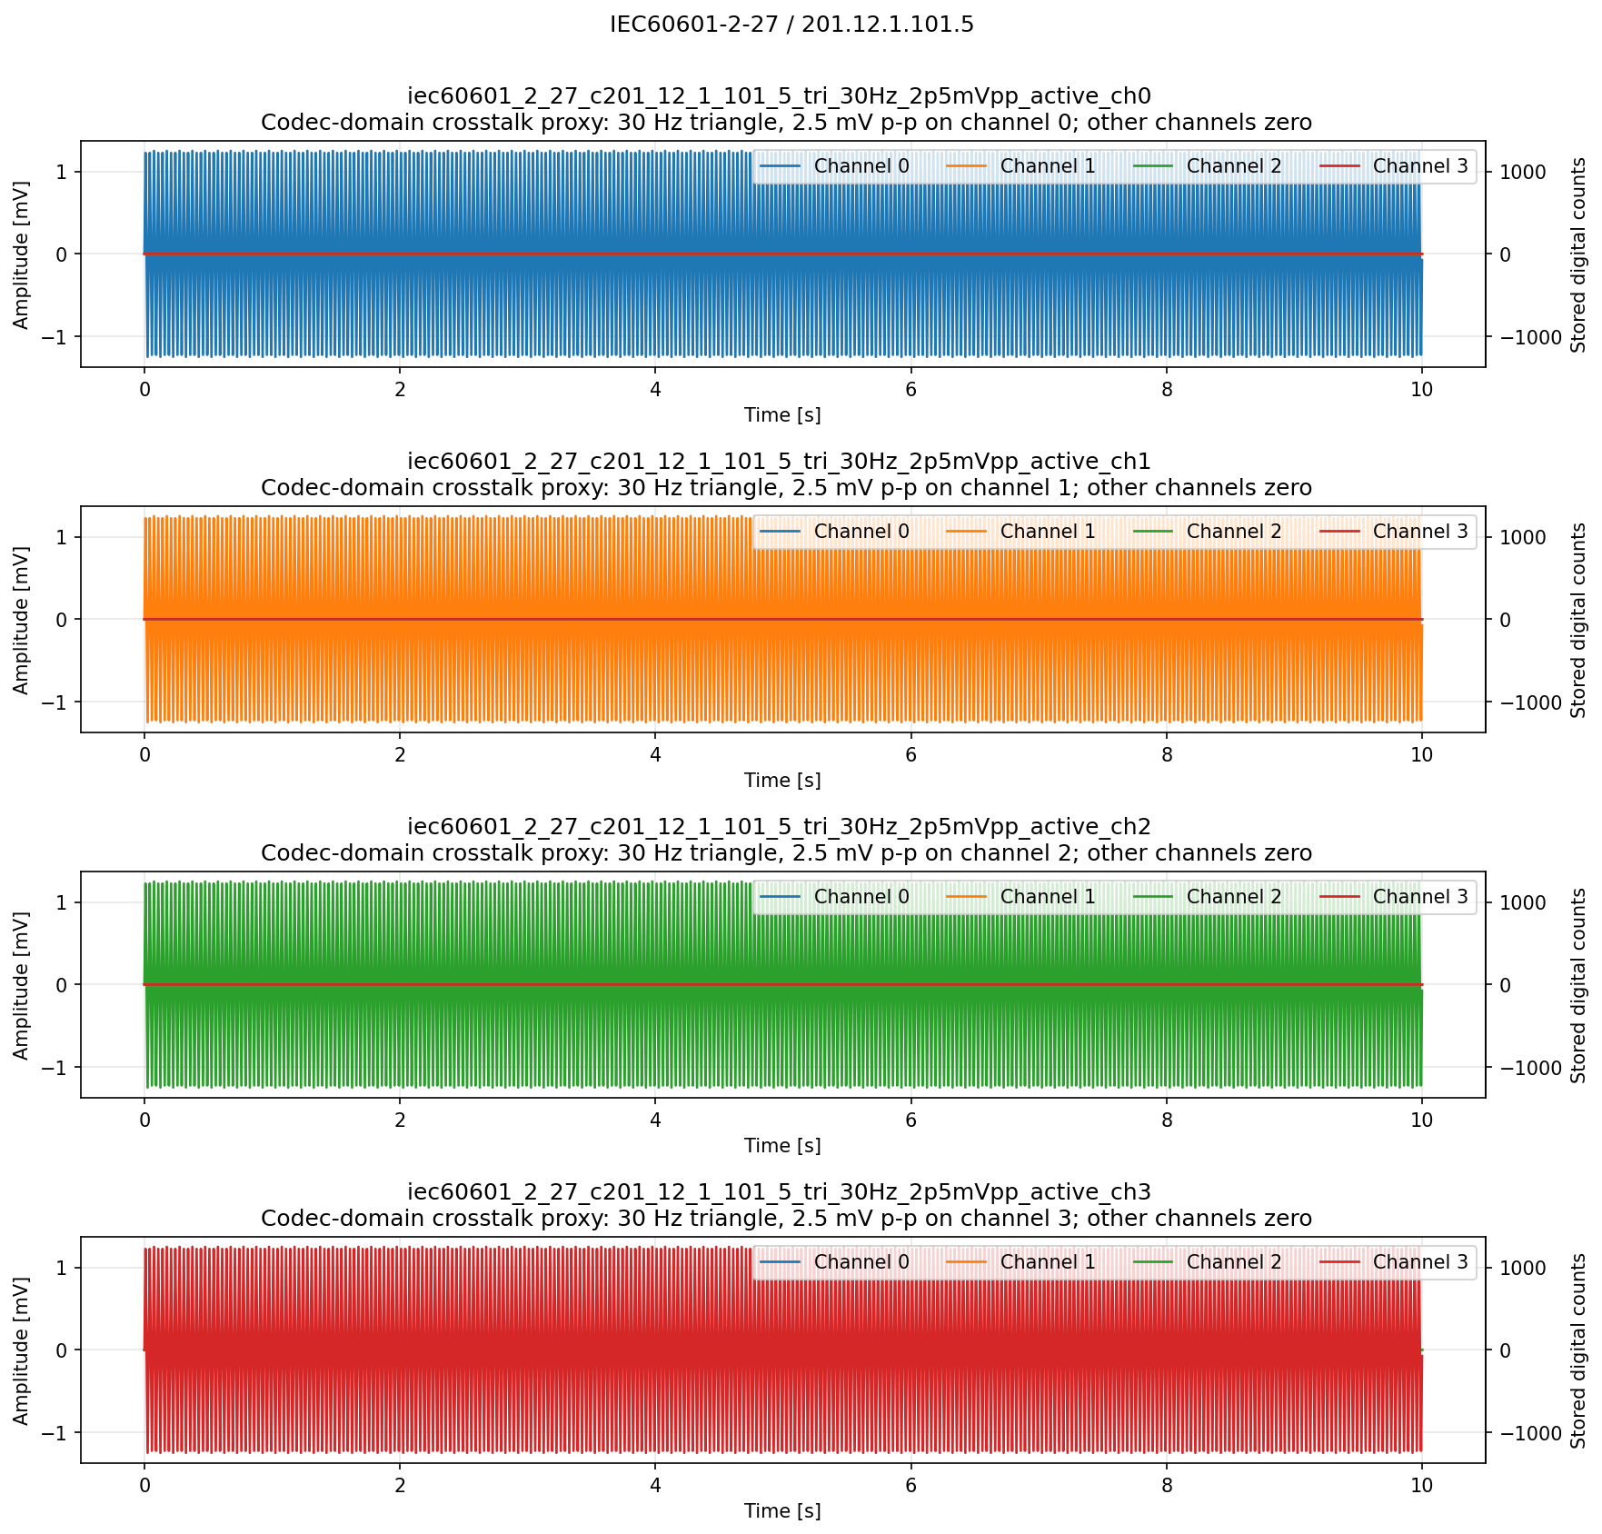
Figure 25. Example synthetic signals testing multichannel crosstalk. IEC 60601-2-27 / 201.12.1.101.5: active channel 30 Hz triangle wave, 2.5 mV p-p, other channels 0 mV

Metrics
One channel is stimulated while all other channels have zero nominal input. The counted crosstalk metric divides the reconstructed peak-to-peak response in each inactive channel by the nominal signal applied to the active channel. A separate active-channel ratio is diagnostic only and reveals amplitude attenuation that could otherwise be hidden by a low crosstalk value.

Active-channel amplitude ratio
For the active channel $a$:
$$A_{active}=A_{pp}\left({\hat{x}}_{a}\right)$$
The active-channel amplitude ratio is:
$$R_{active}=\frac{A_{active}}{A_{input}}$$
It shows whether the intended signal itself has been attenuated or enlarged.
Active-channel amplitude loss can be expressed as:
$$L_{active}\left[\%\right]=100\left(1-R_{active}\right)$$
This diagnostic does not determine crosstalk PASS/FAIL.

Inactive-channel crosstalk ratio
For each inactive channel $c$:
$$A_{unwanted,c}=A_{pp}\left({\hat{x}}_{c}\right)$$
The crosstalk ratio is:
$$C_{c}=\frac{A_{unwanted,c}}{A_{input}}$$
The denominator is the nominal applied input amplitude, not the decoded active-channel amplitude. Therefore, attenuation of the active channel cannot artificially improve the crosstalk ratio.
The test limits for all applicable clauses are as follows:
- IEC 60601-2-25 / 201.12.4.106.2
Pass condition for every inactive channel:
$$100C_{c}≤2\%$$
- IEC 60601-2-27 / 201.12.1.101.5
Pass condition:
$$100C_{c}≤5\%$$
- IEC 60601-2-47 / 201.12.4.4.107
Pass condition:
$$100C_{c}≤5\%$$
For each of the clauses every inactive channel must pass for every active-channel configuration.

Results
The crosstalk tests evaluated whether compression introduced a signal into channels whose input was zero. No inactive-channel response was detected in any tested condition. Separate active-channel amplitude ratios showed that the active waveform could still experience modest amplitude loss, but this did not represent channel leakage.
Table 22: Multichannel crosstalk results summary
Clause | Active-channel cases per condition | Conditions | Inactive-channel measurements | Outcome
IEC 60601-2-25 / 201.12.4.106.2 | 4 | 56 | 672 | 56/56 PASS
IEC 60601-2-27 / 201.12.1.101.5 | 4 | 56 | 672 | 56/56 PASS
IEC 60601-2-47 / 201.12.4.4.107 | 4 | 56 | 672 | 56/56 PASS

IEC 60601-2-25 / 201.12.4.106.2
All 672 inactive-channel ratios were zero, and all 56 gain–QP conditions satisfied the 2% criterion, irrespective of which of the four channels was active (Figure 26a). The diagnostic active-channel amplitude ratio ranged from 0.9648 to 1.002. The minimum, observed at gain 250 and QP 13.5, corresponds to a 3.52% loss of active-signal amplitude (Figure 26b). This attenuation is relevant to signal fidelity but does not constitute crosstalk.
For each gain × QP condition, the results were identical across all evaluated active–inactive channel combinations. Thus, neither the crosstalk metric nor the active-channel amplitude ratio depended on the position of the active channel or the channel order.

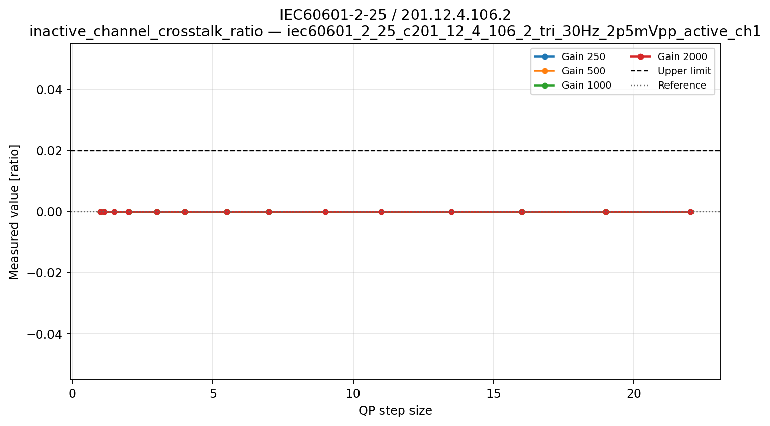
(a)
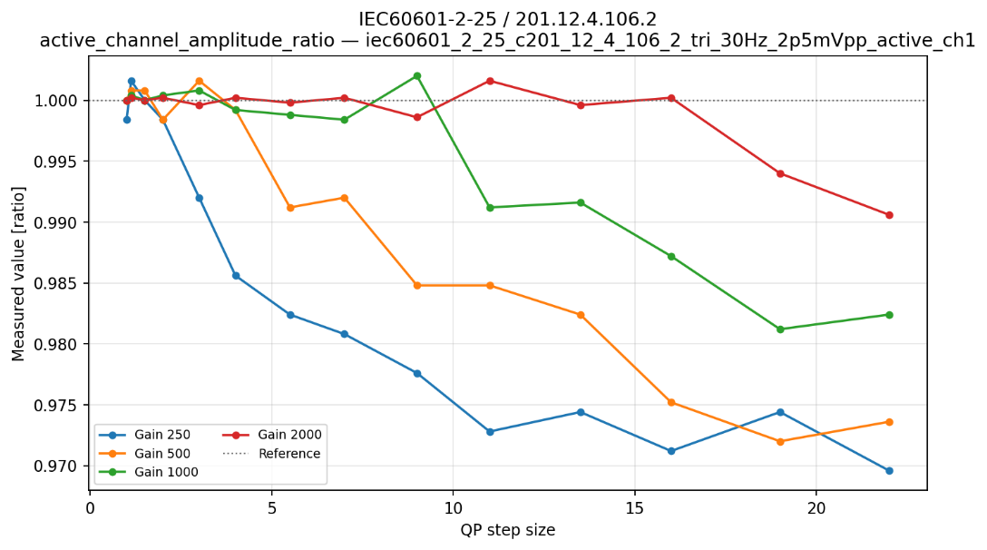
(b)
Figure 26. Inactive-channel crosstalk and active-channel amplitude preservation for IEC 60601-2-25 / 201.12.4.106.2. (a) Inactive-channel crosstalk ratio and (b) active-channel amplitude ratio for one channel across gain and QP. The crosstalk limit is 2% (dashed line) for IEC 60601-2-25 / 201.12.4.106.2 and 5% for IEC 60601-2-27 / 201.12.1.101.5; the active-channel ratio is diagnostic only.

IEC 60601-2-27 / 201.12.1.101.5
As this test used the same 30 Hz, 2.5 mV triangular waveform and test configuration as the IEC 60601-2-25 test, it produced identical measured responses. All 672 inactive-channel ratios were zero, and all 56 conditions therefore passed the less stringent 5% limit. The diagnostic active-channel ratio likewise ranged from 0.9648 to 1.002. Thus, the two clauses differed only in the applied crosstalk limit: 2% for IEC 60601-2-25 and 5% for IEC 60601-2-27.

IEC 60601-2-47 / 201.12.4.4.107
All 672 inactive-channel ratios were zero and all 56 conditions passed the 5% criterion (see Figure 27a). The active-channel amplitude ratio for the 10 Hz, 4 mV sinusoid ranged from 0.997 to 1.006, corresponding to at most 0.6% deviation from the nominal amplitude (see Figure 27b).
No trends or failures were associated with the active-channel position, gain setting, or QP value.
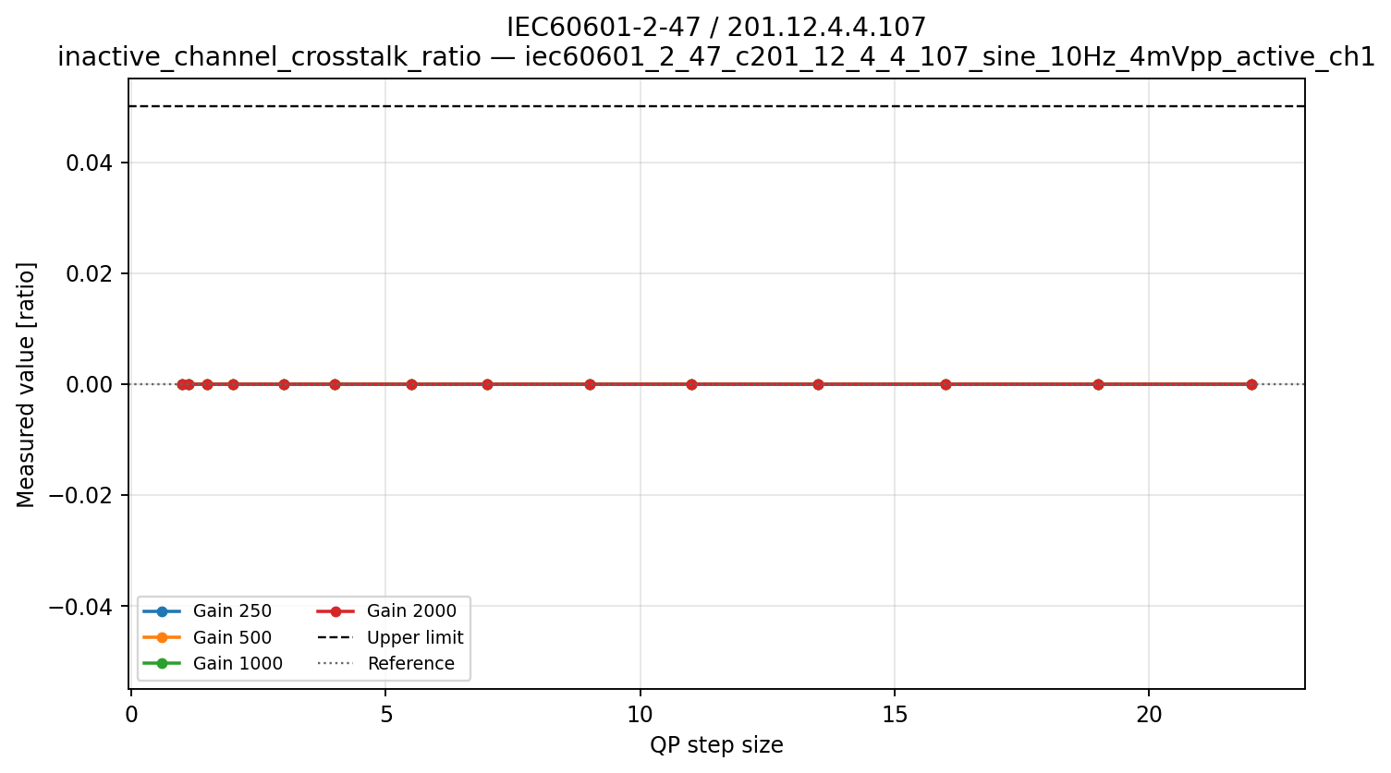
(a)
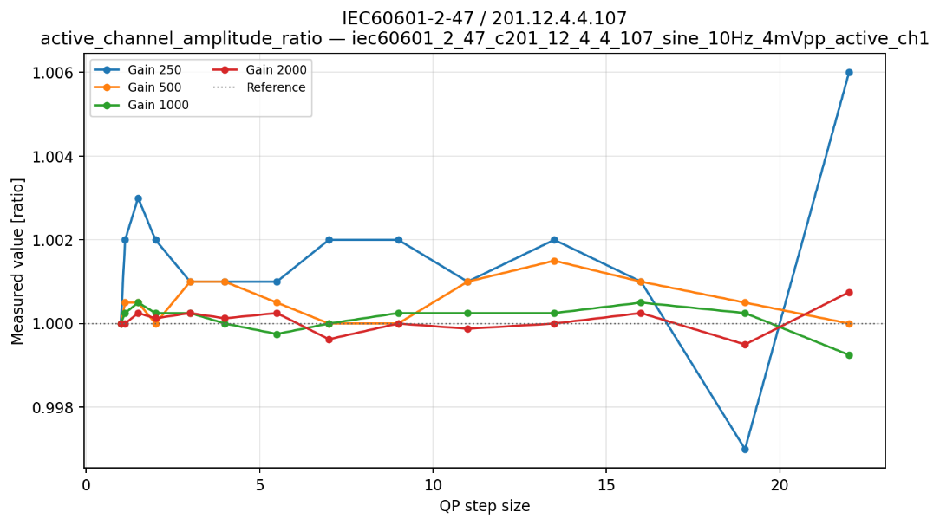
(b)
Figure 27. Sinusoidal multichannel crosstalk for IEC 60601-2-47 / 201.12.4.4.107. (a) Inactive-channel crosstalk ratio and (b) active-channel amplitude ratio for one channel across gain and QP. The 5% crosstalk limit is indicated by the dashed line.

Overall interpretation
No codec-induced signal was detected in any inactive channel, independent of gain, QP, active-channel position or the applied waveform, and all three clause-derived crosstalk metrics therefore passed with substantial margin. The active-channel diagnostics showed, however, that absence of crosstalk does not imply perfect amplitude preservation: the active waveform could undergo modest attenuation while the inactive channels remained exactly zero. Thus, no detectable inter-channel leakage was introduced under the tested conditions. This codec-domain test does not assess analogue or sensor-originated crosstalk, electrical interference, or physiological coupling between channels, nor does it establish the detectability of small codec-induced leakage in recordings where multiple channels contain correlated physiological activity.

Temporal alignment and input-format conditions

General description
This concept evaluates whether codec processing introduces relative timing shifts between channels and whether the tested source sampling rate and digital resolution satisfy the selected input conditions. It ensures the preservation of temporal relationships between channels, which can be important for multilead ECG analysis, event timing, and algorithms that compare features across channels. The measurements identify sample-level codec skew under the tested conditions; they do not assess long-duration clock drift, recorder/playback timing, or display synchronization.

Applicable clauses
Table 23: Temporal-alignment and input-format limits
Clause | Metric | Limit | Current implementation | Qualification
IEC 60601-2-25 / 201.12.4.107.3 | Source sampling rate | ≥500 samples/s per channel | Read from source/manifest; 2000 samples/s | Input-condition check, not acquisition-hardware validation
Same clause | Input quantization | ≤5 µV/LSB | 4, 2, 1 and 0.5 µV/LSB for gains 250–2000 | Input-condition check
Same clause | Channel skew | ≤100 µs | Simultaneous edge proxy | At 2000 samples/s the limit is sub-sample; report zero detected sample skew as diagnostic, not proof of equipment compliance
IEC 60601-2-47 / 201.12.4.4.112 | Channel-to-channel reconstructed edge difference | <20 ms | Rising and falling edges for four simultaneous channels | Every tested edge/channel passes

Synthetic signals
Four channels contain identical 1 mV rectangular pulses with 200 ms width and one pulse per second. The simultaneous rising and falling edges represent time-coincident multichannel events, such as the onset of a sharp cardiac deflection observed across several leads. The source record is sampled at 2000 samples/s per channel and uses the four input gains defined in 5.5. The signal tests relative channel timing after coding, while the metadata checks document the source sampling and quantization conditions at the codec boundary.
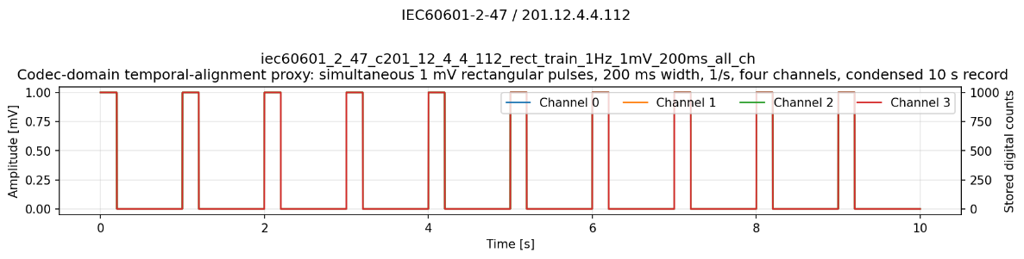
Figure 28. Example channel-edge alignment after T.261 reconstruction.
IEC 60601-2-47 / 201.12.4.4.112: 1 mV rectangular pulses, 200 ms width, 1 Hz, 4 channels

Metrics

Source sampling rate
The current test source uses:
$$f_{s}=2000\text{ samples/s per channel}$$
- IEC 60601-2-25 / 201.12.4.107.3 requires:
$$f_{s}≥500\text{ samples/s per channel}$$
This verifies the input condition of the codec benchmark. It does not test the acquisition hardware of an ECG device.

Input quantization
The gain-to-quantization relationship and the tested values of $q_{LSB}$ are defined in 5.5.
- IEC 60601-2-25 / 201.12.4.107.3 requires:
$$q_{LSB}≤5 μV/LSB$$
All four gains satisfy this input condition.

Channel-to-channel edge skew
The generated reference identifies the expected edge neighbourhood.
For each decoded channel $c$, the threshold is calculated from its own 5th and 95th percentiles:
$$θ_{c}=\frac{P_{5,c}+P_{95,c}}{2}$$
Within ±50 ms of the expected source edge, the code finds the nearest decoded rising or falling threshold crossing.
Decoded channel 0 is used as the timing reference. For channel $c$:
$$S_{c,e}=\frac{1000∣n_{c,e}-n_{0,e}∣}{f_{s}} \left[ms\right]$$
For each record, the code evaluates three rising edges, three falling edges, and channels 1, 2 and 3 relative to channel 0. Thus, 18 edge-skew measurements are normally produced per decoded record.
If a crossing cannot be found, the skew is set to infinity and the measurement fails.
- IEC 60601-2-25 / 201.12.4.107.3
Pass condition:
$$S_{c,e}≤100 μs$$
At 2000 samples/s:
$$T_{s}=\frac{1000}{2000}=500 μs/sample$$
Therefore, the code can only pass the $100 μs$ limit when the decoded edges occur in the same sample. A measured 0 ms result means “no sample-level codec skew detected”; it does not prove acquisition-hardware skew below 100 µs.
- IEC 60601-2-47 / 201.12.4.4.112
Pass condition:
$$S_{c,e}<20 ms$$
Every tested rising and falling edge in every non-reference channel must pass.

Results
The temporal-alignment tests evaluated whether T.261 introduced relative sample displacement between initially synchronous channels. The source rate and input quantization were also checked for IEC 60601-2-25. No sample-level channel displacement was detected. However, the 0.5 ms measurement resolution cannot verify the IEC 60601-2-25 limit of 0.10 ms.
Table 24: Temporal-alignment and input-format results summary
Clause | Conditions | Edge measurements | Input checks | Reported outcome
IEC 60601-2-25 / 201.12.4.107.3 | 56 | 1008 | 112 | Input conditions met; skew diagnostic under-resolved
IEC 60601-2-47 / 201.12.4.4.112 | 56 | 1008 | — | 56/56 codec-domain proxy PASS

IEC 60601-2-25 / 201.12.4.107.3
The source rate was 2000 samples/s per channel, exceeding the minimum of 500 samples/s. The four tested gains corresponded to input resolutions of 4, 2, 1 and 0.5 µV/LSB, all satisfying the ≤5 µV/LSB input condition.
No relative channel displacement was detected in any of the 1008 edge measurements. All reconstructed edges occurred at the same sample index across channels.
At 2000 samples/s, however, one sample represents 0.5 ms, whereas the clause specifies a maximum channel skew of 0.10 ms. The experiment therefore demonstrates the absence of an integer-sample displacement but cannot quantitatively verify the 100 µs requirement.
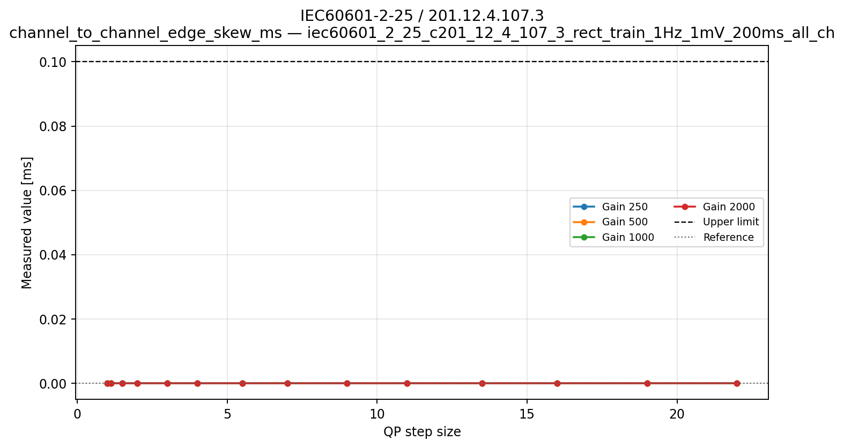
Figure 29. Source conditions and sample-level alignment for IEC 60601-2-25 / 201.12.4.107.3. Maximum detected interchannel edge displacement across QP. No sample-level displacement was detected, but the 0.5 ms timing resolution cannot verify the 0.10 ms equipment limit.

IEC 60601-2-47 / 201.12.4.4.112
All 56 gain–QP conditions passed the selected codec-domain alignment metric. No relative channel displacement was detected in any of the 1008 edge measurements. At the 2000 samples/s evaluation rate, the 0.5 ms resolution is sufficiently fine relative to the <20 ms limit to detect a material codec-induced channel shift.
No gain or QP dependence was observed because every measured skew value was zero. Nevertheless, the experiment used a condensed digital record and did not evaluate recorder acquisition timing, long-duration drift, playback equipment, display alignment or the warning requirements of the complete procedure.
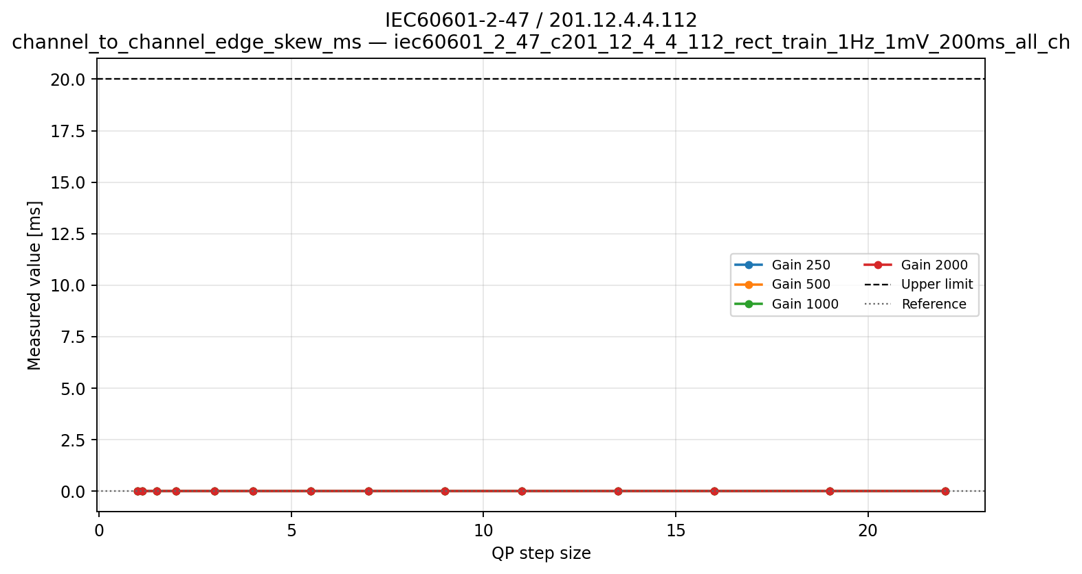
Figure 30. Reconstructed multichannel edge alignment for IEC 60601-2-47 / 201.12.4.4.112. Maximum detected interchannel edge skew across gain and QP. All channels remained aligned to the same sample, corresponding to 0 ms measured codec-domain skew at 0.5 ms resolution.

Overall interpretation
T.261 introduced no detectable sample-level displacement between the synchronously generated channels, and no gain or QP dependence was observed. The 2000 samples/s source rate and the four input quantization steps also satisfied the selected IEC 60601-2-25 input conditions. The significance of the zero-skew result differs between the two clauses: the 0.5 ms measurement resolution is adequate relative to the IEC 60601-2-47 limit of 20 ms, but it cannot verify the IEC 60601-2-25 limit of 100 µs. The results therefore demonstrate preservation of same-sample channel alignment through the codec, but do not assess sub-sample acquisition timing, long-term recorder drift, playback alignment, or complete-equipment temporal conformity.

Overall results

Results overview
The combined evaluation comprised 980 clause-level outcomes across the tested gains and quantization parameters (QP). Of these, 940 were classified as PASS and 40 as FAIL, with no incomplete outcomes in the validated dataset. All 224 IEC 60601-2-47 outcomes passed. IEC 60601-2-27 produced 193 PASS and 31 FAIL outcomes, while IEC 80601-2-26 produced 243 PASS and 9 FAIL outcomes. All 280 IEC 60601-2-25 outcomes were classified as PASS under the implemented assessment. However, 56 temporal-alignment outcomes represent qualified codec-domain checks because the 100 µs skew requirement could not be resolved at the 2000 samples/s evaluation rate. All lossless QP 1 conditions passed.
The metric dataset contained 10,024 individual measurements, of which 554 failed. These included 246 triangular-pulse ratios in IEC 60601-2-25 Method E, 296 ratios in IEC 60601-2-27 Method B and 12 EEG frequency-response measurements. The number of failed measurements differs from the number of failed clauses because results are aggregated according to the applicable clause requirements. In particular, failures of the optional IEC 60601-2-25 Method E did not affect the final clause status because the permitted alternative route passed.
Figures 31–34 present the clause-level outcomes for each gain and QP combination with each cell representing the final clause outcome for one QP condition. The 40 failing conditions were confined to the IEC 60601-2-27 triangular-pulse response test and the IEC 80601-2-26 frequency-response test. All other evaluated criteria met their implemented limits, subject to the stated temporal-alignment qualification.
For the ECG triangular-pulse tests, failures resulted from small differences in the reconstruction of short and long pulses rather than substantial attenuation of the short pulses. IEC 60601-2-25 Method E exceeded the 1.00 upper ratio limit by at most 0.738%, while IEC 60601-2-27 Method B exceeded it by at most 0.704%. No failures occurred at the respective lower limits. In failing cases, the decoded 200 ms reference was typically attenuated slightly more than the 20 ms pulses. Pulse-level inspection also showed differences between the first and subsequent pulses, suggesting sensitivity to coding context. Possible contributors include codec initialization, prediction or transform state, and block positioning, although these mechanisms were not investigated. This may also explain the non-monotonic distribution of failures across gain and QP.
The EEG frequency-response failures showed a different pattern. They were confined to the 50 µV p-p signal at gains 250 and 500 and high QP settings. The elevated 0.5 Hz-to-5 Hz ratios were mainly caused by attenuation of the decoded 5 Hz reference rather than amplification of the 0.5 Hz signal. At gain 250, this attenuation was sometimes non-uniform, with portions of the decoded waveform becoming nearly flat. The 50 µV signal corresponds to only 12.5 digital counts p-p at this gain, making it particularly sensitive to coarse quantization. The observations suggest that low effective amplitude resolution, potentially combined with block-dependent coding effects, contributed to the failures. The specific encoder decisions remain unverified.
Across the other evaluated clauses, reconstruction errors generally increased at lower gain and higher QP without changing the final outcomes. No codec-induced crosstalk or sample-level interchannel displacement was detected, although the 0.5 ms sampling interval could not resolve the 100 µs timing requirement of IEC 60601-2-25.
Overall, the results indicate that most evaluated waveform properties were robust across the tested gain and QP range, while the practical sensitivity of lossy coding increased for very-low-amplitude signals and for ratio metrics in which small reconstruction differences in the reference signal could determine the pass/fail outcome.
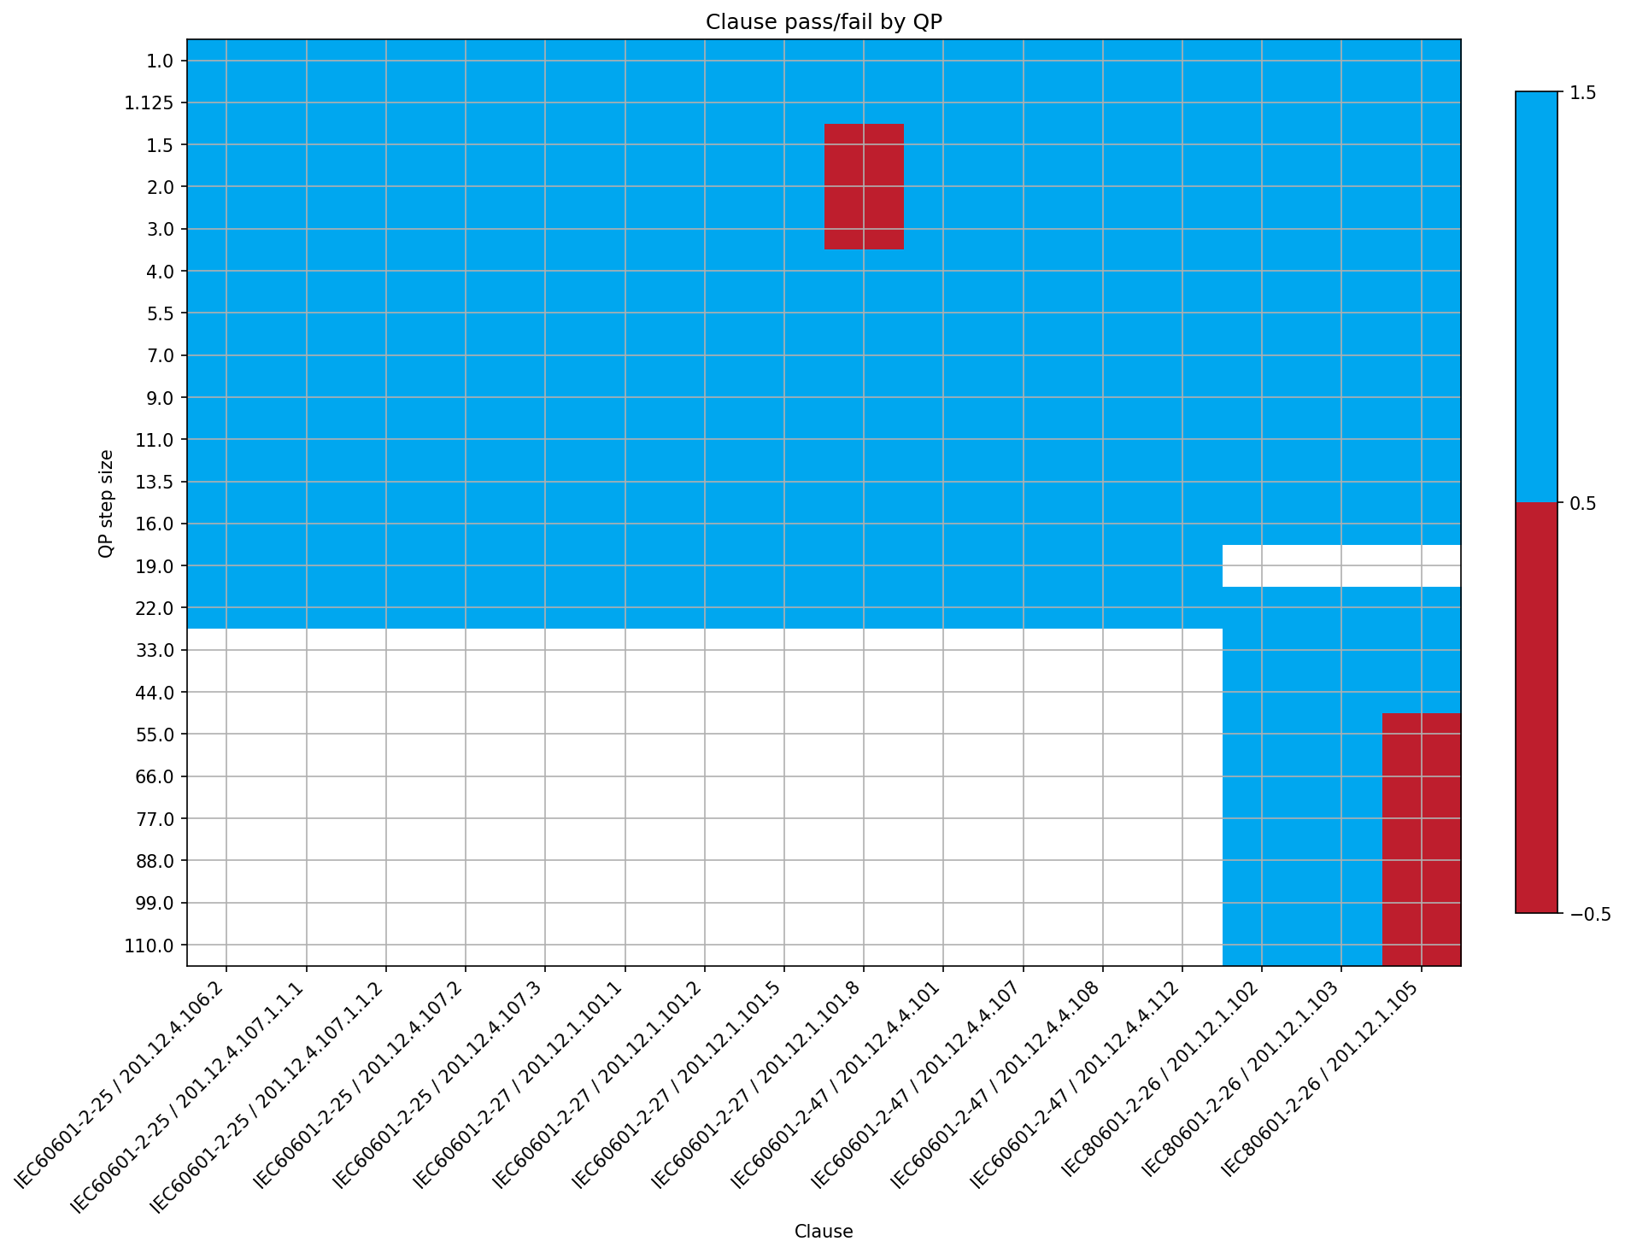
Figure 31. Clause-derived outcomes across QP at gain 250 counts/mV.
Blue cells indicate a PASS, red cells a FAIL.
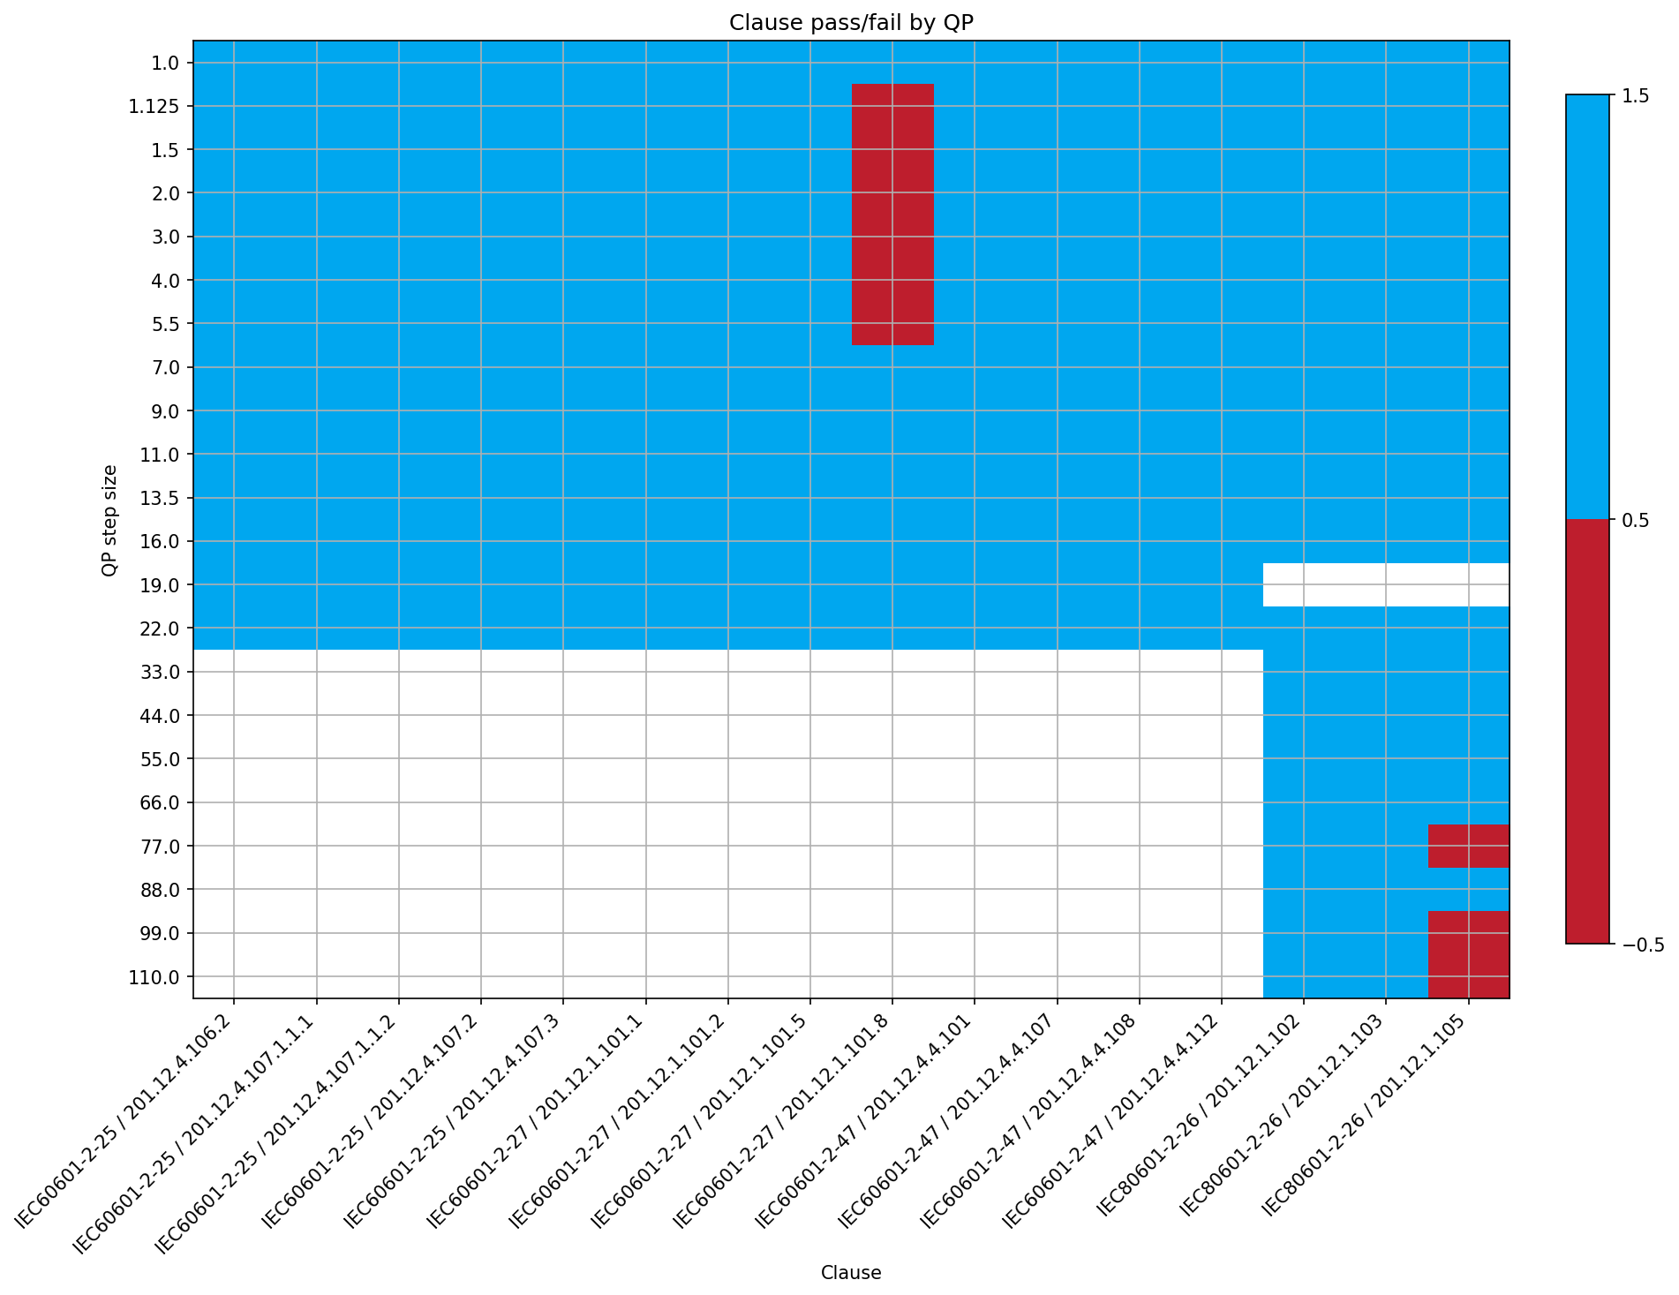
Figure 32. Clause-derived outcomes across QP at gain 500 counts/mV.
Blue cells indicate a PASS, red cells a FAIL.
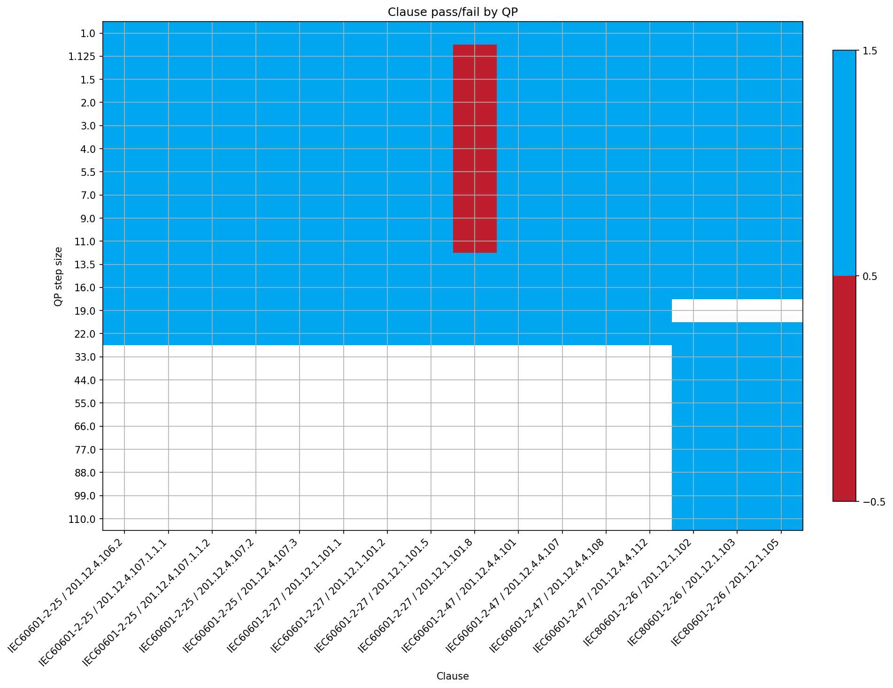
Figure 33. Clause-derived outcomes across QP at gain 1000 counts/mV.
Blue cells indicate a PASS, red cells a FAIL.
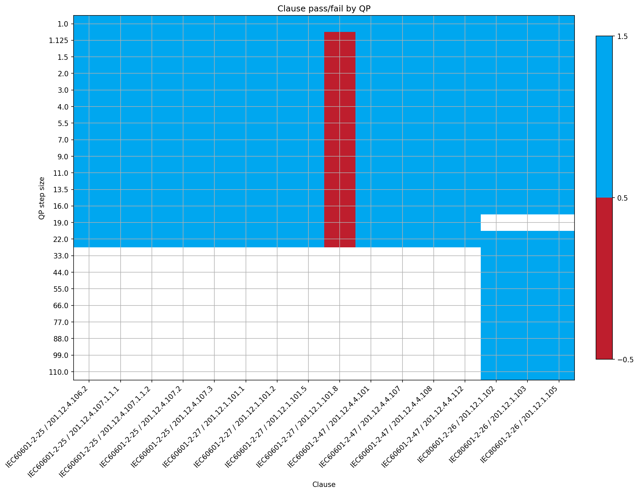
Figure 34. Clause-derived outcomes across QP at gain 2000 counts/mV.
Blue cells indicate a PASS, red cells a FAIL.

Clause-derived results matrix
The clause-derived results matrix in Table 25 summarizes the final outcome, aggregation logic and main trend for each evaluated clause across the tested gain and QP range.
Table 25: Clause-derived results matrix
Standard /Clause | Aggregation rule | Final status | Failed conditions | Main finding
IEC 60601-2-25
201.12.4.106.2 | All inactive channels | PASS 56/56 | None | Inactive-channel ratio was 0. Active-channel diagnostic fell to 0.9648 at worst; amplitude loss is not crosstalk.
201.12.4.107.1.1.1 | Methods (A AND E) OR [A AND (B AND C AND D)] | PASS 56/56 | No clause failures. Method E failed 27 tested steps:  g250 QP 1.125-2;  g500 1.125-4; g1000 1.125-9; g2000 1.5-19 | Method E exceeded 1.00 by at most 0.738%, mainly because decoded 200 ms amplitude decreased slightly more. Methods B AND C AND D passed, so the alternative route preserves clause PASS.
201.12.4.107.1.1.2 | Displacement AND slope | PASS 56/56 | None | Worst displacement 0.0768 mV versus 0.10 mV; worst slope 0.0157 mV/s versus 0.30 mV/s.
201.12.4.107.2 | Worst position proxy | PASS 56/56 | None | Worst 40 Hz p-p error was 0.00834 mV versus 0.50 mV. This is a codec proxy, not a recording-width equipment test.
201.12.4.107.3 | Rate, resolution AND skew proxy | Input conditions met; skew under-resolved | None | Source rate 2000 samples/s; 0.5-4 µV/LSB; detected skew 0 ms. The 100 µs equipment limit is below the 0.5 ms sample interval.
IEC 60601-2-27
201.12.1.101.1 | All triangle and sine cases | PASS 56/56 | None | Maximum triangle error 2.4%; maximum 20 Hz sine error 0.38%. Smallest inputs and low gain are most sensitive.
201.12.1.101.2 | Both offsets | PASS 56/56 | None | Offset ratios 0.9984-1.0020. Zero-offset p-p was 9.792-9.928 mV; most of the nominal shortfall is common to the sampled source/decoded reference rather than an offset-specific effect.
201.12.1.101.5 | All inactive channels | PASS 56/56 | None | Inactive-channel ratio was 0. Same waveform as IEC 60601-2-25 crosstalk, with a less strict 5% limit.
201.12.1.101.8 | Method A AND Method B AND impulse | 25/56 PASS, 31/56 FAIL | Method B failed for 31 conditions:  g250 QP 1.5-3; g500 1.125-5.5; g1000 1.125-11; g2000 1.125-22 | Method A and the impulse component passed. Method B exceeded the strict 1.00 ceiling by at most 0.704%; 31 conditions therefore failed the complete clause.
IEC 60601-2-47
201.12.4.4.101 | All amplitudes and offsets | PASS 56/56 | None | Worst direct p-p error was 0.164 mV for a 10 mV input versus a 1.0 mV limit.
201.12.4.4.107 | All inactive channels | PASS 56/56 | None | Inactive-channel ratio was 0; active-channel amplitude remained within 0.997-1.006 of input.
201.12.4.4.108 | Impulse AND (sine OR triangle route) | PASS 56/56 | None | Impulse, sine and triangle routes all passed. Triangle ratios 0.9699-1.0054; overshoot ≤2.27%. The separate 60% verification diagnostic also passed.
201.12.4.4.112 | All channel edges | PASS 56/56 | None | No sample-level relative skew detected. Codec-domain result only; it does not exercise recorder acquisition timing.
IEC 80601-2-26
201.12.1.102 | All scalp/cortex amplitudes | PASS 84/84 | None | Worst relative error was 16% for the 0.1 mV scalp signal at gain 250/QP 77, within the 20% criterion.
201.12.1.103 | Both offsets | PASS 84/84 | None | Offset ratios 0.9792-1.0426. Absolute zero-offset response falls at low gain/high QP, but offset and zero cases change similarly.
201.12.1.105 | Both frequency ratios | 75/84 PASS, 9/84 FAIL | g250 QP 55, 66, 77, 88, 99, 110; g500 QP 77, 99, 110. | Failures occurred only for the 50 µV p-p signal at low gain and high QP. Attenuation of the decoded 5 Hz reference increased the relative frequency-response ratios. Extended zero-valued intervals were observed in some high-QP reconstructions.

Discussion

Interpretation of codec-domain outcomes
The results show that T.261 preserved most of the evaluated ECG and EEG waveform properties over a broad range of tested configurations. Lossless reconstruction was bit-exact, while the lossy results generally remained within the selected IEC-derived limits for amplitude accuracy, DC-offset response, impulse recovery, crosstalk and channel alignment. The identified lossy failures were restricted to triangular-pulse response in ECG and frequency response at very low EEG signal amplitudes.
This distinction is important. The failures do not indicate a general loss of waveform fidelity, but they show that some signal characteristics are more sensitive to lossy compression than others. In particular, small-amplitude signals and measurements that compare two reconstructed responses can be affected even when the overall reconstruction error remains low. The findings therefore support the use of waveform-specific performance metrics alongside conventional measures such as PSNR and coding rate.

Gain, QP and signal amplitude
Reconstruction error generally increased with QP and decreased with input gain, although the relationship was not always monotonic. The effect was most pronounced for low-amplitude signals, where a small change in reconstructed digital counts can represent a substantial fraction of the original waveform amplitude.
The EEG frequency-response test provides the clearest example. At the lowest gain, the 50 µV peak-to-peak signal was represented by only about 12.5 digital counts. Lower counts/mV represent the same physical waveform using fewer digital counts, making individual quantization changes proportionally larger. At higher QP settings, parts of the reconstructed signal were strongly attenuated or suppressed entirely. The corresponding tests passed at higher gains, indicating that the effective digital representation of the signal plays an important role in determining the usable compression settings. Higher-amplitude ECG sinusoidal, amplitude and impulse tests also retained substantial margin across the evaluated operating range.
These findings suggest that the choice of QP should take account of the smallest signal components that need to be preserved, rather than relying only on the overall amplitude range or a global reconstruction-quality measure.

Frequency and pulse-response metrics
Several of the most sensitive metrics are ratios to a reconstructed reference rather than direct comparisons with the source. Their behaviour therefore depends on reconstruction of both numerator and denominator. This is visible in three different ways. In the DC-offset tests, common attenuation of the offset and zero-offset signals largely cancels in the ratio. In the EEG frequency-response test, attenuation or suppression of the decoded 5 Hz reference can inflate the 0.5 Hz/5 Hz ratio even when the 0.5 Hz signal itself remains close to nominal. In the triangular-pulse tests, slightly greater attenuation of the 200 ms reference than the 20 ms response can move the short-to-long ratio above the upper limit of 1.0.
The pulse tests also showed differences between the first reconstructed pulse and subsequent pulses in some configurations. This suggests a possible dependence on coding context, initialization or block positioning, but the specific mechanism has not yet been established. Further investigation of the encoder's block structure and prediction decisions would be needed to explain this behaviour.
These observations also explain why global quality measures such as PSNR cannot alone establish preservation of clause-relevant waveform properties and why both the individual reconstructed amplitudes and their ratios are useful for understanding codec performance.

Alternative routes, standards evolution and boundary interpretation
The final outcome of a clause depends not only on the reconstructed waveform but also on how the standard combines its individual test requirements. For IEC 60601-2-25, failures of triangular-pulse Method E did not affect the overall result because the alternative sinusoidal-response route passed. For IEC 60601-2-27, similar small deviations resulted in complete-clause failures because Method B was mandatory.
The Draft International Standard text of IEC 80601-2-86 (as balloted in October 2026 by IEC) provides additional context for these findings. Its corresponding triangular-pulse criteria focus on minimum short-pulse response without retaining the same upper limit of unity. The small above-unity deviations observed in this study would therefore not, by themselves, fail those draft criteria. However, the draft requirements were not used to change the results reported against the existing standards.
This comparison highlights the importance of applying the correct measurement definitions, acceptance limits and alternative-route logic when interpreting waveform-preservation results.

Limitations
The evaluation was performed entirely in the digital codec domain using synthetic ECG and EEG signals derived from selected IEC performance requirements. It was not intended to reproduce complete medical-equipment type tests. The assessed metrics describe changes introduced between the digital source samples and the decoded output, excluding analogue acquisition, front-end filtering, calibration, display, recording and other equipment-dependent effects. Consequently, meeting a codec-domain criterion does not establish conformity of a complete medical device with the corresponding IEC requirement.
The synthetic signals were designed to isolate individual waveform properties and support controlled comparisons across gain and QP. They do not represent the full variability of clinical recordings, including physiological morphology, background noise, artefacts, baseline fluctuations and correlations between channels. The multichannel crosstalk tests used inactive channels with zero-valued inputs and therefore assessed unintended signal generation by the codec rather than analogue coupling or interference. Additional evaluation with clinical recordings is needed to determine whether the observed behaviour also occurs with more complex and realistic signals.
Some measurements were constrained by the properties of the generated input and the evaluation procedure. The 2000 samples/s sampling rate allowed detection of relative channel displacement at the sample level but could not verify the 100 µs skew requirement of IEC 60601-2-25. Input signals were also subject to the resolution and rounding used during generation. Furthermore, the reported PSNR values were calculated relative to the full 24-bit digital range and should not be interpreted as direct measures of clinical waveform fidelity, particularly for low-amplitude signals.
The results apply to the tested T.261 reference-software implementation, coding configurations, input gains, QP values and synthetic test vectors. Other encoder implementations or coding decisions may produce different lossy reconstruction behaviour. The possible influence of block-based coding on the observed EEG frequency-response failures was inferred from decoded waveforms and was not verified through analysis of encoder decisions. The findings therefore identify sensitivities within the evaluated configurations rather than defining general performance limits for all T.261 implementations or clinical applications.

Conclusion
The codec-domain benchmark showed bit-exact reconstruction for all lossless QP1 conditions and preservation of most selected ECG and EEG waveform properties across the evaluated lossy operating points. All evaluated amplitude, DC-offset, impulse-response and crosstalk metrics passed, and no sample-level interchannel displacement was observed. The IEC 60601-2-25 100 µs skew requirement remains below the timing resolution of the current test.
Lossy failures were concentrated in two mechanisms. IEC 60601-2-27 triangular-pulse Method B failed 31 of 56 conditions because small differential reconstruction of the 20 ms and 200 ms responses exceeded the strict unity upper ratio boundary by at most 0.704%. IEC 80601-2-26 frequency response failed 9 of 84 conditions for the 50 µV p-p EEG signal at gains 250 and 500 and higher QPs, where low effective digital amplitude led to attenuation and, at the most severe settings, temporal suppression of the decoded 5 Hz reference.
The results therefore identify low-amplitude representation and reference-normalized metrics as the principal sensitivities in the tested configurations rather than a broad loss of waveform fidelity or general frequency-response limitation. Input gain and QP should be selected with the smallest relevant waveform amplitudes in mind.
These findings characterize preservation through the evaluated T.261 codec configuration only. They do not establish conformity of complete ECG or EEG medical equipment with the cited IEC standards.

