ITU – Telecommunications Standardization Sector  STUDY GROUP 21 Question 6/21  Video Coding Experts Group (VCEG)  79th Meeting: 25 April – 1 May 2026, Santa Eulària, Spain | Document: VCEG-CA07 (v1)

Question: | 6/21 (VCEG)
Source: | Sooyoung Park, Byeongho Jo,  Jongmo Sung (ETRI) | Email: | {sooyoung, bhjo, jmseong} @etri.re.kr
Title: | Report of CE-3 (CE on montage-based graph coding for redundant channels)
Purpose: | Core experiment report and proposal
_____________________________

Abstract
Clinical EEG recordings follow standardized montage configurations dictated by established clinical protocols, which inherently impose structured relationships among channels. This core experiment demonstrates that these montage-induced structures can be effectively modeled from a graph-based perspective. We present Montage-based Graph Coding (MGC), a framework developed to systematically identify and exploit these channel relationships. Our results demonstrate that MGC maximizes coding efficiency through high-speed, high-correlation prediction and reconstruction mechanisms. By leveraging these montage-induced structures, the proposed approach achieves significantly enhanced performance in data processing while remaining fully compatible with established clinical acquisition conventions.

Introduction
To extend the current H.BWC framework [6], which relies on sample-level analysis for coding, we introduce a structured approach for multi-channel signals. Our method optimizes electrode combinations to reduce data redundancy, allowing for a more precise and compact analysis of inter-channel dependencies.

What is Montage?
A montage specifies how multiple electrodes are combined to visualize brain activity. While individual electrodes record local potentials relative to a reference, a montage combines these signals into interpretable waveforms, or channels, to emphasize specific spatial relations.

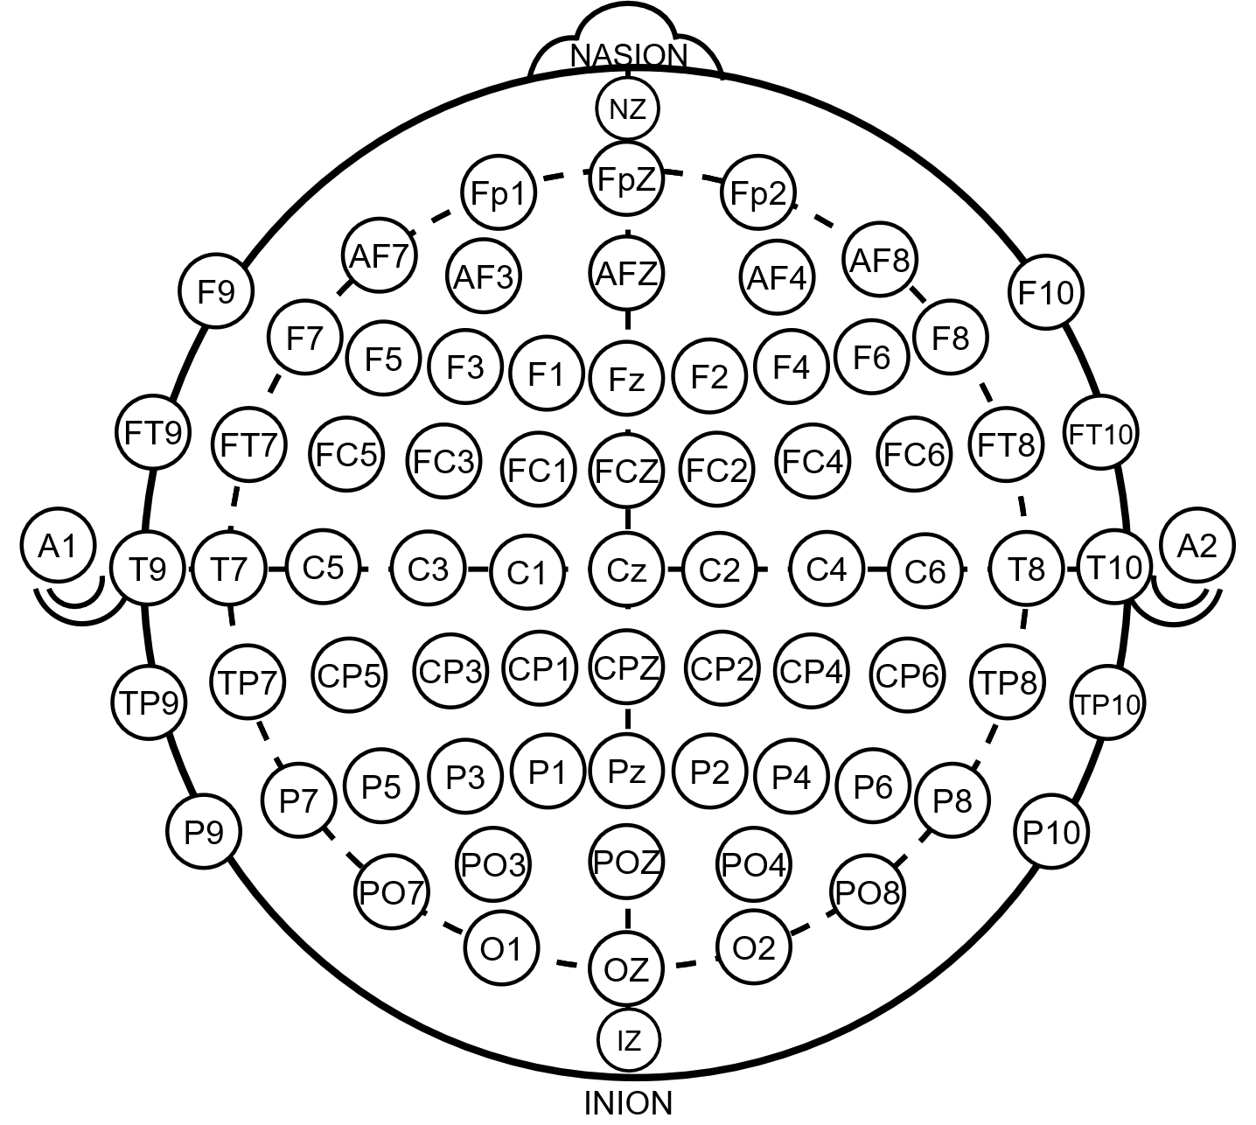
Figure 1-1. 10-10 standardized electrode placement system for EEG (De facto Standard)
As shown in Figure 1-1, the same set of electrodes (e.g., 10-10 standardized electrode placement system) can be connected in various ways to create different montages (Longitudinal, Transverse, etc.). Each connection represents a different view of brain activity. This flexibility is essential for clinical diagnosis, but it inherently leads to the transmission of redundant information, as the same electrode potentials are reused across multiple bipolar derivations.

Motivation: Hidden Redundancy in Bipolar Waveforms
Bipolar channels represent the potential difference between two electrodes ($V_{source}-V_{target}).$ Since the electrode network creates a closed electrical circuit, the relationship between these channels is governed by Kirchhoff's Voltage Law (KVL).
According to KVL, the directed sum of potential differences around any closed loop must be zero. This physical principle implies that in a multi-channel montage, many channels are hidden redundant, meaning they can be mathematically reconstructed using a path of other channels.
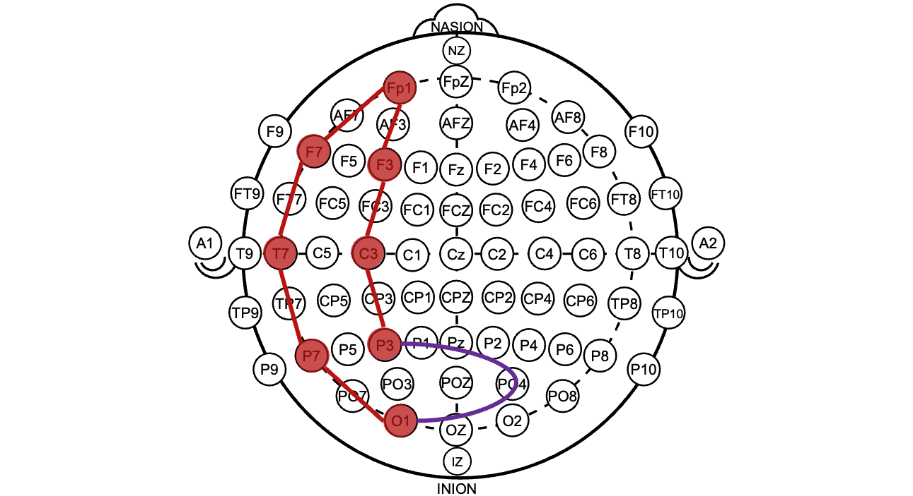
Figure 1-2. Illustration of hidden redundant path
For example, considering the path in Figure 1-2, KVL dictates that the potential difference (P3-O1) is the linear combination of the potential differences along the path connecting P3 to O1:
(P3−O1) = (P3−C3) + (C3−F3) + (F3−Fp1) + (Fp1−F7) + (F7−T7) + (T7−P7) + (P7−O1).
MGC exploits this KVL-based dependency to identify redundancies using only header metadata, allowing the H.BWC encoder to optimize coding efficiency without sample-level signal analysis.

Clinical Necessity of Redundant Montages
According to clinical guidelines (e.g., ACNS Guideline 1 [1]), clinicians must review EEG data through multiple montages to accurately localize abnormalities. Consequently, standard clinical datasets often contain these overlapping signals by design. Storing them without optimization degrades the rate-distortion performance. MGC resolves by integrating structural graph knowledge into the coding loop.

Mathematical Redundancy vs. Physical Reality
While these mathematical relationships hold under ideal conditions, physical recordings in clinical environments often suffer from minor inconsistencies. Factors such as independent hardware filtering per channel, sampling jitter, and electronic noise can prevent the linear combination of reference signals from perfectly equaling the redundant signal. A detailed analysis regarding these physical artifacts and their impact on signal integrity is provided in Section 2.1.3.
The primary goal of H.BWC is to ensure the highest fidelity for both lossy and lossless coding, regardless of whether the redundancy is mathematically perfect. Across all bitrate levels, MGC facilitates a flexible strategy: the system can adaptively employ either “Direct Reconstruction” or “Predictive Coding” to handle the derived bipolar potential differences. This approach optimizes bit-allocation in the RDO loop while maintaining strict diagnostic integrity.

Analysis of Redundancy in H.BWC Datasets
Before introducing the MGC algorithm, we analyzed the channel configurations and signal characteristics of the datasets defined in the H.BWC Common Test Conditions (CTC) [8] to verify the existence and nature of channel redundancy.
A comparative analysis of the channel montages reveals distinct approaches to signal mapping across the evaluated datasets. While most configurations maintain a one-to-one mapping between physical sources and data channels, specific datasets within various clinical modalities employ a multi-stream approach for enhanced diagnostic utility.

Redundancy in CHB-MIT Scalp EEG Dataset
The most prominent example of redundancy is found in standard scalp EEG recordings. In the file chb15_30.edf, the Longitudinal Bipolar (Double Banana) montage is integrated with a Subtemporal Chain. Figure 2-1 illustrates the spatial connectivity of these montages for the chb15_30.edf, highlighting how certain electrodes serve as common nodes for multiple chains. The specific channel configurations are as follows:
- Longitudinal Bipolar: FP1-F7, F7-T7, T7-P7, P7-O1 ... FP2-F8, F8-T8, T8-P8, P8-O2
- Subtemporal Chain: P7-T7, T7-FT9, FT9-FT10, FT10-T8, T8-P8
- Referential: FC1-Ref, FC2-Ref, CP1-Ref, CP2-Ref ...
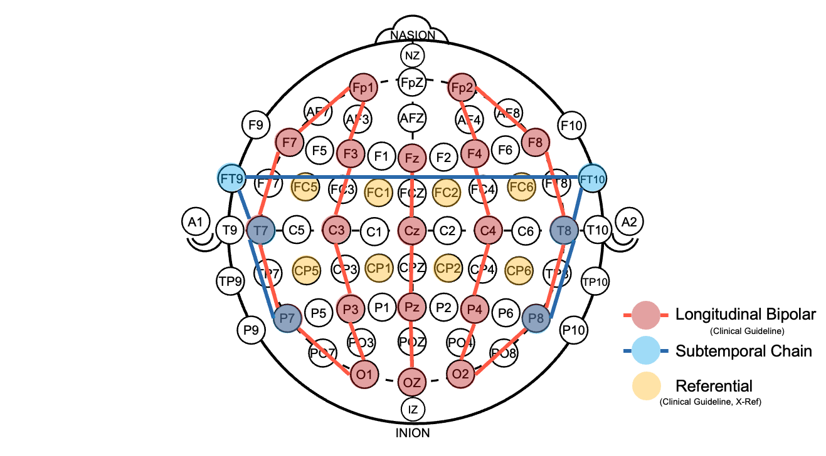
Figure 2-1. Connectivity diagram of the integrated montage in chb15_30.edf
This specific configuration is designed to provide multi-perspective monitoring, particularly for temporal lobe signals. Such hybrid montages are widely utilized in clinical practice and epilepsy research to ensure comprehensive spatial coverage.
The channel configurations of the datasets mentioned above, such as chb15_30.edf, are not arbitrary or dataset-specific; rather, they follow standardized EEG conventions consistent with the ACNS (American Clinical Neurophysiology Society) guidelines [1, 2, 3]. Founded in 1946, the ACNS is a member society of the International Federation of Clinical Neurophysiology (IFCN), and its technical guidelines are extensively referenced in clinical EEG practice worldwide and neurodiagnostic laboratory accreditation frameworks, such as ABRET. While specific montage preferences may vary by region, the ACNS guidelines provide a highly authoritative baseline that ensures diagnostic integrity and cross-institutional data compatibility.
In particular, when the montage schemes specified in ACNS Guideline 3 [2] and Guideline 5 [3] are applied, the resulting bipolar channel configurations inevitably induce structural redundancy among EEG signals. From a mathematical perspective, overlapping bipolar derivations introduce linear dependencies that form closed-loop structures in the corresponding channel graph. This redundancy arises naturally from the use of standardized, guideline-compliant montage schemes.
This structural redundancy is directly observable in the montage tables provided by the ACNS guidelines [2, 3]. Figure 2-2 presents excerpts from these tables, highlighting the channels that are redundant due to KVL.
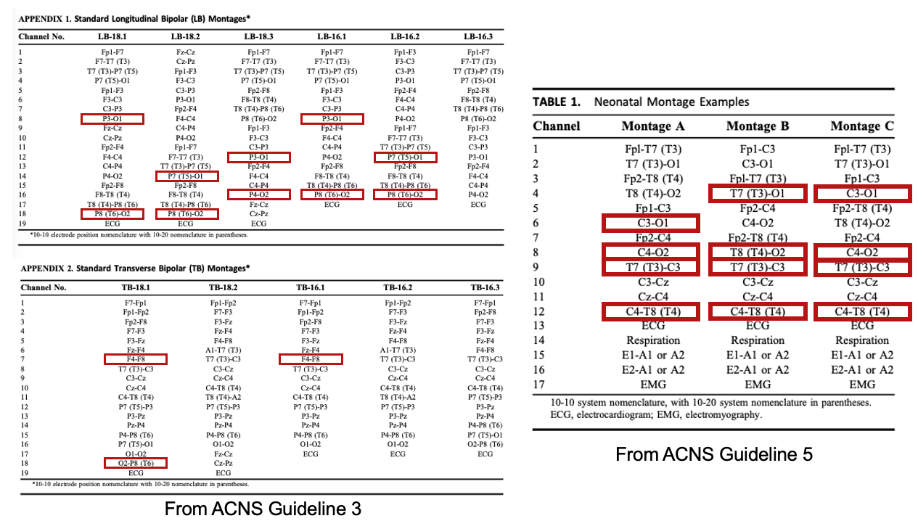
Figure 2-2. Mathematical redundancy in ACNS guideline’s [2, 3] montage scheme (Red box: Redundant channels)

Structural Uniqueness in NMR57 (sEEG) and NMR55 (PSG) Datasets
In the NMR57 dataset (e.g., sub-R1163T_ses-1_task-FR3_acq-bipolar_ieeg.edf), the configuration follows a strictly depth-sequential bipolar approach along the electrode trajectory.
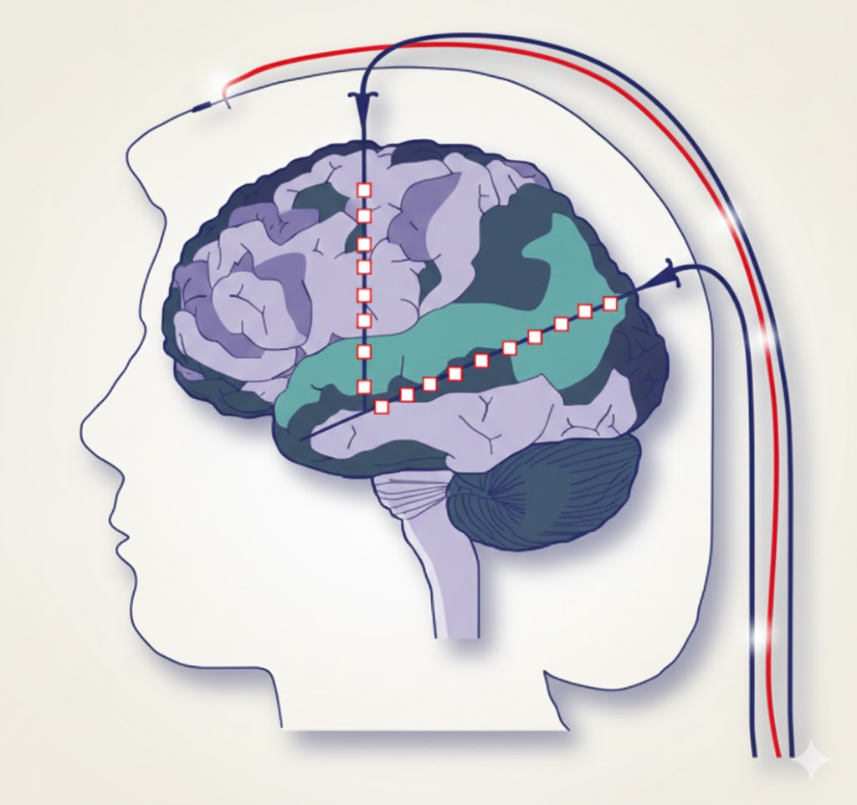
Figure 2-3. Depth EEG scheme
- Mechanism: Channels are derived by calculating the differential between adjacent contacts according to their depth order (e.g., LA1-LA2, LA2-LA3).
- Absence of Redundancy: Although a single contact (e.g., LA2) is shared between adjacent pairs, each channel captures a unique potential gradient at a different depth. No 1:1 signal duplication is found.

- Representative Channels:
  - Lead LY (Lateral/Medial): LY1-LY2, LY2-LY3 ... LY8-LY9
  - Lead LA (Left Amygdala): LA1-LA2, LA2-LA3 ... LA9-LA10
  - Lead LB (Left Hippocampus): LB1-LB2, LB2-LB3 ... LB8-LB9
  - Lead LI (Insular/Other): LI1-LI2, LI2-LI3 ... LI9-LI10
* Note on Redundancy in Specific Bipolar Records:
While depth-sequential arrangements are structurally designed for signal uniqueness, certain bipolar records contain significant redundancy due to overlapping derivations. For instance, in the record sub-R1154D_ses-4_task-FR3_acq-bipolar_ieeg.edf, a substantial portion of the data is mathematically redundant:
- Redundancy Statistics: 38 / 111 channels (38 redundant channels detected among 111 total recordings)
The following examples, selected from the 38 identified channels, illustrate how a single bipolar derivation can be reconstructed through a complex path of other existing channels:
$$(LTCG25-LTCG26) = -(LTCG17-LTCG25)-(LTCG9-LTCG17)-(LTCG1-LTCG9)+(LTCG1-LTCG2)+(LTCG2-LTCG10)+(LTCG10-LTCG18)+(LTCG18-LTCG26),$$
$$(LTCG26-LTCG27) = -(LTCG18-LTCG26)-(LTCG10-LTCG18)-(LTCG2-LTCG10)+(LTCG2-LTCG3)+(LTCG3-LTCG11)+(LTCG11-LTCG19)+(LTCG19-LTCG27).$$

The NMR55 dataset exhibits a streamlined configuration where each channel is dedicated to a distinct physiological modality. In this dataset, multi modal signals such as ECG, EMG, PPG, and EOG are recorded at once.
- Standard PSG Case (sub-8_task-Sleep_acq-psg_eeg.edf)
- Mechanism: Every channel is assigned to a specific clinical sensor for sleep architecture analysis, following the AASM (American Academy of Sleep Medicine) standard.
- Absence of Redundancy: All 8 channels represent unique anatomical or biological sources. There is no literal duplication between the cortical EEG, ocular, and muscular channels.
- Representative Channels:
  - Cortical EEG: PSG_F3, PSG_F4, PSG_C3, PSG_C4, PSG_O1, PSG_O2
  - Ocular/Muscular: PSG_EOG, PSG_EMG
- Vital Monitoring Case (sub-118_task-Sleep_acq-headband_eeg.edf)
- Mechanism: This configuration focuses on cardiovascular activity. It utilizes sensors typically found in wearable headband devices to monitor autonomic responses during sleep.
- Absence of Redundancy: Each channel is dedicated to a specific cardiovascular metric. HB_1 and HB_2 capture the differential heart beat signal, while HB_PULSE provides the integrated pulse rate.
- Representative Channels:
  - Cardiac Activity: HB_1, HB_2 (ECG-based heart beat)
  - Pulse Monitoring: HB_PULSE (PPG-based pulse)

Signal Fidelity and Non-Ideal Redundancy
In a standard bipolar montage, the potential difference between two distant electrodes can be expressed as the sum of any continuous chain of bipolar pairs connecting them. This architectural property creates a mathematical cycle redundancy, where the theoretical potential difference between two nodes should remain identical regardless of the specific path chosen through the electrode array. As illustrated in Figure 2-1, these electrodes are linked in a sequential chain, and to evaluate the fidelity of this redundancy in a real-world scenario, chb15_30.edf was analyzed as a representative case.
By identifying a closed loop within the left hemisphere from FP1 to O1 based on the connections shown in Figure 2-1, we can compare the lateral path against the medial path. Since both trajectories originate and terminate at the same physical locations, the recorded channel P3-O1 can be mathematically reconstructed using the following arithmetic relationship:
(P3−O1)=(FP1−F7)+(F7−T7)+(T7−P7)+(P7−O1)−(FP1−F3)−(F3−C3)−(C3−P3).
When the synthesized P3-O1 signal is compared to the actually recorded P3-O1 channel in the chb15_30.edf file, the data reveals a non-ideal redundancy where the signals do not perfectly align at the sample level. Although the two waveforms maintain a Pearson correlation near 1.0, a direct sample-wise subtraction uncovers a persistent high-frequency residual, as visualized in Figure 2-4.
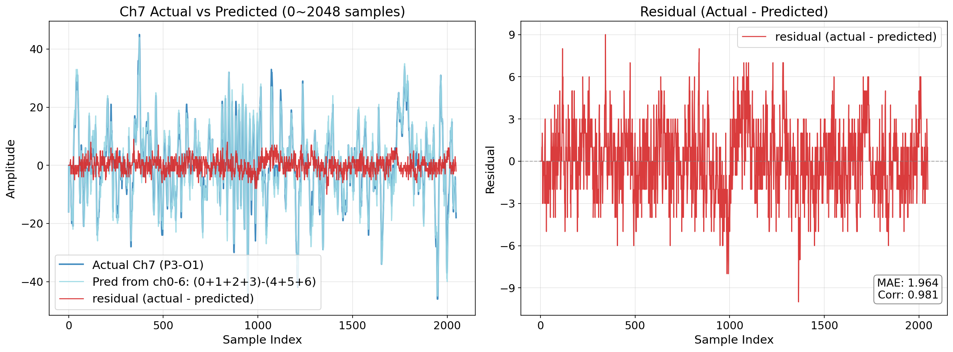
Figure 2-4. Oracle combination analysis of redundant channel in chb15_30.edf
This fidelity gap likely stems from hardware non-idealities. While the recorded channel uses a single amplifier, the synthesized version accumulates independent noise from seven separate stages, degrading the signal-to-noise ratio. Additional factors like sampling jitter and gain mismatches further prevent perfect alignment, proving that redundant channels carry unique hardware noise profiles. To effectively address these structural relationships and their associated noise, we introduce Montage-based Graph Coding (MGC) as a specialized approach for signal representation and coding.

Algorithm Description
The primary objective of MGC is to maximize coding efficiency by utilizing clinical metadata found in channel labels. By physically reconstructing the connection network of electrodes, MGC identifies mathematically redundant signals without analyzing a single sample of the waveform data.
The core of MGC is its deterministic workflow. It is "deterministic" because it relies on standardized labeling rules (EDF/EDF+) [7] and fundamental graph theory, ensuring that any encoder or decoder with access to the same header metadata will always arrive at the exact same reconstruction roadmap.

Graph Construction and Redundancy Detection
MGC resolves the entire redundancy roadmap during the header parsing phase through a deterministic four-step workflow, as illustrated in Figure 3-1. While the following descriptions provide specific implementation details to aid in conceptual clarity, the underlying workflow allows for significant structural flexibility. Consequently, the actual implementation of the four steps may be adapted or optimized differently from the examples presented here in.

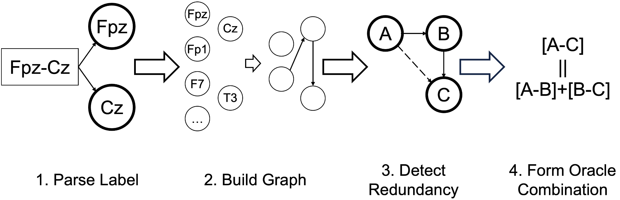
Figure 3-1. Four-step deterministic redundancy check workflow of MGC

Semantic Label Parsing and Node Mapping
The initial stage transforms raw text-based labels into structured physical metadata.
- Normalization and Standard Compliance: First, text normalization is performed on the channel label to ensure consistency. The algorithm then parses the label strictly adhering to the 'polarity rules for EXG labels' defined in the EDF/EDF+ de facto standard [7].
- Deterministic Definition: According to this rule, a label formatted as "A-B" is a deterministic definition: the recorded value is the potential at the first electrode ($V_{A}$) minus the second ($V_{B}$).
- Validity Check: If a channel label does not conform to this standard (e.g., lacks the '-' delimiter or contains ambiguous formatting), the channel is simply omitted from the MGC algorithm's processing scope.
- Unique Node Mapping: To eliminate string-comparison overhead, MGC normalizes electrode names and assigns each a specific integer index. This allows all subsequent graph operations to be performed using high-speed array indexing.
- Directed Edge Definition: Each validated channel is defined as a directed edge.

Incremental Graph Construction
MGC logically reconstructs the electrode network as an undirected graph where electrodes are vertices and channels are edges. To maintain near-zero complexity, it utilizes the Disjoint Set Union (DSU) [4] data structure.
- Data Structure: In the backend, the DSU is implemented simply as an Integer Vector (or Array) where each index represents an electrode, and the value stores its "parent" electrode index. Initially, every identified electrode forms an independent set ($parent[i] = i$), representing a disconnected graph state. As channels are processed, these sets are merged to reflect physical connectivity.

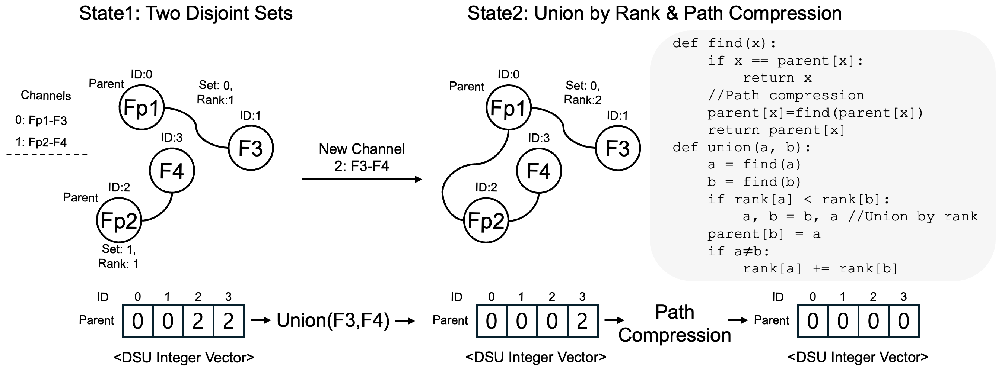
Figure 3-2. DSU implementation with path compression and union by rank.
To maintain near-zero complexity during graph construction, two key optimization techniques are applied to the DSU operations:
- Find Operation with Path Compression [4]: When identifying the root of a network group, the algorithm traces parent pointers. During this traversal, Path Compression is applied, updating every visited node's parent pointer directly to the root. This flattens the tree structure, ensuring that subsequent find operations are performed in near-constant time ($O(1)$).
- Unite Operation with Union by Rank [4]: When linking two previously disconnected electrode sets, MGC uses Union by Rank. This rule ensures that the shorter tree is always attached under the root of the taller tree. This prevents the formation of deep trees (linked-list like structures) and maintains the Flat-Tree Optimization essential for performance.
This process constructs a Spanning Forest, a minimal skeleton of the montage that connects electrodes without cycles. Channels that successfully link two disjoint sets are designated as Reference Channels. Thanks to the combination of Path Compression and Union by Rank, the amortized time complexity is $O(α(E))$, where $E$ is the number of electrodes and $α$ is the Inverse Ackermann function ($≤$4) [5]. This ensures the graph construction effectively runs in linear time $O(M)$ (where $M$ is the total number of channels classified as bipolar according to the EXG polarity rules), incurring negligible computational complexity.

Deterministic Redundancy Detection
Redundancy is identified directly within the unite operation during graph construction. This step determines the value of the is_redundant_flag for each channel.
- Cycle Identification: If the find operation reveals that the source and target electrodes already share the same root (find(u) == find(v)), an electrical path already exists between them.
- Logical Redundancy: Adding this channel completes a cycle (closed loop). As described in Section 1.2, this condition satisfies Kirchhoff's Voltage Law (KVL), implying that the potential difference is mathematically dependent on the existing reference edges.
- Redundancy Flag Assignment:
  - Reference Channel: If find(u) != find(v), the channel is essential for graph connectivity. It is added to the Spanning Forest, and is_redundant_flag is set to 0. It serves as a basis vector for the graph.
  - Redundant Channel: If find(u) == find(v), adding the channel completes a cycle. This implies mathematical dependency (similar to KVL), and is_redundant_flag is set to 1. This channel is mathematically dependent on the existing Reference Channels.

Oracle Combination Formulation
For each channel where is_redundant_flag is 1, MGC derives the exact reconstruction formula. This formula is a linear combination of a specific subset of the Reference Channels (is_redundant_flag == 0). This information is mapped to the ref_channel_mask and ref_channel_sign_mask.
- Path Discovery: MGC performs a Breadth-First Search (BFS) [4] within the Spanning Forest (Reference Channels) to find the unique chain of channels connecting the redundant channel's source and target. As illustrated in Figure 3-3, a layered BFS traversal over the spanning forest identifies connectivity between redundant channel pairs, yielding a deterministic reference path.
  - Mask Generation: The indices of the reference channels involved in this path constitute the ref_channel_mask.
- Deterministic Sign Assignment: During BFS traversal, the polarity of each reference channel in the path is determined by comparing the traversal direction with the reference channel's defined edge direction.
  - Positive (+): If traversal follows the edge direction (Source $→$ Target), the sign is positive. This is mapped to a bit value of 0 in the ref_channel_sign_mask.
  - Negative (-): If traversal opposes the edge direction (Target $→$ Source), the sign is negative. This is mapped to a bit value of 1 in the ref_channel_sign_mask.
- The Oracle Combination: The redundant signal $S_{redundant}=\sum_{k∈Mask}{{\left(-1\right)}^{SignBits_{k}}∙S_{k}}$
Complexity Analysis: The standard time complexity for BFS is $O(V_{BFS}+E_{BFS})$. In the MGC context:
- $V_{BFS}$ corresponds to the number of Electrodes ($E$).
- $E_{BFS}$ corresponds to the number of Reference Channels (edges in the Spanning Forest). Since a Spanning Forest is acyclic, the number of edges is strictly bounded by the number of nodes ($Edes < E$). Consequently, the complexity for one search simplifies to $O(E+E)≈O(E).$ Since this operation is repeated for all $R$ Redundant Channels, the total complexity for oracle combination formulation is $O(R∙E)$.
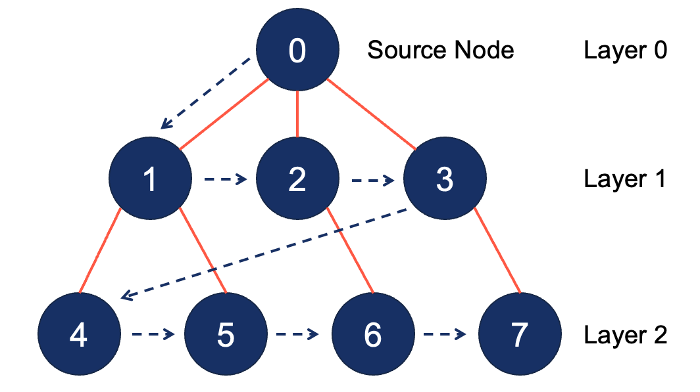
Figure 3-3. Breadth-First Search Algorithm

Total Algorithmic Cost
The total complexity of the graph construction algorithm in MGC is defined as:
$$O\left(M∙α\left(E\right)+R∙E\right)≈O(M)$$
where $M$ is the total number of bipolar channels, $E$ is the electrode count, $R$ is the number of redundant channels.
- Graph Construction Cost $O\left(M∙α\left(E\right)\right)$: DSU operations scale linearly with channels ($M$).
- Oracle Formulation $O(R∙E)$: Path finding scales with redundant channels ($R$) times the forest size ($E$).
- Overall Scalability: The entire process follows a linear complexity of $O(M)$ relative to the dataset size, ensuring negligible overhead compared to signal processing.

Signaling Strategy for Graph Structure
To guarantee robust decoding (even when full header metadata is unavailable), the relationship between Redundant Channels and Reference Channels must be signaled.
To signal the structural relationships derived in Section 3.1, new syntax elements are added to the existing Waveform Parameter Set (WPS). First, an is_redundant_flag is introduced for every channel. A value of 0 indicates a Reference Channel (Basis Set), which contains independent information, while a value of 1 indicates a Redundant Channel (Derived Set) that can be reconstructed from the basis set. For channels identified as redundant, two additional masks are signaled: ref_channel_mask and ref_channel_sign_mask. The ref_channel_mask specifies the constituent subset of Reference Channels required to form the Oracle Combination, while the ref_channel_sign_mask defines the polarity (positive or negative) of each constituent channel in the reconstruction formula. The complete modifications of specification text are provided in the attached CE-3 specification text document. The syntax changes are presented below.
Syntax changes:
waveform_parameter_set( ) { | Descriptor
wps_waveform_parameter_set_id | u(4)
NumChannelGroups = 0
TotalNumChannels = 0
do {
wps_num_channels_in_next_group_minus1 | ue(v)
wps_num_channel_group_repetitions | ue(v)
for( j = 0; j <= wps_num_channel_group_repetitions; j++ ) {
NumChannels[ NumChannelGroups ] =
wps_num_channels_in_next_group_minus1 + 1
channel_group_reref_enable[ NumChannelGroups ] | u(1)
if( channel_group_reref_enable[ NumChannelGroups ] {
channel_group_reref_mode[ NumChannelGroups ] | u(2)
channel_group_reref_channel_idx[ NumChannelGroups ] | ue(v)
}
ChannelGroupStartingPos[ NumChannelGroups++ ] = TotalNumChannels
TotalNumChannels += wps_num_channels_in_next_group_minus1 + 1
}
wps_more_channel_groups_present_flag | u(1)
} while( wps_more_channel_groups_present_flag )
wps_channel_reordering_flag | u(1)
if( wps_channel_reordering_flag ) {
wps_num_channel_swaps_minus1 | ue(v)
for( i = 0; i <= wps_num_channel_swaps_minus1; i++ ) {
wps_swap_frst_idx[ i ] | ue(v)
wps_swap_scnd_idx_min_frst_idx_min1[ i ] | ue(v)
}
}
wps_num_annotation_channels | ue(v)
for( j = 0; j < wps_num_annotation_channels; j++ )
AnnotationChannelNumSamples[ j ] = 0 | ue(v)
for( cgId = 0; cgId < NumChannelGroups; cgId++ ) {
numRedundant = 0
for( ch = 0; ch < NumChannels[ cgId ]; ch++ ) {
wps_redundant_channel_flag[ cgId ][ ch ] | u(1)
numRedundant += wps_redundant_channel_flag[ cgId ][ ch ]
}
for( idx = 0; idx < numRedundant; idx++ ) {
for( ch = 0; ch < NumChannels[ cgId ]; ch++ ) {
wps_redundant_channel_ref_index[ cgId ][ idx ] [ ch ] | u(1)
wps_redundant_channel_ref_sign[ cgId ][ idx ][ ch ] | u(1)
}
}
}
trailing_bits( )
}
Semantics addition in 6.4.2.1:
wps_redundant_channel_flag[ cgId ][ ch ] equal to 1 specifies that the channel ch in the channel group cgId is a redundant channel that can be mathematically reconstructed from a linear combination of reference channels .
wps_redundant_channel_ref_index[ cgId ][ idx ][ ch ] equal to 1 specifies that the reference channel ch is used to reconstruct the idx-th redundant channel within the channel group cgId. This bitmask represents the ref_channel_mask, where each bit indicates whether a specific reference channel is a constituent of the Oracle Combination for the redundant channel.
wps_redundant_channel_ref_sign[ cgId ][ idx ][ ch ] specifies the polarity of the reference channel ch in the reconstruction formula for the idx-th redundant channel, where a value of 1 indicates a negative sign (-).

This design allows future implementations where, if the header is available, the decoder can perform the Section 2.1 logic locally, bypassing the need for these bits ("Zero-bit signaling"). However, the current specification mandates signaling for interoperability.

Coding Modes and RDO Integration
MGC adaptively selects a coding mode based on the precision of the oracle prediction. In practice, while many bipolar relationships are mathematically exact, some datasets may contain slight numerical discrepancies or noise.
- Mode1: Direct Reconstruction
  - The encoder completely bypasses residual coding and CABAC for the channel. The decoder perfectly reconstructs the signal using only the Oracle Combination.

- Mode2: Predictive Coding with RDO
  - The Oracle Combination is used as a high-precision block predictor. The encoder codes only the residual difference between the original signal and the oracle prediction, optimizing bit allocation within the RDO loop.

Signalling for Coding Methods
To support the adaptive modes in Section 3.3, hierarchical flags are introduced at the block level for each redundant channel.
This integration necessitates modifications to the existing predictive transform coding block syntax. By embedding the MGC control flags (direct_recon_flag, mgc_predictive_coding_flag) at the beginning of the block structure, the encoder can conditionally bypass the standard prediction, transform, and entropy coding stages. This structure ensures that for perfectly redundant signals (Mode 1), the signaling overhead is minimized to a single bit, while providing a fallback mechanism for noisy signals (Mode 2). The complete modifications of specification text are provided in the attached CE-3 specification text document. The syntax changes are presented below
Syntax changes:
prediction_trafo_data_block ( ) { | Descriptor
for( ch = 0; ch < numChannels; ch++ ) {
if( wps_redundant_channel_flag[ chGId ][ ch ] = = 1 )
direct_recon_flag | u(1)
if( ( wps_redundant_channel_flag[ chGId ][ ch ] = = 1 ) && ( direct_recon_flag = = 0 ) )
mgc_predictive_coding_flag | u(1)
if( cgps_allow_block_matching_pred_flag | | ( cgps_allow_cross_channel_pred_flag
&& ( ch & DepChMask ) > 0 ) )
block_matching_or_cross_channel_pred_flag | ae(ch)
if( block_matching_or_cross_channel_pred_flag ) {
if( cgps_allow_block_matching_pred_flag &&
cgps_allow_cross_channel_pred_flag
&& ( ch & DepChMask ) > 0 )
cross_channel_pred_flag | ae(ch)
if( cross_channel_pred_flag )
cross_channel_prediction_data( ch )
else
block_matching_prediction_data( ch )
} else {
BlockPredMode = BPM_OFF
if( cgps_allow_dc_pred_flag | | cgps_allow_line_fit_flag ) {
block_pred_off_flag | ae(ch)
if( !block_pred_off_flag )
if( cgps_allow_dc_pred_flag && cgps_allow_line_fit_flag ) {
block_pred_lf_flag | ae(ch)
if( block_pred_lf_flag )
BlockPredMode = BPM_LF
else
BlockPredMode = BPM_DC
} else
BlockPredMode = cgps_allow_dc_pred_flag ? BPM_DC : BPM_LF
}
}
TransformMode = ( cgps_allow_transform_skip_flag = = 0 ) ? TM_DCT : TM_OFF
if( cgps_allow_transform_skip_flag = = 1 ) {
dct_flag | ae(ch)
if( dct_flag )
TransformMode = TM_DCT
}
sample_pred_mode( ch )
if( spred_lpf_flag )
linear_predictive_filtering_data( ch )
if( cgps_max_abs_delta_qp_idx > 0 ) {
block_abs_delta_qp | ae(ch)
if( block_abs_delta_qp > 0 )
block_delta_qp_sign_flag | aep()
blockDeltaQP = block_delta_qp_sign_flag ?
−block_abs_delta_qp : block_abs_delta_qp
CurrBlockQP[ ch ] = Clip3( 0, 1023, CurrBlockQP[ ch ] + blockDeltaQP )
}
if( cgps_allow_zero_lsb_flag && CurrBlockQP[ ch ] = = 0 ) {
zlsb_present_flag | ae(ch)
if( zlsb_present_flag )
num_zlsb_minus1 | aep()
}
NumZLSB = zlsb_present_flag ? 1 + num_zlsb_minus1 : 0
quant_res_sample_data( ch )
if ( direct_recon_flag = = 0 ) {
if( ( cgps_allow_block_matching_pred_flag | | ( cgps_allow_cross_channel_pred_flag && ( ch & DepChMask ) > 0 ) ) && ( mgc_predictive_coding_flag = = 0 ) )
block_matching_or_cross_channel_pred_flag | ae(ch)
if( block_matching_or_cross_channel_pred_flag ) {
if( cgps_allow_block_matching_pred_flag &&
cgps_allow_cross_channel_pred_flag && ( ch & DepChMask ) > 0 )
cross_channel_pred_flag | ae(ch)
if( cross_channel_pred_flag )
cross_channel_prediction_data( ch )
else
block_matching_prediction_data( ch )
} else
if (mgc_predictive_coding_flag = = 0)
block_pred_mode | ae(ch)
if( block_matching_or_cross_channel_pred_flag | |
( block_pred_mode = = BPM_OFF ) | | (mgc_predictive_coding_flag) ) {
sample_pred_mode( ch )
if( spred_lpf_flag )
linear_predictive_filtering_data( ch )
}
if( cgps_max_abs_delta_qp_idx > 0 ) {
block_abs_delta_qp | ae(ch)
if( block_abs_delta_qp > 0 )
block_delta_qp_sign_flag | aep()
blockDeltaQP = block_delta_qp_sign_flag ?
−block_abs_delta_qp : block_abs_delta_qp
CurrBlockQP[ ch ] =
Clip3( 0, 1023, CurrBlockQP[ ch ] + blockDeltaQP )
}
if( spred_lpf_or_diff_flag | | ( spred_rem_mode_idx = = 2 ) ) {
if( ( spred_rem_mode_idx = = 2 ) | | CurrBlockQP[ ch ] > 0 ) {
transform_present_flag | ae(ch)
TransformMode = TM_OFF
if( transform_present_flag ) {
transform_dst_flag
TransformMode = ( transform_dst_flag = = 1 ? TM_DST : TM_DCT )
}
}
}
if( cgps_allow_zero_lsb_flag && CurrBlockQP[ ch ] = = 0 ) {
zlsb_present_flag | ae(ch)
if( zlsb_present_flag )
num_zlsb_minus1 | aep()
}
NumZLSB = zlsb_present_flag ? 1 + num_zlsb_minus1 : 0
quant_res_sample_data( ch )
} | }
}
}

Semantics addition in 6.4.3.2.1:
direct_recon_flag equal to 1 specifies that the current block is reconstructed by a linear combination of reference channels without any residual coding. This flag is only present when wps_redundant_channel_flag[ cgId ][ ch ] is equal to 1. When direct_recon_flag is equal to 1, the entire predictive transform coding block process, including prediction, transform, and entropy coding, is bypassed for the current block. When direct_recon_flag is not present, it is inferred to be 0.
mgc_predictive_coding_flag equal to 1 specifies that the linear combination of reference channels is used as a predictor for the current block. When mgc_predictive_coding_flag is not present, it is inferred to be 0.

Experimental Results of MGC

Tested on H.BWC 5.0 CTC
Table 4-1. Experiment evaluation result compared to H.BWC-5.0 with CTC (joint coding for lossy) [8]
 | Lossy Compression
 | Over BWC-5.0
 | BD-PSNR1 | BD-PSNR2 | EncT | DecT
MIT (ECG) | 0.00% | 0.00% | 101% | 100%
INCART (ECG) | 0.00% | 0.00% | 100% | 100%
CHBMIT (EEG) | -2.06% | -2.06% | 89% | 95%
NMR55 (EEG) | 0.00% | 0.00% | 100% | 102%
NMR57 (EEG) | -1.05% | -2.04% | 93% | 95%
TILT ILLUSION (EEG) | 0.00% | 0.00% | 100% | 99%
Ozdemir (EMG) | 0.00% | 0.00% | 100% | 100%
PTT (PPG) | 0.00% | 0.00% | 100% | 98%
WristPPG (PPG) | 0.00% | 0.00% | 100% | 101%
Overall | -0.34% | -0.46% | 98% | 99%

Table 4-2. Experiment evaluation result compared to H.BWC-5.0 with CTC (joint coding for lossless) [8]
 | Lossless Compression
 | Over BWC-5.0
 | BR-R | EncT | DecT
MIT (ECG) | 0.00% | 101% | 101%
INCART (ECG) | 0.00% | 101% | 101%
CHBMIT (EEG) | -3.18% | 96% | 100%
NMR55 (EEG) | 0.00% | 102% | 100%
NMR57 (EEG) | -5.63% | 96% | 99%
TILT ILLUSION (EEG) | 0.00% | 103% | 100%
Ozdemir (EMG) | 0.00% | 102% | 100%
PTT (PPG) | 0.00% | 101% | 101%
WristPPG (PPG) | 0.00% | 101% | 100%
Overall | -0.98% | 100% | 100%

As summarized in Table 4-1 (Lossy) and Table 4-2 (Lossless), the proposed MGC significantly improves both coding efficiency and processing speed across the CHB-MIT and NMR57 datasets. This improvement is achieved through two distinct operating modes tailored to channel redundancy. The substantial reduction in encoding time is primarily driven by Mode 1 (Direct Reconstruction), which completely bypasses residual coding and CABAC for redundant channels, eliminating unnecessary computational load. Simultaneously, the gain in compression efficiency is maximized by Mode 2 (Predictive Coding with RDO), which utilizes the Oracle Combination as a high-precision predictor to minimize residual energy.

The overall performance improvements are consistently reflected in the BD-rate curves presented in Figures 4-1 through 4-4. Every recording in the CHB-MIT dataset has structural redundancy. In contrast, for the NMR57 dataset, redundancy appears only in certain files rather than across the entire set. Despite this, MGC yields exceptional coding gains in NMR57 dataset.

To further analyze these effects, a detailed per-file performance evaluation for NMR57 is provided in Table 4-3 (Lossless) and Table 4-4 (Lossy). In specific instances where redundancy is high, MGC achieved a remarkable maximum bit-rate reduction (BR-R) of up to -33.00% in lossless mode. Furthermore, for lossy coding, a maximum improvement of -13.21% in terms of BD-PSNR2 was observed.

For datasets or specific records without redundant montages, MGC performs identically to the H.BWC-5.0 [6] as seen in Table 4- 1 and 4-2. The only difference is a 1-bit redundancy flag per channel in the WPS, resulting in negligible bit increase and zero impact on execution time. These findings prove that MGC provides substantial gains in the presence of structural redundancy while maintaining baseline performance in all other cases.
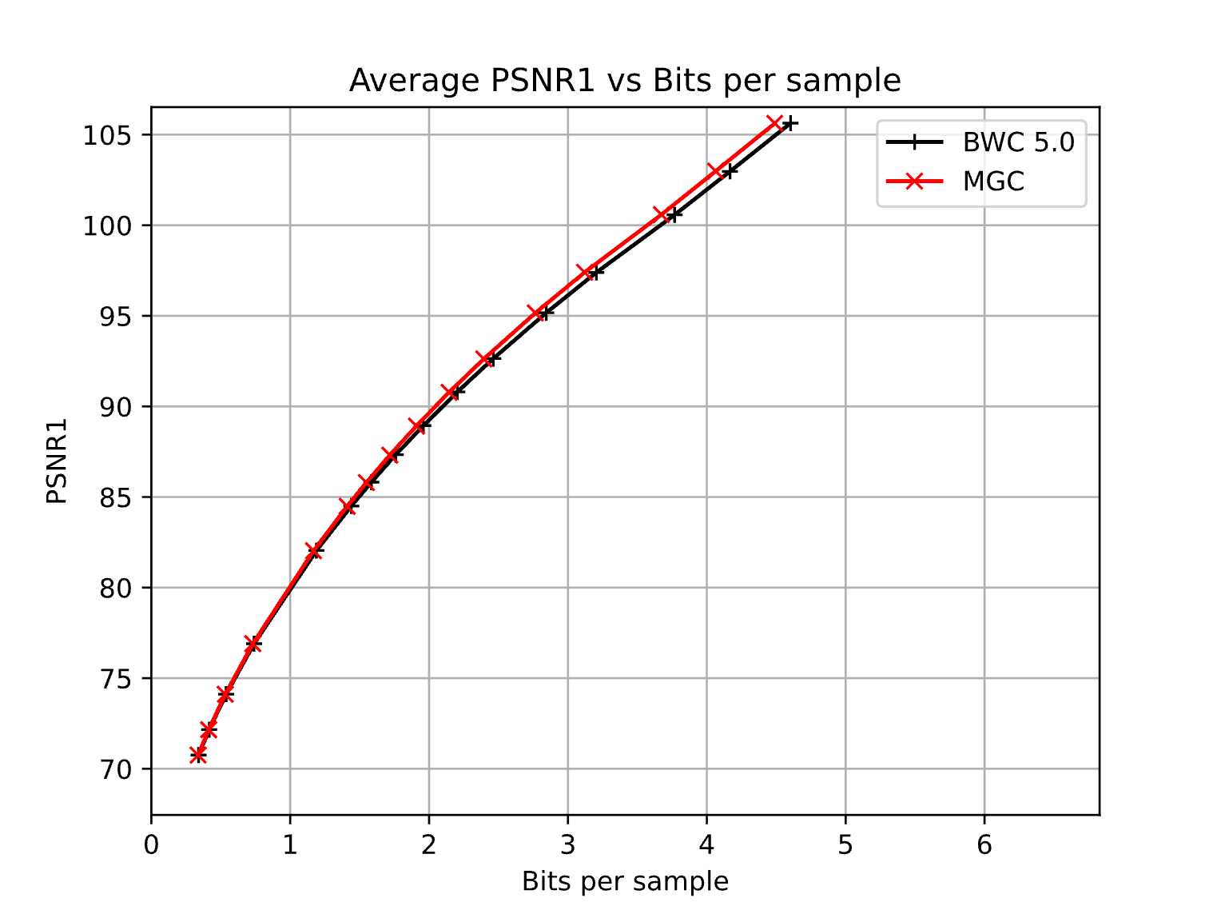
Figure 4-1. BD-rate#1 curve compared to H.BWC-5.0 with CTC (joint lossy, CHB-MIT) [8]
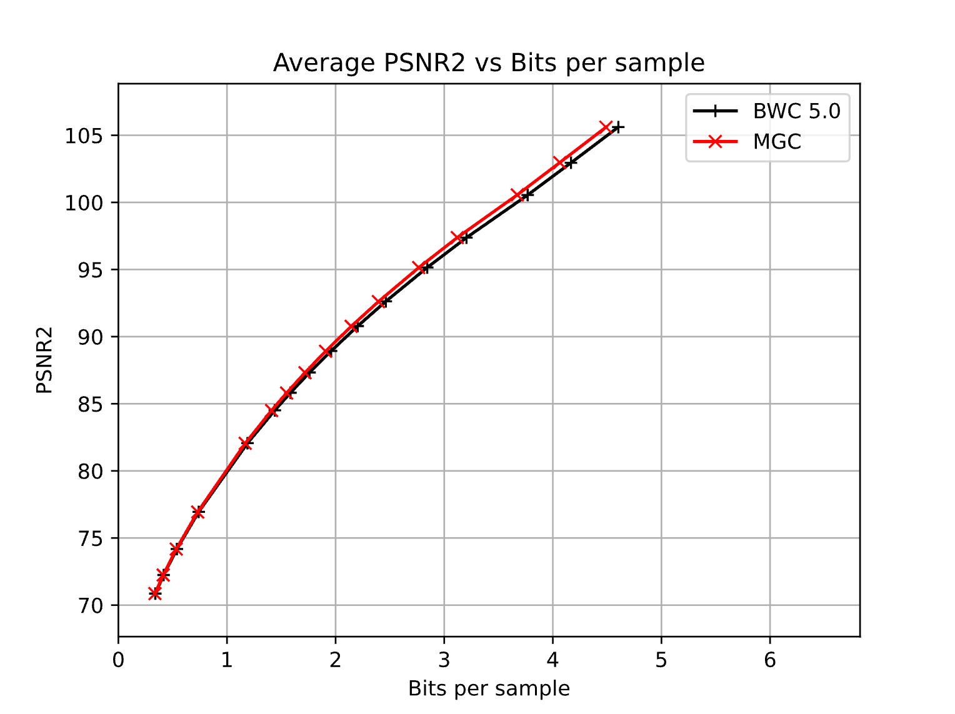
Figure 4-2. BD-rate#2 curve compared to H.BWC-5.0 with CTC (joint lossy, CHB-MIT) [8]
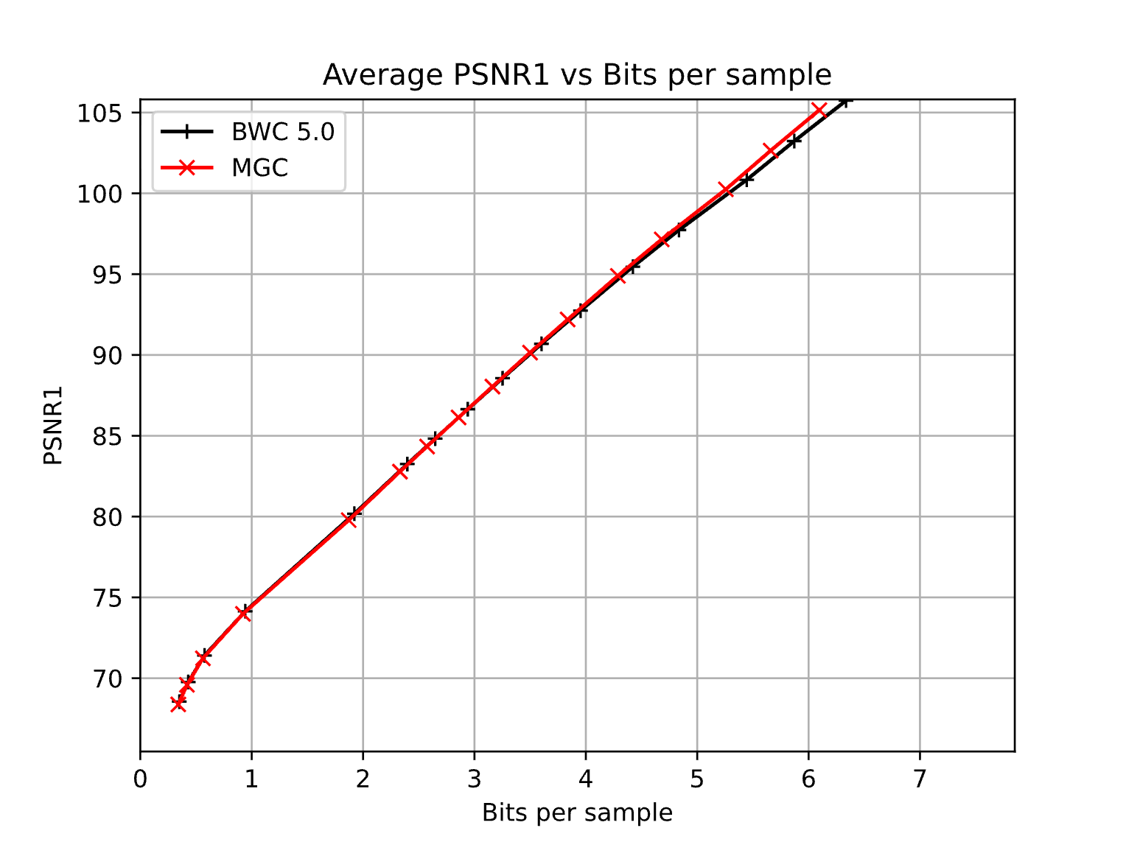
Figure 4-3. BD-rate#1 curve compared to H.BWC-5.0 with CTC (joint lossy, NMR57) [8]

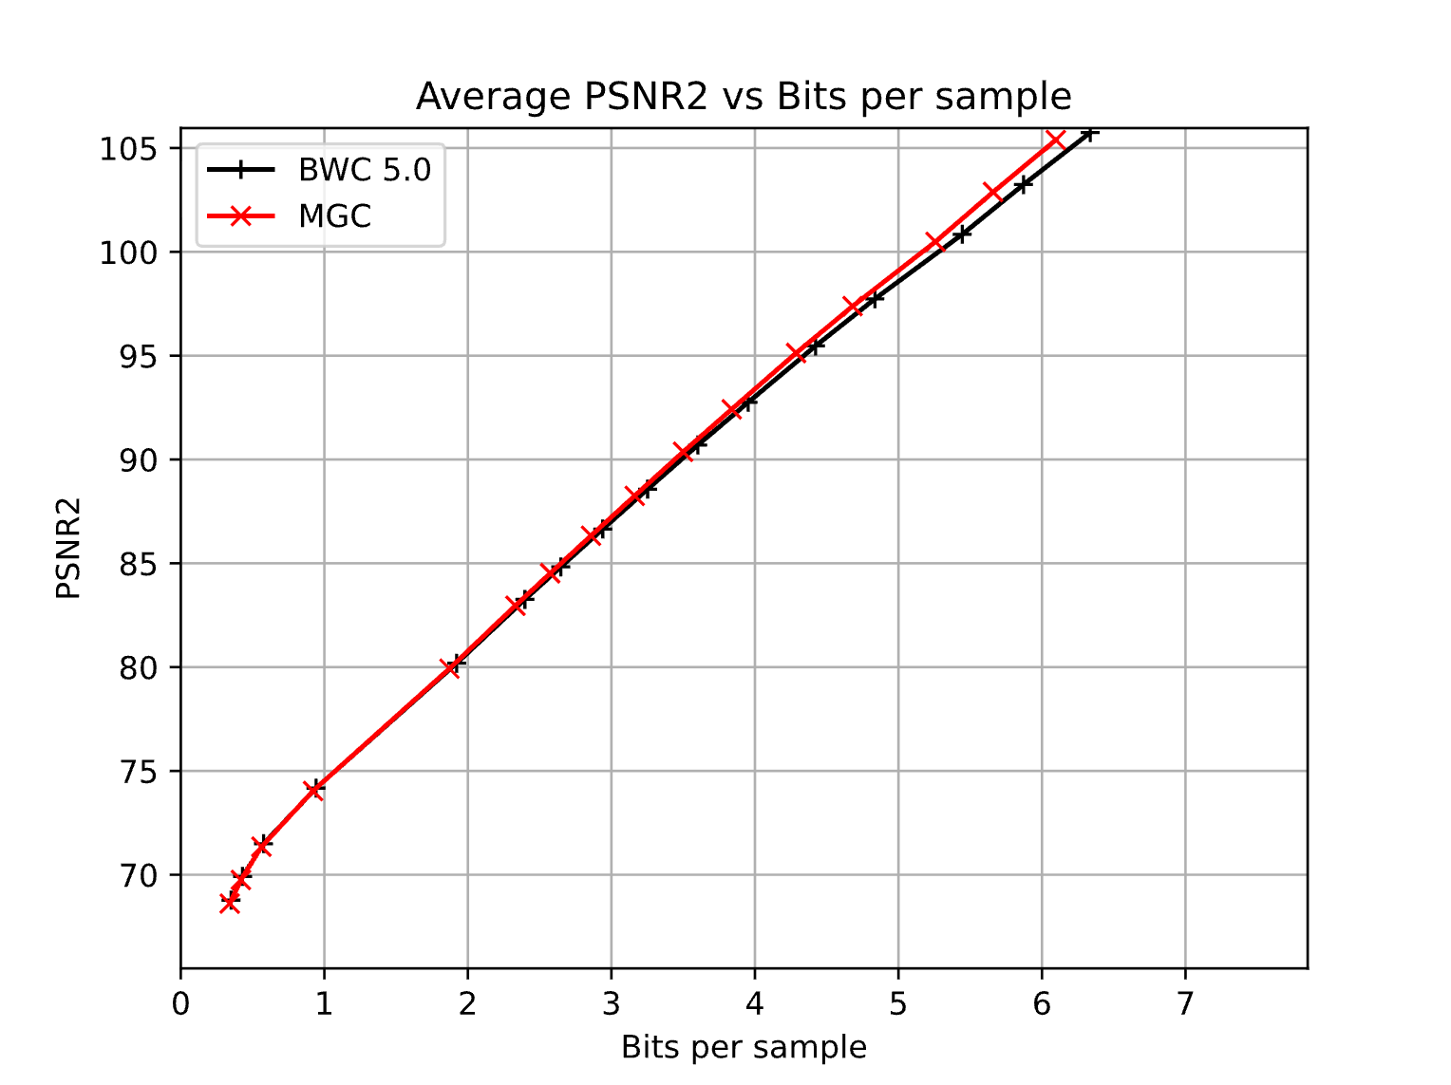
Figure 4-4. BD-rate#2 curve compared to H.BWC-5.0 with CTC (joint lossy, NMR57) [8]

Table 4-3. Per-file bit-rate changes for the NMR57 dataset.
Test File | BR-R | EncTime
sub-R1124J_ses-0_task-FR3_acq-bipolar_ieeg | 0.00% | 103.29%
sub-R1124J_ses-1_task-FR3_acq-monopolar_ieeg | 0.00% | 103.42%
sub-R1145J_ses-0_task-FR3_acq-monopolar_ieeg | 0.00% | 102.83%
sub-R1154D_ses-1_task-FR3_acq-monopolar_ieeg | 0.00% | 103.68%
sub-R1154D_ses-1_task-FR3_acq-bipolar_ieeg | -30.96% | 69.81%
sub-R1154D_ses-3_task-FR3_acq-bipolar_ieeg | -30.20% | 69.43%
sub-R1154D_ses-4_task-FR3_acq-bipolar_ieeg | -31.06% | 69.28%
sub-R1154D_ses-4_task-FR3_acq-monopolar_ieeg | 0.00% | 103.23%
sub-R1161E_ses-0_task-FR3_acq-monopolar_ieeg | 0.00% | 104.61%
sub-R1161E_ses-1_task-FR3_acq-bipolar_ieeg | 0.00% | 103.55%
sub-R1163T_ses-1_task-FR3_acq-monopolar_ieeg | 0.00% | 103.16%
sub-R1166D_ses-0_task-FR3_acq-bipolar_ieeg | -33.00% | 70.47%
sub-R1166D_ses-1_task-FR3_acq-monopolar_ieeg | 0.00% | 103.00%
sub-R1166D_ses-1_task-FR3_acq-bipolar_ieeg | -31.79% | 69.15%
sub-R1170J_ses-0_task-FR3_acq-bipolar_ieeg | 0.00% | 103.33%
sub-R1170J_ses-1_task-FR3_acq-monopolar_ieeg | 0.00% | 103.20%
sub-R1195E_ses-0_task-FR3_acq-bipolar_ieeg | 0.00% | 103.48%
sub-R1195E_ses-1_task-FR3_acq-monopolar_ieeg | 0.00% | 103.37%
sub-R1195E_ses-2_task-FR3_acq-monopolar_ieeg | 0.00% | 102.84%
sub-R1195E_ses-2_task-FR3_acq-bipolar_ieeg | 0.00% | 103.37%
sub-R1200T_ses-0_task-FR3_acq-bipolar_ieeg | 0.00% | 103.21%
sub-R1200T_ses-0_task-FR3_acq-monopolar_ieeg | 0.00% | 103.53%
sub-R1201P_ses-0_task-FR3_acq-monopolar_ieeg | 0.00% | 103.32%
sub-R1202M_ses-1_task-FR3_acq-bipolar_ieeg | -11.88% | 89.61%
sub-R1204T_ses-0_task-FR3_acq-bipolar_ieeg | 0.00% | 103.26%
sub-R1204T_ses-0_task-FR3_acq-monopolar_ieeg | 0.00% | 103.26%
sub-R1223E_ses-0_task-FR3_acq-monopolar_ieeg | 0.00% | 103.38%
sub-R1223E_ses-1_task-FR3_acq-monopolar_ieeg | 0.00% | 103.18%
sub-R1223E_ses-1_task-FR3_acq-bipolar_ieeg | 0.00% | 104.37%
sub-R1293P_ses-1_task-FR3_acq-bipolar_ieeg | 0.00% | 104.36%

Table 4-4. Per-file bd-rate changes for the NMR57 dataset.
Test File | BD-PSNR1 | BD-PSNR2 | EncTime
sub-R1124J_ses-0_task-FR3_acq-bipolar_ieeg | 0.00% | 0.00% | 93.80%
sub-R1124J_ses-1_task-FR3_acq-monopolar_ieeg | 0.00% | 0.00% | 98.31%
sub-R1145J_ses-0_task-FR3_acq-monopolar_ieeg | 0.00% | 0.00% | 102.77%
sub-R1154D_ses-1_task-FR3_acq-monopolar_ieeg | 0.00% | 0.00% | 98.01%
sub-R1154D_ses-1_task-FR3_acq-bipolar_ieeg | -5.52% | -11.24% | 68.56%
sub-R1154D_ses-3_task-FR3_acq-bipolar_ieeg | -5.06% | -10.79% | 63.95%
sub-R1154D_ses-4_task-FR3_acq-bipolar_ieeg | -5.46% | -11.25% | 71.69%
sub-R1154D_ses-4_task-FR3_acq-monopolar_ieeg | 0.00% | 0.00% | 101.34%
sub-R1161E_ses-0_task-FR3_acq-monopolar_ieeg | 0.00% | 0.00% | 107.39%
sub-R1161E_ses-1_task-FR3_acq-bipolar_ieeg | 0.00% | 0.00% | 97.84%
sub-R1163T_ses-1_task-FR3_acq-monopolar_ieeg | 0.00% | 0.00% | 98.53%
sub-R1166D_ses-0_task-FR3_acq-bipolar_ieeg | -7.91% | -13.21% | 67.21%
sub-R1166D_ses-1_task-FR3_acq-monopolar_ieeg | 0.00% | 0.00% | 96.11%
sub-R1166D_ses-1_task-FR3_acq-bipolar_ieeg | -4.98% | -10.69% | 67.80%
sub-R1170J_ses-0_task-FR3_acq-bipolar_ieeg | 0.00% | 0.00% | 101.30%
sub-R1170J_ses-1_task-FR3_acq-monopolar_ieeg | 0.00% | 0.00% | 99.70%
sub-R1195E_ses-0_task-FR3_acq-bipolar_ieeg | 0.00% | 0.00% | 96.58%
sub-R1195E_ses-1_task-FR3_acq-monopolar_ieeg | 0.00% | 0.00% | 102.79%
sub-R1195E_ses-2_task-FR3_acq-monopolar_ieeg | 0.00% | 0.00% | 92.27%
sub-R1195E_ses-2_task-FR3_acq-bipolar_ieeg | 0.00% | 0.00% | 99.5%
sub-R1200T_ses-0_task-FR3_acq-bipolar_ieeg | 0.00% | 0.00% | 102.46%
sub-R1200T_ses-0_task-FR3_acq-monopolar_ieeg | 0.00% | 0.00% | 105.60%
sub-R1201P_ses-0_task-FR3_acq-monopolar_ieeg | 0.00% | 0.00% | 100.44%
sub-R1202M_ses-1_task-FR3_acq-bipolar_ieeg | -2.46% | -4.17% | 89.60%
sub-R1204T_ses-0_task-FR3_acq-bipolar_ieeg | 0.00% | 0.00% | 101.40%
sub-R1204T_ses-0_task-FR3_acq-monopolar_ieeg | 0.00% | 0.00% | 98.81%
sub-R1223E_ses-0_task-FR3_acq-monopolar_ieeg | 0.00% | 0.00% | 98.35%
sub-R1223E_ses-1_task-FR3_acq-monopolar_ieeg | 0.00% | 0.00% | 102.69%
sub-R1223E_ses-1_task-FR3_acq-bipolar_ieeg | 0.00% | 0.00% | 101.91%
sub-R1293P_ses-1_task-FR3_acq-bipolar_ieeg | 0.00% | 0.00% | 101.47%

Complexity Test
To evaluate the computational overhead of the proposed MGC, we analyzed the execution time of the graph construction process relative to the average encoding duration for a single multi-channel block. The analysis was conducted using the H.BWC-5.0 reference software for the CTC EEG configuration, where the MAX_BLOCK_SIZE is set to 1024 samples and the StepSizeForQP is 1.125.
For a rigorous assessment, we selected the files with the highest channel counts from each dataset, chb15_04.edf (32 channels, CHB-MIT) and sub-R1154D_ses-4_task-FR3_acq-bipolar_ieeg.edf (111 channels, NMR57), to represent the most demanding scenarios for graph construction.
Table 4-5. Complexity comparison between Graph Construction and Block Encoding (H.BWC-5.0, joint coding)
File Name | Channels | Graph Construction ($T_{GC}$) | Block Enc ($T_{BE}$, BlockSize 1024) | Ratio (${T_{GC}}/{T_{BE}})$
chb15_04.edf | 32 | 0.052636 msec | 140.681 msec | 0.037%
sub-R1154D_ses-4_task-FR3_acq-bipolar_ieeg.edf | 111 | 0.208964 msec | 989.613 msec | 0.021%

As shown in Table 4-5, the measurement results empirically validate that the MGC graph construction algorithm follows a linear complexity of $O(M)$. Most notably, the average ratio of graph construction time to the encoding duration of a single MAX_BLOCK_SIZE multi-channel block was found to be less than 0.04%. It should be noted that while this ratio is calculated against a single block for a conservative assessment, the graph construction is a one-time initialization process. Therefore, its relative overhead becomes effectively zero as the recording session continues over time. This confirms that MGC delivers its additional functionalities at no extra computational cost. The results prove that the proposed method provides significant gains in both compression and speed without introducing any perceptible bottleneck to the block-wise, multi-channel encoding pipeline.

Conclusion
MGC is a powerful, low-complexity tool that identifies channel redundancy using header information with near-zero computational overhead. It delivers significant compression gains for redundant channels while incurring no penalties for common datasets.
With a linear complexity of $O(M)$, the graph construction cost is negligible compared to the entire encoding process and is effectively amortized to zero over long-term recordings. Furthermore, MGC offers the potential to operate as a "zero-bit overhead, always-on" feature in future H.BWC versions with metadata access. Given that redundant channels are frequently encountered in practical EEG recordings, as evidenced by both the NMR57 and CHB-MIT datasets. Based on its proven efficiency and seamless integration, we propose the adoption of MGC into the next version of H.BWC, as it delivers substantial additional functionality at no extra computational cost.

Patent rights declaration(s)
ETRI may have current or pending patent rights relating to the technology described in this contribution and, conditioned on reciprocity, is prepared to grant licenses under reasonable and non-discriminatory terms as necessary for implementation of the resulting ITU-T Recommendation | ISO/IEC International Standard (per box 2 of the ITU-T/ITU-R/ISO/IEC patent statement and licensing declaration form).

References
- S. R. Sinha et al., “ACNS Guideline 1: Minimum Technical Requirements for Performing Clinical Electroencephalography,” J. Clin. Neurophysiol., vol. 33, no. 4, pp. 303-307, Aug. 2016. doi: 10.1097/WNP.0000000000000308
- J. N. Acharya et al., “ACNS Guideline 3: A Proposal for Standard Montages to Be Used in Clinical EEG,” J. Clin. Neurophysiol., vol. 33, no. 4, pp. 312-316, Aug. 2016. doi: 10.1097/WNP.0000000000000317
- J. Kuratani et al., “ACNS Guideline 5: Minimum Technical Standards for Pediatric Electroencephalography,” J. Clin. Neurophysiol., vol. 33, no. 4, pp. 320-323, Aug. 2016. doi: 10.1097/WNP.0000000000000321
- T. H. Cormen, C. E. Leiserson, R. L. Rivest, and C. Stein, Introduction to Algorithms, 3rd ed. Cambridge, MA, USA: MIT Press, 2009, Chapter 21.
- R. E. Tarjan, “Efficiency of a Good But Not Quite Linear Set Union Algorithm,” J. ACM, vol. 22, no. 2, pp. 215–225, Apr. 1975. doi: 10.1145/321879.321884
- VCEG, “Reference software for biomedical waveform data compression,” tag BWC-5.0, March. 2026. https://www.vcgit.hhi.fraunhofer.de/vceg-sw/bwc/-/tags/
- B. Kemp et al., “Standard texts and polarity rules”, September 2003. https://www.edfplus.info/specs/edftexts.html
- J. Pfaff et al., “Common test conditions and evaluation procedures for H.BWC technical experiments,”, Teleconference, Jan. 2026. https://www.itu.int/wftp3/av-arch/video-site/2601_Tel/VCEG-BZ03-Post-Geneva_CTC-v1.docx

