ITU – Telecommunications Standardization Sector  STUDY GROUP 21 Question 6  Video Coding Experts Group (VCEG)  79th Meeting: 25 April – 1 May 2026, Santa Eulària, Spain | Document: VCEG-CA06 (v1)

Question: | 6/21 (VCEG)
Source: | Jongmo Sung, Byeongho Jo, Sooyoung Park (ETRI) | Email: | {jmseong, bhjo, sooyoung} @etri.re.kr
Title: | Report of CE-2 on Group-wise Inter-Channel LMS
Purpose: | Core experiment report and proposal

Abstract
This document presents the CE report on group-wise inter-channel LMS within H.BWC.
_____________________________

Introduction
In VCEG-BZ21 [1], a group-wise inter-channel LMS (GIC-LMS) predictor was proposed to share inter-channel LMS weights within each bin group consisting of a predefined number of DCT bins. The GIC-LMS aims to improve lossless coding efficiency while preserving computational complexity by performing LMS prediction and weight updates on a group-by-group basis rather than on a bin-by-bin basis, as in TM-5.0.

Technical description of the CE-2
By adopting a group-wise IC-LMS prediction approach instead of a bin-wise approach, more stable prediction coefficients are expected. This is due to the reduced gradient variance in the group-based formulation, which may improve the convergence behavior of the adaptive process.
The conceptual diagrams of the IC-LMS in TM-5.0 and the proposed GIC-LMS are shown in Figure 1 and Figure 2, respectively.
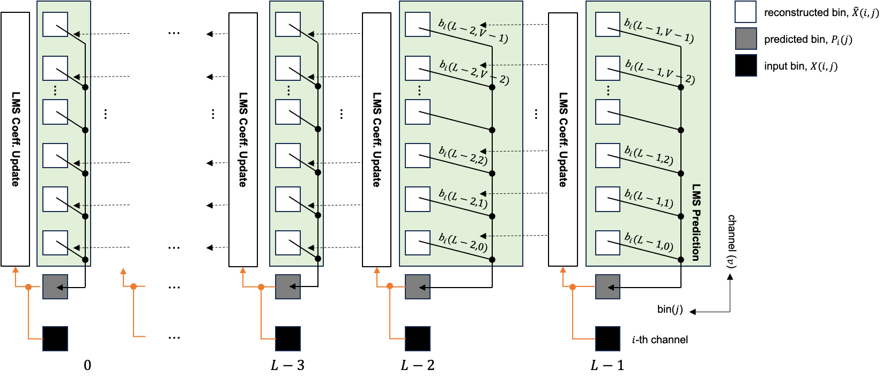
Figure 1. IC-LMS

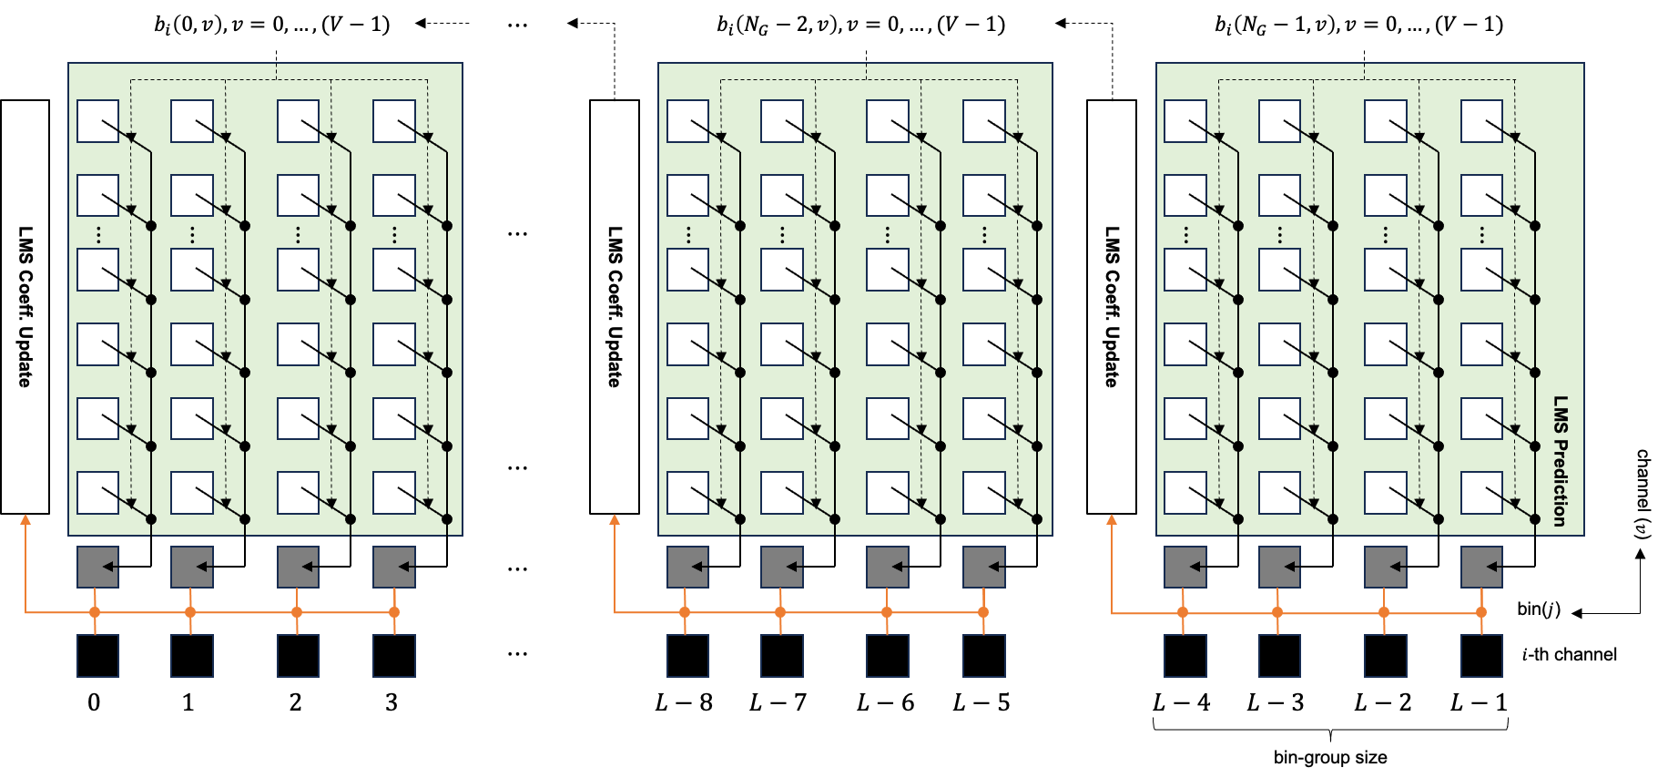
Figure 2. Group-wise IC-LMS
The prediction and coefficient update procedures of GIC-LMS can be mathematically formulated as follows.
Prediction: $k=(N_{G}-1), …, 1, 0$
$$P_{i}\left(j\right)= \sum_{v=0}^{V-1}{b_{i}\left(k,v\right)\tilde{X}\left(i-1-v,j\right),} j∈G_{k}$$
Coefficients update: $k=(N_{G}-1), …, 1, 0$
- Prediction residual: $D_{i}\left(j\right)= X\left(i,j\right)-P_{i}\left(j\right), j∈G_{k}$
- Quantization: ${\tilde{D}}_{i}\left(j\right)←D_{i}\left(j\right), j∈G_{k}$
- Reconstruction: $\tilde{X}\left(i,j\right)={\tilde{D}}_{i}\left(j\right)+P_{i}\left(j\right), j∈G_{k}$
- Group energy: $X_{i,energy}(k)=Σ_{j∈G_{k}}Σ_{v=0}^{V-1}{\left\{\tilde{X}\left(i-1-v,j\right)\right\}}^{2}$
- Group coefficients update:
$$b_{i}\left(k-1,v\right)←b_{i}\left(k,v\right)+\frac{1}{X_{i,energy}\left(k\right)}Σ_{j∈G_{k}}{\tilde{D}}_{i}\left(j\right)·\tilde{X}\left(i-1-v, j\right), j∈G_{k}$$
where $V$ is the number of prediction channels, $N_{G}$ is the number of bin groups, $G_{k}$ is the set of bin indices in the $k$-th bin group, and $b_{i}\left(k,v\right)$ is the inter-channel prediction coefficient for the $k$-th bin group and the $v$-th channel. $X\left(i,j\right)$ and $\tilde{X}\left(i,j\right)$ denote the input and reconstructed spectral bins, respectively, at the $i$-the channel and the $j$-th bin. $P_{i}\left(j\right),D_{i}\left(j\right)$, and ${\tilde{D}}_{i}\left(j\right)$ denote the predicted bin, the residual bin, and the reconstructed residual bin, respectively. As shown in the above equations, the inter-channel prediction coefficients, $b_{i}\left(k,v\right)$ are shared within the $k$-th bin group.

Performance evaluation
As the proposed GIC-LMS operates on a bin group basis, it introduces an implementation issue in the lossy mode and is not inherently applicable to the independent channel coding mode. Therefore, it has been applied only to the lossless joint channel coding mode. Moreover, AR-LMS, which constitutes the other part of the LMS prediction, is configured to operate only on the first channel and is disabled for the remaining channels by setting ‘lmsOrder’ parameter to zero. In this CE-2 evaluation, the bin group size was set to 4.
Table 1 summarizes the lossless performance of the proposed GIC-LMS over the BWC TM-5.0 CTC anchor [2] on the BWC datasets.
Table 1. Proposed GIC-LMS results over BWC TM-5.0 (joint channel coding)
 | Lossless Compression  (category-independent application) |  |  | Lossless Compression  (category-dependent application)
 | Over BWC-5.0 |  |  | Over BWC-5.0
 | BR-R | EncT | DecT | BR-R | EncT | DecT
 | BWC |  |  | BWC
MIT (ECG) | 0.01% | 103% | 98% | 0.00% | 101% | 100%
INCART (ECG) | 0.62% | 105% | 92% | 0.00% | 101% | 99%
CHBMIT (EEG) | -0.08% | 101% | 92% | -0.08% | 101% | 92%
NMR55 (EEG) | 0.02% | 102% | 99% | 0.02% | 102% | 99%
NMR57 (EEG) | -1.08% | 99% | 114% | -1.08% | 99% | 114%
TILT ILLUSION (EEG) | -0.03% | 98% | 102% | -0.03% | 98% | 102%
Ozdemir (EMG) | 0.00% | 103% | 99% | 0.00% | 100% | 100%
PTT (PPG) | 0.04% | 104% | 99% | 0.00% | 101% | 100%
WristPPG (PPG) | 0.13% | 96% | 100% | 0.00% | 94% | 97%
Average | -0.04% | 101% | 99% | -0.13% | 100% | 100%
Average (EEG only) | -0.29% | 100% | 102% | -0.29% | 100% | 102%
The left part of Table 1 shows the evaluation results when GIC-LMS is applied to all of categories. In these results, the application of GIC-LMS predictor achieves an overall average bit-rate reduction (BR-R) of -0.04%, with encoder and decoder computational complexities of 101% and 99%, respectively. Slight BR-R degradations are observed for the ECG, EMG, and PPG datasets, whereas the average BR-R is improved by 0.29% for the EEG datasets. In particular, a BR-R of -1.08% is achieved for the NMR57 dataset.
Based on these observations, the application of GIC-LMS can be differentiated according to the dataset category. Specifically, GIC-LMS is disabled for ECG, EMG, and PPG category, while it is enabled only for EEG category. The right part of Table 1 shows the lossless performance of GIC-LMS when its application is selectively controlled according to the dataset category. The application of GIC-LMS is controlled through ‘cgps_allow_groupwise_cc_lms_flag’ in the encoding configuration file for each category. When ‘cgps_allow_groupwise_cc_lms_flag’ is set to ‘0’, the existing IC-LMS is used instead of GIC-LMS. As shown on the right part of Table 1, BR-R values of 0% are obtained for the ECG, EMG, and PPG datasets by setting ‘cgps_allow_groupwise_cc_lms_flag’ to zero.
It is therefore more appropriate to apply GIC-LMS using a category-dependent configuration, which corresponds to applying GIC-LMS only to the EEG category.

Changes to the draft specification text
The allowance of the GIC-LMS tool is signalled for each sequence at the CGPS level through ‘cgps_allow_groupwise_cc_lms_flag’. In addition, a per-block GIC-LMS selection flag, ‘groupwise_cc_lms_flag’, is transmitted to the decoder. The ‘groupwise_cc_lms_flag’ is signalled using the equal-probability (EP) binary coder only when the LMS flag, ‘lms_flag’, is enabled.
The syntax and text changes to Draft 5 of the specification [3] are highlighted in yellow, as follows:

Syntax changes for 6.3.2.2 Channel group parameter set syntax:
channel_group_parameter_set( ) { | Descriptor
cgps_channel_group_parameter_set_id | u(8)
[omitted]
if( cgps_allow_lms_flag ) {
cgps_allow_lms_split_flag | u(1)
cgps_lms_ar_order_over_four | u(4)
cgps_allow_cc_lms_flag | u(1)
if( cgps_allow_cc_lms_flag ) {
cgps_max_order_cc_lms_minus_one | u(6)
cgps_allow_groupwise_cc_lms_flag | u(1)
}
}
cgps_ctx_init_flag | u(1)
trailing_bits( )
}

Syntax changes for 6.3.3.2.7 LMS data syntax:
lms_data( ch ) { | Descriptor
lms_flag | ae(ch)
if ( lms_flag ) {
if( cgps_allow_groupwise_cc_lms_flag && ch > 0 )
groupwise_cc_lms_flag | aep()
if( cgps_allow_lms_split_flag && (cgps_allow_cc_lms_flag && ch > 0
&& ( LastScanPos > ( 1 << ( Log2BlockSize –1 ) ) ) | | LastScanPos > ( 1 <<
( Log2BlockSize – 1 ) ) + 1 )
lms_split_flag | ae(ch)
if( cgps_lms_ar_order_over_four > 0 ) {
enable_ar_lms[ 0 ] | ae(ch)
if( lms_split_flag )
enable_ar_lms[ 1 ] | ae(ch)
}
if( cgps_allow_cc_lms_flag && ch > 0 ) {
enable_cc_lms[ 0 ] | ae(ch)
if( lms_split_flag )
enable_cc_lms[ 1 ] | ae(ch)
}
}
}

Text addition for 6.4.2.2 Channel group parameter set semantics:
cgps_allow_groupwise_cc_lms_flag equal to 1 specifies that the group-wise cross-channel prediction mode is allowed.

Text addition for 6.4.3.2.7 LMS data semantics:
groupwise_cc_lms_flag equal to 1 indicates that the group-wise inter-channel least mean squares prediction is used for DCT coefficients. The entire DCT coefficients is split into multiple groups containing an uniform number of DCT coefficients, and the prediction and update process are performed on a group basis. The prediction coefficients are shared within each DCT coefficient-group.

Text addition for 7.5 Backward adaptive prediction:
The backward adaptive prediction is based on a normalized least means squared (NLMS) prediction algorithm that operates in the DCT domain and provides both intra-channel and inter-channel prediction. For intra-channel prediction, the NMLS prediction algorithm operates in the negative frequency, that is higher frequencies are used to predict lower frequencies. The intra-channel prediction and inter-channel prediction can be enabled independently through the syntax elements enable_ar_lms and enable_cc_lms, respectively. Furthermore, the DCT spectrum can be split into two equal parts with the syntax element lms_split_flag. In the case that the lms_split_flag syntax element is enabled, the intra-channel and inter-channel prediction can be controlled independently, and there are two syntax elements for both enable_ar_lms and enable_cc_lms, see clause6.3.3.2.7. The prediction coefficients and buffer states for both the intra-channel and inter-channel prediction shall be reset every frame. Furthermore, if bitstream lms_split_flag is enabled, the prediction coefficient and buffer states are reset for both halves of the DCT spectrum.
Furthemore, the group-wise inter-channel prediction can be enabled through the syntax element groupwise_cc_lms_flag. For group-wise inter-channel prediction, the reconstructed frequency groups in the previous channels are used to predict the frequency group in the current channel using prediction coefficients shared within the frequency group.
The DC term shall not be predicted if the syntax element lms_split_flag is disabled, however, the DC term shall be predicted if the syntax element lms_split_flag is enabled.
The NLMS update step is dependent on the DCT data bit-depth as specified in clause 7.4.1
Inputs to this process:
- A flag specifying if the LMS prediction is split ( lms_split_flag ) ( see clause 6.4.3.2.7 )
- An array of two flags enabling the LMS across frequency ( enable_ar_lms[ 0 ] and enable_ar_lms[ 1 ] ) ( see clause 6.4.3.2.7)
- An array of two flags enabling the LMS across channels ( enable_cc_lms[ 0 ] and enable_cc_lms[ 1 ] ) ( see clause 6.4.3.2.7 )
- A flag specifying enabling the group-wise inter-channel LMS (groupwise_cc_lms_flag) ( see clause 6.4.3.2.7 )
- A variable specifying the length of the transform ( blockLength )
- A variable specifying the bit depth of the transform data ( signalBitDepth ) ( see clause 7.4.1 )
- A variable specifying the quantizer parameter for the current channel ( CurrBlockQP[ ch ] ) ( see clause 7.4.1 )
- An array of transform data for the previous channels ( signal[ c ][ n ], with c = 0…Ch – 1 and n = 0...blockLength − 1 )
- An array of transform domain residual data ( resData[ n ], with n = 0.. blockLength − 1 )
Outputs to this process:
- An array of transform data for the current channel ( chanData[ Ch ][ n ], with n = 0...blockLength −1 )

Text addition for 9.5 Backward adaptive prediction in the encoder:
The backward adaptive prediction in the encoder is very similar to the decoder backward adaptive predictive structure found in clause 7.5. While the core normalized least-mean squares ( NLMS ) algorithm is normatively specified, the selection of the values of the control parameters (lms_split_flag, enable_ar_lms[ 0 ], enable_cc_lms[ 0 ], enable_ar_lms[ 1 ], enable_cc_lms[ 1 ], groupwise_cc_lms_flag), and the quantization process are up to the encoder implementation and not normatively specified.
The function qntIndex, tCoeff = GetQuantInvQuant(origIndex, currState) invokes the quantization process from clause 9.9 with origIndex set to the input origIndex, qState set to currState, qntIndex set to the output qntIndex and tCoeff set to the output tCoeff.
Inputs to this process are:
- A flag specifying if the LMS prediction is split ( lms_split_flag ) ( see clause 6.4.3.2.7 )
- An array of 2 flags enabling the LMS across frequency ( enable_ar_lms[ 0 ] and enable_ar_lms[ 1 ] ) ( see clause 6.4.3.2.7 )
- An array of 2 flags enabling the LMS across channels ( enable_cc_lms[ 0 ] and enable_cc_lms[ 1 ] ) ( see clause 6.4.3.2.7 )
- A flag specifying enabling the group-wise inter-channel LMS (groupwise_cc_lms_flag) ( see clause 6.4.3.2.7 )
- A variable specifying the length of the transform ( blockLength )
- A variable specifying the bit depth of the transform data ( signalBitDepth ) ( see clause 7.4.1 )
- A variable specifying the quantizer parameter for the current channel ( CurrBlockQP[ Ch ] ) ( see clause 7.4.1 )
- An array of transform data for the previous channels and the current channel (chanData[ c ][ n ], with c = 0…Ch and n = 0...blockLength − 1)
Output to this process is:
An array of transform domain residual data ( resData[ n ], with n = 0.. blockLength – 1 )

As shown in the above syntax and text changes, the specification changes required to adopt the GIC-LMS tool are minimal.

Conclusion
An evaluation of the proposed GIC-LMS was performed under CE-2 in the lossless joint channel coding mode, and its effectiveness was demonstrated by achieving an average BR-R improvement of -0.29% over TM-5.0 for the EEG datasets. In particular, a BR-R improvement of -1.08% was achieved for the NMR57 dataset. In terms of computational complexity, only negligible additional encoding and decoding time was introduced compared to TM-5.0.
From the signalling perspective, only minimal syntax changes are required, consisting of the introduction of a 1-bit flag indicating whether GIC-LMS is selected.
Based on the demonstrated coding gains and the minimal impact on the specification text and source code, we propose that GIC-LMS be adopted in the next version of H.BWC.

Patent rights declaration(s)
ETRI may have current or pending patent rights relating to the technology described in this contribution and, conditioned on reciprocity, is prepared to grant licenses under reasonable and non-discriminatory terms as necessary for implementation of the resulting ITU-T Recommendation ISO/IEC International Standard (per box 2 of the ITU-T/ITU-R/ISO/IEC patent statement and licensing declaration form).

References
- B. Jo et. al., “CE proposal on group-wise inter-channel LMS with residual-triggered adaptation for lossless EEG coding,” Teleconference, January 2026. https://www.itu.int/wftp3/av-arch/video-site/2601_Tel/VCEG-BZ21-GroupwiseInterChannelLMS-v2_clean.docx
- J. Pfaff et. al., “Common test conditions and evaluation procedures for H.BWC (planned T.261) technical experiments,” Teleconference, January 2026. https://www.itu.int/wftp3/av-arch/video-site/2601_Tel/VCEG-BZ27-CTC-Output-v1-CTC-v1.docx
- J. Pfaff et. al., “H.BWC (planned T.261) Draft 5 Specification Text,” Teleconference, January 2026.

