ITU – Telecommunications Standardization Sector  STUDY GROUP 21 Question 6  Video Coding Experts Group (VCEG)  77th Meeting: 26 June – 4 July 2025, Daejeon, KR | Document VCEG-BY15-v1

Question: | 6/21 (VCEG)
Source: | Telefon AB – LM Ericsson | Email: | lukasz.litwic@ericsson.com  anders.furuskar@ericsson.com
Title: | On requirements for next generation video coding standard
Purpose: | Information

Abstract

Video traffic constitutes over 70% of all traffic in mobile networks and its share is increasing. This contribution presents an analysis of how video compression performance gains (bitrate reduction) impact efficiency of modern mobile network systems. The analysis is based on cell edge user throughput and its impact on total traffic in a cell. Different video compression gains scenarios are simulated for downlink and uplink traffic, including low-latency conditions. Our results show that improvements to video compression performance may yield capacity gains on top of increased capacity resulting directly from more efficient source coding. These gains vary between different scenarios and operating points. Significant capacity gains can be achieved when reducing video bitrates in uplink or low latency video traffic.

Introduction
Over the last 10 years the growth of video traffic in mobile networks has been a known phenomenon. Data reported in Ericsson’s Mobility Report in June 2024 [1] and shown in Figure 1 shows that video traffic grew at a rate of 57% CAGR between 2014 and 2024. In 2024 video traffic in mobile networks reached an estimated 97 exabytes per month and the total share of all traffic was estimated at 74%. Video coding developments on the other hand have historically allowed for video bitrate reduction of 50% while maintaining the same quality every 10 years. This means growth of video traffic has outpaced significantly the efficiency gains achieved with video codecs. At the same time, the goal of 50% bitrate reduction for next generation video coding standard has been challenged. This contribution attempts to indicate the relationship between the reduction of video bitrates due to more efficient video compression and its impact on efficiency of modern mobile network systems.
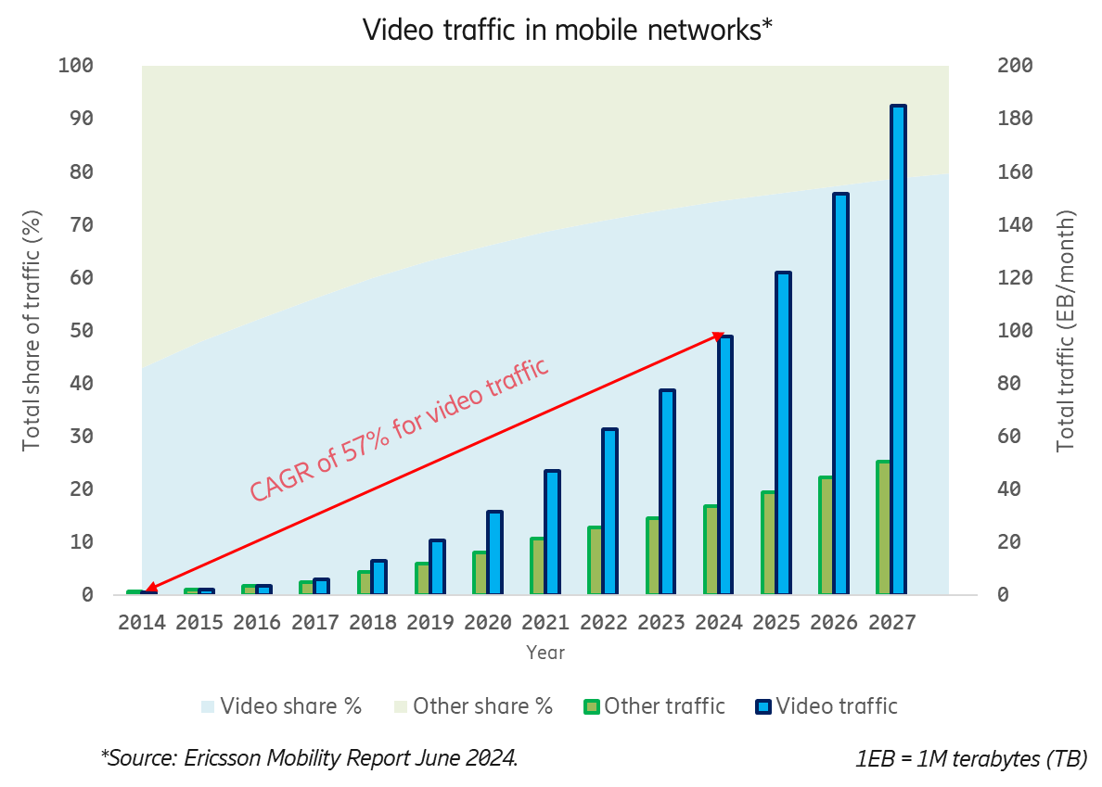
Figure 1 Video traffic in mobile networks based on Ericsson’s Mobility Report [1].

Mobile network system simulation

The analysis presented in this contribution is based on simulations of a file download and upload traffic and the resulting user throughput in a mobile network system. Performance is measured as cell edge user throughput as a function of the traffic that can be served per cell in a mobile network. User throughput is a measure of how fast files are down- or uploaded and includes effects of the users’ position in a cell, interference from neighboring cells, and queuing behind other users. Cell edge is defined as the 5th percentile of user distribution, which means that 95% of users in a cell achieve better performance, e.g. due to better signal quality. The use of cell-edge user throughput is common, and motivated by that, overall user satisfaction may be determined by quality of experience at the edge of the cell, and thus such an analysis is important in network planning and management.

Simulations were performed for an ITU Urban Macro scenario with 1km inter-site distance, which models base station deployments, user locations, and radio propagation in dense urban areas including conditions such as large fraction of indoor users or high-loss buildings.

Figure 2 shows the relationship between cell-edge user throughput and overall traffic per cell for both uplink and downlink traffic. Simulations were performed for a set of frequency bands in the range 0.7 – 3.5 GHz. It is important to note that while data is representative of a modern wireless system (such as a 5G system) in general, specific profiles may differ from cell to cell or between operators. Therefore, in our analysis we don’t aim to point to exact targets for video compression, but we seek to establish overall trends and derive potential impacts for a next generation video coding standard.

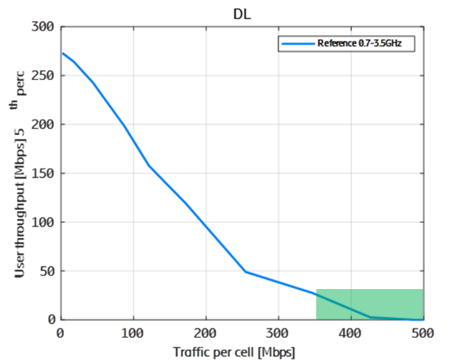 | 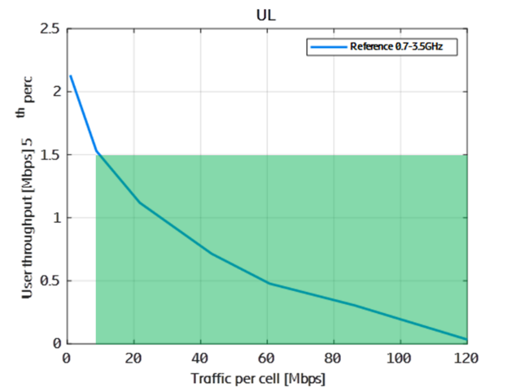
Figure 2 Simulated relationships between user throughput (y-axis) and total traffic per cell (x-axis) for downlink (DL) and uplink (UL) traffic. Simulations performed at the 5th percentile of users’ distribution.
The plots show the relationship between cell-edge user throughput and total traffic per cell. The relationship shows that when traffic increases the user throughput decreases. This is because with higher traffic, the probability of having to queue behind other users in your own cell as well as the probability of being interfered by users in neighbor cells increase. Alternatively, to understand the capacity impact of the video compression performance, if a user can get acceptable video quality for a lower user throughput, it can tolerate more queuing and interference, and hence the network can serve more traffic. As an example, in the uplink diagram to the right, the blue curve shows that if average user throughput at the edge of the cell requires 1.5 Mbit/s, the total available traffic in the cell can be no larger than 10 Mbit/s. On the other hand, when user throughput at the edge of the cell requires 0.5 Mbit/s, we can have a total of 60 Mbit/s. Hence, by decreasing the throughput for a user at the cell edge by a factor of three, total traffic per cell can increase by a factor of six. This non-linear behavior means that bit rates are not a zero-sum game.

The highlighted area (in green) represents the choice of operating range where we performed the analysis. This selection is discussed separately for the downlink and uplink case in respective sections of the document.

Video compression performance impact on downlink traffic

Downlink traffic represents all data sent to users and is representative of most video traffic in today’s networks such as video streaming. Typically, video streaming is not latency sensitive and on the encode side it allows for use of relatively complex encoder implementations which overall allows for most efficient compression to be achieved.

Based on data in Figure 2 we simulated the impact of different levels of video compression performance gains (bitrate reduction for the same quality): 15%, 33% and 50%. This was done by selecting an operating point typical for video streaming applications (0-30 Mbit/s) and sampling the data from Figure 2 according to selected video compression performance gains. We sampled data for 3 different operating points: anchor video at 30 Mbit/s, 10 Mbit/s and 4 Mbit/s. The last operating point is representative of mobile streaming bitrates with HD video quality (720p or 1080p). 30 Mbit/s and 10 Mbit/s represent operating points which may be relevant for Ultra HD or Immersive (VR/stereoscopic) video streaming to devices that could be connected to mobile network via FWA (Fixed Wireless Access).

Figure 3 shows how video compression performance gain results in an increase in the number of served users in a cell. Data is shown for 3 chosen operating points described above as well as a baseline result based exclusively on video compression (source coding) gain (dashed grey line). The baseline results are calculated by taking the nominal performance gains (bitrate reduction), i.e., 15% 33% and 50% and translating into increase in users such that 50% bitrate reduction equated 2x increase in served users.

We observe an additional increase in the number of users that is above the baseline provided by source coding, and we refer to this as capacity gain. Stated another way, if we improved compression efficiency so that the bit rate could be halved, we would expect a doubling of the number of users we can have in the cell. However, because of the zero-sum characteristics described in Figure 1, we can get more than a doubling. If we start with a 30 Mbit/s video bit rate, a 50% compression performance gain will yield a ~14% capacity gain which results in an increase in served users by a factor of 2x1.14 = ~2.3. Hence, in this case, the nonlinearity of the situation means that we get a boost from a mere doubling (2.0) to an increase of 2.3. For lower operating points, such as 10 Mbit/s, this capacity gain reduced to about ~5%. Furthermore, smaller improvements in compression efficiency give a smaller boost. For instance, for the 30 Mbit/s case, at 33% compression performance gain, we measure ~10% capacity gain in addition to reference capacity increase. From our results we see that capacity gain increases with video compression gain and is higher for 30 Mbit/s than for lower operating points.

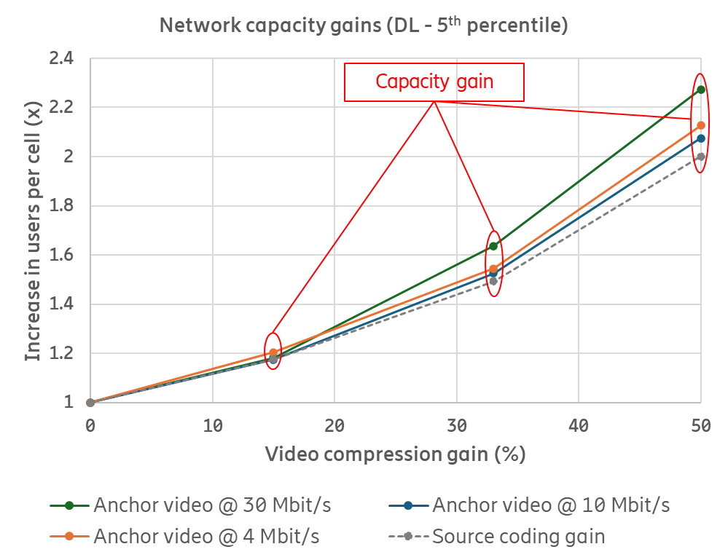
Figure 3 Network capacity gains calculated as function of video compression gains (bitrate reduction). Results are presented for the downlink (DL) scenario and three operating points: 30 Mbit/s, 10 Mbit/s and 4 Mbit/s.
In Figure 4 we have added one data point from simulations representing low latency downlink conditions such as cloud video gaming service delivered at an end-to-end latency of 100ms. This data point represents a bit rate saving of 50% for an operating point of 10 Mbit/s and results in capacity gain of 33% giving an overall increase of users per cell by a factor of 2.6.

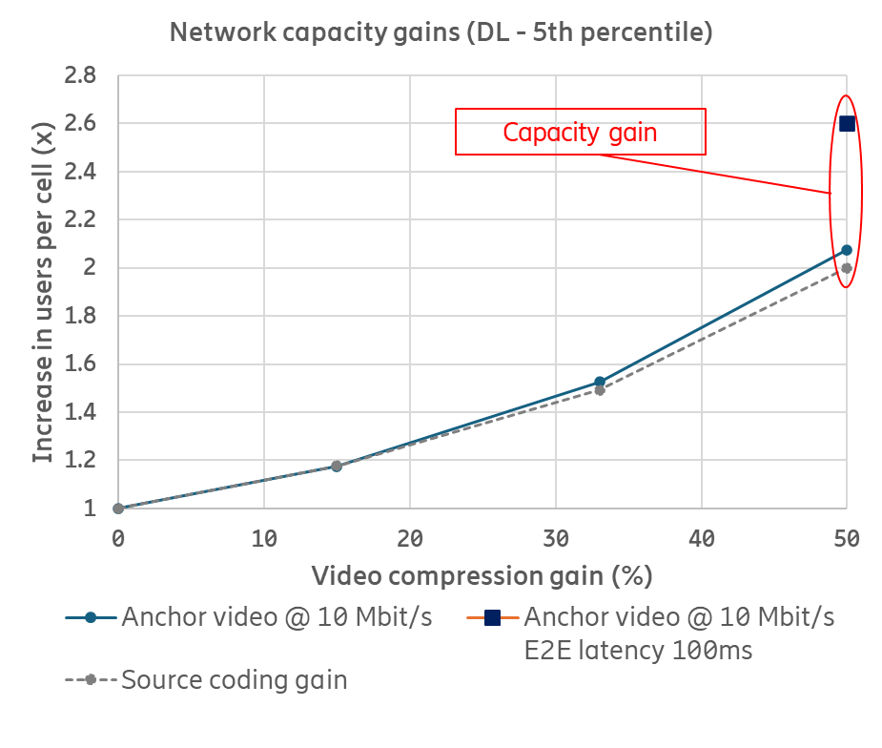
Figure 4 Network capacity gains calculated as function of video compression gains (bitrate reduction). Results are presented for a downlink (DL) scenario at an operating point of 10 Mbit/s at unconstrained and low latency conditions (one data point at 50% video compression gain).
Such a significant increase in capacity for low-delay conditions stems from the fact that the operating point is shifted to a case for which the capacity dependency on bitrate is even stronger.

Video compression performance impact on uplink traffic

We performed the same analysis for uplink traffic. There is a significant difference in downlink and uplink performance which results in overall lower bitrates being available for uplink traffic. For a cell edge user, the operating range is below 2 Mbit/s which limits the range of services deployed. Historically, most video traffic on mobile networks (such as via video streaming services) has been via downlink with very limited need for the use of uplink. However, an increasing number of use cases make use of uplink video traffic. Such applications include video communication, video content upload, autonomous driving or AI assistants.

For our analysis we chose two operating points, one at 1.5 Mbit/s and another at 1.0 Mbit/s. Based on data shown in Figure 2 we observe that the curve becomes quite steep for higher user throughput and any improvement in video compression efficiency would results in dramatic improvements to system capacity. However, such results must be taken with a grain of salt, since simulation assumptions such as operating range and how close we are to the performance limit of the system, may not be realized for an average user in a real-life deployment.

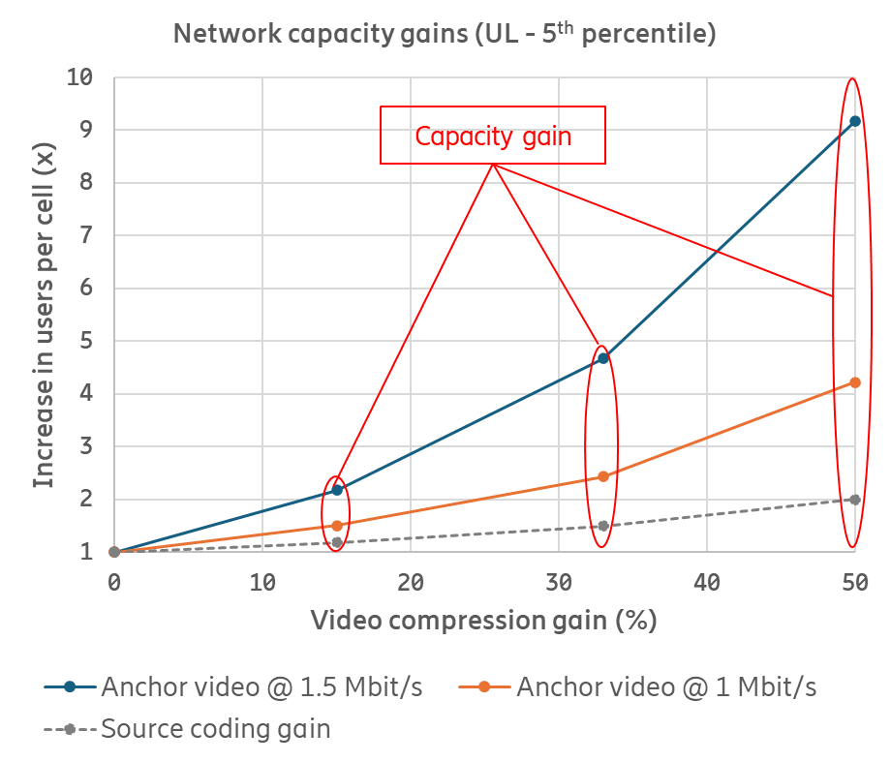
Figure 5 Network capacity gains calculated as function of video compression gains (bitrate reduction). Results are presented for a downlink (DL) scenario at an operating point of 10 Mbit/s at unconstrained and low latency conditions (one data point at 50% video compression gain).
Still, if we use the data from Figure 1, we arrive at results, shown in Figure 5, we see that any video compression performance improvement that reduce average user throughput required provides a substantial capacity gain over the nominal gain corresponding to more efficient source coding. For example, for a video anchor operating at 1 Mbit/s, a bitrate reduction of 15% results in capacity gain of 27%, and a bitrate reduction of 33% (i.e., down to 660 kbit/s) results in capacity gain of 62%.

Impacts for next generation video coding standard

Based on the above analysis we see potential impacts for next generation video coding standard in the following aspects of video traffic in modern mobile network systems:
- Video compression improves the overall performance of mobile networks.
- Reducing the average video bitrate for a user may contribute to capacity gains in the network. Those gains may depend on several factors including type of traffic (downlink/uplink), latency, operating point as well as reduction due to video compression gains.
- For low latency downlink traffic, capacity gains increase compared with unconstrained latency. Data shown in our analysis is limited to one data point for video streaming at 10 Mbit/s reduced to 5 Mbit/s. In this example, such a bitrate reduction results in capacity gain of 33%. This is an increase from around 4% capacity gain for streaming with unconstrained latency.
- For uplink video traffic, the operating range for cell edge users is 1.5 Mbit/s or lower. Video compression performance gain has a very positive impact and results in significant capacity gain, e.g., 66% capacity gain on top of source coding gain when reducing average video bitrate from 1 Mbit/s to 660 kbit/s.

From a video coding system design perspective, we recognize that some of the use cases which would benefit the most from improved video compression performance, such as low latency streaming or video services using an uplink channel, do not always have access to extensive encoding resources. This can be due to limited form factor, such as encoding on a mobile device, or due to a deployment model which is one-to-one, such as in a cloud gaming service, in contrast with one-to-many used in video streaming where a higher cost of encoding could be justified.

In summary, we recommend that the next video coding standard should aim to provide video compression gains which can be realized across different scenarios and bitrate ranges, with the emphasis on allowing compression gains also for low latency video transmission and with a constrained encoder complexity which can be justified by small form factor devices as well as economically feasible in one-to-one deployments.

We note that the analysis presents a view from a mobile network and video coding system perspective while service deployment spans a whole ecosystem of content and service providers, operators and end-user devices. Therefore, any commercial implications of the above analysis may be highly influenced by several factors not included in this analysis.

References

Ericsson Mobility Report, June 2024, available at https://www.ericsson.com/en/reports-and-papers/mobility-report/reports.

