ITU – Telecommunications Standardization Sector  STUDY GROUP 21 Question 6  Video Coding Experts Group (VCEG)  77th Meeting: 26 June – 4 July 2025, Daejeon, KR | Document VCEG-BY14-v1

Question: | 6/21 (VCEG)
Source: | Sam Jelfs, Tsvetomira Tsoneva, Werner Oomen (Philips) | Email: | sam.jelfs@philips.com
Title: | CE Proposal on signalling compression artefacts
Purpose: | Proposal
_____________________________

Abstract
For widespread adoption of the standard in the healthcare domain it is important that the clinicians have confidence in the output of any lossy compression, and that they can reliably detect what is a true signal artefact, an artefact introduced by poor signal capture, and an artefact introduced by the compression. This document proposes a new CE on the inclusion of signal quality metrics in the bitstream format, allowing for the detection and reporting of artefacts introduced during compression.

Problem statement
Lossy compression can introduce artefacts to the signals that may potentially resemble or, alternatively, mask clinically relevant features. It is critical that the clinicians reviewing the decoded signals can reliably distinguish what is a relevant feature from what is an artefact introduced during data collection or during compression.
When decoding the bitstream, the absolute quality of the reconstruction cannot be known. Some indications may be given based on the encoder settings that are carried in the bitstream, but on an absolute level the decoder does not know what the quality of the signal reconstruction is. Conversely, the encoder can estimate what the expected quality is for any given time point.
Figure 1 shows the 1-second rolling average PSNR1 for one recording in the ‘incartdb’ dataset. In the upper subplot, encoding with a step size of 1.125 results in PSNR1 values ranging from 107 dB to 131 dB, or is otherwise lossless. In the lower subplot, at the most lossy encoding with a step size of 22, this variation is between 79 dB and 89 dB. In both cases, the overall PSNR (of either 118 dB at step size of 1.25 or 82 dB at step size 22) is not representative of the actual reconstruction quality for the entire duration of the recording. This temporal variation in reconstruction error can be important for the diagnostic suitability of the recording and can significantly impact the diagnostic reliability of the recording.
The H.BWC syntax specification contains an annotation channel per waveform parameter set, intended for carrying annotations added during data collection. This annotation channel can be extended to also include metrics such as a rolling windowed PSNR calculation, or other clinically accepted quality metric. Incorporating such metrics would enhance the interpretability of the encoded data with minimal impact on overall bitrate, thereby adding valuable functionality to the bitstream syntax.

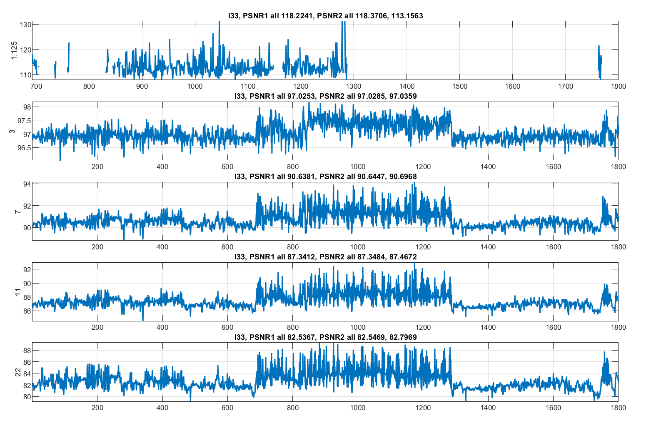
Figure 1 Plots for recording I33 from the 'incartdb' dataset, showing 1 second (256 samples) rolling average PSNR1

Conclusion
We propose a new CE to be started at this meeting regarding the inclusion of additional metadata to enable the decoder to know what the introduced error due to compression is. This can be a valuable metric to ensure that clinicians have confidence in the standard and in the diagnostic value of the lossy-compressed signals.

Patent rights declaration(s)
Philips may have current or pending patent rights relating to the technology described in this contribution and, conditioned on reciprocity, is prepared to grant licenses under reasonable and non-discriminatory terms as necessary for implementation of the resulting ITU-T Recommendation | ISO/IEC International Standard (per box 2 of the ITU-T/ITU-R/ISO/IEC patent statement and licensing declaration form).

________________________

