|  |  |
| --- | --- |
| **ITU – Telecommunications Standardization Sector**  STUDY GROUP 21 Question 6  **Video Coding Experts Group (VCEG)**  77th Meeting: 26 June – 4 July 2025, Daejeon, Korea | Document VCEG-BY13-v1 |

|  |  |  |  |
| --- | --- | --- | --- |
| Question: | 6/21 (VCEG) | | |
| Source: | **Heiner Kirchhoffer, Jonathan Pfaff, Tung Nguyen, Sophie Pientka, Paul Haase, Heiko Schwarz,** **Detlev Marpe, Thomas Wiegand (Fraunhofer HHI)**  **Christof Fersch, Janusz Klejsa, Heidi-Maria Lehtonen, Harald Mundt, Panji Setiawan, Mark Vinton (Dolby Laboratories)** | Email: | [heiner.kirchhoffer@hhi.fraunhofer.de](mailto:heiner.kirchhoffer@hhi.fraunhofer.de),   [heidi-maria.lehtonen@dolby.com](mailto:heidi-maria.lehtonen@dolby.com) |
| Title: | **Harmonization of quantization methods in H.BWC** | | |
| Purpose: | Proposal | | |

_____________________________

# Abstract

In BWC-2.1, there are two different mapping rules to derive a quantization step size. Each of the mapping rule is associated with a syntax element that controls the resulting step size. The two syntax elements are cgps_indep_init_block_qp and cgps_global_gain. It is proposed to remove the mapping rule associated with cgps_indep_init_block_qp and replace it with the mapping rule of cgps_global_gain. Experimental results show that the Rate-Distortion performance is almost the same.

# Proposed harmonization of quantization methods

The two syntax elements cgps_global_gain and cgps_indep_init_block_qp both correspond to quantization parameters that are associated with corresponding mapping rules for deriving a quantization step size from the quantization parameter.

It is proposed to replace the two syntax elements cgps_global_gain and cgps_indep_init_block_qp by a new syntax element cgps_qp that is signaled as a 10 bit unsigned integer. For the quantization method associated with cgps_global_gain, it is sufficient to replace all occurrences of cgps_global_gain with cgps_qp in the current draft specification. I.e., the behavior of the quantization method associated with cgps_global_gain is unchanged.

The quantization method associated with cgps_indep_init_block_qp is replaced with one that corresponds to the quantization method associated with cgps_global_gain. The following changes to the current draft specification are proposed to accomplish this:

**Clause 7.3.2.2 in the current draft specification:**

|  |  |
| --- | --- |
| **~~cgps_indep_init_block_qp~~ cgps_qp** | u(~~8~~ 10) |
| cgps_ctx_init_flag | u(1) |
| ~~cgps_global_gain~~ | ~~u(10)~~ |

**Clause 7.3.2.3 in the current draft specification:**

|  |  |
| --- | --- |
| for( i = 0; i < NumChannels[ if_channel_group_id ]; i++ ) { |  |
| CurrBlockQP[ i ] = ~~cgps_indep_init_block_qp~~ cgps_qp |  |

**Clause 7.3.3.3.1 in the current draft specification:**

|  |  |
| --- | --- |
| CurrBlockQP[ ch ] =  Clip3( 0, ~~255~~ 1023, CurrBlockQP[ ch ] + blockDeltaQP ) |  |

**Clause 7.4.3.2 in the current draft specification:**

**~~cgps_indep_init_block_qp~~ cgps_qp** specifies the initial quantization parameter.

**Clause 8.6.1 in the current draft specification is replaced with:**

Output of this process are the intermediate reconstructed residual transform coefficients tCoeff[ i ] with 0 <= i < (1 << Log2BlockSize).

The variable leftShiftTrigTrafo is set to be equal to 32 – BitDepthMax – dct_headroom[ Log2BlockSize ].

The variable maxCoeffVal is set to be equal to (1<<31) – 1 and the variable minCoeffVal is set to be equal to – maxCoeffCal – 1.

The values of the variables qScale and qShift are determined as follows:

* qScale = inv_quant_scale[ CurrBlockQP[ch] & 31 ]  
  qShift = 29 – ( CurrBlockQP[ch] >> 5 )  
  if( qShift < 0 ) {  
   qScale <<= –qShift  
   qScale = min( qScale, ( 1 << 31 ) – 1 )  
   qShift = 0  
  }  
  downShift = qShift – 8  
  if( downShift > 0 ) {  
   addRound = 1 << (downShift – 1 )  
   qScale = ( qScale + addRound ) >> downShift  
   qShift = 8  
  }

The reconstructed residual transform coefficients tCoeff[ i ] with 0 <= i < ( 1 << Log2BlockSize ) are derived as follows:

* If transform_skip_flag is equal is equal to 1, the following applies:
  + If qShift > 0,
  + addRound = 1 << ( qShift – 1 )
  + tCoeff[ i ] = QuantIndices[ i ] * qScale +  
     ( QuantIndices[ i ] < 0 ? addRound – 1 : addRound ) >> qShift
  + tCoeff[ i ] = Clip3( minCoeffVal, maxCoeffVal, tCoeff[ i ] )
  + Otherwise, (qShift <= 0),
  + tCoeff[ i ] = Clip3( minCoeffVal, maxCoeffVal, tCoeff[ i ] * ( qScale << –qShift) )
  + Otherwise (transform_skip_flag is not equal to 1) the following applies:
  + The variable qShift is modified to qShift – leftShiftTrigTrafo + 1.
  + The variable tCoeff [ i ] is determined by the following pseudo-code process:  
    if( qShift > 0 ) {  
     offset = 1 << ( qShift – 1 )
  + nextState = 0  
     for( i = last_scan_pos, i >= 0 , i = i – 1 ) {  
     if( QuantIndices[ i ] != 0 ) {  
     valCurr = ( Abs( QuantIndices[ i ] ) << 1) – ( nextState & 1 ) ) * qScale )  
     valCurr = ( valCurr + offset ) >> qShift  
     tCoeff[ i ] = QuantIndices[ i ] < 0 ? Max( minCoeffVal, –valCurr ) :  
     Min( maxCoeffVal, valCurr )  
     }  
     else  
     {  
     tCoeff[ i ] = 0  
     }  
     nextState = QStateTransTabel[ nextState ][ QuantIndices[ i ] & 1 ]  
     }  
    } else {  
     nextState = 0  
     for( i = last_scan_pos, i >= 0 , i = i – 1 ) {  
     if( QuantIndices[ i ] != 0 ) {  
     offsetCurr = ( QuantIndices[ i ] < 0 ) ? nextState & 1 : – ( nextState & 1 )  
     valCurr =(QuantIndices[ i ] << 1) + offsetCurr ) * qScale   
     tCoeff[ i ] = Clip3( minCoeffVal, maxCoeffVal, valCurr )  
     }  
     else  
     {  
     tCoeff[ i ] = 0  
     }  
     nextState = QStateTransTabel[ nextState ][ QuantIndices[ i ] & 1 ]  
     }  
    }

**Clause 9.4.2.2 in the current draft specification:**

currQP = ~~cgps_indep_init_block_qp~~ ( cgps_qp >> 2 ) − qpPosProb0

# Experimental results

The proposed changes have been implemented on top of the main branch of the BWC software repository, after merge request MR#21 has been merged. During the time of writing this document, it was the most recent version of the main branch and compared to tag BWC-2.1, it contains overflow fixes for the transform. This version is used as the reference and it is denoted "main_after_MR21" in the experimental results.

Note that support for the DST transform has not been implemented for the proposed method. Therefore, all simulations have been conducted with DST transform switched off (for anchor and test). This only affects ECG signals.

New context model initialization values have been calculated because the context model initialization is now based on cgps_qp >> 2 instead of cgps_indep_init_block_qp.

The full results and RD-charts can be found in the acompanying Excel and PDF files.

## Summary of results

The proposed method is denoted "QP_harmonization_new_inits" in the experimental results.

### Joint channel coding results

Reference: main_after_MR21, Test: QP_harmonization_new_inits

|  |  |  |  |  |
| --- | --- | --- | --- | --- |
|  | **Lossy Compression** | | | |
|  | **Over main_after_MR21** | | | |
|  | BD-PSNR1 | BD-PSNR2 | EncT | DecT |
| MIT (ECG) | -0.41% | -0.42% | 102% | 99% |
| INCART (ECG) | -0.02% | 0.04% | 100% | 100% |
| CHBMIT (EEG) | -0.01% | -0.01% | 98% | 99% |
| NMR55 (EEG) | 0.10% | -0.04% | 99% | 100% |
| NMR57 (EEG) | 0.24% | 0.24% | 102% | 98% |
| Ozdemir (EMG) | 0.00% | 0.00% | 100% | 99% |
| **Overall** | -0.02% | -0.03% | 100% | 99% |

### Independent channel coding results

Reference: main_after_MR21, Test: QP_harmonization_new_inits

|  |  |  |  |  |
| --- | --- | --- | --- | --- |
|  | **Lossy Compression** | | | |
|  | **Over main_after_MR21** | | | |
|  | BD-PSNR1 | BD-PSNR2 | EncT | DecT |
| MIT (ECG) | -0.47% | -0.48% | 102% | 100% |
| INCART (ECG) | -0.12% | -0.05% | 100% | 100% |
| CHBMIT (EEG) | 0.48% | 0.47% | 101% | 100% |
| NMR55 (EEG) | 0.47% | 0.53% | 100% | 101% |
| NMR57 (EEG) | 0.27% | 0.30% | 100% | 99% |
| Ozdemir (EMG) | -0.02% | -0.02% | 100% | 99% |
| **Overall** | 0.10% | 0.12% | 100% | 100% |

## Context initialization impact

To show the impact of the context model initialization, a further test run has been conducted where cgps_qp is converted to cgps_indep_init_block_qp so that both values correspond to the same quantizer step size. This test is denoted "QP_harmonization_old_inits" in the experimental results and it uses the same context model initialization values as "main_after_MR21".

### Joint channel coding results

Reference: QP_harmonization_old_inits, Test: QP_harmonization_new_inits

|  |  |  |  |  |
| --- | --- | --- | --- | --- |
|  | **Lossy Compression** | | | |
|  | **Over QP_harmonization_old_inits** | | | |
|  | BD-PSNR1 | BD-PSNR2 | EncT | DecT |
| MIT (ECG) | -0.12% | -0.12% | 101% | 99% |
| INCART (ECG) | -0.15% | -0.15% | 100% | 99% |
| CHBMIT (EEG) | -0.07% | -0.07% | 100% | 99% |
| NMR55 (EEG) | 0.00% | 0.10% | 100% | 100% |
| NMR57 (EEG) | -0.02% | -0.02% | 101% | 99% |
| Ozdemir (EMG) | -0.01% | -0.01% | 100% | 99% |
| **Overall** | -0.06% | -0.04% | 100% | 99% |

### Independent channel coding results

Reference: QP_harmonization_old_inits, Test: QP_harmonization_new_inits

|  |  |  |  |  |
| --- | --- | --- | --- | --- |
|  | **Lossy Compression** | | | |
|  | **Over QP_harmonization_old_inits** | | | |
|  | BD-PSNR1 | BD-PSNR2 | EncT | DecT |
| MIT (ECG) | -0.15% | -0.15% | 101% | 99% |
| INCART (ECG) | -0.10% | -0.11% | 100% | 98% |
| CHBMIT (EEG) | 0.02% | 0.02% | 101% | 98% |
| NMR55 (EEG) | 0.00% | -0.01% | 100% | 99% |
| NMR57 (EEG) | 0.07% | 0.07% | 100% | 97% |
| Ozdemir (EMG) | -0.03% | -0.03% | 100% | 99% |
| **Overall** | -0.03% | -0.03% | 100% | 98% |

## Observed misleading behavior of BD-PSNR

For some sequences, the proposed method shows a BD-PSNR loss which is unexpected. However, if looking at the BD-plots, it can be seen that often only the RD point with the highest PSNR differs for the proposed method and the reference. The following chart illustrates this behavior:

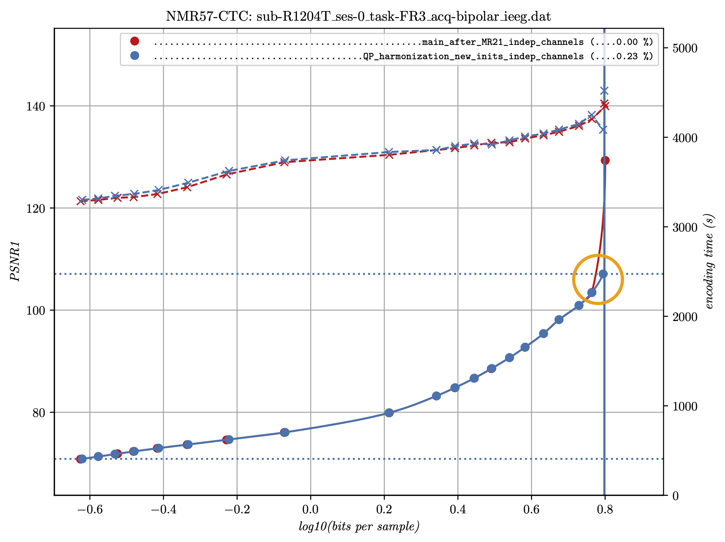

Note that the horizontal axis is logarithmic and the interpolation between RD points is done in the same way as it is done for BD PSNR calculation. Printed in this way, the area between the two curves is proportional to the BD PSNR value. The dotted horizontal blue lines shows the minimum and maximum value vor BD PSNR calculation (i.e., the area where both curves have PSNR values).

As can be seen from the chart, only the highest lossy point for the reference and the proposed method noticably contribute to the BD PSNR (see the orange circle).

This behavior can be explained as follows. The lossy RD point with the hightest PSNR uses a different encoder control for the reference and the proposed method. The encoder of the reference uses a value of 0 for cgps_global_gain (which corresponds to lossless) while cgps_indep_init_block_qp is set to a value greater than 0 (which corresponds to lossy). Consequently, the modes that use cgps_global_gain are encoded losslessly while others are coded lossily. This results in a particularly high PSNR value.

In contrast, the proposed method uses the same lossy cgps_qp for all modes and no block uses a lossless coding mode. Consequently, the PSNR doesn't reach such high values.

**This observation reveals a flaw of the current BD PSNR calculation. It revards an encoder that tries to generate a lossy RD point with the smallest possible but nonzero MSE, resulting in an astronomical PSNR value.**

## Conclusion

As discussed in section 3.3, there seems to be a small BD PSNR loss for some sequences. However, when looking at the PSNR curves, it turns out that this almost always is caused by an undesired behavior of the encoder of the reference (mixing lossy and lossless modes). Consequently, **the proposed method performs better than the BD PSNR values might suggest** and we propose to adopt the proposed method.

# Patent rights declaration(s)

**Fraunhofer HHI may have current or pending patent rights relating to the technology described in this contribution and, conditioned on reciprocity, is prepared to grant licenses under reasonable and non-discriminatory terms as necessary for implementation of the resulting ITU-T Recommendation | ISO/IEC International Standard (per box 2 of the ITU-T/ITU-R/ISO/IEC patent statement and licensing declaration form).**

**Dolby Laboratories may have current or pending patent rights relating to the technology described in this contribution and, conditioned on reciprocity, is prepared to grant licenses under reasonable and non-discriminatory terms as necessary for implementation of the resulting ITU-T Recommendation | ISO/IEC International Standard (per box 2 of the ITU-T/ITU-R/ISO/IEC patent statement and licensing declaration form).**

________________________