|  |  |
| --- | --- |
| **ITU – Telecommunications Standardization Sector**  STUDY GROUP 21 Question 6  **Video Coding Experts Group (VCEG)**  77th Meeting: 26 June – 4 July 2025, Daejeon, KR | Document VCEG-BY10-v1 |

|  |  |  |  |
| --- | --- | --- | --- |
| Question: | 6/21 (VCEG) | | |
| Source: | **Sam Jelfs, Tsvetomira Tsoneva, Tjeu Mans, Werner Oomen (Philips)** | Email: | [sam.jelfs@philips.com](mailto:sam.jelfs@philips.com) |
| Title: | **CE proposal on signal re-referencing.** | | |
| Purpose: | Proposal | | |

_____________________________

# Abstract

This document proposes a new CE on the automated re-referencing of biomedical signals to enable improved compression performance. The vast majority of biomedical signals are bioelectrical in nature and are recorded as voltage differences between a measuring electrode and a reference electrode or a composite reference. Adapting the reference for each channel in a fully invertible way can reduce the inter-channel entropy and enable more efficient encoding. In initial testing, BD rate improvements of 4.2% have been achieved.

# Problem statement

As illustrated in Figure 1, in bioelectrical signals there are two forms of measurements, namely bipolar, where each signal is the differential voltage between different pairs of electrodes; and monopolar (also termed unipolar) where each signal is the differential voltage between an electrode and a common reference.

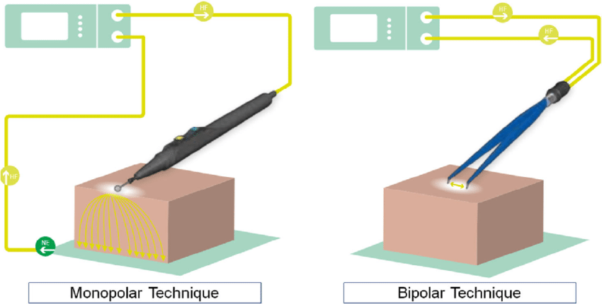

Figure 1 - Monopolar (unipolar) vs. Bipolar measumrent technique

For monopolar measurements the reference signal may be a single electrode (‘common reference’) used as the reference for all channels (say an ear clip electrode), or it may be the average of all of the electrodes (‘average reference’).

The selection of the reference can significantly impact the signal quality by reducing common-mode noise, improve spatial resolution by emphasizing local activity, and reduce inter-channel redundancy. It should also be noted that re-referencing (also termed re-montaging) is common in bioelectrical signal analysis, and changing from common reference to average reference (and vice versa) is possible after data collection.

When recordings have high channel counts and high correlation between channels, the use of a common reference can reduce the common variations within the channel signals, highlighting only the variances between the channels.

# CE Proposal

To improve the efficiency of the H.BWC compression codec we propose to employ run-time re-referencing of the signals. Two methods are proposed:

1. Common Average Referencing (CAR)
2. Channel Selection Referencing (CSR)

In the case of Common Average Referencing, during encoding a new channel is created that is the average of all other channels, this CAR channel is then subtracted from the initial channels, and encoded alongside the resultant (residual) channels. While this increases the number of channels in the bitstream by 1, the resultant other channels can be encoded much more efficiently, in many cases still leading to an overall lower bitrate, in particular for signals with high channel count.

Alternatively, a single channel can be selected as the reference channel and this can then be subtracted out from the other channels. Typically, this reference channel would be the channel with the highest average correlation with the other channels. In this instance the bitstream needs only to carry an additional index to the reference channel to enable the inverse re-referencing at the decoder side. The total channel count remains unchanged.

In both cases the encoder signals which channel is used as reference, and whether the reference channel is to be included in the decoded output or not.

Figure 2 shows the rate distortion curves for the default processing mode (in blue) compared to the channel selection re-referenced (CSR) data using the channel that has the highest correlation with respect to all other channels, as the reference channel. The results are for the monopolar recordings from the NMR57 dataset.

Figure 2 - Example of re-referencing using the Channel Selection Referencing methos (red) in comparison to the default encoding method. NMR57 dataset, monopolar recordings only. BD rate change of 4.19% results.

It is noted that Re-referencing only works for channels that are from the same modality. Currently, the test data sets used for the CTCs typically contain more than 1 signal type within the same recording. This CE will therefore only be applicable to the NMR57 and chbmit datasets initially.

# Conclusion

We propose a new CE on the automatic re-referencing of signals to improve encoder performance. Currently, the implementation is based on the v1.0 test model and needs to be updated with final revisions aimed to be ready for review in the coming period. We ask for this proposal to be accepted into the CE planning.

# Patent rights declaration(s)

**Philips may have current or pending patent rights relating to the technology described in this contribution and, conditioned on reciprocity, is prepared to grant licenses under reasonable and non-discriminatory terms as necessary for implementation of the resulting ITU-T Recommendation | ISO/IEC International Standard (per box 2 of the ITU-T/ITU-R/ISO/IEC patent statement and licensing declaration form).**

________________________