|  |  |
| --- | --- |
| **ITU – Telecommunications Standardization Sector**  STUDY GROUP 21 Question 6  **Video Coding Experts Group (VCEG)**  77th Meeting: 26 June – 4 July 2025, Daejeon, KR | Document VCEG-BY07-v1 |

|  |  |  |  |
| --- | --- | --- | --- |
| Question: | 6/21 (VCEG) | | |
| Source: | **Sooyoung Park, Byeongho Jo,**  **Jongmo Sung, Seungkwon Beack (ETRI)** | Email: | {sooyoung, bhjo, jmseong, skbeack}@etri.re.kr |
| Title: | **Harmonization of H.BWC for LMS Prediction in the transform domain** | | |
| Purpose: | Proposal | | |

_____________________________

# Abstract

This contribution proposes a harmonized integration of the DMC mode (proposed by Dolby) into the Full RDO (proposed by HHI) framework for the H.BWC Test Model [1]. To address limitations such as bypass mode redundancy, entropy coding inconsistency, and DCT buffer overhead for inter-channel LMS prediction (IC_LMS_DCT) in transform domain, a lightweight **inter-channel average (IC-Avg)** mode is introduced. The IC-Avg mode simplifies LMS computation by using fixed prediction coefficients and eliminates the need for DCT buffer construction by directly averaging reconstructed signals. By integrating a 1-bit extension into the DC mode of Full RDO framework, IC-Avg does not require additional RDO loop complexity. Experimental results show consistent encoding-time reductions (up to 15%) as well as BD-rate improvements, especially in shorter block size. The results suggest further potential when combined with CABAC for LMS prediction and full RDO integration.

# Introduction

In the current H.BWC Test Model (TM: tagged as BWC-2.1), the DMC mode and the Full RDO mode are independently defined with distinct decision structures. DMC mode encodes all channels using one of four predefined prediction combinations: (1) bypass mode, (2) Intra-channel DCT LMS prediction (AR_LMS_DCT) mode, (3) inter-channel DCT LMS prediction (IC_LMS_DCT) mode, or (4) both AR_LMS_DCT and IC_LMS_DCT. In contrast, the Full RDO mode employs a comprehensive rate-distortion optimization loop. It exhaustively explores various combinations of prediction (e.g., DC, LF, IC, BM) and transform modes (e.g., DCT, DST, identity transform) on a **per-channel** basis.

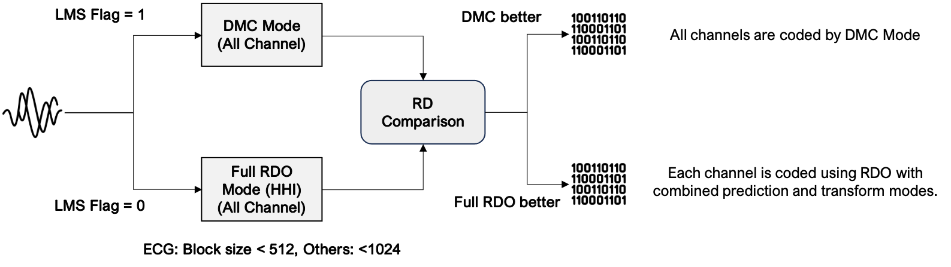

Figure 1‑1. Block diagram of current TM coding scheme

As illustrated in **Figure 1-1**, the current TM operates using a top-level binary decision between these two paths—DMC versus Full RDO—by comparing their RD costs. The result of this decision is signaled using a single flag (lms_lpc_mode_flag).

Ideally, optimal coding efficiency would be achieved by jointly considering candidates from both DMC and Full RDO modes. However, the current TM structure performs each mode independently and compares their RD costs afterward, resulting in a sub-optimal design. As illustrated in Figure 1-2, we propose a harmonized framework in which DMC candidates are integrated into the Full RDO loop.

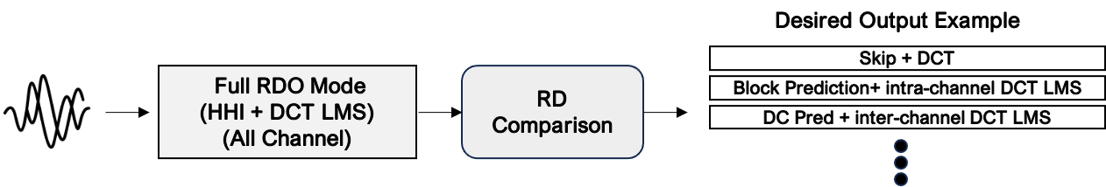

Figure 1‑2. Desired harmonization coding scheme for H.BWC

However, simply merging DMC mode into the Full RDO loop is not straightforward, as several issues must be addressed to ensure a clean and effective integration.

# Technical description

## Redundancy of Bypass Mode in DMC

The bypass mode in DMC is equivalent to a combination of skip prediction and DCT transform already available in the Full RDO framework. Since this is functional duplication, it would be preferable to integrate the unified bypass mode.

## Entropy Coding Inconsistency for LMS Mode

Another issue is that the LMS prediction in DMC mode currently rely on Huffman coding for entropy coding, whereas the Full RDO mode uses CABAC. To ensure consistent RD comparison and proper integration, LMS prediction must also adopt CABAC-based entropy coding. This issue has been addressed in the proposal described in **VCEG-BX14 [2]**, and is expected to be resolved accordingly.

## Buffer Overhead in IC-DCT LMS

IC_LMS_DCT mode requires a reconstructed DCT buffer. In the current TM, this buffer is created only when DMC mode is selected, but is still maintained even if all channels use bypass mode. When integrating DMC mode into the Full RDO loop, the buffer must be constructed regardless of LMS prediction selection, increasing complexity and computation. To reduce this computational burden, we propose an i**nter-channel average mode** that simplified IC_LMS_DCT mode without DCT buffer construction and updating LMS coefficient. This reduces computation burden while maintaining similar coding performance.

# Proposed Method: IC-Average Mode under DC Prediction

The proposed **inter-channel average (IC-Avg)** mode is a simplified form of IC_LMS_DCT, where all LMS coefficients are fixed to **1/num_channels**. This formulation eliminates the need for coefficient updates, resulting in a computation reduction in LMS prediction. Moreover, since the average of DCT coefficients across channels is equivalent to the average in the time domain, the proposed method avoids DCT computation entirely. The inter-channel average is directly computed from the reconstruction buffer without DCT. This leads to substantial computational savings in both encoding and decoding.

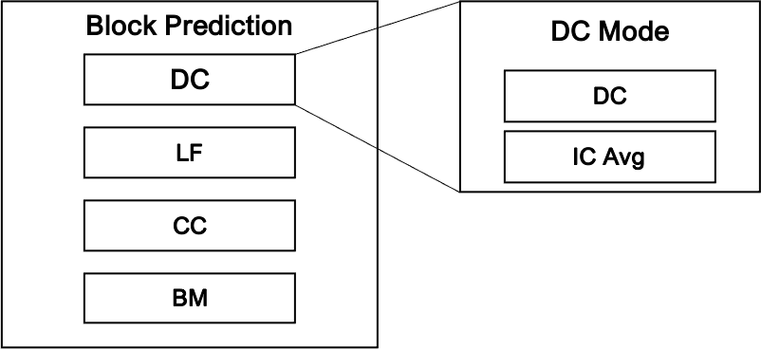

Figure 3‑1. Proposed IC-Average mode structure using 1-bit flag

To integrate the IC-Avg mode efficiently, we propose extending the existing **DC prediction mode** by adding a **1-bit flag** to optionally enable IC-Avg, as illustrated in **Figure 3-1**. The DC mean value, already computed for mean removal, is reused as the prediction for IC-Avg without additional operations.

As shown in **Figure 3-2**, IC-Avg operates in an **open-loop manner** within the DC **prediction** mode and does not add new candidates to the RDO loop. Therefore, it introduces **no additional RD search complexity**, while enabling inter-channel prediction benefits with minimal overhead.

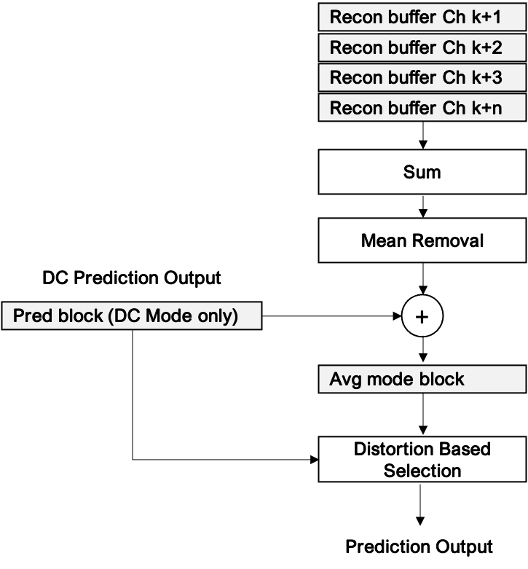

Figure 3‑2. Block diagram of the IC-Avg mode in DC prediction

# Experimental Results of IC-Avg Mode

## Experiment Setup

The experiments were conducted following the **Common Test Conditions (CTC) [3]** using the full **development set**. As illustrated in **Figure 1-1**, the current TM is configured such that **DMC and Full RDO compete only for short blocks**, while **DMC is exclusively used for long blocks** (block size >512 for EEG/EMG, >256 for ECG).

Since the proposed IC-Avg mode is designed to harmonize IC_LMS_DCT within the RDO loop, it is not working in long block size where only the DMC mode is active in the current TM structure. Therefore, to assess its effectiveness, we evaluated two test setups: 1) keeping the original DMC mode for long blocks, as in the TM with CTC, 2) evaluating only under short-block conditions.

## Evaluation on TM with CTC

Table 4-1 presents the experimental results for ECG, EMG, and EEG datasets. In this test setup, the proposed IC-Avg mode was applied to short blocks within the DC prediction mode, while the original DMC mode was retained for long blocks. Thus, the results primarily reflect the effectiveness of the proposed method in short-block conditions.

Table 4‑1. Experiment evaluation results compared to TM with CTC

|  |  |  |  |  |
| --- | --- | --- | --- | --- |
| Dataset | BD rate #1 (%) | BD rate #2 (%) | $∆$ EncT (%) | $∆$ DecT (%) |
| MIT_ECG_Dataset | 0.624 | 0.621 | **84.8** | **99.5** |
| Ozdemir_EMG | **-0.100** | **-0.099** | **85.0** | **94.6** |
| CHBMIT_EEG | **-0.097** | **-0.108** | **91.4** | 104.6 |

Across all datasets, we observed that DCT buffer control was skipped for short blocks, resulting in an 8–15% reduction in encoding complexity. Furthermore, the proposed method led to BD-rate improvements in short blocks for the EMG and EEG datasets, demonstrating both complexity reduction and coding efficiency gains. While encoding complexity consistently decreased across all datasets, a decoding-time gain of approximately 5% was observed only in the EMG dataset.

## Evaluation on Short Blocks Only

To isolate the impact of the proposed method and exclude effects from long-block configurations, we modified the TM configuration so that only **short blocks** are processed. Specifically, the following parameters were adjusted:

* LOG2_MAX_BLOCK_SIZE: 9 (originally 11)
* MAX_SPLIT_DEPTH: 1 (originally 3)
* MIN_SPLIT_DEPTH_FULL_TEST: 0 (originally 2)

This experiment directly highlights the impact between the DMC mode and the proposed IC-Avg mode. As a result, the method achieved a 9–15% reduction in encoding time without significantly affecting decoding time, while also delivering BD-rate improvements across the datasets.

Table 4‑4. Experiment evaluation results compared to TM with short blocks only configuration

|  |  |  |  |  |
| --- | --- | --- | --- | --- |
| Dataset | BD rate #1 (%) | BD rate #2 (%) | $∆$ EncT (%) | $∆$ DecT (%) |
| Ozdemir_EMG | **-0.012** | **-0.013** | **84.3** | 100.5 |
| CHBMIT_EEG | **-0.027** | **-0.033** | **91.9** | 104.2 |

As CABAC for LMS was not available, AR_LMS_DCT prediction could not be used for ours. Despite this limitation, the proposed scheme demonstrated meaningful improvements, indicating potential for further gains with full integration into the unified RDO framework, as illustrated in **Figure 1-2**.

# Conclusion

We proposed the IC-Avg mode as a simplified version of IC_LMS_DCT mode, enabling practical integration of DMC mode into the Full RDO loop. By avoiding DCT buffer usage and reducing LMS coefficient updating computation, the method achieves meaningful complexity savings, comparable or improved rate-distortion performance. Evaluation under both CTC and short-block-only configurations confirms that the proposed scheme improves BD-rate while significantly reducing encoding time. These results demonstrate the feasibility of a harmonized coding framework and indicate further gains can be expected through CABAC for LMS support and RDO-based integration.

We kindly request the inclusion of a Core Experiment on the proposed technology in the next H.BWC meeting.

# Patent rights declaration(s)

**ETRI may have current or pending patent rights relating to the technology described in this contribution and, conditioned on reciprocity, is prepared to grant licenses under reasonable and non-discriminatory terms as necessary for implementation of the resulting ITU-T Recommendation | ISO/IEC International Standard (per box 2 of the ITU-T/ITU-R/ISO/IEC patent statement and licensing declaration form).**

# References

1. VCEG, “Reference software for biomedical waveform data compression,” tag BWC-2.1, May. 2025. <https://www.vcgit.hhi.fraunhofer.de/vceg-sw/bwc/-/tags/>
2. J. Pfaff et al., “Harmonization of entropy coding methods in H.BWC”, Teleconference, March 2025. https://www.itu.int/wftp3/av-arch/video-site/2503_Tel/VCEG-BX14-v1-EntropyCoding.docx
3. J. Pfaff et al., “Common test conditions and evaluation procedures for H.BWC technical experiments,”, Teleconference, March. 2025. <https://www.itu.int/wftp3/av-arch/video-site/2503_Tel/VCEG-BX23-v1-CTC.docx>