|  |  |
| --- | --- |
| **ITU – Telecommunications Standardization Sector**  STUDY GROUP 21 Question 6  **Video Coding Experts Group (VCEG)**  76th Meeting: 27 March – 4 April 2025, by teleconference | Document VCEG-BX16-v1 |

|  |  |  |  |
| --- | --- | --- | --- |
| Question: | 6/21 (VCEG) | | |
| Source: | **Leon Holtmeier, Sophie Pientka, Heiner Kirchhoffer, Paul Haase, Jonathan Pfaff, Heiko Schwarz, Detlev Marpe, Thomas Wiegand (Fraunhofer HHI)** | Email: | [leon.holtmeier@hhi.fraunhofer.de](mailto:leon.holtmeier@hhi.fraunhofer.de) |
| Title: | **Description of the application of high-level syntax for reordering and grouping of channels for EEG signals** | | |
| Purpose: | Information | | |

1. **Introduction**

This document describes an application of the H.BWC high level syntax to apply a reordering and a grouping of channels for EEG data based on the 10-20 and 10-10 electrode labeling systems. It is shown that, due to the local correlation of channels for EEG measurements, reordering channels according to their placement can lead to significant improvements for inter-channel predictions when channels are separated into channel groups. It is shown that additionally, variable sizes of channel groups can be applied to further improve the prediction and decrease the encoding runtime.

1. **EEG ordering systems**

The International 10-20 system is the standard method for positioning EEG electrodes on the scalp [1]. Electrodes are positioned at sites that are 10% or 20% of the total distance between specific anatomical landmarks. Each electrode is labeled with a letter indicating the brain region (F: frontal, T: temporal, C: central, P: parietal, O: occipital), a number (odd numbers for left hemisphere, even for right), and "z" for midline electrodes. The extended 10-10 system (see Figure 1) adds additional electrodes between the positions of the 10-20 system.

The channel grouping demonstrated in this document is based on the assumption that signal channels in EEG measurements are correlated based on brain region and locality. This means that ordering channels according to their locality and grouping them based on their brain region should lead to improvements in cross channel predictions.

The proposed process can be applied if an EDF file has sufficiently labeled channels, given by the "label" field of the channel header.

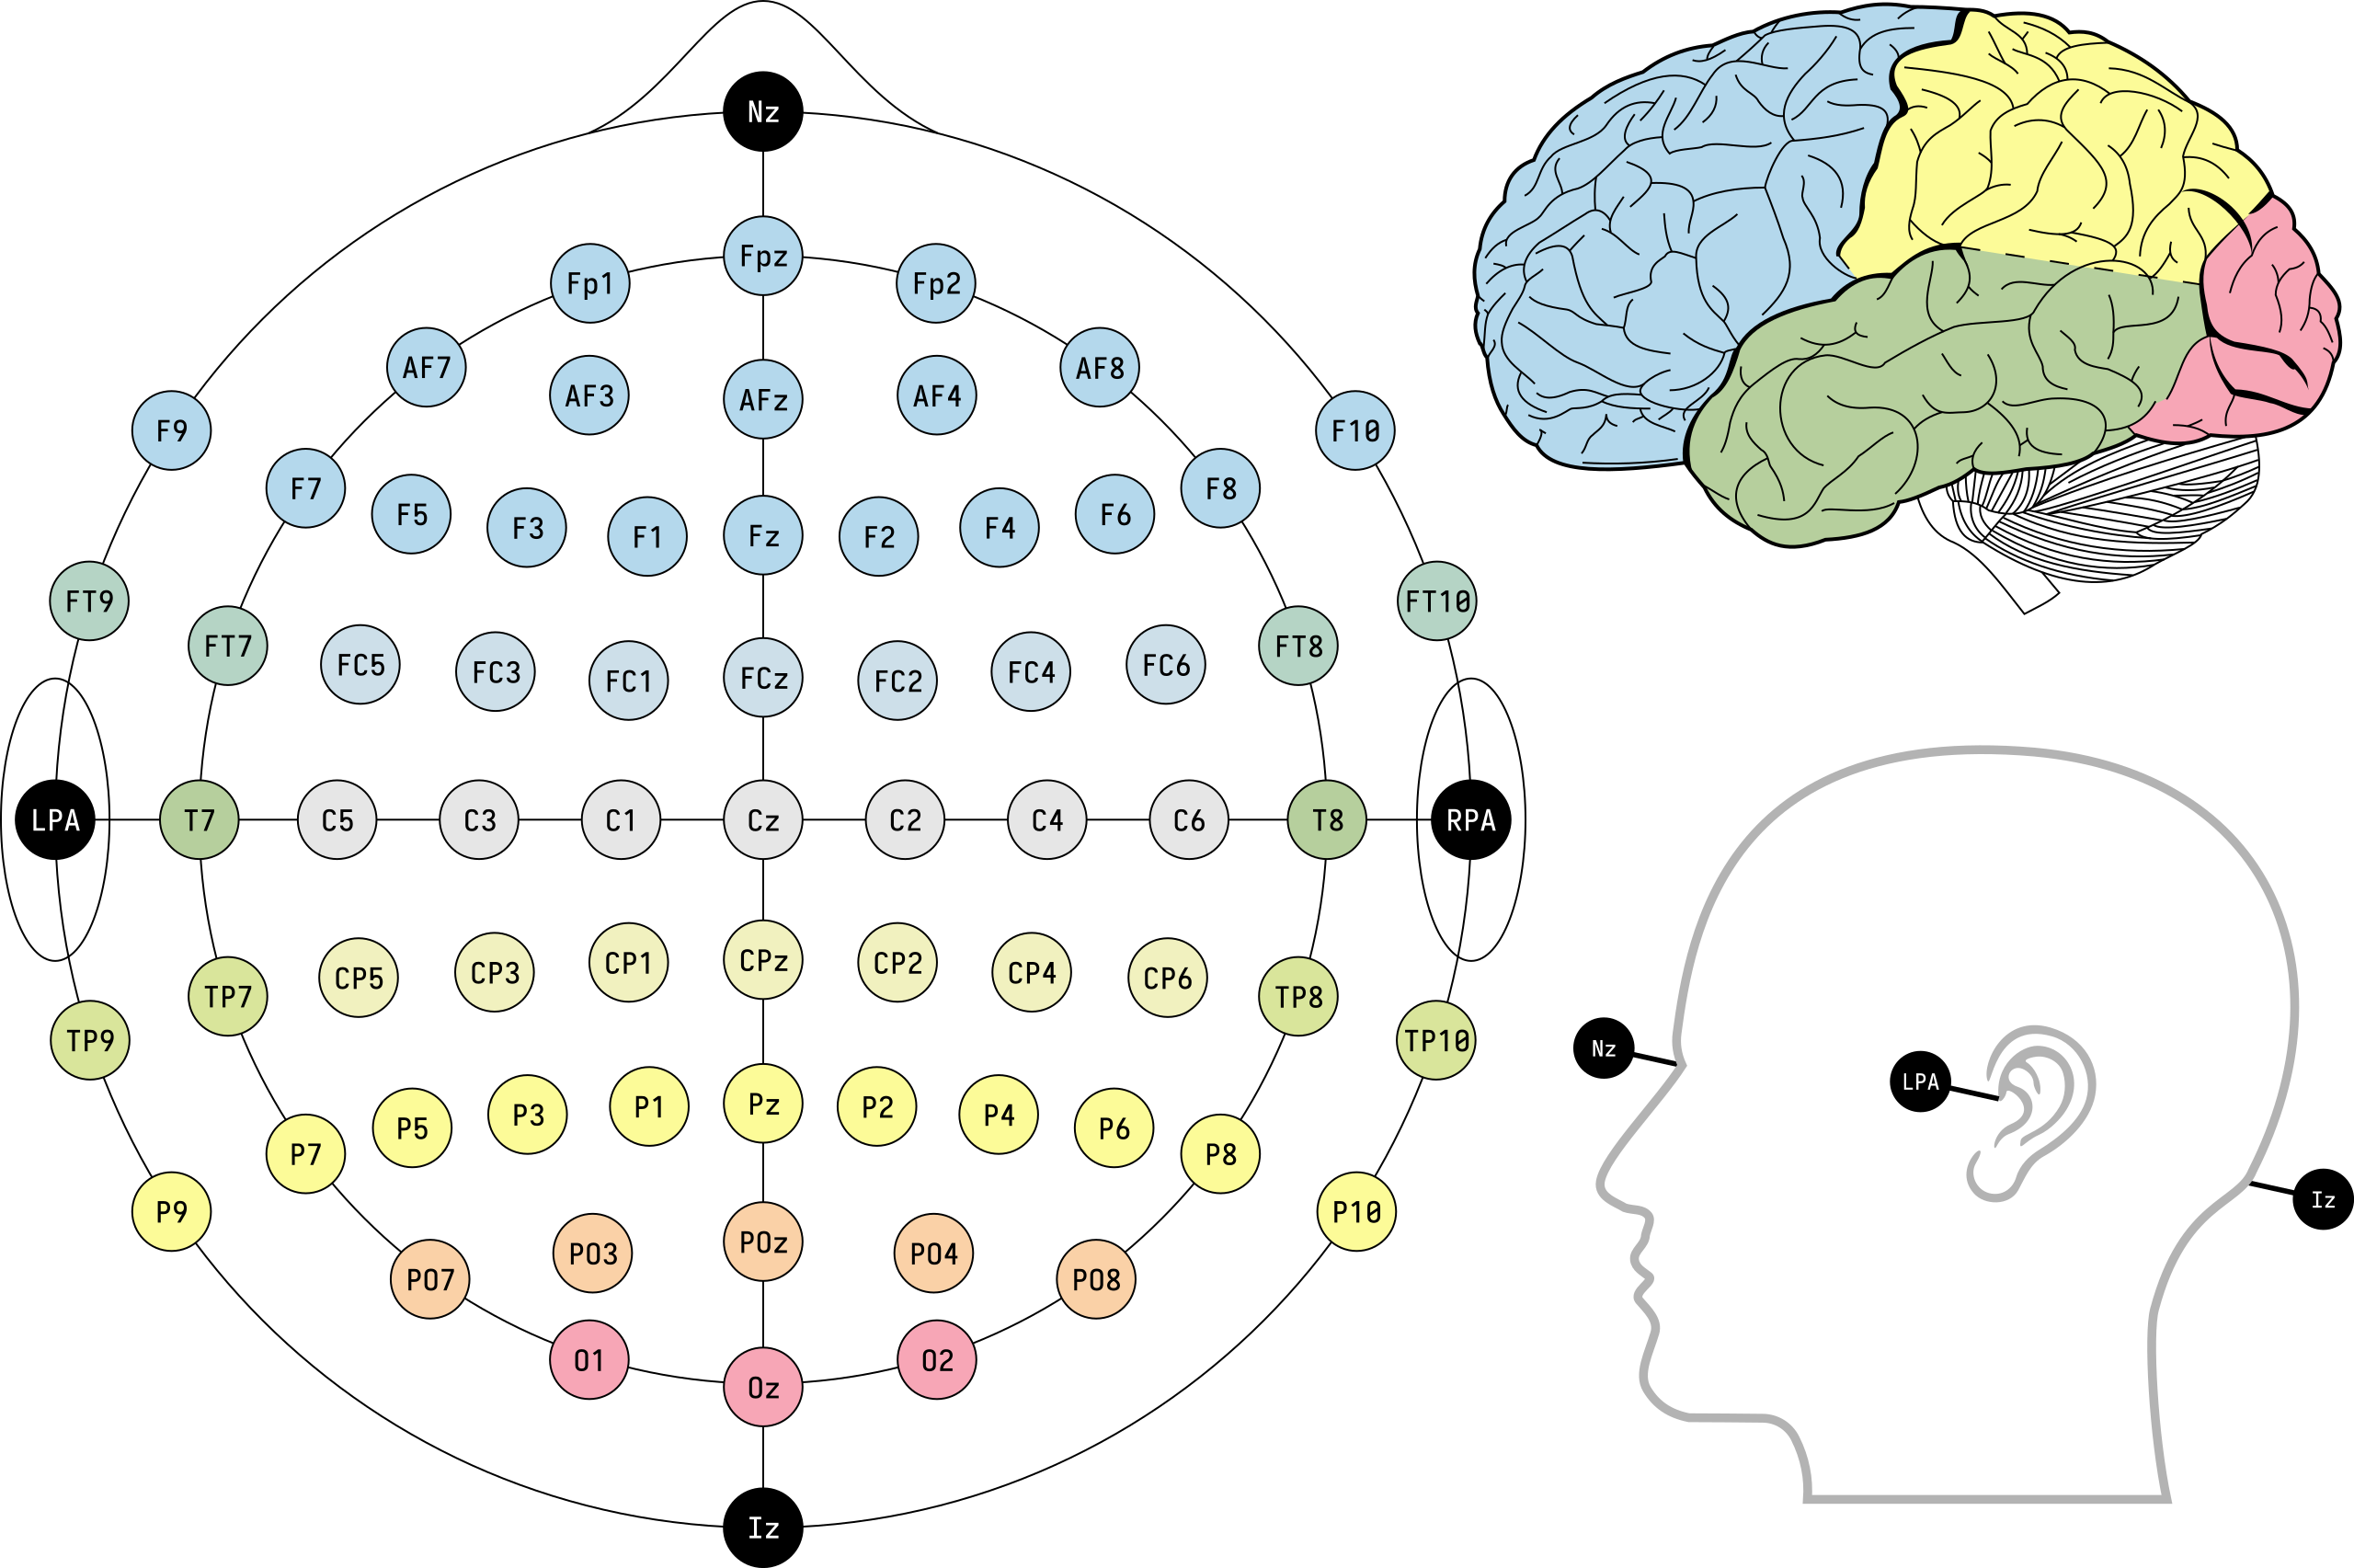

Figure 1. The 10-10 system [3]

# Review of the channel grouping syntax of the current H.BWC

The current H.BWC draft specification [2] supports a flexible grouping of the channels into channel groups of variable orders and sizes where channel groups can be coded independently from each other. The motivation of this functionality is to allow an independent processing and accessing of the channel groups at encoders and decoders.

The relevant syntax is described in clause 7.3.2.1 Waveform parameter set RBSP syntax and 8.1.2 Channel output index derivation process. The channel order is encoded as a series of swaps using the following syntax elements:

* **wps_channel_reordering_flag**
* **wps_num_channel_swaps_minus1**
* **wps_swap_frst_idx**
* **wps_swap_scnd_idx_min_frst_idx_min1**

The channel groups are encoded with the following syntax elements:

* **wps_num_channels_in_next_group_minus1**
* **wps_num_channel_group_repetitions**
* **wps_more_channel_groups_present_flag**

For the experiments in this document, the permutation representing the new channel order is derived from the labels of the channel headers in the input EDF file. The inverse of this permutation is then encoded as a series of swaps (see Table 2 for an example). These swaps are then used after the decoding process to restore the original mapping.

The channel groups are determined and encoded according to the new channel order (see Table 3 for an example).

# Experimental Results

To show this process, a subset with 42 EDF files of the CHB-MIT Scalp EEG Database [4] is used. In this dataset the channel labels do not exactly fit the labels of the 10-20 or 10-10 system, but are a combination of two 10-20 electrode names, indicating the electrode in between. Thus, the label names were mapped onto the corresponding 10-10 electrode labels. The following table shows the original labels, the corresponding 10-10 system label names, as well as the original channel index, the reordered index and two alternative channel groupings: variable and fixed.

Table 1: Labels and reordered indexes.

|  |  |  |  |  |  |
| --- | --- | --- | --- | --- | --- |
| **Original label** | **Mapped label** | **Reordered index** | **Original index** | **Group (variable)** | **Group (fixed)** |
| FP1-F7 | AF7 | 0 | 0 | 0 | 0 |
| FP1-F3 | AF3 | 1 | 4 |
| FP2-F4 | AF4 | 2 | 8 |
| FP2-F8 | AF8 | 3 | 12 |
| FT9-FT10 | FT9 | 4 | 20 | 1 | 1 |
| F7-T7 | FT7 | 5 | 1 |
| F3-C3 | FC3 | 6 | 5 | 2 |
| FZ-CZ | FCZ | 7 | 16 |
| F4-C4 | FC4 | 8 | 9 | 2 |
| F8-T8 | FT8 | 9 | 13 |
| T7-FT9 | T7 | 10 | 19 | 3 |
| T7-P7 | TP7 | 11 | 2 |
| C3-P3 | CP3 | 12 | 6 | 4 | 3 |
| CZ-PZ | CPZ | 13 | 17 |
| C4-P4 | CP4 | 14 | 10 |
| FT10-T8 | T8 | 15 | 21 | 5 |
| T8-P8 | TP8 | 16 | 14 | 4 |
| T8-P8 | TP8 | 17 | 22 |
| P7-T7 | P7 | 18 | 18 | 6 |
| P7-O1 | PO7 | 19 | 3 |
| P3-O1 | PO3 | 20 | 7 | 5 |
| P4-O2 | PO4 | 21 | 11 |
| P8-O2 | PO8 | 22 | 15 |

Table 2 shows the values of syntax elements

* **wps_swap_frst_idx** and
* **wps_swap_scnd_idx_min_frst_idx_min1**

for this example.

Table 2: Syntax elements implementing ordered channel swaps

|  |  |
| --- | --- |
| **wps_swap_frst_idx** | **wps_swap_scnd_idx_min_frst_idx_min1** |
| 1 | 3 |
| 1 | 4 |
| 1 | 10 |
| 1 | 1 |
| 1 | 17 |
| 1 | 8 |
| 1 | 12 |
| 1 | 14 |
| 1 | 5 |
| 1 | 18 |
| 1 | 2 |
| 2 | 8 |
| 2 | 18 |
| 2 | 12 |
| 2 | 19 |
| 2 | 14 |
| 2 | 10 |
| 2 | 6 |
| 2 | 5 |

The channel groups for the variable version of the channel grouping are encoded as follows:

Table 3: Syntax element values for encoding channel groups

|  |  |  |  |  |  |  |
| --- | --- | --- | --- | --- | --- | --- |
| **wps_num_channels_in_next_group_minus1** | 3 | 1 | 3 | 1 | 2 | 4 |
| **wps_num_channel_group_repetitions** | 0 | 0 | 0 | 0 | 1 | 0 |
| **wps_more_channel_groups_present_flag** | 1 | 1 | 1 | 1 | 1 | 0 |

Table 4 shows comparisons of the PRD-based average BD-rate and runtime, measured against a baseline without any channel groups or reordering. It shows that reordering improves the PRD-based BD rate by a Factor of 1.9 when using channel groups of fixed size 4 with similar runtime. Using the more fitting vairable channel group sizes significantly reduces the encoder runtime, while the PRD-based BD rate is slightly improved.

Table 4: Experimental results

|  |  |  |
| --- | --- | --- |
| **Configuration** | **BD rate** | **Runtime (enc.)** |
| Original order (channel group size = 4) | 19.93 % | 67.72 % |
| Reordered (channel group size = 4) | 10.69 % | 66.39 % |
| Reordered (variable channel group size) | 10.49 % | 60.66 % |

# References

1. M. R. Nuwer, G. Comi, R. Emerson, A. Fuglsang-Frederiksen, J.-M. Guérit, H. Hinrichs, A. Ikeda, F. J. C. Luccas, and P. Rappelsburger, (1998). IFCN standards for digital recording of clinical EEG. In Electroencephalography and Clinical Neurophysiology (Vol. 106, Issue 3, pp. 259–261). Elsevier BV. <https://doi.org/10.1016/s0013-4694(97)00106-5>.
2. J. Pfaff and C. Fersch, “H.BWC Draft Specification Text,” Q.6/SG21, doc. SG21-C0019, Geneva, Jan. 2025.
3. L. R. Krol - Own work, CC0, <https://commons.wikimedia.org/w/index.php?curid=96859272>.
4. J. Guttag, (2010). CHB-MIT Scalp EEG Database (version 1.0.0). PhysioNet. <https://doi.org/10.13026/C2K01R>.

# Patent rights declarations(s)

**Fraunhofer HHI may have current or pending patent rights relating to the technology described in this contribution and, conditioned on reciprocity, is prepared to grant licenses under reasonable and non-discriminatory terms as necessary for implementation of the resulting ITU-T Recommendation (per box 2 of the ITU-T/ITU-R/ISO/IEC patent statement and licensing declaration form).**

________________________