|  |  |
| --- | --- |
| **ITU – Telecommunications Standardization Sector**  STUDY GROUP 21 Question 6  **Video Coding Experts Group (VCEG)**  76th Meeting: 27 March – 4 April 2025, by teleconference | Document VCEG-BX03-v1 |

|  |  |  |  |
| --- | --- | --- | --- |
| Question: | 6/21 (VCEG) | | |
| Source: | **Sooyoung Park, Byeongho Jo,**  **Jongmo Sung, Seungkwon Beack (ETRI)** | Email: | {sooyoung, bhjo, jmseong, skbeack}@etri.re.kr |
| Title: | **Core Experiment on LPC-based block-matching prediction for H.BWC** | | |
| Purpose: | Proposal | | |

_____________________________

# Abstract

This document presents ETRI’s Core Experiment on LPC-based block-matching prediction of biomedical waveforms.

# Introduction

In the last Q6/21 meeting, specific features for H.BWC were discussed for testing in Core Experiments (CEs) as described in [1]. This document describes the CE on LPC-based block-matching prediction, which was initially proposed in our Call for Proposal (CfP) response [2].

Biomedical waveform data such as EEG, ECG, and EMG exhibit diverse signal characteristics. The signal prediction process, essential for improving coding efficiency, can be performed in various signal domains. In the block-wise predictive transform coding of the Test Model (TM), the prediction modes are primarily applied in the signal domain. Linear predictive coding (LPC) is widely used in conventional speech and audio signal compression for removing short-term redundancies inherent in the signal. It is well-known that LPC-filtered residual signals are more effective for predicting long-term redundancies [3]. Based on this rationale, this CE applies the LPC scheme to perform block-wise prediction for biomedical waveform signals.

The objective of this CE is to enhance the rate-distortion trade-off by introducing a prediction mode operating in the LP residual domain. Since the LPC-based block-matching prediction method provides an additional prediction mode to estimate the sample values of the curren input block from previously reconstructed samples, it can be regarded as an addition to the existing Test Model.

In this contribution, we present the technical description, draft specification changes, and evaluation results of the proposed CE.

# Technical description

Figure 2‑1 shows a high-level block diagram of the proposed CE within the block-wise predictive transform coding. The block-wise predictive transform coding in the TM supports various prediction modes: DC, line-fitting (LF), cross-channel (CC), and block-matching (TM-BM). For this CE, an LPC-based block-matching (LPC-BM) prediction was introduced as an additional prediction mode.

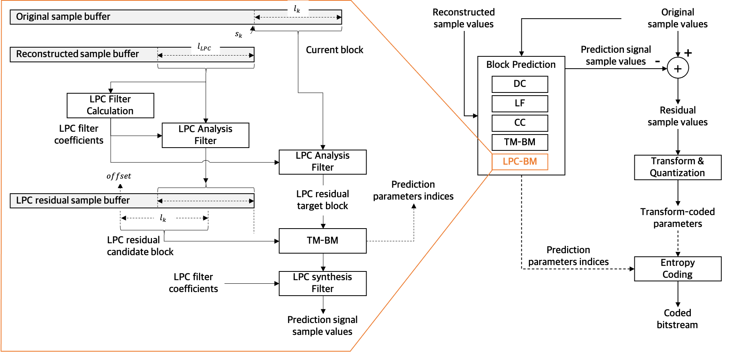

Figure 2‑1. Block diagram of the LPC-based block-matching scheme in the block-wise predictive transform coding

To search for the best block-matching offset in the LPC residual domain, an LPC residual sample buffer is maintained, which stores the LPC residual of previously reconstructed samples in the reconstructed sample buffer. Before searching for the matched block of the current block, $b_{k}$ of $l_{k}$ samples, the $p$-th order LPC filter coefficients are computed using $l_{LPC}(=2048)$ left-adjacent samples in the reconstructed sample buffer. These samples are filtered by the LPC analysis filter to generate LPC residual samples, which are stored in the LPC residual sample buffer. As shown in Table 2‑1, different LPC order is applied depending on the dataset category, and these orders were determined empirically.

Table 2‑1. LPC order

|  |  |
| --- | --- |
| Dataset category | LPC order ($p$) |
| ECG | 16 |
| EEG | 32 |
| EMG | 32 |

The current block is also filtered using the same LPC analysis filter to obtain the LPC residual target block. By deriving the LPC filter coefficients from the previously reconstructed samples rather than from the original current block, there is no need to transmit the LPC filter coefficients to the decoder. To better harmonize with the TM-BM approach, the best residual block matched to the target block is searched in a similar manner to the TM-BM. Accordingly, the proposed LPC-BM prediction operates as an additional block prediction mode. The final mode selection is determined based on the rate-distortion optimization (RDO) criterion.

# TM draft specification changes

In this CE, we introduced an LPC-based block matching prediction data syntax (lp_block_matching_prediction_data) in prediction_trafo_data_block of predictive transform coding block syntax as follows (the changes are high-lighted in yellow):

|  |  |
| --- | --- |
| prediction_trafo_data_block ( ) { | Descriptor |
| { |  |
| for( ch = 0; ch < numChannels; ch++ ) { |  |
| if( cgps_allow_block_matching_pred_flag | | ( cgps_allow_cross_channel_pred_flag &&  ( ch & DepChMask ) > 0 ) ) |  |
| **block_matching_or_cross_channel_pred_flag** | ae(v) |
| if( block_matching_or_cross_channel_pred_flag ) { |  |
| if( cgps_allow_block_matching_pred_flag &&   cgps_allow_cross_channel_pred_flag  && ( ch & DepChMask ) > 0 ) |  |
| **cross_channel_pred_flag** | ae(v) |
| if( cross_channel_pred_flag ) |  |
| cross_channel_prediction_data( ch ) |  |
| else |  |
| **lp_block_matching_pred_flag** | ae(v) |
| if ( lp_block_matching_pred_flag ) |  |
| lp_block_matching_prediction_data( ch ) |  |
| else |  |
| block_matching_prediction_data( ch ) |  |
| }else |  |
| **block_pred_mode** | ae(v) |
| if( block_matching_or_cross_channel_pred_flag | |  ( block_pred_mode = = BPM_OFF ) ) { |  |
| sample_pred_mode( ) |  |
| if( spred_lpf_flag ) |  |
| linear_predictive_filtering_data( ch ) |  |
| } |  |
| …. | … |
| quant_res_sample_data( ) |  |
| } |  |
| } |  |

The syntax of LPC-based block matching prediction data (lp_block_matching_prediction_data) is an LPC counterpart of the existing block matching prediction data (block_matching_prediction_data) as follows:

|  |  |
| --- | --- |
| lp_block_matching_prediction_data( ch ) { | Descriptor |
| if( cgps_allow_bm_pred_mult_hyp_flag **)** |  |
| **lp_bm_pred_mult_hyp_flag** | ae(v) |
| **lp_bm_pred_add_offset_flag** | ae(v) |
| for( n = 0; n <= lp_bm_pred_mult_hyp_flag; n++ ) { |  |
| if( cgps_bm_pred_filtering_mode > 0 **)** |  |
| **lp_bm_pred_filter_flag[ n ]** | ae(v) |
| if( lp_bm_pred_filter_flag[ n ] && cgps_bm_pred_filtering_mode = = 2 ) |  |
| **lp_bm_pred_filter_idx[ n ]** | ae(v) |
| if( cgps_allow_bm_offset_pred_prev_ch_flag && ( ch & DepChMask ) > 0 ) |  |
| **lp_bm_pred_off_pred_prev_ch_flag[ n ]** | ae(v) |
| **lp_bm_pred_abs_offd_greater0_flag[ n ]** | ae(v) |
| if( lp_bm_pred_abs_offd_greater0_flag[ n ] ) { |  |
| **lp_bm_pred_abs_offd_minus1**[ n ] | ae(v) |
| **lp_bm_pred_offd_sign_flag**[ n ] | ae(v) |
| } |  |

Semantics associated with the syntax introduced by this CE are specified as follows:

|  |
| --- |
| **lp_block_matching_pred_flag** equal to 1 indicates that the prediction is generated by invoking the LPC-based block matching prediction mode.  **lp_bm_pred_mult_hyp_flag** equal to 1 indicates that the LPC-based block matching prediction mode with two hypotheses is used. When lp_bm_pred_mult_hyp_flag is not present, it is inferred to be 0.  **lp_bm_pred_add_offset_flag** equal to 1 indicates that an offset, derived from previous reconstructed samples, is added to the LPC-based block matching prediction.  **lp_bm_pred_filter_flag**[ n ]equal to 1 indicates that the reference samples used for the n-th hypothesis of the LPC-based block matching prediction are to be filtered, where the set of filter coefficients is determined by the syntax element lp_bm_pred_filter_idx[ n ]. When bm_pred_filter_flag[ n ] is not present, it is inferred to be 0.  **lp_bm_pred_filter_idx**[ n ]specifies the index filterIdx used to derive the array BMFiltCoeffs[ n ][ i ], with 0 <=i < 7, of filter coefficients according to Table 7-17 for filtering the reference samples of the n-th hypothesis of the LPC-based block matching prediction. When lp_bm_pred_filter_idx[ n ] is not present, it is inferred to be 1:  **lp_bm_pred_off_pred_prev_ch_flag**[ n ] equal to 1 indicates that the value of offset minus block size for the n-th LPC-based block matching prediction hypothesis is predicted from the value of offset minus block size of the n-th hypothesis of the previous channel. When lp_bm_pred_off_pred_prev_ch_flag[n] is not present, it is inferred to be 0.  **lp_bm_pred_abs_offd_greater0_flag**[ n ] equal to 1 indicates that the offset difference to the predicted value of offset minus block size for the n-th hypothesis of the LPC-based block matching prediction is not 0.  **lp_bm_pred_abs_offd_minus1**[ n ] plus 1 specifies the absolute value of the offset difference to the predicted value of offset minus blocksize for the n-th hypothesis of the LPC-based block matching prediction.  **lp_bm_pred_offd_sign_flag**[ n ] specifies the sign of the offset difference to the predicted value of offset minus blocksize for the n-th hypothesis of the LPC-based block matching prediction as follows:  – When lp_bm_pred_offd_sign_flag[ n ] is equal to 0, the corresponding offset difference has a positive sign.  – Otherwise (lp_bm_pred_offd_sign_flag[ n ] is not equal to 0), the corresponding offset difference has a negative sign.  When lp_bm_pred_offd_sign_flag[ n ] is not present, it is inferred to be 0. |

# Experimental evaluation

We evaluated the proposed LPC-based block matching method using a Bjøntegaard Delta (BD) rate between the technology under test and the anchor, as well as the percentage changes of the geometric means of the runtimes relative to the anchor, in accordance with the common test condition (CTC) and evaluation procedures described in [4].

There are five biomedical datasets and two encoding configurations specified in [4]. However, due to the large volume of data and the limited time, we evaluated only a subset of those combinations. BD rates were measured for StepSizeForQP values listed in [4], except StepSizeForQP value of “1” for lossless mode. Furthermore, since we observed that the BD rate improvement became negligible at the smallest StepSizeForQP in lossy modes, StepSizeForQP value of 1 and 1.125 for ECG, 1 for EMG and 1.125 for EEG were not used in the evaluation. Table 4‑1 summarizes the evaluation results. Each value was computed by averaging the results over all input sequences in the respective dataset. Detailed evaluation results for each input sequence, including BD rate, PSNRs, and runtimes versus BPS, are provided in the attached zip file (“VCEG-BX03-experimental-results-v1.zip”).

Table 4‑1. Experimental evaluation results

|  |  |  |  |  |  |
| --- | --- | --- | --- | --- | --- |
| Configuration | Dataset | BD rate #1 (%) | BD rate #2 (%) | $∆$ EncT (%) | $∆$ DecT (%) |
| Joint | MIT_ECG | -0.298 | -0.299 | 147.9 | 27.24 |
| Ozdemir_EMG | -0.011 | -0.010 | 124.90 | 61.39 |
| CHBMIT_EEG | 0.005 | 0.005 | 94.97 | 102.20 |
| NMR55_EEG | (tbd) | (tbd) | (tbd) | (tbd) |
| NMR57_EEG | (tbd) | (tbd) | (tbd) | (tbd) |
| Independent | MIT_ECG | -0.297 | -0.299 | 150.41 | 26.54 |
| Ozdemir_EMG | -0.012 | -0.011 | 151.19 | 49.16 |
| CHBMIT_EEG | -0.003 | -0.001 | 205.70 | 32.19 |
| NMR55_EEG | (tbd) | (tbd) | (tbd) | (tbd) |
| NMR57_EEG | -0.034 | -0.034 | 12.015 | 41.77 |

The BD rates are consistently improved across all combinations of dataset and encoding configuration, ranging from -0.299 to 0.005 %. Encoder runtimes increase for all combinations, with the worst case of 205.70 %, and the decoder runtimes also increase for all combinations, with the worst case of 102.20 %.

# Conclusion

In this CE, we proposed an LPC-based blocking-matching prediction method to improve the rate-distortion trade-off of the TM. Evaluation results show that the BD rates are consistently improved across various biomedical waveform datasets. While the encoder runtimes increase significantly, the decoder runtimes remain comparable to those of the TM.

We sincerely request that the proposed technology be adopted in the next H.BWC Test Model.

# Patent rights declaration(s)

**ETRI may have current or pending patent rights relating to the technology described in this contribution and, conditioned on reciprocity, is prepared to grant licenses under reasonable and non-discriminatory terms as necessary for implementation of the resulting ITU-T Recommendation | ISO/IEC International Standard (per box 2 of the ITU-T/ITU-R/ISO/IEC patent statement and licensing declaration form).**

# References

1. J. Pfaff and C. Fersch, “Core experiments for H.BWC,” Q.6/SG21, *SG21-TD71R1/WP3*, Geneva, Jan. 2025.
2. J. Sung et al., “ETRI response to Call for Proposals for Recommendation H.BWC on the coding of biomedical waveform data,” VCEG-BW05, Nov. 2024. <https://www.itu.int/wftp3/av-arch/video-site/2411_Kem/>
3. A. M. Kondoz, Digital Speech: Coding for Low Bit Rate Communication Systems. Chichester, UK: Wiley, 1994.
4. J. Pfaff and C. Fersch, “Common test conditions and evaluation procedures for H.BWC technical experiments,” Q.6/SG21, *SG21-TD68/WP3*, Geneva, Jan. 2025.

________________________