ITU - Telecommunications Standardization Sector  STUDY GROUP 16 Question 6  Video Coding Experts Group (VCEG)  43th Meeting: Torino, IT, 17-22 July, 2011 | Document VCEG-AQ11  Filename: VCEG-AQ11.doc  (WG11 M21278)

Question: | Q.6/SG16 (VCEG)
Source: | Marco Grangetto, Mario Stroppiana, Alessandra Mosca  Politecnico di Torino  With endorsement of:  Utah Scientific, Motorola, Hitachi, RAI - Radiotelevisione italiana , Institut für Rundfunktechnik (IRT), Tèlè diffusion de France (TDF), Vestek, Telecom Italia, BLT, DigiKoalice, CSP Innovazione nelle ICT, Quartarete , Cittàdigitali Srl, Università di Torino, Politecnico di Torino , ANTIK Technology, SIM2 Multimedia, Sisvel Technology | :
Title: | Specification of a novel frame packing arrangement in the SEI message
Purpose: | Proposal

- Introduction
Frame packing is the key technology that is being adopted in the first generation of 3DTV broadcasting services.
Squeezing the Left and Right images in a single High Definition frame allows the service provider to reuse part of the existing production infrastructure and the whole of the existing distribution infrastructure. In most cases, the set top boxes already deployed at the user’s premises for HD services can also be reused.
Unfortunately, the frame packing requires subsampling/decimation of the source images to make them squeezable in half the size of a HD frame and, depending on the chosen technique, this might cause two different adverse consequences:
- in the case of vertical or horizontal subsampling, the image resolution in the two directions will be different, causing a degradation of the perceived image quality,
- if the applied subsampling technique is staggered subsampling or quincunx, the balance between horizontal and vertical resolution is preserved, at the price of a loss of diagonal resolution. However, in order to produce the composite image, the staggered pixels need to be “aligned” giving rise to a loss of correlation (the edges look somewhat jagged), and consequently the following encoding stage may generate compression artefacts and/or a higher bit rate is required in order to obtain a satisfactory quality.
Moreover, due to the geometrical layout of the composite frame, that contains both the left and the right views, the resulting video will not be service (backwards) compatible: legacy HD decoders will be able to decompress the video, but 2D TV-sets will display the composite picture and not, as it would be desirable, one of the two composing images (L or R).
In this document a new frame packing arrangement, called Tile Format, is proposed. This new frame packing format is designed to overcome the disadvantages of the known formats, providing a satisfactory quality for both 3D and 2D decoding and display: in the first case, the Tile Format is displayed as a couple of 720p videos, providing the Right and Left views, in the second case, it is possible to let a 2D decoder selectively display only the area of the decoded frame containing the Left view.
The Tile Format is currently being used in a couple of digital terrestrial 3D broadcasting trials (such as 4Rete in northern Italy, Città Digitali in central Italy) that should, in the next months, evolve in commercial services. Moreover, SES-Astra is currently transmitting a 3D satellite service using the Tile Format. A proper signalling for this format in the AVC/H.264 specification would allow the development of all the relevant pieces of equipment (real time encoders and decoders) needed for the end-to-end distribution chain.
In section 3 of this document an amendment to the AVC/H.264 specification is proposed in order to provide the signalling for the Tile Format. The proposed amendment extends the number of frame packing arrangements by adding a new format, to be coded as value 6 in table D-8 of the ISO/IEC 14496-10 specification (Definition of frame_packing_arrangement_type).

- Technical description of the Tile Format (TF)
The TF is a frame compatible solution that allows fitting two 16:9 pictures in a 16:9 container picture having 3/2 the width and the height of the contained pictures.
The most immediate example is fitting two 720p pictures (the left and right view of a stereoscopic video, respectively) within a 1080p picture by means of proper tiling. The TF specification is graphically depicted in Figure 1: the left view occupies the top left corner of the 1080 picture, whereas the right view is tiled into three regions that are arranged according to the strategy shown in Figure 1.

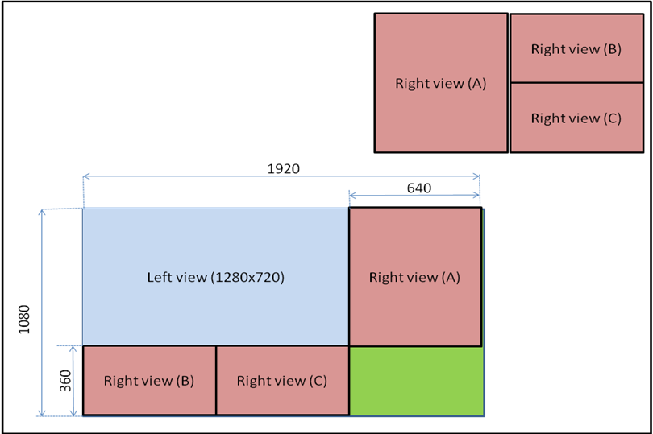Figure 1 - Frame compatible Tile Format
This frame packing format has two relevant features:
- when a native 720p content production is used, the left and right views of a stereoscopic video can be placed within the container 1080p without any subsampling,
- one of the two views, left unchanged, can be used as a 2D video component if a suitable signalling to a 2D decoder is provided.
While a more detailed analysis of the Tile Format is given in Annex A, it is worth to highlight a number of features that characterize this frame packing method and make useful especially in the broadcasting environment.
  - General features of Tile Format (TF)
As already stated above, the Tile Format allows the extraction of a 2D HD (720p) view from the frame compatible format by using proper signaling in the coded bitstream or by means of a suitable application on the receiver.
If the source content is in the 720p format, no subsampling is needed to compose the Tile Format. When the source content is in 1080p format, isotropic subsampling can be applied, preserving the square pels form factor.
The upscaling of the 2D compatible format (720p to 1080p) is supported natively by all the existing Full HD TV sets.
  - Bandwidth requirements of Tile Format (TF)
The bitrate needed for AVC compression is comparable to the birate used for 3D video distribution in SbS or TaB formats. Rate/PSNR measurements are available in the aforementioned Annexes A.
When compared to the simulcast, the Tile Format (like all the frame compatible formats) might appear to be slightly less efficient. The real value of the frame compatible formats is in the fact that they can be treated as a plain HD format, using the existing contribution and distribution infrastructures, while simulcast or MVC would require new infrastructures, designed to transport synchronized pairs of video streams from the stereocameras up to the distribution encoders.
Typical encoders using default configuration options are not able to exploit interview redundancy within the frame compatible formats.
  - Coding artifacts
Annex A provides a detailed analysis of the impact of the tiling in the coding of the Left and Right images. While the Left image (used for 2D backward compatibility) is left unimpaired by the compression process, some artifacts caused by the tiling can be found in the Right view only at low bitrates. A detailed objective analysis, based on PSNR measurements over the stitching lines, confirms that such artifacts disappear at medium/high bitrates.
Moreover, since the human visual system is able to compensate for minor impairments in one of the two views composing the stereoscopic pair, the artifacts present in the Right images are generally well masked after stereoscopic fusion.
- Broadcasting trials
The architecture of the broadcasting trials currently active in northern and central Italy over DVB-T and with continental coverage via satellite, is illustrated in Figure 2.
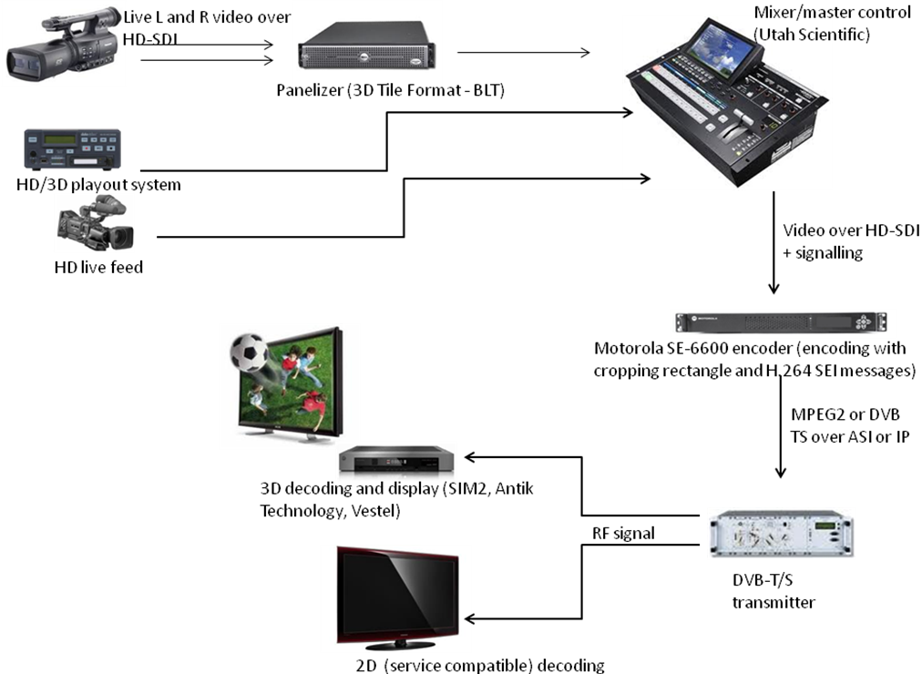
Figure 2 – Broadcasting architecture
As already stated, the Frame Compatible Formats allow the distribution of 3D video contents over existing HD infrastructure. Since the 2D compatible video is in the 720p format, 2D and 3D contents can be seamlessly mixed over the same program, serving at the same time 2D and 3D users. Quartarete TV is currently broadcasting 4 hours of 3D content every day, while Città Digitali is broadcasting 24 hours a day.
The 3D Tile Format operated by Astra is active 4 hours a day.
The video contents broadcast so far include a mix of sport and fashion events, interviews, documentaries and concerts.
Two video encoding formats are being tested:
- 1080p25
- 1080p50
The bitrate available for video encoding over the terrestrial channels is 8 Mbit/s, while on the satellite channel it is 9 Mbit/s.
The video source, therefore, can be either 3D stereoscopic or 2D HD, live or from file based playout system.
The live stereo source is fed to a real time panelizer that composes the Tile Format. The panelizer used in the trials have been prototyped by BLT Italia.
The output from the panelizer (that is a plain HD video stream) is fed to a master control used to switch between a plurality of HD video sources. The master control provides logo/graphics insertion, video transitions (fade-to-black, etc…) over panelized and non panelized video streams. This appliance has been prototyped by Utah Scientific.
The output from the master control is compressed by a custom AVC encoder: it has been manufactured by Motorola starting from a SE6600 platform to enable manual setting of the cropping rectangle SPS parameter and to support the usage of non standard (yet!) frame_packing_arrangement_type values within the SEI signaling, enabling the broadcaster to signal the Tile Format to suitable decoders/receivers.
The stream output from the encoder is multiplexed within terrestrial mux by 4RETE and Città Digitali and assembled in a service bouquet by Astra. The TS is used to modulate according to, respectively, DVB-T and DVB-S Standards and broadcast them free to air.
On the user side, DVB-T/S set top box manufactured by SIM2 Multimedia are being used; furthermore, prototype receivers are being developed: namely a TV set manufactured by Vestel and a DVB-T/S set top box manufactured by ANTIK Technology.. The TV set supports natively the decoding of the Tile Format, the set top boxes convert the Tile Format to one of the so-called “3D frame packing formats” defined by the the HDMI specification.

- Support by the industry
As already illustrated in the above paragraphs, several manufacturers, broadcasters and network operators have been collaborating to the development, testing and deployment of the Tile Format.
The following table provides a list of all the entities willing to support the signaling of the Tile Format within the AVC specification.
Professional equipment manufacturers
Utah Scientific | Video switches and routers
Motorola | Digital head-end appliances and user terminals (STBs)
Hitachi | Professional and consumer video equipment
BLT | Digital Video Servers
CE manufacturers
Antik Technology | STB manufacturer
SIM2 Multimedia | STB and video projector systems manufacturer | High end manufacturer
Vestek | R&D for the Vestel group | Leading European CE manufacturer. Several millions of TV sets and STBs sold every year under more than 360 different trademarks
Broadcasters and network operators
RAI – Radiotelevisione italiana | Italian Public Service Broadcaster
Telecom Italia | Major Italian telco operator
Institut für Rundfunktechnik (IRT) | Joint research center of German speaking public service broadcasters (ARD, ZDF, DRadio, ORF and SRG/SSR)
Tèlè diffusion de France (TDF) | Major European broadcast network operator
DigiKoalice | Alliance of Digital TV Broadcasters in the Czech Republic
Quartarete | Italian regional broadcaster
Città Digitali | Italian regional broadcaster
Academy and research centers
Università di Torino
Politecnico di Torino
CSP Innovazione nelle ICT
Sisvel Technology
- Proposed amendment to the AVC/H.264 specification
The proposed amendment is to extend the number of frame packing arrangements by adding a new format, to be coded as value 6 in table D-8 of the ISO/IEC 14496-10 specification (Definition of frame_packing_arrangement_type). This new value should be defined as illustrated in Figure D-8 (see Figure 2 below).
Proposed amendment to Table D-8 of the ISO/IEC 14496-10
Value | Interpretation
6 | Each component plane of the decoded frames contains a tile format packing arrangement of corresponding planes of two constituent frames as illustrated in Figure D-8.

Figure D-8 (see Figure 2 below) illustrates a typical rearrangement of the Tile Format arrangement scheme.
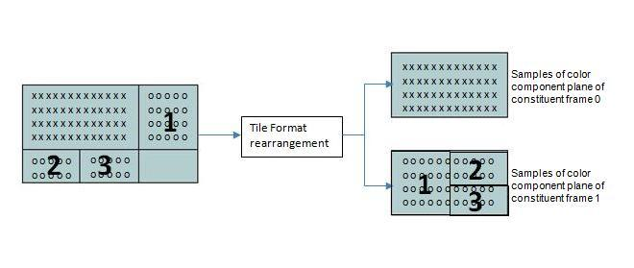
Figure 2 -Figure D-8 Rearrangement and upconversion of tile format packing arrangement (frame_packing_arrangement_type equal to 6 with quincunx_sampling_flag equal to 0)

Annex A – Technical assessment of the Tile Format
A.1 - TF performance compressed according to AVC/H.264
The effects of tiling when using the AVC/H.264 compression standard are evaluated. In particular, the most important phenomena to be investigated are the possible reduction in coding efficiency and the creation of decoding artifacts caused by the artificial edges produced by tiling.
The outline of the experimental testbed is shown in Figure A.1. The stereoscopic sequence, in form of a pair of 720p videos in raw YUV 4:2:0 format, is processed by the Tile Format Composer that outputs a standard 1080p raw video sequence having the same framerate of the input video pair. Several stereo sequences have been used, with framerates of 25 and 50 fps. Then, the 1080p video sequence is encoded and decoded according the AVC standard. Finally, the two 720p views are reconstructed by the Tile Format Decomposer, allowing to compare them versus the original video in terms of Peak Signal to Noise Ratio (PSNR).
Figure A.1 Experimental testbed

The PSNR meter computes the PSNR for the Luma and Chroma components, according to the usual definition of PSNR. For a more precise assessment of the effect of the tiling process, the possibility to evaluate the PSNR locally, on the vertical and horizontal stripes along the stitching lines of the right view, is added. The computation is kept local on a w pixels wide stripe and allows to capture the presence of artifacts due to the composition of the TF frame. In the following, the symbols PSNRV(w) and PSNRH(w) are used to identify the local evaluation of PSNR on the vertical and horizontal stripes, respectively.
It has been noticed that the presence of artifacts can be well correlated with the values PSNRV(w) and PSNRH(w) provided that a small w parameter is selected , e.g. w=6. In fact, larger values of w increase the number of contributions in the computation of the mean square errors, masking the presence of very local artifacts.

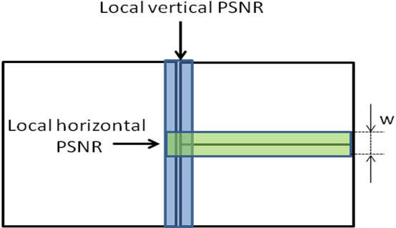Figure A.2 - Local PSNR definitions
The AVC/H.264 encoding/decoding chain is formed by:
- x264 encoder (source code snapshot as of November 11, 2010)
- AVC/H.264 reference decoder (JM 17.1)
The x264 encoder is run with the settings reported in Table A.1.

Table A.1 - AVC/H.264 encoding options
Parameter | Setting
Profile | High
Level | 4.0 or 4.2 (according to the used framerate)
IntraPeriod | 15
GOP structure | Hierarchical
Number of Reference Frames | 4
SearchMode | Fast Search (Hex mode)
Deblocking Filter | ON
CABAC Entropy Coding | ON
Rate Control | ON
A.2 - Experimental results
The experiments have been carried out on two stereoscopic sequences in YUV 4:2:0 raw format, namely:
- Maga: 31 s long animation movie, 2 video streams (L and R) in 720p25 format;
- Las Vegas Fair: 20 s long sequence, 2 video streams (L and R) in 720p50 format
The two stereoscopic sequences have been panelized in the Tile Format and then compressed using AVC. The resulting videos have been decoded and the two views recomposed from the Tile Format. The PSNR of the two views respect to the original source video signals has been calculated.
Furthermore, the two 720p source videos have been compressed independently (simulcast). In this case, half the bitrate of the Tile Format has been used for each view so as to compare the obtained image quality in terms of PSNR for the same overall bitrate. The PSNR for the reconstructed video from the Tile Format and for the simulcast have been plotted as function of the bitrate, so as to evaluate the bandwidth requirements to support this frame compatible format.

It is worth remembering that, as already stated above in this document, even though simulcast might seem slightly to outperform the Tile Format in some cases, the price to be payed is reasonable as compared to the changes in the broadcasting infrastructure needed to support formats that are not frame compatible.
In Figure A.3 and in Figure A.4 the Luma PSNR is reported as a function of the overall coding rate for the left and right view of the Maga sequence. Please note that the horizontal axis refers to the overall bit budget used to encode both views. The obtained results clearly show that the TF does not introduce any coding penalty with respect to simulcast in a wide range of the coding rate from few hundred kbps up to 20 Mbps. In particular, the presence of the artificial edges due to tiling of the right view does not impact on the average coding performance of AVC/H.264.

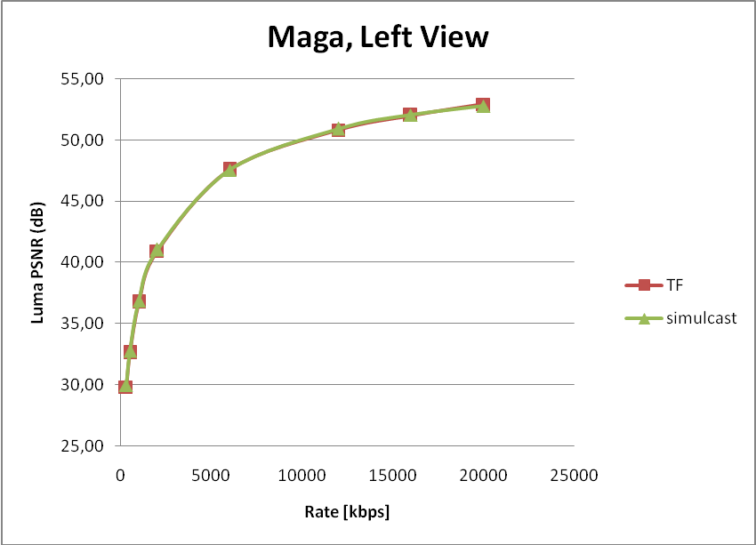
Figure A.3 Maga sequence: Luma PSNR of the left view

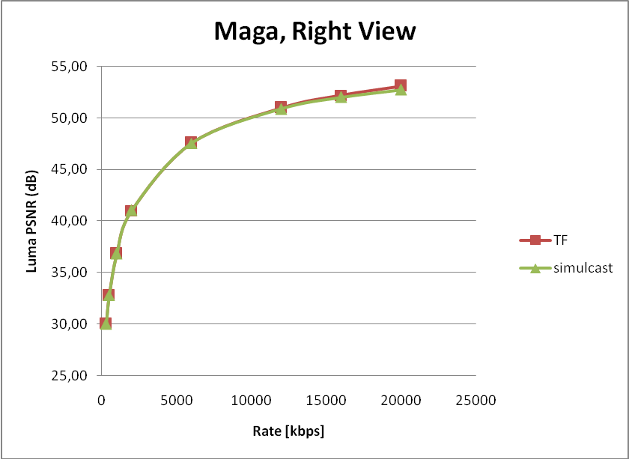
Figure A.4 4 Maga sequence: Luma PSNR of the right view
Figure A.5 and Figure A.6 show the same results for the Las Vegas Fair sequence. Also in this case the average rate distortion performance obtained with the TF technique is equal to the one yielded by the simulcast of the two views.
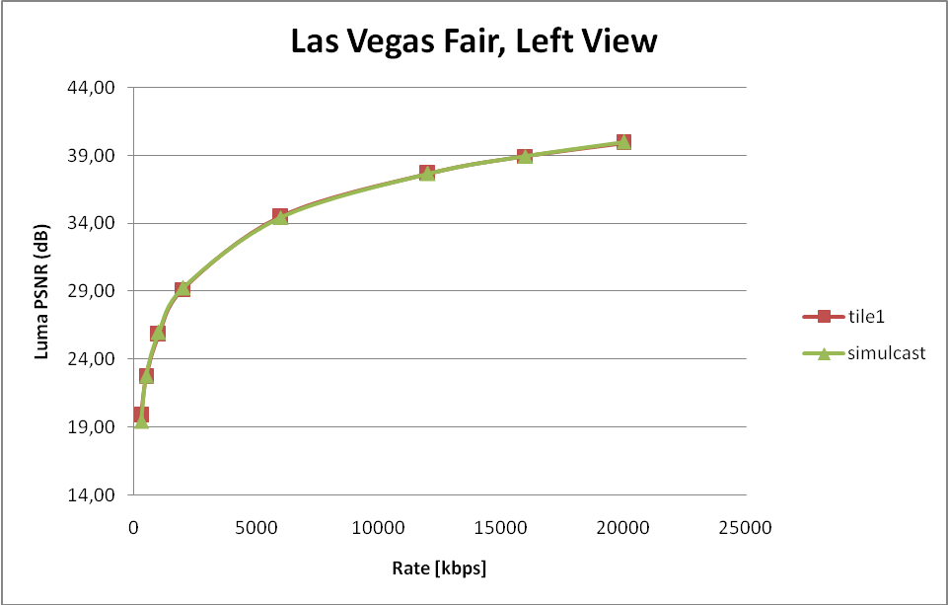
Figure A.5 Las Vegas Fair sequence: Luma PSNR of the left view

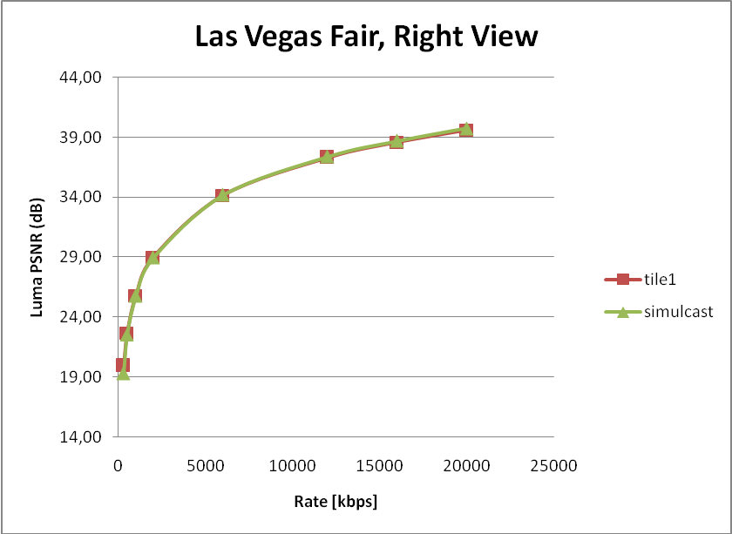
Figure A.6 Las Vegas Fair sequence: Luma PSNR of the right view

Figure A.7 shows the values of PSNRH(w) with w=8 pixels for the Maga sequence (luma component of the right view), i.e. the quality of the image on the horizontal stripe where tiling occurs, versus the overall bitrate. It can be noticed that the horizontal artifact on the TF yields an impairment of less than 1 dB with respect to the simulcast when the bitrate is below 1 Mbps. On the other hand, as far as a reasonable bit rate budget is used for the TF 1080p sequence, the quality on the horizontal stripes of TF and simulcast almost coincides. In Figure A.8 the values of PSNRV(w) with w=8 for the same sequence are reported. It is worth pointing out that also the vertical artifacts do not impair the image quality, if a bitrate higher than 1 Mbps is used for coding the TF sequence. Again, the gap between simulcast and TF at low bitrates, e.g. below 1 Mbps, is less than 2 dB.

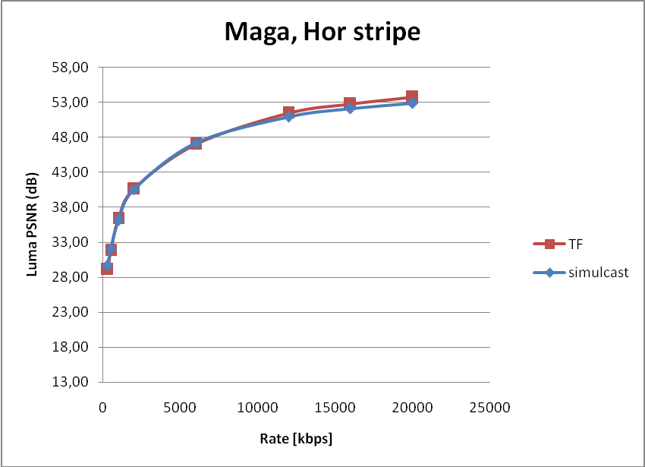
Figure A.7 Maga sequence: Luma PSNR on horizontal stripe

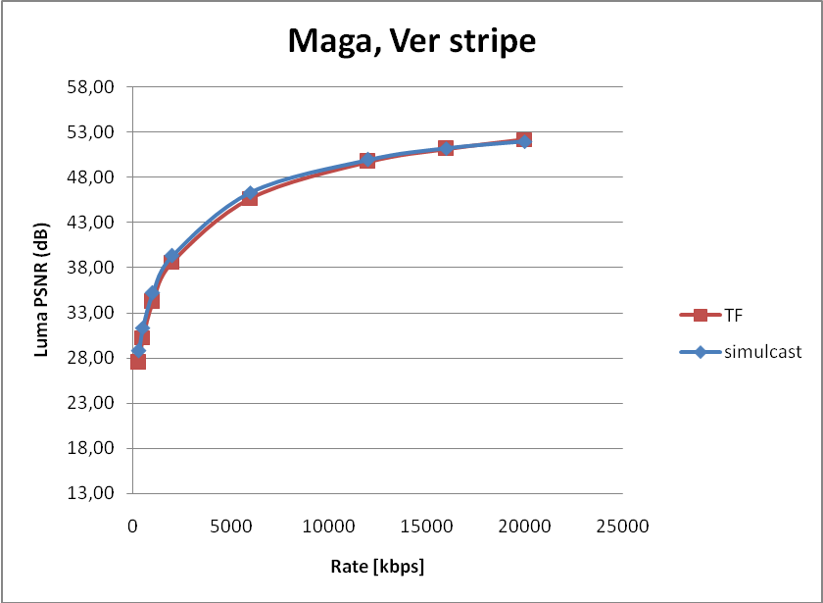
Figure A.8 Maga sequence: Luma PSNR on vertical stripe

Very similar results have been obtained for the Las Vegas Fair sequence; they are omitted for conciseness.
Finally, a set of snapshots (Figures A.9-A.12) of the right view of the tested sequences are provided to show the effect of tiling in terms of subjective quality. Figures A.9 and A.10 report a frame zoomed in the bottom-right corner to better appreciate the presence of compression artifacts (indicated by the white arrow). The same frame compressed at 2 Mbps and 12 Mbps is shown for comparison. Figures A.11 and A.12 report a frame from the sequence Maga. Again, the same frame is shown compressed at 1 and 5 Mbps for comparison. It can be noted that the horizontal and vertical artifacts are visible only for the lowest bitrate. The artifacts are clearly due to the fact that the compression/quantization errors are correlated with the signal; as a first approximation the compression errors can be highly correlated with the coding mode selected by the AVC/H.264 encoder for a given macroblock. In the simulcast case adjacent macroblocks of the right view tend to be coded with the same or similar coding modes yielding similar compression artifacts. On the contrary, the macrobloks along the stitching lines are not adjacent in the TF frame thus being affected by potentially different compression impairments. The presence of statistically different compression artifacts on the right view after recomposition of the original 720p picture may be annoying for the human eye. Nevertheless, such compression impairments can be noted only at low bitrates (not used for professional broadcasting), i.e. low overall video quality.

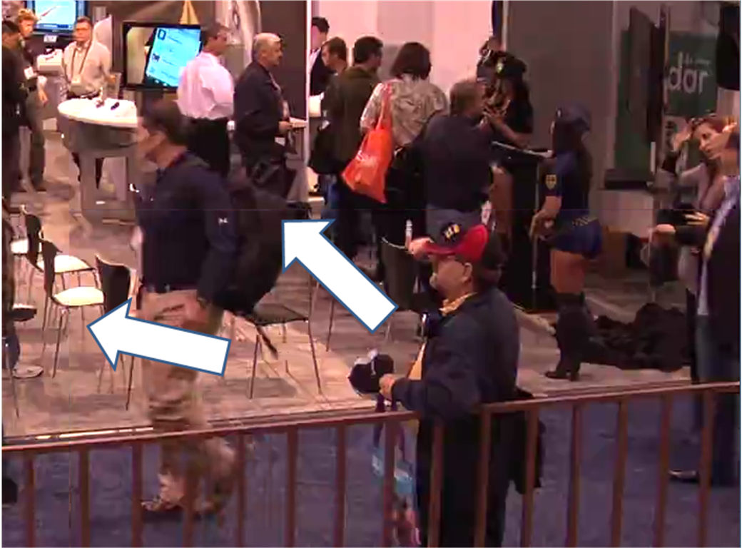
Figure A.9 Las Vegas Fair zoomed snapshot, 2 Mbps

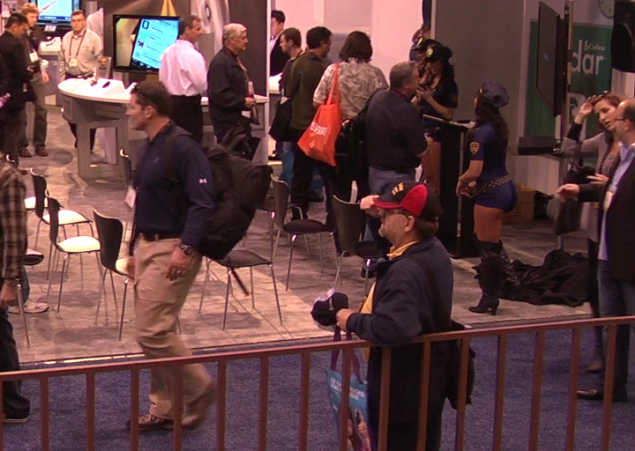
Figure A.10 Las Vegs Fair zoomed snapshot, 12 Mbps
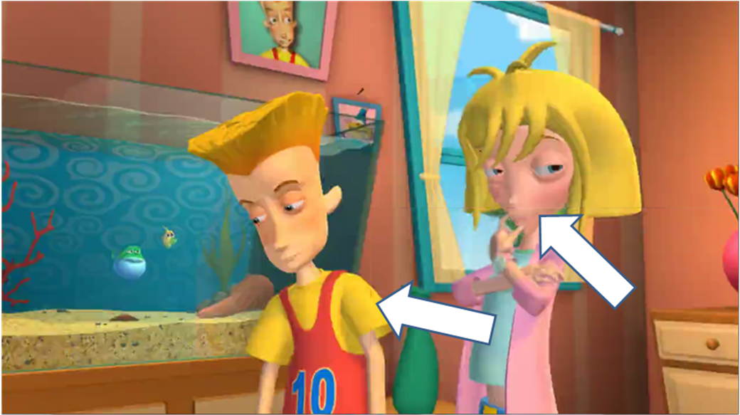
Figure A.11 Maga zoomed snapshot, 1 Mbps


Figure A.12 Maga zoomed snapshot, 6 Mbps

A.3 – Conclusions on experimental results of TF performance
The experimental results made for assessing the effects of tiling on the AVC/H.264 compression of HD stereo video sequences allows to validate the TF performance and to conclude that:
- the tile format approach does not impair the compression performance in terms of average rate distortion results, with respect to the simulcast of two 720p sequences;
- the use of the tile format yields some compression artifacts on the right view at low coding rates, i.e. below 1 Mbps;
- the use of the tile format does not impair the image quality at medium/high bit rates (i.e. typical bitrates used in the broadcast scenario).

