ITU - Telecommunications Standardization Sector  STUDY GROUP 16 Question 6  Video Coding Experts Group (VCEG)  29th Meeting: Bangkok, Thailand, 16-20 January, 2006 | Document VCEG-AB06  Filename: VCEG-AB06.doc

Question: | Q.6/SG16 (VCEG)
Source: | Matthias Narroschke  Institut für Informationsverarbeitung  Universität Hannover  Appelstr. 9a  30167 Hannover  Germany  Hans Georg Musmann  Institut für Informationsverarbeitung  Universität Hannover  Appelstr. 9a  30167 Hannover  Germany | Tel:  Fax:  Email:  Tel:  Fax:  Email: | +49 511 762 5304  +49 511 762 5333  narrosch@tnt.uni-hannover.de  +49 511 762 5317  +49 511 762 5333  musmann@tnt.uni-hannover.de
Title: | Adaptive prediction error coding in spatial and frequency domain for H.264/AVC
Purpose: | Proposal
_____________________________

Abstract
H.264/AVC is based on hybrid coding using motion compensated prediction and transform coding of the prediction error. The transform is efficient if the prediction error samples are correlated. For marginally correlated samples the transform is inefficient. In this contribution, adaptive prediction error coding in the spatial and frequency domain is proposed. In the spatial domain, scalar quantization and entropy coding using CABAC is applied. For each block of the prediction error, either standardized transform coding or spatial domain coding is used. The algorithm with lower rate-distortion costs is chosen. Furthermore, it is proposed to combine the adaptive coding with a displacement vector resolution of 1/8-pel, which further reduces the correlation between the prediction error samples and is therefore a benefit for the coding in the spatial domain. For QCIF, CIF, and SDTV the PSNR is increased by up to 0.4 dB and for HDTV by up to 0.02 dB by the adaptive coding compared to H264/AVC at the same bit rate. In combination with a displacement vector resolution of 1/8-pel, the PSNR is increased by up to 1 dB for QCIF, CIF, and SDTV and by up to 0.05 dB for HDTV.

Introduction
In H.264/AVC [1], the temporal redundancy is reduced by the use of predictive coding. In order to predict the current image signal $s$, a prediction image signal $\hat{s}$ is obtained from already reconstructed images by using block based motion estimation and motion compensated prediction. A displacement vector $\vec{D}$ is assigned to each block referring to the position of the block in an already reconstructed image. The prediction error signal $e$ and the displacement vector $\vec{D}$ are encoded and transmitted. In order to reduce the spatial redundancy of the prediction error signal, transform coding is applied blockwise. The blocksize of the transform is 4x4 or 8x8 picture elements. The coefficients $c$ are quantized with the step size controlled by the quantization parameter QP. The quantized coefficients $c^{'}$ are zigzag scanned starting at the DC-coefficient resulting a 1D array. This array is entropy-coded by CABAC [2], which is optimized for an array of coefficients with decreasing energy. The coding efficiency of the transform is high if the prediction error samples $e$ are correlated. For marginally correlated samples the transform is inefficient. Therefore, it is proposed in this contribution to code the prediction error in the spatial domain as depicted in Figure 1. Each prediction error block is either coded in spatial or in the frequency domain. The information about the domain is sent as side information.
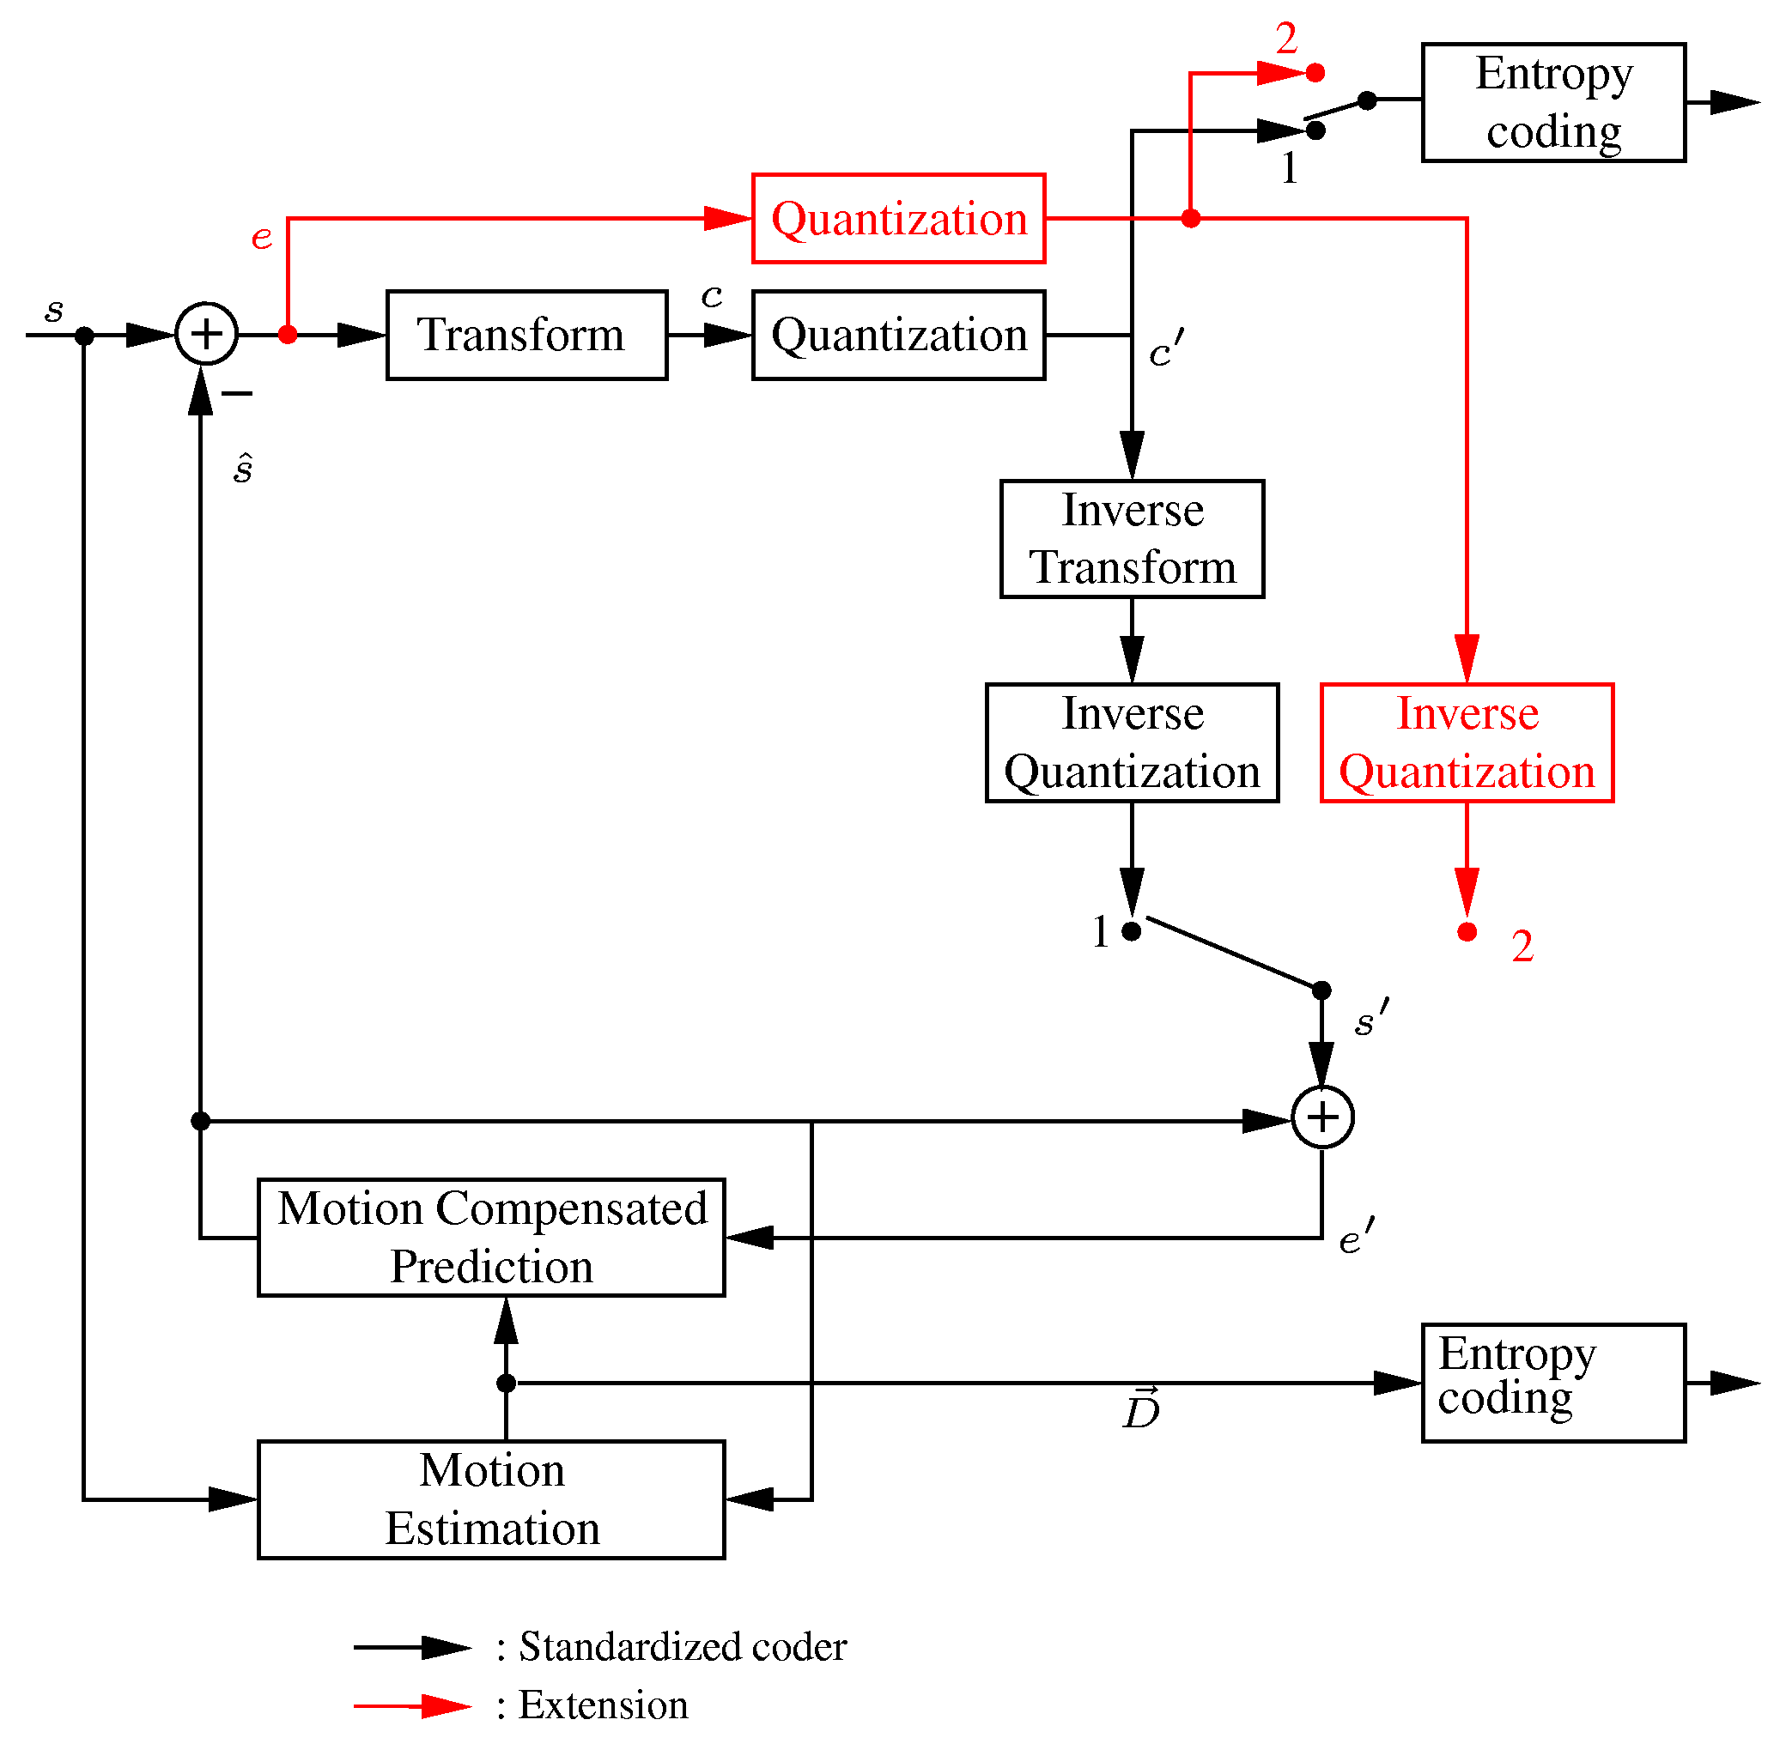
Figure 1. Block diagram of the proposed hybrid video encoder.

Quantizer design in the spatial domain
H.264/AVC supports rate distortion optimized quantization of the coefficients $c$ with two different distortion measures. The first measure is the mean squared quantization error, the second one is the subjectively weighted quantization error which is realized by the use of quantization weighting matrices. Correspondingly, two scalar quantizers are designed for the spatial domain. Since the distribution of the prediction error $P\left(e\right)$ is close to a Laplacian distribution, as shown in Figure 2, a scalar dead-zone plus uniform threshold quantizer is used in the case of mean squared quantization error optimization as proposed in [3].
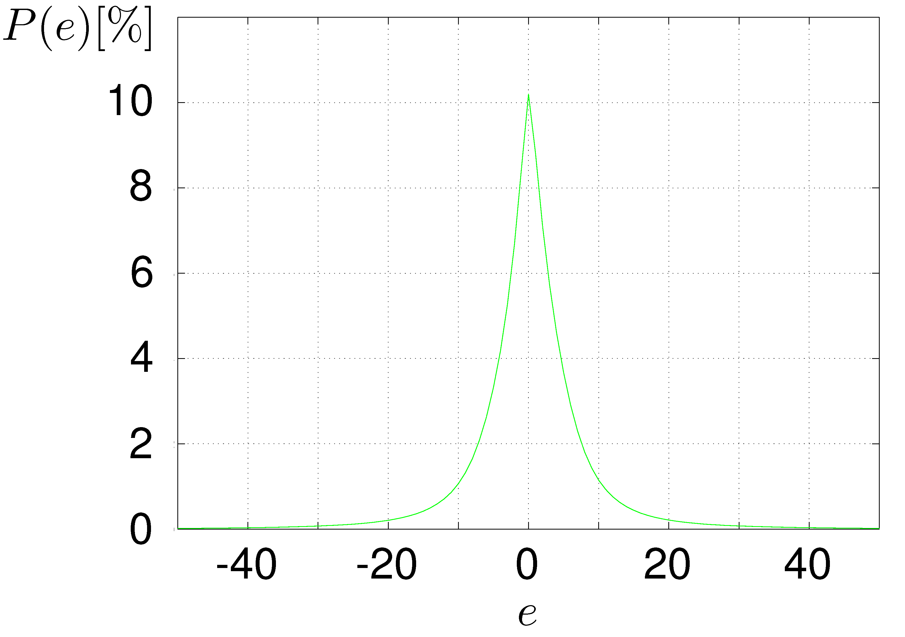
Figure 2: Measured distribution of the prediction error for the quantization parameter QP=23.
Figure 3 visualizes the parameters $\text{s,z}$ and $Δ$ of the quantization and inverse quantization. For each quantization parameter QP, an individual quantizer is designed. Table 1 shows the parameters $\text{s,z}$ and $Δ$ for commonly used QPs. In the case of subjectively weighted quantization error optimization, a non uniform quantizer is applied with representative levels $r_{i}$, $−r_{i}$ and decision thresholds in the middle of adjacent $r_{i}$, which are also shown in Table 1. In this case, visual masking [4] that occurs at luminance edges is exploited. Consequently, large quantization errors are allowed at edges, small ones if the image signal is flat. In Figure 3, the measured mean absolute reconstruction error $\overline{|q_{\text{FD}}(|e|)|}$ of subjectively weighted quantization in the frequency domain is shown for each absolute value of the prediction error $|e|$. It also shows the absolute reconstruction error of subjectively weighted quantization in the spatial domain $|q_{\text{SD}}(|e|)|$. The representative levels $r_{i}$ are adjusted such that the mean absolute reconstruction error is the same for quantization in the frequency and in the spatial domain with respect to the quantization intervals in the spatial domain.

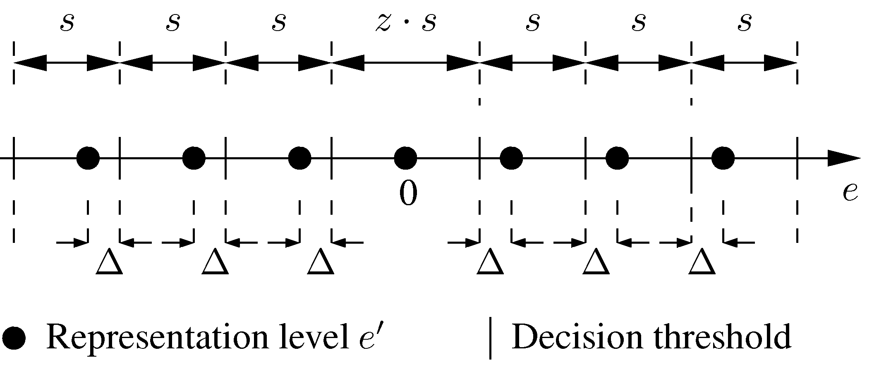
Figure 3. Quantizer characteristic for the spatial domain coding in the case of mean squared error optimization.
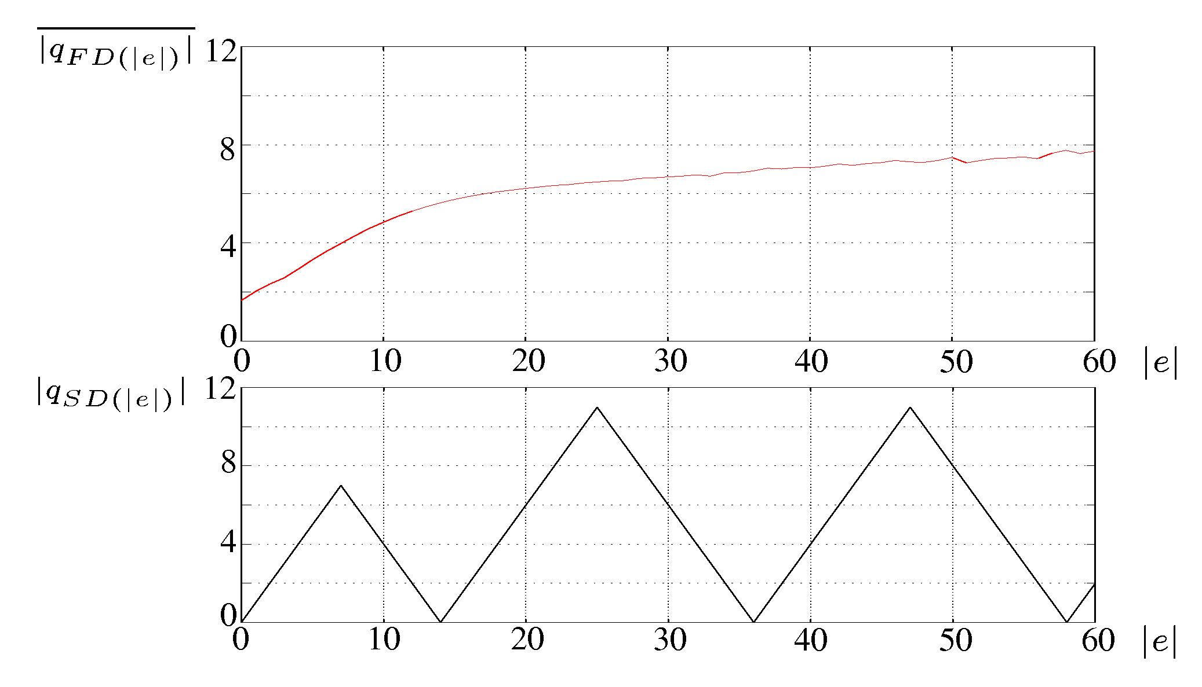
Figure 4. Measured mean absolute reconstruction error$\overline{|q_{\text{FD}}(|e|)|}$of subjectively weighted quantization in the frequency domain and absolute reconstruction error$|q_{\text{SD}}(|e|)|$of subjectively weighted quantization in the spatial domain versus absolute value of the prediction error $|e|$.

Table 1. Parameters $\text{s,z}$ and $Δ$ of the quantizer in the case of mean squared error optimization and representative levels $r_{i}$ of the quantizer in the case of subjectively weighted quantization error optimization.
QP | $$s$$ | $$z$$ | $$Δ$$ | $$r_{1}$$ | $$r_{2}$$ | $$r_{3}$$ | $$r_{4}$$ | $$r_{5}$$
23 | 9.6 | 1.6 | 2.7 | 0 | 11 | 28 | 46 | 66
26 | 14.8 | 1.4 | 4.8 | 0 | 14 | 36 | 58 | 110
29 | 22.2 | 1.4 | 6.9 | 0 | 20 | 54 | 92 | 148
32 | 30.2 | 1.4 | 9.3 | 0 | 28 | 76 | 130 | 220

Entropy coding
For entropy coding of the quantized samples in the spatial domain also CABAC is used as for the coding of the quantized coefficients in the frequency domain. However the scan is changed. The scan in the spatial domain is controlled by the magnitude of the gradient $G_{\hat{s}}$ of the prediction image $\hat{s}$ at the same spatial position (see Figure 5). The samples to be coded are arranged in an order of decreasing gradients $G_{\hat{s}}$. The magnitude of the gradient at a spatial position x,y is calculated by:
$G_{\hat{s}}(x,y)=\sqrt{g_{x}^{2}(x,y)+g_{y}^{2}(x,y)}$ with
$g_{x}^{2}(x,y)=\frac{1}{8}\left[2\hat{s}(x+1,y)+\hat{s}(x+1,y−1)+\hat{s}(x+1,y+1)−2\hat{s}(x−1,y)−\hat{s}(x−1,y−1)−\hat{s}(x−1,y+1)\right]$$g_{y}^{2}(x,y)=\frac{1}{8}\left[2\hat{s}(x,y+1)+\hat{s}(x+1,y+1)+\hat{s}(x−1,y+1)−2\hat{s}(x,y−1)−\hat{s}(x+1,y−1)−\hat{s}(x−1,y−1)\right]$
Furthermore, separate probability models are used in the spatial domain whereas the initialization of the models is derived from the statistic of the quantized samples. The context modeling is done in the same way as in the frequency domain.

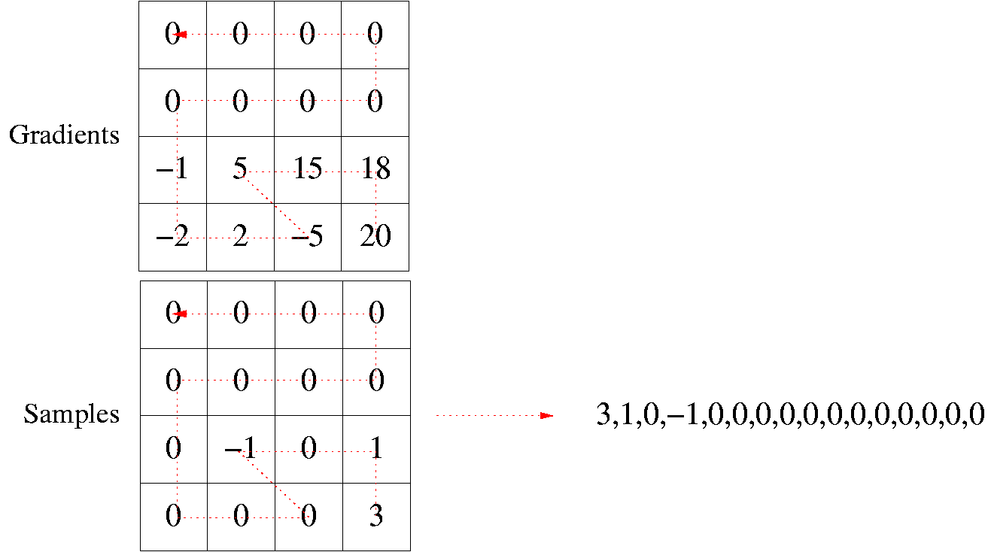
Figure 5: Scan of quantized samples in the spatial domain according to the magnitude of the gradient in the prediction image at the same spatial position.

Coding of the side information

For each individual slice, a flag in the slice header indicates if all blocks of the slice, which are of the size 4x4 or 8x8 picture elements, are coded in the frequency domain or if at least one block is coded in the spatial domain. This flag is coded by one bit.
If at least one block of the current slice is coded in the spatial domain it is indicated by a flag for each individual macroblock of the current slice if all blocks of the current macroblock are coded in the frequency domain or if at least one block is coded in the spatial domain. This flag is coded conditioned by the flags of the already coded neighboring macroblocks to the top and to the left.
If at least one block of the macroblock is coded in the spatial domain, it is indicated by a flag for each block of the macroblock if coding in the frequency or in the spatial domain is applied. This flag is coded conditioned by the flags of the already coded neighboring blocks to the top and to the left.

Coder control
For all luminance prediction error blocks of each macroblock either coding in the frequency and in the spatial domain or coding exclusively in the frequency domain is applied according to the lower rate-distortion costs.
All chrominance blocks are coded in the frequency domain.

Displacement vector resolution of 1/8-pel
It is proposed to increase the resolution of the displacement vectors from ¼-pel to 1/8-pel as described in detail in [5][6][7]. During the standardization activities of H.264/AVC, this technique has already been incorporated in former versions of the reference software until version JM43a [8]. The increased resolution further improves the motion compensated prediction and reduces the correlation between prediction error samples, which is a benefit for the coding in the spatial domain.

Experimental results

For experimental investigations, the adaptive prediction error coding is integrated into version JM98 of the reference software of H.264/AVC. High Profile with CABAC and 5 reference frames is applied. In the case of progressive video sequences, the frame structure I B RB B P … and in the case of interlaced video sequences the frame structure I B B P … is used. For interlaced video sequences, picture adaptive frame-field coding is applied. Rate-distortion optimization in the “High Complexity Mode” is turned on. Both kinds of quantization are testet. In the Figures below, operational rate-distortion curves are shown for the mean squared quantization error optimization for various test sequences with the spatial resolutions QCIF, CIF, SDTV, and HDTV. The operational rate distortion curves measured for the mean squared quantization error optimization and for the subjectively weighted quantization error optimization are approximately the same. For QCIF, CIF, and SDTV, the PSNR is increased by up to 0.4 dB by the adaptive coding compared to H264/AVC at the same bit rate. For HDTV, the PSNR is increased by up to 0.02 dB. In combination with 1/8-pel displacement vector resolution, the PSNR is increased by up to 1 dB for QCIF, CIF, and SDTV and by up to 0.05 dB for HDTV.

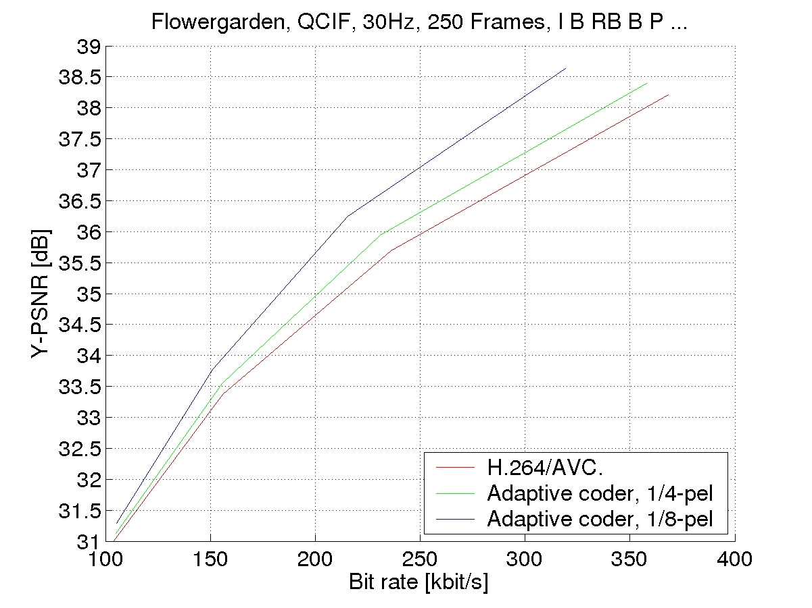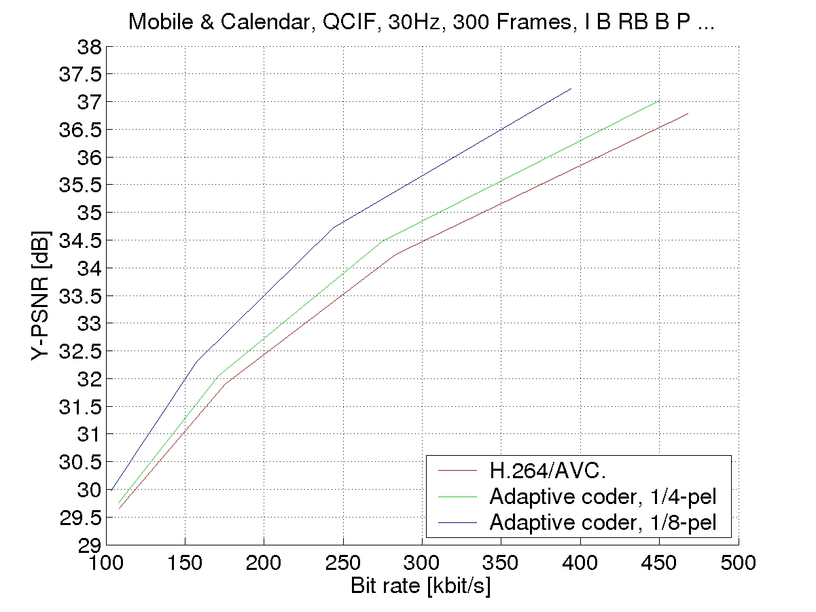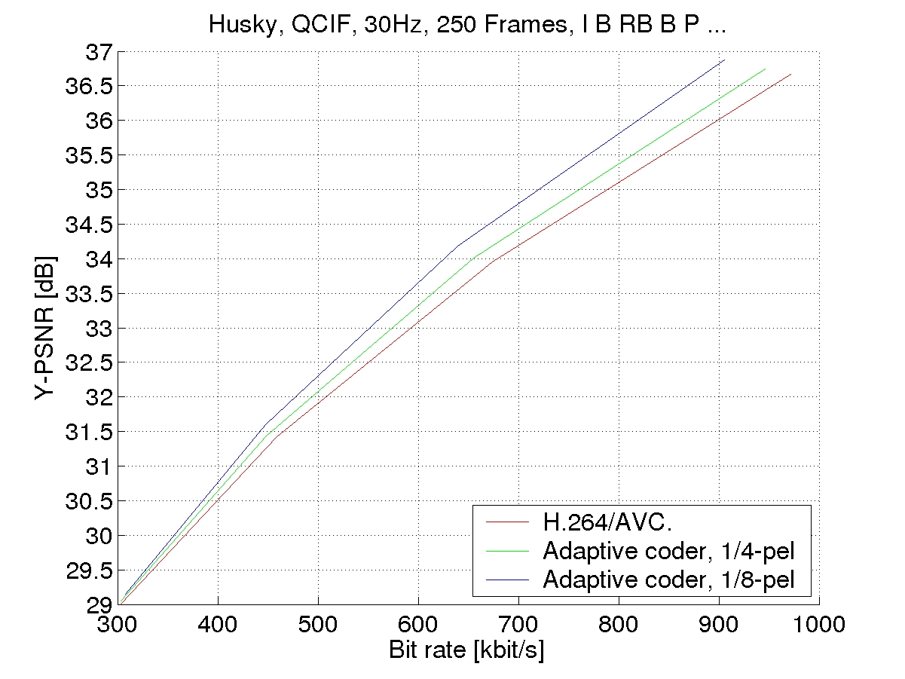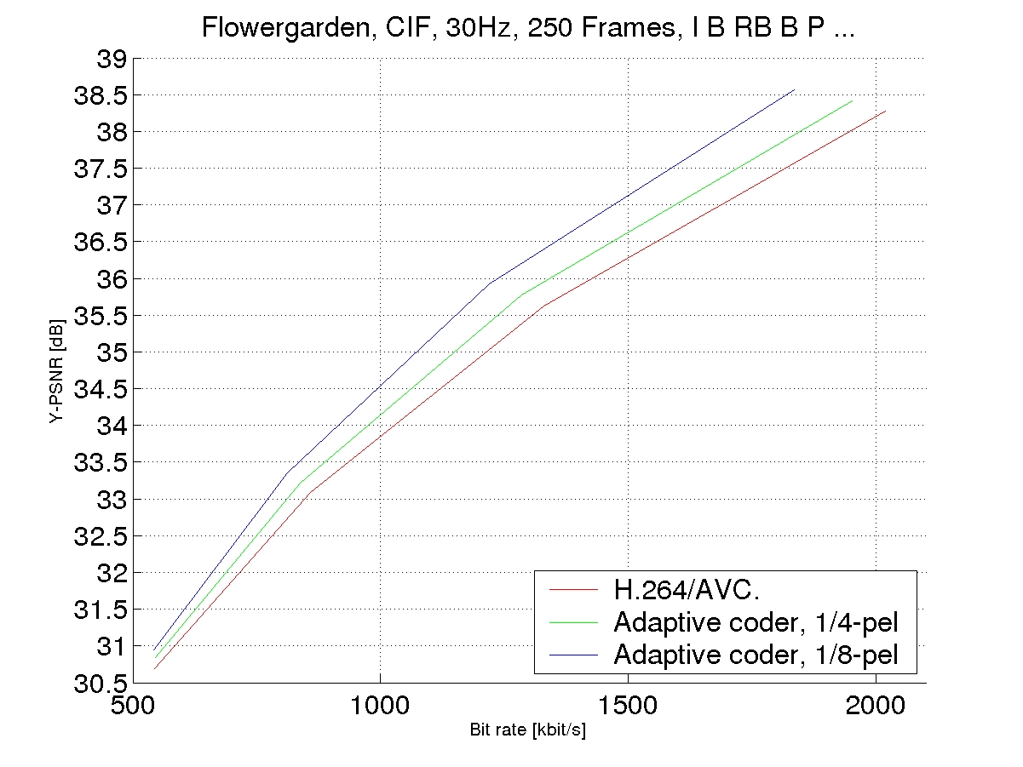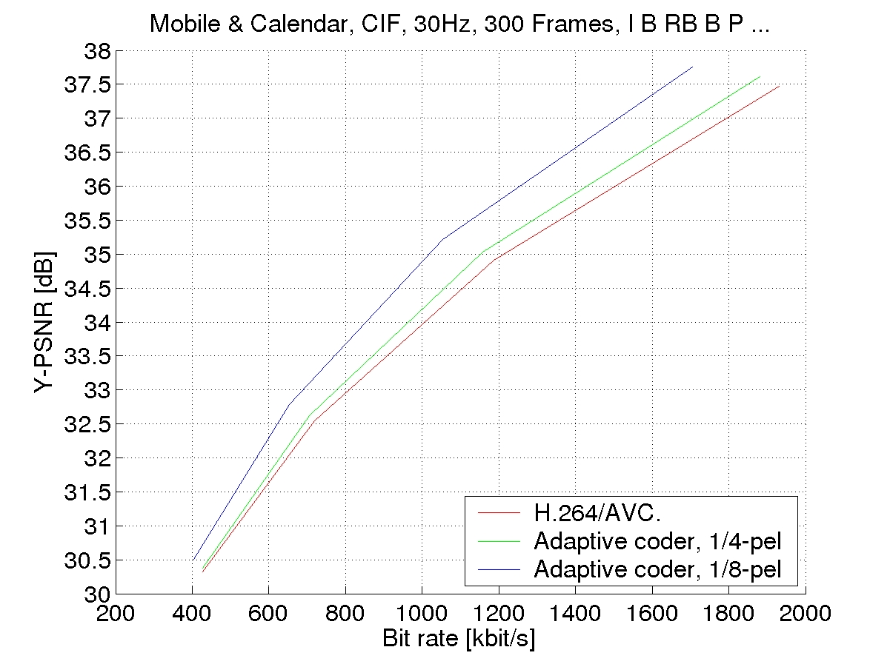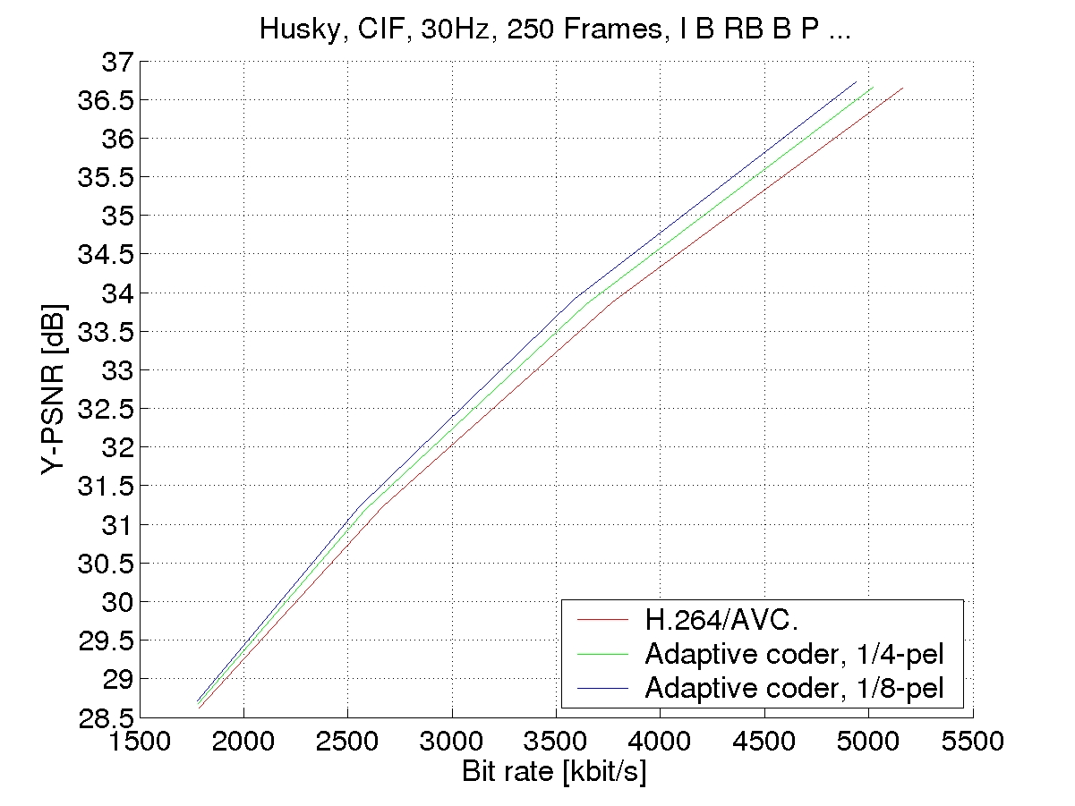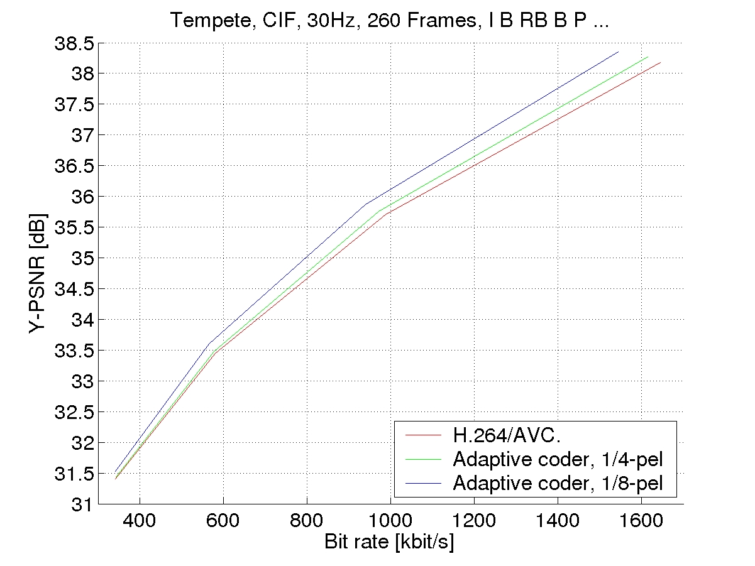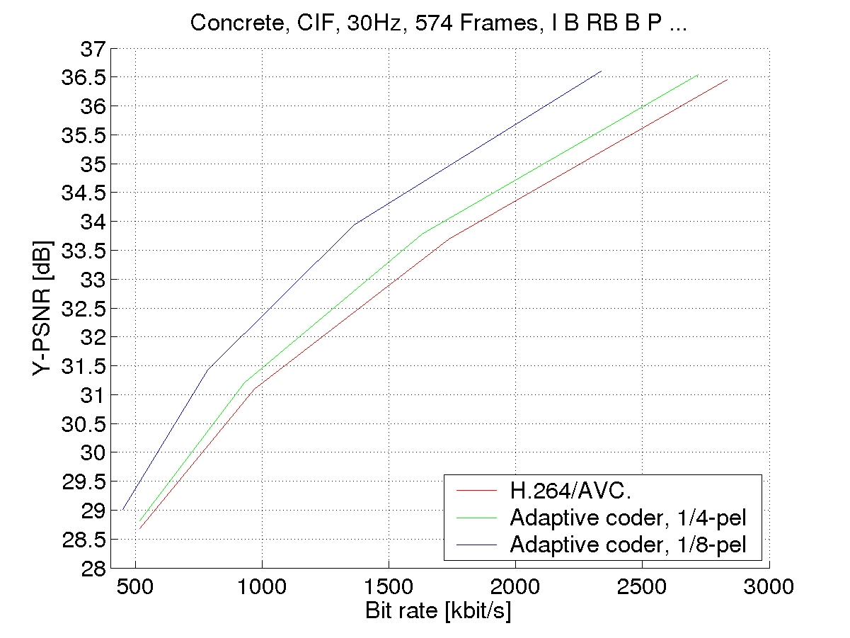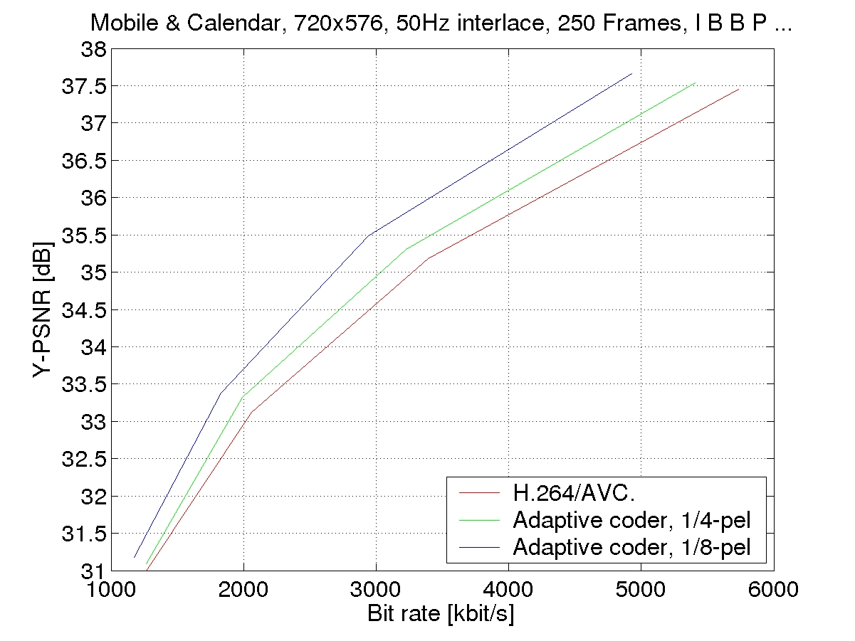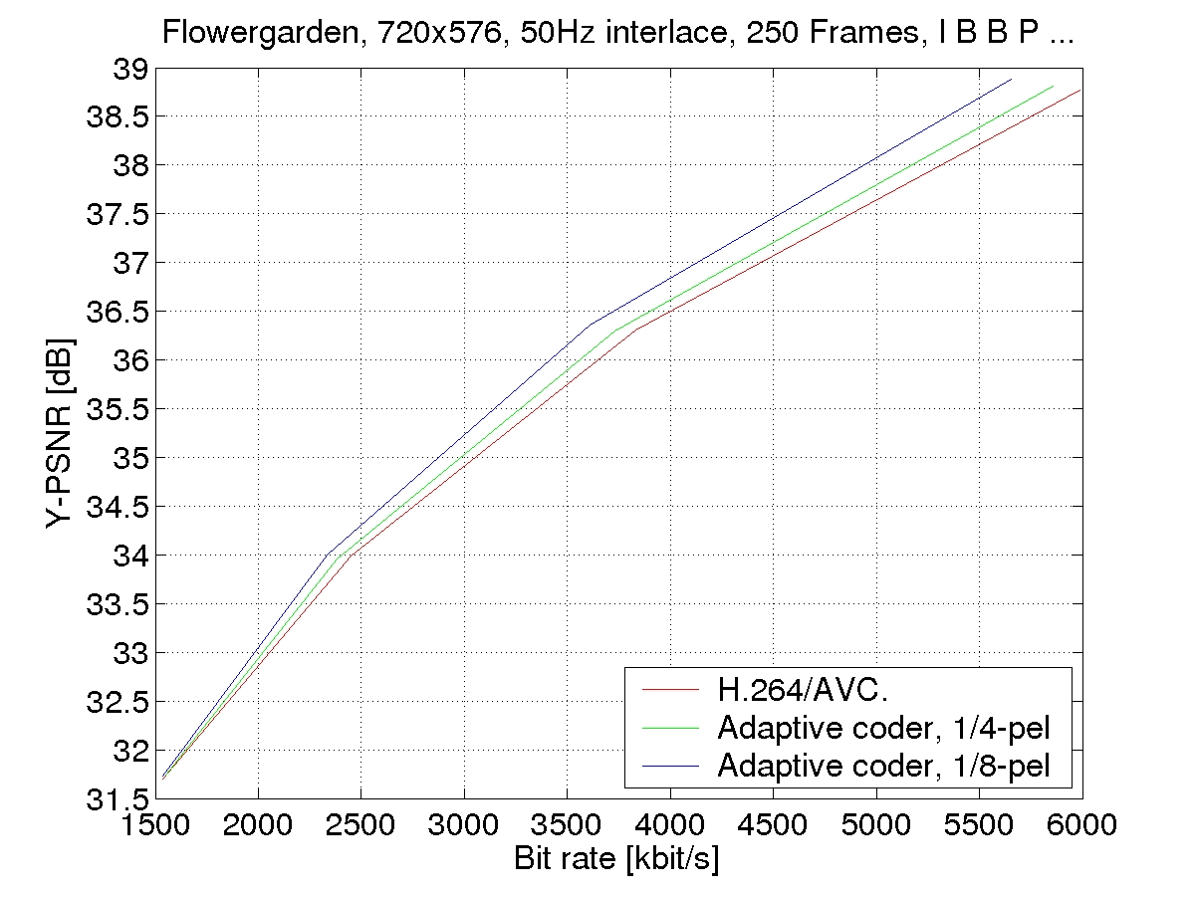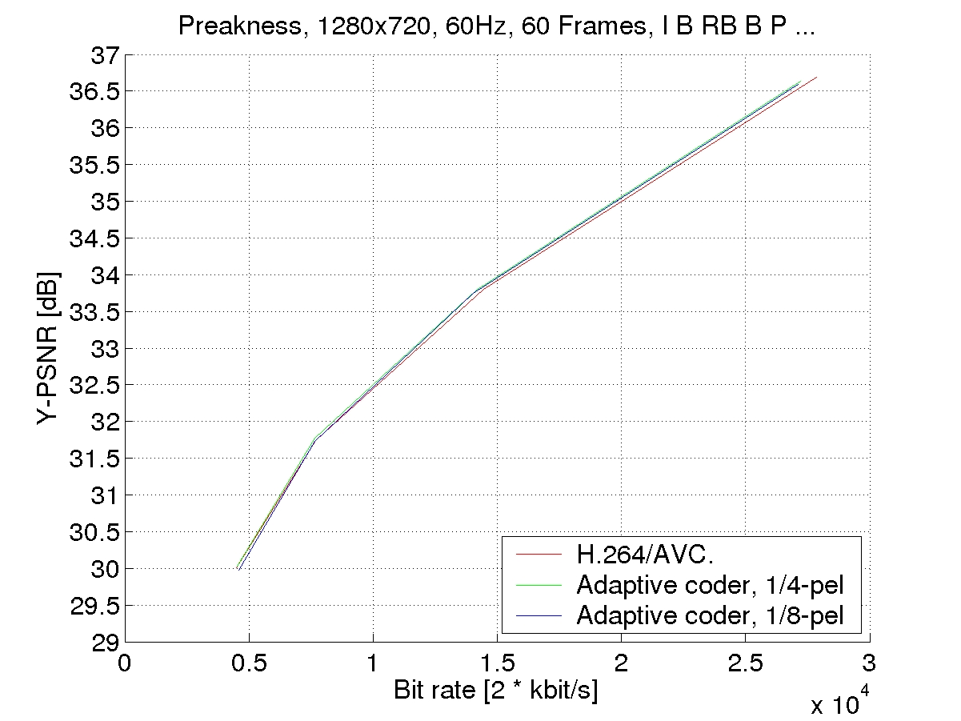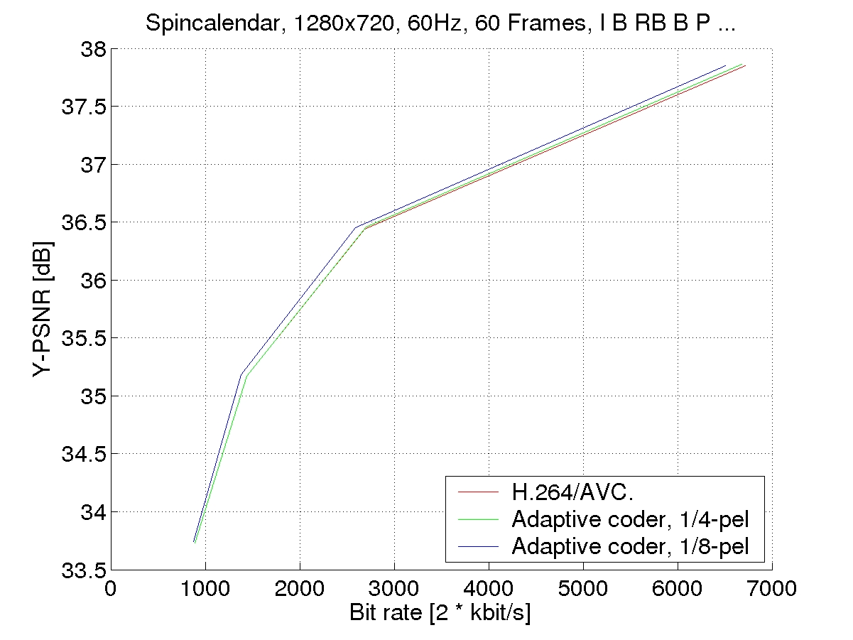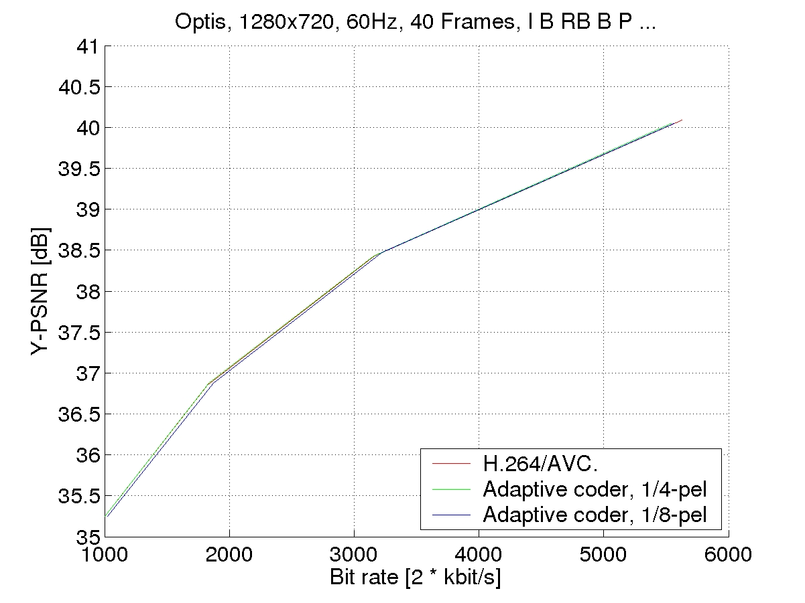

References

- ISO/IEC 14496-10:2003, “Coding of Audiovisual Objects - Part 10: Advanced Video Coding'', 2003, also ITU-T Recommendation H.264 ``Advanced video coding for generic audiovisual services”.
- D. Marpe, H. Schwarz und T. Wiegand, “Context-Based Adaptive Binary Arithmetic Coding in the H.264/AVC Video Compression Standard”, IEEE Transactions on Circuits and Systems for Video Technology, vol. 13, pp. 620-636, July 2003.
- G. J. Sullivan, S. Sun, “On Dead-Zone Plus Uniform Threshold Scalar Quantization”, Proceedings of VCIP 2005, Beijing, 2005.
- A. Fiorentini, M.T. Zoil, “Detection of a Target Superimposed to a Step Pattern of Illumination. II. Effects of a Just-Perceptible Illumination Step”, Atti. Fond. G. Ronchi, 22, pp. 207-217, 1967.
- T. Wedi, H.G. Musmann, “Motion- and Aliasing-Compensated Prediction for Hybrid Video Coding”, IEEE Transactions on Circuits and Systems for Video Technology, vol. 13, pp. 577-586, July 2003.
- T. Wedi, “1/8-pel Displacement Vector Resolution for Interlaced Video Coding”, Joint Video Team (JVT), doc. JVT-B066, Geneva, CH, Jan. 2002.
- T. Wedi, “Advanced Motion Compensated Prediction Methods”, ITU-T Q.6/SG16, doc. VCEG-X10, Palma de Malloca, Spain, Oct. 2004.
- Reference software of H.264/AVC, version JM43a, downloadable at http://iphome.hhi.de/suehring/tml/download/old_jm/jm43a.zip

