ITU - Telecommunications Standardization Sector  STUDY GROUP 16 Question 6  Video Coding Experts Group (VCEG)  26th Meeting: Busan, KR, 16-22 April, 2005 | Document VCEG-Z16  Filename: VCEG-Z16.doc

Question: | Q.6/SG16 (VCEG)
Source: | Woo-Shik Kim,  Dmitry Birinov,  Dae-Sung Cho,  Hyun Mun Kim  Computing Lab. Samsung AIT  P.O.Box 111, Suwon 440-600  Korea | Tel:  Fax:  Email: | 82-31-280-9204  hyunmun27.kim@samsung.com
Title: | Enhancements to RGB coding in H.264/MPEG-4 AVC FRExt
Purpose: | Proposal
_____________________________

Introduction

A new RGB coding technology called “Residual Color Transform” had been developed in the course of standardization of the H.264/MPEG-4 AVC Fidelity Range Extensions (FRExt) [1]. This RGB coding tool is to support high fidelity in professional applications such as digital cinema, professional television production, and post production markets.
In this document, we propose some improvements on the residual color transform to elevate the efficiency of the RGB coding. This is to suggest a new work item of advanced high-fidelity video coding for the next standard. We think that the advanced high-fidelity video coding methods including lossless and near lossless are getting important not just in the professional industry but also in the consumer industry as high-resolution flat panel displays and high quality 3-CCD digital cameras increase.

Residual color transform

High-level block diagram of video system with residual color transform (RCT)

The residual color transform (RCT) is a coding tool in H.264/MPEG-4 AVC High 4:4:4 profile [1] for efficient coding of RGB video sequences. The high-level block diagram of RGB coding using the RCT is shown in Error: Reference source not found. In the conventional system, the captured RGB data is converted into other color space such as YCbCr for encoding. After decoding, the reconstructed YCbCr data is converted back to RGB for display. During these conversions, the color distortion is inevitable due to the rounding error involved. As shown in Fig 1, RGB coding using the RCT enables compression in the RGB space directly. This results in the reduction of the color distortion while maintaining or improving the compression efficiency.

Residual color transform (RCT)

To effectively eliminate the correlation among three color components at once, we applied the YCgCo transform [2] to the residual data after intra/inter prediction. The YCgCo transform has advantages of low-complexity integer transform and invertible feature when the lossless coding is desired. Since this transform is applied to the residual data of the RGB color components as shown in Error: Reference source not found, we named it as “residual color transform (RCT)”.
Below are the forward and backward RCT equations:

Fig. 1 High-level block diagram of video system with RCT in MPEG-4 AVC/H.264 FRExt

Forward: Backward:

where ΔX and ΔX' denote the intra/inter predicted and reconstructed residual values, respectively, and Δ²X and Δ²X' denote the residual color transformed and reconstructed signals, respectively. The notation “>>” denotes the right shift operation, which approximates a division by 2. Note that the variable t is used for the temporary calculation purpose.

Enhancements to RGB Coding

Inter-plane prediction (IPP)

In the previous section, we briefly introduced the current RCT scheme of the H.264/MPEG-4 AVC FRExt. In this section, we further analyze the correlation among color components, and derive a new method to reduce this correlation to achieve the coding efficiency.
To increase the coding efficiency in RGB space, we exploit the redundancy between color components after intra/inter predictions. The intra prediction utilizes the spatial correlation while the inter prediction uses the temporal correlation. To see whether there is still redundancy between color components after the intra/inter prediction, we plot the correlation between the residual signals of each component. As shown in Fig. 1, after the intra/inter prediction, there still exists very strong correlation between residual images of each color components. To reduce this redundancy we applied linear regression predictor. Our experimental data showed identity function is good enough. So we subtracted the reconstructed G residue image from the R and B residual images. We named this prediction as “inter-plane prediction (IPP)” [3-7].
The equations for the forward and backward IPP operations are:

Encoding: Decoding:

where ΔX denotes the intra/inter predicted residual value, ΔX' denotes the reconstructed residual value, and Δ²X and Δ²X' denote the inter-plane predicted and reconstructed signals, respectively.
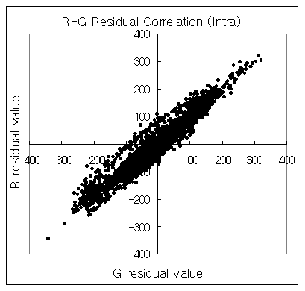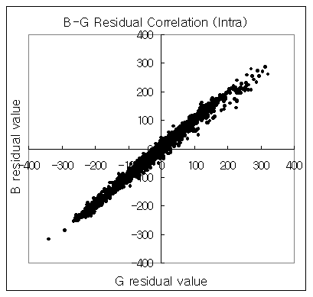
(a) (b)

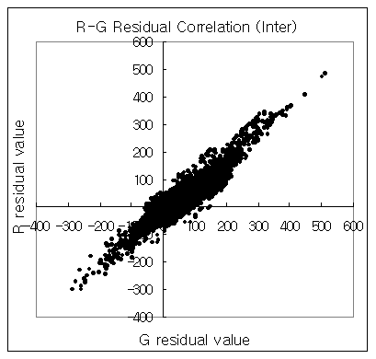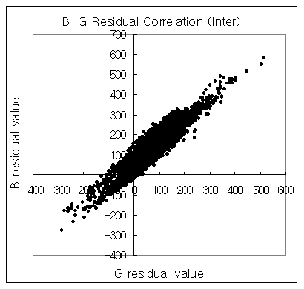
(c) (d)

Fig. 1 Inter-color correlation between residual components. (a) and (b) show the correlation of the intra predicted residual signals, where (a) shows the correlation between R and G residual values and (b) shows that of B and G residual values. (c) and (d) show the correlation of the inter predicted residual signals, where (c) shows the correlation between R and G residual values and (d) shows that of B and G residual values.
Therefore, the RGB video could be directly coded by intra/inter prediction that uses the spatial/temporal correlation of each color component, followed by the inter-color-component prediction on the residual data. The IPP method gives higher coding efficiency than the RCT does in the relatively higher bit-rates. So it is useful to apply the IPP and the RCT methods adaptively based on the bit-rates or the characteristic of the coded sequences.

Single mode prediction

If all color components have their own motion vector in the inter prediction, the residual data of each color component would have different characteristics, which result in less correlation among the residual data of different color components. Therefore, it is important to use the same motion vector and same prediction mode for all color components to get high correlation among the residual data. It also gives natural look when RGB data has similar texture characteristics. Since the current MPEG-4 AVC/H.264 video coding method [1] already uses the same motion vector for the luma and chroma data, the IPP and RCT methods take an advantage of strong correlation among the color components.
This is also true for the intra prediction case. For example, in the MPEG-4 AVC/H.264 video coding method [1], there are 9 modes of 4×4 intra prediction and 4 modes of 16×16 intra prediction for luma component, and 4 modes of 8x8 prediction for chroma components. Since the prediction modes of luma are different from those of chroma, the correlation becomes weak. This would not be optimal for RCT and IPP or for similar in-loop transforms. Hence it is better to use the same intra prediction mode for all color components to increase the coding efficiency. We call it a single mode prediction, in which the chroma components use the same prediction mode as in luma component. As proposed in [4], this can be achieved by applying the luma intra prediction scheme such as 4x4, 8x8, and 16x16 [1] to the chroma prediction scheme.
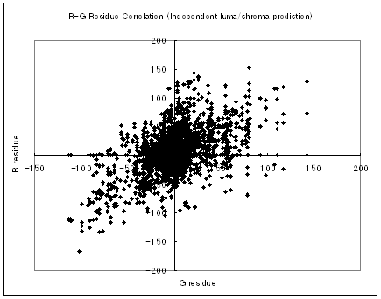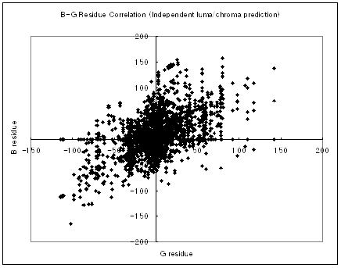
(a) (b)

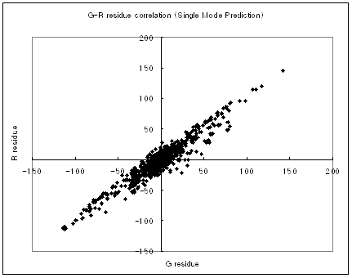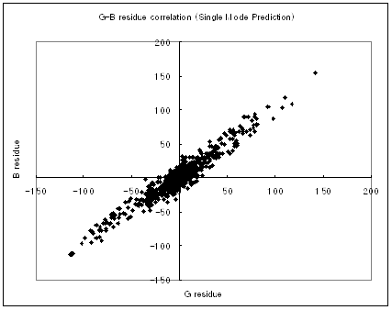
(c) (d)

Fig. 2 Inter-color correlation between residual components. (a) and (b) show the correlation of the intra predicted residual signals with independent luma/chroma prediction, where (a) shows the correlation between R and G residual values and (b) shows that of B and G residual values. (c) and (d) show the correlation of the intra predicted residual signals with single mode prediction, where (c) shows the correlation between R and G residual values and (d) shows that of B and G residual values.
The inter-color correlation between residual components is shown in Fig. 2. When we employ the same prediction both in luma and chroma (single mode coding), we can take advantage of the higher correlation among color components.

Contents adaptive coding

So far, we proposed two residual color transform methods – one uses YCgCo transform inside the coding loop, and the other uses inter-plane prediction. According to our observations through huge experiments using various high quality test image sets such as HD materials, film scanned images, and Thomson Viper sequences, there is no panacea for the wide range of images and bit rates – some has severe film grain noise in one color component, other has thermal noises, and another has saturated color characteristics, etc. In some cases, the RCT using YCgCo performs better, while the IPP performs better in other cases. In a typical case, even the RGB coding without any color conversion either inside or outside the coding loop performs the best. We also observed that coding all components as monochrome image showed good coding efficiency in some cases. This can be treated as a 4:0:0 case in H.264/MPEG-4 AVC FRExt [1] where whole image is treated as a luma component.
Therefore, we need to apply the RCT adaptively according to the image characteristics. We found that the sequence level adaptivity is efficient to cope with this problem. Since the usage of the RCT is signaled using a one bit flag in the current H.264/MPEG-4 AVC FRExt, it can be extended to notify the various color transforms.
We can further increase the coding efficiency by applying an independent intra prediction mode in which the luma prediction methods are employed in the chroma components. Or the aforementioned single mode prediction can be employed depending on image characteristics. This can be easily signaled by using one bit flag that indicates the selection between the single mode prediction and the independent prediction mode.
For inter coding cases, it is better to unify the coding mode and to share the motion vector to avoid the overhead of motion vector coding cost.

Simulation results

This section summarizes the simulation results of the improvements to RGB coding in H.264/MPEG-4 AVC FRExt. We evaluated the IPP and the RCT with the single mode prediction method by comparing them with the H.264/MPEG-4 AVC FRExt as described below. We used the JM9.3 reference software for the simulation.
Table 1. RGB PSNR gains (average of RGB components) relative to YCgCo at 20 & 60 Mbps
RGB PSNR20 Mbps60 MbpsRCT (FREXT)RCTIPPRCT (FREXT)RCTIPPAnalog TV0.10.20.30.10.20.9CardToss0.00.20.40.00.20.9Dinner0.00.20.40.00.10.5tomatoes0.00.10.1-0.10.20.2Breeze0.10.20.00.20.40.0Average0.0 0.1 0.2 0.0 0.2 0.5
Table 2. Y PSNR gains relative to YCgCo at 20 & 60 Mbps
Y PSNR20 Mbps60 MbpsRCT (FREXT)RCTIPPRCT (FREXT)RCTIPPAnalog TV0.20.20.70.20.41.5CardToss0.20.30.80.20.41.5Dinner0.20.40.70.20.31.5tomatoes0.10.20.30.00.30.4Breeze0.20.30.30.30.40.5Average0.2 0.3 0.6 0.2 0.3 1.1

The test conditions are as follows:

- Test material : Film & Viper sequences (1920x1088 @ 24 Hz, progressive )
- Search range: 64
- QP : 12, 18, 24, 30, 36
- Number of reference frame: 3
- Entropy coding: CABAC
- RD-optimized mode selection: On
- GOP structure: IBBP…
- Number of slice groups: 1

Each method is described as follows:
- IPP : the proposed method using the IPP and the single mode prediction
- RCT : the proposed method using the RCT and the single mode prediction
- RCT (FRExt) : RGB coding using YCgCo for the residual color transform [1]
- YCgCo : the external YCgCo coding, in which RGB input data are converted to YCgCo before encoding [1]

Fig 4. The Comparison of coding efficiency in lossless modes
Since we are to evaluate the fidelity of the reconstructed RGB images, we measured the average of PSNR over all color components in Error: Reference source not found. It shows the PSNR gain of each method over the YCgCo method at the two different high bit-rates (20Mbps and 60Mbps). In case of YCgCo, the reconstructed images are converted back to RGB components before comparison. It shows the efficiency of IPP and single mode prediction method.
We also compared the results of Y PSNR in YCgCo domain, with approximately equal fidelity for the chroma channels in order to isolate the effect on the luma channel (the most important channel) in Error: Reference source not found.
It is important to support the lossless and near-lossless compression of video in the near future. Those are fields of applications where the current video coding standards have not fully been exploited yet. In MPEG-4 AVC/H.264 FRExt the lossless coding is fulfilled by omitting the spatial transform and quantization in the process of Error: Reference source not found, which are not invertible operations. In the proposed method the lossless coding is also guaranteed by skipping the spatial transform and quantization. You can see the efficiency of the IPP and the single mode prediction is also valid for the lossless coding as shown in Fig 3.
In addition, we also performed the simulation of intra-only coding. In this case, we included a case that all color components are treated as a monochrome image to evaluate the performance of applying the independent intra prediction mode. Fig. 5 shows the RD curves of this simulation.

(a) Dinner Table (RGB PSNR) (b) Dinner Table (Y PSNR)

(c) Rolling Tomatoes (RGB PSNR) (d) Rolling Tomatoes (Y PSNR)

(e) Breeze (RGB PSNR) (f) Breeze (Y PSNR)

Fig. 5. RD-curves as a result of the intra-only coding simulation

Conclusions

The proposed technologies work well over various high quality image sets such as film scanned data and Thomson Viper sequences. It makes the proposed RGB coding methods ideal for the digital cinema or other high quality multimedia applications. We recommend that the proposed coding tools should be supported in the next video coding standards.

References

- “Fidelity range extensions amendment to ITU-T Rec. H.264 | ISO/IEC 14496-10 AVC,” ISO/IEC JTC1/SC29/WG11 and ITU-T SG16 Q.6, Document JVT-L047 (2004).
- H. Malvar and G. Sullivan, “YCoCg-R: A color space with RGB reversibility and low dynamic range,” ISO/IEC JTC1/SC29/WG11 and ITU-T SG16 Q.6, Document JVT-I014 (2003).
- W.-S. Kim, D. Cho, and H. M. Kim, “Inter-Plane Prediction for RGB Coding,” IEEE Int’l Conf. on Image Processing (ICIP’04), Singapore (2004).
- W.-S. Kim, D. Cho and H. M. Kim, “Color Format Extension,” ISO/IEC JTC1/SC29/WG11 and ITU-T SG16 Q.6 Document JVT-H018, May 2003.
- W.-S. Kim, D. Cho and H. M. Kim, “Proposal for the unsolved issues in professional extensions,” ISO/IEC JTC1/SC29/WG11 and ITU-T SG16 Q.6, Document JVT-I012, Jul. 2003.
- W.-S. Kim, D. Cho and H. M. Kim, “Inter-plane Prediction for RGB Coding,” ISO/IEC JTC1/SC29/WG11 and ITU-T SG16 Q.6, Document JVT-I023, Sep. 2003.
- W.-S. Kim, D. Cho and H. M. Kim, “Inter-plane Prediction for RGB Coding II,” ISO/IEC JTC1/SC29/WG11 and ITU-T SG16 Q.6, Document JVT-J017, Dec. 2003.

IPR statement

Samsung may have IPR connected to the proposed method and based on reciprocity Samsung is prepared to grant a license on reasonable and non discriminatory terms.

