ITU-T Video Coding Experts Group (ITU-T SG16 Q.6)  24th Meeting: 18-22 October 2003, Palma de Mallorca | Document: VCEG-X10  Filename: input.doc

Title: | Advanced Motion Compensated Prediction Methods
Status: | Input Document to VCEG
Purpose: | Proposal
Author(s) or  Contact(s): | Thomas Wedi  Panasonic R&D Center Germany  Monzastr. 4c  63225 Langen, Germany | Tel: | +49 6103 766 1194
Author(s) or  Contact(s): |  | Email: | wedi@panasonic.de
Source: | Panasonic
_____________________________

Abstract
In this contribution, new results on two advanced motion compensated prediction schemes for coding efficiency improvements are presented. This are results on

- Motion compensated prediction using displacement vectors with 1/8-pel resolution
- Motion compensated prediction using an frame-adaptive interpolation filter

In earlier VCEG and JVT contributions, results on these schemes were presented separately [1][2][3]. Compared to these earlier contributions the results in this contribution consists of the following differences:

- The two methods are combined.
- The coding efficiency of the frame-adaptive interpolation filters is enhanced.

Both differences lead to a further improved coding efficiency. Compared to H.264/AVC (JM2), bitrate savings up to 20 % are achieved.

In the following section 2 the prediction with 1/8-pel displacement vectors and in section 3 the adaptive interpolation scheme is briefly introduced. Experimental results are presented in section 4 and in the Appendix. Section 5 gives some hints for further work, especially with respect to adaptive interpolation filters. The conclusions and the proposal is given in Section 6.

1/8-pel displacement vectors for motion compensated prediction
In order to interpolate an image signal on subpel positions, interpolation filters are used. The following Figure 1 shows the interpolation process for motion vector resolution of 1/8-pel.

Figure 1: Interpolation process for 1/8-pel MV resolution
In case of 1/8-pel MV resolution, the frame has to be upsampled by a factor of 8 (8:1 resolution). This is done by applying Filter 1 that produces the 2:1 resolution, followed by Filter 2 that produces the 4:1 resolution and Filter 3 that produces the final 8:1 resolution.

An adaptive interpolation filter for motion compensated prediction

In this proposal an adaptive interpolation scheme is presented. This interpolation scheme is based on filter coefficients that are adapted once per frame to the non-stationary statistical properties of the video signal. The filter-coefficients are coded and transmitted. In case of ¼-pel displacement vectors only the 6-tap filter and in case of 1/8-pel displacements only the 8-tap filter are changed to an filter with adaptive filter coefficients (see Figure 1). For this purpose two different type of filters are used – a so called 2D and a 3D interpolation filter. The 2D filter separable filter that operates in the spatial domain only. The 3D filter is a filter that operates in the spatial and temporal domain. The following Figure 2 visualizes the operation of these filters.

Figure 2: Visualization of the separable adaptive 2D and 3D interpolation.
Since the filters are assumed to be separable in the spatial domain, Figure 2 shows only 1D spatial image lines of successive images (s(t), s’(t-1), s’(t-2)). In case of the separable 2D interpolation, a 1D 6-tap symmetric filter is applied to interpolate the reconstructed image s’(t-1). Therefore, only three coefficients are adapted. In case of the 3D interpolation one more coefficient is used that follows the already transmitted preceding motion vector d(t-1) and filters the corresponding sample from image s’(t-2). Thus, only one more filter coefficient is used compared to the 2D case.

Estimation of Filter Coefficients
The scheme of filter-coefficient estimation is not part of this proposal. It is an encoder issue. However, the motion compensated prediction with the filter-coefficient estimation that is used in this contribution, consists of the following steps:

- Displacement vectors are estimated. For this purpose, an initial filter is applied.
- Estimation of filter-coefficients by minimizing the energy of the prediction error when performing the motion compensated prediction with the displacement vectors from step 1. For this purpose a downhill simplex minimization method is used.
- The current frame is predicted by the motion compensated prediction. For this purpose the adapted filter-coefficients of step 2 and the displacement vectors of step 1 are applied.

In step 2 the coefficients of the adaptive interpolation filters are estimated once per frame. The image signal and the displacement vectors of the original frame are taken into account.

Transmission of Filter Coefficients
The filter used is transmitted in the picture header using the following steps:

- A codeword is sent that determines whether the default filter or the adaptive filter is used. In case of the default filter, no further information has to be transmitted. In case of the adaptive filter, the filter coefficients are sent in step 2.
- For the filter coefficient coding, a differential coding scheme is applied. The coefficients are quantized with 8 bit and the differences to the coefficients of the previous frame are transmitted in the picture header.

Experimental Results
The experimental results, that are presented in the Appendix, are based on features and settings were used:

- Used software: JM-2
- Number of reference frames: 1 and 5
- RD-opt is turned on
- De-blocking filter is used
- CABAC is used
- Coding structure: IPPPPP…. (no B-frames)

For each sequence in the Appendix, two different type of graphs are shown.:

  - A graph with different rate distortion curves that show the results that are obtained if 1/8-pel and adaptive interpolation filters are combined. In these graphs, results for different number of reference frames are used.
  - In order to see the contribution of each method on the overall coding gain, graphs with bar pots are depicted. These graphs show bitrate savings that are obtained for all possible combinations of the methods mentioned above. Each bar plot shows the bitrate saving for a specific PSNR and for a specific number of reference frames that is used.

Issues for further work on the adaptive interpolation filter method
- Introduce the prediction schemes in the recent H.264/AVC software
- Optimize the adaptive filters estimation for B-frame prediction
- Investigate the possibility to extend the frame-adaptive filter to a spatial-adaptive filter (e.g. on MB basis)
- The recent work on the presented techniques were focused on coding efficiency improvement, rather then on computational complexity. With respect to computational complexity the following statements can be made:
  - The decoder complexity is not increased significantly.
  - Due to the numerical method for estimating the filter coefficients complexity incensement in the encoder is increased.
Several methods to reduce the encoder complexity are possible:
  - Use a filter set and select the filter out of the set.
  - Use a non-iterative method for calculation. E.g. based on the Wiener-Hopf-Equation.

Conclusions and Proposal
Two advanced motion compensated prediction methods were presented that lead to a significant coding efficiency improvement. Compared to JM-2 (without B-frames), bitrate savings up to 25 % are achieved with 1/8-pel and adaptive interpolation filters (also without B-frames). Furthermore, issues for further work were pointed out.

Due to the significant coding efficiency improvement and the possibility for further work, we propose to put the presented topic in a common VCEG framework, e.g. an AdHoc group on of “advanced motion compensated prediction methods” or “advanced interpolation methods.

References

- T. Wedi, "Adaptive Interpolation Filter with Reduced Complexity", Joint Video Team (JVT), doc. JVT-D052, Klagenfurt, Austria, July 2002
- T. Wedi, "New Results on Adaptive Interpolation Filter ", Joint Video Team (JVT), doc. JVT-C059, Fairfax, Virginia, USA, May 2002
- T. Wedi, "1/8-pel Displacement Vector Resolution for Interlaced Video coding", Joint Video Team (JVT), doc. JVT-B066, Geneva, CH, Jan. 2002

Appendix

Results for Bus (CIF):

Rate distortion plot:
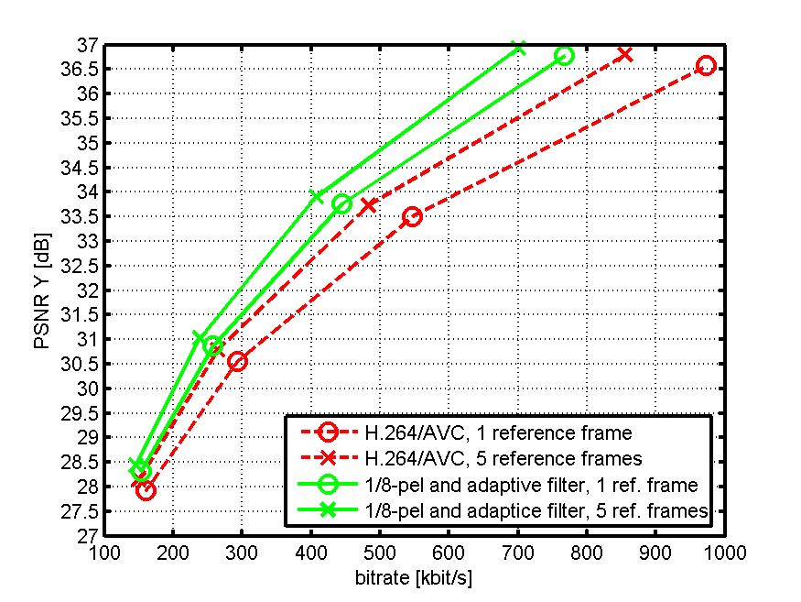
Bitrate savings:
PSNR: 29.0 dB (left), 36.5 dB (right)
Nr of ref. frames: 1(top), 5 (bottom)

Results for Flower Garden (CIF):

Rate distortion plot:
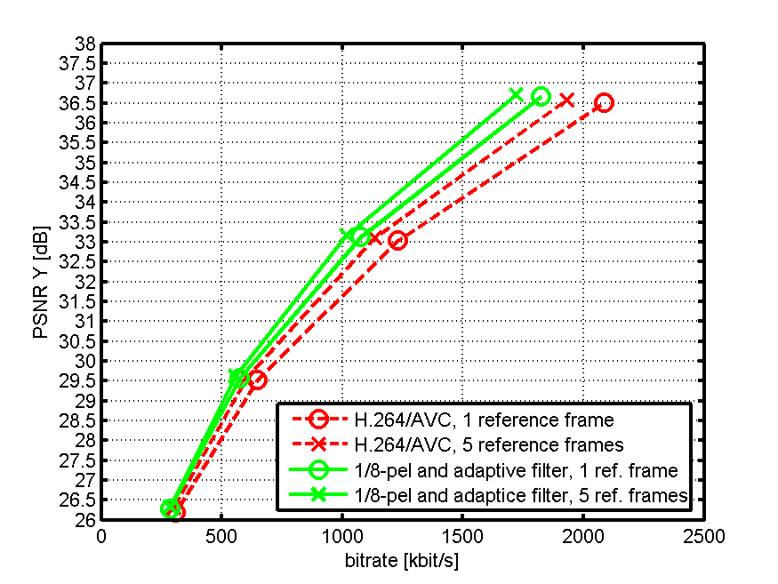
Bitrate savings:
PSNR: 26.5 dB (left), 36.5 dB (right)
Nr of ref. frames: 1(top), 5 (bottom)

Results for Foreman (CIF):

Rate distortion plot:
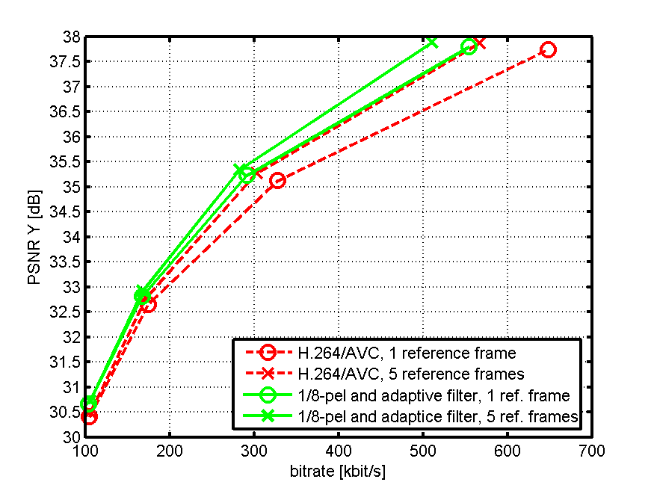
Bitrate savings:
PSNR: 31.0 dB (left), 37.5 dB (right)
Nr of ref. frames: 1(top), 5 (bottom)

Results for Mobile & Calendar (CIF):

Rate distortion plot:
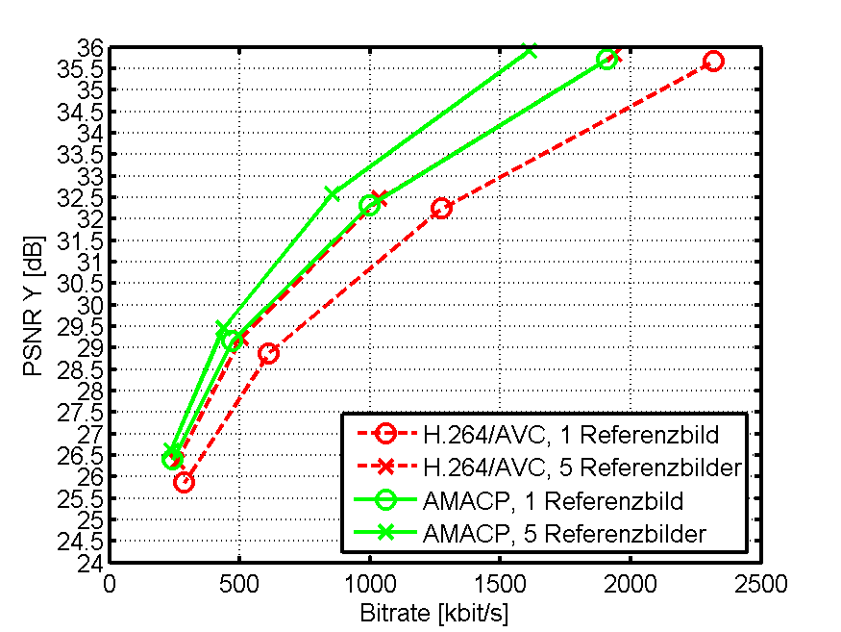
Bitrate savings:
PSNR: 29.0 dB (left), 35.5 dB (right)
Nr of ref. frames: 1(top), 5 (bottom)

