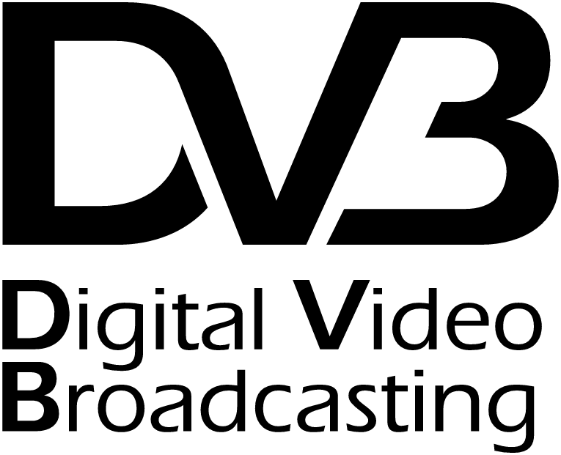
Liaison Statement

Source: DVB TM Ad-Hoc Group on Audio-Visual Content (DVB-AVC)
To: John Magill
Chairman WP3/16
Leonardo Chiariglione
Convenor, ISO/IEC JTC 1/SC 29/WG 11
Telecom Italia Labs / Italy
Gary Sullivan
Rapporteur | Chair, JVT
Microsoft Corp. / USA
Thomas Wiegand
Associate Rapporteur | Co-Chair, JVT
Heinrich-Hertz Institute / Germany
Ajay Luthra
Co-Chair, JVT
Title: DVB-AVC Response to Liaison Statement COM 16 – LS 14
Contact: Ken McCann
Chairman DVB-AVC
ZetaCast Ltd.
Email: ken@zetacast.com
Tel: +44 1962 625347
Geneva, 16th January 2003
We welcome the progress made in developing the H.264/AVC video coding standard and wish to inform you that DVB intends to incorporate H.264/AVC in the DVB suite of specifications. The DVB specifications that will be affected are:
TR 102 005 (new specification)
TR 101 154 (existing specification to be revised)
TR 102 154 (existing specification to be revised)
These specifications will cover DVB services delivered over IP as well as DVB services based on the MPEG-2 Transport Stream.
We request information on the revised timescale for the final approval of the H.264/AVC standard in ITU-T and ISO/IEC and on the timescale for the support of H.264/AVC in an MPEG-2 Transport Stream as specified by ITU-T Rec. H.222.0 / ISO/IEC 13818-1. To facilitate our preparatory work, we also request access to the draft versions of the H.264/AVC specification and of Amendment 3 to ITU-T Rec. H.222.0 / ISO/IEC 13818-1.

