Joint Video Team (JVT) of ISO/IEC MPEG & ITU-T VCEG  (ISO/IEC JTC1/SC29/WG11 and ITU-T SG16 Q.6)  2nd Meeting: Geneva, CH, Jan. 29 - Feb. 1, 2002 | Document: JVT-B116  Filename: JVT-B116.doc  Generated: 2002-02-01

Title: | Core Experiment on Interlace Chroma Phase Shift
Status: | Output
Purpose: | Output of subject-specific activity
Author(s) or  Contact(s): | Kazushi Sato, Teruhiko Suzuki and Yoichi Yagasaki  GCO East Tower Osaki East Tech.  1-11-1 Osaki Shigagawa-ku  Tokyo 141-0032 Japan  Yoshinori Suzuki  Hitachi, Ltd.  1-280, Higashi-koigakubo,  Kokubunji-shi,  Tokyo 185-8601 Japan | Tel:  Fax:  Email:  Tel:  Fax:  Email: | +81 3 5448 3669  +81 3 5448 3891  kazushi@av.crl.sony.co.jp  +81 42 323 1111  +81 42 327 7776  yosinori@crl.hitachi.co.jp
Source: | Sony Corporation and Hitachi, Ltd.
_____________________________
- Introduction

Interlaced field scanning was introduced originally as an analog video compression technique. Although progressive picture scanning is generally regarded as superior for digital compression and display, the use of interlaced field scanning has persisted in many camera and display designs. In particular, except for movies nearly all entertainment video delivered to home televisions originates in interlaced form. The MPEG-2 standard has been used effectively now for several years to deliver this interlaced video over satellite, cable, and fiber. However, we are now receiving requirements to deliver that material at bit rates less than 2 Mbits/sec and are finding that MPEG-2 cannot deliver sufficient video quality at those rates. Since the video compression in H.26L seems likely to be able to provide ample quality at those rates, it is important to make sure that H.26L has adequate syntax to support the interlace needs for video.

The purpose of this contribution is to define a core experiment to evaluate the benefit of possible semantics changes to JVT JM-1 [3] to compress interlaced video.
In [4] we showed that macroblocks with the vertical component of the motion vector mv_{y}=$±$2.0, $±$6.0, $±$10.0, … contain severe image degradation in chrominance signal when the input video is in 4:2:0 interlaced format. We also proposed adaptive chroma phase shifting to solve this problem. The goal of this experiment is to verify that by employing adaptive chroma phase shifting output image quality of the sequence with motion is improved, not only in the sense of PSNR, but also of visual quality and to verify that our proposed algorithm will not have a negative impact on other sequence in terms of PSNR and computational complexity.

- Definition of Interlace

Our definition of interlaced video comes from Annex W of H.263 [2]. An interlaced frame contains two fields, top and bottom, which are interleaved. The top field consists of the first (i.e., top), third, fifth, etc. lines of the complete picture. The bottom field consists of the second, fourth, sixth, etc. lines of the complete picture. A Top Field Picture consists of only the top field lines of a total frame. A Bottom Field Picture consists of only the bottom field lines of a picture. When sending interlaced field indications, an encoder shall use a picture size (custom picture size, if necessary) such that the picture dimensions correspond to those of a single field.
The vertical sampling positions of the chrominance samples in interlaced field coding of a top field picture are specified as shifted up by 1/4 luminance sample height relative to the field-sampling grid in order for these samples to align vertically to the usual position relative to the full-picture sampling grid. The vertical sampling positions of the chrominance samples in interlaced field coding of a bottom field picture are specified as shifted down by 1/4 luminance sample height relative to the field-sampling grid in order for these samples to align vertically to the usual position relative to the full-picture sampling grid. The horizontal sampling positions of the chrominance samples are specified as unaffected by the application of interlaced field coding. The vertical sampling positions are shown with their corresponding temporal sampling positions in Fig 2.1.

Fig 2.1

3. Adaptive Chroma Phase Shifting

In this section adaptive chroma phase shifting proposed in [4] is described.
Fig. 3.1 illustrates phases of luminance and chrominance signals a frame-mc macroblock with mv_{vertical} =$±$2.0, $±$6.0, $±$10.0 … when the input signal is in 4:2:0 interlace format. In this case ideal chroma position is in the opposite field of the chroma phase in a frame memory, and it causes significant image degradation not only in the sense of PSNR but also of visual quality when the macloblock contains motion.
In Fig 3.2 and Fig 3.3 examples of image degradation due to this problem are shown.

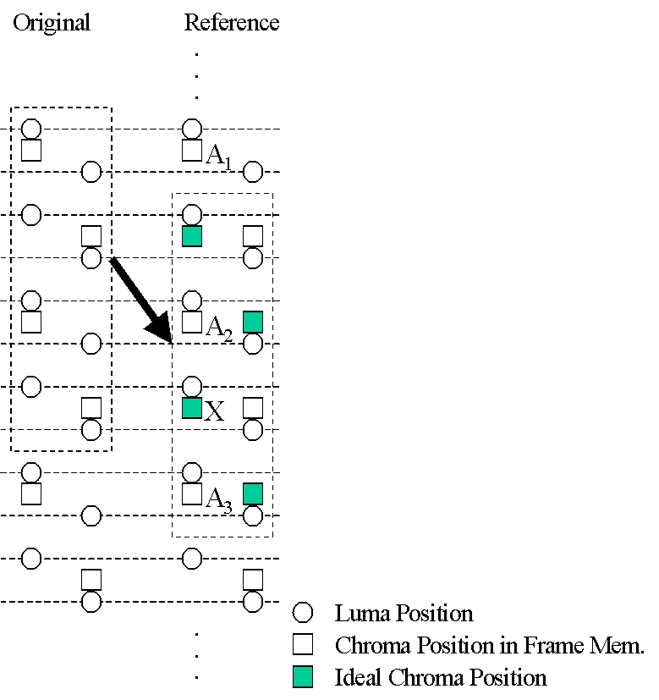

Fig 3.1

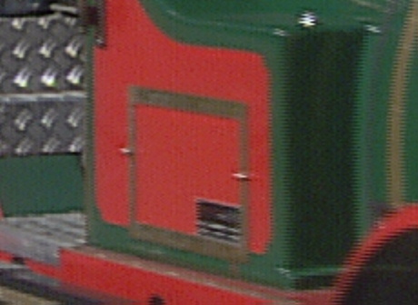

(a) Original Image

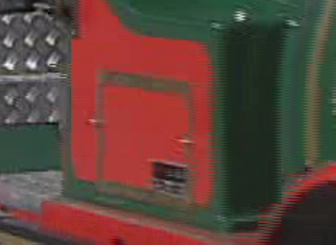

(b) Predicted Image with MPEG-2 Encoder

Fig 3.2



(a) Original Image

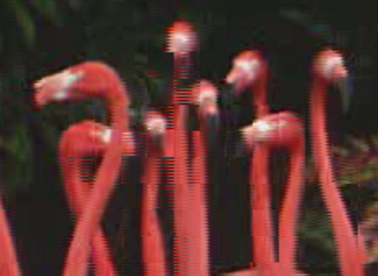

(b) Predicted Image with MPEG-2 Encoder

Fig 3.3

To fix the problem shown in Fig 3.1, we propose the following semantics change for motion compensation. No syntax change is necessary.
When the value of vertical component of the motion vector mv_{vertical} =$±$2.0, $±$6.0, $±$10.0 … , the pixel “X” in Fig 3.1 is generated by intra-field prediction. The following filter is used for this interpolation:
(3.1)
{1, -5, 20, 20, -5, 1} //32

That is, the chroma pixel value “X” is calculated as:

$$X=(A_{0}+(−5)⋅A_{1}+\text{20}⋅A_{2}+\text{20}⋅A_{3}+(−5)⋅A_{4}+A_{5}+\text{16})/{\text{32}}$$
(3.2)

- Test Condition

The proposed algorithm described in the previous section will have an impact on the visual quality of the decoded image rather than on PSNR. We define two sets of experiments as follows: (a) experiments to verify that our proposed algorithm will have a positive impact with sequences which contain specific motion, and (b) experiments to verify that our proposal will not have a negative impact with other sequences in term of PSNR or computational complexity.
Both for experiment (a) and (b), the following GOP structures are tested. The picture format in frame memory is frame structure.

- I and P Pictures only: IPPP…
1-a. Without chroma phase shifting
1-b. With chroma phase shifting
2. I, P and B Picutres:
2-a. Without chroma phase shifting
2-b. With chroma phase shifting

Table 4.1 shows the test condition:

Entropy Coding | UVLC
Hadamard | On
QP | QP_{I}=QP_{P}=16,20,24,28  QP_{B}=QP_{I}+2
RD Optimization | On
MC | 1/4-pel accuracy
Reference Frames | 1
Search Range | 16
Restricted Search Range | 2

Table 4.1

The following output data will be provided for each experiment:
Experiment (a):
For experiment (a), visual quality evaluation is of higher priority, so demonstration with D-1 shall be prepared. The output image of JM software is in 4:2:0 format, but in displaying it with a monitor it is necessary to convert it into in 4:2:2 format. 4:2:0-to-4:2:2 conversion will be executed with intra-field interpolation described in [8] as follows:
In top field, the chrominance samples in 4:2:2 format are obtained by interpolating the chrominance samples in top field only of the 4:2:0 format. Referring to line numbers defined in the 4:2:2 frame, samples on lines 1, 5, 9, … are copied from the corresponding lines in the 4:2:0 field. Samples on lines 3, 7, 11, … are interpolated by the even tap filter [1,1]//2 from the corresponding adjacent lines in the 4:2:0 field.
In bottom field, the chrominance samples in the 4:2:2 field are obtained by interpolating the chrominance samples in bottom field only of the 4:2:0 format. Referring to line numbers defined in 4:2:2 frame, samples on lines 2, 6, 10, … are interpolated from the corresponding adjacent lines in the 4:2:0 field using a [1, 3]//4 filter. Samples on line 4, 8, 12, … are interpolated by a [3, 1]//4 filter from the corresponding adjacent lines in the 4:2:0 field.

An example of alternative way of visual quality evaluation is shown in Fig 4.1. Suppose that in Fig 4.1(a) image degradation in the portion with square is significant. Then this portion is enlarged with zero-th order hold and shall be shown like Fig 4.2 (b).

As supplemental data, statistics described in experiment (b) shall also be provided.

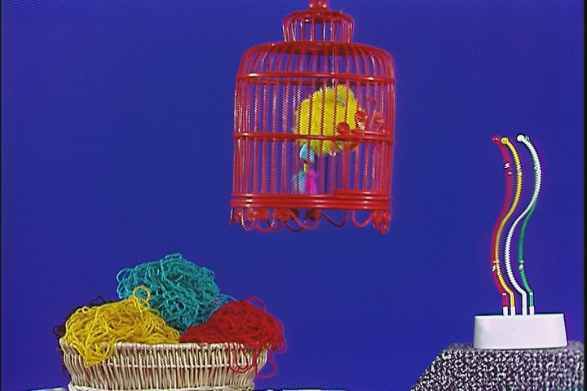
(a)

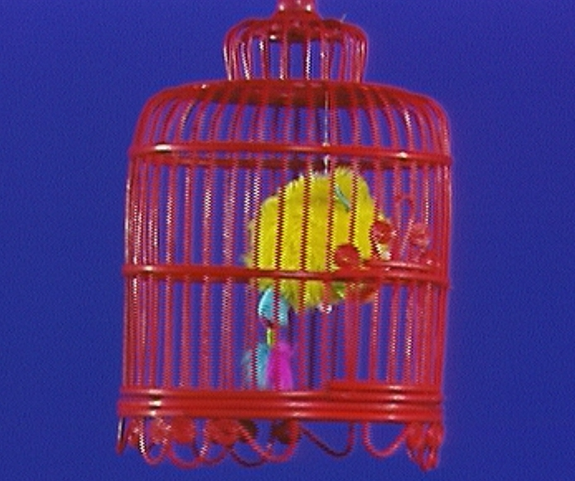
(b)

Fig 4.1

Experiment (b):
For experiment (b), the tables with following statistics data shall be made available for each bit-stream with chroma phase shifting together with anchor bit-streams:

-PSNR (separate for luma and chroma) for the whole sequence
-Bit-rate for the whole sequence
-Difference in PSNR between chroma phase shifting and anchor
-Difference in bit-rate between chroma phase shifting and anchor

In addition, the result of objective differences between RD-curves of two coders shall be reported using two types of measurements, averaged difference in bit-rate and PSNR, described in [7].
Data on computational complexity, which shall be measured with time function or Vtune, shall also be provided.

Test sequences in Table 4.2 and Table 4.3 will be used for experiment (a) and (b) respectively.

Sequence | Resolution | Frame Rate
Src13 | 720x480 | 30Hz
Popple | 720x480 | 30Hz
European Market | 1920x1088 | 30Hz
Flamingo | 1920x1088 | 30Hz

Table 4.2

Sequence | Resolution | Frame Rate
Mobile (src15) | 720x480 | 30Hz
Flower | 720x480 | 30Hz
src2 | 720x576 | 25Hz
src3 | 720x576 | 25Hz

Table 4.3

- Concluding Remarks

We have defined an experimental implementation on JVT interlaced coding. With the experiment described in this document we should be able to verify whether adaptive chroma phase shifting will have a positive impact on the output image quality of sequences with specific motion and will not have a negative impact on other sequences in term of output image quality and computational complexity, when the input is in 4:2:0 interlaced format.

References
[1] ISO/IEC 13818-2:2000 Information technology -Generic coding of moving pictures and associated audio information: Video
[2] ITU-T Recommendation H.263 (Video Coding for Low Bit Rate Communication), Annex W, specifying optional Additional Supplemental Enhancement Information, November 2000.
[3] “Anticipatory Join t Model (JM) of Enhanced-Compression Video Coding”, ISO/IEC JTC 1/SC 29/WG11 N4355, July 2001
[4] “New Interlace Coding Tools”, K. Sato, T. Suzuki and Y. Yagasaki, Joint Video Team (JVT) of ISO/IEC MPEG & ITU-T VCEG document, JVT-B068, January 2002
[5] “Core Experiment on Interlaced Video Coding”, P. Borgwardt, ITU – Telecommunications Standardization Sector STUDY GROUP 16 Question 6, Video Coding Experts Group (VCEG) document, VCEG-N85r1, Septermber 2001
[6] The Video Quality Expert Group (http://www.vqeg.org)
[7] “Calculation of average PSNR differences between RD-curves”, G. Bjontegaard, ITU – Telecommunications Standardization Sector STUDY GROUP 16 Question 6, Video Coding Experts Group (VCEG) document, VCEG-M33, March 2001
[8] “TestModel5”, ISO/IEC,JTC/SC29/WG11/N0400, 1993

JVT Patent Disclosure Form

International Telecommunication Union  Telecommunication Standardization Sector | International Organization for Standardization | International Electrotechnical Commission
 |  | 
Joint Video Coding Experts Group - Patent Disclosure Form
(Typically one per contribution and one per Standard | Recommendation)

Please send to:
JVT Rapporteur Gary Sullivan, Microsoft Corp., One Microsoft Way, Bldg. 9, Redmond WA 98052-6399, USA
Email (preferred): Gary.Sullivan@itu.int Fax: +1 425 706 7329 (+1 425 70MSFAX)

This form provides the ITU-T | ISO/IEC Joint Video Coding Experts Group (JVT) with information about the patent status of techniques used in or proposed for incorporation in a Recommendation | Standard. JVT requires that all technical contributions be accompanied with this form. Anyone with knowledge of any patent affecting the use of JVT work, of their own or of any other entity (“third parties”), is strongly encouraged to submit this form as well.

This information will be maintained in a “living list” by JVT during the progress of their work, on a best effort basis. If a given technical proposal is not incorporated in a Recommendation | Standard, the relevant patent information will be removed from the “living list”. The intent is that the JVT experts should know in advance of any patent issues with particular proposals or techniques, so that these may be addressed well before final approval.

This is not a binding legal document; it is provided to JVT for information only, on a best effort, good faith basis. Please submit corrected or updated forms if your knowledge or situation changes.

This form is not a substitute for the ITU ISO IEC Patent Statement and Licensing Declaration, which should be submitted by Patent Holders to the ITU TSB Director and ISO Secretary General before final approval.

Submitting Organization or Person:
Organization name | Sony Corp.
Mailing address | Gate City Osaki East Tower 20 F  1-11-1 Osaki Shinagawa-ku,  Tokyo, 141-0032
Country | Japan
Contact person | Kazushi Sato
Telephone | +81-3-5435-3669
Fax | +81-3-5435-3891
Email | kazushi@av.crl.sony.co.jp
Place and date of submission | Tokyo, Japan on Jan. 23rd in 2002
Relevant Recommendation | Standard and, if applicable, Contribution:
Name (ex: “JVT”) |  | JVT
Title |  | Core Experiment on Interlace Chroma Phase Shift
Contribution number |  | 116

(Form continues on next page)

Disclosure information – Submitting Organization/Person (choose one box)
2.0 The submitter is not aware of having any granted, pending, or planned patents associated with the technical content of the Recommendation | Standard or Contribution.

or,
The submitter (Patent Holder) has granted, pending, or planned patents associated with the technical content of the Recommendation | Standard or Contribution. In which case,

  - The Patent Holder is prepared to grant – on the basis of reciprocity for the above Recommendation | Standard – a free license to an unrestricted number of applicants on a worldwide, non-discriminatory basis to manufacture, use and/or sell implementations of the above Recommendation | Standard.
X
2.2 The Patent Holder is prepared to grant – on the basis of reciprocity for the above Recommendation | Standard – a license to an unrestricted number of applicants on a worldwide, non-discriminatory basis and on reasonable terms and conditions to manufacture, use and/ or sell implementations of the above Recommendation | Standard.

Such negotiations are left to the parties concerned and are performed outside the ITU | ISO/IEC.
2.2.1 The same as box 2.2 above, but in addition the Patent Holder is prepared to grant a “royalty-free” license to anyone on condition that all other patent holders do the same.
2.3 The Patent Holder is unwilling to grant licenses according to the provisions of either 2.1, 2.2, or 2.2.1 above. In this case, the following information must be provided as part of this declaration:
- patent registration/application number;
- an indication of which portions of the Recommendation | Standard are affected.
- a description of the patent claims covering the Recommendation | Standard;
In the case of any box other than 2.0 above, please provide the following:
Patent number(s)/status
Inventor(s)/Assignee(s)
Relevance to JVT
Any other remarks:
(please provide attachments if more space is needed)

(form continues on next page)
Third party patent information – fill in based on your best knowledge of relevant patents granted, pending, or planned by other people or by organizations other than your own.

Disclosure information – Third Party Patents (choose one box)
X | 3.1 The submitter is not aware of any granted, pending, or planned patents held by third parties associated with the technical content of the Recommendation | Standard or Contribution.
 | 3.2 The submitter believes third parties may have granted, pending, or planned patents associated with the technical content of the Recommendation | Standard or Contribution.
For box 3.2, please provide as much information as is known (provide attachments if more space needed) - JVT will attempt to contact third parties to obtain more information:

3rd party name(s)
Mailing address
Country
Contact person
Telephone
Fax
Email
Patent number/status
Inventor/Assignee
Relevance to JVT

Any other comments or remarks:

