Joint Video Team (JVT) of ISO/IEC MPEG & ITU-T VCEG  (ISO/IEC JTC1/SC29/WG11 and ITU-T SG16 Q.6)  2nd Meeting: Geneva, CH, Jan. 29 - Feb. 1, 2002 | Document: JVT-B102  Filename: JVT-B102.doc  Generated: 2002-01-28

Title: | Error Robust Macroblock Mode and Reference Frame Selection
Status: | Input Document to JVT
Purpose: | Proposal
Author(s) or  Contact(s): | Thomas Stockhammer  Dimitrios Kontopodis  Institute for Communications Engineering  Munich University of Technology  D-80290 Munich  Germany | Tel:  Email: | +49-89-28923474  stockhammer@ei.tum.de
Source: | Munich University of Technology
_____________________________

Summary
This proposal contains two encoder test model extensions to increase the error resilience in combination with multiple reference frames. The first part restricts the selectable reference frames in the rate-distortion optimized reference frame and macroblock selection such that no pixels are used for prediction which have been intra refreshed for error resilience reasons later. In addition the rate-‘expected-decoder-distortion’ optimized macroblock mode selection presented in VCEG-N50 is extended such that the reference frame is included in the optimization process. Results will be presented based on the Internet test conditions.

Introduction
The test model encoder of TML9.4 [1] allows to encode sequences with a more frequent amount of macroblock intra updates. This can be done regularly or based on rate-distortion criteria. In addition, for enhanced coding efficiency TML9.4 also allows to use multiple reference frames. However, when both options are combined and a transmission over error-prone networks is performed in many cases multiple reference frames perform worse than allowing just one reference frames (see included results). The reason for this is illustrated in Figure 1 where four frames of the test sequence tempete are shown.
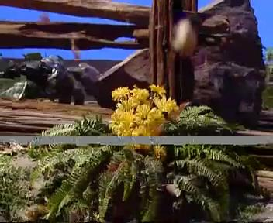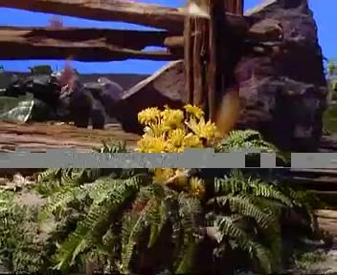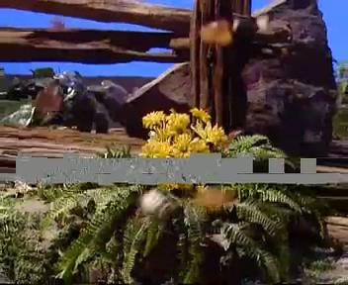
Figure 1 Decoded frames No. 9, 10, 11, 12 of erroneous Tempete test sequence with multiple reference frames and regular intra updates for unrestricted reference frames
The CIF sequence was encoded with regular intra-updates (1 GOB per frame) and transmitted over the Internet test patterns [2] with starting position 0. A slice and, therefore, a transmission packet consists of two lines of macroblocks. 5 reference frames were allowed. For illustration purpose the applied error concealment is previous frame concealment for P-frames and 127 for the I-frame. In the first frame one packet was lost. The error is still present in decoded frame 9. In frame 10, a regular intra update is performed and the gray parts have disappeared. However, as the selected reference frame in frame 11 for the intra updated part is smaller than 10 for most MBs, a significant part of the gray area pops up again. The same phenomenon occurs in frame 12 for the intra updated part. This problem is not just obvious in the rate-distortion performance but also subjectively very annoying.
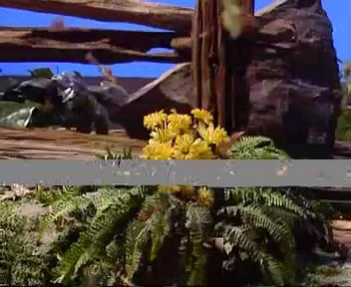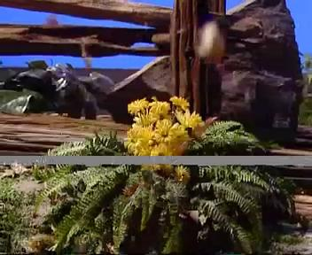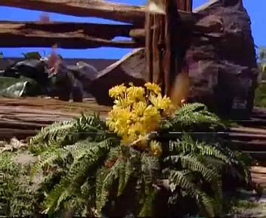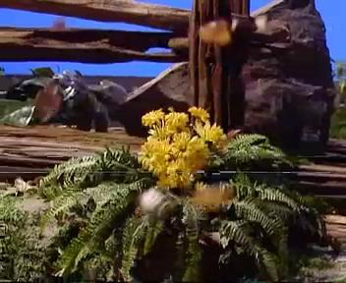
Figure 2 Decoded frames No. 9, 10, 11, 12 of erroneous Tempete test sequence with multiple reference frames and regular intra updates for restricted reference frames

This example shows the basic problem when multiple reference frames and intra updates are combined. However, not allowing multiple reference frames in error prone environments would lower the compression efficiency significantly. Therefore, a careful restriction of reference frames is necessary. We introduce a simple but powerful method for the reference frame restriction. The same picture sequence is shown in Figure 2 for the reference frame restriction. The bitrate increase for the entire sequence in this case is about 5%.
Additionally, we extend the macroblock mode selection introduced in VCEG-M50 such that also the reference frame selection is included in the optimization process. Results for RTP/IP test conditions as well as selected sequences will be presented.

Reference Frame Restriction
In the following we will present a reference frame restriction which basically attempts to avoid to reference frames prior to a forced intra refresh where forced intra updates means for error resilience reasons. The reference frame restriction can be used together with any kind of error-resilience MB intra updates (regular, random, optimized).
Therefore, let us define for each macroblock a number which specifies the reference frame in which the last forced intra update was introduced. The forced intra update vector is defined as . Additionally, we define a binary vector which indicates with a 1 that this macroblock was intra updated because of error resilience reasons. The detailed generation of these vectors will be discussed later. Then, for each macroblock in frame the following four steps are carried out to restrict the reference frames:
- For each inter MB coding mode from the set of possible inter coding modes and for each reference frame from the set of accessible reference frames the rate-constrained motion estimation is conducted to obtain optimized motion vectors from the set of possible motion vectors which obviously depends on the macroblock mode (4x4, 16x16, etc.). This is achieved by minimizing the Lagrangian cost applying the Lagrangian multiplier and can be formalized as
,
with the distortion after the motion compensation process and the number of bits required for the motion vectors.
- In a second step the set of possible combinations of macroblock modes and reference frames is restricted. From the entire set those combinations are removed which reference image parts have undergone a forced intra update later than the referenced frame. Therefore, we obtain the set of valid combinations for all inter modes. This can be formalized as
,
where performs an operation for MB using motion vector and the forced intra update vector to find out if this reference frame can be used for reliable prediction. A motion compensation process is performed to find out which area is referenced. The pseudo-C code for this function is attached in the Appendix. This reference frame is compared with the applied reference frame and only if this is greater equal than this combination it is inserted in .
- Furthermore, based on the restricted set and the set of intra coded modes we now select the best macroblock mode and reference frame combination based on rate-distortion arguments. The set of accessible coding options for P-frames is defined as the union of the restricted set of inter modes and all possible intra modes for P-frames , i.e., . Therefore, to obtain an optimized macroblock mode for macroblock the Lagrangian cost functional is minimized, i.e.
,
with the number of bits required code the macroblock with this mode and the distortion as follows. If we use regular or random intra update the distortion applied here is the sum of the squared difference between the original and the reconstructed macroblock pixels in MB . In the case of channel optimized intra updates the expected distortion at the decoder would be used. For more details we refer to the next section.
- Finally, we have to find out if this macroblock was intra coded because of error resilience reasons or if the RD optimization in (3) selected intra coding. Therefore, if this macroblock was intra coded, i.e., , then (3) is repeated with and the sum of the squared difference between the original and the reconstructed macroblock pixels in MB . The result of the optimization is denoted as . Then, the error resilience flag for this macroblock appropriately, i.e. with the Kronecker symbol set to 1 if the condition is true.
When all macroblocks for this frame are processed the forced intra update vector has to be updated for all macroblocks where the error resilience flag is set to 1, i.e. .
Appropriate starting conditions have to be used in the beginning of the sequence. Also, a more efficient implementation in terms of complexity seems to be possible and appropriate modulo operations on the reference frame buffer can be used. However, this seems not be of primary interest at this point.

Optimized Macroblock Mode and Reference Frame Selection
In this section we will briefly present the optimized mode selection process when the reference frames are included in the optimization process. To include the reference frames in the process is useful as the prediction from reference frames which are further in the past might be of advantage in terms of error resilience. The algorithm for the channel adaptive rate-distortion optimized macroblock mode and reference frame selection is identical to the one presented in the previous section. However, the distortion in (3) has to be selected appropriately. We will briefly summarize the concept presented in VCEG-N50 to obtain the expected distortion for MB in frame . is the sum of the expected squared pixel distortion at the decoder when encoding the current macroblock with coding option . In the case of packet losses, the random variable channel behavior after transmitting frame is defined by a binary sequence with the number of packets necessary to transmit frame . A in the channel sequence indicates a correct received packet whereas a indicates a lost packet. We denote the random variable of the binary channel loss sequence up to frame as indicating the length of this sequence in the index. The pixel distortion is not known at the encoder as it depends on the reconstructed denoted as pixel value and, therefore, on the random channel behavior. We emphasize the dependency on the channel and the selected coding option by defining . However, we assume that the encoder has knowledge on the probability distribution of . Then , with the original pixel value, the encoder can get an estimate of the reconstructed value at the decoder, and, therefore of the distortion as
,
where the expectation is over the channel .
To obtain this expectation the following simple method is used. Assume that we have copies of the random variable channel behavior at the encoder, denoted as . Additionally, assume that the set of random variables are identically and independently distributed (iid). Then, as , it follows by the strong law of large numbers that
,
holds with probability 1. An interpretation of the left hand side leads to a simple solution of the previously stated problem to estimate . In the encoder copies of the random variable channel behavior and the decoder are operated. The reconstruction of the pixel value depends on the channel behavior and the decoder including error concealment. The copies of channel and decoder pairs in the encoder operate independently. Therefore, the expected distortion at the decoder can be estimated accurately in the encoder if is chosen large enough. A more complexity-efficient method [5,6,7] might replace this powerful and simple but complex distortion estimation in the future.

Results for RTP/IP Test Conditions
A selected amount of results will be presented on the application of the two presented methods. All results are based on the Internet test conditions [2] with the Foreman sequence: QCIF, QP such that the total bitrate is below 64 kbit/s with 40 byte overhead, 7.5 frames/s, slice size 33 and 99 MBs, 10% packet loss file, previous frame error concealment (pfc) and advanced error concealment scheme (aec). The sequence was encoded once and was transmitted 50 times over the error pattern. The starting position in the error pattern has been increased by 1 of the last position of the previous run. Regular intra updates (1 GOB per frame) as well as optimized intra updates with encoder loss rate 10% and 20% have been used. 1 or 5 reference frames were used where 5r denotes that the reference frames have been restricted according to the presented algorithm. The results are shown in Table.

Table 1 Selected results for presented test conditions
Exp | QP | EC | RefFr | Slices | Arg. | RDopt | Intra | Losses | Dec. | Runs | Bit Rate | PSNRy | PSNRu | PSNRv | PSNRa | Min | Max
1 | 19 | pfc/aec | 1 | 0 | 0 | 1 | 1 | 0 | 0 | 50 | 63.755 | 26.960 | 37.450 | 37.643 | 30.488 | 18.535 | 30.999
2 | 23 | pfc/aec | 1 | 0 | 0 | 2 | 0 | 10 | 30 | 50 | 61.782 | 28.642 | 36.959 | 36.947 | 31.412 | 21.041 | 30.163
3 | 19 | pfc/aec | 5 | 0 | 0 | 1 | 1 | 0 | 0 | 50 | 61.9 | 24.816 | 36.786 | 36.892 | 28.824 | 13.614 | 30.075
4 | 23 | pfc/aec | 5 | 0 | 0 | 2 | 0 | 10 | 30 | 50 | 60.551 | 28.485 | 36.992 | 36.900 | 31.305 | 20.948 | 30.093
5 | 19 | pfc/aec | 5r | 0 | 0 | 1 | 1 | 0 | 0 | 50 | 63.15 | 26.958 | 37.415 | 37.633 | 30.480 | 18.430 | 30.740
6 | 22 | pfc/aec | 5r | 0 | 0 | 2 | 0 | 10 | 30 | 50 | 62.069 | 28.694 | 37.246 | 37.323 | 31.557 | 20.744 | 30.722
7 | 24 | pfc/aec | 5r | 0 | 0 | 2 | 0 | 20 | 30 | 50 | 58.747 | 28.655 | 36.612 | 36.526 | 31.293 | 21.413 | 29.988
8 | 21 | pfc | 1 | 1 | 33 | 1 | 1 | 0 | 0 | 50 | 59.418 | 25.099 | 36.831 | 36.917 | 29.024 | 21.909 | 27.771
9 | 24 | pfc | 1 | 1 | 33 | 2 | 0 | 10 | 30 | 50 | 59.987 | 27.504 | 36.655 | 36.486 | 30.526 | 22.880 | 28.740
10 | 20 | pfc | 5 | 1 | 33 | 1 | 1 | 0 | 0 | 50 | 58.243 | 23.638 | 36.846 | 37.070 | 28.078 | 18.986 | 27.768
11 | 24 | pfc | 5 | 1 | 33 | 2 | 0 | 10 | 30 | 50 | 59.434 | 27.329 | 36.616 | 36.511 | 30.407 | 22.727 | 28.750
12 | 21 | pfc | 5r | 1 | 33 | 1 | 1 | 0 | 0 | 50 | 58.826 | 25.229 | 36.843 | 36.955 | 29.119 | 22.150 | 27.855
13 | 23 | pfc | 5r | 1 | 33 | 2 | 0 | 10 | 30 | 50 | 60.544 | 27.440 | 37.115 | 37.086 | 30.660 | 22.166 | 29.616
14 | 25 | pfc | 5r | 1 | 33 | 2 | 0 | 20 | 30 | 50 | 59.732 | 27.639 | 36.665 | 36.537 | 30.626 | 23.176 | 28.880
15 | 21 | aec | 5r | 1 | 33 | 1 | 1 | 0 | 0 | 50 | 58.826 | 26.428 | 37.143 | 37.140 | 29.999 | 23.525 | 28.600
16 | 23 | aec | 5r | 1 | 33 | 2 | 0 | 10 | 30 | 50 | 60.544 | 27.766 | 37.164 | 36.911 | 30.857 | 25.164 | 29.433
17 | 25 | aec | 5r | 1 | 33 | 2 | 0 | 20 | 30 | 50 | 59.732 | 27.809 | 36.692 | 36.508 | 30.740 | 26.585 | 28.911

The following observations can be made based on the average Y-PSNR and the bit rate in kbit/s:
- For all cases, using 5 reference frames without restrictions (exp 3, 4, 10, 11) is worse than using 1 reference frame (exp 1, 2, 8, 9) and this is worse than using 5 reference frames with restrictions (exp. 5, 6, 7, 12, 13, 14).
- For all cases, the optimized intra update outperforms the regular intra updates, compare exp. 1-2, 3-4, 5-6-7, 8-9, 10-11, 12-13-14, 15-16-17.
- The gains for the non-optimized case with the reference frame restriction is more significant than with the optimized case.
- The advanced error concealment provides gains compared to the previous error concealment.
In conclusion the proposed algorithm gives significant benefits for regular intra updates and smaller but visible improvements on optimized intra updates.

References
- T. Wiegand, “H.26L Test Model Long Term Number 9 (TML-9) draft 1,” JVT JM-1, December 2001.
- ITU-T Q15-I-61, “Common Conditions for H.323/Internet Case”, VCEG (SG16/Q15), Ninth Meeting, Santa Redbank, NJ, October 1999.
- T. Stockhammer, T. Oelbaum, D. Marpe, and T. Wiegand, “H.26L Simulation Results for Common Conditions for H.323/Internet Case,” ITU-T VCEG-N50, VCEG (SG16/Q6), Fourteenth Meeting, Santa Barbara, CA, September 2001.
- R. Zhang, S. L. Regunathan, and K. Rose, “Video Coding with Optimal Inter/Intra-Mode Switching for Packet Loss Resilience,” in IEEE JSAC, vol. 18, no. 6, pp. 966-976.
- G. Cote, S. Shirani, F. Kossentini, “Optimal mode selection and synchronization for robust video communications over error-prone networks”, in IEEE JSAC, vol. 18, no. 6, pp. 952 -965.
- T. Wiegand, N. Färber, K. Stuhlmüller, and B. Girod, “Error-resilient video transmission using long-term memory motion-compensated prediction”, in IEEE JSAC, vol. 18, no. 6, pp. 1050-1062.

Appendix: Pseudo C-Code for Reference Frame Restriction
boolean CheckReliabilityOfRefFrame(int *v, int *f, int k, int r)
{
for all pixels in MB k
{
GetAllReferencedPixel(v, k);
for each referenced pixel j of this pixel
{
i = getMacroblockNr(j);
if(f[i] < r)
return FALSE
}
}
return TRUE;
}

JVT Patent Disclosure Form

International Telecommunication Union  Telecommunication Standardization Sector | International Organization for Standardization | International Electrotechnical Commission
 |  | 
Joint Video Coding Experts Group - Patent Disclosure Form
(Typically one per contribution and one per Standard | Recommendation)

Please send to:
JVT Rapporteur Gary Sullivan, Microsoft Corp., One Microsoft Way, Bldg. 9, Redmond WA 98052-6399, USA
Email (preferred): Gary.Sullivan@itu.int Fax: +1 425 706 7329 (+1 425 70MSFAX)

This form provides the ITU-T | ISO/IEC Joint Video Coding Experts Group (JVT) with information about the patent status of techniques used in or proposed for incorporation in a Recommendation | Standard. JVT requires that all technical contributions be accompanied with this form. Anyone with knowledge of any patent affecting the use of JVT work, of their own or of any other entity (“third parties”), is strongly encouraged to submit this form as well.

This information will be maintained in a “living list” by JVT during the progress of their work, on a best effort basis. If a given technical proposal is not incorporated in a Recommendation | Standard, the relevant patent information will be removed from the “living list”. The intent is that the JVT experts should know in advance of any patent issues with particular proposals or techniques, so that these may be addressed well before final approval.

This is not a binding legal document; it is provided to JVT for information only, on a best effort, good faith basis. Please submit corrected or updated forms if your knowledge or situation changes.

This form is not a substitute for the ITU ISO IEC Patent Statement and Licensing Declaration, which should be submitted by Patent Holders to the ITU TSB Director and ISO Secretary General before final approval.

Submitting Organization or Person:
Organization name | Siemens AG; CT IC 2
Mailing address | Otto Hahn Ring 6; 81730 München
Country | Germany
Contact person | Gero Bäse
Telephone | +49 89 636 53193
Fax | +49 89 636 52393
Email | Gero.Baese@mchp.Siemens.de
Place and date of submission
Relevant Recommendation | Standard and, if applicable, Contribution:
Name (ex: “JVT”) |  | JVT
Title |  | Error Robust Macroblock Mode and Reference Frame Selection
Contribution number |  | JVT-B106

(Form continues on next page)

Disclosure information – Submitting Organization/Person (choose one box)
2.0 The submitter is not aware of having any granted, pending, or planned patents associated with the technical content of the Recommendation | Standard or Contribution.

or,
The submitter (Patent Holder) has granted, pending, or planned patents associated with the technical content of the Recommendation | Standard or Contribution. In which case,

 | - The Patent Holder is prepared to grant – on the basis of reciprocity for the above Recommendation | Standard – a free license to an unrestricted number of applicants on a worldwide, non-discriminatory basis to manufacture, use and/or sell implementations of the above Recommendation | Standard.
2.2 The Patent Holder is prepared to grant – on the basis of reciprocity for the above Recommendation | Standard – a license to an unrestricted number of applicants on a worldwide, non-discriminatory basis and on reasonable terms and conditions to manufacture, use and/ or sell implementations of the above Recommendation | Standard.

Such negotiations are left to the parties concerned and are performed outside the ITU | ISO/IEC.
 | 2.2.1 The same as box 2.2 above, but in addition the Patent Holder is prepared to grant a “royalty-free” license to anyone on condition that all other patent holders do the same.
2.3 The Patent Holder is unwilling to grant licenses according to the provisions of either 2.1, 2.2, or 2.2.1 above. In this case, the following information must be provided as part of this declaration:
- patent registration/application number;
- an indication of which portions of the Recommendation | Standard are affected.
- a description of the patent claims covering the Recommendation | Standard;
In the case of any box other than 2.0 above, please provide the following:
Patent number(s)/status |  | Filed?
Inventor(s)/Assignee(s) |  | Gero Bäse, Jürgen Pandel, Thomas Stockhammer, Dimitrios Kontopodis
Relevance to JVT |  | Test model encoder relevance
Any other remarks:
(please provide attachments if more space is needed)

Third party patent information – fill in based on your best knowledge of relevant patents granted, pending, or planned by other people or by organizations other than your own.

Disclosure information – Third Party Patents (choose one box)
3.1 The submitter is not aware of any granted, pending, or planned patents held by third parties associated with the technical content of the Recommendation | Standard or Contribution.

3.2 The submitter believes third parties may have granted, pending, or planned patents associated with the technical content of the Recommendation | Standard or Contribution.

For box 3.2, please provide as much information as is known (provide attachments if more space needed) - JVT will attempt to contact third parties to obtain more information:

3rd party name(s)
Mailing address
Country
Contact person
Telephone
Fax
Email
Patent number/status
Inventor/Assignee
Relevance to JVT
Any other comments or remarks:

