Joint Video Team (JVT) of ISO/IEC MPEG & ITU-T VCEG  (ISO/IEC JTC1/SC29/WG11 and ITU-T SG16 Q.6)  2nd Meeting: Geneva, CH, Jan. 29 - Feb. 1, 2002 | Document: JVT-B094r1  Filename: JVT-B094r1.doc  Generated: 2002-01-25

Title: | Water Ring Scan method for H.26L based FGS
Status: | Input Document to JVT
Purpose: | Information
Author(s) or  Contact(s): | Gwang Hoon Park and Yoon Jin Lee  Kyunghee University  1, Seocheon-Ri, Giheung-Eup, Yongin-City,  Kyunggi-Do, Korea  Won-Sik Cheong, Kyuheon Kim and Jinwoong Kim  Broadcasting Media Technology Department, ETRI  161, Gajeong-Dong, Yuseong-Gu, Daejon, Korea  Young Kwon Lim  net&tv  5th Floor Himart Building,  1007-46 Sadang-Dong Dongjak-Gu, Seoul, Korea | Tel:  Email: | +82 31 201 2469  ghpark@khu.ac.kr  +82 42 860 5165  wscheong@etri.re.kr  +82 2 581 2305  young@netntv.co.kr
Source: | ETRI, Kyunghee University, and net&tv

Introduction

MPEG and ITU-T have launched Joint Video Team to establish a new video coding standard. In this standardization effort, H.26L will be used as baseline. Test results show that H.26L has very high coding efficiency and outperforms MPEG-4 ASP.
MPEG-4 Fine Granularity Scalability (FGS) has been designed in response to the growing need for video coding methodologies for video streaming on various types of networks and bandwidths, and provides the capabilities to distribute robust enhanced video bitstream at wide range of bitrates with multiple layers. Thus, MPEG-4 FGS decoder can accept a truncated enhancement-layer bitstream and also reconstruct a quality-improved video on the basis of received partial bitstream until then. From these facts, it is easily noticed that the FGS is a highly desirable functionality for a new H.26L based video coding standard.
However, FGS is not included in the working scope of JVT, in spite of its desirable functionality, due to the tight standardization schedule of JVT Phase 1. Therefore, FGS should be considered as an important work item for JVT Phase 2 activity.
In this document, we will notify the limitation of the current FGS if it is directly adopted into H.26L based scalable coding methodology.
Also, we will introduce the water ring scan method as a potential technology that can improve subjective picture quality of a decoded scalable video.

Limitation of the FGS coding scheme

The current MPEG-4 FGS Verification Model uses a raster scan order to code the enhancement bitstream. Raster scan order, as shown in Fig. 1, is the sequential coding order that start from the macroblock (or block) located in the upper-left part up to the macroblock (or block) located in the bottom-right part of the image frame, which is usually used for moving picture coding.
Since the current MPEG-4 FGS is based on the raster scan order, the image frame is sequentially decoded from upper-left to lower-right. When most of macroblocks are successfully decoded, the picture quality of entire frame is visually enhanced. When some bitstreams in a certain layer are not available, only the upper region of an image frame is enhanced as shown in Fig. 2. Thus, it may not improve the region of interest usually located in center region of the image frame.

Figure 1. Raster Scan Order usually used in the moving picture coding methodologies.

Figure 2. Macroblocks that decoding is completed in case raster scan order is applied in FGS Coding.

Water Ring Scan Method

Most video sequences usually have their important objects in particular location, for example, the center of image frame. If the interest region is most-preferentially encoded, transmitted and decoded, it would appeal to users with better picture quality even if the quality of the other boundary part is not good enough due to truncation caused by bandwidth limitation.
In this section, we will introduce the water ring scan method that can simply improve the picture quality of the region of the interest in the decoded scalable video.
The idea of the proposed scan order (we call it as “water ring scan order”) is come from water ring expanded in the lake from the location that a gravel falls as shown in Fig. 3. If we adopt the ‘water ring in the lake’ to moving picture coding problem, a coding can be firstly started at the location the gravel falls (designated location by user). Whenever the water ring is created and expanded (rectangular-shape water ring), encoding and decoding are sequentially performed at the location where the water ring is generated, and is expanded until boundary of the image frame.
In other words, if the particular coding origin (location a gravel falls: in a unit of macroblock) to be transmitted most-preferentially to a decoder is selected, that macroblock to the origin would be firstly encoded and also decoded. Secondly the nearest neighbor macroblocks are encoded and transmitted. And nearer neighbor macroblocks located at just outside of the previous encoded macroblocks are then encoded and transmitted and so on. This scan order is recursively expanded until all the macroblocks are coded in the image frame. If the location of the origin is known to the both of encoder and decoder such as fixing the origin for all pictures, then the coordinate of the origin does not have to be transmitted to a decoder. It is straightforward and very simple to construct.
Simple mechanism of water ring scan order is explained as follows:
Step 1. Decide the origin of the water ring (water_ring(0)) and encode the information on it.
Step 2. Increment i in a unit of macroblock (or block) and decide the location of the ith generated water ring (water_ring(i)) and encode the information on it.
Step 3. Repeat step 2 until all the information of the image frame to be coded is encoded.

Figure 3. Basic Idea of Water Ring Scan Order.

Water ring(i) consists of the macroblocks (or blocks) located at 1-1, 1-2, 2-1, 2-2, 3-1, 3-2, 3-3, 3-4 as shown in Fig. 4. If we set the origin point of the water ring as (x, y), then 1-1 is the set of macroblock (or block) locations in (x-i) and (y-i < y < y+i), 1-2 is the set of macroblock locations in (x+i) and (y-i < y < y+i), 2-1 is the set of macroblock locations in (y-i) and (x-i < x < x+i), 2-2 is the set of macroblock locations in (y+i) and (x-i < x < x+i), and finally 3-1 is (x-i, y-i), 3-2 is (x+i, y-i), 3-3 is (x-i, y+i), 3-4 is (x+i, y+i), respectively.

Figure 4. Coordinates of the macroblocks that are in i^{th} water ring (water_ring (i))

Water Ring Scan Method for the H.26L based FGS methodologies

FGS encoder of the enhancement layer takes the original image and the reconstructed image as inputs, and produces the FGS bitstream as an output.
FGS encoding procedure is explained as follows:
[1] The reconstructed picture is subtracted from the original picture to obtain an image domain residue.
[2] The image domain residue is then transformed into DCT domain coefficients.
[3] After all the DCT residues of the picture are obtained, the maximum value of the residues is found and the maximum number of bitplanes for the picture is determined.
[4] For each bitplane of each macroblock of DCT residues, water ring scan order is used to decide the order of transmission of bitstream and the start point of scanning (i.e. the location of the origin). According to the order of transmission decided by water ring scan method, the VLC symbols are formed and encoded by variable length coding algorithm to produce the output bitstream.
To reconstruct the enhanced picture, the enhancement bitstream is firstly decoded by using bit-plane VLD according to water ring scan order. The decoded bit-planes in the DCT domain are the residues of the DCT coefficients. After the IDCT, the image domain residues are reconstructed. They are added to the base-layer’s reconstructed clipped pixels to generate the enhanced picture. The reconstructed enhancement picture pixels are limited into the value range between 0 and 255 by clipping the FGS enhancement layer to generate the final enhancement video.

Simulation Results

In this section, we will present the simulation results that shows the performance of the water ring scan method in comparison with the H.26L based coding schemes (TML-9 is used for all compared schemes).
Since the H.26L based “FGS” CODEC (that uses MPEG-4 Part 2 FGS enhancement layer coding scheme) is not available until now (we are implementing it right now), water ring scan method is implemented on the H.26L based “PFGS” CODEC released by Microsoft Asia (It is based on a proposal introduced in MPEG M7788 document).
The ‘Stefan’ sequence at 10Hz, CIF format is used as a test sequence.
Since H.26L based CODEC does not have any rate control mechanism so far, fixed quantization is used in the comparison of the simulation results.
The range of motion vector is limited in ±16 pixels.
Only first frame is encoded as I frame, and the other frames are encoded as P frames.
The RD optimisation is not used.
The performances of the three coding schemes such as, H.26L “Single Layer” coding, H.26L based “PFGS” and H.26L based “Water Ring + PFGS” coding, are compared.
The regional PSNR’s (PSNR’s are calculated in the 14 macroblocks X 10 macroblocks located in center of image frame) and frame PSNR’s calculated from the decoded results of each algorithm are shown in Fig. 5 and Fig. 6, respectively. Since most of video sequences have important objects in the center of image frame, regional PSNR is considered to be a good index of subjective quality comparison.
Coding results for the H.26L “single layer” coding are obtained by fixing quantization steps as 31, 26, 25, 22, 20, 19, 17, 16, and 15, respectively.
For both H.26L based “PFGS” coding and the H.26L based “water ring + PFGS” coding, based layer bitstreams are obtained by fixing the quantization step as 31 (as a result, about 138kbps is obtained). And the enhancement bitstreams are truncated by the FGS Server at 96kbps, 128kbps, 256kbps, 384kbps, 512kbps, 640kbps, 768kbps and 896kbps, and added to base layer bitstream.
As shown in Fig. 5, the proposed “water ring scan + PFGS” coding scheme achieves 0.93dB ~ 3.16dB better coding efficiency over the H.26L based “PFGS” coding scheme.
Proposed water ring scan method also has only about 0.5dB ~ 1.3 dB lower from the H.26L based “single layer” coding.
From these simulation results, we can conclude that the water ring scan method can significantly improve the subjective quality of “any” FGS coding methodologies (such as “H.26L based PFGS” and “MPEG-4 Part II FGS” methodologies. However, the performance of the water ring on “H.26L based FGS” is not investigated so far, we can assume it’s capability).

Conclusion

This document proposes the water ring scan method for H.26L based FGS methodologies.
As shown in the simulation results, proposed water ring scan method can significantly improve the performance of the H.26L based FGS methodologies.

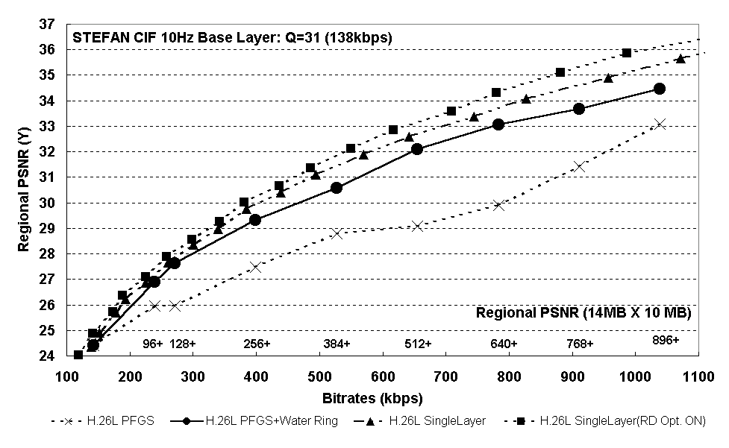
Figure 5. The regional PSNR’s obtained from three coding schemes for Stefan sequence at 10Hz, CIF-resolution.

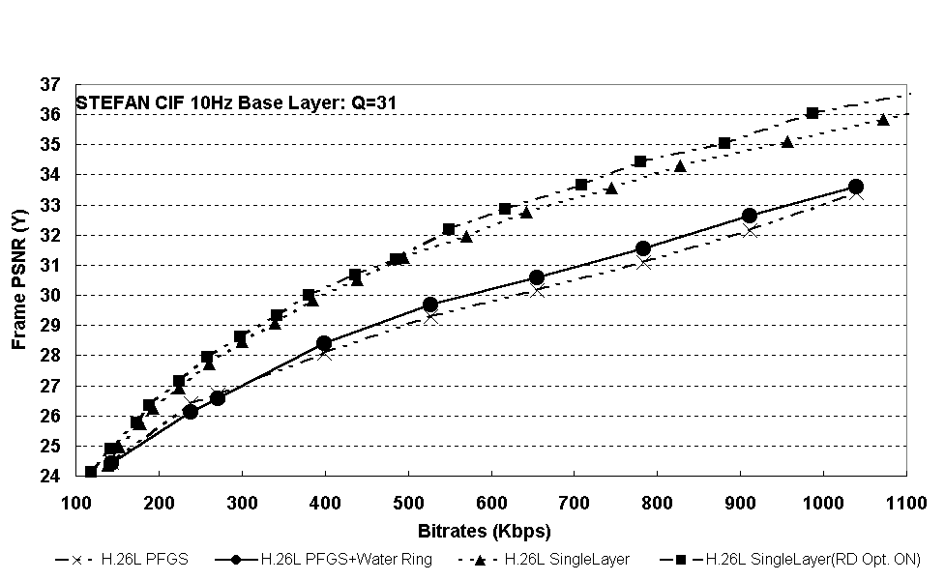
Figure 6. The frame PSNR’s obtained from three coding schemes for Stefan sequence at 10Hz, CIF-resolution.

