Joint Video Team (JVT) of ISO/IEC MPEG & ITU-T VCEG  (ISO/IEC JTC1/SC29/WG11 and ITU-T SG16 Q.6)  2nd Meeting: Geneva, CH, Jan. 29 - Feb. 1, 2002 | Document: JVT-B068  Filename: JVT-B068.doc  Generated: 2002-01-23

Title: | New Interlace Coding Tools
Status: | Input Document to JVT
Purpose: | Proposal
Author(s) or  Contact(s): | Kazushi Sato, Teruhiko Suzuki and Yoichi Yagasaki  GCO East Tower Osaki East Tech.  1-11-1 Osaki Shigagawa-ku  Tokyo 141-0032 Japan | Tel:  Fax:  Email: | +81 3 5448 3669  +81 3 5448 3891  kazushi@av.crl.sony.co.jp
Source: | Sony Corporation
_____________________________
- Introduction

Interlaced field scanning was introduced originally as an analog video compression technique. Although progressive picture scanning is generally regarded as superior for digital compression and display, the use of interlaced field scanning has persisted in many camera and display designs. In particular, except for movies nearly all entertainment video delivered to home televisions originates in interlaced form. The MPEG-2 standard has been used effectively now for several years to deliver this interlaced video over satellite, cable, and fiber. However, we are now receiving requirements to deliver that material at bit rates less than 2 Mbits/sec and are finding that MPEG-2 cannot deliver sufficient video quality at those rates. Since the video compression in H.26L seems likely to be able to provide ample quality at those rates, it is important to make sure that H.26L has adequate syntax to support the interlace needs for video.

In MPEG-2 specification alternate scan method of the transform coefficients is available and it gives better compression for interlaced video when there is significant motion. Current H.26L specification contains single scan mode and double scan mode, but it does not contain scan methods which provide higher coding efficiency with interlaced sequences. In this contribution we propose alternate scan methods for 4x4 block.
Another purpose of this proposal is to introduce a semantics change for adaptive chroma phase shifting for 4:2:0 interlaced video, which prevents severe image degradation that is typically observed in MPEG-2 video compression.

- Alternate Scan

2.1 Previous Work
Two methods for scanning DCT coefficients are available in MPEG-2 as shown in Fig. 2.1. The zigzag order shown in Fig. 2.1 (a) is used in JPEG, H.261 and MPEG-1. The alternate scan, shown in Fig. 2.1 (b), often gives better compression for interlaced video when there is significant motion.

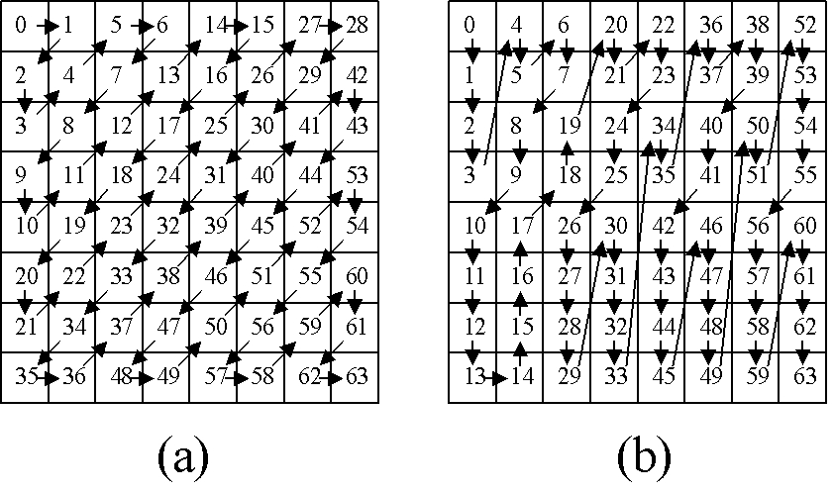
Fig. 2.1

In Table 2.1, comparison of zigzag scan and alternate scan is shown. The simulation condition is as follows:

Codec | MPEG-2
Sequence | “Cheer”, “Mobile”, “Flower”, “Football”  720x480; interlaced; 30Hz; 30frames
QP | Q_{I}=Q_{P}=16; Q_{B}=18 (fixed)
GOP structure | N=15; M=3
MV Search Range | 30
DCT/MC mode | Field / Frame Adaptive

 | Zigzag Scan [bytes] | Alternate Scan [bytes] | Bit Reduction
“Cheer” | 824047 | 809069 | 1.81%
“Mobile” | 706714 | 707758 | -0.15%
“Flower” | 623090 | 590830 | 5.2%
“Football” | 607194 | 585592 | 2.70%

Table 2.1

2.2 Proposed Algorithm
Current H.26L specification is based on 4x4 transform, and it contains two kinds of scan mode as shown in Fig. 2.2: that is, for luma signal of intra MB with QP<24, single scan (shown in Fig. 2.2 (a) ) is employed. Otherwise double scan (shown in Fig. 2.2 (b) ) is employed.

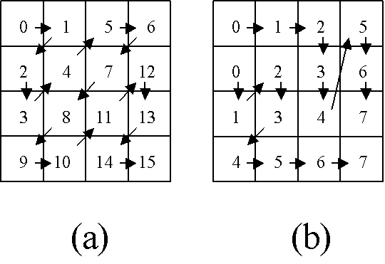

Fig. 2.2

Therefore we propose alternate scan methods shown in Fig. 2.3. Scan method shown in Fig. 2.3 (a) can be replaced with the current single scan method shown in Fig. 2.2 (a), and the one shown in Fig. 2.3 (b) can be replaced with the current double scan method shown in Fig. 2.2 (b).

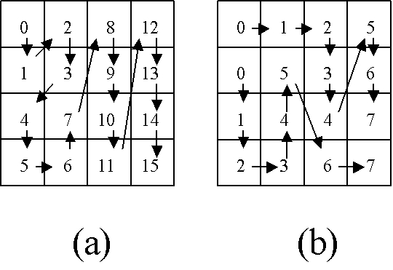

Fig. 2.3

  - Syntax & Semantics Change
As slice is a unit of random access in current H.26L standard, we propose the following syntax change in the slice header:

slice_header(){
:
load_single_scan_mode;
load_double_scan_mode;
if(load_single_scan_mode)
single_scan_mode;
if(load_double_scan_mode)
double_scan_mode;
:
}

The semantics of the “single_scan_mode” field and the “double_scan_mode” field are described in Table 2.2. It is possible that each code_number be coded with UVLC.

Code Number | single_scan_mode / double_scan_mode
0 | zigzag scan (Fig. 2.2 (a) or (b) )
1 | alternate scan (Fig. 2.3 (a) or (b) )

Table 2.2

For luma signal of intra MB with QP<24, single scan (shown in Fig. 2.2 (a) or Fig. 2.3 (a) ) is employed. Otherwise double scan (shown in Fig. 2.2 (b) or Fig. 2.3 (b) is employed. If “single_scan_mode” or “double_scan_mode” is not contained in the slice header, the scan methods used in the last slice are used in the subsequent macroblocks in the slice. If they are not contained in the first slice header in a sequence, zigzag scan methods shown in Fig. 2.2 are used.

2.4 Simulation Result
To demonstrate the advantage of our proposal, the following simulation is executed:

Codec | H.26L (TML9.0)
Sequence | Src19,22 (720x480, 30Hz)  Src6,5,9 (720x576, 25Hz)  Interlace, Frame Structure, 60frames
QP | Q_{I}=Q_{P}=16; Q_{B}=18
GOP Structure | - IIIIIIIIIII….  - IPPPPPP…  - IBBPBB…
Entropy Coding | UVLC
RD Optimization | on
Hadamard | yes
MC | 1/4-pel accuracy
Reference Frames | 3
MV Search Range | 16

The simulation results for GOP structure (a), (b) and (c) are shown in Table 2.3, 2.4, and 2.5 respectively. In our proposal, scan methods can be changed in the slice layer, but in each of the following simulations, both single_scan_mode and double_scan_mode are fixed as zigzag or alternate for the entire sequence.

 | Zigzag Scan [bytes] | Alternate Scan [bytes] | Bit Reduction
src19 | 2879126 | 2768128 | 3.86%
src22 | 3817547 | 3884546 | -1.76%
src6 | 3068941 | 3035303 | 1.10%
src5 | 3340671 | 3126028 | 6.43%
src9 | 3943424 | 3886987 | 1.43%

Table 2.3

 | Zigzag Scan [bytes] | Alternate Scan [bytes] | Bit Reduction
src19 | 1878855 | 1811300 | 3.60%
src22 | 1128853 | 1107874 | 1.86%
src6 | 1024259 | 1008232 | 1.56%
src5 | 1925363 | 1822885 | 5.32%
src9 | 2320740 | 2252365 | 2.95%

Table 2.4

 | Zigzag Scan [bytes] | Alternate Scan [bytes] | Bit Reduction
src19 | 1602544 | 1547540 | 3.43%
src22 | 809321 | 798936 | 1.28%
src6 | 853513 | 844417 | 1.07%
src5 | 1790660 | 1697121 | 5.22%
src9 | 1909800 | 1861033 | 2.55%

Table 2.5

- Adaptive Chroma Phase Shifting for 4:2:0 Interlaced Video

  - Previous Work
Fig. 3.1 illustrates phases of luminance and chrominance signals a frame-mc macroblock with mv_{vertical} =$±$2.0, $±$6.0, $±$10.0 … when the input signal is in 4:2:0 interlace format. In this case ideal chroma position is in the opposite field of the chroma phase in a frame memory, and it causes significant image degradation not only in the sense of PSNR but also of visual quality when the macloblock contains motion.

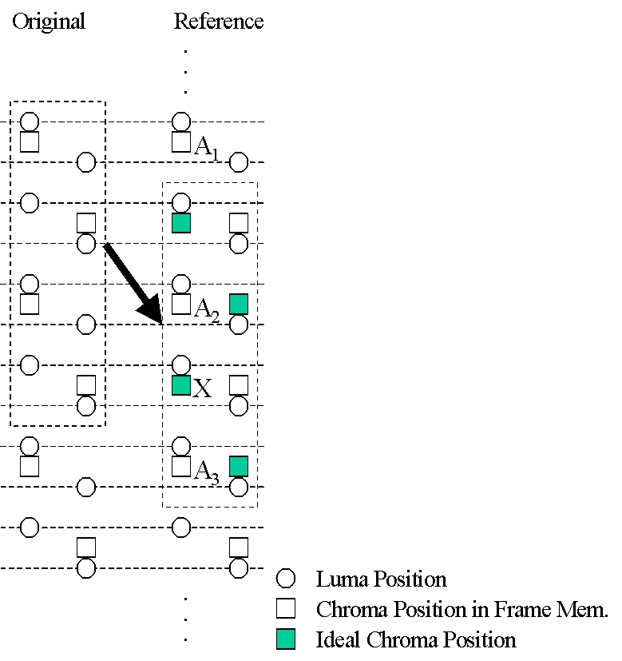

Fig 3.1

  - Proposed Algorithm
To fix the problem shown in Fig 3.1, we propose the following semantics change for motion compensation. No syntax change is necessary.
When the value of vertical component of the motion vector mv_{vertical} =$±$2.0, $±$6.0, $±$10.0 … , the pixel “X” in Fig 3.1 is generated by intra-field prediction. The following filter is used for this interpolation:
(3.1)
{-1, 5, 20, 20, 5, -1} /32

  - Simulation Result
To demonstrate the advantage of our proposal, the following simulation is executed:

Codec | H.26L (TML9.0)
Sequence | Src6 (720x576, 25Hz)  Interlace, Frame Structure, 15frames
QP | Q_{I}=Q_{P}=16
GOP Structure | IPPPPP…
Entropy Coding | UVLC
RD Optimization | on
Hadamard | yes
MC | 1/4-pel accuracy
Reference Frames | 3
MV Search Range | 16

The simulation result is shown in Table 3.1.

 | SNRY | SNRU | SNRV | Total Bit P | Bit Reduction
TML9.0 | 36.17 dB | 38.21 dB | 39.31 dB | 2518776 | N/A
Proposed | 36.19 dB | 38.22 dB | 39.24 dB | 2378192 | 5.58%

Table 3.1

- Conclusion

Current scan methods specified in H.26L are not optimized for interlace video signal. Therefore we propose alternate scan methods both for the single scan mode and for the double scan mode. We also propose that optional fields called “single_scan_mode” and “double_scan_mode” be contained in slice headers, which specify scan methods used in the subsequent macroblocks. The simulation results show that the new scan methods we propose can reduce generated bits by up to 6%.
When a macroblock is in frame-mc mode and the value of vertical component of the motion vector is mv_{vertical} =$±$2.0, $±$6.0, $±$10.0 … , the ideal chroma position is in the opposite field of the chroma pixel in the frame memory. We propose adaptive chroma phase shifting to solve this problem.

We propose this tool and propose to establish CE to evaluate these new tools more in detail.

References
[1] ISO/IEC 13818-2:2000 Information technology -- Generic coding of moving pictures and associated audio information: Video
[2] “Anticipatory Join t Model (JM) of Enhanced-Compression Video Coding”, ISO/IEC JTC 1/SC 29/WG11 N4355, July 2001

JVT Patent Disclosure Form

International Telecommunication Union  Telecommunication Standardization Sector | International Organization for Standardization | International Electrotechnical Commission
 |  | 
Joint Video Coding Experts Group - Patent Disclosure Form
(Typically one per contribution and one per Standard | Recommendation)

Please send to:
JVT Rapporteur Gary Sullivan, Microsoft Corp., One Microsoft Way, Bldg. 9, Redmond WA 98052-6399, USA
Email (preferred): Gary.Sullivan@itu.int Fax: +1 425 706 7329 (+1 425 70MSFAX)

This form provides the ITU-T | ISO/IEC Joint Video Coding Experts Group (JVT) with information about the patent status of techniques used in or proposed for incorporation in a Recommendation | Standard. JVT requires that all technical contributions be accompanied with this form. Anyone with knowledge of any patent affecting the use of JVT work, of their own or of any other entity (“third parties”), is strongly encouraged to submit this form as well.

This information will be maintained in a “living list” by JVT during the progress of their work, on a best effort basis. If a given technical proposal is not incorporated in a Recommendation | Standard, the relevant patent information will be removed from the “living list”. The intent is that the JVT experts should know in advance of any patent issues with particular proposals or techniques, so that these may be addressed well before final approval.

This is not a binding legal document; it is provided to JVT for information only, on a best effort, good faith basis. Please submit corrected or updated forms if your knowledge or situation changes.

This form is not a substitute for the ITU ISO IEC Patent Statement and Licensing Declaration, which should be submitted by Patent Holders to the ITU TSB Director and ISO Secretary General before final approval.

Submitting Organization or Person:
Organization name | Sony Corp.
Mailing address | Gate City Osaki East Tower 20 F  1-11-1 Osaki Shinagawa-ku,  Tokyo, 141-0032
Country | Japan
Contact person | Kazushi Sato
Telephone | +81-3-5435-3669
Fax | +81-3-5435-3891
Email | kazushi@av.crl.sony.co.jp
Place and date of submission | Tokyo, Japan on Jan. 23rd in 2002
Relevant Recommendation | Standard and, if applicable, Contribution:
Name (ex: “JVT”) |  | JVT
Title |  | New Interlace Coding Tools
Contribution number |  | 068

(Form continues on next page)

Disclosure information – Submitting Organization/Person (choose one box)
2.0 The submitter is not aware of having any granted, pending, or planned patents associated with the technical content of the Recommendation | Standard or Contribution.

or,
The submitter (Patent Holder) has granted, pending, or planned patents associated with the technical content of the Recommendation | Standard or Contribution. In which case,

  - The Patent Holder is prepared to grant – on the basis of reciprocity for the above Recommendation | Standard – a free license to an unrestricted number of applicants on a worldwide, non-discriminatory basis to manufacture, use and/or sell implementations of the above Recommendation | Standard.
X
2.2 The Patent Holder is prepared to grant – on the basis of reciprocity for the above Recommendation | Standard – a license to an unrestricted number of applicants on a worldwide, non-discriminatory basis and on reasonable terms and conditions to manufacture, use and/ or sell implementations of the above Recommendation | Standard.

Such negotiations are left to the parties concerned and are performed outside the ITU | ISO/IEC.
2.2.1 The same as box 2.2 above, but in addition the Patent Holder is prepared to grant a “royalty-free” license to anyone on condition that all other patent holders do the same.
2.3 The Patent Holder is unwilling to grant licenses according to the provisions of either 2.1, 2.2, or 2.2.1 above. In this case, the following information must be provided as part of this declaration:
- patent registration/application number;
- an indication of which portions of the Recommendation | Standard are affected.
- a description of the patent claims covering the Recommendation | Standard;
In the case of any box other than 2.0 above, please provide the following:
Patent number(s)/status
Inventor(s)/Assignee(s)
Relevance to JVT
Any other remarks:
(please provide attachments if more space is needed)

(form continues on next page)
Third party patent information – fill in based on your best knowledge of relevant patents granted, pending, or planned by other people or by organizations other than your own.

Disclosure information – Third Party Patents (choose one box)
X | 3.1 The submitter is not aware of any granted, pending, or planned patents held by third parties associated with the technical content of the Recommendation | Standard or Contribution.
 | 3.2 The submitter believes third parties may have granted, pending, or planned patents associated with the technical content of the Recommendation | Standard or Contribution.
For box 3.2, please provide as much information as is known (provide attachments if more space needed) - JVT will attempt to contact third parties to obtain more information:

3rd party name(s)
Mailing address
Country
Contact person
Telephone
Fax
Email
Patent number/status
Inventor/Assignee
Relevance to JVT

Any other comments or remarks:

