Joint Video Team (JVT) of ISO/IEC MPEG & ITU-T VCEG  (ISO/IEC JTC1/SC29/WG11 and ITU-T SG16 Q.6)  2nd Meeting: Geneva, CH, Jan. 29 - Feb. 1, 2002 | Document: JVT-B065  Filename: JVT-B065.doc  Generated: 2002-01-23

Title: | ABT Coding Results for Interlaced ITU-R 601 Video
Status: | Input Document to JVT
Purpose: | Information
Author(s) or  Contact(s): | Ulrich Benzler  Robert Bosch GmbH FV/SLM  PO Box 77 77 77  31132 Hildesheim, Germany | Tel:  Fax:  Email: | ++49-5121-493087  ++49-5121-49173087  ulrich.benzler@de.bosch.com
Source: | Robert Bosch GmbH
_____________________________
Summary
In this paper, results of the Adaptive Block Transforms (ABT) for interlaced ITU-R 601 source material are presented, both for Inter-only and Inter&Intra ABT coding. The simulations reveal an improved performance of the proposed scheme compared with the TML (~0.4 dB PSNR gain / ~8% bit rate saving), validating the results presented in [JVT-B053].

Introduction
In this paper, coding results of the Adaptive Block Transforms (ABT) for interlaced ITU-R 601 source material are presented.
The concept of ABT was presented to VCEG in several documents [VCEG-L15, VCEG-M62, VCEG-N49, VCEG-O31]..At the Pattaya meeting, a simplified ABT concept was presented using only the 4x4 and the 8x8 transform matrix [VCEG-O30]. Here, we present the coding results of this simplified ABT coding of inter and intra blocks when applied to interlaced ITU-R 601 video. A full description of the applied ABT coding scheme can be found in [JVT-B053].
The paper is organized as follows: First we present the simulation conditions for ABT inter and intra coding according to the Interlaced and the Transform AdHoc groups [VCEG-O59]. In the second part, the performance of ABT in the TML-9.0 software is given for these conditions. Due to the size of the sequences and the resulting computation time for the simulations, only a subset of the quantization parameters QP listed in [VCEG-O59] and only ITU-R 601 resolution (no HHR resolution) was used.

Experimental Results
Simulation results are given according to the common interlaced coding conditions that were agreed on by the Interlaced and the Transform Size AdHoc groups [VCEG-O59]. The ABT coding tools were integrated into the TML9.0 software that was released at the Pattaya meeting.

Encoding of interlaced Video
The common condition for interlaced video include field based encoding of interlaced sequences with B-frames. It was agreed that the following setting should be used:
IP BB BB PP BB BB PP …
i.e., the top field of frame #0 is coded I, the bottom field P, the fields of frames #1,#2 are coded B, the two fields of frame #3 are coded P, and so forth.
The reference software as well as the ABT implementation were modified to enable IP BB BB PP coding of a field sequence. Encoding of the B-frames is performed after encoding of the top field of the next P-frame.

Simulation Conditions
The following common conditions were used for the simulations
Picture Structure  (field based) | - II II II  - IP PP PP PP  - IP BB BB PP BB BB PP
Motion Resolution | ¼ pel
Quantization Parameters | 16,24 [QP(B) = QP(I/P)+2]
Search Range | 16 pixel
Hadamard (SATD) | ON
Reference Frames | 2
Entropy Coding | CABAC

The following test sequences were used
Sequence Name | Frame Size | No. of Frames
F1_car | 720x576 | 220
Canoa | 720x576 | 220
Rugby | 720x576 | 220
Tempete | 720x480 | 260
Football | 720x480 | 260
Bus | 720x480 | 150

The sequences (except for Bus) are available from the VQEG ftp site (www.vqeg.org). They were converted from 422 to 420 using the converter tool provided by Peter Borgwardt [VCEG-N85]. In a pre-experiment all sequences showed improved coding performance for field based coding compared to frame based coding. Therefore, only field based coding was used for the simulations.

ABT Modes
For performance evaluation of ABT two settings were used for the simulations:
- ABT Inter only. For intra coding the TML intra techniques are used
- ABT Inter&Intra. ABT is used for Inter and Intra Coding

Results
As only a subset of the QP values could be simulated due to the large computation time, the difference in terms of rate and PSNR as calculated using the Bjontegaard measurement method [VCEG-M33] can not be given (four rate-distortion points are needed for this method). The performance of ABT inter and ABT inter&intra in comparison to the performance of the TML encoder validates the results presented in [JVT-B053]. The corresponding RD plots are given in the Appendix.

Discussion and Conclusion
Simulation results are presented for the concept of Adaptive Block Transforms (ABT) for Inter and Intra coding. The simulations reveal an improved performance of the proposed scheme, validating the results presented in [JVT-B053].
We propose to adopt the ABT into the JM for higher resolutions (larger than CIF), particularly for video formats that use interlaced scanning.

References
[JVT-B053] Mathias Wien, ' ABT Coding for Higher Resolution Video ', Document JVT-B053, Joint Video Team (JVT) of ISO/IEC MPEG and ITU-T VCEG, Geneva, Switzerland, 29 Jan -1 Feb.. 2002.
[VCEG-O59] Peter Borgwardt, 'Core Experiment on Interlaced Video Coding', Document VCEG-O59, ITU-T Video Coding Experts Group (VCEG) Meeting 15, Pattaya, Thailand, 4-6 Dec 2001.
[VCEG-O31] Mathias Wien and Achim Dahlhoff, 'Intra Coding using Variable Block Sizes',
Document VCEG-O31, ITU-T Video Coding Experts Group (VCEG) Meeting 15, Pattaya, Thailand, 4-6 Dec 2001.
[VCEG-O30] Mathias Wien and Jens-Rainer Ohm, 'Simplified Adaptive Block Transforms',
Document VCEG-O30, ITU-T Video Coding Experts Group (VCEG) Meeting 15, Pattaya, Thailand, 4-6 Dec 2001.
[VCEG-N85] Peter Borgwardt, 'Core Experiment on Interlaced Video Coding', ITU-T Q6/16 VCEG, Document VCEG-N85r1, Santa Barbara, CA, USA, Sep. 2001.
[VCEG-N49] M. Wien and A. Dahlhoff, 'New ABT Results using CABAC', ITU-T Q6/16 VCEG, Doc. VCEG-N49, Santa Barbara, CA, USA, Sep. 2001.
[VCEG-M62] M. Wien and A. Dahlhoff, 'Adaptive Block Transforms', ITU-T Q6/16 VCEG, Doc. VCEG-M62, Austin, TX, April 2001.
[VCEG-M33] Gisle Bjontegaard, 'Calculation of average PSNR differences between RD
curves,' Document VCEG-M33, ITU-T Video Coding Experts Group (VCEG) Meeting, Austin, TX, USA, 2-4 April 2001.
[VCEG-L15] M.Wien and C.Mayer, ‘ABT Coding Elements’, ITU-T VCEG,
Document VCEG-L15, Eibsee, Germany, January 2000

Appendix

IP BB BB PP
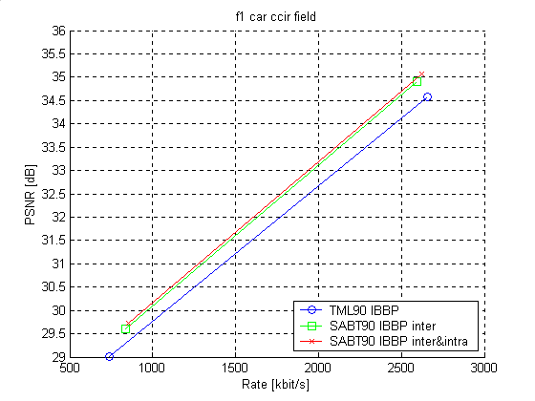

f1 car ccir field TML90 IBBP
QP Rate PSNR
24 737365 29.01
16 2656229 34.57
f1 car ccir field ABT90 IBBP inter
QP Rate PSNR
24 836271 29.61
16 2594077 34.90
f1 car ccir field ABT90 IBBP inter&intra
QP Rate PSNR
24 854725 29.74
16 2619999 35.08
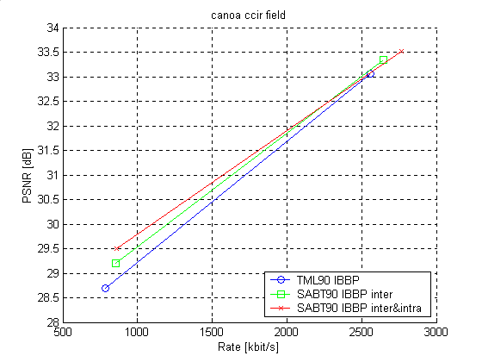

canoa ccir field TML90 IBBP
QP Rate PSNR
24 782908 28.69
16 2561851 33.07
canoa ccir field ABT90 IBBP inter
QP Rate PSNR
24 854448 29.19
16 2645725 33.34
canoa ccir field ABT90 IBBP inter&intra
QP Rate PSNR
24 859093 29.49
16 2764750 33.51
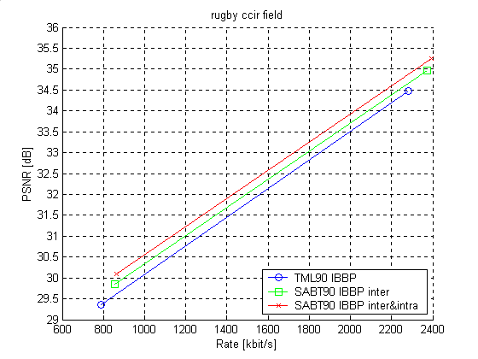
rugby ccir field TML90 IBBP
QP Rate PSNR
24 789702 29.35
16 2280146 34.48
rugby ccir field ABT90 IBBP inter
QP Rate PSNR
24 855213 29.84
16 2374594 34.96
rugby ccir field ABT90 IBBP inter&intra
QP Rate PSNR
24 864807 30.10
16 2393694 35.25
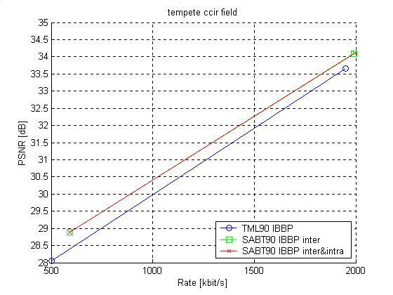
tempete ccir field TML90 IBBP
QP Rate PSNR
24 502834 28.05
16 1950447 33.67
tempete ccir field ABT90 IBBP inter
QP Rate PSNR
24 590152 28.88
16 1991108 34.10
tempete ccir field ABT90 IBBP inter&intra
QP Rate PSNR
24 591986 28.89
16 1995187 34.11
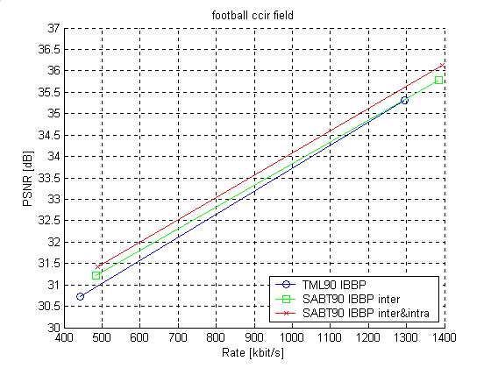
football ccir field TML90 IBBP
QP Rate PSNR
24 443390 30.72
16 1296063 35.31
football ccir field ABT90 IBBP inter
QP Rate PSNR
24 484352 31.21
16 1384681 35.79
football ccir field ABT90 IBBP inter&intra
QP Rate PSNR
24 489597 31.41
16 1395154 36.13
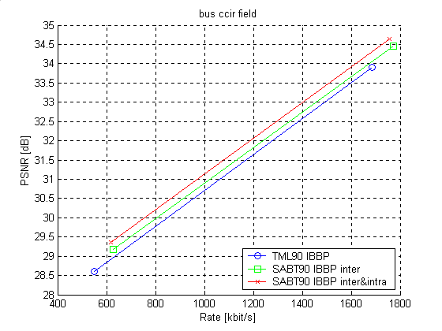
bus ccir field TML90 IBBP
QP Rate PSNR
24 548505 28.60
16 1684067 33.91
bus ccir field ABT90 IBBP inter
QP Rate PSNR
24 626953 29.17
16 1772842 34.47
bus ccir field ABT90 IBBP inter&intra
QP Rate PSNR
24 616777 29.36
16 1756968 34.63

IP PP PP
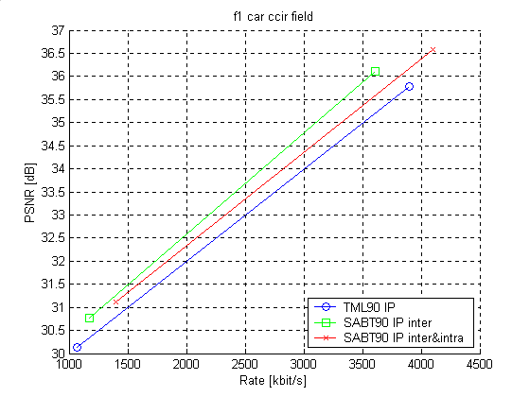
f1 car ccir field TML90 IP
QP Rate PSNR
24 1064886 30.14
16 3901527 35.79
f1 car ccir field ABT90 IP inter
QP Rate PSNR
24 1176804 30.77
16 3607754 36.10
f1 car ccir field ABT90 IP inter&intra
QP Rate PSNR
24 1402222 31.11
16 4103269 36.58
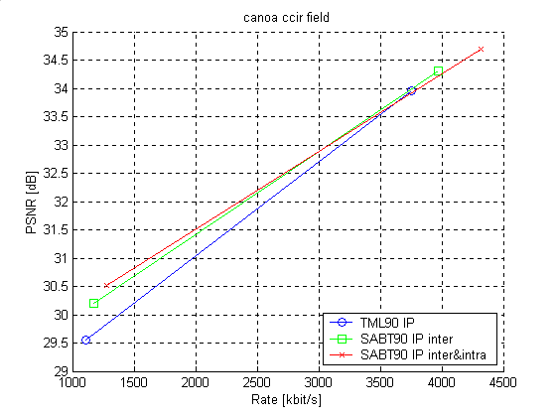
canoa ccir field TML90 IP
QP Rate PSNR
24 1108726 29.54
16 3756193 33.95
canoa ccir field ABT90 IP inter
QP Rate PSNR
24 1173085 30.20
16 3973453 34.31
canoa ccir field ABT90 IP inter&intra
QP Rate PSNR
24 1275954 30.53
16 4315838 34.69
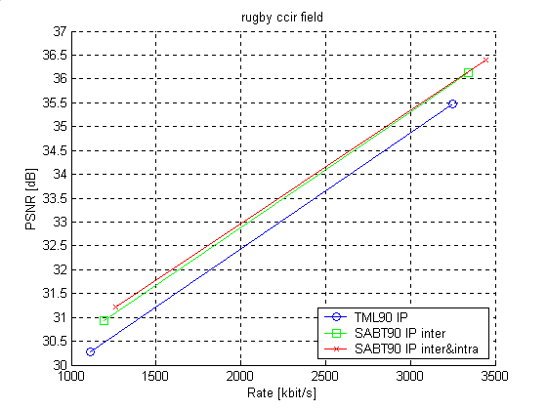
rugby ccir field TML90 IP
QP Rate PSNR
24 1114671 30.28
16 3250291 35.48
rugby ccir field ABT90 IP inter
QP Rate PSNR
24 1195612 30.93
16 3340728 36.13
rugby ccir field ABT90 IP inter&intra
QP Rate PSNR
24 1262094 31.22
16 3444645 36.40
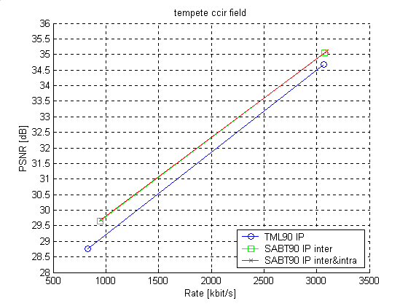
tempete ccir field TML90 IP
QP Rate PSNR
24 826496 28.76
16 3066808 34.67
tempete ccir field ABT90 IP inter
QP Rate PSNR
24 944440 29.66
16 3078028 35.05
tempete ccir field ABT90 IP inter&intra
QP Rate PSNR
24 953584 29.69
16 3096790 35.09
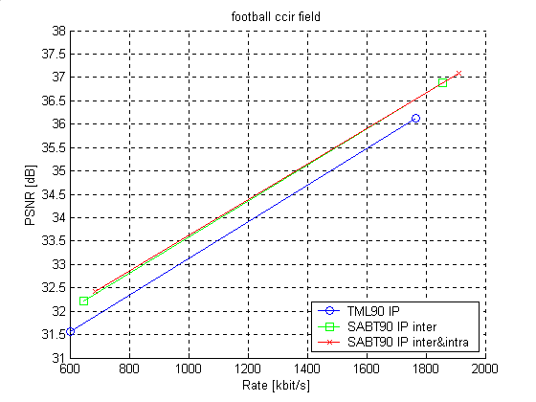
football ccir field TML90 IP
QP Rate PSNR
24 601620 31.56
16 1764695 36.13
football ccir field ABT90 IP inter
QP Rate PSNR
24 647706 32.21
16 1857651 36.88
football ccir field ABT90 IP inter&intra
QP Rate PSNR
24 685082 32.42
16 1911550 37.10
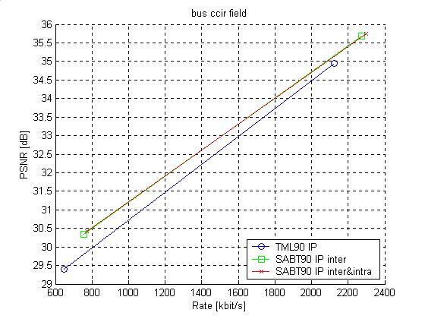
bus ccir field TML90 IP
QP Rate PSNR
24 648982 29.40
16 2125883 34.96
bus ccir field ABT90 IP inter
QP Rate PSNR
24 754399 30.34
16 2272111 35.68
bus ccir field ABT90 IP inter&intra
QP Rate PSNR
24 771061 30.43
16 2297254 35.74

II II II
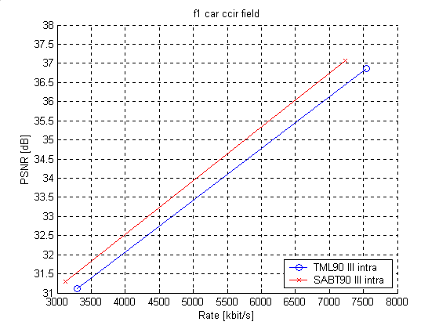
f1 car ccir field TML90 III intra
QP Rate PSNR
24 3294551 31.11
16 7547599 36.86
f1 car ccir field ABT90 III intra
QP Rate PSNR
24 3124545 31.29
16 7228862 37.08
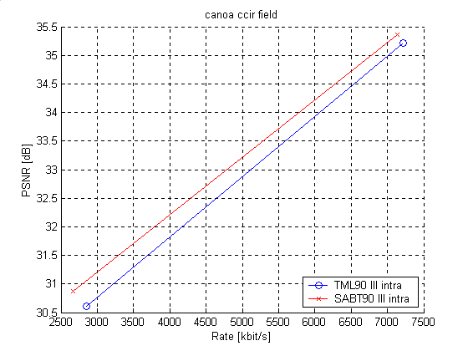
canoa ccir field TML90 III intra
QP Rate PSNR
24 2854421 30.61
16 7217065 35.22
canoa ccir field ABT90 III intra
QP Rate PSNR
24 2665164 30.87
16 7132787 35.37
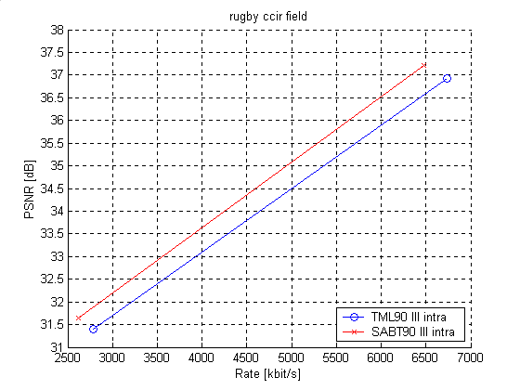
rugby ccir field TML90 III intra
QP Rate PSNR
24 2785558 31.40
16 6737170 36.94
rugby ccir field ABT90 III intra
QP Rate PSNR
24 2617677 31.65
16 6480278 37.21
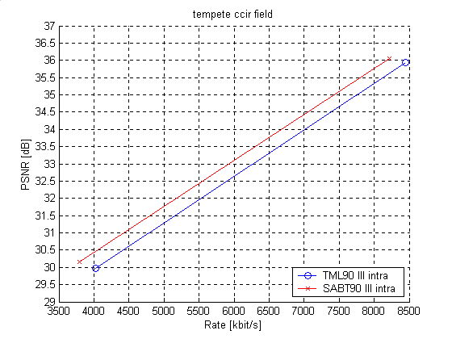
tempete ccir field TML90 III intra
QP Rate PSNR
24 4029909 29.98
16 8444831 35.93
tempete ccir field ABT90 III intra
QP Rate PSNR
24 3794610 30.15
16 8216266 36.06

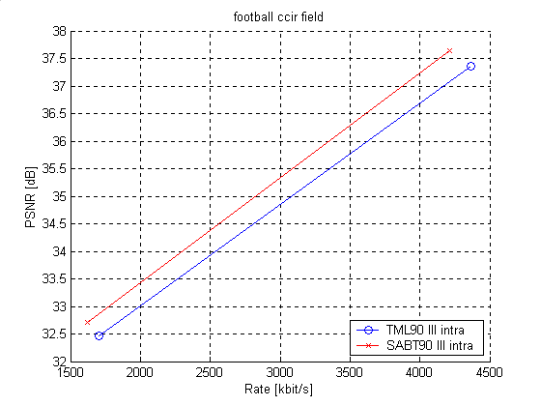
football ccir field TML90 III intra
QP Rate PSNR
24 1700819 32.46
16 4361774 37.35
football ccir field ABT90 III intra
QP Rate PSNR
24 1622178 32.71
16 4213422 37.64

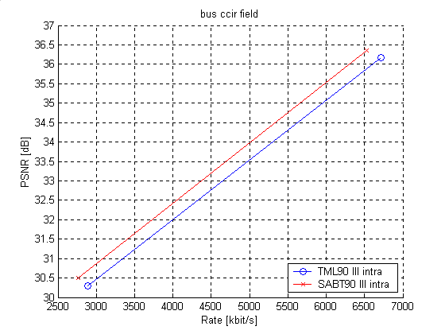
bus ccir field TML90 III intra
QP Rate PSNR
24 2890290 30.31
16 6716814 36.16
bus ccir field ABT90 III intra
QP Rate PSNR
24 2760994 30.51
16 6528546 36.36

JVT Patent Disclosure Form

International Telecommunication Union  Telecommunication Standardization Sector | International Organization for Standardization | International Electrotechnical Commission
 |  | 
Joint Video Coding Experts Group - Patent Disclosure Form
(Typically one per contribution and one per Standard | Recommendation)

Please send to:
JVT Rapporteur Gary Sullivan, Microsoft Corp., One Microsoft Way, Bldg. 9, Redmond WA 98052-6399, USA
Email (preferred): Gary.Sullivan@itu.int Fax: +1 425 706 7329 (+1 425 70MSFAX)

This form provides the ITU-T | ISO/IEC Joint Video Coding Experts Group (JVT) with information about the patent status of techniques used in or proposed for incorporation in a Recommendation | Standard. JVT requires that all technical contributions be accompanied with this form. Anyone with knowledge of any patent affecting the use of JVT work, of their own or of any other entity (“third parties”), is strongly encouraged to submit this form as well.

This information will be maintained in a “living list” by JVT during the progress of their work, on a best effort basis. If a given technical proposal is not incorporated in a Recommendation | Standard, the relevant patent information will be removed from the “living list”. The intent is that the JVT experts should know in advance of any patent issues with particular proposals or techniques, so that these may be addressed well before final approval.

This is not a binding legal document; it is provided to JVT for information only, on a best effort, good faith basis. Please submit corrected or updated forms if your knowledge or situation changes.

This form is not a substitute for the ITU ISO IEC Patent Statement and Licensing Declaration, which should be submitted by Patent Holders to the ITU TSB Director and ISO Secretary General before final approval.

Submitting Organization or Person:
Organization name | Robert Bosch GmbH
Mailing address | PO Box 106050  70049 Stuttgart
Country | Germany
Contact person | Ulrich Benzler
Telephone | +49-5121-493087
Fax | +49-5121-49173087
Email | ulrich.benzler@de.bosch.com
Place and date of submission | Geneva, Switzerland January 29th 2002
Relevant Recommendation | Standard and, if applicable, Contribution:
Name (ex: “JVT”) |  | JVT
Title |  | ABT Coding Results for Interlaced ITU-R 601 Video
Contribution number |  | JVT-B065

(Form continues on next page)

Disclosure information – Submitting Organization/Person (choose one box)
2.0 The submitter is not aware of having any granted, pending, or planned patents associated with the technical content of the Recommendation | Standard or Contribution.

or,
The submitter (Patent Holder) has granted, pending, or planned patents associated with the technical content of the Recommendation | Standard or Contribution. In which case,

  - The Patent Holder is prepared to grant – on the basis of reciprocity for the above Recommendation | Standard – a free license to an unrestricted number of applicants on a worldwide, non-discriminatory basis to manufacture, use and/or sell implementations of the above Recommendation | Standard.
2.2 The Patent Holder is prepared to grant – on the basis of reciprocity for the above Recommendation | Standard – a license to an unrestricted number of applicants on a worldwide, non-discriminatory basis and on reasonable terms and conditions to manufacture, use and/ or sell implementations of the above Recommendation | Standard.

Such negotiations are left to the parties concerned and are performed outside the ITU | ISO/IEC.
2.2.1 The same as box 2.2 above, but in addition the Patent Holder is prepared to grant a “royalty-free” license to anyone on condition that all other patent holders do the same.
2.3 The Patent Holder is unwilling to grant licenses according to the provisions of either 2.1, 2.2, or 2.2.1 above. In this case, the following information must be provided as part of this declaration:
- patent registration/application number;
- an indication of which portions of the Recommendation | Standard are affected.
- a description of the patent claims covering the Recommendation | Standard;
In the case of any box other than 2.0 above, please provide the following:
Patent number(s)/status
Inventor(s)/Assignee(s)
Relevance to JVT
Any other remarks:
(please provide attachments if more space is needed)

(form continues on next page)
Third party patent information – fill in based on your best knowledge of relevant patents granted, pending, or planned by other people or by organizations other than your own.

Disclosure information – Third Party Patents (choose one box)
3.1 The submitter is not aware of any granted, pending, or planned patents held by third parties associated with the technical content of the Recommendation | Standard or Contribution.

3.2 The submitter believes third parties may have granted, pending, or planned patents associated with the technical content of the Recommendation | Standard or Contribution.

For box 3.2, please provide as much information as is known (provide attachments if more space needed) - JVT will attempt to contact third parties to obtain more information:

3rd party name(s)
Mailing address
Country
Contact person
Telephone
Fax
Email
Patent number/status
Inventor/Assignee
Relevance to JVT

Any other comments or remarks:

