ITU - Telecommunications Standardization Sector  STUDY GROUP 16 Question 6  Video Coding Experts Group (VCEG)  _________________  15th Meeting: Pattaya, Thailand, 4-6 Dec., 2001 | Document VCEG-O19  Filename: VCEG-O19.doc  Generated: 26 November ’01

Question: | Q.6/SG16 (VCEG)
Source: | Min-Cheol Hong  Soongsil University  School of Electronic Engineering  Seoul, Korea  Young Man Park  Digital Media Research Lab.  LG Electronics  Seoul, Korea | Tel:  Fax:  Email: | +82-2-820-0716  +82-2-821-7653  mhong@e.ssu.ac.kr
Title: | Further Experimental Results of VCEG-N30 (loop filter for improving visual quality)
Purpose: | Proposal
_____________________________
A modified loop filter for improving visual quality was proposed in Santa Barbara meeting. The consensus about the loop filter was that visual quality was clearly improved, but the complexity of the filter was slightly higher over TML8 in-loop filter at high bit rates (about 3-4%). This contribution is to enhance the filter such in a way that the complexity is reduced with keeping better visual quality over the TML8.5 in-loop filter. We shortly describe the major changes over VCEG-N30.

- Detection

QP | 0 | 1 | 2 | 3 | 4 | 5 | 6 | 7 | 8 | 9 | 10 | 11 | 12 | 13 | 14 | 15 | 16 | 17 | 18 | 19 | 20 | 21 | 22 | 23 | 24 | 25 | 26 | 27 | 28 | 29 | 30 | 31
β | 0 | 0 | 0 | 0 | 0 | 0 | 0 | 0 | 2 | 2 | 2 | 4 | 4 | 4 | 6 | 6 | 6 | 7 | 8 | 8 | 9 | 9 | 10 | 10 | 11 | 11 | 12 | 12 | 13 | 13 | 14 | 14
Table 1. Threshold parameter, β as a function of QP

$$\left|r_{1}−r_{1+i}\right|∗i>β (1)$$
where maximum of i is determined by block strength such as

$$\text{max}(i)=$$
The right filter activity parameter $a_{r}$ is equal to the smallest integer i > 0 not larger than max(i) for which Eq. (1) holds. The left filter activity parameter $a_{l}$is similarly obtained, and the left and right block activities are used to select filtered pixels of left and right blocks in the same way.
- Adaptive filtering
As we described on VCEG-N30, it is more reasonable that different filter coefficients are used for different QP values, since the degree of blocking artifact is dependent to QP value. The filter coefficients are slightly changed to obtain better visual quality. The weak filtering is taken placed as following;
$$\begin{aligned}L_{1}=(\text{fcoef}2∗(l_{2}+r_{1})+\text{fcoef}1∗l_{1}+\text{32})/{\text{64}} \\ L_{2}=(\text{fcoef}2∗(l_{3}+l_{1})+\text{fcoef}1∗l_{2}+\text{32})/{\text{64}} \\ R_{1}=(\text{fcoef}2∗(l_{1}+r_{2})+\text{fcoef}1∗r_{1}+\text{32})/{\text{64}} \\ R_{2}=(\text{fcoef}2∗(r_{1}+r_{3})+\text{fcoef}1∗r_{2}+\text{32})/{\text{64}} \\ \text{fcoef}2=(\text{64}−2∗\text{fcoef}1)/2 (3)\end{aligned}$$
where the filter coefficients take QP dependent values

QP | 0 | 1 | 2 | 3 | 4 | 5 | 6 | 7 | 8 | 9 | 10 | 11 | 12 | 13 | 14 | 15 | 16 | 17 | 18 | 19 | 20 | 21 | 22 | 23 | 24 | 25 | 26 | 27 | 28 | 29 | 30 | 31
Fcoef1 | 36 | 36 | 36 | 36 | 36 | 36 | 36 | 36 | 36 | 36 | 36 | 36 | 32 | 32 | 32 | 30 | 30 | 28 | 28 | 26 | 26 | 26 | 24 | 24 | 24 | 24 | 22 | 22 | 22 | 22 | 22 | 22

On the other hand, the strong filter is defined as
$$\begin{aligned}L_{l}=(\text{fcoef}2∗(l_{3}+r_{2})+\text{fcoef}1∗(l_{2}+l_{1}+r_{1})+\text{64})/{\text{128}} \\ L_{2}=(\text{fcoef}2∗(l_{4}+r_{1})+\text{fcoef}1∗(l_{3}+l_{2}+l_{1})+\text{64})/{\text{128}} \\ L_{3}=(\text{fcoef}2∗(l_{3}+l_{1})+\text{fcoef}1∗(l_{4}+l_{3}+l_{2})+\text{64})/{\text{128}} \\ R_{1}=(\text{fcoef}2∗(l_{2}+r_{3})+\text{fcoef}1∗(l_{1}+r_{1}+r_{2})+\text{64})/{\text{128}} \\ R_{2}=(\text{fcoef}2∗(l_{1}+r_{4})+\text{fcoef}1∗(r_{1}+r_{2}+r_{3})+\text{64})/{\text{128}} \\ R_{3}=(\text{fcoef}2∗(r_{3}+r_{1})+\text{fcoef}1∗(r_{2}+r_{3}+r_{4})+\text{64})/{\text{128}} \\ \text{fcoef}2=(\text{128}−3∗\text{fcoef}1)/2 (4)\end{aligned}$$
where filter coefficients for the strong filter are
QP | 0 | 1 | 2 | 3 | 4 | 5 | 6 | 7 | 8 | 9 | 10 | 11 | 12 | 13 | 14 | 15 | 16 | 17 | 18 | 19 | 20 | 21 | 22 | 23 | 24 | 25 | 26 | 27 | 28 | 29 | 30 | 31
Fcoef1 | 40 | 40 | 40 | 40 | 40 | 40 | 40 | 40 | 40 | 40 | 40 | 40 | 36 | 36 | 36 | 34 | 34 | 32 | 32 | 30 | 30 | 30 | 28 | 28 | 28 | 28 | 26 | 26 | 26 | 26 | 26 | 26
3. Projection operator
The proposed Clip functions take a tighter bound than VCEG-N30. It is
QP 0 1 2 3 4 5 6 7 8 9 10 11 12 13 14 15 16 17 18 19 20 21 22 23 24 25 26 27 28 29 30 31
Clip(qp,1) 0 0 0 0 0 0 0 0 1 1 1 1 1 1 1 1 1 1 1 2 2 2 2 3 3 3 4 4 5 5 6 7
Clip(qp,2) 0 0 0 0 0 0 1 1 1 1 1 1 1 1 2 2 2 2 2 2 2 2 3 3 3 4 4 5 6 6 7 8
Clip(qp,3) 0 0 0 1 1 1 1 1 1 1 1 1 1 2 2 2 2 2 2 2 3 3 3 4 4 5 5 6 7 8 9 10

4. Experimental results
The proposed loop filter has been tested with several QP values, various video sequences, frames rates, and resolutions. The experimental results show that the proposed algorithm effectively reduces blocking artifact at a specific QP range (QP=10-19). Also, 5-10% complexity saving is obtained as a side effect. Figures 1-4 show examples of the noticeable difference between TML8.5 loop filter and the loop filter. In order to see the difference both at high bit rates and at low bit rate, QP values that we tested with are 10,12,14,16,18,20,22,24. We define H4 and L4 as the results of QP={10,12,14,16} and QP={18,20,22,24}, respectively. PSNR comparison is in VCEG-O19.xls, and demonstration will be shown in the meeting.

[Reference]
1. Gisle Bjontegaard (Ed.), ``H.26L Test Model Long Term Number 8 (TML8)’’, June 2001.
- M.-C. Hong and Y. M. Park, ``Modified Loop Filter for Improving Visual Quality,’’
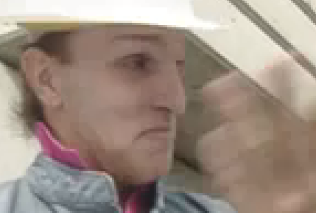
(a) Result of TML8.5 loop filter
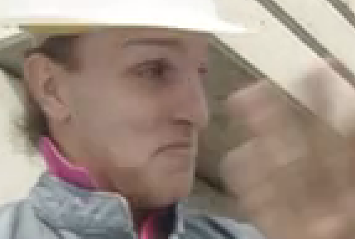
(b) Result of proposed loop filter
Figure 1. Example of visual difference (QP=13)
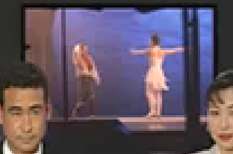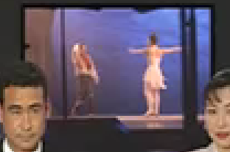
- Result of TML8.5 loop filter (b) Result of proposed loop filter
Figure 2. Example of visual difference (QP=14)

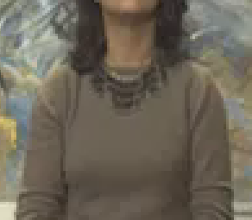
(a) Result of TML8.5 loop filter (b) Result of proposed loop filter
Figure 3. Example of visual difference (QP=14)

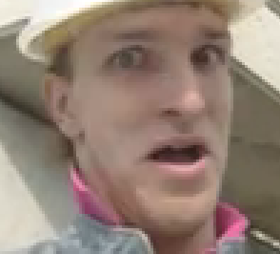
- Result of TML8.5 loop filter (b) Result of proposed loop filter
Figure 4. Example of visual difference (QP=14)

Submitting Organization or Person:
Organization name |  | Soongsil University/LG Electronics
Mailing address |  | Soongsil University, School of Electronic Engineering  Sangdo-Dong, Dongjak-Gu  Seoul  LG Electronics  Woomyeon-Dong  Seoul
Country |  | Korea
Contact person |  | mhong@e.ssu.ac.kr
Telephone |  | +82-2-820-0716
Fax |  | +82-2-821-7653
Email |  | mhong@e.ssu.ac.kr
Place and date of submission |  | Seoul / 2001.11.27
Relevant Recommendation and, if applicable, Contribution:
Number (ex: “H.26L”) |  |  |  | H.26L
Title |  |  |  | Further Experimental Results on VCEG-N30
Contribution number |  |  |  | VCEG-O19
Disclosure information – Submitting Organization/Person (choose one box)
2.0 The submitter is not aware of having any granted, pending, or planned patents associated with the technical content of the Recommendation/Contribution.

or,
The submitter (Patent Holder) has granted, pending, or planned patents associated with the technical content of the Recommendation/Contribution. In which case,

 | - The Patent Holder is prepared to grant – on the basis of reciprocity for the above ITU-T Recommendation – a free license to an unrestricted number of applicants on a worldwide, non-discriminatory basis to manufacture, use and/or sell implementations of the above ITU-T Recommendation.
2.2 The Patent Holder is prepared to grant – on the basis of reciprocity for the above ITU-T Recommendation – a license to an unrestricted number of applicants on a worldwide, non-discriminatory basis and on reasonable terms and conditions to manufacture, use and/ or sell implementations of the above ITU-T Recommendation.

Such negotiations are left to the parties concerned and are performed outside the ITU-T.
 | 2.2.1 The same as box 2.2 above, but in addition the Patent Holder is prepared to grant a “royalty-free” license to anyone on condition that all other patent holders do the same.
2.3 The Patent Holder is unwilling to grant licenses according to the provisions of either 2.1, 2.2, or 2.2.1 above. In this case, the following information must be provided as part of this declaration:
- patent registration/application number;
- an indication of which portions of the Recommendation are affected.
- a description of the patent claims covering the Recommendation;
In the case of any box other than 2.0 above, please provide the following:
Patent number(s)/status |  |  | On pending
Inventor(s)/Assignee(s) |  |  | Min-Cheol Hong and Y. M. Park/ LG Electronics
Relevance to VCEG
Any other remarks:
(please provide attachments if more space is needed)

Disclosure information – Third Party Patents (choose one box)
3.1 The submitter is not aware of any granted, pending, or planned patents held by third parties associated with the technical content of the Recommendation/Contribution.

3.2 The submitter believes third parties may have granted, pending, or planned patents associated with the technical content of the Recommendation/Contribution.

For box 3.2, please provide as much information as is known (provide attachments if more space needed) - VCEG will attempt to contact third parties to obtain more information:

3rd party name(s)
Mailing address
Country
Contact person
Telephone
Fax
Email
Patent number/status
Inventor/Assignee
Relevance to VCEG

