ITU - Telecommunications Standardization Sector  STUDY GROUP 16 Question 6  Video Coding Experts Group (VCEG)  _________________  14th Meeting: Santa Barbara, CA, USA, 24-27 Sep., 2001 | Document VCEG-N55  Filename: VCEG-N55.doc  Generated: 17 September ’01

Question: | Q.6/SG16 (VCEG)
Source: | Yoshihiro Miyamoto and Kei-ichi Chono  NEC Corporation  Kawasaki, 216-8555 JAPAN | Tel:  Fax:  Email: | +81 44 856 8141  +81 44 856 2232  miyamoto@dsp.cl.nec.co.jp
Title: | Analysis of fractional pixel interpolation for MC prediction
Purpose: | Information
_____________________________

Background
Since the Portland meeting, the filtering techniques for fractional pixel interpolation have been discussed. The discussion was concentrated on the complexity reduction of filtering process on 1/4 pixel position. However, the simplification of the precision for fractional pixel interpolating has not been examined. This contribution provides information on the experimental results using a short filter (2-tap filter) and the TML 6-tap filter for interpolating on 1/2 and 1/4 pixel positions.

Experiments
We have compared the performance of the filters. Attached Figures show the rate-distortion results.

1/2 pixel prediction without in-loop filter : 2-tap better than 6-tap (especially on very low bitrate)

1/2 pixel prediction with in-loop filter : 2-tap better than 6-tap

1/4 pixel prediction with/without in-loop filter : 6-tap better than 2-tap

Scalability of the precision for fractional pixel interpolation
The experimental results show that the 2-tap filter has enough performance for 1/2 pixel prediction, though the 6-tap one is better at predicting with higher fractional pixel interpolation. In the view of implementation, the complexity of the 6-tap filter is very high. Therefore, we believe that the 1/2 pixel prediction using the 2-tap filter is appropriate for low-cost coding systems. The scalability of the precision for fractional pixel interpolating is useful for realizing various coding systems. An appropriate filter should be selected on the basis of the pixel precision as follows,

1/2 pixel precision : 2-tap average filter,

1/4 pixel precision : the TML 6-tap filter (both on 1/2 and 1/4 pixel positions),

1/8 pixel precision : to be discussed.
The precision may be indicated in Sequence header or GOP header.

Conclusion
We would suggest that the scalability of the pixel precision for MC prediction could be incorporated into the next TML.
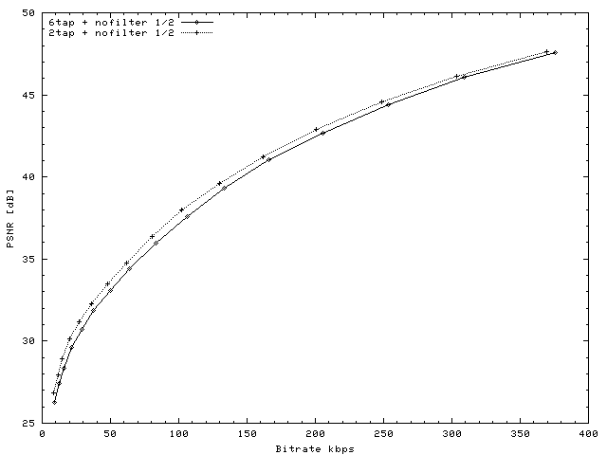
News QCIF 10fps (1/2pel MC without in-loop filter)
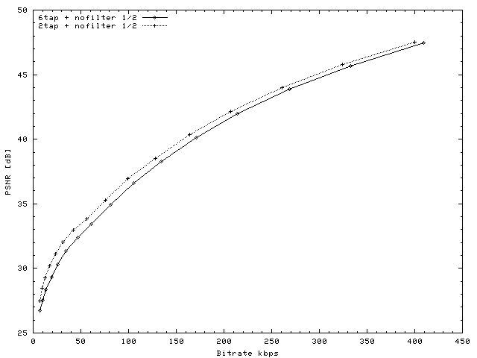
Silent QCIF 10fps (1/2pel MC without in-loop filter)
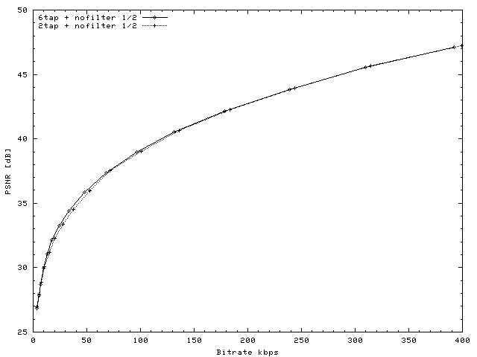
Container QCIF 10fps(1/2pel MC without in-loop filter)
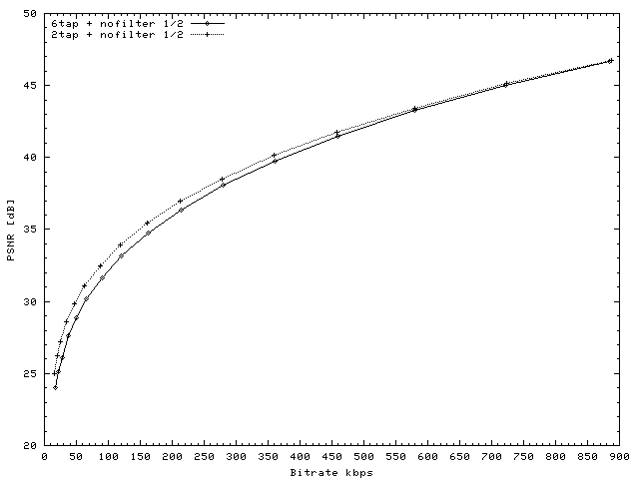
Foreman QCIF 10fps (1/2pel MC without in-loop filter)
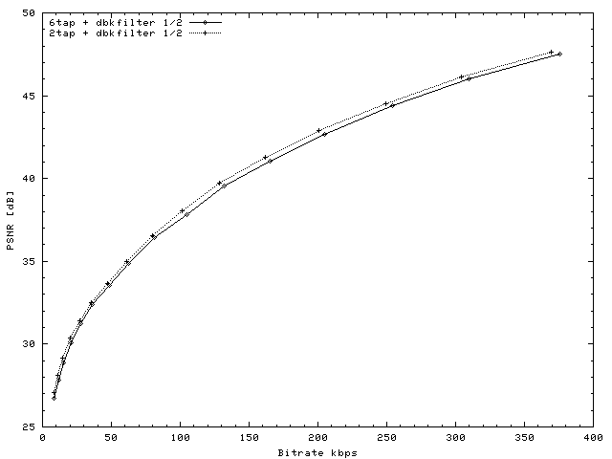
News QCIF 10fs(1/2pel MC with in-loop deblock-filter)
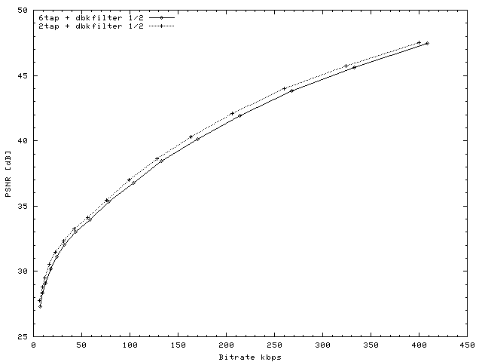
Silent QCIF 10fps(1/2pel MC with in-loop deblock-filter)
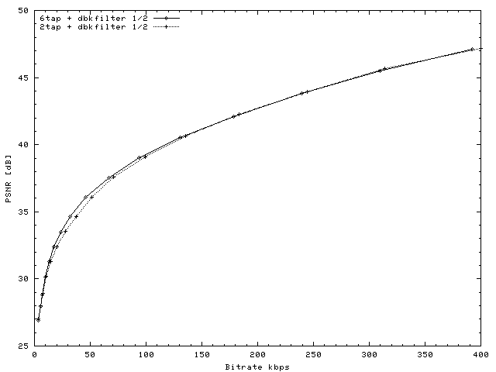
Container QCIF 10fps (1/2pel MC with in-loop deblock-filter)
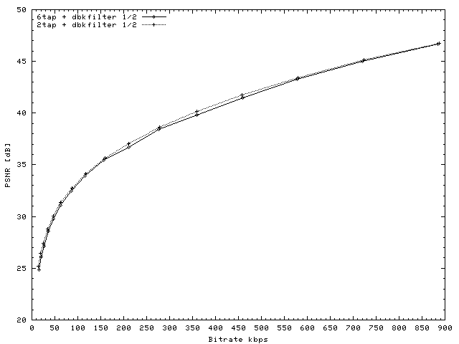
Foremen QCIF 10fps(1/2pel MC with in-loop deblock-filter)
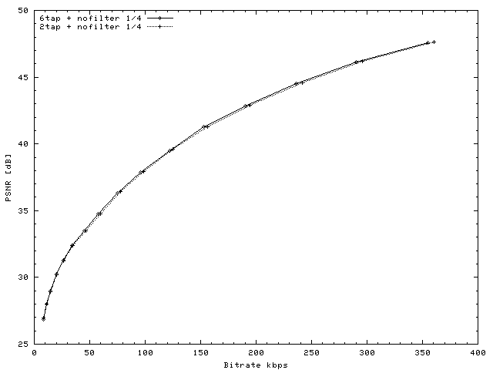
News QCIF 10fps (1/4pel MC without in-loop filter)
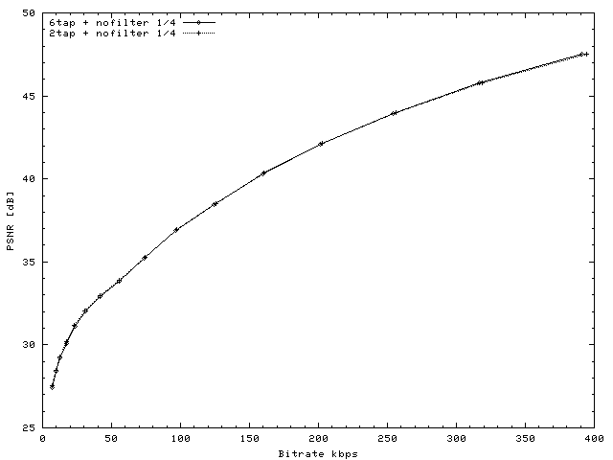
Silent QCIF 10fps (1/4pel MC without in-loop filter)
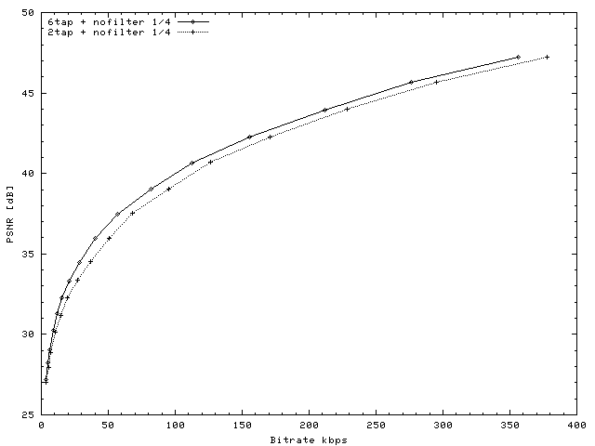
Container QCIF 10fps(1/4pel MC without in-loop filter)
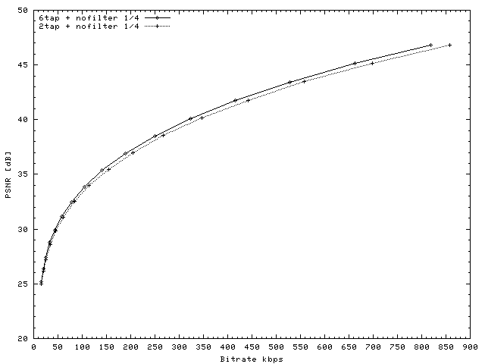
Foreman QCIF 10fps (1/4pel MC without in-loop filter)
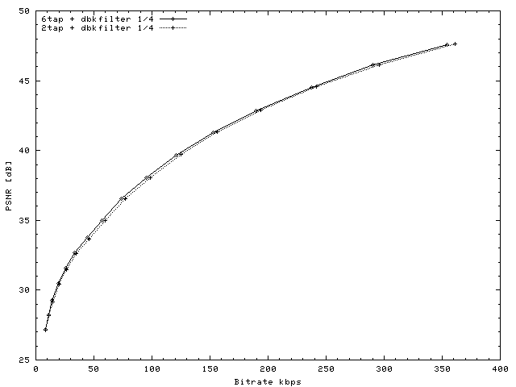
News QCIF 10fps(1/4pel MC with in-loop deblock-filter)
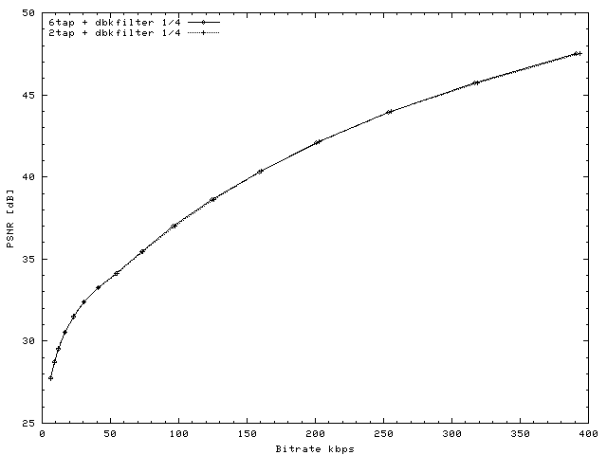
Silent QCIF 10fps(1/4pel MC with in-loop deblock-filter)
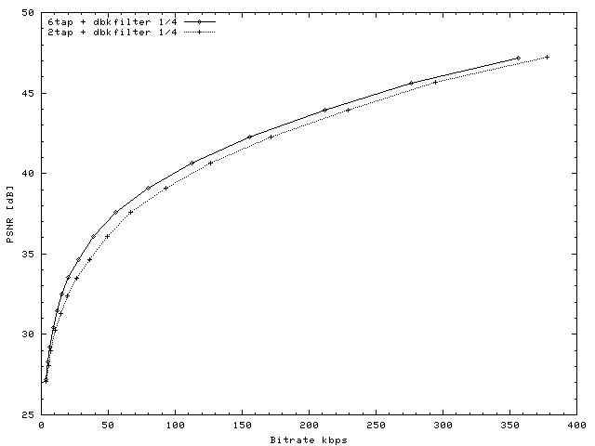
Container QCIF 10fps (1/4pel MC with in-loop deblock-filter)
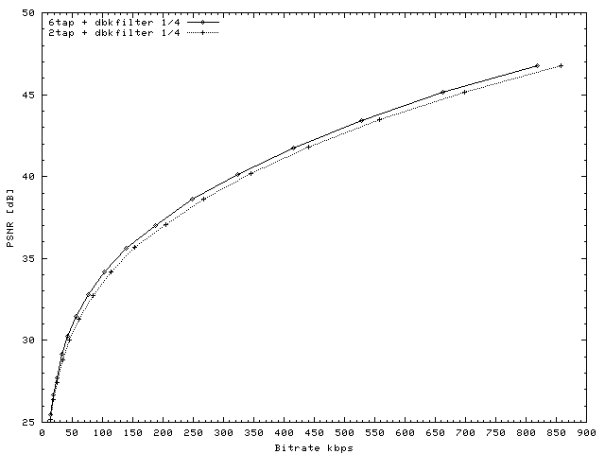
Foremen QCIF 10fps(1/4pel MC with in-loop deblock-filter)

