ITU - Telecommunications Standardization Sector  STUDY GROUP 16 Question 6  Video Coding Experts Group (VCEG)  _________________  14th Meeting: Santa Barbara, CA, USA, 24-27 Sep., 2001 | Document VCEG-N53  Filename: VCEG-N53.doc  Generated: Sept 17. 2001

Question: | Q.6/SG16 (VCEG)
Source: | Sang-Eun Han  Information System Laboratory  Stanford University  Stanford, CA 94305, USA | Tel:  Fax:  Email | +1 650 723 3476  +1 650 724 3648  sehan@stanford.edu
 | Bernd Girod  Information Systems Laboratory  Stanford University  Stanford, CA 94305, USA | Tel:  Fax:  Email | +1 650 724 6354  +1 650 725 8286  bgirod@stanford.edu
Title: | SNR Scalable Coding with Leaky Prediction
Purpose: | Proposal

Introduction

Scalable video codecs, generating bitstreams decodable at different rates, have been proposed for heterogeneous networks where we have to cope with different receiver capabilities and changing transmission conditions such as available bitrate and packet loss rate. They also show gain over simulcast in a multicast scenario [1][2].

While providing the rate adaptability, scalable coding is less efficient than non-scalable video coding optimized for a particular transmission bitrate. This coding inefficiency is mainly due to the reduced exploitation of the temporal dependency between adjacent frames. Even if there are high quality reference frames available at the encoder, the base layer codec does not use them for prediction because the enhancement layer bitstream is not guaranteed to transmit to the decoder over erroneous networks. Higher error protection for the enhancement layer would be a possible solution, but it increases the overhead.

In this contribution we propose a new scalable coding scheme – SNR Scalable Coding with Leaky Prediction (SNR-LP) - for H.26L. By partial employment of enhancement layer information into the prediction loop in base layer, we can considerably improve the coding efficiency while preserving bitrate adaptation and error resilience.

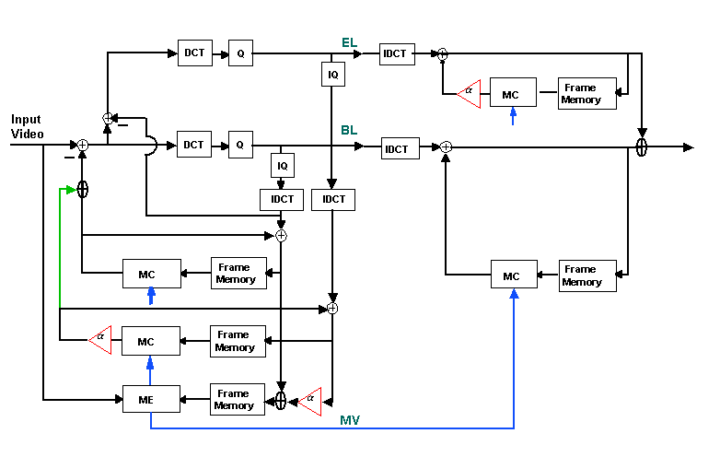

Figure 1: The structure of Scalable Coding with Leaky Prediction

Proposed Scalable Coding with Leaky Prediction

The structure of our proposed scalable coding scheme is shown in Figure 1. It is similar to the conventional SNR scalability [3] in that the enhancement layer encodes the residual error between the original and the reconstructed frames in the base layer. The difference is that in our scheme the prediction is based on the base layer and the enhancement layer. We refer to this as Inter Layer Prediction. Higher quality reference frames provide more accurate motion prediction for the base layer to improve coding efficiency.

Another point is to keep the motion compensation for the reconstruction within the same quality layers (Intra Layer Prediction). This allows efficient independent layers and will make sure that SNR-LP coding scheme can recover from packet losses or errors. Even when the transmission bitrate drops and cannot support both layers, the lost or erroneous higher layers in a frame will not affect on the lower layer quality. Figure 2 illustrates the data flow in the prediction for both layers.

Figure 2: Date flow in SNR-LP

The base layer residual is obtained by Inter Layer Prediction, but the base layer picture is reconstructed just as a combination of Intra Layer Prediction and the residual. Due to this mismatch at the encoder, the base layer quality will be degraded over time. By periodically inserting zero prediction coefficient for the enhancement layer (α=0 in Figure 1), which we refer to as Intra Layer Update, the intrinsic drift in the base layer will stop while maintaining the overall coding efficiency. This leaky prediction also provides the error resiliency in the enhancement layer when the prediction coefficient is less than 1 (α<1 in Figure 1). Usually the bandwidth needed for the transmission of base layer bitstream can be guaranteed, and the enhancement layer requires more protection from the packet loss or errors. The channel noise in the enhancement layer will be decreased gradually and gracefully over a few frames [4].

Encoder

Base Layer
The base layer encoding/decoding process remains unchanged except the extra frame memory for motion estimation and motion compensation for the prediction, where the weighted sum of base layer and enhancement layer is stored for the next frame.

Enhancement Layer
The enhancement layer codes the residual errors from the base layer with the same coding blocks of 4x4 integer transform, quantization and UVLC as in the base layer. The Intra Layer Prediction in the enhancement layer is based on the prediction mode and the motion vectors in the base layer so that no additional mode information and extra motion vectors are necessary to transmit.

Decoder

Each layer has an independent motion compensation loop. However, the prediction mode information and the motion vectors in the base layer are reused for decoding the enhancement layer pictures.

Simulation Results

The implementation of the scalable coding is based on the software TML8.4 (tml84.zip). The test condition is followed, and Table 1 shows the test sequences used for the simulation.

Test conditions:
- Full search with search range of 16
- Unrestricted Motion Vectors (UMV)
- Low-complexity mode in motion estimation and mode decision
- No loop filter both in base layer and enhancement layer
- No multiple reference frames
- Constant QP for the entire sequence
- Same quantization table for both base and enhancement layer

Sequence | Picture format | Frame rate | No. of frames
Container | QCIF | 10 | 100
News | QCIF | 10 | 100
Foreman | QCIF | 10 | 100
Silient Voice | QCIF | 15 | 150
Paris | CIF | 15 | 150
Mobile | CIF | 30 | 300
Tempete | CIF | 30 | 260
Table 1: Test sequences

Although employing the entire enhancement information (α=1) would give the best coding efficiency, it deteriorates the base layer quality over time. This drift is introduced by the fact that the reference frames are different for the prediction and for the reconstruction. To prevent the severe degradation of the base layer pictures, we periodically set the prediction coefficient to zero, our so-called Intra Layer Update, which limits the compression gain for the enhancement layer.

In this document, we only present one rate-distortion(RD) plot for each sequence. The RD plots contain the following curves:
- TML8.4 : non-scalable coding
- Upward Prediction : only use upward prediction (α=0)
- Intra Layer Update(#) : insert α=0 every # frames

Conclusions

In this contribution, a SNR scalable coding scheme with leaky prediction is proposed. By the higher quality reference frame available for prediction, this scheme provides adaptation for the available bitrate while keeping the overall coding efficiency. The trade-off can be made between coding efficiency and the scalability feature. This work can be extended to the multilayer scalable coding scheme including temporal and spatial scalabilities. Furthermore, the robustness to packet losses will be shown at a future meeting.

Acknowledgement

The authors would like to thank Markus Flierl for valuable discussions and insightful suggestions.

References

[1] B. Girod, N. Färber and U. Horn, “Scalable Codec Architectures for Internet
Video-on-Demand,” Proc. 1997 Asilomar Conference on Signals and Systems, Pacific
Grove, CA, USA, Nov. 1997
[2] ITU-T SG16/Q15, Q15-K-10, “Experiment in H.26L Fine Granularity Scalability,” Portland,
OR, USA, Aug. 2000
[3] ITU-T SG16/Q15, “Rec. H.263, Video Coding for Low Bitrate Communication, version 2,”
Jan. 1998
[4] N. S. Jayant and P. Noll, Digital Coding of Waveforms, Prentice-Hall 1984

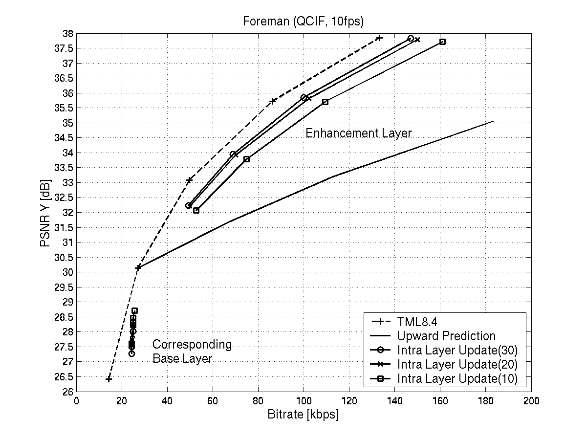

Interpola resolution (2x6tab f

