ITU - Telecommunications Standardization Sector  STUDY GROUP 16 Question 6  Video Coding Experts Group (VCEG)  _________________  14th Meeting: Santa Barbara, CA, USA, 24-27 Sep., 2001 | Document VCEG-N51  Filename: VCEG-N51.doc  Generated: 26 September ’01

Question: | Q.6/SG16 (VCEG)
Source: | Sheng Zhong  José Roberto Alvarez  Alexander (Sandy) MacInnis  Broadcom Corporation  3151 Zanker Road  San José, CA 95134 | Tel:  Fax:  Email: | (408) 501-8347  (408) 501-7836  jalvarez@broadcom.com
Title: | Improved Sub-Pel Interpolation Filters
Purpose: | Proposal
_____________________________

Introduction
We propose a new interpolation filter that can be used in direct mode interpolation. The current TML-8 model uses a combination of 6 taps and linear interpolation to arrive at the quarter-pel values, and a combination of 8 taps and linear interpolation for the eighth-pel case. The proposed filter in this paper can be used to perform motion estimation and motion compensation directly for both ¼ and ¹/₈ sub-pel precisions. The method of interpolation used is separable, first in the horizontal direction and then in the vertical direction.
We have designed a single filter using 8 phases, each phase consisting of 6 taps, that can be used for both the quarter-pel and the eighth-pel interpolation cases with good results. The starting point for the work in the present proposal was ITU-VCEG document entitled “H.26L Test Model Long Term Number 8 (TML-8) draft0” (July 10th, 2001). The proposed filter is similar to those in TML-8, with the major difference being that all phases (4 or 8) are optimized for phase shifting, rather than relying on linear interpolation to obtain the finer resolution positions.

Goals

The main reasons for the new filter are:
- Implement direct interpolation: The TML-8 document and several VCEG emails indicate that it has already been agreed to change to direct interpolation, without showing a specific solution. This proposal directly addresses that requirement.
- Improved performance: Interpolation filter designed as phase shifter for all required sub-pel positions should provide improved motion compensation performance, and experiments so far indicate that this is the case.
- Reduced complexity: Direct implementation reduces complexity by eliminating the extra step of bilinear interpolation. If we can specify the ¹/₈ pel filter as a 6-tap filter rather than 8 taps, the computational complexity is further reduced by almost one-half, i.e. to (6/8)² = 9/16. Experiments so far indicate that this provides suitable MC performance. In addition, the coefficients in each phase of the proposed filter sum to 256, rather than 512 as some of them in the TML-8 1/8 pixel filter; this further reduces complexity.

Proposed Interpolation Filters
We propose one single filter designed to be an optimal phase shifter, consisting of 6 taps and 8 phases. The proposed filter serves as a 4-phase or ¼ pel filter simply by using only phases {0, 2, 4, 6}. The coefficients in this filter are specified in the appendix below.
We also designed an 8-phase by 8-tap filter using the same methodology, but found the 8-phase by 6-tap solution to be better overall than this more complex filter.

Experimental Results
To verify the performance of the proposed filter, we isolated the interpolation (or sub-pel phase shift) performance of the filter by testing in an environment where only motion estimation and motion compensation are performed. We performed various full-search motion estimations on 4x4 or 16x16 blocks for ¼ pel or ¹/₈ pel motion estimations and calculated PSNR for the predicted pictures using the filters in TML-8 and our proposed filter. Results are shown below.
Additional experiments are under development to substitute the proposed filter for the existing filters in the TML-8 software and compare the performance of the resulting encoder/decoder combination with the existing TML-8 code. Initial preliminary results from this work are encouraging.
In the isolated MC experiment, we obtained the data indicated in the tables below. Table1 refers to the ¼ pel interpolation using full search on the ¼ pel locations for 4x4 blocks. The row labeled “Avg PSNR” indicates improvement (+) or degradation (-) in average PSNR when comparing our proposed filter with the documented TML-8 filters. “Max Improvement” refers to the single best picture in the sequence. “Max Degradation” means the single worst picture. In Table 2, we compare the performance using the proposed 8-phase by 6-tap filter to the TML-8 8-phase by 8-tap filter for the ¹/₈ pel interpolation case, where full search is first done on the integer locations and then ¹/₈ pel refinement is done around the best integer location for 16x16 blocks.

 | Mobile | Foreman | Paris | Table Tennis
Avg PSNR | +0.13 dB | +0.07dB | +0.06 dB | +0.31 dB
Max Improvement | +0.44 dB | +0.37 dB | +0.17 dB | +1.22 dB
Max Degradation | -0.06 dB | -0.11 dB | -0.06 dB | -0.065 dB
%Pictures Better | 92% | 74% | 88% | 86%
%Pictures Worse | 8% | 26% | 12% | 14%
Table 1 – Comparisons (¼ pel Interpolation) between the proposed filter using 4 phases / 6 taps vs. TML-8

 | Mobile | Foreman | Paris | Table Tennis
Avg PSNR | +0.0081 dB | -0.014 dB | +0.021 dB | +0.002 dB
Max Improvement | +0.049 dB | +0.06 dB | +0.102 dB | +0.07 dB
Max Degradation | -0.037 dB | -0.06 dB | -0.09 dB | -0.107 dB
%Pictures Better | 65% | 26% | 80% | 58%
%Pictures Worse | 35% | 74% | 20% | 42%
Table 2 – Comparisons (¹/₈ pel Interpolation) between the proposed filter using 8 phases / 6 taps vs. TML-8

IPR Statement

Broadcom agrees with the underlying purpose of the request in VCEG-L37r2. To this end and subject to reciprocity on behalf of all other contributors and to other reasonable terms and conditions, Broadcom would be willing to grant licenses, either royalty-based or royalty-free depending on a relationship of its contributions to the baseline and advanced profiles.

Appendix A: Filter Coefficients
Proposed Filter (8-phase/6-tap)
Integer: ( 0 0 256 0 0 0)/256
Phase 1: ( 7 -23 247 32 -11 4)/256
Phase 2: (12 -37 225 71 -22 7)/256
Phase 3: (14 -42 193 113 -33 11)/256
Phase 4: (13 -40 155 155 -40 13)/256
Phase 5: (11 -33 113 193 -42 14)/256
Phase 6: ( 7 -22 71 225 -37 12)/256
Phase 7: ( 4 -11 32 247 -23 7)/256

TML-8 Filter (8-phase/8-tap)
Integer( 0 0 0 256 0 0 0 0)/256
1/8 (-3 12 -37 485 71 –21 6 -1)/512
2/8 (-3 12 -37 229 71 –21 6 -1)/256
3/8 (-6 24 -76 387 229 –60 18 -4)/512
4/8 (-3 12 -39 158 158 –39 12 -3)/256
5/8 (-4 18 -60 229 387 –76 24 -6)/512
6/8 (-1 6 -21 71 229 –37 12 -3)/256
7/8 (-1 6 -21 71 485 –37 12 -3)/512

Appendix B: Graphical Results

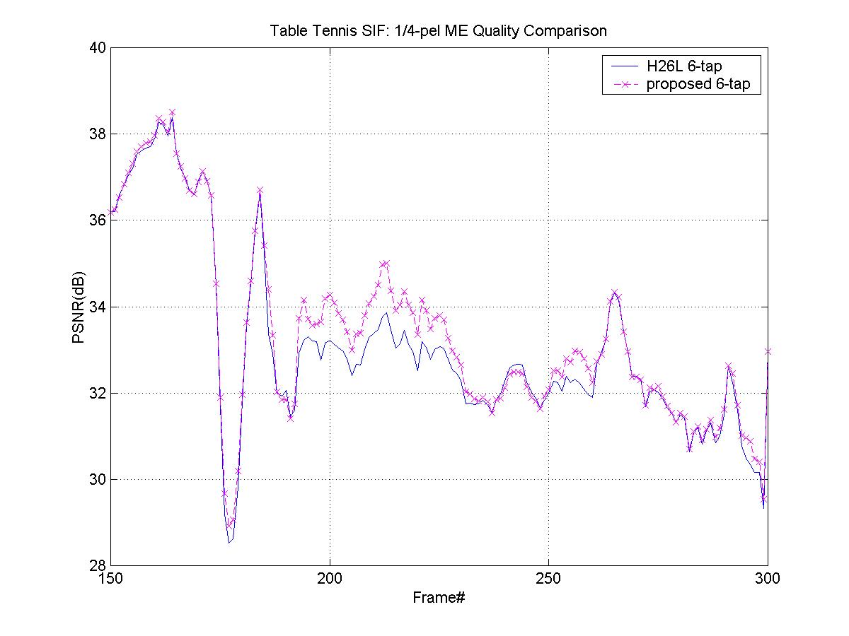
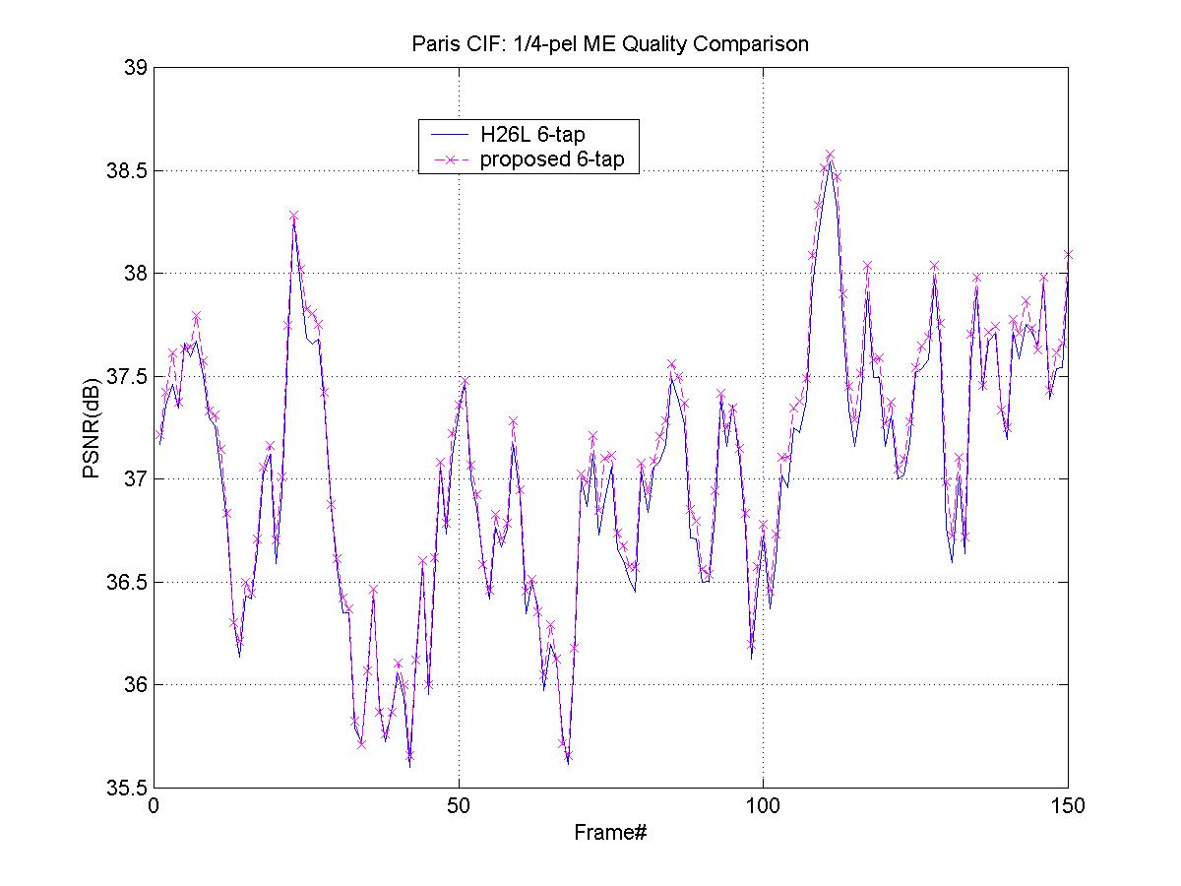
Figure 1. 1/4 ME (Table Tennis)

Figure 2. 1/4 ME (Paris)

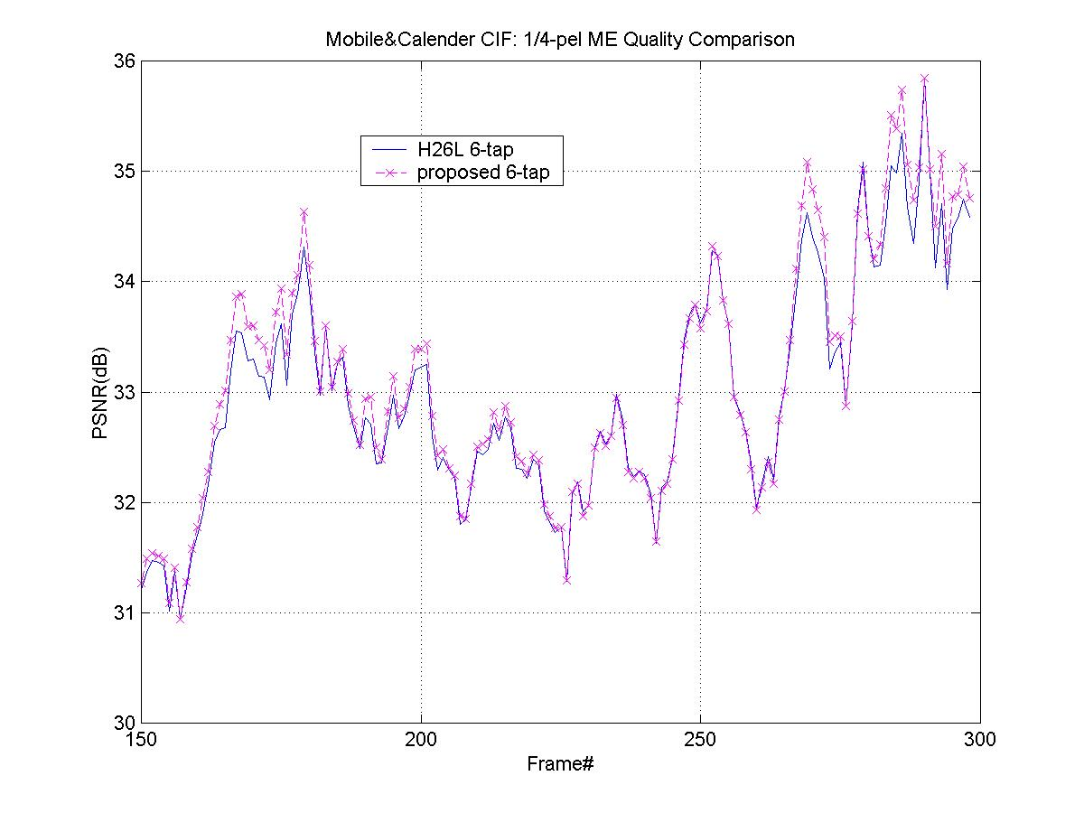

Figure 3. 1/4 ME (Mobile&Calendar)

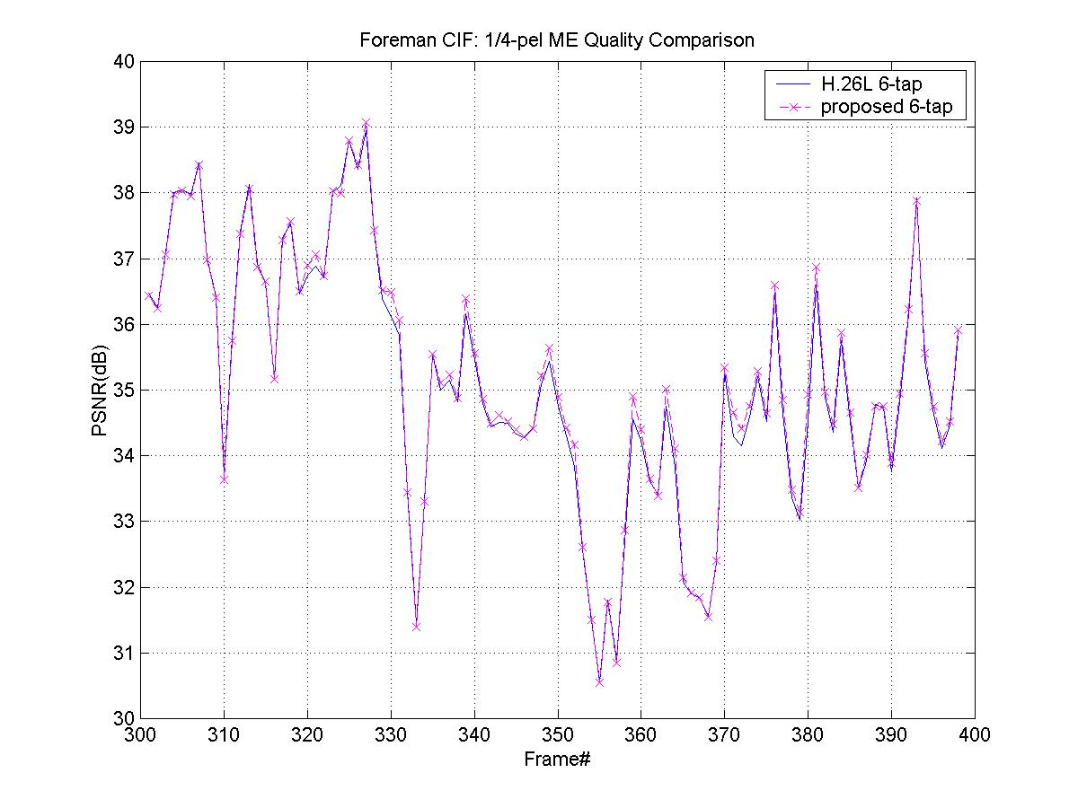
Figure 4. 1/4 ME (Foreman)

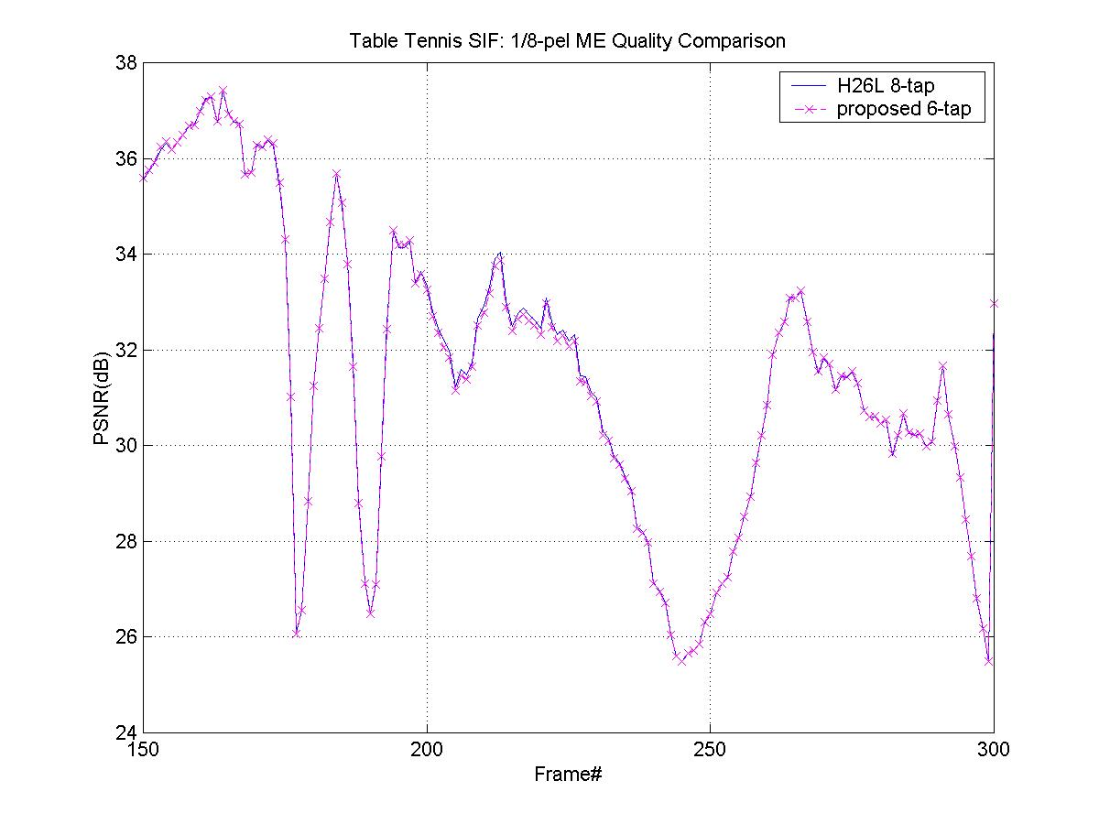
Figure 5. 1/8 ME (Table Tennis)
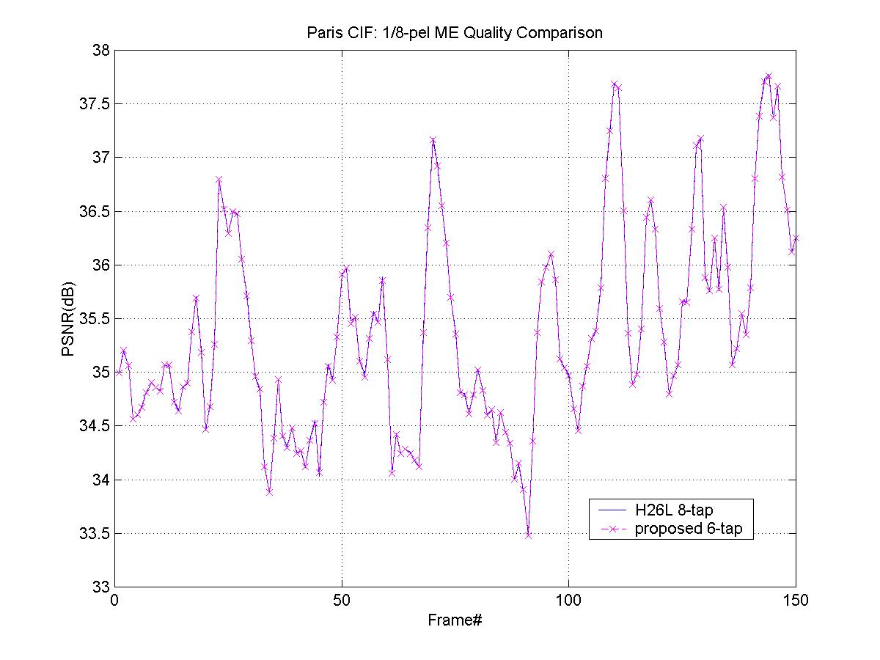
Figure 6. 1/8 ME (Paris)

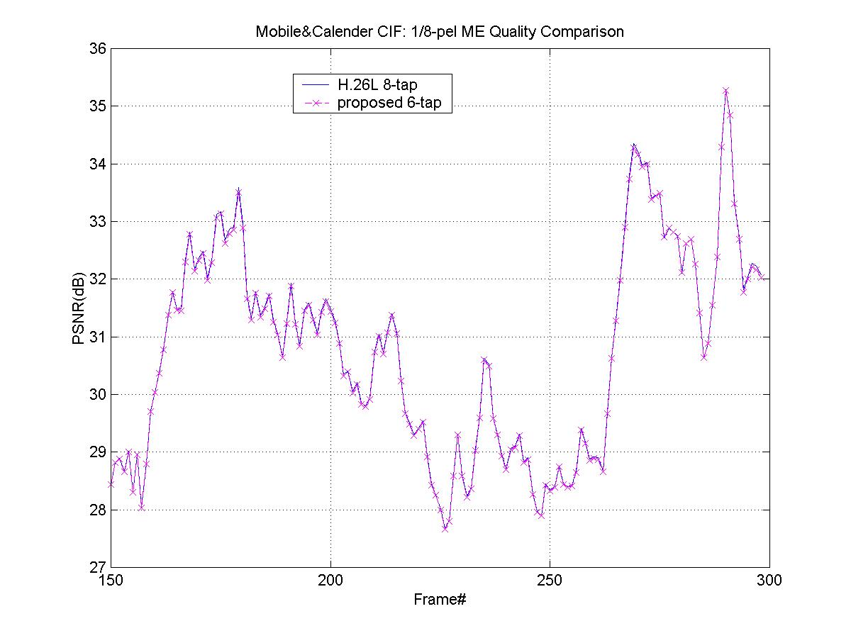
Figure 7. 1/8 ME (Mobile&Calendar)

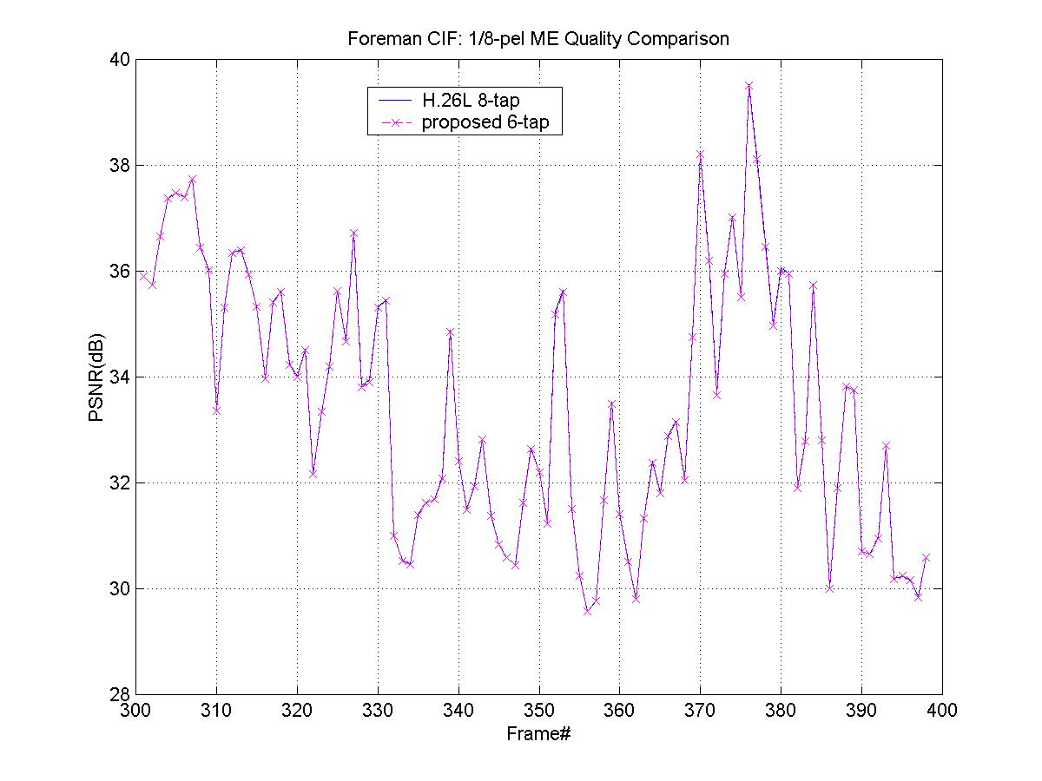

Figure 8. 1/8 ME (Foreman)

