ITU - Telecommunications Standardization Sector  STUDY GROUP 16 Question 6  Video Coding Experts Group (VCEG)  _________________  14th Meeting: Santa Barbara, CA, USA, 24-27 Sep., 2001 | Document VCEG-N35  Filename: VCEG-N35.doc  Generated: 10. September ’01

Question: | Q.6/SG16 (VCEG)
Source: | Peter Amon, Gero Bäse, Klaus Illgner, Jürgen Pandel  Siemens AG, CT IC 2  81730 Munich  Germany | Tel:  Fax:  Email: | +49 636 53193  +49 636 52393  gero.baese@mchp.siemens.de
Title: | Efficient coding of synchronized H.26L streams
Purpose: | Information
_____________________________

Introduction and Motivation
Sending videos across networks is a common application nowadays. Varying network conditions, several types of networks and completely different user groups are requiring particularly adapted encoder resp. server architectures. Efficiency is the main target on provider side and ease of use everywhere, every time and with every device for the customer. Streaming of files and live streaming are two major utilizations of the upcoming H.26L standard.

For many application scenarios, video streams are offered in several versions with different quality. Different quality levels and therefore different bit-rates are useful for
- different capabilities of the receiver device (TV, PC, PDA, ...),
- different networks (DSL, ISDN, UMTS, ...) and
- different levels of pay-per-view services.
A change between different levels is also useful for varying channel conditions to adopt to the available data-rate and to secure a minimum video quality at receiver side.

A common way to achieve different quality layers is to encode a sequence several times at different bit-rates. To provide different levels of quality in a network, the different streams are sent simultaneously to the different receiver devices (Simulcast). From a providers point of view this is very inefficient. A new compression standard should facilitate technological improvements even for different transmission scenarios. Complexity and bandwidth utilization are important factors raising market barriers.

Therefore, a new coding scheme is presented that provides several quality levels at a bit rate significantly lower than simulcast. . This is achieved by synchronizing the encoders and differentially coding of the transform coefficients.

Concept

Structure
The structure of our system as shown in figure 1 reminds of simulcast coding. Synchronized encoder stages are producing streams at different quality levels. High-end decoders will be able to utilize the best quality whereas low complexity devices will receive the matching stream.

Encoder Part
The encoders of our system are not running independent of each other like it is in simulcast encoding. They are synchronized in order to have the same high level decisions (e.g. prediction mode) at each stage. This allows an efficient differential encoding of the coefficients. Figure 1 shows an example of the synchronized encoders with three stages.

The abbreviations in Figure 1 and Figure 2 are
- T: transformation,
- Q: quantization,
- IQ: ‘inverse quantization’,
- IT: inverse transformation,
- FB: frame buffer,
- MV: motion vectors,
- EC: entropy coder,
- ED: entropy decoder.

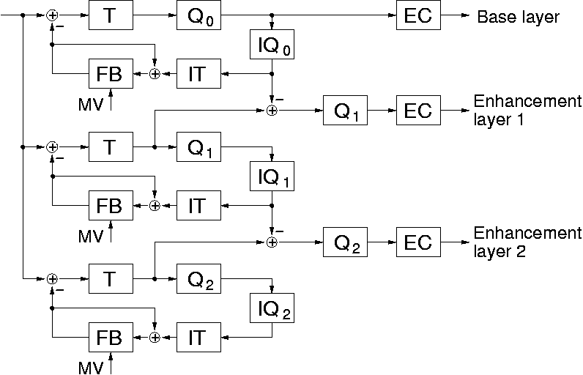
Figure 1: Encoder part

Decoder Part
The decoder part does the entropy decoding and inverse quantization of the different streams. The coefficients of the different streams are added up and given to the inverse transformation part followed by the decoding loop. For low complexity devices only one stage is used to decode the matching stream. Figure 2 shows an example of the decoder part with three stages.

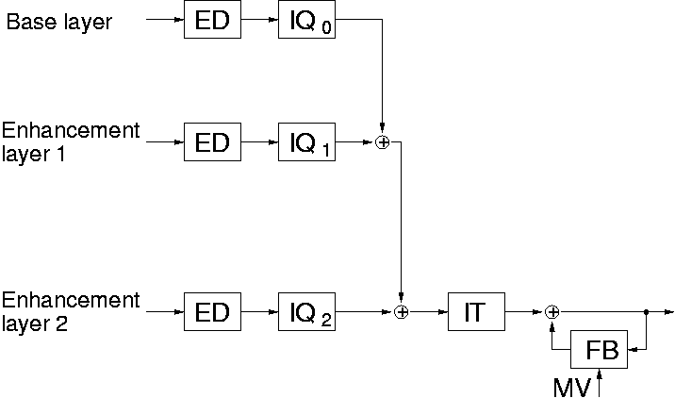
Figure 2: Decoder part

Quantization
The quantization parameters of the different levels have to be adjusted to each other. Therefore, the quantization tables for A(QP) and B(QP) have to be modified. The first important requirement is that the numbers of A and B for consecutive quality levels have an integer relation to each other. E.g. for the higher quality level i and the next lower level i-1 the following relation shall hold:

A(QP_{i}) / A(QP_{i-1}) = B(QP_{i-1}) / B(QP_{i}) = n_{i} = Integer, i = 0, . . . , q-1, (1)

where q is the number of different quality layers including base layer. For a practical situation where the quality layers are not too much different, a value of n_{i} = 2 for all consecutive levels is selected. This is done for the quantization of the luminance and chrominance coefficients.

A second important requirement is the relation between the coefficient K and its dequantized value K’. In the current quantization algorithm there is a scaling factor s = 2²⁰ / 676². For the differential coding of coefficients a scaling factor s = 1 is required, therefore the relation between A and B is now given by:

A(QP) * B(QP) = 2²⁰ . (2)

With these requirements we slightly modify the table for A starting with the same A(QP₃₁) =17 as before. We also keep about 12% increase of the step size between consecutive quantization levels and 6 levels for the doubling of the step size. From the values of A we calculate the value of B so that (2) is approximately fulfilled (see table below):

const int JQ[32][2] =
{
{608, 1725 },
{544, 1928 },
{496, 2114 },
{432, 2427 },
{384, 2731 },
{352, 2979 },
{304, 3450 },
{272, 3856 },
{248, 4228 },
{216, 4854 },
{192, 5462 },
{176, 5958 },
{152, 6900 },
{136, 7712 },
{124, 8456 },
{108, 9708 },
{ 96, 10924 },
{ 88, 11916 },
{ 76, 13800 },
{ 68, 15424 },
{ 62, 16912 },
{ 54, 19416 },
{ 48, 21848 },
{ 44, 23832 },
{ 38, 27600 },
{ 34, 30848 },
{ 31, 33824 },
{ 27, 38832 },
{ 24, 43696 },
{ 22, 47664 },
{ 19, 55200 },
{ 17, 61696 },
};

Table of numbers A(QP_{j}) , B(QP_{j}) for j = 0, . . . , 31.

Synchronization
Overall efficient coding will be reached by determining high level coding decisions only once. This decisions are provided and utilized at every other encoder stage. Necessary exchanged information are:
- The decision between intra and inter prediction,
- deblocking and interpolation filters for prediction,
- additionally for intra prediction
- the decision between the intra prediction on macroblock level or 4x4 block level,
- the decision between the different intra prediction modes,
- additionally for inter prediction
- the number of the reference frame,
- the block size (16x16, 16x8, 8x16, 8x8, 8x4, 4x8, 4x4) for the motion vectors and
- the motion vectors for the single blocks.

High level decisions have to be transmitted only once (base layer). Every other stage of the encoder delivers mainly coded coefficients (enhancement layers). A few additional information is needed e.g. for coded block pattern. This combination of encoding stages provides lower complexity at the encoder side, much better bandwidth utilization and allows a broad range of customized devices.

The determination of these high level decisions can be made at any stage, so the most important level can be optimized. E.g. in the case of three stages, the synchronization parameters can be optimized for the second quality level in order to avoid great divergence between the optimal and the synchronized high level decisions.

Complexity
The complexity of the encoder part is reduced compared to simulcast encoding. The time consuming motion vector search has to be performed only once and the rate-distortion optimized determination of the prediction mode as well.

The complexity of the high-end decoder is increased compared to a decoder for a single stream. But the additional parts only include entropy decoding pipes, inverse quantization and adders. The inverse transformation and the decoding loop with prediction and filtering are the same like in the original decoder.

First Results
Figure 3 shows the results of the advanced simulcast coding schemes compared to unicast coding and simulcast coding. The simulcast coding and the advanced simulcast coding scheme consist of two layers. The first layer was chosen at the same rate (resp. quantization parameter QP₁₆). The second level was also chosen with the same quantization parameter QP₁₀. Due to the differential encoding of the coefficients the second level is reached earlier by the advanced simulcast coding scheme. Its quality is slightly below the quality of simulcast coding scheme, because due to synchronization the high-level decisions were optimized for the base layer. (Note: The optimization can also be done at the enhancement layer).

Figure 3: Comparison between simulcast and advanced simulcast (2 quality layers)

The results show, that the advanced simulcast approach leads for this simulation to a reduction of about 55 kbit/s corresponding to a saving of about 23%.

Figure 4 shows the comparison using three quality levels. Here the advanced simulcast coding scheme is optimized for the first enhancement layer. Here again a significant reduction of the rate can be seen with only a slight decrease in the quality levels of the base layer an the second enhancement layer. Here the total reduction is also about 23%.

Figure 4: Comparison between simulcast and advanced simulcast (3 quality layers)

The coding parameters for both simulations were
- sequence: foreman,
- size: QCIF,
- frequency: 10 fps,
- length: 10s,
- number of reference frames: 2,
- inter coding modes: 16x16, 16x8, 8x16, 8x8, 8x4, 4x8, 4x4,
- motion vector search range: 32,
- motion vector resolution: 1/8 pel,
- rate-distortion optimization: off,
- Hadamard transform: used,
- entropy coding mode: CABAC.

Level Prediction
While the concept described in Section 2 combines quantized and nonquantized transformation coefficients, we plan to investigate a direct prediction of the higher layer levels from the lower layer levels. To achieve optimal prediction of the levels of the higher layer i+1, the levels at the lower layer i should be multiplied by a factor α_{i+1} > 1. This factor α_{i+1} depends on the ratio of the quantization parameters A_{i+1} and A_{i} :
α_{i+1} = A_{i+1} / A_{i}, for i = 0, . . . ,q-1 . (3)

A simplified block diagram of the encoder for level prediction is shown in Figure 5.

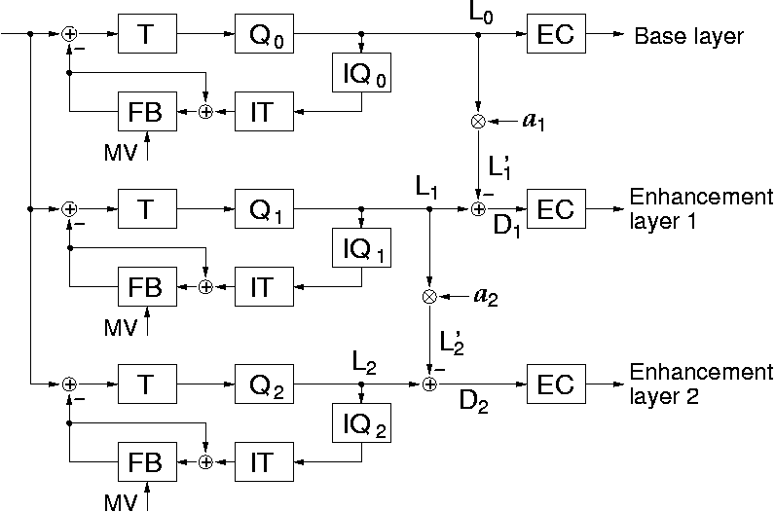

Figure 5: Three encoders with “level prediction”

Instead of multiplying a level L_{i} with a floating point number α_{i+1} we use an integer multiplication and a subsequent right shift to avoid floating point operation and to assure that the multiplication is performed exactly in the same way in encoder and decoder. The prediction level L_{i+1}´ is then calculated by:

L_{i+1}´ = sign(L_{i}) * [|L_{i}| M_{i+1} / 2^{n}], M_{i+1} = [2^{n} A_{i+1} / A_{i}] for i = 0, . . . ,q-1, (4)

where [x] is the integer part of x. The base layer levels L₀ and the prediction errors D_{i} = L_{i} - L_{i}´ will be entropy coded and transmitted to the decoder.

In Fig. 6 the block diagram of the decoder is shown. The prediction level is again given by eq. (4) and there is no need for an extra transmission of the multiplication factor α_{i+1} . Depending on how many data layers are transmitted to the receiver, the decoder must switch to the right position in order to get the right coefficient level. In any case only one frame buffer is needed. When data of a higher layer is lost due to some bad transmission condition, the decoder shall switch to the next uncorrupted lower layer.

The advantage of this level prediction is that there is no longer a restriction on the quantization step size. The table of A and B could remain unchanged and it is no longer necessary to fulfill eqs (1) and (2) in Section 2.

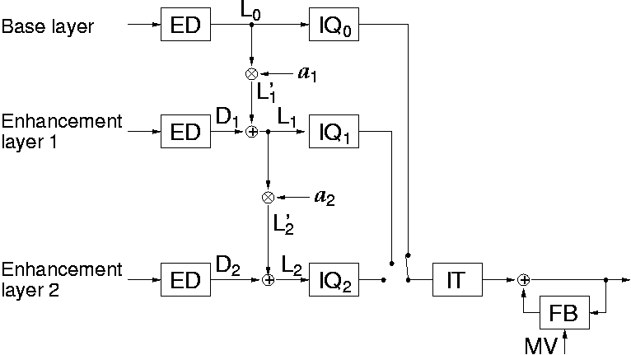

Figure 6: Decoder with level prediction

Conclusions

The proposed advanced simulcast scheme shows a significant better performance than simulcast coding, to which it has to be compared to. The more quality levels are encoded and the more similar the rates of the individual quality levels of a simulcast coder are the higher is the expected gain achieved by the advanced simulcast coding scheme presented here. For the few simulations which have been done so far, a data rate reduction in the range of 20% is obtained compared to simulcast.

The complexity on encoder side is reduced dramatically, since the computationally very complex mode and motion vector search has only to be done once. The complexity of the high-level decoder is only slightly increased, while the base layer still can be decoded with the same complexity compared to a decoder for a single stream.

We plan to go on with this work and we will to compare the approach with the level prediction approach described in Section 4. Both approaches are very simple especially on decoder side and can be appropriately used for streaming applications to multiple users with different terminal capabilities.

