ITU - Telecommunications Standardization Sector  STUDY GROUP 16 Question 6  Video Coding Experts Group (VCEG)  _________________  Thirteenth Meeting: Austin, Texas, USA, 2-4 April, 2001 | Document VCEG-M39  Filename: VCEG-M39.doc  Generated: 27 March ’01

Question: | Q.6/SG16 (VCEG)
Source: | Byeong-Moon Jeon  LG Electronics Inc.  Digital Media Research Lab.  16 Woomyeon-Dong, Seocho-Gu,  Seoul 137-724, Korea | Tel:  Fax:  Email: | +82-2-526-4404  +82-2-3461-1347  jeonbm@lge.com
Title: | Flexible Residual Coding for Direct Mode in B Pictures
Purpose: | Proposal
_____________________________
1. Introduction
Currently, MB_Type table for B pictures in TML-6 (Table A.1) does not define ‘direct_skip’ mode indicating no residual data. For example, assume that the current macroblock uses direct mode. If the macroblock has residual data, CBP and coded residual data are obviously signaled. But although it has no residual data, CBP=0 (1bit) should be signaled under the current MB_Type table. This fact results in the loss in terms of bit cost by signaling unnecessary information. Unfortunately, an alternative way to newly define ‘direct_skip’ mode in the current MB_Type table is not available due to the fact that TML-6 uses a universal VLC. Therefore, in order to achieve effective bit saving in direct mode, this document proposes a flexible residual coding method for direct mode, a way to permit ‘direct_skip’ mode depending on the prediction mode used in temporally subsequent P picture with no change of MB_Type table.
For further details, under the assumption that a macroblock of B picture selects direct mode as an optimum prediction mode, the macroblock may use ‘direct_skip’ mode if the mode used for the corresponding macroblock in the subsequent P picture was SKIP or 16x16 and it may use direct mode with ‘residual coding’ if the corresponding macroblock in the subsequent P picture used one of the remaining prediction modes. And some luminance and chrominance constraints are given to support use of ‘direct_skip’ mode, which are applied to encoding process of P pictures only when B pictures are inserted to bit stream.

2. Definition of direct_skip mode and luma/chroma constraints in P picture
The aim of this document is to yield RD gains over B pictures in TML-6 by using the flexible direct mode employing direct_skip. Therefore, we suppose that the optimum prediction mode of the current macroblock in B picture (we call it ‘target macroblock’ from now) is direct mode through this section.

2.1 Case : the corresponding macroblock in the subsequent P picture used SKIP mode
When the mode used for the corresponding macroblock in the temporally subsequent P picture was SKIP, the probability that target macroblock is identical to both of the corresponding macroblocks in the previous and subsequent P pictures is very high (refer to Figure 1, where the dotted arrow indicates the zero motion between the previous and subsequent P pictures). Thus, we define the target macroblock employs direct_skip mode when the mode of the corresponding macroblock in the subsequent P picture was SKIP.
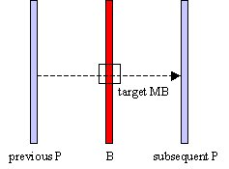
Figure 1. Mode of the macroblock in the subsequent P picture is SKIP
However, there are some exceptional cases that we have to notice. Figure 2 shows those cases that the target macroblock is completely different from two corresponding macroblocks.

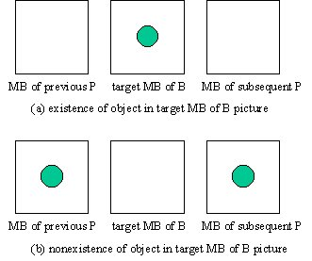
Figure 2. Exceptional cases
Figure 2 tells us that we have to use direct mode with residual coding to decode the target macroblock well although the macroblock in the subsequent P picture used SKIP mode. Therefore, in order to guarantee the above definition of direct_skip mode, we need to prevent the macroblock in the subsequent P picture from selecting the SKIP mode while encoding it. We will deal with this issue at section 2.3.

2.2 Case : the corresponding macroblock in the subsequent P picture used 16x16 mode
In addition to the case that the mode of the corresponding macroblock in the subsequent P picture was SKIP, this document proposes another way to employ direct_skip mode based on object motion among the spatially corresponding macroblocks in the previous reference picture, B picture, and the subsequent P picture. Figure 3 shows the available object motions among three macroblocks, where P1 and P2 indicate the macroblocks in the previous reference picture and the subsequent P picture.
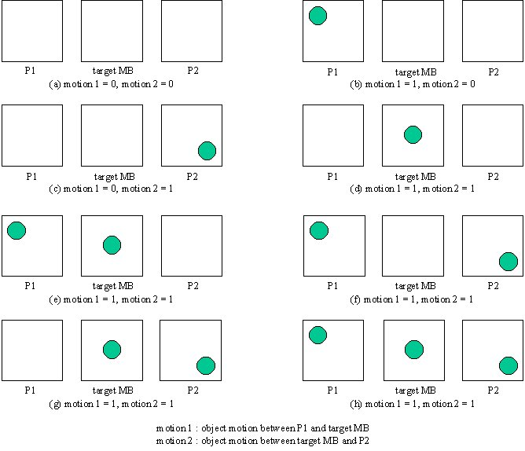
Figure 3. Object motions among P1, target MB, and P2
In order to detect object motion, we use the simple approach that compares two corresponding macroblocks pixel by pixel for detecting changes between them. Suppose that two macroblocks contain stationary components and a moving object. Comparing a macroblock against a corresponding macroblock results in the difference of the two macroblocks canceling the stationary components, leaving only nonzero entries that correspond to the nonstationary components.
A difference image, $d(i,j)$ between P1 and target macroblock may be defined as
$$d(i,j)=\begin{aligned}\left\{1{}_{}^{}{}_{}^{}{}_{}^{}{}_{}^{}\text{if}{}_{}^{}\left|P1(i,j)−B(i,j)\right|>θ | \right.\end{aligned}$$
where $θ$ is a threshold. All pixels with value 1 in $d(i,j)$ are considered the result of object motion. Typically, a difference image often contains isolated 1-valued entries that are the result of noise but we also regard it as the result of object motion. If all pixels in $d(i,j)$ are 0’s, there is no object motion between two macroblocks and this means that they contain only stationary components.
In Figure 3, motion 1 comparing P1 with target macroblock is set if any pixel in $d(i,j)$ is 1. The same definition is adopted to motion 2 comparing target macroblock with P2. In Figure 3 (a), motion1 and motion 2 are 0’s and so three macroblocks have the same features that they only contain stationary components. Thus, one of forward, backward, and bi-directional modes is expected to be selected as the optimum mode for target macroblock. At this point, recall that we assumed the optimum mode of target macroblock was direct. From the fact that direct mode is selected instead of forward, backward, or bi-directional mode, we can estimate the prediction from direct mode is much closer to original target macroblock than that from the other modes. In other words, it is available to approximate the prediction from direct mode to original target macroblock.
Figure 3 (b) shows that only the motion 2 is 0. We can expect that backward mode is selected as the optimum mode for target macroblock since target macroblock and P2 have the same features. In spite of such an expectation, the fact that direct mode is selected implies the prediction from direct mode is much closer to original target macroblock than that from backward mode. Similarly, from Figure 3 (c), we estimate that the prediction from direct mode is much closer to original target macroblock than that from forward mode which is expected to be selected as the optimum mode since P1 and target macroblock have the same features.
From Figure 3 (a), (b), and (c), we define the mode of target macroblock is direct_skip if either of two motions (i.e., motion 1 or motion 2) is 0 and the mode of the corresponding macroblock in the subsequent P picture (i.e., P2) was 16x16. There are two main reasons why we use 16x16 mode of P2 for the direct_skip mode of target macroblock. One is that, you will find it at section 2.3, if we meet the macroblock having the same cases as Figure 2 while encoding P picture, we will constrain the macroblock to choose the prediction mode from 6 block structures (i.e., 16x8, 8x16, …, 4x4) and intra in order to prevent it from performing SKIP mode. The other reason is that since the occurrence of 16x16 mode selection is high according to the entropy theory, the bit saving is rather higher compared to other modes if direct_skip mode is determined by referring to 16x16 mode of P2.
On the other hand, Figure 3 (d) through (h) show that motion 1 and motion 2 are all 1’s. This means neither of three macroblocks has the same feature. In addition, we cannot measure how close to original target macroblock the prediction from direct mode is. Thus, we have to use direct mode with residual coding to reconstruct the target macroblock although the macroblock in subsequent P picture used 16x16 mode. In order to guarantee the above definition of direct_skip mode, we need to prevent the macroblock in subsequent P picture from selecting the 16x16 mode while encoding it.

2.3 luminance constraint in P picture
In terms of object motion, Figure 2 is identical to Figure 3 (d) through (h) whose motion 1 and motion 2 are all 1’s. Thus, we consider those cases together to get the luminance constraint applied to encoding process of P picture. If we find out the macroblock with motion 1 = 1 and motion 2 = 1 through motion detecting approach while encoding P picture, we constrain the macroblock to choose the prediction mode from 6 block structures (i.e., 16x8, 8x16, …, 4x4) and intra. In the experiments, we use 20 as threshold value to detect the object motion and this threshold is considered as an enough small value to judge whether two macroblocks have stationary components or not, and we use previous decoded picture for P1 and original pictures for target macroblock and P2.
This constraint guarantees that the macroblock selecting SKIP mode does not include such the cases as Figure 2 and the macroblock selecting 16x16 mode does not include such the cases as Figure 3 (d)~(h). Therefore, when encoding or decoding the target macroblock in B picture, we can use direct_skip mode if the mode of P2 is SKIP or 16x16 and use direct mode with residual coding if the mode of P2 is one of the remaining modes, under the assumption that the optimum mode of the target macroblock is determined as direct mode.

2.4 chrominance constraint in P picture
Chrominance component of video has color information, while luminance component provides the video information such as motion and brightness. If there is a critical color change between two spatially corresponding macroblocks and luminance conditions for direct_skip mode are satisfied (i.e., either of two motions is 0), the target macroblock decoded from direct_skip has serious error because the decoded chrominance is not correct. Thus, we have to use direct mode with residual coding in this case.
For the chrominance constraint, in the same manner as detecting object motion, two difference images are obtained by comparing chrominance pixel by pixel between P1 and target macroblock and between target macroblock and P2. If any pixel in two difference images is 1, then we constrain the macroblock to choose the prediction mode from 6 block structures (i.e., 16x8, 8x16, …, 4x4) and intra. In the experiments, we use 60 as threshold value for chrominance constraint and this is considered as an enough value to judge whether there is a critical color change between two macroblocks. This constraint guarantees that target macroblock cannot use direct_skip mode when encoded or decoded, although the luminance conditions for direct_skip mode are satisfied.

3. Experimental results
The experiments were run at 30 fps, fixed quantization parameters, and B picture pattern such as IBPBP and IBBP to show the objective gains that can be achieved with flexible residual coding for direct mode in B pictures. The results are given in document VCEG-M39.xls.
The number of macroblocks complying with the luminance and chrominance constraints depends on the sequences. Low motion sequences like container, news, and silent have a small number of macroblocks complying with the constraints, while high motion sequences like tempete, mobile, and foreman have a large number of macroblocks complying with the constraints. Based on this, low motion sequences are expected to achieve better bit saving since those macroblocks do not influence an increase of bit rate of P pictures and bit rate of B picture will be decreased due to the use of direct_skip mode. However, high motion sequences do not achieve effective bit saving since a larger number of macroblocks complying with constraints may bring about an increase of the bit rate of P pictures. At this point, notice that luminance and chrominance constraints are applied to encoding process of P pictures only when B pictures are added to bit stream.
The table below summarizes the obtained gains against TML-6 and describes that there is no loss of performance in high motion sequences with the exception of mobile at low bit rate.

Sequences | IBPBP |  | IBBP
Sequences | High bit rate  (QP=12, 16, 20) | Low bit rate  (QP= 24, 28) | High bit rate  (QP=12, 16, 20) | Low bit rate  (QP= 24, 28)
Container | Max 0.3 dB | Max 1.0 dB | Max 0.3 dB | Max 1.0 dB
News | Max 0.2 dB | Max 0.3 dB | Max 0.3 dB | Max 0.4 dB
Silent | Max 0.2 dB | Max 0.4 dB | Max 0.3 dB | Max 0.4 dB
Paris | Max 0.2 dB | Max 0.4 dB | Max 0.2 dB | Max 0.2 dB
Foreman | Max 0.1 dB | 0 dB | Max 0.2 dB | Max 0.1 dB
Tempete | 0 dB | 0 dB | 0 dB | 0 dB
Mobile | 0 dB | Max -0.1 dB | 0 dB | 0 dB

In order to compare computational complexities between B pictures based on TML-6 and B pictures using flexible direct mode, the document VCEG-M39.xls includes the graphs about the encoding time measured at the same machine.

