ITU - Telecommunications Standardization Sector  STUDY GROUP 16 Question 6  Video Coding Experts Group (VCEG)  _________________  Thirteenth Meeting: Austin, Texas, USA, 2-4 April, 2001 | Document VCEG-M26  Filename: VCEG-M26.doc  Generated: 30 March ’01

Question: | Q.6/SG16 (VCEG)
Source: | Chengjie Tu (cjtu@fastvdo.com),  Trac Tran (tran@fastvdo.com),  Pankaj Topiwala (pnt@fastvdo.com) FastVDO Inc. 5565 Sterrett Pl., #322 Columbia, MD 21044 USA | Tel:  Fax:  Email: | 410-730-9191  410-730-2957  pnt@fastvdo.com
Title: | A projection-based motion estimation approach for H.26L
Purpose: | Proposal.

0. Abstract
This document introduces a fast block-based motion estimation algorithm based on projection. The idea is simple: blocks cannot match well if their corresponding 1D projections do not match well. We can take advantage of this observation to translate the expensive 2D block matching problem to a simpler 1D matching one by quickly eliminating a majority of potential matching candidates. Our novel motion estimation algorithm offers computational scalability through a single parameter and global optimum can still be approached. Moreover, an efficient implementation to compute projections and to buffer recyclable data is also presented. Experiments show that the proposed algorithm is several times faster than exhaustive search with nearly identical prediction performance. Motion estimation consumes 66% of the complexity of the MPEG-4 encoder [Kuhn], and similarly for H.26L. Reduced complexity solution are needed, especially for low-power and wireless applications. A special case of our approach corresponds to [Kim92].

1. Introduction
Motion estimation/compensation (ME/MC) is a widely used method in video coding that can eliminate high temporal redundancy of a video sequence and is the key to high compression of video. Due to its simplicity, Block-based ME (BME) dominates most state-of-the-art codecs, including all of the international standards, such as MPEG-2 [MPEG2], H.263+ [h263p], MPEG-4 [MPEG4], and the upcoming H.26L [h26L].

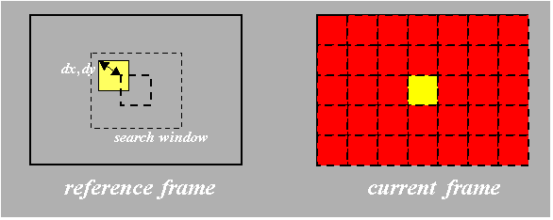
Figure 1. Block-based motion estimation (BME).

BME partitions a current frame into non-overlapped blocks. For each block, BME searches all displaced blocks within a search window in the reference frame to find the best matched block. The displacement of the best-matched block is called the motion vector. In virtually every video-coding scheme envisioned, and certainly every international standard video coding scheme, it is the system of motion vectors and prediction residuals, instead of the raw video data, that are coded. The mean of absolute differences (MAD) is the most commonly used matching criterion because it's computationally inexpensive. The mean square error (MSE) is also used occasionally to get slightly better peak signal to noise ratio (PSNR) performance. In either case, an expensive 2D (block) matching operation is involved. The simplest search method is an exhaustive search, wherein 2D matching is applied to all candidate blocks. However, the computational complexity of the exhaustive search method is often prohibitively high. Many fast algorithms have been developed to reduce the amount of computation.

Early termination is a BME framework that can guarantee optimal matching performance by maintaining a lower bound of the matching errors. The calculation of a particular matching computation (e.g., MAD) can be terminated early if it already exceeds a known lower bound. In this way, most candidate blocks can be excluded early by matching only part of the blocks. The tighter the lower bound, and the earlier it is reached in the matching process, the more effective this early termination approach becomes and the faster the algorithm executes. Thus the order of searching is of great importance. The spiral search method is a typical example of this philosophy. It starts with the zero displacement and moves spirally to candidates with larger displacements. Hence the spiral search method tries to optimize the search order. The combination of early-termination techniques and the spiral search method can significantly speed up BME computations without losing any prediction performance, and hence are commonly employed in high-performance codecs. The successive elimination algorithm (SEA) [Li, Brunig] is another example of optimal block matching wherein the authors present a method to obtain much tighter lower bounds.

In contrast to these above methods that gain some efficiencies through improved search techniques without sacrificing performance, there are a variety of fast algorithms used in practical systems which generally sacrifice some prediction performance for reduced BME complexity. In fact, the difference in quality levels of various video codecs available in the market today mainly depends on the quality of the BME algorithms implemented inside. Algorithms such as three-step search [Koga], the logarithmic search [Jain] and conjugate direction search[Kumar], all subsample the motion displacement space. They thus reduce the number of candidate blocks, and can be extremely fast at the expense of prediction performance. Hierarchical search, which uses reduced resolution for the first one or more stages of the search, has been investigated not only in the spatial domain [Chun] but also in the transform domain [Zhang]. Algorithms along this philosophy such as the telescopic search [iso93] and the predictive pattern search [zzb] assume temporal continuity of motion displacements and use prediction to initialize the search, then concentrate most of later searches locally around the initial points. Needless to say, such algorithms cannot guarantee any matching optimality.

The computational complexity of BME is the direct consequence of the expensive 2D block matching process. This manuscript presents a BME algorithm based on projection (PBME) that can reduce the number of 2D matchings tremendously. The relationship between motion and projection has been well-established before [Milanfar]. [Kim92] introduced fast feature-based motion estimation based on integral projection. In our proposed algorithm, we expand on his work to envision a transform-based ME formalism, much like energy compaction. We also develop a novel hybrid approach in which most candidate blocks are eliminated by matching 1D projections of the blocks, but the final matching is done in 2D. We will also describe the efficient computation of projections, as well as the buffering of recyclable data – two important aspects of the proposed algorithm. By controlling the percentage of candidates excluded by 1D matching, the execution speed of the PBME algorithm is also controlled.

The fast algorithm presented in this paper avoids most of expensive 2D matchings. 1D projections of 2D blocks are used to eliminate the majority of candidates by matching in 1D, which is much faster than matching 2D blocks. 2D matching only applies to small fraction of candidates to approach global optimum. An efficient implementation to compute projections and to buffer reusable data is also presented. The computational scalability can be achieved by controlling how many candidates to be excluded by 1D-matching. The search result is very close to the exhaustive search and the speed is close to the three-step search. The main idea of this invention can be illustrated by figure 2, where the 1D projections are matched rather than the blocks themselves.

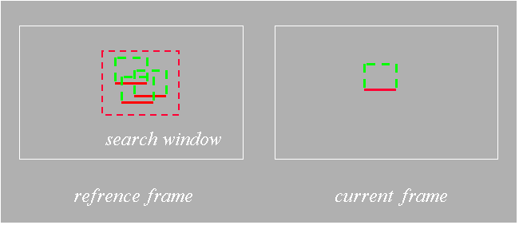
Figure 2. Main idea of the PBME approach – match projections of blocks.

2. Projection

2.1 Definition
Suppose the frame size is W x H, the block size is B_{h} x B_{v}, and the search window size is W_{h} x W_{v.} Then to predict one block, there are W_{h}*W_{v} candidates to search. A common block size is 16x16 (macroblock size), which we use often in illustrative examples.

Let $B^{x,y}$ denote the 2D block of pixels with top-left position at (x,y) in a video frame, and let $B_{i,j}^{x,y}$ where 0 i < B_{h,} and 0 j < B_{v,} be the pixel value at j^{th} row and i^{th} column of the block. Define the (vertical) projection of $B^{x,y}$ to be ${\text{PB}}^{x,y}$, a 1D row vector whose i^{th} value is the sum of the i^{th} column of $B^{x,y}$:

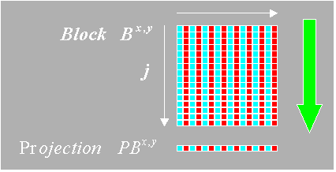
${\text{PB}}_{i}^{x,y}=\sum_{j=0}^{B_{v}−1}{B_{i,j}^{x,y}}$,
0 i < B_{h,} and 0 j < B_{v.}

Figure 3. The projection of a 2D block.

By projection, a B_{h} x B_{v} 2D block is reduced to a B_{h}-component 1D vector, and only DC information of each column is preserved.

We can further define the total sum of $B^{x,y}$ to be:

${\text{TB}}^{x,y}=\sum_{i=0}^{B_{h}−1}{{\text{PB}}_{i}^{x,y}}=\sum_{i=0}^{B_{h}−1}{\sum_{j=0}^{B_{v}−1}{B_{i,j}^{x,y}}}$.

Thus ${\text{TB}}^{x,y}$preserves the DC information of $B^{x,y}$.

2.2 Fast Projection
In the current frame, there are only (W*H/B_{h}*B_{v}) non-overlapped blocks and the computational load to compute projection is small ( O(W*H) operations). In other words, the complexity only increases linearly with the video size (number of pixels).

By contrast, in the reference frame, there are W*H different blocks (one starting at each pixel). $B^{x,y}$ and its direct right (lower) neighbor $B^{x+1,y}$ ($B^{x,y+1}$) share all pixels except two columns (rows). If ${\text{PB}}_{i}^{x,y}$ is known, for example, then ${\text{PB}}_{i}^{x+1,y}$ and ${\text{PB}}_{i}^{x,y+1}$ can be updated efficiently, as follows:
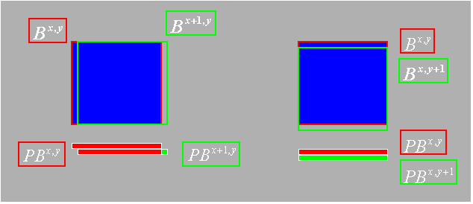

Figure 4. Incremental calculation of block projections.

${\text{PB}}_{i}^{x,y+1}={\text{PB}}_{i}^{x,y}−B_{i,0}^{x,y}+B_{i,B_{v}−1}^{x,y+1},$ and

${\text{PB}}^{x+1,y}=\begin{aligned}\left\{{\text{PB}}^{x,y}, i<B_{h}−1 | \right.\end{aligned}$.
Starting with $B^{0\text{.}0}$, with proper buffering, on average only 2 operations per update are required to get the projection of a block in this approach. The cost for projection is thus only O(2W*H) operations.

2.3 Buffering Scheme
To search for the motion vectors of a strip of blocks with their top corners at y in the current frame, only the blocks with their top corners within $\left[y−{W_{h}}/2, y+{W_{h}}/2\right]$ are involved in the reference frame, which is a $W$x$W_{h}$strip. So a $W$x$W_{h}$ buffer, instead of one for $W$x$H$ (usually $H$>> $W_{h}$) is sufficient to store all reusable projections. When moving to the next strip, we need to slide up the buffer by B_{h} lines, discard the B_{h} lines moving out and update B_{h} lines moving in using fast projection. An additional B_{h}-point buffer is necessary by the current frame.

3. Projection-based BME

3.1 2D Matching
For a block $C^{x,y}$ in the current frame, BME searches all displaced blocks $R^{x+\text{dx},y+\text{dy}}$ in the search window in the reference frame for the best matched block. The commonly used matching error metric called maximum amplitude difference (MAD) is given by:

$\text{MAD}\left(\text{dx},\text{dy}\right)=\sum_{i=0}^{B_{h}−1}{\sum_{j=0}^{B_{v}−1}{\left|C_{i,j}^{x,y}−R_{i,j}^{x+\text{dx},y+\text{dy}}\right|}}$ .

The computational cost of this expensive 2D block matching is $O(B_{h}∗B_{v})$ operations, and must be computed for every pair of current block and reference block displacement.

BME tries to find the minimum value of MAD, MAD_{min}, and the corresponding displacement (dx, dy) of the optimal motion vector for $C^{x,y}$.

${\text{MAD}}_{\text{min}}= \underset{\text{dx},\text{dy}}{\text{argmin}}\text{MAD}(\text{dx},\text{dy}), \text{subject} \text{to} |\text{dx}| <\frac{W_{h}}{2}, |\text{dy}| <\frac{W_{v}}{2}$.

There are $W_{h}∗W_{v}$candidates to search for, so we require $O(B_{h}∗B_{v}∗W_{h}∗W_{v})$ operations to get just one motion vector.

3.2 1D Matching
By contrast, the matching error MAD of the 1D projections of blocks $C^{x,y}$and $R^{x+\text{dx},y+\text{dy}}$is
$$\text{PMAD}\left(\text{dx},\text{dy}\right)=\sum_{i=0}^{B_{h}−1}{\left|{\text{PC}}_{i}^{x,y}−{\text{PR}}_{i}^{x+\text{dx},y+\text{dy}}\right|}\text{.}$$

It's a light 1D matching and only $O(B_{h})$operations are involved, given the projections, which is only $\frac{1}{B_{v}}$th of the 2D matching cost.

Define PMAD_{min} as
$${\text{PMAD}}_{\text{min}}= \underset{\text{dx},\text{dy}}{\text{argmin}}\text{PMAD}(\text{dx},\text{dy}), \text{subject} \text{to} |\text{dx}| <\frac{W_{h}}{2}, |\text{dy}| <\frac{W_{v}}{2}$$
This cost function will serve as a threshold that we will exploit to eliminate most of the matching candidates as described in the next section.

3.3 Excluding Candidates by 1D Matching
The intuition is that the projections of two well-matched blocks must match well. In other words, two blocks can't match well if their projections don't match well. In fact, according to the triangle inequality:

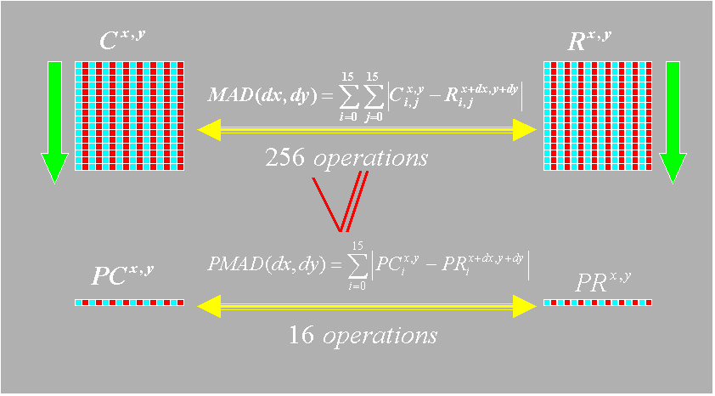
$$\begin{aligned}\text{MAD}\left(\text{dx},\text{dy}\right)=\sum_{i=0}^{B_{h}−1}{\sum_{j=0}^{B_{v}−1}{\left|C_{i,j}^{x,y}−R_{i,j}^{x+\text{dx},y+\text{dy}}\right|}} \\ =\sum_{i=0}^{B_{h}−1}{\left|\sum_{j=0}^{B_{v}−1}{\left|C_{i,j}^{x,y}−R_{i,j}^{x+\text{dx},y+\text{dy}}\right|}\right|≥}\sum_{i=0}^{B_{h}−1}{\left|{\text{PC}}_{i}^{x,y}−{\text{PR}}_{i}^{x+\text{dx},y+\text{dy}}\right|}=\text{PMAD}(\text{dx},\text{dy})\text{.}\end{aligned}$$

Figure 5. Comparing 2D matching cost vs. the 1D matching cost: MAD vs. PMAD.

Hence, if PMAD > MAD_{min}, then MAD > MAD_{min} and the candidate cannot be the best matched block. Typically, the majority of candidates will satisfy this PMAD > MAD_{min} constraint, and so can be eliminated from further consideration. Then 2D matching is only necessary for those candidates with PMAD MAD_{min} , which is often a small percentage of blocks, in order to obtain an optimal matching and corresponding motion vector.

3.4 Estimating MAD_{min}
MAD_{min} is clearly necessary to exclude candidates by 1D matching, but unfortunately it is not available in advance. An estimated value, called MAD_{e} will be used instead. The smaller the value of MAD_{e}, the more candidates we can eliminate from 1D matching, and the faster the algorithm executes. If MAD_{e} MAD_{min}, then optimality of the motion vector estimation is still preserved. However, if MAD_{e} < MAD_{min}, then optimality is not necessarily preserved, and as MAD_{e} decreases further, the farther from optimality the algorithm becomes.

A good way to estimate MAD_{min} is based on PMAD_{min}

${\text{MAD}}_{e}≈α {\text{MAD}}_{\text{min}}$,

where $α$ is a scaling factor. A W_{h}*W_{v} buffer is neccesary to keep PMAD(dx,dy) values for all candidates. It turns out empirically that this estimation method is quite robust because it is partially adaptive – PMAD_{min} contains information about the block.

By adjusting the parameter $α$, the complexity of the search can be systematically controlled and computational scalability can be achieved.

3.5 The Overall Algorithm
Let us recapitulate the overall procedure for the proposed projection-based BME algorithm.

- Compute and buffer necessary projections using fast projection algorithm.
- Compute and buffer 1D matching error PMAD(dx,dy) for all candidates.
- Estimate MAD_{e} based on PMAD_{min} .
- For those candidates with PMAD(dx,dy) MAD_{e} , perform 2D matching to find the best matched block.

3.6 Extension to MSE
If the mean-squared error (MSE) is used instead of MAD as the matching criterion, we can still derive fast algorithms. Recall that in the 2D MSE matching metric is defined by

$$\text{MSE}\left(\text{dx},\text{dy}\right)=\sum_{i=0}^{B_{h}−1}{\sum_{j=0}^{B_{v}−1}{{\left|C_{i,j}^{x,y}−R_{i,j}^{x+\text{dx},y+\text{dy}}\right|}^{2}}}$$

and the 1D MSE matching error in the projection domain is

$$\text{PMSE}\left(\text{dx},\text{dy}\right)=\sum_{i=0}^{B_{h}−1}{{\left|{\text{PC}}_{i}^{x,y}−{\text{PR}}_{i}^{x+\text{dx},y+\text{dy}}\right|}^{2}}\text{.}$$
It is easy to see that in this case as well, the triangle inequality holds:

$$\text{MSE}\left(\text{dx},\text{dy}\right)≥\text{PMSE}\left(\text{dx},\text{dy}\right)\text{.}$$

This fact leads straightforwardly to an efficient algorithm of the same structure.

3.7 Discussion

Here we discuss several important implementation issues as well as variations of our proposed PBME algorithm.

- In this proposed algorithm (PBME), early termination and spiral search-type methods can applied in both 1D and 2D matching tasks to further improve the execution speed of the algorithm, and as such are incorporated by reference in this algorithm. Even without use of further techniques, we can achieve 4-10X complexity reduction over full-search.

- Although only vertical projection is discussed in this manuscript, an entirely analogous algorithm ensues by using horizontal projections. We believe that vertical projection may be generally preferred, since video sequences tend to have more horizontal breadth, and more horizontal motion in the scenes. However, horizontal projection may be more suitable for certain sequences.

- An even more greedy approach that may be based on matching just the total sum of blocks, ${\text{TB}}^{x,y}$, does not work well in practice. This is DC matching, and it is certainly very fast: we can derive fast methods to both compute the DC as well as manage the 1D butter. Although DC matching is very efficient (only one operation per match), the sum contains too little information about a block. Our analysis indicates that DC matching yields too many mismatches to be effective.

- By using both vertical and horizontal projections, a few more candidate blocks can be eliminated by 1D matching. However, the saving is just enough to compensate the cost of the extra projection. Besides, extra buffers are necessary. Hence, the combination of two 1D projections is not better than using a single projection.

- The case α = 1 corresponds effectively to the case treated in [Kim92].

4. Simulation Results
Popular QCIF (176 x 144) test sequences were used as test sequences to compare the prediction performance as well as the speed of the proposed algorithm, in reference to the exhaustive search algorithm, within a coding framework exemplified by H.263+. The (macro-) block size is 16 x 16 pixels, and the search window size is 32 x 32 pixels. The reference frame is symmetrically extended by 16 pixels at all edges to allow motion vectors to point outside the frame. The extended reference frame is bilinearly interpolated to enable half-pixel accuracy BME. To compute a half-pixel accuracy motion vector, the best matched block with whole-pixel displacement is found first and then its 8 direct neighbours with half-pixel displacement are also checked to get the best matched block with half-pixel accuracy. Now, 32 x 32 + 8=972 2D matchings are need to perform the exhaustive search algorithm, while 32 x 32=964 1D matchings plus at least 9 2D matchings are needed to perform the proposed algorithm. Both algorithms employed early termination and spiral search methods for reduced complexity. To favor the zero motion vector, the corresponding 2D matching error is reduced by a constant amount (100 for MAD and 1000 for MSE), as is often done.

In this analysis, three QCIF test sequences (Foreman, News, Akiyo) were used to benchmark the proposed PBME algorithm, with parameter α = 2, 4, 8, against the exhaustive search algorithm. The following plots clearly indicate that the performance of our fast algorithms is virtually identical to the exhaustive search algorithm. The only video segment with visible quality loss is the subsequence of frames 250 – 350 of the Foreman sequence, where the camera pans rapidly. Tables 1 through 3 tabulate the overall MAD and MSE error metrics. We can observe that using MJAD as the matching criterion yields slightly better objective results. These tables also summarize the percentage of candidates where 2D matching was necessary. This percentage is always 100% for the exhaustive search by definition. For our algorithms, the smaller values of α yield faster performance. The actual running on a PIII Dell Dimension Workstation with 128 MB RAM (running Red Hat Linux 6.1) is also presented. The proposed algorithm is 3-5 times faster than the exhaustive search algorithm, with almost identical performance. The prediction performance only degrades slightly when α is reduced from 8 to 2. However, the PBME algorithm’s complexity decreases drastically. Further, computational scalability by adaptively adjusting this parameter can be achieved at a small cost.

5. Conclusions

We have presented a projection-based fast BME algorithm called PBME in this manuscript. An efficient method to compute and buffer projections, which is crucial to the algorithm, was developed. The algorithm greatly reduces the computational complexity of BME while preserving prediction integrity. Matching their 1D projections can eliminate most candidate blocks, which is much faster than matching 2D blocks. The prediction performance is close to the global optimum while the speed is several times faster than the exhaustive search algorithm. This algorithm makes software-only real-time encoding practical for QCIF size video input and beyond, on modest desktop machines. Furthermore, computational scalability, which is often difficult to achieve with other algorithms, can be easily obtained in this scheme by controlling a single parameter.

IPR Statement
This contribution has IPR associated with the technical contents of this proposal.

References

[MPEG-2] ISO/IEC JTC1 IS 13818-2 (MPEG-2), “Information technology – generic coding of moving pictures and associated audio information,” 1996.
[H263p] M. Cote, B. Erol, and F. Kossentini, “H.263+: Video coding at low bit rates,” IEEE Tran. Circuits Syst. Video Tech., 8, No.7, pp. 849-866, 1999.
[MPEG-4] MPEG website, www.cselt.it/mpeg
[H26L] ITU-T Video Coding Experts Group, H.26L.
[Li] W. Li and E. Salari, “Successive elimination algorithm for motion estimation,” IEEE Trans. Image Proc., 4, pp.105-107, Jan. 1995.
[Brunig] M. Brunig and B. Menser, “Fast full search block matching using subblocks and successive approximatio of the error measure,” Proc. SPIE, Image and Video Comm. And Proc., 2974, pp. 235-244, Jan. 2000.
[Koga] T. Koga, “Motion compensated interframe coding for video conferencing,” NTC ’81, National Telecomm. Conf., pp. G5.3.1-G5.3.5, Dec. 1981.
[Jain] J. Jain and A. Jain, “Displacement measurement and its application in interframe image coding,” IEEE Trans. Image Proc., COM-29, pp. 1799-1808, Dec., 1981.
[Kumar] S. Kumar, “A simple FPGA-based conjugate search motion estimator,” IEEE Asia-Pacific Conf. Circuits and Sys., pp. 109-114, Dec. 1994.
[Chun] K. Chun and J. Ra, “An improved block-matching algorithm based on successive refinement of motion vector candidates,” Signal Proc: Image Comm. 6, pp. 115-122, 1994.
[Zhang] Y. Zhang and S. Zafar, “Motion-compensated wavelet transform coding for color video compression,” IEEE Trans. Circuits and Sys. Vid. Tech., 2, No.3, pp. 285-296, Sept., 1992.
[zzb] S. Zafar, Y. Zhang, and J. Baras, “Predictive block-matching motion estimation for TV coding – part I: Interblock prediction,” IEEE Trans. Broadcasting 37 (3), pp. 97-101, Sept. 1991.
[iso93] “Information technology – coding of moving picdtures and associated audio for digital storage media at up to about 1.5 mbits/s,” ISO/IEC 1172-2, Part 2, 1993.
[Milanfor] P. Milanfor, “A model of the effect of image motion in the radon transform domain,” IEEE Trans. Image Proc. 8 (3), pp. 1276-1281, Sept. 1999.
[Kim92] J. Kim and R. Park, “A fast feature-based block matching algorithm using integral projections,” IEEE Jour. Sel. Areas in Comm., vol.10, no.5, pp. 968-971, Jun. 1992.
[Kuhn] P. Kuhn, Algorithms, Complexity Analysis and VLSI Architectures for MPEG-4 Motion Estimation, Kluwer, 1999.
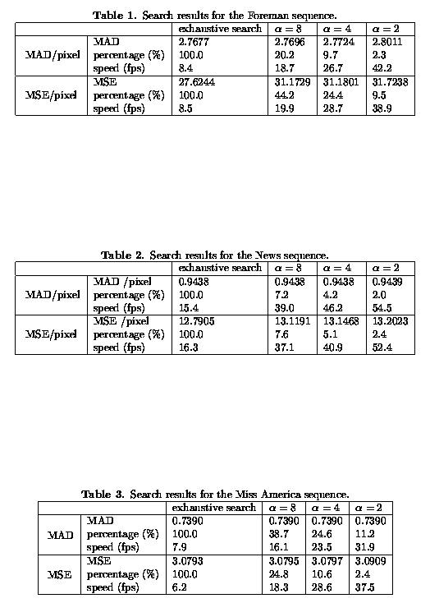

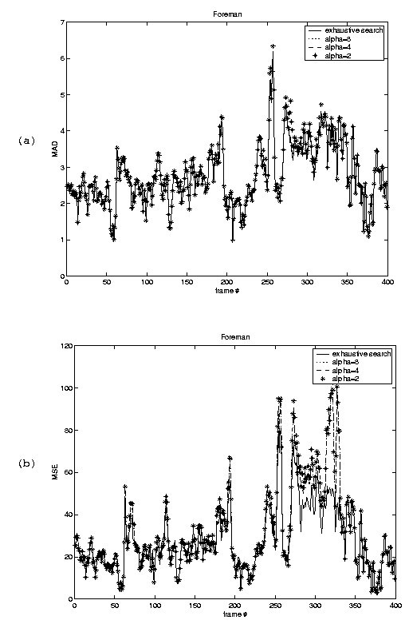

Figure 6. Prediction error metrics for the Foreman sequence: (a) MAD, (b) MSE.
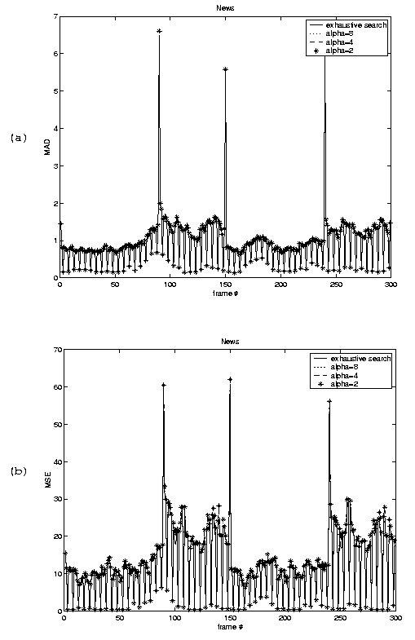

Figure 7. Prediction error metrics for the News sequence: (a) MAD, (b) MSE.

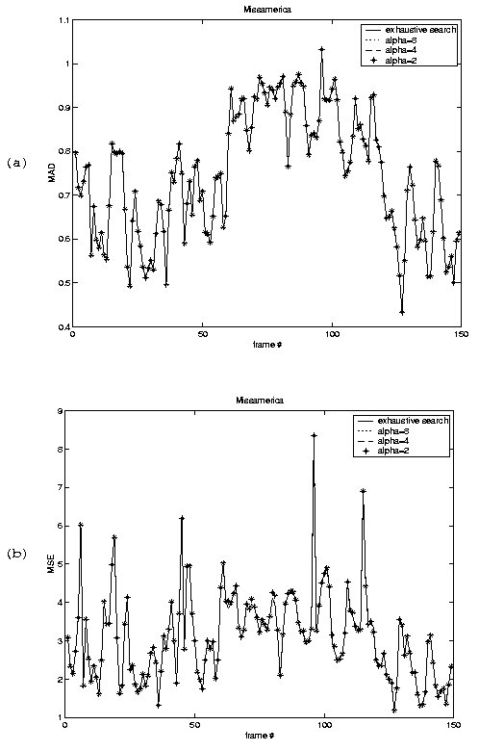

Figure 8. Prediction error metrics for the Miss America sequence: (a) MAD, (b) MSE.

