ITU - Telecommunications Standardization Sector  STUDY GROUP 16  Video Coding Experts Group (Question 15)  _________________  Eleventh meeting: Portland, Oregon, 22-25 August, 2000 | Document Q15-K-35  Filename: q15k35.doc  Generated: 11 Aug 2000

Question: | Q.15/SG16
Source: | Jani Lainema, Marta Karczewicz  Nokia Research Center  6000 Connection Drive  Irving, TX 75039, U.S.A. | Tel:  Fax:  Email: | +1 972 894 4045  +1 972 894 4589  jani.lainema@nokia.com
Title: | Concerns about TML-4 Intra coding
Purpose: | Proposal
_____________________________

Introduction
TML-4 Intra coding and especially the new 16x16 based prediction modes seem to create visually disturbing blockiness in both Intra and Inter frames. This document shows some examples about the problem and proposes a solution to it.

Reducing blocking by stronger filtering
Figure 1 shows an example of visible 16x16 blockiness created mostly by combined DC coding in both luminance and chrominance coding. One alternative to reduce this kind of blockiness would be to code the 4x4 DC values separately without additional 4x4 (luma) or 2x2 (chroma) transforms. However, this approach would most likely lead to reduced compression efficiency.
Another way to improve the visual quality is to adapt the filter on the boundaries where this type of blocking artefacts are known to exist. This contribution proposes to use a 5-tap averaging filter on the 16x16 grid boundaries if at least another of the adjacent blocks is Intra coded and there is 'certain amount of flatness' present in both sides of the block boundary. Activity parameters S0₁, S1₁, S0₂ and S1₂ calculated in the beginning of the TML-4 filtering process (see Q15-J-28) are used to analyse the flatness. If all these parameter are below a threshold given by Lim(qp)/2 (also defined in Q15-J-28) and the absolute value of the difference of the boundary pixels is in the [2, QP/4-1] interval:
d_{modified} = (b + c + d + e + f + 2)/5
c_{modified} = (a + b + c + d_{modified} + e + 2)/5
b_{modified} = (a + 2*b + c_{modified} + d_{modified} + 2)/5
e_{modified} = (c + d + e + f + g + 2)/5
f_{modified} = (d + e_{modified} + f + g + h + 2)/5
g_{modified} = (e_{modified} + f_{modified} + 2*g + h + 2)/5
a, b, c, d, e, f, g and h are the four pixels on both sides of the block boundary as define in Q15-J-28 (the block boundary is between d and e). When filtering the next block boundary, pixel g may get overwritten. To compensate the effect g_{modified} is stored and used as b when filtering the next boundary. If any of the conditions given above are not holding TML-4 filter is applied.
Figures 1 to 4 below provide examples of the performance of the averaging filter. Further demonstrations are provided in the Portland meeting.
Due to the heavy filtering PSNR-performance is slightly degraded (max. 0.1 dB in Luminance and 0.4 dB in chrominance). RD-curves can be found in q15k35.xls.

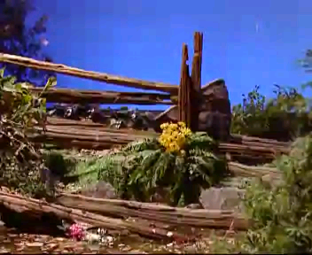
Figure 1: TML-4 Intra coded frame (68.5kb)
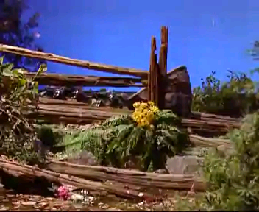
Figure 2: TML-4 Intra coded frame with modified filter (68.5kb)

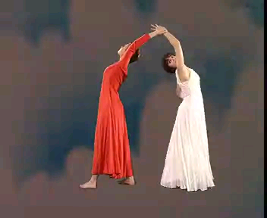
Figure 3: TML-4 Intra coded frame (32 kb)
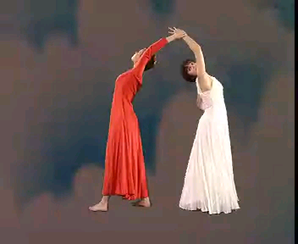
Figure 4: TML-4 Intra coded frame with modified filter (32 kb)

