ITU - Telecommunications Standardization Sector  STUDY GROUP 16  Video Coding Experts Group (Question 15)  _________________  Eleventh Meeting: Portland, Oregon, USA, 22-25 August, 2000 | Document Q15-K-24  Filename: q15k24.doc  Generated: 16 Aug ’00

Question: | Q.15/SG16
Source: | Mathias Wien, Claudia Mayer,  Jens-Rainer Ohm  Institut für Elektrische Nachrichtentechnik  RWTH Aachen  52074 Aachen, Germany | Tel:  Fax:  Email: | +49-241-80 7681  +49-241-8888 196  wien@ient.rwth-aachen.de  mayer@ient.rwth-aachen.de  ohm@ient.rwth-aachen.de
Title: | Integer Transforms for H.26L using Adaptive Block Transforms
Purpose: | Proposal
_____________________________

Introduction
In [1] the application of Adaptive Block Transforms (ABT) for transform coding of the prediction error in H.26L was proposed. The basic idea of ABT is to connect the block sizes of the applied transforms to the size of the blocks used for motion compensation. Since these block sizes are transmitted for motion compensation, no additional side information needs to be transmitted to the decoder.
In [1] float DCT matrices of sizes 4x4, 8x8, and 16x16 and an entropy based rate estimation were used to compare the ABT scheme to the TML with fixed 4x4 blocks. In these preliminary experiments the ABT coder showed a gain of up to 1.5dB against the scheme with fixed 4x4 blocks.

In this document integer approximations of the DCT matrix of size 8x8 and 16x16 are proposed for application with ABT. The transforms both have a norm that is a multiple of 17 and can be operated in 32bit arithmetic. The quantization and coding procedure are designed the same way as in the TML. The quantization procedure uses a set of five quantization tables that reflects the varying norms of the transform blocks. For encoding of the quantized coefficients, scan blocks of 16 coefficients are used. This preliminary approach allows for application of the TML VLC as well as for a simple R/D optimization on the encoder side, similar to the optimization used in the TML.

However, we assume that the TML VLC is suboptimum to achieve efficient entropy coding in the context of ABT, and expect more gain by using an optimized VLC.

Adaptive Block Transforms
In the TML seven tilings of a macroblock with a corresponding set of motion vectors are used for motion compensation. Each of the occuring blocks shall be coded with a transform of the maximal applicable size. For the transformation of the 16x16, 16x8, 8x16, 8x8, 8x4, 4x8, and 4x4 blocks, horizontal and vertical transform matrices of size 4x4, 8x8, and 16x16 are needed.
The blocks are transformed by

1 2 3 4 5 6 7
Figure 1: Macroblock modes in TML-4
C_{nxm} = T_{m} x B_{nxm} x T_{n}^{T}, (1)

where B_{nxm} denotes a block with n pixels m rows. T_{n} and T_{m} are the horizontal and vertical transform matrices of size nxn and mxm, respectively. C_{nxm} denotes the transformed nxm block. The transform matrices are not normalized. Normalization is performed during the quantization and dequantization procedures.

Motion Estimation

The variable block sizes and transforms of ABT have to be concidered during motion estimation. Here, the SATD is calculated using the block size given by the macroblock mode. Hadamard transforms of size 4x4, 8x8, and 16x16 are employed using a fast implementation, e.g. [6]. Besides the SATD, the motion estimation is unchanged from the TML.

Integer Transform Matrices

The transform matrices proposed here are integer approximations to the DCT of size 8x8 and 16x16. In the following the integer transforms are denoted by ICT for Integer Cosine Transform.
In [2] an 8x8 approximation of the DCT is given with the constant basis vector equal to 13. Here, the zero basis functions of the 8x8 and 16x16 ICT matrices are equal to 17. While solutions for the 8x8 can be found directly by searching the integer coefficients with respect to symmetry and orthogonality restrictions, this does not yield a solution in the 16x16 case. The method for finding the proposed 16x16 ICT matrix is based on [4], where the Hadamard transform and a conversion matrix are used for the approximation of the DCT.
The value of 17 instead of 13 was chosen, because 17^2 can be decomposed into more square numbers than 13^2. This is essential for the design of the transform. The ICT matrices are:

T8 = [
17 17 17 17 17 17 17 17
24 20 12 6 -6 -12 –20 -24
23 7 -7 -23 -23 -7 7 23
20 -6 -24 –12 12 24 6 -20
17 -17 –17 17 17 -17 –17 17
12 -24 6 20 -20 -6 24 -12
7 –23 23 -7 -7 23 -23 7
6 -12 20 –24 24 -20 12 -6 ];

T16 = [
17 17 17 17 17 17 17 17 17 17 17 17 17 17 17 17
25 21 25 21 9 -3 9 -3 3 -9 3 -9 -21 -25 -21 -25
29 13 11 -5 5 -11 -13 -29 -29 -13 -11 5 -5 11 13 29
9 -3 9 -3 -25 -21 -25 -21 21 25 21 25 3 -9 3 -9
23 7 -7 -23 -23 -7 7 23 23 7 -7 -23 -23 -7 7 23
25 21 -25 -21 -9 3 9 -3 3 -9 -3 9 21 25 -21 -25
11 -5 -29 -13 13 29 5 -11 -11 5 29 13 -13 -29 -5 11
9 -3 -9 3 25 21 -25 -21 21 25 -21 -25 -3 9 3 -9
17 -17 -17 17 17 -17 -17 17 17 -17 -17 17 17 -17 -17 17
21 -25 -21 25 -3 -9 3 9 -9 -3 9 3 -25 21 25 -21
13 -29 5 11 -11 -5 29 -13 -13 29 -5 -11 11 5 -29 13
-3 -9 3 9 -21 25 21 -25 25 -21 -25 21 -9 -3 9 3
7 -23 23 -7 -7 23 -23 7 7 -23 23 -7 -7 23 -23 7
21 -25 21 -25 3 9 3 9 -9 -3 -9 -3 25 -21 25 -21
-5 -11 13 -29 29 -13 11 5 5 11 -13 29 -29 13 -11 -5
-3 -9 -3 -9 21 -25 21 -25 25 -21 25 -21 9 3 9 3 ];

The 4x4 ICT matrix is the transform proposed in the TML [5]. The transformed blocks have to be normalized. The norms of all nxm-transforms are listed below. The different norms are concidered during the quantization/normalization process described in the next section.

Block Size | Norm N²_{nxm}
16x16 | 16 * 17^2
16x8 | 8 * sqrt(2) * 17^2
8x16 | 8 * sqrt(2) * 17^2
8x8 | 8 * 17^2
8x4 | 4 * sqrt(2) * 13 * 17
4x8 | 4 * sqrt(2) * 13 * 17
4x4 | 4 * 13^2

Quantization Tables

The quantization is performed the same way as in the TML. Here, five quantization tables are needed, since the non-square blocks 16x8/8x16 and 8x4/4x8 can use the same tables, respectively. The number of quantization tables could be reduced if a higher arithmetic precision is used (then the quantization table of the 8x8 ICT could be scaled by 2 and be used for the 16x16 ICT) and/or if a 4x4 transform of norm 4 * 17^2 would be applied.

The quantization tables for the new block sizes are listed below. They are designed to have the same normalized quantization step size as the TML quantizers. Therefore the quantization table for 4x4 blocks can be taken from the TML. The values in the quantization tables follow the condition

A_{nxm} * B_{nxm} * N²_{nxm} = 2^40.

QUANTIZATION TABLES
QP | 16x16 |  | 16x8 = 8x16 |  | 8x8 |  | 8x4 = 4x8
QP | A | B | A | B | A | B | A | B
0 | 91 | 565 | 128 | 803 | 181 | 1136 | 335 | 2100
1 | 81 | 635 | 114 | 902 | 162 | 1270 | 299 | 2353
2 | 72 | 714 | 102 | 1008 | 144 | 1428 | 266 | 2645
3 | 64 | 803 | 91 | 1130 | 128 | 1607 | 237 | 2968
4 | 57 | 902 | 81 | 1270 | 114 | 1804 | 211 | 3334
5 | 51 | 1008 | 72 | 1428 | 102 | 2017 | 188 | 3742
6 | 45 | 1143 | 64 | 1607 | 91 | 2260 | 168 | 4188
7 | 40 | 1286 | 57 | 1804 | 81 | 2539 | 149 | 4721
8 | 36 | 1428 | 51 | 2017 | 72 | 2857 | 133 | 5289
9 | 32 | 1607 | 45 | 2286 | 64 | 3214 | 118 | 5962
10 | 29 | 1773 | 40 | 2571 | 57 | 3609 | 105 | 6700
11 | 25 | 2057 | 36 | 2857 | 51 | 4033 | 94 | 7484
12 | 23 | 2236 | 32 | 3214 | 45 | 4571 | 84 | 8375
13 | 20 | 2571 | 29 | 3546 | 40 | 5142 | 75 | 9380
14 | 18 | 2857 | 25 | 4114 | 36 | 5714 | 67 | 10500
15 | 16 | 3214 | 23 | 4472 | 32 | 6428 | 59 | 11924
16 | 14 | 3673 | 20 | 5142 | 29 | 7093 | 53 | 13274
17 | 13 | 3956 | 18 | 5714 | 25 | 8228 | 47 | 14968
18 | 11 | 4675 | 16 | 6428 | 23 | 8943 | 42 | 16750
19 | 10 | 5142 | 14 | 7346 | 20 | 10285 | 37 | 19014
20 | 9 | 5714 | 13 | 7911 | 18 | 11428 | 34 | 20691
21 | 8 | 6428 | 11 | 9350 | 16 | 12856 | 30 | 23450
22 | 7 | 7346 | 10 | 10285 | 14 | 14693 | 26 | 27058
23 | 6 | 8571 | 9 | 11428 | 13 | 15823 | 24 | 29313
24 | 6 | 8571 | 8 | 12856 | 11 | 18700 | 21 | 33500
25 | 5 | 10285 | 7 | 14693 | 10 | 20570 | 19 | 37026
26 | 5 | 10285 | 6 | 17141 | 9 | 22855 | 17 | 41382
27 | 4 | 12856 | 6 | 17141 | 8 | 25712 | 15 | 46900
28 | 4 | 12856 | 5 | 20570 | 7 | 29385 | 13 | 54116
29 | 3 | 17141 | 5 | 20570 | 6 | 34283 | 12 | 58625
30 | 3 | 17141 | 4 | 25712 | 6 | 34283 | 10 | 70350
31 | 2 | 25712 | 4 | 25712 | 5 | 41139 | 9 | 78167

Scanning Method

To deal with the heterogenous block sizes in ABT, the concept of the well-known zig-zag is modified to allow for the application of CBP and the TML VLC scan. In H.26L the CBP concerns a set of 64 coefficients in 4 transformed blocks. To apply this CBP in MBs with 16x8, 8x16 or 16x16 transforms, these blocks are first scanned using the zig-zag scan and then ordered into groups of 64 coefficients. Figure 2 shows examples for the 8x8 transform (b), the 16x16 transform (c) and the 16x8 transform (d). The starting points and the direction of the scans are marked inside the blocks. To apply the VLC from the TML, the resulting subblocks are divided into scans of 16 coefficients (scan blocks).
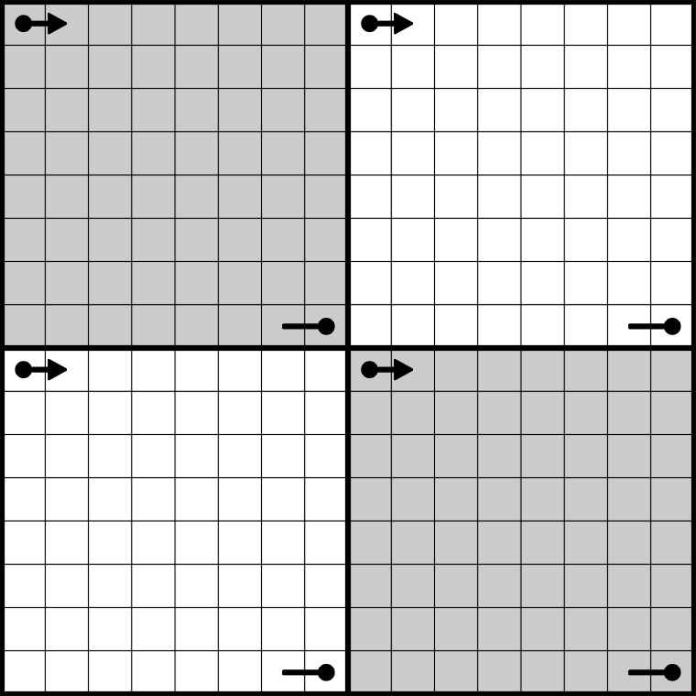
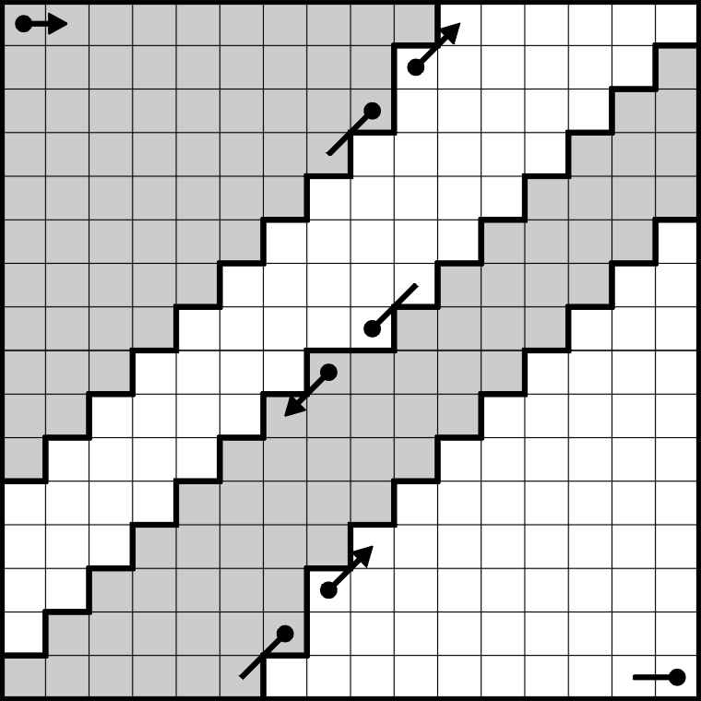
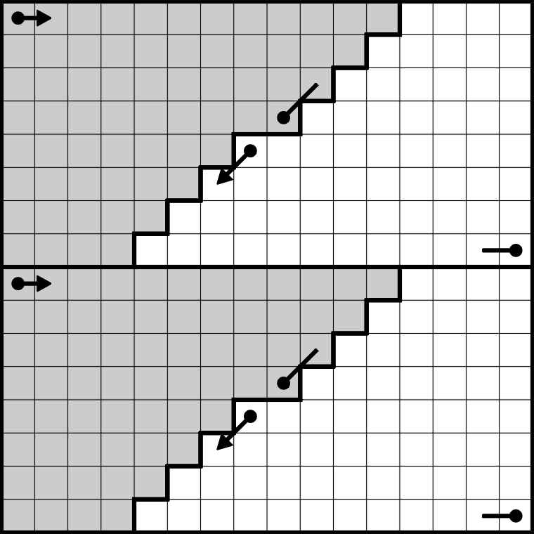
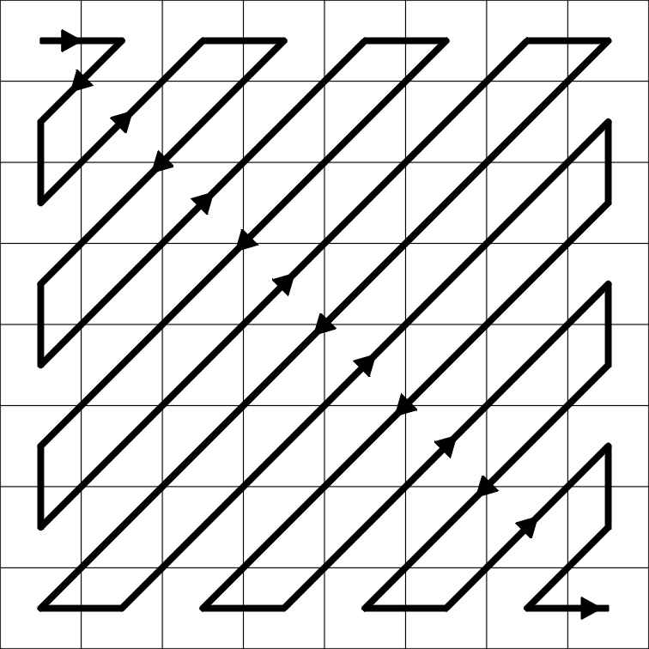

Rate-Distortion Optimization
(a) (b) (c) (d)
Figure 2: (a) Scan of a 8x8 block. The four Blocks affected by the CBP: (b) 8x8 transform, (c) 16x16 tranform, and (d) 16x8 transform.
Single coefficients of value ±1 may be very expensive to code without much improvement in picture quality. The TML employes a simple R/D optimization on the encoder side to avoid encoding of expensive subblocks. For each CBP the following steps are performed during the scan
- Set coeff_cost to zero
- If |level| > 1, add MAX_VALUE to coeff_cost (the block is important)
- If |level| = =1, add value to coeff_cost depending on run
value(run) = [3,2,2,1,1,1,0,0,...]
- If coeff_cost < Threshold1, set CBP to zero (the block is unimportant)

coeff_cost is accummulated for each MB. If sum_coeff_cost < Threshold2 the CBP for the entire MB is set to zero. This concept is used for ABT as well.

A problem arises if one of four scan blocks in a CBP is important while the others only contain very few coefficients of |level|=1. Then the three expensive scan blocks are coded in addition to the important scan block.
For further improvement we propose to use a threshold (Threshold0) for each scan block. If the block is unimportant (e.g. only a single coefficient of level=1), the scan block is set to zero. The scan block then only needs 1 bit to be coded.

Experimental Results

An entropy based performance comparison of the ABT coder (based on TML-2) with ICT matrices and with float DCT matrices is given at the end of this paper. The results are shown for FOREMAN and SILENT. As can be seen, the proposed ICT matrices perform very well compared to the DCT. For other sequences we achieved similar results.

In Document Q15-K-25 [3] the R/D performance of the current ABT coder is presented. The TML VLC and scan blocks with 16 coefficients are used for encoding. Also, a comparison of the coder perfomance when using either the 8x8 transform matrix with a constant basis vector of 13 or of 17 is given. See Q15-K-25 for details.

Conclusion and Future Work

Integer transform matrices of size 8x8 and 16x16 are proposed for application of ABT in H.26L. In a pre-experiment, the proposed matrices showed a comparable performance to float DCT matrices.
New quantization tables and a new scanning method for the transformed blocks are given. A modification of the single coefficient elimination is proposed. The scan allows for coding with the TML VLC when using scan blocks of 16 coefficients. Since the TML VLC is not optimized for this application, we expect further gain when using an optimized VLC. The coding method for 8x8 blocks proposed in [2] may be used as a starting point.
Furthermore, the deblocking filter used in the TML has to be modified to fit into the ABT scheme. Also, the application of ABT to chroma should be investigated.

References

[1] Mathias Wien and Claudia Mayer, ‘New Integer Transforms for H.26L’, ITU-T Q15/SG16,
Document Q15-J-41, Osaka, May 2000

[2] Gisle Bjontegaard, ‘Addition of 8x8 Transform to H.26L’, ITU-T Q15/SG16, Document Q15-I-39,
Red Bank, NJ, October 2000

[3] Mathias Wien and Till Halbach, ‘Results of H.26L Core Experiment on Adaptive Block Transforms’,
ITU-T Q15/SG16, Document Q15-K-25, Portland, OR, August 2000

[4] R. Srinivasan and K. Rao, ‘An Approximation to the Discrete Cosine Transform for n=16’,
Signal Processing 5, pp. 81-85, 1983

[5] Gisle Bjontegaard, ‘H.26L Test Model Long Term Number 4 (TML-4)’, ITU-T Q15/SG16,
Document Q15-J-72, Osaka, May 2000

[6] D.F. Elliott and K.R. Rao, ‘Fast Transforms: Algorithms, Analyses, Applications’, Academic Press,
New York, London, 1982

