ITU - Telecommunications Standardization Sector  STUDY GROUP 16  Video Coding Experts Group (Question 15)  _________________  Eleventh Meeting: Portland, Oregon, USA, 22-25 August, 2000 | Document Q15-K-09  Filename: q15k09.doc  Generated: 17 Aug ’00

Question: | Q.15/SG16
Source: | Klaus Illgner, Gero Baese  Siemens AG, ZT IK 2  81730 Munich  Germany | Tel:  Fax:  Email: | +49 – 89 – 636 44199  +49 – 89 – 636 51115  klaus.illgner@mchp.siemens.de
Title: | Experiment in H.26L Fine Granularity Scalability
Purpose: | Information
_____________________________
- Introduction

This paper reports results for the core experiment on fine-granular scalability as defined in Q15J70.

- Test Conditions

This document reports results from test made with the FGS scheme proposed by HHI. The test conditions are:
- TML version 4 for coding the base layer, including all option
- Hadamard transform: enabled
- Max search range for motion estimation: 16
- Number of predicted frames for motion estimation: 5
- Postfilter: None
- Error robustness: disbaled
- Inter block search 16x16: enabled
- Inter block search 16x8 : enabled
- Inter block search 8x16: enabled
- Inter block search 8x8 : enabled
- Inter block search 8x4 : enabled
- Inter block search 4x8 : enabled
- Inter block search 4x4 : enabled
- A simplified rate control has been added by HHI to
- Account for the higher bit rate of the INTRA-coded startup frame
- Allow to encode periodically INTRA farmes within the sequence
- Periodically frames are coded INTRA to allow to switch at the decoder side between different quality levels (bitstreams). The INTRA-coding period has been set to 1fps.

NOTE: This condition is a very restrictive one, targeted for GPRS-scenarios, where the available channel bandwidth can fall even below the rate of the baselayer codec. In conditions where the rate for the baselayer is guaranteed (streaming) the FGS-codec has a significant advantage as a periodic INTRA-update is not necessary.

The PSNR results are generated from a decoder perspective. Depending on the currently available channel bandwith the decoder can only decode bitstreams available at that bitrate. This means for the simulcast scenario, that the bitrate of the decoded bitream has to be smaller or equal to the channel bandwith. In contrast the FGS decoder can always decode at the channel bandwidth. Therefore 3 decoding scenarios have been defined
- The channel bandwidth is fixed.
- The channel bandwidth follows a ramp function over time.
- The channel bandwidth is obtained from a realisitc GPRS scenario.

The following test conditions have been applied:
- 3-layer scenario 24+36+48kbit/s, QCIF, 10fps fixed, variable QP, INTRA-update 1fps
- 2-layer scenario 24+84kbit/s, QCIF, 10fps fixed, variable QP, INTRA-update 1fps
- 3-layer scenario 32+40+56kbit/s, QCIF, 10fps fixed, variable QP, INTRA-update 1fps
- 3-layer scenario 64+82+110kbit/s, CIF, 10fps fixed, variable QP, INTRA-update 1fps

- Test Results

  - Fixed Bandwidth

3-Layer Simulcast (24/36/48), fixed bandwidth

Sequence  PSNR [dB] |  | Channel bandwidth
 |  | 24 kbit/s  FGS base layer |  | 60 kbit/s |  | 108 kbit/s
 |  | SIM  24kbit/s | FGS  24kbit/s | SIM  36kbit/s | FGS  24+36kbit/s | SIM  48kbbit/s | FGS  24+84kbit/s
Carphone | Y | 31.07 | 31.07 | 33.10 | 32.67 | 34.51 | 34.15
Carphone | U | 37.69 | 37.69 | 38.60 | 38.41 | 39.45 | 39.46
Carphone | V | 38.69 | 38.69 | 39.33 | 39.04 | 40.12 | 40.20
Foreman | Y | 29.03 | 29.03 | 31.27 | 30.42 | 32.90 | 31.81
Foreman | U | 36.89 | 36.89 | 37.64 | 37.68 | 38.30 | 38.60
Foreman | V | 37.69 | 37.69 | 38.78 | 38.67 | 39.55 | 39.88
News | Y | 29.06 | 29.06 | 31.69 | 30.19 | 33.76 | 31.83
News | U | 36.11 | 36.11 | 37.30 | 36.73 | 38.62 | 37.66
News | V | 37.14 | 37.14 | 37.93 | 37.97 | 39.34 | 39.02
Silent | Y | 29.76 | 29.76 | 31.76 | 30.79 | 33.36 | 32.19
Silent | U | 35.95 | 35.95 | 36.93 | 36.62 | 37.79 | 37.46
Silent | V | 37.42 | 37.42 | 38.30 | 38.38 | 39.12 | 39.52

2-Layer Simulcast (24/84), fixed bandwidth

Sequence  PSNR [dB] |  | Channel bandwidth
 |  | 24 kbit/s  FGS base layer |  | 108 kbit/s
 |  | SIM  24kbit/s | FGS  24kbit/s | SIM  84kbit/s | FGS  24+84kbit/s
News | Y | 29.06 | 29.06 | 37.87 | 31.83
News | U | 36.11 | 36.11 | 41.17 | 37.66
News | V | 37.14 | 37.14 | 41.71 | 39.02
Silent | Y | 29.76 | 29.76 | 36.65 | 32.19
Silent | U | 35.95 | 35.95 | 39.87 | 37.46
Silent | V | 37.42 | 37.42 | 41.00 | 39.52

NOTES:
- The diagrams show slightly different behaviour since the rate control was not able to generate exactly the intended average bitrate.
- The Unicast case listed in the diagrams indicates the upper bound.

3-Layer Simulcast (32/40/56), fixed bandwidth

Sequence  PSNR [dB] |  | Channel bandwidth
 |  | 32 kbit/s  FGS base layer |  | 72 kbit/s |  | 128 kbit/s
 |  | SIM  32kbit/s | FGS  32kbit/s | SIM  40kbit/s | FGS  32+40kbit/s | SIM  56kbbit/s | FGS  32+96kbit/s
Coastguard | Y | 27.96 | 27.96 | 28.78 | 29.29 | 30.12 | 29.67
Coastguard | U | 39.90 | 39.90 | 40.16 | 42.24 | 40.85 | 42.65
Coastguard | V | 41.76 | 41.76 | 41.97 | 43.59 | 42.45 | 44.28
Foreman | Y | 30.37 | 30.37 | 31.99 | 32.00 | 33.76 | 32.46
Foreman | U | 37.39 | 37.39 | 37.85 | 38.17 | 38.76 | 38.48
Foreman | V | 38.41 | 38.41 | 39.07 | 39.43 | 40.22 | 39.86
News | Y | 33.10 | 33.10 | 34.52 | 34.69 | 36.90 | 35.09
News | U | 38.05 | 38.05 | 39.06 | 39.01 | 40.52 | 39.31
News | V | 38.71 | 38.71 | 39.68 | 39.93 | 41.02 | 40.26
Silent | Y | 33.49 | 33.49 | 34.78 | 34.69 | 36.67 | 34.99
Silent | U | 38.00 | 38.00 | 38.70 | 38.77 | 40.06 | 38.98
Silent | V | 39.29 | 39.29 | 40.08 | 40.43 | 41.14 | 40.68

2-Layer Simulcast (32/96), fixed bandwidth

Sequence  PSNR [dB] |  | Channel bandwidth
 |  | 32 kbit/s  FGS base layer |  | 128 kbit/s
 |  | SIM  32kbit/s | FGS  32kbit/s | SIM  96kbit/s | FGS  32+96kbit/s
Coastguard | Y | 27.96 | 27.96 | 32.52 | 28.62
Coastguard | U | 39.90 | 39.90 | 42.60 | 40.72
Coastguard | V | 41.76 | 41.76 | 44.09 | 42.91
Foreman | Y | 30.37 | 30.37 | 36.51 | 33.50
Foreman | U | 37.39 | 37.39 | 40.08 | 39.22
Foreman | V | 38.41 | 38.41 | 41.82 | 40.94
News | Y | 33.10 | 33.10 | 40.66 | 36.11
News | U | 38.05 | 38.05 | 43.72 | 40.19
News | V | 38.71 | 38.71 | 44.20 | 41.09
Silent | Y | 33.49 | 33.49 | 40.00 | 35.81
Silent | U | 38.00 | 38.00 | 42.71 | 39.52
Silent | V | 39.29 | 39.29 | 43.57 | 41.27

foreman_qcif_32
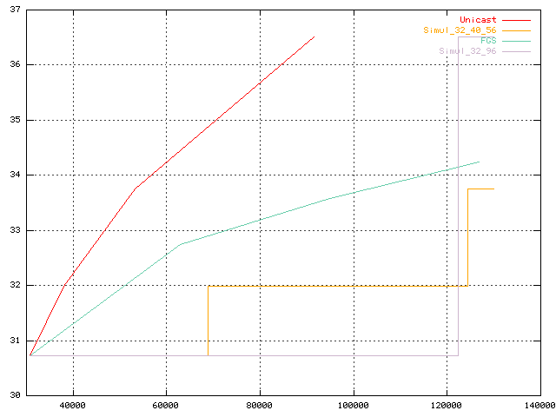

news_qcif_32
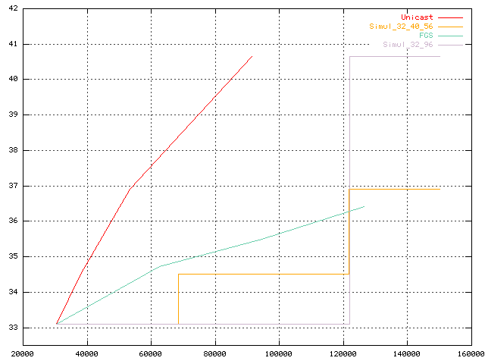

3-Layer Simulcast (64/82/110), fixed bandwidth

Sequence  PSNR [dB] |  | Channel bandwidth
 |  | 64 kbit/s  FGS base layer |  | 146 kbit/s |  | 256 kbit/s
 |  | SIM  64kbit/s | FGS  64kbit/s | SIM  82kbit/s | FGS  64+82kbit/s | SIM  110kbit/s | FGS  64+192kbit/s
Carphone | Y | 31.15 | 31.15 | 32.27 | 32.55 | 33.55 | 32.85
Carphone | U | 37.35 | 37.35 | 37.67 | 37.91 | 38.42 | 38.03
Carphone | V | 38.67 | 38.67 | 39.20 | 39.49 | 39.85 | 39.66
Coastguard | Y | 26.05 | 26.05 | 26.79 | 26.98 | 27.68 | 27.26
Coastguard | U | 39.27 | 39.27 | 39.66 | 40.48 | 40.11 | 40.74
Coastguard | V | 40.61 | 40.61 | 41.05 | 41,73 | 41.35 | 42.07
Paris | Y | 26.18 | 26.18 | 27.72 | 27.27 | 29.47 | 28.16
Paris | U | 34.07 | 34.07 | 34.68 | 34.65 | 35.59 | 35.19
Paris | V | 34.46 | 34.46 | 35.03 | 34.95 | 35.88 | 35.56

2-Layer Simulcast (64/192), fixed bandwidth

Sequence  PSNR [dB] |  | Channel bandwidth
 |  | 64 kbit/s  FGS base layer |  | 256 kbit/s
 |  | SIM  64kbit/s | FGS  64kbit/s | SIM  192kbit/s | FGS  64+192kbit/s
Coastguard | Y | 26.05 | 26.05 | 29.65 | 28.19
Coastguard | U | 39.27 | 39.27 | 40.89 | 41.27
Coastguard | V | 40.61 | 40.61 | 42.12 | 43.18
Carphone | Y | 31.15 | 31.15 | 35.99 | 33.68
Carphone | U | 37.35 | 37.35 | 39.60 | 38.43
Carphone | V | 38.57 | 38.57 | 41.16 | 40.14
Paris | Y | 26.18 | 26.18 | 32.81 | 27.83
Paris | U | 34.07 | 34.07 | 37.61 | 35.00
Paris | V | 34.46 | 34.46 | 37.77 | 35.50

Carphone_64

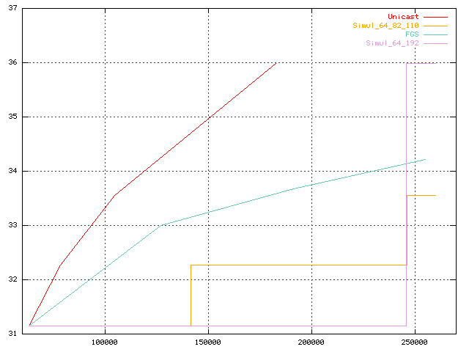

coastguard_64

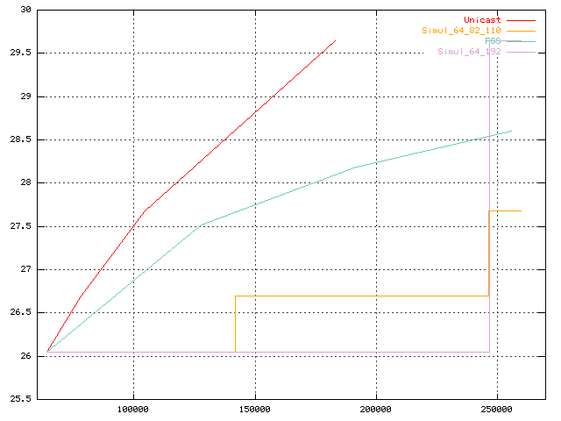

paris_cif_64
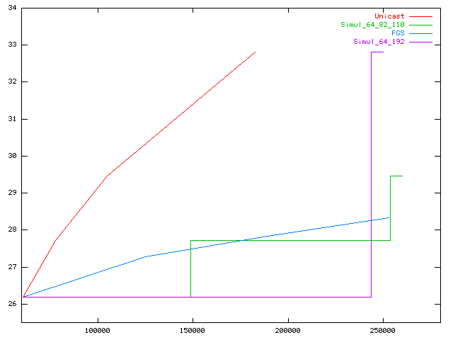

Observations:
- The FGS coder outperforms the simulcast coder at higher bitrates .
- At a baselayer bitrate >32kbit/s the FGS-coder does reach for most sequences the same or even exceeds the quality (PSNR) of the simulcast coder at the bitrates, where the simulcast coder can just switch to next higher quality level..
- At high bitrates a higher gain can be achieved, while at lower bitrates the FGS-coder mostly outperforms the medium simulcast layer.
- Although the gain depends on the bitrates assigned to the simulcast layers a sustained gain is reachable for higher bitrates.
- In the 2-layer scenario the simulcast outperforms the FGS-coder
- The simulcast coder can switch immediately to a much higher quality level as more bits are available for the high quality bitstream (simulcast). In contrast the baselayer of the FGS coder is still coded at the minimum bitrate.
- If the channel bandwidth does not match the bitrates generated by the simulcast coder the FGS-coder performs better than the simulcast coder. The reason is that the simulcast decoder must switch back to the next lower bitrate available, while the FGS-coder can fully exploit the channel bandwidth available.
- The characteristics observed seem to be a pretty fundamental as they do not change for larger images coded at higher rates (CIF @ 64kbit/s).

The 2-layer scenario is less likely, since in order to enable smooth transitions and a flexible adaptation to different channel bandwidths a real simulcast system must provide more than one additional layer. Moreover, as the gap increases a significant jump in quality can be observed, while the FGS-coder provides smooth quality improvement and grace-full degradation.

➔ The performance degradation for the bandwidth conditions (3-layer simulcast) listed is moderate. For some sequences (carphone, scenario 1) the FGS coder reaches even almost the performance of the simulcast scenario.

  - Variable Bandwidth (ramp function)

3-Layer Simulcast (24/36/48)

Note:
The delayed switch of the simulcast coder between layers is related to the fact, that the simulcast coder has to wait for the next INTRA-coded frame.

Observations:
- For most bitrate ranges the FGS-coder performs significantly better than the simulcast coder performs.
The improvement is in particular noticeable as for the baselayer higher bitrates are used, and concequently the total bandwidth increases.
- The FGS-coder performs worse only at the bitrate ranges close to the bitrates at which the simulcast coders operate.
- The FGS coder can provide a smooth quality increase / decrease while in the simulcast case the switch between different quality levels causes a noticable jump of the quality.
- The FGS-coder utilises optimally the available channel bandwidth.
- This characteristic can be observed for different images sizes (QCIF / CIF) at different bitrates.

- Conclusion

The fine-granular scalable coding concept proofed to perform very well, especially for channels with varying capacity. Under such conditions a simulcast coder
- must provide at least 3-layers for suitable adaptation to channel conditions
- jumps between the layers as channel conditions change
- has to wait for the next INTRA-coded frame for switching between the layers / or must simultaneously decode all lower quality layers.

In contrast the FGS-coder
- Optimally utilizes the available channel bandwidth
- Provides smooth quality transitions without noticable jumps
- provides objectively better quality compared to the simulcast coders for most bitrate ranges (PSNR)
- outperforms the simulcast scenario at higher bitrates.
- performs worse than simulcast only at small bandwidth slots around the transition from one simulcast layer to the next higher layer

Note:
The FGS-coder has also excellent potential for improvements.

