ITU - Telecommunications Standardization Sector  STUDY GROUP 16  Video Coding Experts Group (Question 15)  _________________  Tenth Meeting: Osaka, Japan, 16-18 May, 2000 | Document Q15-J-14  Filename: q15j14.doc  Generated: 02 Mai. ’00

Question: | Q.15/SG16
Source: | Thomas Wedi  Institut für Theor. Nachrichtentechnik und Informationsverarbeitung,  University of Hannover  Appelstr. 9A  D-30167 Hannover, Germany | Tel:  Fax:  Email: | +49 511 7625304  +49 511 7625333  wedi@tnt.uni-hannover.de
Title: | Interpolation filters for motion compensated prediction with 1/4 and 1/8-pel accuracy
Purpose: | Proposal
_____________________________

Introduction

Document Q15i35 presents a motion compensated prediction scheme for H.26L which uses motion vectors (MV) with 1/4- and 1/8-pel accuracy. At the Geneva meeting Telenor presented a contribution (COM-16 D.361) which makes use of this approach. However, the Telenor approach uses different interpolation filters with shorter impulse responses.

The Telenor document mainly focuses on the 1/4-pel accuracy. For 1/4-pel the results for four different filter combinations were presented. But for 1/8-pel only results for one filter combination were presented without comparison with other filter combinations.

This contribution basically verifies the Telenor results for 1/4-pel accuracy and gives some additional results for 1/8 pel accuracy.

Interpolation for motion compensated prediction

Interpolation process

In order to interpolate the image signal on subpel positions, interpolation filters are used. The interpolation is equivalent to an upsampling of the frame. The following Figure 1 shows the interpolation process for the two motion vector accuracies of 1/4-pel and 1/8-pel. This is the same process that was already presented in Q15i35, and which was also used in the Geneva Telenor contribution (COM-16 D.361).

Figure 1: Interpolation process for 1/4 and 1/8-pel MV-accuracies

In the case of motion vectors with 1/4-pel accuracy, the frame has to be upsampled by a factor of 4 (4:1 resolution). This is done by applying Filter 1 which produces the 2:1 resolution, followed by Filter 2 which produces the final 4:1 resolution.
In the case of 1/8-pel MV-accuracy, the frame has to be upsampled by a factor of 8, which is done by additional filtering of the 4:1 resolution using a third filter.
Since for the 1/4-pel interpolation two different filters and for 1/8-pel interpolation three different filters can be used, there are several possible filter combinations for each MV-accuracy.

Interpolation filters

Applied Interpolation filters:

In Table 1 the different interpolation filters are shown. In this table the Filter length, the impulse response and a short description of the filters are given.

Filter length | Impulse response | Description
2-tap | (16,16)/32 | Bilinear Filter
4-tap | (-4,20,20,-4)/32 | Telenor Filter (COM-16 D.361)
6-tap | (1,-5,20,20,-5,1)/32 | Telenor Filter (COM-16 D.361)
8-tap | (-1,3,-6,20,20,-6,3,-1)/32 | Wiener Filter (Q15i35)
Table 1: Interpolation Filters

The first filter in Table 1 is the bilinear filter (2-tap). The 4-tap and 6-tap filters were presented by Telenor in document COM-16 D.361. The fourth filter is the 8-tap Wiener filter that was presented in Q15i35.

In this contribution the same filters are used for horizontal and vertical filtering. For the assumption, that the source of the progressive sequences are interlaced sequences, it makes sense to use different filters for horizontal and vertical filtering. But, since this need not be the case for all applications, this restriction is not made in this contribution. Therefore it is assumed that the statistical properties of the sequences to be coded are the same for horizontal and vertical direction.

Furthermore, in this contribution no “stronger filter positions” are used. Telenor presented in document COM-16 D.361 a different filter for so called “stronger filter positions”. Since no improvements for the coding efficiency could be shown, and since a subjective comparison shows that the images without stronger filter positions look clearly noisier (stated in COM-16 D.361) but also clearly sharper (our impression of the images shown in COM-16 D.361), the separate filtering of the “stronger filter positions” is not used in this contribution.

Abbreviations:

In order to specify the applied filter combinations for the interpolation process, abbreviations are used. In Figure 2 the meaning of the abbreviations is illustrated for one example (1/8-pel MV-accuracy). In the abbreviations the filters are represented by their filter length (e.g. bilinear: 2-tap → abbreviation: (2)).

Figure 2: Example of an abbreviation for a filter combination in the 1/8-pel interpolation scheme (see also Figure 1). In this abbreviation the used filters are
represented by their filter length.

Motion Estimation

In a motion compensated prediction scheme the motion vector candidate and the block-size pattern (e.g. 16x16, four 8x8, etc) have to be estimated for each macroblock (MB). This is done by the following 5 steps:

- Make a full search to find the best 1/1-pel vector.
- Check the 8 1/2-pel positions around the best 1/1-pel vector in order to find the best 1/2-pel vector.
- Check the 8 1/4-pel positions around the best 1/2-pel vector in order to find the best 1/4-pel vector.
- Check the 8 1/8-pel positions around the best 1/4-pel vector in order to find the best 1/8-pel vector.
- Select the motion vector accuracy and block-size pattern, which produces the lowest rate-distortion cost.

Experimental Results

Table 2 shows the test-sequences recommended in Q15i62. Since the test-sequence Forest is not available for the group, the test-sequence Flower Garden is used instead.

Test-sequence | Res. | Frame rate | No. of frames
Mobile & Calendar | CIF | 30 | 300
Flower Garden | CIF | 30 | 250
Tempete | CIF | 30 | 260
Paris | CIF | 15 | 300
Silent Voice | QCIF | 15 | 300
Container | QCIF | 10 | 300
News | QCIF | 10 | 300
Foreman | QCIF | 10 | 300

Table 2: Applied test-sequences.

In Table 3 the investigated filter combinations are shown. In this table and in the following rate-distortion plots (RD plots) the abbreviations described in Figure 2 are used.

MV resolution | 1/8-pel | 1/4-pel
Investigated filter combinations | (882) | (82)
Investigated filter combinations | (862) | (62)
Investigated filter combinations | (842) | (42)
Investigated filter combinations | (662)
Investigated filter combinations | (642)
Investigated filter combinations | (442)

Table 3: Investigated filter combinations for each MV-accuracy. The meaning of the
abbreviations (e.g. (862)) are described in Figure 2.
In the following two subsections the rate distortion plots for all sequences specified in Table 2 and for all filter combinations specified in Table 3 are shown. In subsection 4.1 the RD plots for 1/4-pel MV-accuracy and in subsection 4.2 the RD plots for 1/8 pel accuracy are shown, respectively. For all results 5 reference frames are used.

Rate-distortion plots for 1/4-pel accuracy

Each rate-distortion plot of this subsection contains the following curves:

- 1/3-pel with cubic interpolation (TML1)
- 1/4-pel with 3 different filter combinations (see Table 3)
- AMA-6 with 1/2, 1/3 and 1/6-pel accuracy (TML2)

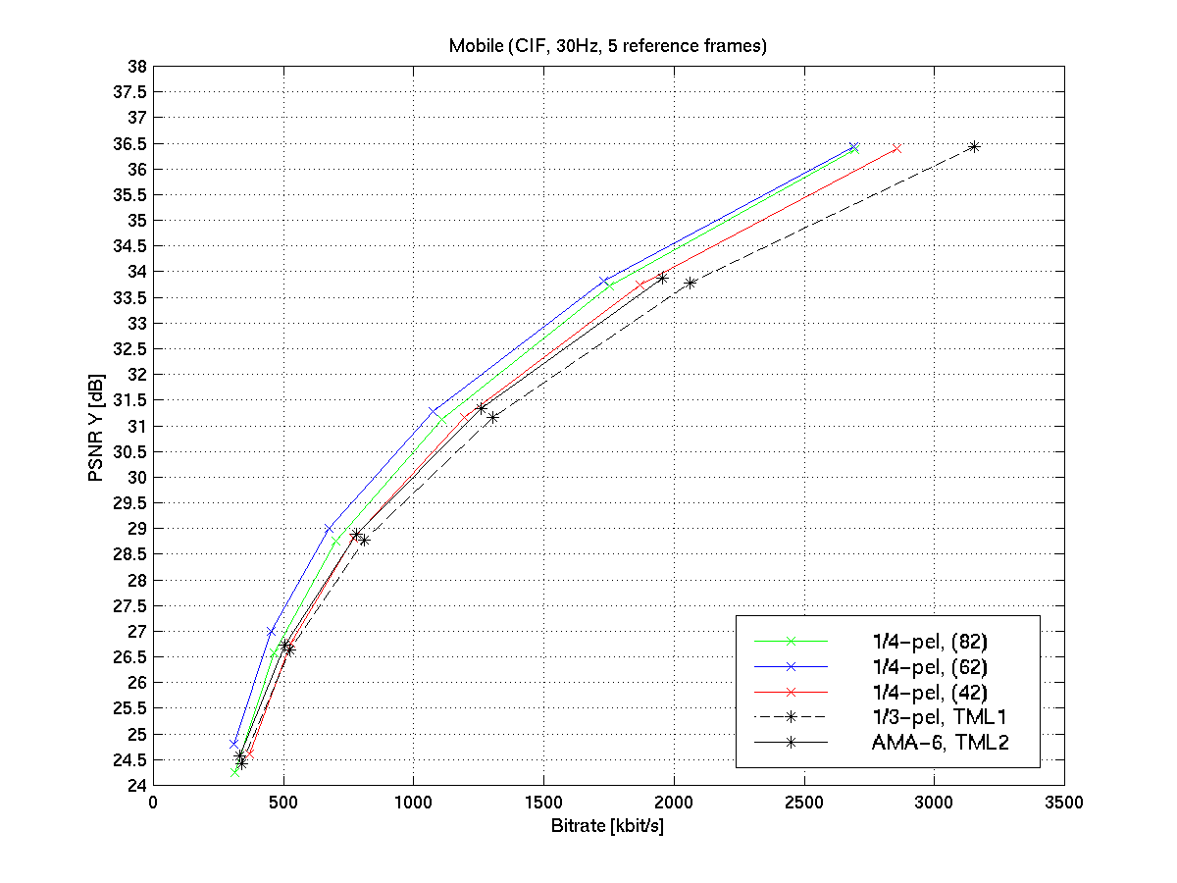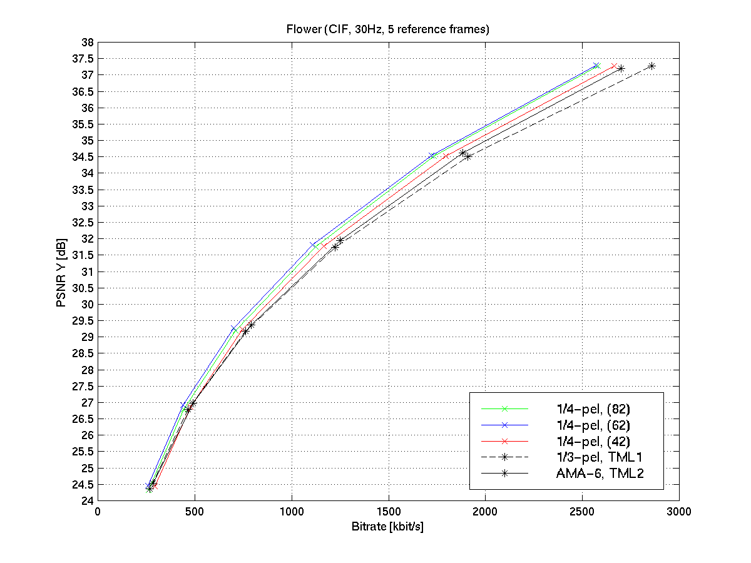
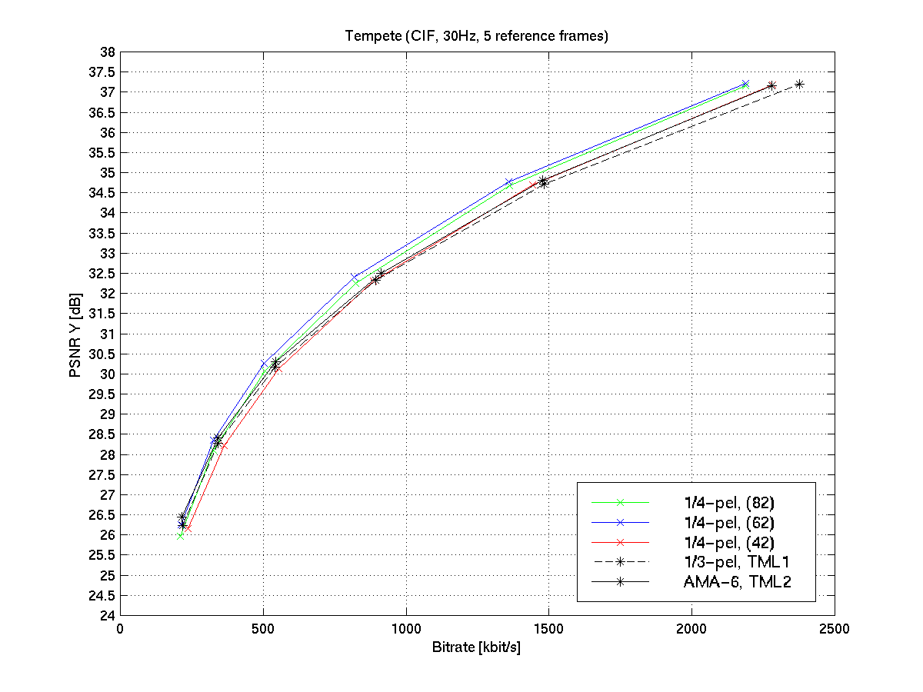
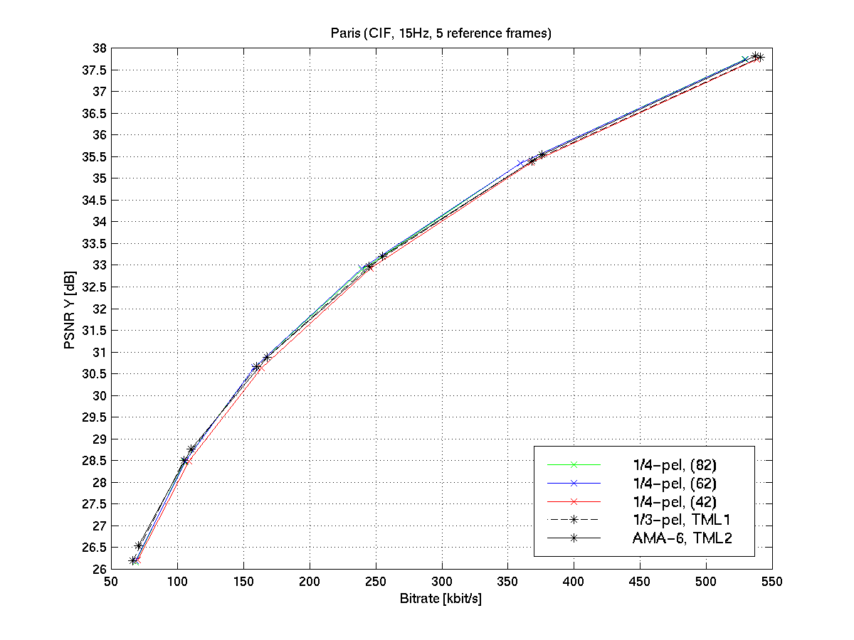
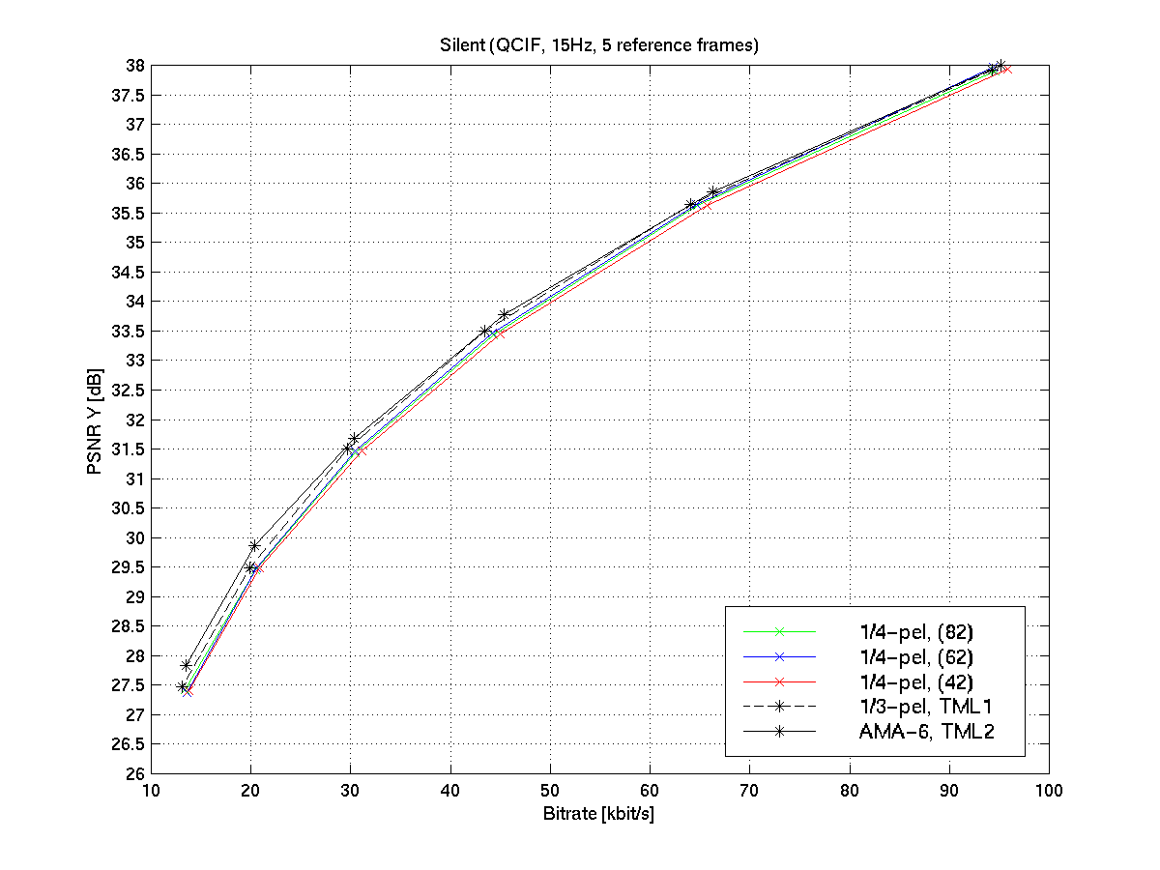
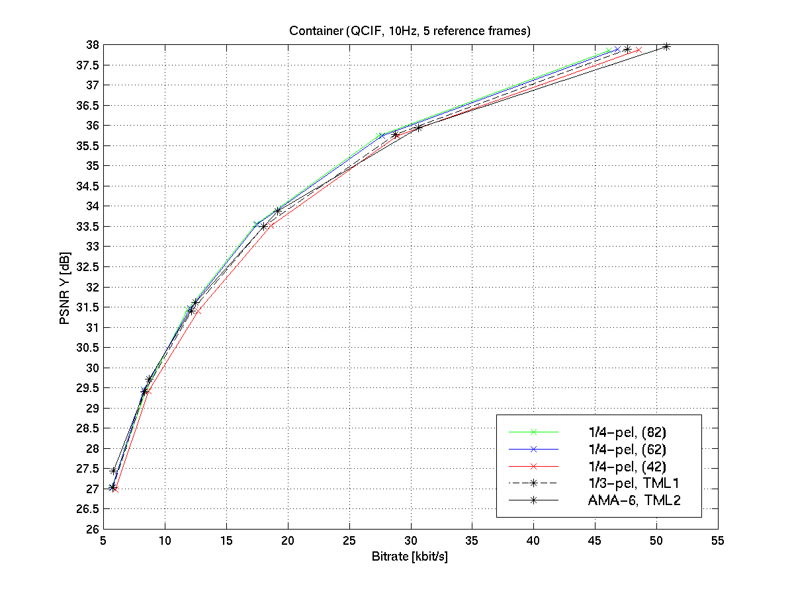
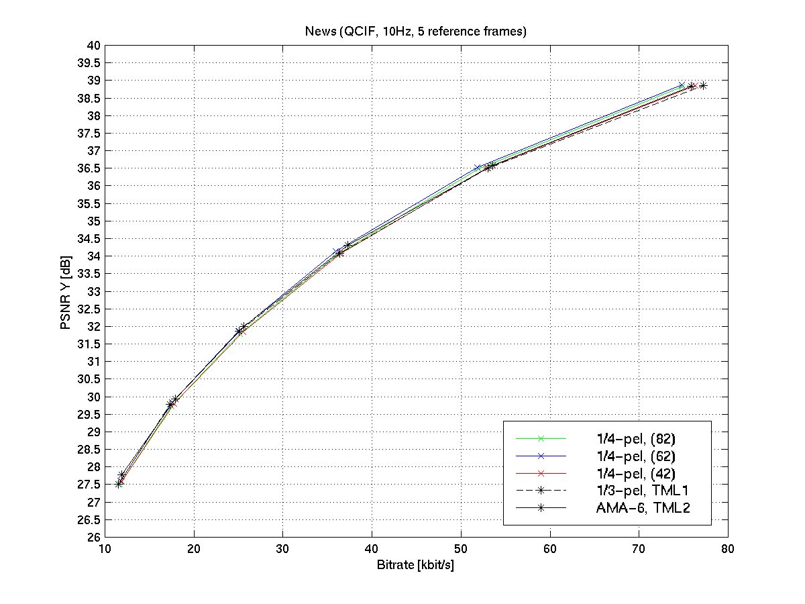
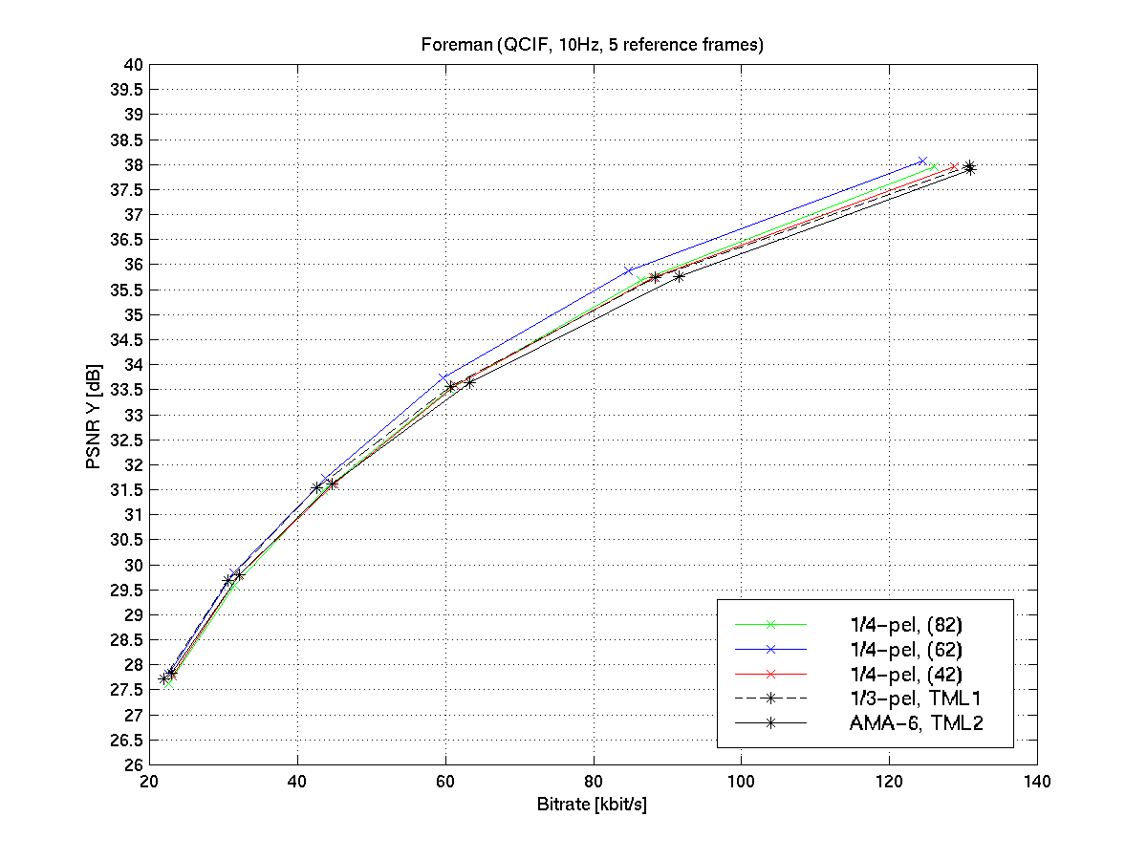

Rate-distortion plots for 1/8-pel accuracy

Each rate-distortion plot in this subsection contains the following curves:

- 1/3-pel with cubic interpolation (TML1)
- 1/8-pel with 6 different filter combinations (see Table 3)
- best 1/4-pel version (see subsection 4.1)
- AMA-6 with 1/2, 1/3 and 1/6-pel accuracy (TML2)
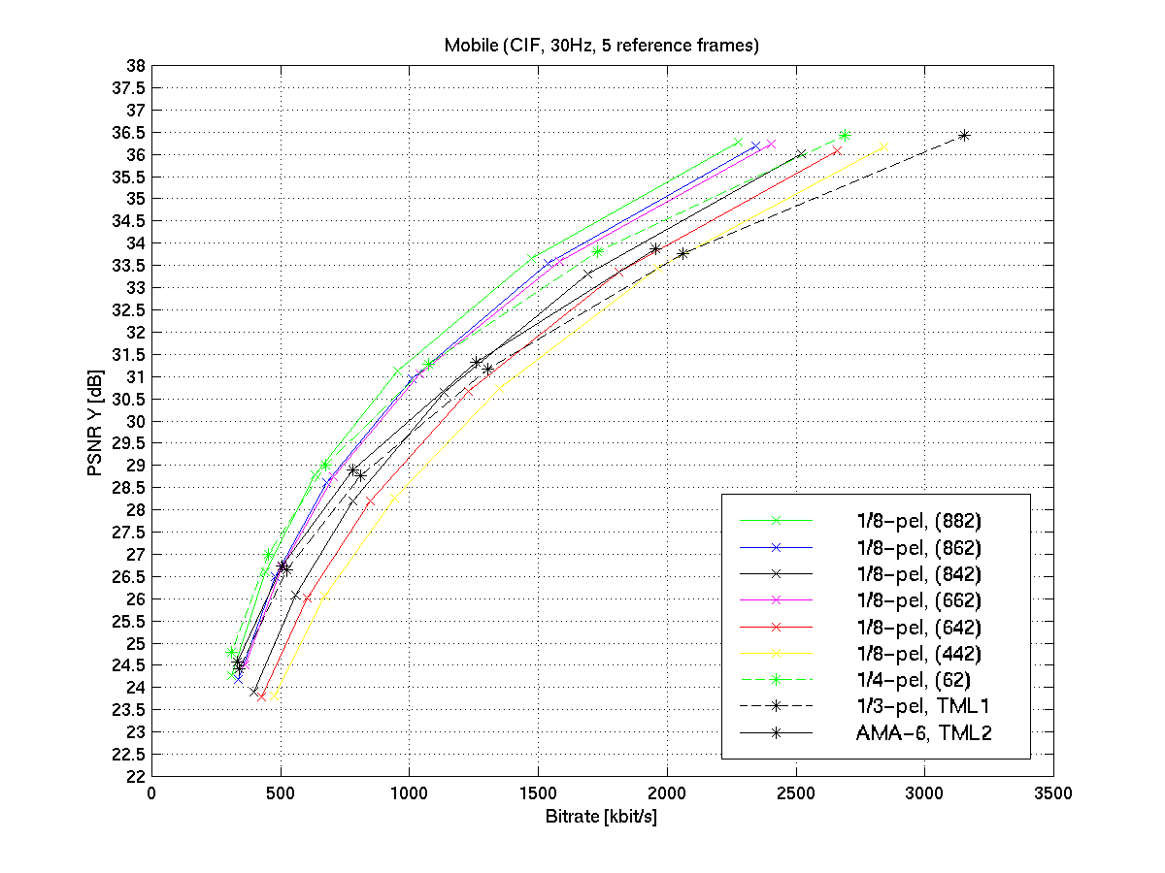
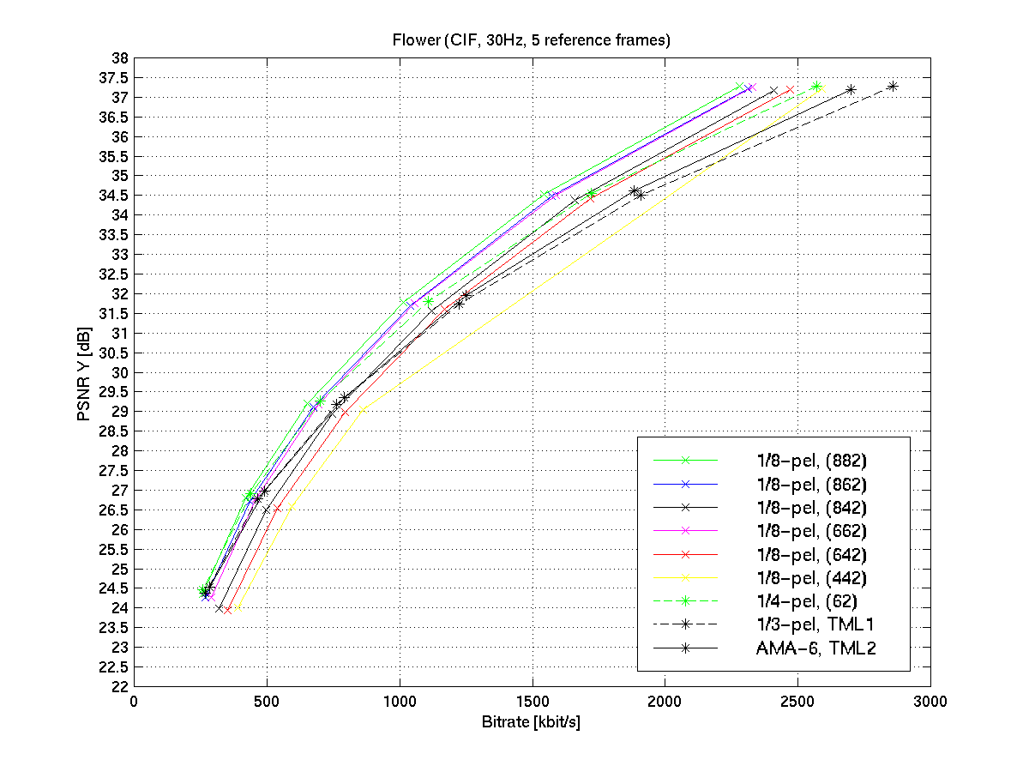
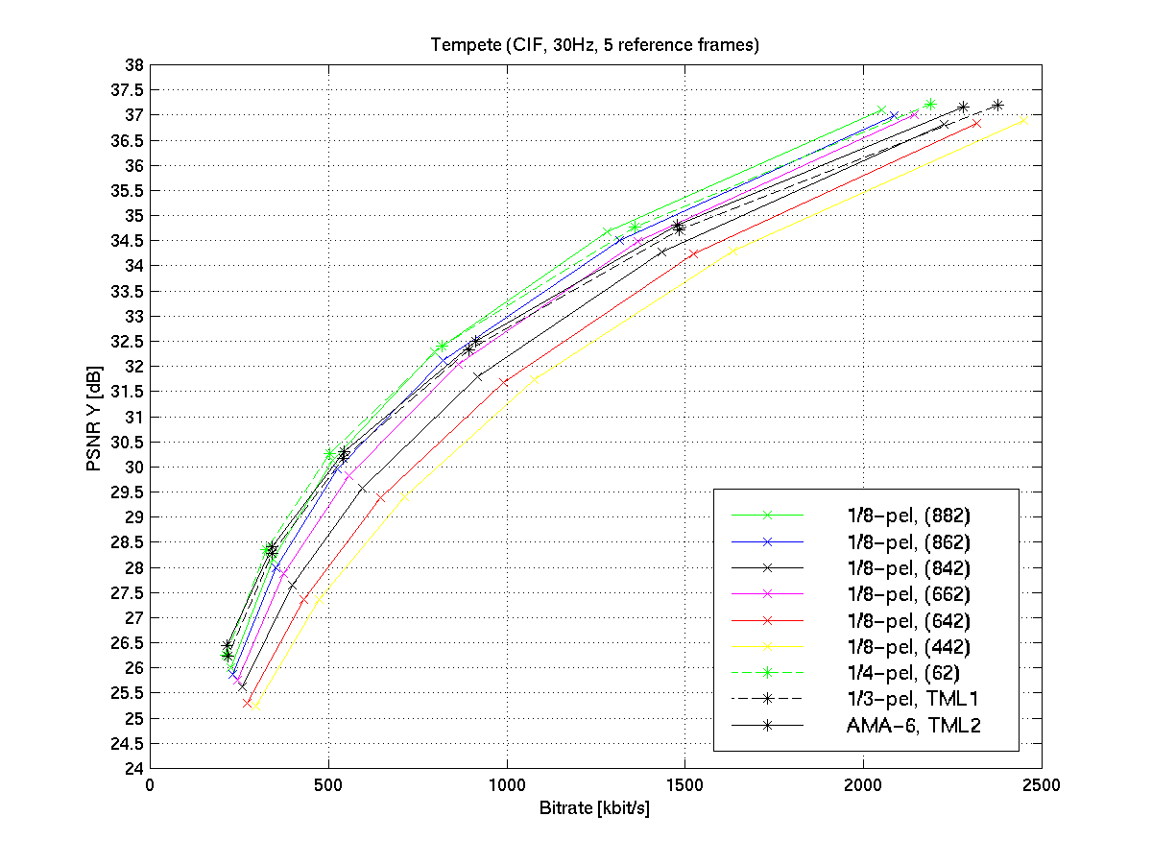
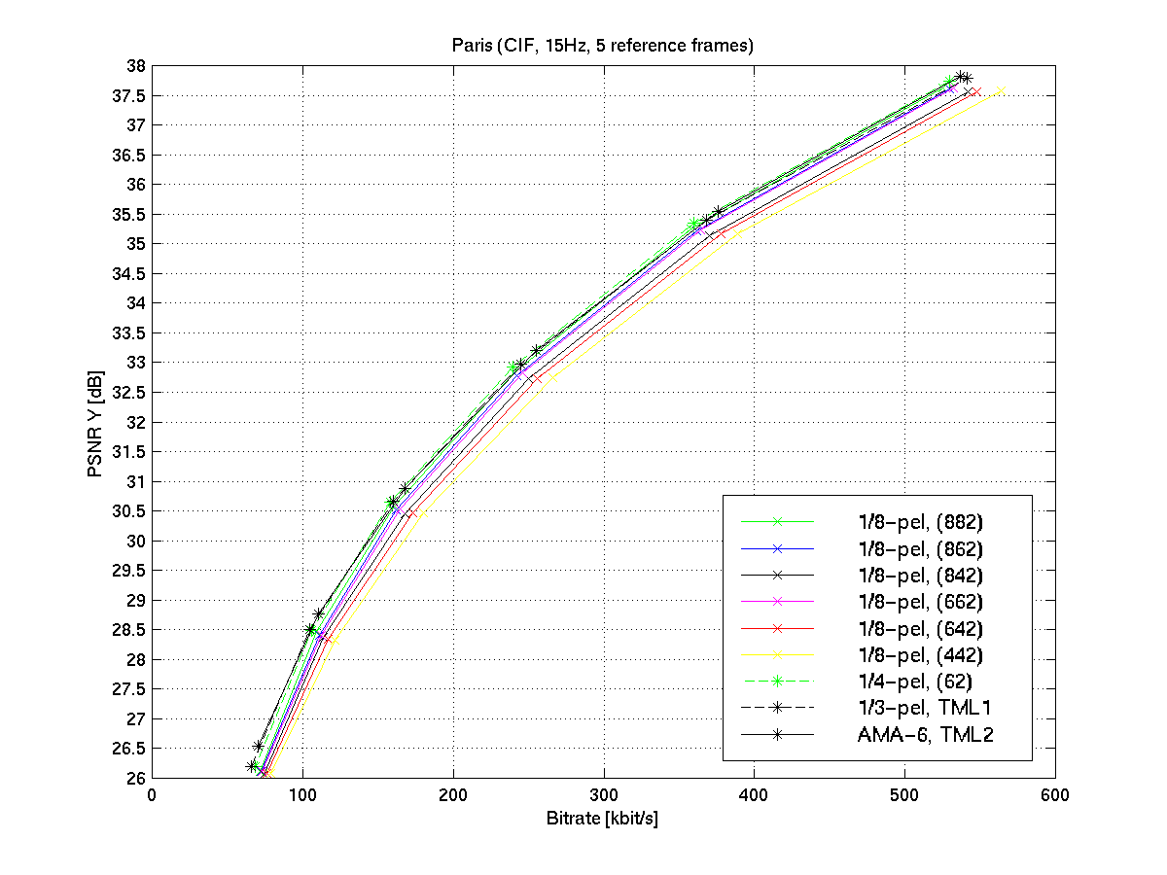
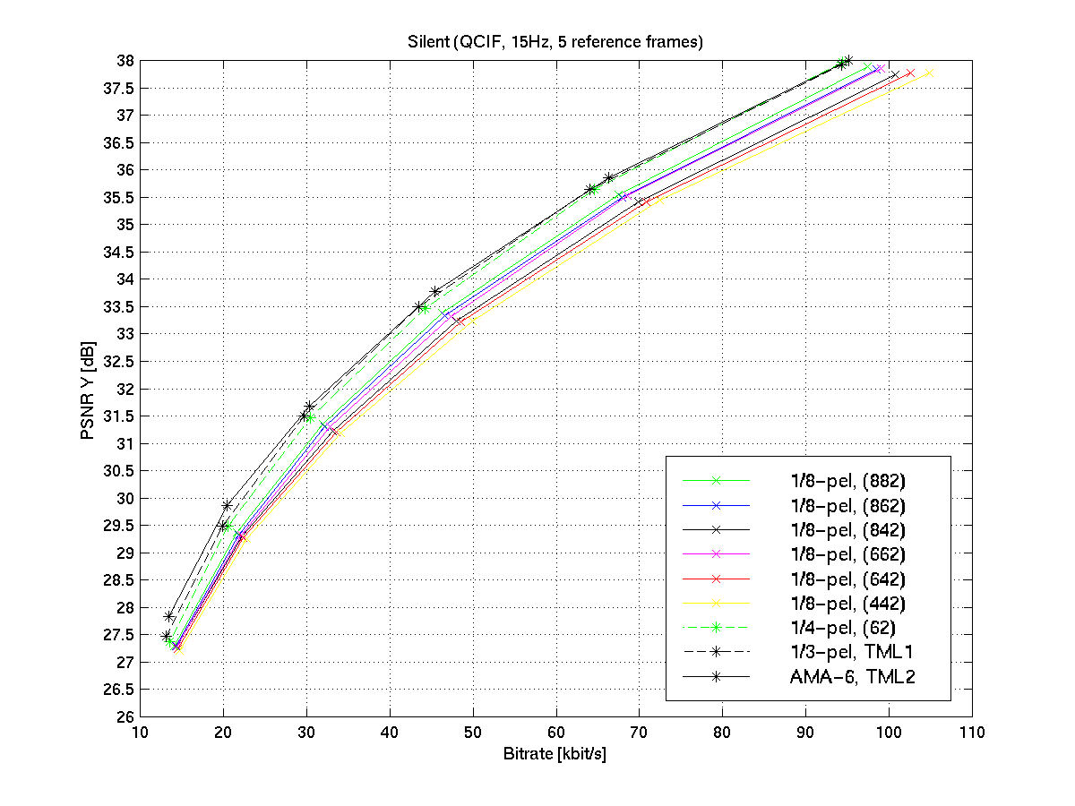
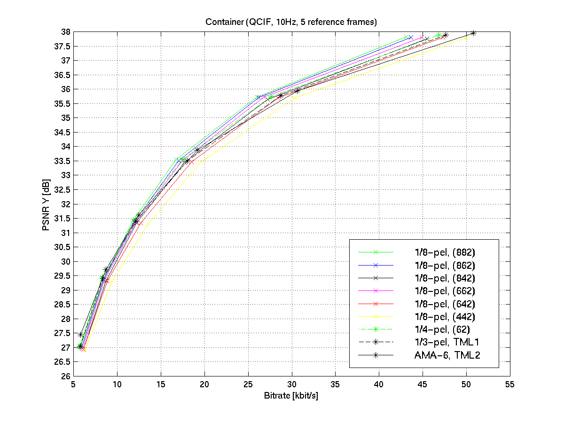
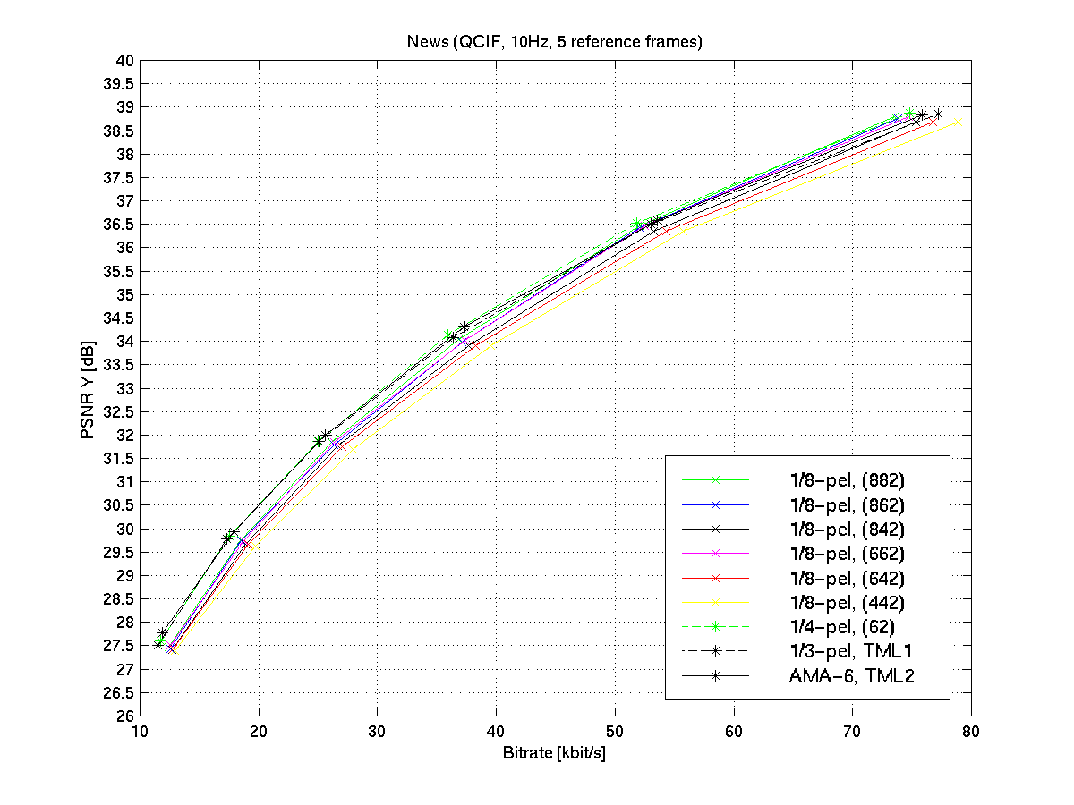
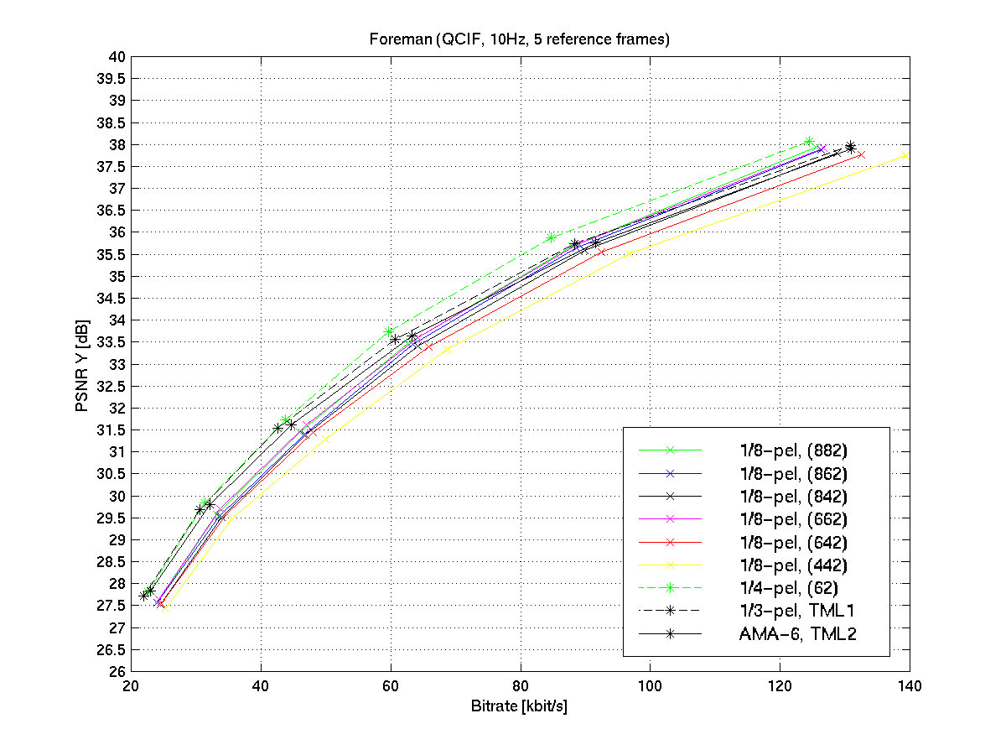

Summary

1/4-pel results:

- Up to 1.0 dB gain with 1/4-pel compared to 1/3-pel. Only loss for sequence silent.
- The 6-tap filter leads to a gain up to 0.5 dB compared to the 8-tap filter
- The 4-tap filter leads to a loss up to 1.0 dB compared to the 8-tap filter

If only 1/4-pel is applied, the combination of 6-tap and bilinear filter (62) seems to the best choice.

1/8-pel results:

- Gains between –0.7 dB (for lower data rates) and 2.0 dB (for higher data rates) with 1/8-pel compared to 1/3-pel
- The 8-tap filter leads to a gain up to 1.0 dB compared to the 6-tap filter
- The 4-tap filter leads to a loss up to 2.0 dB compared to the 8-tap filter

If only 1/8-pel is applied, the combination of 8-tap and bilinear filter (882) seems to be the best choice.

Recommended MV-accuracies for fixed motion compensation without AMA:

If fixed MV-accuracies are used (no AMA), it is recommended to use the 1/4-pel MV-accuracy with the combination of 6-tap and bilinear filters for the lower data rates and the 1/8-pel MV-accuracy with the combination of 8-tap and bilinear filters for the higher data rates instead of fixed 1/3-pel MV accuracy.

Proposed filters for motion compensation using AMA with 1/2, 1/4 and 1/8-pel:

The filter combinations with 8-tap, 6-tap and bilinear filters should be studied. ➔ see Q15j15

References
D.361: G. Bjontegaard, “Motion Compensation with 1/4 pixel accuracy”, ITU-T SG16/Q15, Geneva, Feb. 00.
Q15i62: G. Bjontegaard, “Recommended Simulation Conditions for H.26L”, ITU-T SG16/Q15, doc. Q15-I-62, Red Bank, Oct. 99.
Q15i59: J. Ribas-Corbera, “Core Experiment on Motion Compensated Prediction: Accuracy and Interpolation”, ITU-T SG16/Q15, doc. Q15-I-59, Red Bank, Oct. 99.
Q15j09: G. Bjontegaard, L. Kerofsky, “ H.26L Core Experiment on Adaptive Motion Accuracy (AMA) for 1/2, 1/4, and 1/8 Sample Accuracy Motion Compensation”, ITU-T SG16/Q15, doc. Q15-J-35, Osaka, May 00.
Q15i35: T. Wedi, “Motion and Aliasing Compensated prediction for H.26L”, ITU-T SG16/Q15, doc. Q15-I-35, Red Bank, Oct. 99.
Q15j15: T. Wedi, “Results of core experiment on Adaptive Motion Accuracy (AMA) with 1/2, 1/4 and 1/8-pel accuracy”, ITU-T SG16/Q15, doc. Q15-I-35, Red Bank, Oct. 99.

